FÍSEÁIN
1 | Stair na Gaeilge  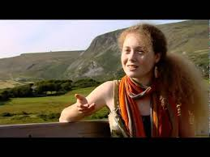 | https://www.youtube.com/watch?v=bzH1phxBEEQ
2 | Céard í an Ghaeltacht?  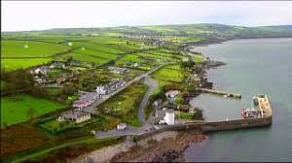 | https://www.youtube.com/watch?v=RgYEQ80uvNU
3 | Sealbhú Mionteanga!  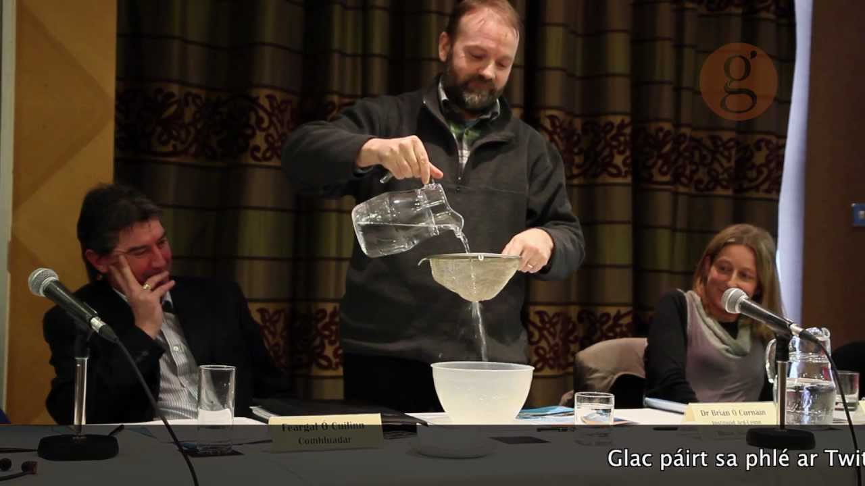 | Mar pháirt de Thóstal na Gaeilge 2013, d’úsáid an Dr Brian Ó Curnáin modh iontach simplí le taispeáint cad atá ag tarlú maidir le sealbhú teanga sa Ghaeltacht! Is fiú go mór amharc ar an fhíseán sin.  https://www.youtube.com/watch?v=UxrO67DVNxM
4 | 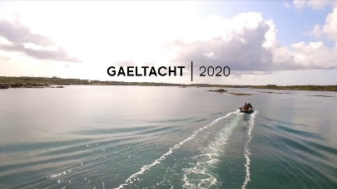 | https://www.youtube.com/watch?v=VpH0iES94Ak
5 | An tOllamh Gearóid Ó Tuathaigh: | https://twitter.com/7latg4/status/1108408508314206214?lang=en
6 | An Dr Brian Ó Curnáin: | https://www.facebook.com/7LATG4/videos/an-dr-brian-%C3%B3-curn%C3%A1in/1290759464395150/
7 | An tOllamh Alan Titley | https://twitter.com/7latg4/status/1213483334107586561?lang=en
 | 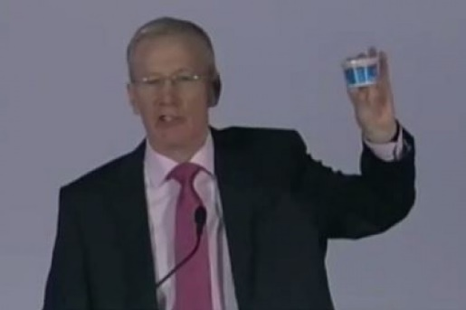 | https://www.bbc.com/news/uk-northern-ireland-29895593
8 | 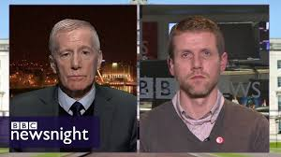 | https://www.youtube.com/watch?v=Td4dT-AkKbM
LÁITHREÁIN GHRÉASÁIN
1 | 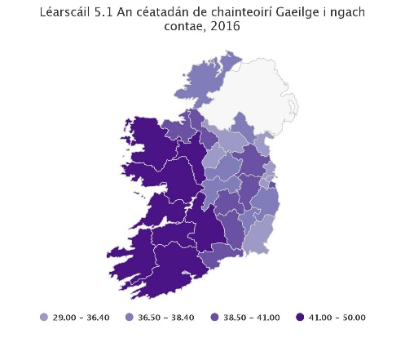 | https://www.cso.ie/en/releasesandpublications/ep/pcp10esil/p10esil/gag/
2 | Cainteoirí Laethúla Gaeilge de réir toghroinne, 2016  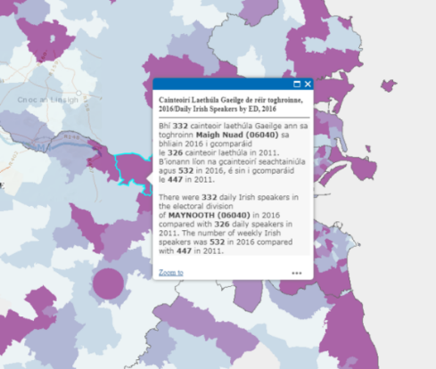 | http://census.cso.ie/p10map51/
3 |   Teorainneacha na dToghrann | https://census.cso.ie/censusasp/saps/boundaries/eds_bound.htm
4 | 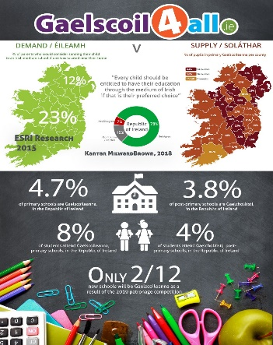 | http://gaelscoil4all.ie/  http://www.gaeltaca.ie/en/campaign/gaelscoil-gach-scoil.html
5 |  | https://www.ninis2.nisra.gov.uk/public/PivotGrid.aspx?ds=2791&lh=44&yn=2011&sk=136&sn=Census%202011&yearfilter=2043
6 | 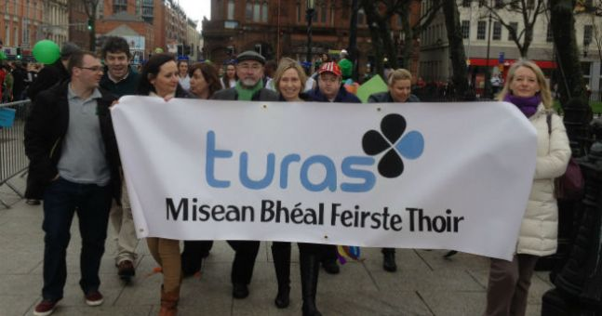 | https://www.ebm.org.uk/turas/
7 | 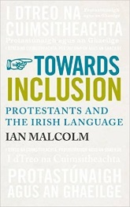 | https://irishwithian.wordpress.com/about/
8 | 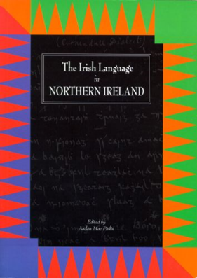 | https://cain.ulster.ac.uk/issues/language/mccoy97.htm#learn  https://www.irishnews.com/news/northernirelandnews/2019/06/08/news/new-booklet-telling-story-of-irish-language-in-east-belfast-to-be-launched-next-week-1637347/
9 | 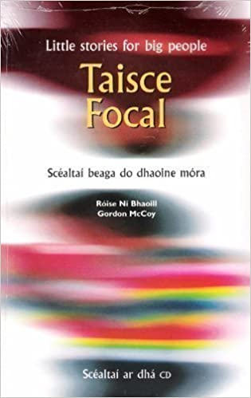 | http://www.bbc.co.uk/northernireland/irish/blas/arts/leabhar/taisce_focal.shtml  http://www.beo.ie/Rubric.aspx?RubricID=253
10 | 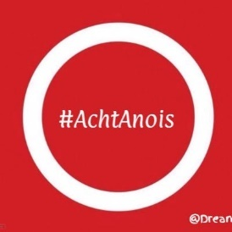 | https://twitter.com/dreamdearg?lang=en
11 | 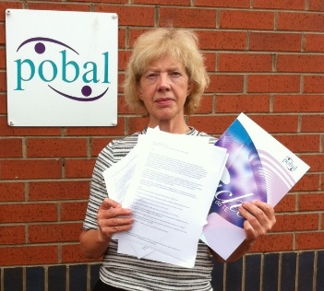 | https://en-gb.facebook.com/pobal.achtgaeilge
12 | 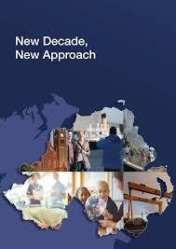 | https://www.dfa.ie/news-and-media/press-releases/press-release-archive/2020/january/new-decade-new-approach-.php
13 | Fás na Gaelscolaíochta sna Sé Chontae   | https://www.bbc.com/news/uk-northern-ireland-55136935
14 | Catagóir Daonra % de Dhaonra na Gaeltachta Oifigiúla  A 17,199 18%  B 9,780 10%  C 16,871 18%  Gan Stádas 51,653 54%  An t-Iomlán 95,503 100% | http://anghaeltacht.net/ctg/080323foinse.html
15 | “Níl fanta sa Ghaeltacht ach 17,000 cainteoir laethúla Gaeilge!” | https://www.rte.ie/gaeilge/2020/0423/1134291-gaeltacht-2020-an-mairfidh-si/
16 | Na Ceantair Ghaeltachta  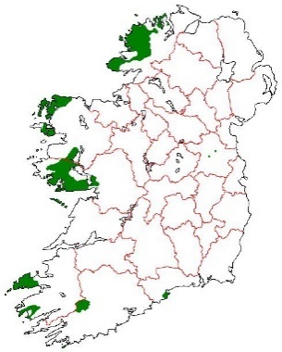 | https://en.wikipedia.org/wiki/User:D.de.loinsigh
17 | 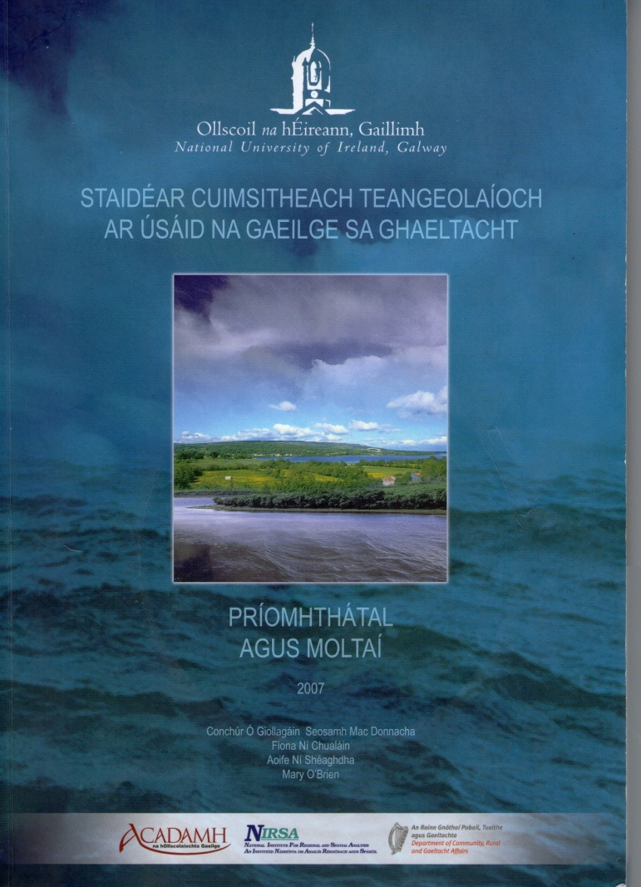 | https://www.cogg.ie/wp-content/uploads/Linguistic-Study-of-the-Use-of-Irish-in-the-Gaeltacht.pdf
18 | 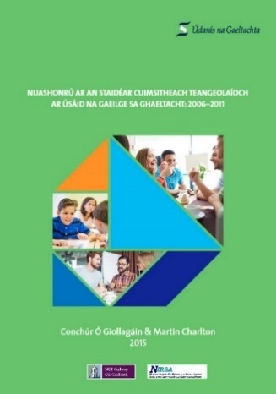 | https://www.udaras.ie/2015/05/28/tuarascail-ar-nuashonru-ar-an-staidear-cuimsitheach-teangeolaioch-ar-usaid-na-gaeilge-sa-ghaeltacht-2006-2011-foilsithe-ag-udaras-na-gaeltachta/
19 | 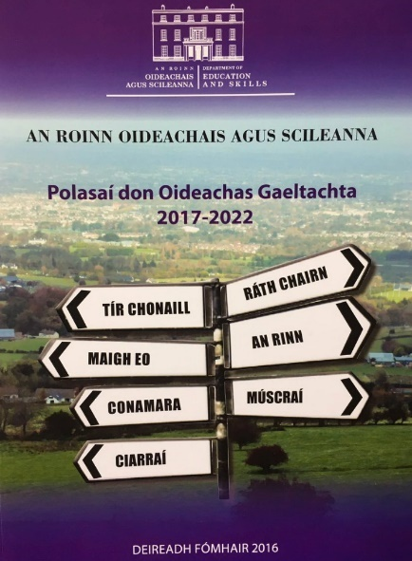 | https://www.education.ie/ga/An-C%C3%B3ras-Oideachais/Polasai-don-Oideachas-Gaeltachta-2017-2022/
20 | 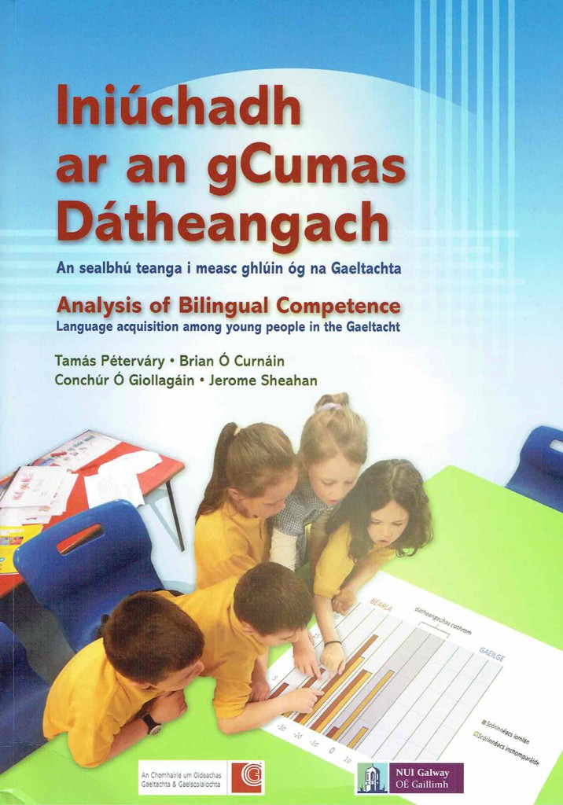 | https://www.cogg.ie/wp-content/uploads/iniuchadh-ar-an-gcumas-datheangach.pdf
21 | Amharcóir Pleanála Teanga GIS / Language Planning Viewer GIS  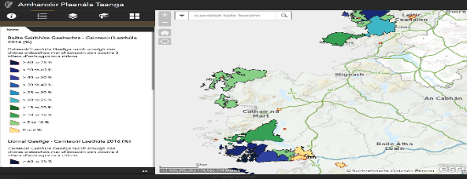 | https://data.gov.ie/showcase/amharc-ir-plean-la-teanga-gis-language-planning-viewer-gis
22 | Pleananna Teanga Ceadaithe/Faofa  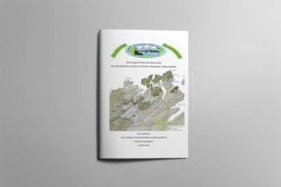 | https://udaras.ie/an-ghaeilge-an-ghaeltacht/pleanail-teanga/pleananna-faofa/
23 | 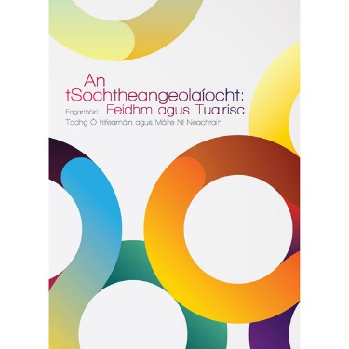 | https://coislife.ie/product/an-tsochtheangeolaiocht/?lang=en
24 | 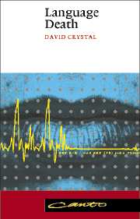 | https://www.cambridge.org/core/books/language-death/3DB03D3B36D66FF59416EDD1BD38C76B

Bhí sé de nós ag Comhdháil Náisiúnta na Gaeilge comhdhálacha a reáchtáil ar bhonn bliantúil faoi théamaí éagsúla. Bunaíodh Comhdháil Náisiúnta na Gaeilge sa bhliain 1943 agus cuireadh deireadh leis an eagraíocht sa bhliain 2014.

