Blood Alcohol Content
Cian Mac Liatháin, ID: 11476078

Introduction
How well does the number of beers a student drinks predict their blood alcohol content?
The following research questions are of interest:
- Is there evidence to suggest a difference in the typical blood alcohol content (BAC) between the male student population and female student population.
- Explore the relationship between blood alcohol content (BAC) and the number of beers consumed (Beers) with correlation analysis.
- Fit a linear regression model to the relationship between blood alcohol content (BAC) and the number of beers (Beers), interpreting the fitted values in the estimated relationship. Comment on the significance of the estimated effect. Use the estimated relationship to find the fitted value of blood alcohol content when the number of beers consumed is 5.

Subjective Impression
A sample of, very willing, volunteers drank a randomly assigned number of cans of a certain brand of beer.A number of hours later a police officer measured their blood alcohol content, BAC. The gender of participants was also recorded.
To investigate if any difference exists when comparing BAC by gender the following output provides some summary statistics and graphical displays for the female and male samples for comparison.
BAdata%>%group_by(Gender)%>%summarise(n=n(),mean=mean(BAC),median=median(BAC), sd=sd(BAC), min= min(BAC), max=max(BAC))
# A tibble: 2 x 7
Gender n mean median sd min max
<chr> <int> <dbl> <dbl> <dbl> <dbl> <dbl>
1 F 13 3.91 3.5 2.61 0.1 8.1
2 M 19 6.16 4 4.77 1 15.6
ggplot(BAdata,aes(y=BAC,fill=Gender))+geom_boxplot()+coord_flip()
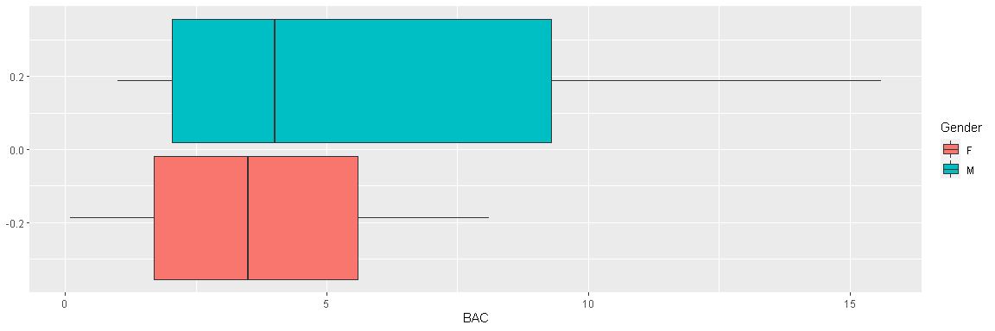
We can see from the summary statistics that there was higher blood alcohol content (BAC) found in the male sample than the female, with a mean of 6.157895 in males compared to a mean of 3.907692 in females. More variance is also seen in the males, with a higher standard deviation of 4.768218 compared to the females’ 2.606230.
It is evident from the box plots that both the male and female samples are positively skewed, and the male sample has a higher range of blood alcohol content (BAC) of 14.6 compared to the females’ range of 8, both samples have no obvious outliers.
To explore the relationship between blood alcohol content (BAC) and the number of beers consumed (Beers), a scatterplot and Pearson correlation coefficient for the sample is produced.
ggplot(BAdata,aes(x=Beers,y=BAC))+geom_point()
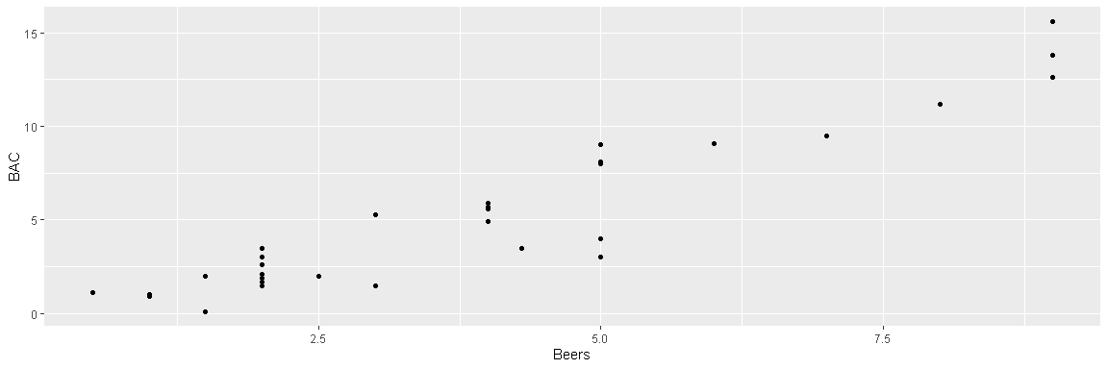
cor(BAdata$BAC,BAdata$Beers)
[1] 0.940536
It is visually evident from the scatterplot that there is a positive linear relationship between blood alcohol content (BAC) and beers consumed (Beers), with an observed Pearson correlation coefficient of 0.940536, indicating a strong positive relationship in the sample between the two variables.

Formal Analysis
A hypothesis test is carried out to determine if the sample gives evidence to suggest a difference in the typical blood alcohol content (BAC) between the male student population and female student population.
Since both sample sizes are small, it is important to assess the normality of the population of male and female blood alcohol content (BAC), to know whether a t-test is applicable. This can be done using an Anderson-Darling normality test.
maleBAC <- BAdata %>% filter(Gender == "M") %>% pull(BAC)
femaleBAC <- BAdata %>% filter(Gender == "F") %>% pull(BAC)
ad.test(maleBAC)
Anderson-Darling normality test
data: maleBAC
A = 0.87674, p-value = 0.01975
ad.test(femaleBAC)
Anderson-Darling normality test
data: femaleBAC
A = 0.29895, p-value = 0.5324
With a p-value of 0.5324, there is no evidence to reject the null hypotheses for the female population. However, the male p-value of 0.01975 is small enough to reject the null hypothesis, and suggests that the distribution of blood alcohol content (BAC) in the male population may depart from normality.
Since a 2-sample t-test assumes normality in both populations, it would not be appropriate to use in this case. Instead, we can compare the estimated median value of blood alcohol content (BAC) in the male student population and female student estimated population using a Wilcoxon Rank Sum Test, which does not assume normality in the data.
wilcox.test(BAC~Gender,BAdata,conf.level=0.95,correct=F)
Wilcoxon rank sum test
data: BAC by Gender
W = 90.5, p-value = 0.2052
alternative hypothesis: true location shift is not equal to 0
The p-value of 0.2052 indicates there is no evidence of a difference comparing the median blood alcohol content (BAC) for the population of all male students and the median blood alcohol content (BAC) for the population of all female students.
A linear regression model is fitted to the sample data to explain the variability in the response blood alcohol level with the predictor number of beers consumed.
fit<-lm(BAC~Beers,BAdata)
summary(fit)
Call:
lm(formula = BAC ~ Beers, data = BAdata)
Residuals:
Min 1Q Median 3Q Max
-3.9200 -0.6138 0.3592 0.9113 2.3132
Coefficients:
Estimate Std. Error t value Pr(>|t|)
(Intercept) -1.0385 0.4851 -2.141 0.0405 *
Beers 1.5917 0.1050 15.165 1.31e-15 ***
---
Signif. codes: 0 '***' 0.001 '**' 0.01 '*' 0.05 '.' 0.1 ' ' 1
Residual standard error: 1.428 on 30 degrees of freedom
Multiple R-squared: 0.8846, Adjusted R-squared: 0.8808
F-statistic: 230 on 1 and 30 DF, p-value: 1.31e-15
anova(fit)
Analysis of Variance Table
Response: BAC
Df Sum Sq Mean Sq F value Pr(>F)
Beers 1 468.70 468.70 229.98 1.31e-15 ***
Residuals 30 61.14 2.04
---
Signif. codes: 0 '***' 0.001 '**' 0.01 '*' 0.05 '.' 0.1 ' ' 1
Interpretation of the fitted model:
When beers consumed (Beers) is 0, blood alcohol content (BAC) is estimated to be -1.0385. As beers consumed (Beers) increases by 1, blood alcohol content (BAC) increases by 1.5917 on average.
The coefficient of determination for the model with predictor beers consumed (Beers) is 0.8846, i.e. 88.46% of the variability observed in the response variable blood alcohol content (BAC), is explained by the model with predictor beers consumed (Beers).
Inference:
The ANOVA test statistic is 229.98 with p-value printed as 1.31e-15. Since this p-value is small there is evidence to reject the null hypothesis, there is evidence to suggest the model with predictor Beers is explaining the variability in the response variable BAC in the population.
The t-test test statistic is 15.165 with p-value printed as 1.31E-15. Since this p-value is small there is evidence to reject the null hypothesis, there is evidence to suggest beers consumed (Beers) is a good predictor of the response variable blood alcohol content (BAC) in the population.
The estimated relationship is used to find the fitted value of blood alcohol content when the number of beers consumed is 5. A prediction interval and confidence interval is provided.
predict(fit, new=data.frame(Beers=c(5)) ,interval="prediction")
fit lwr upr
1 6.920011 3.950714 9.889308
predict(fit, new=data.frame(Beers=c(5)) ,interval="confidence")
fit lwr upr
1 6.920011 6.35735 7.482672
When beers consumed is 5, blood alcohol content is estimated to be 6.920011 on average. For an individual student who has consumed 5 beers, predicted response blood alcohol content is estimated to be between 3.950714 and 9.889308.
For all student consumption being 5 beers, average blood alcohol content is estimated to be between 6.35735 and 7.482672.

