Exploring Mathematics Proficiency
Name: Cian Mac Liatháin, ID: 11476078

Introduction
Data obtained from a study investigating the relationship of educational achievement of students to their home environment included measurements for a sample of 35 school districts of average mathematics proficiency Mathprof. In order to investigate what variables may predict mathematics proficiency five candidate explanatory variables are considered:
- parents, the percentage of students with both parents living at home.
- homelib, the percentage of students with three or more types of reading materials at home (books, encyclopedias, magazines, newspapers etc),
- reading, the percentage of students who read more than 10 pages a day.
- tvwatch, the percentage of students who watch TV for six hours or more per day,
- absences, the percentage of students absent three days or more in the previous month,

Subjective Impression
The descriptive statistics and plots below summarise the sampled measurements.
ggpairs(mathprofdata)
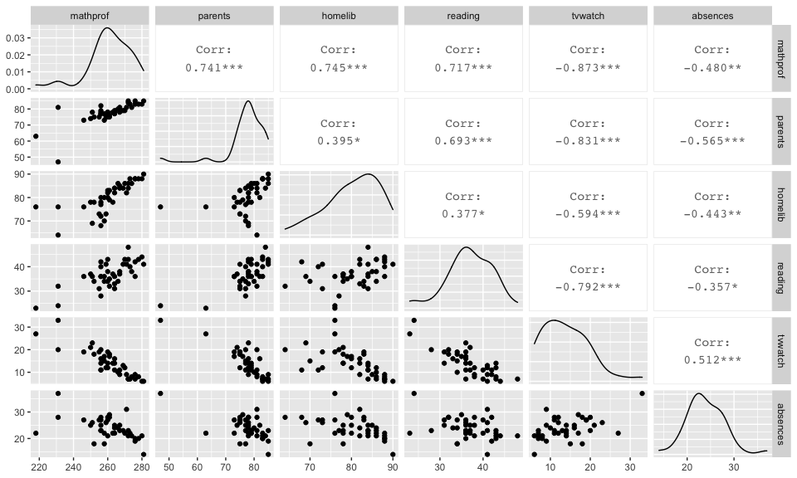
The observed Pearson correlation coefficient for the percentage of students with both parents living at home (parents) and average mathematical proficiency of the school district (mathprof) is 0.741. Since this is close to 1 in magnitude and positive in value this indicates a strong increasing linear relationship in the sample.
The observed Pearson correlation coefficient for the percentage of students with three or more types of reading materials at home (homelib) and average mathematical proficiency of the school district (mathprof) is 0.745. Since this is close to 1 in magnitude and positive in value this indicates a strong increasing linear relationship in the sample.
The observed Pearson correlation coefficient for the percentage of students who read more than 10 pages per day (reading) and average mathematical proficiency of the school district (mathprof) is 0.717. Since this is close to 1 in magnitude and positive in value this indicates a strong increasing linear relationship in the sample.
The observed Pearson correlation coefficient for the percentage of students who watch TV for 6 hours or more per day (tvwatch) and average mathematical proficiency of the school district (mathprof) is -0.873 Since this is close to 1 in magnitude and negative in value this indicates a strong decreasing linear relationship in the sample.
The observed Pearson correlation coefficient for the percentage of students who were absent 3 or more days in the previous month (absences) and average mathematical proficiency of the school district (mathprof) is -0.480. Since this is less than 0.5 in magnitude and negative in value this indicates a moderate decreasing linear relationship in the sample.

Formal Analysis
Fitting a multiple linear regression model with all five of the candidate predictors to the sample data gives the following output:
fit<-lm(mathprof~parents+homelib+reading+tvwatch+absences,mathprofdata)
summary(fit)
Call:
lm(formula = mathprof ~ parents + homelib + reading + tvwatch +
absences, data = mathprofdata)
Residuals:
Min 1Q Median 3Q Max
-17.0131 -2.9395 0.4694 2.5336 9.3248
Coefficients:
Estimate Std. Error t value Pr(>|t|)
(Intercept) 155.0304 36.2383 4.278 0.000145 ***
parents 0.3911 0.2571 1.521 0.137399
homelib 0.8639 0.1797 4.807 3.05e-05 ***
reading 0.3616 0.2690 1.345 0.187679
tvwatch -0.8467 0.3525 -2.402 0.021927 *
absences 0.1923 0.2636 0.729 0.470718
---
Signif. codes: 0 '***' 0.001 '**' 0.01 '*' 0.05 '.' 0.1 ' ' 1
Residual standard error: 5.268 on 34 degrees of freedom
Multiple R-squared: 0.861, Adjusted R-squared: 0.8406
F-statistic: 42.13 on 5 and 34 DF, p-value: 1.276e-13
Interpretation of the fitted model:
When all of the explanatory variables (parents, homelib, reading, tvwatch, absences) have value 0, mathematical proficiency (mathprof) is estimated to be 155.0304 on average.
For each percentage increase of students in the school district who have both parents living at home (parents), mathematical proficiency increases by 0.3911 on average, holding the other explanatory variables (homelib, reading, tvwatch, absences) constant.
For each percentage increase of students in the school district with three or more types of reading materials at home (homelib), mathematical proficiency increases by 0.8639 on average, holding the other explanatory variables (parents, reading, tvwatch, absences) constant.
For each percentage increase of students in the school district who read more than 10 pages per day (reading), mathematical proficiency increases by 0.3616 on average, holding the other explanatory variables (parents, homelib, tvwatch, absences) constant.
For each percentage increase of students in the school district who watch TV for 6 hours or more per day (tvwatch), mathematical proficiency decreases by -0.8467 on average, holding the other explanatory variables (parents, homelib, reading, absences) constant.
For each percentage increase of students in the school district who were absent 3 or more days in the previous month (absences), mathematical proficiency increases by 0.1923 on average, holding the other explanatory variables (parents, homelib, reading, tvwatch) constant.
The coefficient of determination for the model with the five predictor variables is 0.861, i.e. 86.1% of the variability observed in the response variable mathematical proficiency in the sample, is explained by the model with predictors parents, homelib, reading, tvwatch and absences.
Inference:
The ANOVA test statistic has value 42.13 with a p-value of 1.276e-13. The p-value is small, there is evidence to reject the null hypothesis, there is evidence to suggest the model with parents, homelib, reading, tvwatch and absences is explaining the variability in average mathematical proficiency of a school district in the population, i.e. at least one good predictor in the model.
The t-test for the coefficient of parents gives a test statistic of 1.521 and p-value 0.137399. The p-value is large, there is no evidence to reject the null hypothesis, there is no evidence to suggest that percentage of students with both parents living at home is a good predictor of the average mathematical proficiency of a school district in the population.
The t-test for the coefficient of homelib gives a test statistic of 4.807 and p-value 3.05e-05 The p-value is small, there is evidence to reject the null hypothesis, there is evidence to suggest that percentage of students with three or more types of reading materials at home is a good predictor of the average mathematical proficiency of a school district in the population.
The t-test for the coefficient of reading gives a test statistic of 1.345 and p-value 0.187679 The p-value is large, there is no evidence to reject the null hypothesis, there is no evidence to suggest that percentage of students who read more than 10 pages per day is a good predictor of the average mathematical proficiency of a school district in the population.
The t-test for the coefficient of tvwatch gives a test statistic of -2.402 and p-value 0.021927 The p-value is small, there is evidence to reject the null hypothesis, there is evidence to suggest that percentage of students who watch more than 6 hours of television per day is a good predictor of the average mathematical proficiency of a school district in the population.
The t-test for the coefficient of absences gives a test statistic of 0.729 and p-value 0.470718 The p-value is large, there is no evidence to reject the null hypothesis, there is no evidence to suggest that percentage of students who were absent 3 or more days in the previous month is a good predictor of the average mathematical proficiency of a school district in the population.

