Gapminder: Trends in Life Expentancy, Ireland and China - a comparison.
Name: Cian Mac Liatháin ID: 11476078

Introduction
A study into changes in socio-economic development recorded a number of variables:
- lifeExp: life expectancy of a newborn child
- year: year of measurement
- time: time of measurement coded as number of years since 1950.
- country: country of measurement

Subjective Impression
To investigate if any difference exists in the change in life expectancy over time comparing countries. The following output provides some summary statistics and graphical displays for the different countries.
gapminder%>%group_by(country) %>% summarise(n(),mean(lifeExp),median(lifeExp),sd(lifeExp))
# A tibble: 8 x 5
country `n()` `mean(lifeExp)` `median(lifeExp)` `sd(lifeExp)`
<chr> <int> <dbl> <dbl> <dbl>
1 Brazil 12 62.2 62.4 7.04
2 Canada 12 74.9 75.0 3.95
3 China 12 61.8 64.8 10.3
4 Egypt 12 56.2 54.7 10.1
5 Finland 12 73.0 73.5 4.30
6 Ireland 12 73.0 72.6 3.62
7 Mexico 12 65.4 66.2 8.19
8 United States 12 73.5 74.0 3.34
ggplot(gapminder,aes(x=year,y=lifeExp, colour=country))+geom_point()
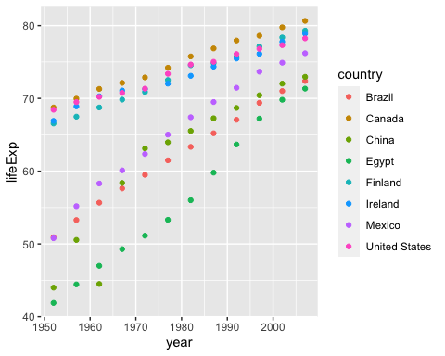

Formal Analysis
Focus in this report is given to comparing two countries: Ireland and China.
A linear regression model is fitted to the sample data to explain the variability in the response variable, life expectancy (lifeExp), with two predictors, time since 1950 (time) and the country (country).
data<-gapminder%>%filter(country%in%c("Ireland","China"))
fit<-lm(lifeExp~time+country,data=data)
summary(fit)
Call:
lm(formula = lifeExp ~ time + country, data = data)
Residuals:
Min 1Q Median 3Q Max
-10.899 -2.338 1.147 2.768 4.094
Coefficients:
Estimate Std. Error t value Pr(>|t|)
(Intercept) 51.02019 1.84241 27.692 < 2e-16 ***
time 0.36494 0.04812 7.584 1.92e-07 ***
countryIreland 11.23167 1.66106 6.762 1.09e-06 ***
---
Signif. codes: 0 '***' 0.001 '**' 0.01 '*' 0.05 '.' 0.1 ' ' 1
Residual standard error: 4.069 on 21 degrees of freedom
Multiple R-squared: 0.831, Adjusted R-squared: 0.8149
F-statistic: 51.62 on 2 and 21 DF, p-value: 7.825e-09
In the model, countryIreland is an indicator variable taking value 1 for when the country is Ireland and 0 for when the country is not, in this case a value of 0 indicates the country is China.
Interpretation:
- The constant when indicator variable countryIreland=0 and when indicator variable time=0 is 51.02019, indicating that the average life expectancy of a newborn child in China in 1950 is 51.02019 years old.
- Coefficient of the predictor variable time, 0.36494 : for each additional year in time since 1950, the life expectancy of a newborn child increases by 0.36494 years of age on average,in both countries.
- Coefficient of the predictor variable countryIreland, 11.23167: this is the difference on average in life expectancy between newborn children in Ireland and China - i.e. the life expectancy of newborn children in Ireland is greater than newborn children in China by 11.23167 years of age on average.
Inference:
Testing for non zero coefficient of predictor time, the estimated effect is 0.36494, with standard error 0.04812, the test statistic is 7.584, with p-value < 0.0001. There is evidence to reject the null hypothesis and evidence to suggest the true coefficient of predictor time is not equal to 0, i.e. the effect of years since 1950 on the life expectancy of newborn children is significant in the population.
Testing for non zero coefficient of the indicator variable countryIreland, the estimated effect is 11.23167, with standard error 1.66106,the test statistic is 6.762, with p-value < 0.0001. There is evidence to reject the null hypothesis and evidence to suggest the true coefficient of predictor countryIreland is not equal to 0, evidence of a difference in newborn children’s life expectancy comparing those born in Ireland to those born in China in the population.
The linear regression model is adapted to incorporate an interaction term for the two predictors.
fit<-lm(lifeExp~time*country,data=data)
summary(fit)
Call:
lm(formula = lifeExp ~ time * country, data = data)
Residuals:
Min 1Q Median 3Q Max
-7.9980 -0.5250 0.1166 0.7186 5.3147
Coefficients:
Estimate Std. Error t value Pr(>|t|)
(Intercept) 46.12917 1.57122 29.359 < 2e-16 ***
time 0.53073 0.04597 11.545 2.68e-10 ***
countryIreland 21.01370 2.22204 9.457 8.02e-09 ***
time:countryIreland -0.33159 0.06501 -5.100 5.46e-05 ***
---
Signif. codes: 0 '***' 0.001 '**' 0.01 '*' 0.05 '.' 0.1 ' ' 1
Residual standard error: 2.749 on 20 degrees of freedom
Multiple R-squared: 0.9265, Adjusted R-squared: 0.9155
F-statistic: 84.08 on 3 and 20 DF, p-value: 1.637e-11
ggplot(data, aes(y=lifeExp, x=year, colour=country))+geom_point()+
geom_smooth(method="lm", se=T)
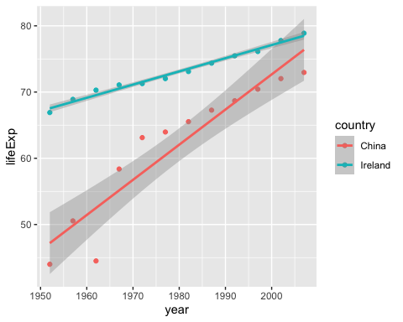 In the model, countryIreland is an indicator variable taking value 1 for when the country is Ireland and 0 for when the country is not, in this case a value of 0 indicates the country is China.
Interpretation:
- The constant when indicator variable countryIreland=0 and when indicator variable time=0 is 46.12917, indicating that the average life expectancy of a newborn child in China in 1950 is 46.12917 years old.
- Coefficient of the predictor variable time, 0.53073 : for each additional year in time since 1950, the life expectancy of a newborn child in China increases by 0.53073 years of age on average.
- Coefficient of the predictor variable countryIreland, 21.01370: this is the difference on average in life expectancy of newborn children in Ireland and China, - i.e. the life expectancy of newborn children in Ireland is greater on average than newborn children in China by 21.01370 years.
- Coefficient of the interaction term time:countryIreland, -0.33159: difference in slopes comparing life expectancy of newborn children in Ireland to China, 0.53073-0.33159=0.19914 : for newborn children in Ireland, for each additional year since 1950 life expectancy increases by 0.19914 years of age on average. This increase in life expectancy per year since 1950 is 0.33159 less than the increase in the life expectancy per year since 1950 for newborn children born in China, on average.
Inference:
Testing for non zero coefficient of predictor time, the estimated effect is 0.53073, with standard error 0.04597, the test statistic is 11.545, with p-value < 0.0001. There is evidence to reject the null hypothesis and evidence to suggest the true coefficient of predictor time is not equal to 0, i.e. the effect of years since 1950 on the life expectancy of newborn children in China is significant in the population.
Testing for non zero coefficient of the indicator variable countryIreland, the estimated effect is 21.01370, with standard error 2.22204,the test statistic is 9.457, with p-value < 0.0001. There is evidence to reject the null hypothesis and evidence to suggest the true coefficient of countryIreland is not equal to 0, evidence of a difference in newborn children’s life expectancy comparing those born in Ireland to those born in China in the population.
Testing for non zero coefficient of the coefficient of the interaction term time:countryIreland, the estimated effect is -0.33159, the test statistic is -5.100, with p-value <0.0001. There is evidence to reject null hypothesis there is evidence to suggest the coefficient of the interaction term is not equal to 0, evidence of a difference in slopes in the relationship of life expectancy of newborn children and years since 1950 comparing those those born in China and Ireland in the population.

