Exploring Mathematics Proficiency - Variable Selection
Name: Cian Mac Liatháin ID: 11476078

Introduction
Data obtained from a study investigating the relationship of educational achievement of students to their home environment included measurements for a sample of 35 school districts of average mathematics proficiency Mathprof. In order to investigate what variables may predict mathematics proficiency five candidate explanatory variables are considered:
- Parents, the percentage of students with both parents living at home.
- Homelib, the percentage of students with three or more types of reading materials at home (books, encyclopedias, magazines, newspapers etc),
- Reading, the percentage of students who read more than 10 pages a day.
- Tvwatch, the percentage of students who watch TV for six hours or more per day,
- Absences, the percentage of students absent three days or more in the previous month.
The aim of this report is to build a parsimonious model to predict mathprof and to use the model to make a prediction for a district where parents 78% of students have both parents living at home, 82% of students have three or more types of reading materials at home reading, 36% of students read more than 10 pages a day, 14% students watch TV for six hours or more per day and 25% students were absent three days or more in the previous month.

Subjective Impression
The descriptive statistics and plots below summarise the sampled measurements.
ggpairs(mathprofdata)
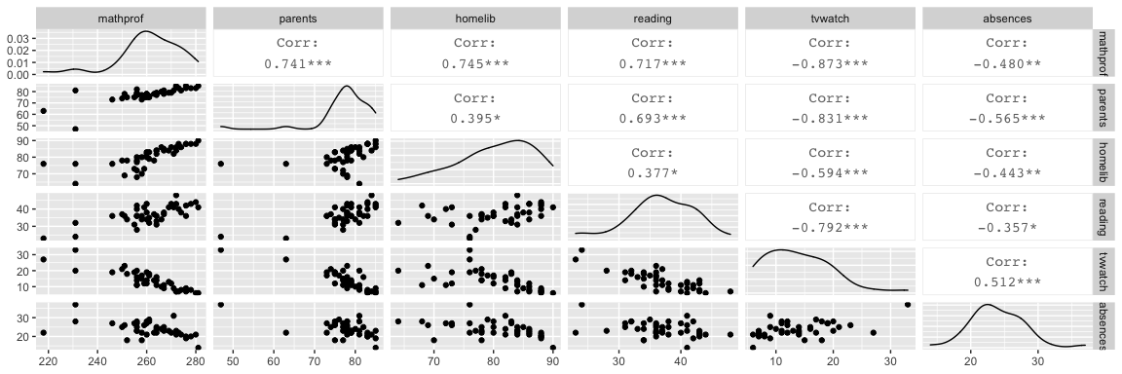
The observed Pearson correlation coefficient for the percentage of students with both parents living at home (parents) and average mathematical proficiency of the school district (mathprof) is 0.741. Since this is close to 1 in magnitude and positive in value this indicates a strong increasing linear relationship in the sample.
The observed Pearson correlation coefficient for the percentage of students with three or more types of reading materials at home (homelib) and average mathematical proficiency of the school district (mathprof) is 0.745. Since this is close to 1 in magnitude and positive in value this indicates a strong increasing linear relationship in the sample.
The observed Pearson correlation coefficient for the percentage of students who read more than 10 pages per day (reading) and average mathematical proficiency of the school district (mathprof) is 0.717. Since this is close to 1 in magnitude and positive in value this indicates a strong increasing linear relationship in the sample.
The observed Pearson correlation coefficient for the percentage of students who watch TV for 6 hours or more per day (tvwatch) and average mathematical proficiency of the school district (mathprof) is -0.873 Since this is close to 1 in magnitude and negative in value this indicates a strong decreasing linear relationship in the sample.
The observed Pearson correlation coefficient for the percentage of students who were absent 3 or more days in the previous month (absences) and average mathematical proficiency of the school district (mathprof) is -0.480. Since this is less than 0.5 in magnitude and negative in value this indicates a moderate decreasing linear relationship in the sample.

Formal Analysis
A parsimonious model is the simplest best fitting model, the best fitting model in which the number of explanatory variables is kept to a minimum.
To determine which variables are in the parsimonious model a best subsets routine is fitted, with all of the 5 predictors as candidate predictors, to the sample data giving the following output:
models<-ols_step_best_subset(lm(mathprof~. ,data=mathprofdata))
models%>%as.data.frame%>%select(predictors)
predictors
4 tvwatch
11 homelib tvwatch
22 homelib reading tvwatch
26 parents homelib reading tvwatch
31 parents homelib reading tvwatch absences
plot(models)
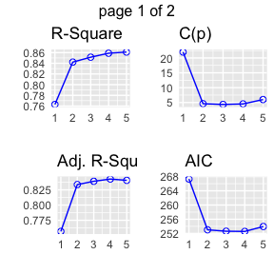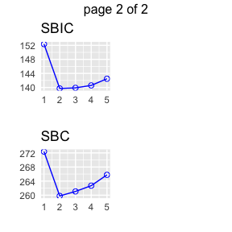
The folowing prints values of variable selection criteria for the models focusing on values of the coefficient of determination, Rsquare, values of adjusted Rsquare, values of Mallow’s $C_{p}$ and values of AIC.
models%>%as.data.frame%>%select(rsquare,adjr,cp,aic)%>%round(3)
rsquare adjr cp aic
4 0.763 0.757 21.993 267.305
11 0.842 0.834 4.604 253.027
22 0.851 0.839 4.354 252.624
26 0.859 0.843 4.532 252.568
31 0.861 0.841 6.000 253.947
The coefficient of determination, Rsquare, is the proportion of variability explained in the response mathprof being explained by the predictors in the model. The higher this value the better, this is maximised at value 0.861 for the model with all five predictors. However, the value of Rsquare will always increase when a predictor is added to the model, if the additional predictor is good, Rsquare will increase by a relatively large amount, if the predictor is poor Rsquare will increase by a relatively small amount.
Adjusted Rsquare adds a penalty term dependent on the number of predictors in the model:
- When adding predictor homelib to a model with tvwatch, the value of Rsquare has increased from 0.763 to 0.842 and adjusted Rsquare has increased from 0.757 to 0.834.
- When adding predictor reading to a model with tvwatch and homelib, the value of Rsquare has increased from 0.842 to 0.851 and adjusted Rsquare has increased by a small amount from 0.834 to 0.839.
- When adding predictor parents to a model with tvwatch, homelib and reading, the value of Rsquare has increased from 0.851 to 0.859 and adjusted Rsquare has increased by a small amount from 0.839 to 0.843.
- When adding predictor absences to a model with tvwatch, homelib, reading and parents, the value of Rsquare has increased from 0.859 to 0.861 and adjusted Rsquare has decreased from 0.843 to 0.841.The additional variability explained is not enough to overpower the penalty for adding the predictor.
Adjusted Rsquare is maximised for model 4: predictors parents, homelib, reading and tvwatch.
Mallows $C_{p}$ should satisfy the condition $C_{p}$ $≤$ p+1, where p is the number of predictors in the model. This is not satisfied for the first three models but is satisfied for the last two models since 4.532 $≤$ 5, 6 $≤$ 6.
AIC is minimised for model 4: parents homelib reading tvwatch, at value 252.568.
Therefore the parsimonious model for this data is a model with four predictor variables: parents, homelib, reading and tvwatch.

Fitting a multiple linear regression model with the four predictors in the parsimonious model to the sample data gives the following output:
fit<-lm(mathprof~parents+homelib+reading+tvwatch,mathprofdata)
summary(fit)
Call:
lm(formula = mathprof ~ parents + homelib + reading + tvwatch,
data = mathprofdata)
Residuals:
Min 1Q Median 3Q Max
-18.244 -2.708 1.041 2.655 7.823
Coefficients:
Estimate Std. Error t value Pr(>|t|)
(Intercept) 167.1281 32.0045 5.222 8.19e-06 ***
parents 0.3240 0.2384 1.359 0.1829
homelib 0.8286 0.1719 4.819 2.76e-05 ***
reading 0.3782 0.2662 1.421 0.1642
tvwatch -0.8507 0.3501 -2.430 0.0204 *
---
Signif. codes: 0 '***' 0.001 '**' 0.01 '*' 0.05 '.' 0.1 ' ' 1
Residual standard error: 5.233 on 35 degrees of freedom
Multiple R-squared: 0.8589, Adjusted R-squared: 0.8427
F-statistic: 53.24 on 4 and 35 DF, p-value: 2.108e-14
Interpretation of model coefficients:
- Constant term: when all of the explanatory variables (parents, homelib, reading, tvwatch) have value 0, mathematical proficiency (mathprof) is estimated to be 167.1281 on average.
- Coefficient of parents: for each percentage increase of students in the school district who have both parents living at home (parents), mathematical proficiency increases by 0.3240 on average, holding the other explanatory variables (homelib, reading, tvwatch) constant.
- Coefficient of homelib: for each percentage increase of students in the school district with three or more types of reading materials at home (homelib), mathematical proficiency increases by 0.8286 on average, holding the other explanatory variables (parents, reading, tvwatch) constant.
- Coefficient of reading: for each percentage increase of students in the school district who read more than 10 pages per day (reading), mathematical proficiency increases by 0.3782 on average, holding the other explanatory variables (parents, homelib, tvwatch) constant.
- Coefficient of tvwatch: for each percentage increase of students in the school district who watch TV for 6 hours or more per day (tvwatch), mathematical proficiency decreases by 0.8507 on average, holding the other explanatory variables (parents, homelib, reading) constant.
- The coefficient of determination for the model with the four predictor variables is 0.8589, i.e. 85.89% of the variability observed in the response variable mathprof in the sample, is explained by the model with predictors parents, homelib, reading, and tvwatch.
For a school district where 78% of students have both parents living at home, 82% of students have three or more types of reading materials at home reading, 36% of students read more than 10 pages a day, 14% students watch TV for six hours or more per day and 25% students were absent three days or more in the previous month, an interval estimate is produced for the average mathematical proficiency in the district. In this model, only parents, homelib, reading and tvwatch measurements are required, absences are superfulous measurements and are not required.
predict(fit, new=data.frame(parents=c(78), homelib=c(82), reading=c(36), tvwatch=c(14)), interval="prediction")
fit lwr upr
1 262.0515 251.2735 272.8295
For a school district that has those measurements for the four predictor variables, the average mathematical of the students is estimated to be between 251.2735 and 272.8295

