Emissions
Name: Cian Mac Liatháin ID: 11476078

Introduction
Scientists at a research station in Germany wish to build a model to explain variability in CO2 levels in the atmosphere. They recorded the CO2 levels, measured in parts per million, for each day from the start of April 2001 through to November 2001, and used time as a possible explanatory variable, defined as day of the year, i.e. observing CO2 for days 91-334.
The aim of this report is to build a model for the relationship between CO2 over time, i.e. using the predictor Days, and assuming that model continues to be applicable past the time of the last observation, predict CO2 for day 350.

Subjective Impression
The descriptive statistics and plots below summarise the sampled measurements.
ggplot(data=emissions, aes(x=Days, y=CO2))+geom_point()
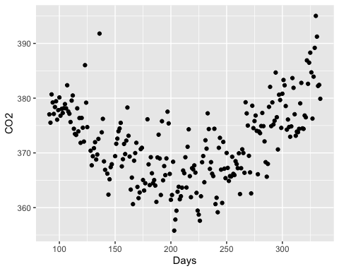
cor(emissions$Days, emissions$CO2)
[1] 0.162579
The Pearson correlation coefficient of 0.162579 indicates a weak linear relationship between the predictor variable Days and response variable CO2. This is also reflected in the scatterplot above, which indicates a quadratic relationship between the predictor and response variables.

Formal Analysis
A simple linear regression, $CO2_{i}=β_{0}+β_{1}Days_{i}+ϵ_{i}$, is fitted to the sample data giving the following output:
model1<-lm(CO2~Days,emissions)
summary(model1)
Call:
lm(formula = CO2 ~ Days, data = emissions)
Residuals:
Min 1Q Median 3Q Max
-15.8842 -5.4579 0.1714 5.0589 21.2848
Coefficients:
Estimate Std. Error t value Pr(>|t|)
(Intercept) 3.684e+02 1.451e+00 253.963 <2e-16 ***
Days 1.623e-02 6.425e-03 2.526 0.0122 *
---
Signif. codes: 0 '***' 0.001 '**' 0.01 '*' 0.05 '.' 0.1 ' ' 1
Residual standard error: 6.963 on 235 degrees of freedom
Multiple R-squared: 0.02643, Adjusted R-squared: 0.02229
F-statistic: 6.38 on 1 and 235 DF, p-value: 0.0122
plot(model1,1)
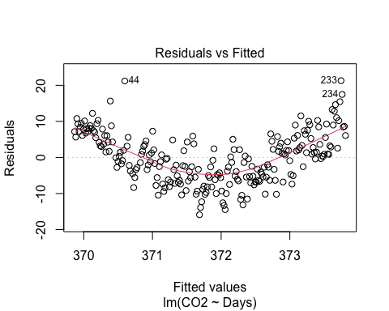
plot(model1,2)
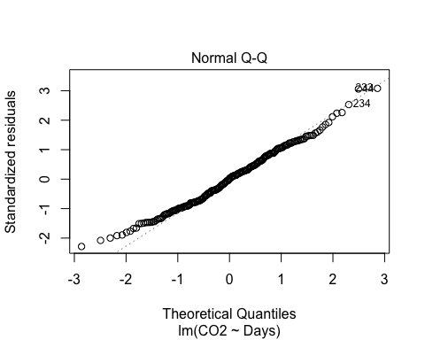
In order to use linear regression modelling of data, we are required to make assumptions about the linearity of the data, normality of residuals, homogeneity of residuals’ variance and independence of residuals’ error terms.
A quadratic relationship is evident from the scatterplot above, rather than a linear one, and the Pearson correlation coefficient of 0.162579 indicates a very weak linear relationship between the predictor variable Days and response variable CO2.
In our Residuals vs Fitted plot we can see constant variance of the residual, however there is a quadratic pattern evident in the pattern rather than the radnomly distributed data points we want.
The Normal Q-Q plot can be used to investigate whether the residuals are normally distributed. If the residuals are normally distributed, they should lie along the diagonal line of equality. We can see in this output the standardised residuals are strongly following the line of equality indicating normal distribution.
Based on the diagnostic plots above, our required assumptions are not met using this model. The Residuals vs Fitted plot is indicating a quadratic relationship in our data, and for this reason a different model should be used that can account for the quadratic relationship between the predictor variable Days and response variable CO2.
model2<-lm(CO2~Days+I(Days^2),emissions)
summary(model2)
Call:
lm(formula = CO2 ~ Days + I(Days^2), data = emissions)
Residuals:
Min 1Q Median 3Q Max
-10.2482 -3.0799 -0.2524 2.8430 20.1527
Coefficients:
Estimate Std. Error t value Pr(>|t|)
(Intercept) 4.150e+02 2.856e+00 145.28 <2e-16 ***
Days -4.760e-01 2.874e-02 -16.57 <2e-16 ***
I(Days^2) 1.158e-03 6.684e-05 17.32 <2e-16 ***
---
Signif. codes: 0 '***' 0.001 '**' 0.01 '*' 0.05 '.' 0.1 ' ' 1
Residual standard error: 4.619 on 234 degrees of freedom
Multiple R-squared: 0.5734, Adjusted R-squared: 0.5698
F-statistic: 157.3 on 2 and 234 DF, p-value: < 2.2e-16
plot(model2,1)
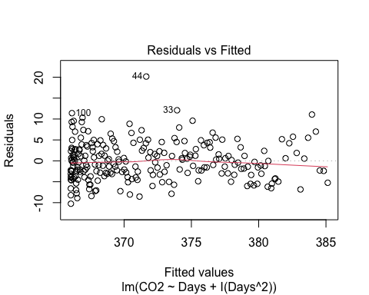
plot(model2,2)
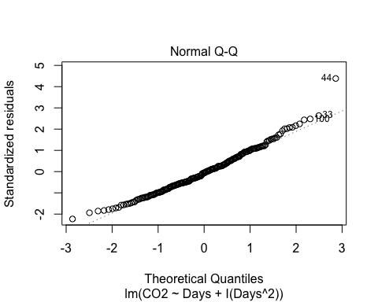 We can see after adding the quadratic term that the Residuals vs Fitted plot that the residuals are now showing constant variance and a randomly scattered pattern.
Out t-tests in the summary output are testing whether the coefficients of our predictor variables, Days and Days^2 are different than 0 in the population. B a small p-value of 2e-16, there is evidence to reject the null hypothesis that their true coefficient value is = 0. There is evidence to suggest that the true coefficient of both the Days term and the quadratic term Days^2 is different to 0, and it is needed in the model to predict our response variable CO2.
Using this model, an interval estimate for the CO2 levels in the atmosphere is estimated for the 350th day of the year.
predict(model2, new=data.frame(Days=350), interval="prediction")
fit lwr upr
1 390.1833 380.8121 399.5545
The level of C02 in the atmosphere is predicted to be between 380.121 and 399.5545 parts per million when Days = 350 i.e. on the 16th of December.

