Graduation Rates
Name: Cian Mac Liatháin ID: 11476078

Introduction
Data obtained from a study exploring the relationship between graduation rates in colleges with a number of candidate predictor variables, was collected for a sample 45 colleges. The graduation rates, GradRate, were recorded as % of first year students that graduated within 5 years and two candidate predictor variables:
- Sat25, the 25th percentile SAT score of first years entering the college,
- Sat75, the 75th percentile SAT score of first years entering the college.

Subjective Impression
The descriptive statistics and plots below summarise the sampled measurements.
ggpairs(graduate)
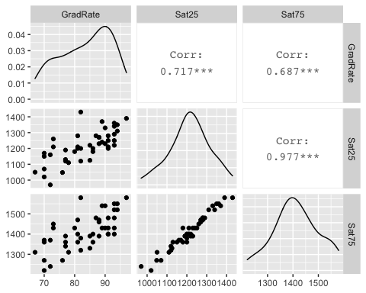
The observed Pearson correlation coefficient for the 25th percentile SAT score of first years entering the college (Sat25) and graduation rate (GradRate) is 0.717. Since this is close to 1 in magnitude and positive in value this indicates a strong positive linear relationship in the sample. This strong increasing linear relationship is reflected in the scatterplot above.
The observed Pearson correlation coefficient for the 75th percentile SAT score of first years entering the college (Sat75) and graduation rate (GradRate) is 0.687. Since this is close to 1 in magnitude and positive in value this indicates a strong positive linear relationship in the sample. This strong increasing linear relationship is reflected in the scatterplot above.
The observed Pearson correlation coefficient between our two predictor variables Sat25 and Sat75 is 0.977, showing a very strong positive linear relationship between them. This is a clear sign of multicollinearity.This strong increasing linear relationship is reflected in the scatterplot above.

Formal Analysis
A linear regression model using both candidate predictors,
$GradRate_{i}=β_{0}+β_{1}Sat{25}_{i}+β_{2}Sat{75}_{i}+ϵ_{i}$,
is fitted to the sample data giving the following output:
model1<-lm(GradRate~Sat25+Sat75,graduate)
summary(model1)
Call:
lm(formula = GradRate ~ Sat25 + Sat75, data = graduate)
Residuals:
Min 1Q Median 3Q Max
-14.779 -2.622 1.188 3.934 8.778
Coefficients:
Estimate Std. Error t value Pr(>|t|)
(Intercept) 20.50042 20.39630 1.005 0.3206
Sat25 0.08211 0.04154 1.977 0.0547 .
Sat75 -0.02604 0.04708 -0.553 0.5831
---
Signif. codes: 0 '***' 0.001 '**' 0.01 '*' 0.05 '.' 0.1 ' ' 1
Residual standard error: 5.924 on 42 degrees of freedom
Multiple R-squared: 0.5169, Adjusted R-squared: 0.4939
F-statistic: 22.47 on 2 and 42 DF, p-value: 2.313e-07
The ANOVA test is testing our model with a null hypothesis $H_{0}$ that neither predictors Sat25 or Sat75 are explaining the variability, does not explain the variability in the response variable GradRate in the population: $β_{1}$ = $β_{2}$ =0. The alternative hypothesis $H_{a}$ concludes that at least one of the predictor variables Sat25 and Sat75 are good predictors and are explaining the variability in the response variable GradRate in the population: at least one $β_{1}$ ≠ 0, $β_{2}$ ≠ 0
The ANOVA test statistics in our output is 22.47 with a p-value of 2.313e-7. Since this p-value is small, there is evidence to reject $H_{0}$, there is evidence to suggest the alternative hypothesis $H_{a}$: at least one of Sat25 and Sat75 are good predictors of GradRate in the population.
The t-tests in the output are used to determine whether the coefficient of the predictor variable Pages is significantly different from 0, i.e. $H_{0}$: $β_{1}$ = 0 versus $H_{a}$:$β_{1}$ ≠ 0
Our t-test for the predictor variable Sat25 has a test statistics of 1.977 and a p-value of 0.0547. This p-value is not small, there is no evidence to reject $H_{0}$: no evidence to suggest $H_{a}$:$β_{1}$ ≠ 0. There is no evidence to suggest that Sat25 is a good predictor of the response variable GradRate in the population.
Our t-test for the predictor variable Sat75 has a test statistics of -0.553 and a p-value of 0.5831. This p-value is not small, there is no evidence to reject $H_{0}$: no evidence to suggest $H_{a}$:$β_{2}$ ≠ 0. There is no evidence to suggest that Sat75 is a good predictor of the response variable GradRate in the population.
This contradiction between the ANOVA and t-tests, where our ANOVA test suggests that at least one of Sat25 and Sat75 is a good predictor of GradRate while each of their t-tests suggest no evidence that either are good predictors, is due to to the multicollinearity highlighted earlier. The correlation present between the predictors interferes with the outcome of our

