Applied Statistics II R exam
Cian Mac Liatháin ID: 11476078
2021-03-25
- You have 50 minutes to complete this examination paper.
- At the end of the examination you should upload a Microsoft Word file including your answers together with sufficient R code for the Examiners to work out how you arrived at your answers.
- Mark allocations are shown in brackets.
- Attempt BOTH questions, beginning your answer to each question on a new page of your Word file.
- Submit your Word file using Turn It In on the ST312 Blackboard site
- If you have any issues knitting your file, submit the Rmd file instead

Question 1 MetroCommutes (60 marks)
library(Stat2Data)
data("MetroCommutes")
Description
Commute times for four cities
Format
A data frame with 2000 observations on the following 3 variables.
City
Boston, Houston, Minneapolis, or Washington
Distance
Distance of commute (in miles)
Time
Time of commute (in minutes)
Details
The data are distances (miles) and times (minutes) of daily commute (one-way) for random samples of 500 commuters in each of four cities (Boston, Houston, Minneapolis, Washington) in 2007. The random samples were taken from the Metropolitan Public Use File of the 2007 American Housing Survey
Source
2007 American Housing Survey https://www.census.gov/programs-surveys/ahs/data/2007/ahs-2007-public-use-file–puf-.html
Questions
- Calculate summary statistics of Time across the four cities (5 marks)
MetroCommutes %>% group_by(City) %>% summarise(Count= n(),Mean = mean(Time),
StdDev=sd(Time), Minimum = min(Time),
Q1 = quantile(Time, 0.25), Median = median(Time),
Q3 = quantile(Time, 0.75), Maximum=max(Time))
## # A tibble: 4 x 9
## City Count Mean StdDev Minimum Q1 Median Q3 Maximum
## * <fct> <int> <dbl> <dbl> <int> <dbl> <dbl> <dbl> <int>
## 1 Boston 500 25.7 17.6 1 15 20 35 120
## 2 Houston 500 25.1 17.5 1 15 20 30 120
## 3 Minneapolis 500 22.7 16.9 1 10 20 30 161
## 4 Washington 500 31.7 21.2 0 15 30 45 180
From the summary, we can see similar mean commute times in the samples from the cities of Boston, Houston and Minneapolis but a much larger mean commute time in Washington. Washington also shows higher variance than the other cities.
- Produce boxplots of Time for each city and comment on your plot (10 marks)
ggplot(MetroCommutes, aes(x = City, y = Time, fill = City)) + geom_boxplot()
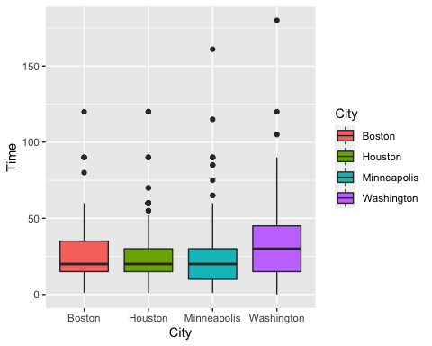 Investigate the boxplots we can see that all four of the cities have a similar median commute time. The data from all four of the cities contain outliers of longer commute times, and the cities of Boston, Houston and Minneapolis can be seen to have similar variance, with Washington having a longer range. The data from the cities of Boston and Houston look to be right-skewed, while the data from Minneapolis and Washington seem symmetrical.
- Perform a one-way ANOVA to compare Time between the cities, interpret the p-value and give your conclusion. (20 marks)
anova1 <- aov(Time~City, data=MetroCommutes)
summary(anova1)
## Df Sum Sq Mean Sq F value Pr(>F)
## City 3 21731 7244 21.51 1.04e-13 ***
## Residuals 1996 672162 337
## ---
## Signif. codes: 0 '***' 0.001 '**' 0.01 '*' 0.05 '.' 0.1 ' ' 1
The null hypothesis is that the three cities have the same average commute time in the population, i.e. $H_{0}:α_{1}=α_{2}=α_{3}=α_{4}=0$. The alternative hypothesis is that at least one of the the four cities has a different average commute time in in the population. With a small p-value of 1.04e-13, we reject the null hypothesis and conclude that there is evidence to suggest that at least one of the cities sizes has a different average commute time than the other three.
- Check whether the conditions necessary hold for the ANOVA model to be appropriate by providing relevant plots and your interpretation. (15 marks)
When carrying out an Analysis of Variance of data, we are required to make assumptions about the normality of residuals, homogeneity of residuals’ variance and independence of residuals’ error terms.
plot(anova1,1)
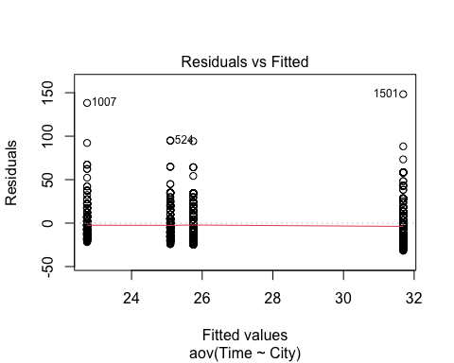
plot(anova1, 2)
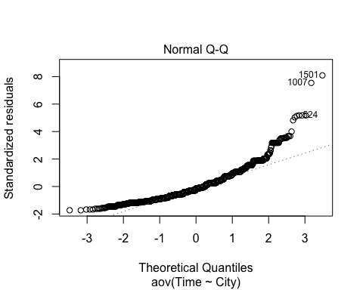 In our Residuals vs Fitted plot we can see relatively constant variance of the residuals.
The Normal Q-Q plot can be used to investigate whether the residuals are normally distributed. If the residuals are normally distributed, they should lie along the diagonal line of equality. We can see in this output there is significant deviance from the line in the tails, which suggests that our normality assumption is not met and a transformation may be required.
The independence assumption is based on how the data was collected and is outside the scope of this analysis.
- Repeat the ANOVA after an appropriate transformation of Time (10 marks) [hint: log(0) is not defined]
log_anova1 <- aov(log(Time+1)~City, data=MetroCommutes)
summary(log_anova1)
## Df Sum Sq Mean Sq F value Pr(>F)
## City 3 27.8 9.283 17.36 3.98e-11 ***
## Residuals 1996 1067.4 0.535
## ---
## Signif. codes: 0 '***' 0.001 '**' 0.01 '*' 0.05 '.' 0.1 ' ' 1
We repeat the ANOVA after applying a log transformation to the data. As part of the log transformation we also add a small value of 1 to each data point, as there are data values of 0 and the log(0) is undefined.
We can see from our ANOVA that our p-value remains small, suggesting there is evidence to reject the null hypothesis for our transformed data also, evidence to suggest that there is a difference in average commute time in the population between the cities.
plot(log_anova1,1)
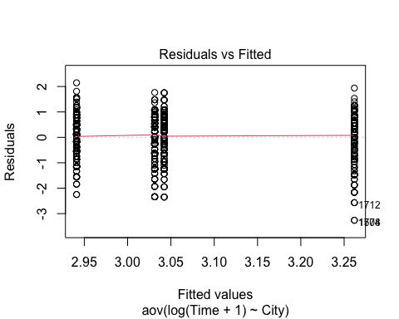
plot(log_anova1, 2)
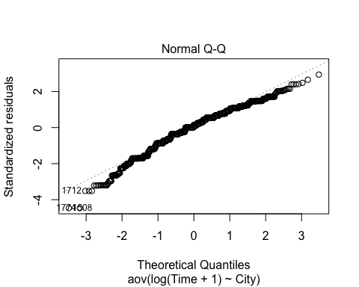 In our Residuals vs Fitted plot we can see relatively constant variance of the residuals of the transformed data.
From the Normal Q-Q plot we can see that the transformed data better follows a normal distribution, however there is still significant deviance in the tails.

Question 2 Is having a dog good for exercise? (40 marks)
library(Stat2Data)
data("WalkTheDogs")
Description
Daily pedometer data for one of the authors
Format
A data frame with 223 observations on the following 7 variables.
StepCount
Number of steps taken in the day
Kcal
Calories burned (according to pedometer)
Miles
Miles walked
Weather
cold, rain, or shine
Day
Day of week (F=Friday, M=Monday, R=Thursday, S=Saturday, T=Tuesday, U=Sunday, W=Wednesday)
Walk
Were the dogs walked? (1=yes or 0=no)
Steps
Steps in units of 1,000 (so StepCount/1000)
Details
One of the authors recorded daily pedometer data, the weather, and whether or not he walked the dogs.
Source
One of the author’s pedometer records.
Questions
A researcher set out to investigate whether walking their dog (Walk) had an effect on the number of steps they took (Steps), recorded using a mobile app. They were also interested if the Weather (cold, rain or shine) was associated with the number of steps (Steps). Analyse the data to answer the researchers questions using any methods that you think may be appropriate. Include your interpretation and conclusions. (40 marks)
As the research aims to identify whether a categorical variable ‘Walk’ is having an effect on a continuous variable ‘Steps’, a One-Way Analysis of Variance may offer important insight. First we will summarise the data.
WalkTheDogs %>% group_by(Walk) %>% summarise(Count= n(),Mean = mean(StepCount),
StdDev=sd(StepCount), Minimum = min(StepCount),
Q1 = quantile(StepCount, 0.25), Median = median(StepCount),
Q3 = quantile(StepCount, 0.75), Maximum=max(StepCount))
## # A tibble: 2 x 9
## Walk Count Mean StdDev Minimum Q1 Median Q3 Maximum
## * <int> <int> <dbl> <dbl> <int> <dbl> <dbl> <dbl> <int>
## 1 0 155 5391. 2942. 674 3040. 4988 7026 14327
## 2 1 68 6837. 2488. 3642 5151. 6350 7631 18194
We can see from the summary statistics that the average number of steps taken on the days when the dog were not walked is less than on days when the dogs were walked, with more variance on those days when the dogs weren’t walked as well.
anova2 <- aov(StepCount~Walk, data=WalkTheDogs)
summary(anova2)
## Df Sum Sq Mean Sq F value Pr(>F)
## Walk 1 9.892e+07 98924152 12.51 0.000493 ***
## Residuals 221 1.748e+09 7907629
## ---
## Signif. codes: 0 '***' 0.001 '**' 0.01 '*' 0.05 '.' 0.1 ' ' 1
The null hypothesis is that the average number of steps walked in the population is the same between days where the dogs aren’t / are walked, i.e. $H_{0}:α_{1}=α_{2}==0$. The alternative hypothesis is that there is a difference in average number of steps in the population bet. With a small p-value of 0.000493, we reject the null hypothesis and conclude that there is evidence to suggest that there is a significant difference in average number of steps walked on days where the dogs are walked.
plot(anova2,1)
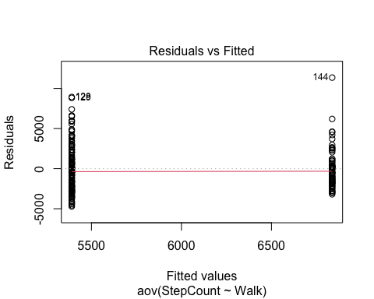
plot(anova2,2)
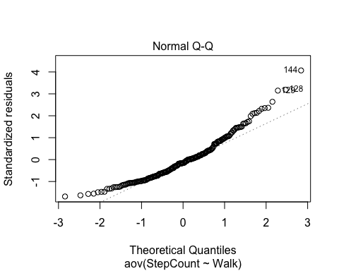 Investigating the assumptions required for anova, we can see that the residuals seem to show constant variance.
The Normal-QQ plot, however, indicates that there is significant deviance form a Normal distribution and suggests a transformation may be appropriate.
log_anova2 <- aov(log(StepCount)~Walk, data=WalkTheDogs)
summary(log_anova2)
## Df Sum Sq Mean Sq F value Pr(>F)
## Walk 1 5.72 5.723 19.72 1.42e-05 ***
## Residuals 221 64.14 0.290
## ---
## Signif. codes: 0 '***' 0.001 '**' 0.01 '*' 0.05 '.' 0.1 ' ' 1
The p-value remains small for the ANOVA on the transformed data, there is still evidence to suggest a difference in population means of number of steps between days where dogs are and arent’t walked.
plot(log_anova2,1)
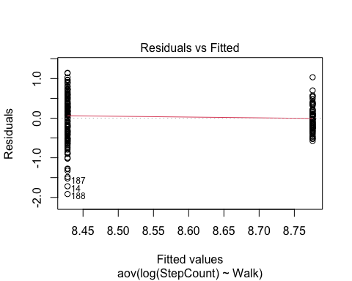
plot(log_anova2,2)
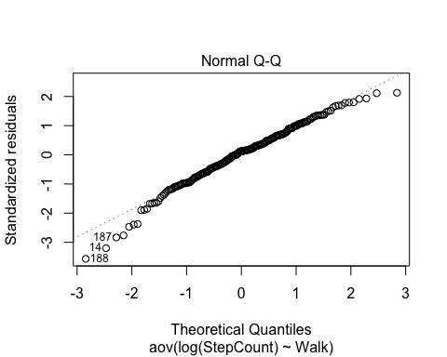
The Residuals vs Fitted plot seems to show less constant variance between the residuals.
The Normal Q-Q plot, howver, shows a much better adherence to a normal distribution.
Our ANOVA model can be built on to include variables that may have an effect on our dependent variable, and we can carry out an ANCOVA using the Weather as a covariate.
ancova2 <- aov(log(StepCount)~Walk+Weather, data=WalkTheDogs)
summary(ancova2)
## Df Sum Sq Mean Sq F value Pr(>F)
## Walk 1 5.72 5.723 21.146 7.19e-06 ***
## Weather 2 4.87 2.436 9.002 0.000175 ***
## Residuals 219 59.27 0.271
## ---
## Signif. codes: 0 '***' 0.001 '**' 0.01 '*' 0.05 '.' 0.1 ' ' 1
We can see from the output that both Walk and Weather have small p-values, there is evidence to suggest that there is a significant difference in population mean number of steps taken between days where dogs are and aren’t walked, when accounting for the variance introduced by different types of weather.
ancova3 <- aov(log(StepCount)~Walk*Weather, data=WalkTheDogs)
summary(ancova3)
## Df Sum Sq Mean Sq F value Pr(>F)
## Walk 1 5.72 5.723 21.127 7.29e-06 ***
## Weather 2 4.87 2.436 8.994 0.000177 ***
## Walk:Weather 2 0.49 0.244 0.899 0.408343
## Residuals 217 58.78 0.271
## ---
## Signif. codes: 0 '***' 0.001 '**' 0.01 '*' 0.05 '.' 0.1 ' ' 1
There is not a signifant interaction between Walk and Weather, so we need not add this itneraction to our ANCOVA model.
plot(ancova2, 1)
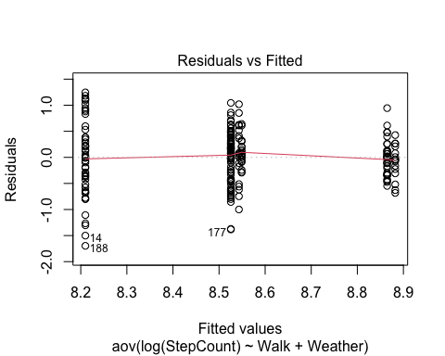
plot(ancova2,2)
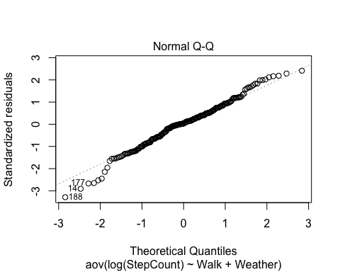 The Residuals vs Fitted plot seems to show relatively constant variance of the residuals.
The Normal Q-Q plot, shows relatively good adherence to a normal distribution.
We conclude that our required assumptions are met.
ancova4 <- aov(log(StepCount)~Walk+Weather+Day, data=WalkTheDogs)
summary(ancova4)
## Df Sum Sq Mean Sq F value Pr(>F)
## Walk 1 5.72 5.723 22.004 4.86e-06 ***
## Weather 2 4.87 2.436 9.367 0.000126 ***
## Day 6 3.87 0.645 2.481 0.024336 *
## Residuals 213 55.40 0.260
## ---
## Signif. codes: 0 '***' 0.001 '**' 0.01 '*' 0.05 '.' 0.1 ' ' 1
Further analysis suggests that the day of the week may also explain some of the variance seen in the average number of steps walked
plot(ancova4,1)
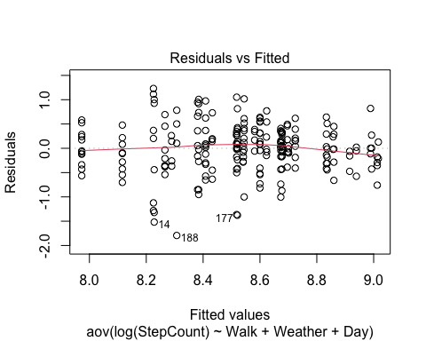
plot(ancova4,2)
