BIS Project: Excel for QA and QC

The exercises you have undertaken in Excel in this module have applied a variety of Quality Assurance and Quality Control techniques. Many of the assignments are based on Six Sigma techniques that focus on improving product quality and customer satisfaction. These techniques are widely used in industry to promote process improvements. It may be useful to have a printout (or softcopy) of the exercises to hand.
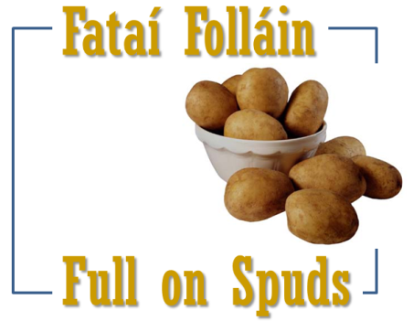
Quality Assurance (QA) is a systematic approach to check that a product or service being developed to meet specified requirements. The objective of QA is to improve work processes and efficiency associated with the product or service. A practice of continual improvement should favourably place the company in competing with other organisations in the same sector. On the other hand, Quality Control (QC) is focused on ensuring that the manufactured product or performed service adheres to clear quality criteria.

Seán has a company called ‘Full on Spuds’ that deliver potatoes to catering companies working mainly in hotels and factories. The company is growing its base from Galway to the adjacent counties. In time, he intends to have a nationwide service operating to the highest possible standards.
This workbook contains sheets with details on customers and suppliers.

- Open the file FULLONSPUDS and save it as FULLONSPUDS_PROJECT. Note that there are numerous worksheets contained within this Excel workbook file.
- COMPLAINTS worksheet: Select this worksheet. You can see that it sets out a listing of recent customer grievances. Create a Pivot Table that sets out the customer complaints as shown below. The Pivot Table you create should NOT be on a separate worksheet (i.e. it should be on the COMPLAINTS worksheet).
This Pivot Table adds the severity readings, so for example, while five complaints were received by customer A373 (Clare Coast Grill), the total severity score for these grievances adds up to 14 (see below). Anchor your Pivot Table in cell G7.
When complete, your pivot table might look something like this:
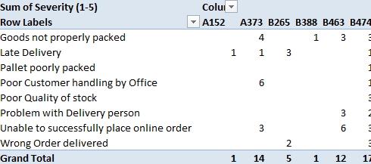
 | Question 1 – Based on your Pivot Table, which customer had the greatest number of complaints (by severity)?  Question 2 – Based on your Pivot Table, which issue generated the greatest number of complaints (by severity)?  Write your answers in the DECLARATION worksheet.
- PARETO_CHART worksheet: This worksheet does not exist yet… as you are going to create it!
Use the data in the CUMULATIVE_COMPLAINTS worksheet to product a Pareto chart to clearly illustrate the most frequent complaints. Before you start, you may need to sort the complaint list in order. You also have to input formulae to calculate the ‘Cumulative number of complaints’ and ‘Cumulative % of complaints’. Your separate PARETO_CHART worksheet and might look a bit like this, using suitable labels and titles as appropriate:
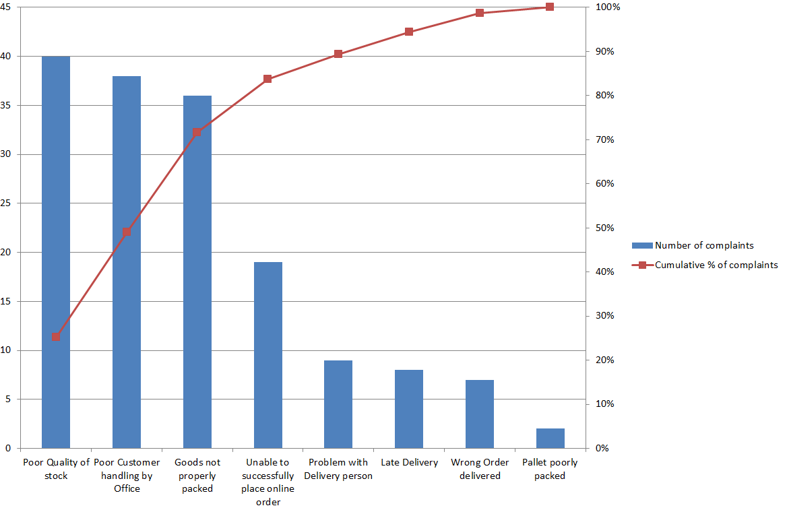
 | Question 3 – Based on your Pareto Chart, what are the most significant customer criticisms (based on the greatest number of complaints)?  Write your answer in the DECLARATION worksheet.
- GROWER_SUMMARY worksheet: This worksheet will pull in the monthly ‘Rejected stock (as a %)’ figures for each of the four growers from the respective worksheets. Once these figures are in place, work out the Standard Deviation and place it in cell B2. Next, input the relevant formulas to ascertain the monthly average for the growers rejected stock, then the annual average amount in the adjacent column. Once you have calculated the Upper Control Limit (UCL) and the Lower Control Limit (LCL) based on one Standard Deviation, you are ready to create a Control Chart.
Your Control Chart should NOT be on a separate worksheet.
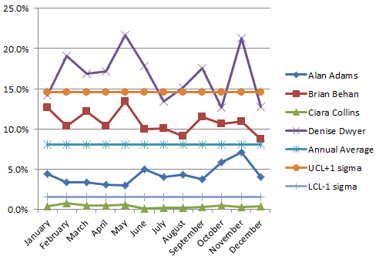 | 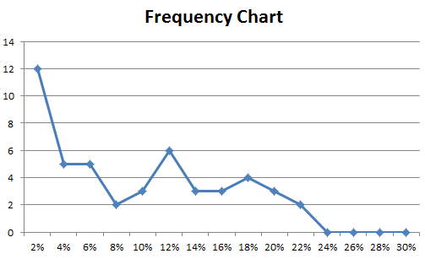
Next, create a Frequency Chart to show the incidence of monthly reject percentages of each of the growers. The bin limits are already set out for you in column K of this worksheet.
The Frequency Chart should NOT be on a separate worksheet.
 | Question 4 – What are the values for the UCL and LCL?  Question 5 – What growers data should generate the most concern?  Write your answer in the DECLARATION worksheet.
- DECLATION worksheet: Finally, type a declaration on this sheet to state that you did the work presented in this file is your own. This statement should include your name and student number. Without this statement, the work presented will NOT be accepted.
- Save your workbook file.
- Submit the FULLONSPUDS_PROJECT to me via LearnOnline (Moodle).
Good luck in your exams!

