CT511 DATABASES: CONTINUOUS ASSESSMENT PART 1

KATIE MAHER 16426496
CIAN MAC LIATHÁIN 11476078
JOHN MURRAY 03636194
JOHN MURPHY 17354531

As part of this project, we were asked to help a company migrate from paper-based records to a DBMS. In order to do this, we were informed by the steps in the Software Development Lifecycle. The first step, problem identification & project planning, is outlined in the overview section. We then move onto the analysis phase, where we conceptualise data modelling using EERDs, tables, and associated business rules.

SECTION 1: ROLES
SECTION 2: OVERVIEW
SECTION 3: EERD
SECTION 4: TABLES
SECTION 5: BUSINESS RULES

SECTION 1: ROLES
All: All team members were co-operative and attended team meetings. Together, we helped construct the scenario, came up with the necessary entities and attributes associated with these entities. Each team member had a say in each section of the assignment.
Katie: Katie drew up the first mock-up EERD, contributed to the overview, and helped on the business rules.
Cian: Cian contributed to the tables, helped construct the relationships on the EERD, and helped on the overview.
John Murray: John drew up the final EERD on LucidChart, helped construct the relationships on the EERD, and helped with the business rules.
John Murphy: John contributed to the tables and overview and helped write the business rules.

SECTION 2: OVERVIEW



‘Mom & Pop Records’, an independent vinyl shop based in Co. Galway, have enjoyed continuous success for many years. Because of this, they made the decision to expand their business and open a second shop in Dublin. This meant that they could grow their customer base to the other side of the country and generate more revenue.
Expanding their shop to a second location highlighted some difficulties in the management of their data. Up until now, it was sufficient to keep track of products and orders through a paper-based file system, which the manager updates regularly. However, this system has many pitfalls – since this system relies on the manager’s manual input, spelling errors are more likely. As well as this, there is the possibility of data duplication, as the manager could accidentally enter a piece of information twice. If any data changes – for example, a customer’s address – the manager would have to find every piece of data pertaining to this customer and update it. This leaves room for data inconsistency. Searching for specific information, such as vinyls that cost between €25-30, is tedious and difficult. The use of a paper-based system also raises security issues, as data is not well protected, and there are no backups should the data be damaged in some way.
Once the second store opened, these problems only became more difficult to manage. There were far more orders to keep track of, and they quickly realised that with their current paper-based system, they would essentially have to duplicate all their data in order for the second store to access it. It also meant that it was extremely difficult to concurrently keep track of products and orders between shops, and this also caused issues with data integrity. Initially the owners decided a computer file-based system would work allowing the ability to quickly send files back and forth between stores. They found issues here too with data duplication, data inconsistency and data redundancy. It became apparent that these file systems would not suffice, and a bigger, more robust solution was needed.
The use of a Database Management System (DBMS) would help resolve some of these issues. A DBMS allows concurrent access to one shared relational database, which meant that the managers of both shops could update and search for data in one place, thus reducing the possibility of data inconsistency. Each product, order and customer would have a unique ID, making it easy to find specific information on a product or order. Being able to sort vinyl orders by artist or genre would help the shops identify which products are selling the best, therefore allowing them to update the stock on these products more regularly. In contrast, they could also see which products are selling poorly and thus may not need to be stocked as often.
By having different tables (e.g., for products, orders, and customers), and linking these tables through primary keys and foreign keys, a DBMS would reduce the chances of repeating information unnecessarily, therefore there is no data duplication. A DBMS is also a much safer alternative as data is kept securely, and there are backup and recovery options, meaning data is never lost.
A DBMS would also offer the opportunity for the store to expand even further, as it could work as a backend for an online store. The database could automatically store data, such as shipment statuses and costs, link these details to their corresponding orders and update current stock. As well as this, the website would allow customers to create accounts, the details of which would also be stored in the database. This would also allow them to make better use of their data – for example, they could use targeted advertising to reach a wider audience
As the store keeps data on their customers, under EU law they must be GDPR compliant. The DBMS can be used to minimise data integrity risks – for example, it can be designed to limit access to only those authorised to interact with the database, thus providing increased protection for their customers' data. It can also provide a log of the activity within the database allowing for auditing, as well as providing customers with their data when requested under GDPR.
Although implementing a DBMS would involve significant investment, such as purchasing of hardware, these benefits outlined above would outweigh this cost. Overall, a DBMS would help significantly improve the storing of information in these shops. Data would be safer, more consistent, and easier to que
SECTION 3: EERD

Entitity  SECTION 4: TABLE | Attributes |  | Datatypes
COMPANY | VatNo |  | Primary key, char (9)
 | AccountNo |  | int (8)
 | Name |  | varchar (20)
 | Address |  | varchar (100)
STORE | CRN |  | Primary key, int (2), auto-increment
 | Eircode |  | char (7)
 | Type |  | varchar (40)
 | Size |  | decimal (5,2)
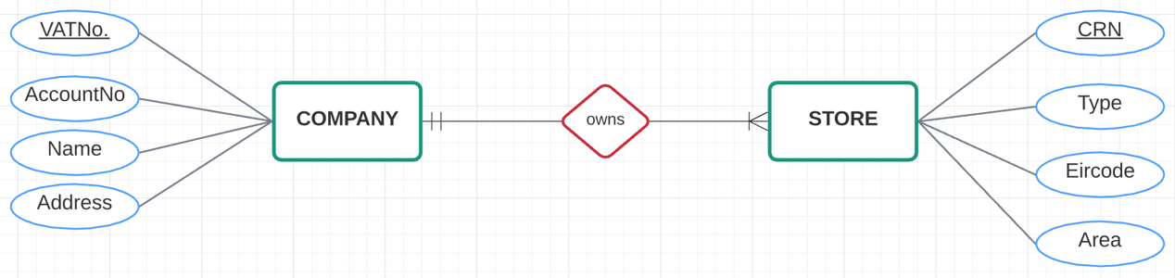 |  |  | The relationship between COMPANY and STORE is manadatory 1 to Many. This is because Company has always owned at least one STORE, and may grow further.  Thee relationship between STORE and COMPANY is manadatory one, as every STORE is owned by the same COMPANY.
BUILDING | BuildingID |  | Primary key, int (2), auto-increment
 | Address |  | varchar (100)
 | PhoneNo |  | numeric (10)
 | Utility |  | varchar (20)
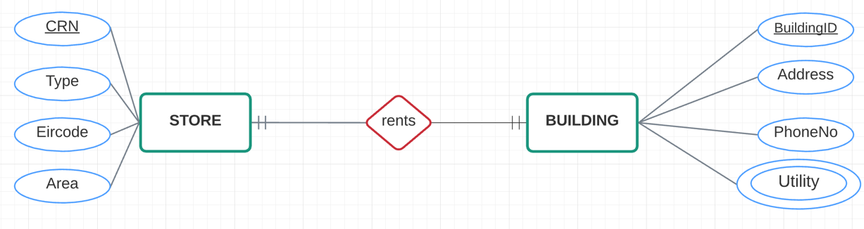 |  |  | The relationship between STORE and BUILDING is manadatory one. This is because each STORE rents a single BUILDING.  The relationship between BUILDING and STORE is mandatory one, as each BUILDING in our database is rented by a single STORE.
EMPLOYEE | PPSNo |  | Primary key, varchar (8)
 | Name |  | varchar (60)
 | FirstName |  | varchar (30)
 | LastName |  | varchar (30)
 | Address |  | varchar (100)
 | DateHired |  | date (10)
 | EmployeeType |  | varchar (7)
 | PayType |  | varchar (8)
HOURLY | HourlyRate |  | decimal (3,2)
SALARIED | Salary |  | decimal (6,2)
 | StockOptions |  | decimal (6,2)
SALES | Quota |  | numeric (6)
MANAGER | Department |  | varchar (10)
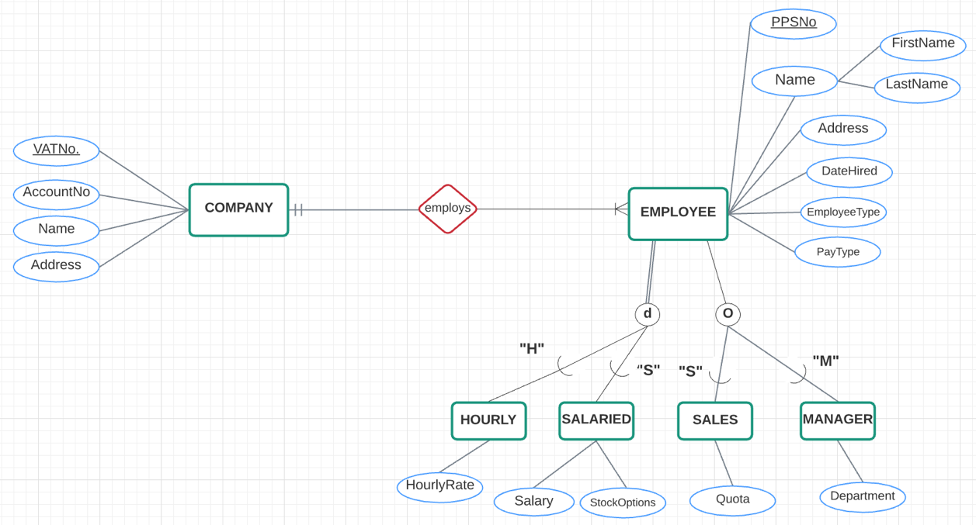 |  |  | EMPLOYEE has two disjoint subtypes HOURLY and SALARIED with a completeness constraint of Total Specialisation as all employees' PayType is either hourly or salaried.  EMPLOYEE has two overlapping subtypes SALES and MANAGER with a completeness constraint of Partial Specialisation, as employees may have managerial and sales responsibilities, and the EmployeeTypes stored in the database are not exhaustive.  The relationship betweem COMPANY and EMPLOYEE is mandatory one to many, as the company employs multiple employees.  The relationship between EMPLOYEE and COMPANY is mandatory one as each employee is employed by one company, Mom & Pop Records.
SUPPLIER | SupplierID |  | Primary key, int (2), auto-increment
 | Name |  | varchar (80)
 | Email |  | varchar (50)
 | Address |  | varchar (100)
PRODUCT | ProductID |  | Primary key, int (3), auto-increment
 | Quantity |  | int (3)
 | Price |  | decimal (4, 2)
 | ProductType |  | varchar (10)
 | Description |  | varchar (200)
VINYL | Artist |  | varchar (80)
 | Title |  | varchar (80)
 | ReleaseDate |  | date (10)
 | Genre |  | varchar (20)
MERCHANDISE | Artist |  | varchar (80)
 | Type |  | varchar (40)
(supplies) | SupplyQuantity |  | int (3)
 | SupplyDate |  | datetime (19)
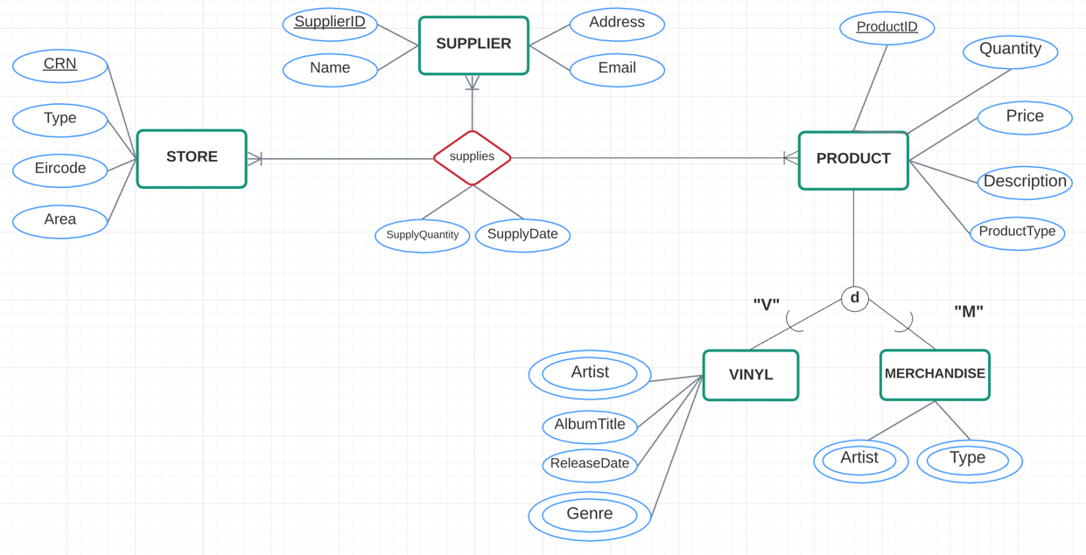 |  |  | PRODUCT has two disjoint subtypes VINYL and Merchandise with a completeness constraint of Partial Specialisation, as a product may not be both VINYL and MERCHANDISE but these subtypes are not exhaustive of all possible PRODUCT in each store.  The relationship between STORE and PRODUCT is mandatory one to many, as all STORES are supplied at least one type of PRODUCT.  The relationship between PRODUCT and STORE is mandatory one to many as each PRODUCT is supplied to at least one STORE.  The relationship between PRODUCT/STORE and SUPPLIER is mandatory one to many as each PRODUCT/STORE is supplied by at least one SUPPLIER.
WEBSITE | IPAddress |  | Primary key, varchar (15)
 | Host |  | varchar (15)
 | Email |  | varchar (50)
 | Domain |  | varchar (40)
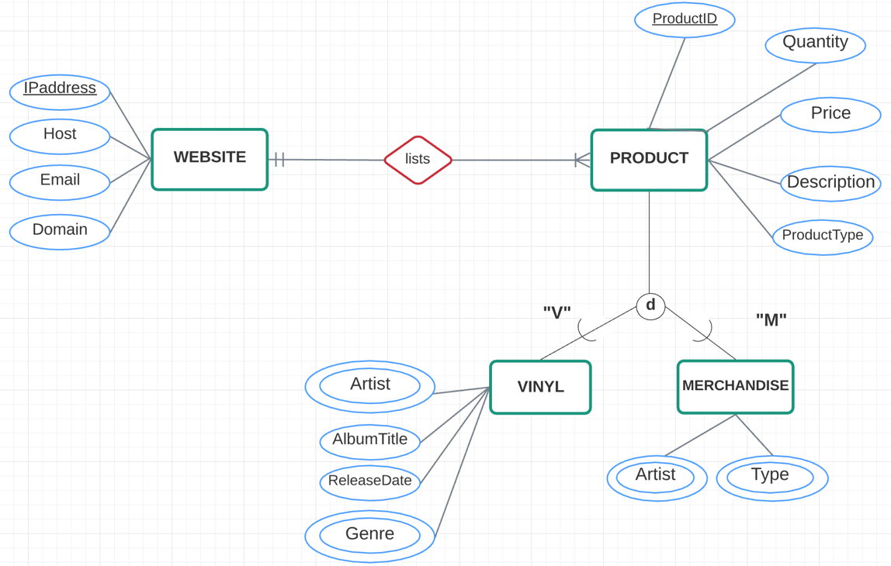 |  |  | The relationship between WEBSITE and PRODUCT is mandatory one to many, as the WEBSITE is designed to list all PRODUCT currently in stock in stores.  The relationship between PRODUCT and WEBSITE is mandatory one as each PRODUCT should be listed, but only on the one WEBSITE.
ACCOUNT | AccountID |  | Primary key, int (5), auto-increment
 | Email |  | varchar (50)
 | Username |  | varchar (30)
 | Password |  | varchar (30)
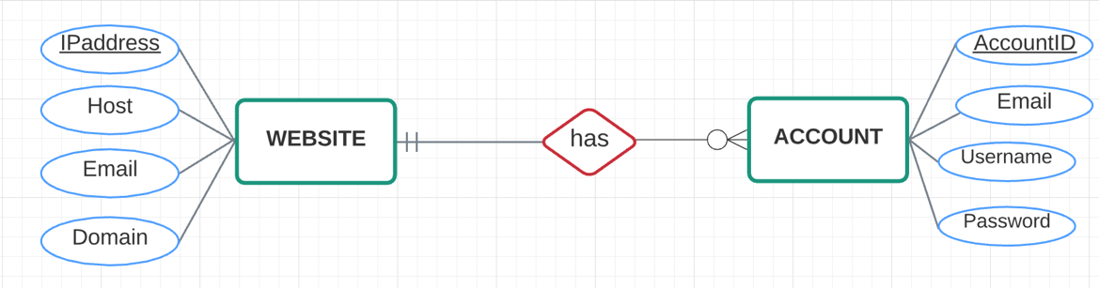 |  |  | The relationship between WEBSITE and ACCOUNT is optional zero to many as an ACCOUNT may not be created on the WEBSITE.  The relationship between ACCOUNT and WEBSITE is mandatory one, as each ACCOUNT is linked to the one website.
CUSTOMER |  | CustomerID | Primary key, int (5), auto-increment
 |  | Name | varchar (60)
 |  | FirstName | varchar (30)
 |  | LastName | varchar (30)
 |  | Address | varchar (100)
 |  | Email | varchar(50)
 |  | DOB | date (10)
 |  | Age | int (2)
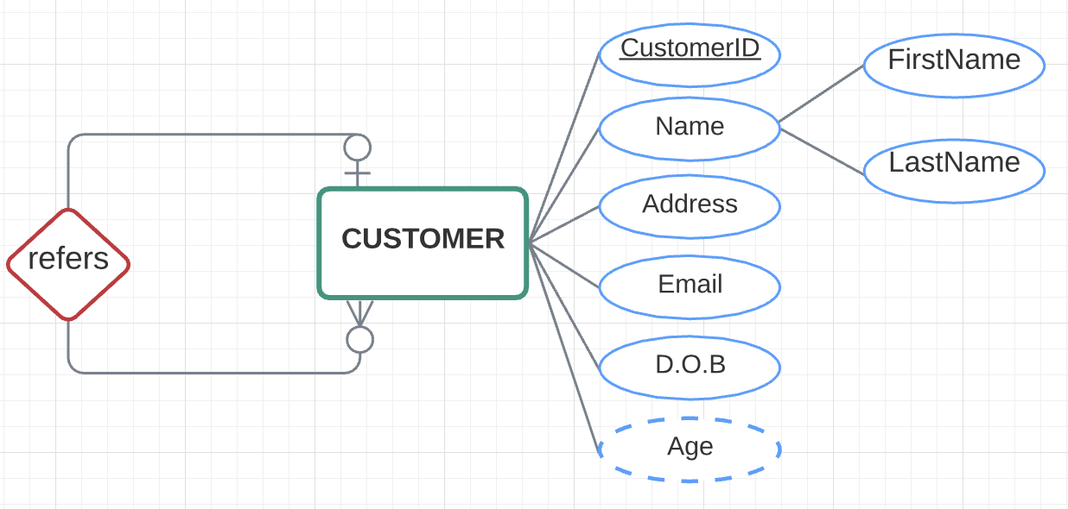 |  |  | CUSTOMER has an unary relationship with itself.  The relationship between a referring CUSTOMER and a referred CUSTOMER is optional zero to many, as a customer may refer mutliple other customers.  The relationship between a referred CUSTOMER and a referring CUSTOMER is optional one, as a customer may only be referred by one other customer, but a customer may still exist without being referred.
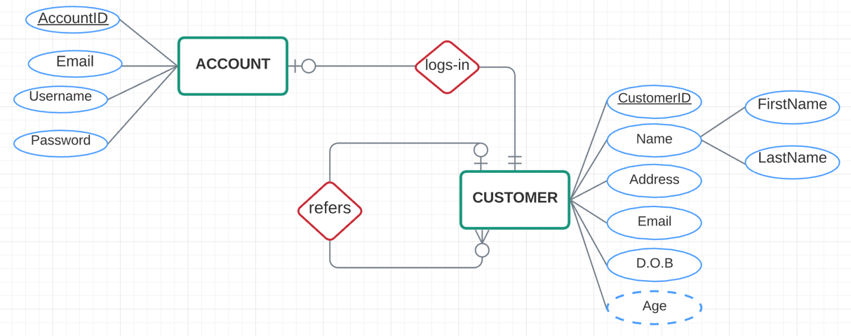 |  |  | The relationship between ACCOUNT and CUSTOMER is mandatory one, as each ACCOUNT is owned by exactly one CUSTOMER.  The relationship between CUSTOMER and ACCOUNT is optional one, as each CUSTOMER may only have one account, but a customer may exist without creating an account.
ORDER |  | OrderID | Primary key, int (6), auto-increment
 |  | OrderDate | date (10)
 |  | Total | decimal (6,2)
 |  | Description | varchar (200)
 |  | PaymentInfo | varchar (40)
 |  | OrderType | varchar (40)
ONLINE |  | Address | varchar (100)
 |  | ShippingCost | decimal (3,2)
IN-STORE |  | MerchantReceipt | varchar (200)
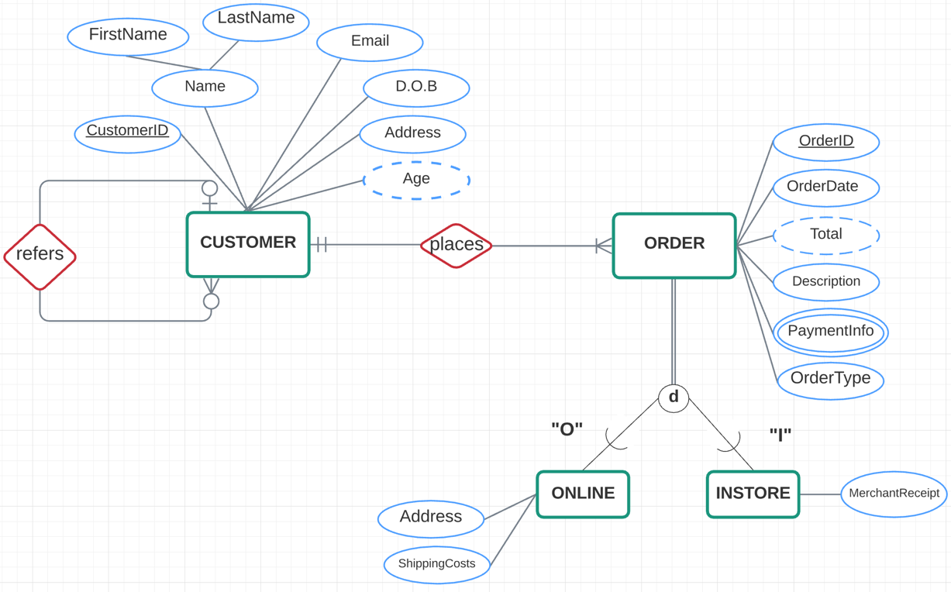 |  |  | ORDER has two disjoint subtypes ONLINE and INSTORE with a completeness constraint of Total Specialisation, as all orders must have been made either in-store or online.  The relationship between CUSTOMER and ORDER is mandatory one to many, as each custoemr exists due to having made an order but can continue to make multiple.  The relationship between ORDER and CUSTOMER is mandatory one, as each ORDER is placed by a single customer.
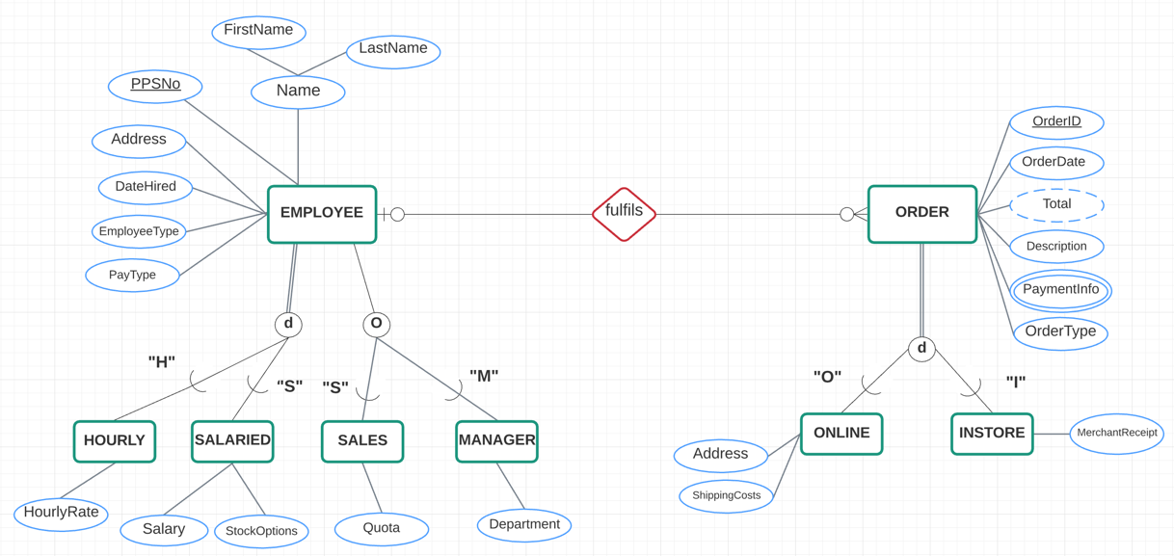 |  |  | The relationship between EMPLOYEE and ORDER is optional zero to many as an employee may exist without having fulfilled any orders.  The relationship between ORDER and EMPLOYEE is optional one, as each order may be fulfilled only by a single employee but orders may also be cancelled and left unfulfilled.
DISTRIBUTOR |  | DistributorID | Primary key, int (2), auto-increment
 |  | Name | varchar (20)
 |  | Address | varchar (100)
 |  | PhoneNo | int (10)
delivered by |  | TrackingNo | varchar (30)
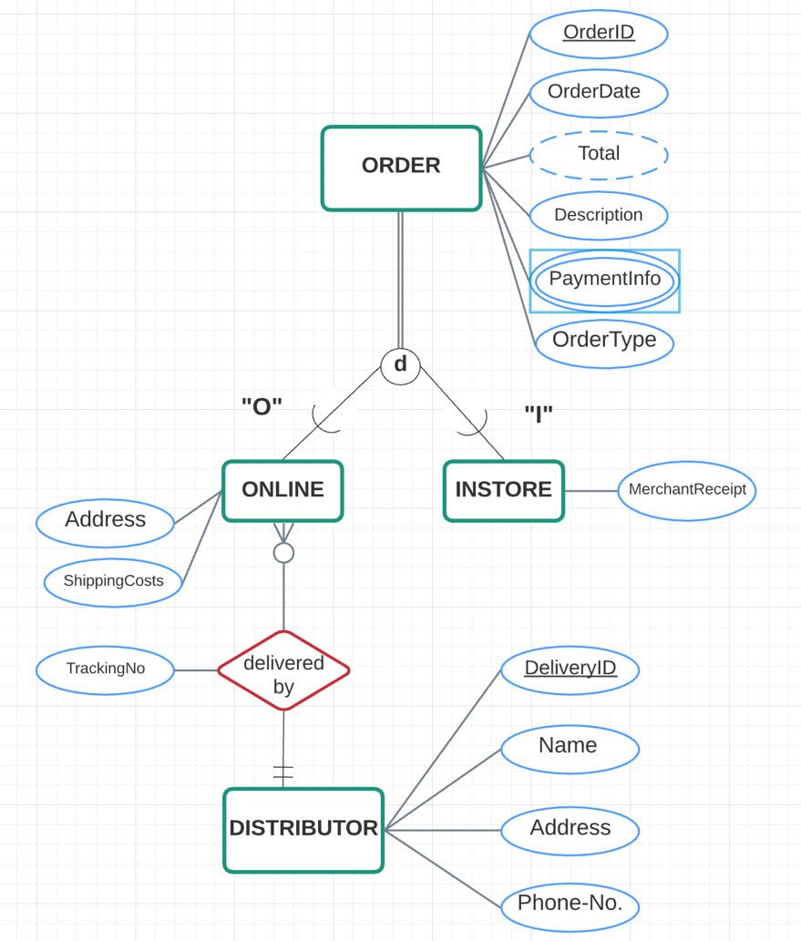 |  |  | The relationship between ONLINE and DISTRIBUTOR is mandatory one, as each online order is delivered to a customer by only one chosen distributor.  The relationship between DISTRIBUTOR and ONLINE is optional zero to many as a delivery option may not have been assigned to any order yet, and each distributor may deliver multiple orders.
ORDERITEM |  | Quantity | int (2)
 |  | Discount | int (2)
 |  | SpecialOption | varchar (30)
 |  | Price | decimal (5,2)
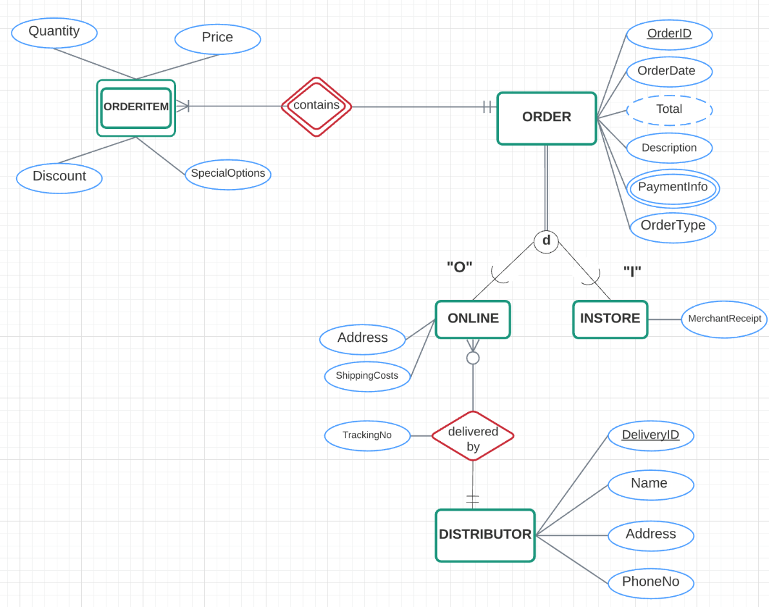 |  |  | The relationship between ORDER and ORDERITEM is mandatory one to many as each order must contain at least one order item.  The relationship between ORDERITEM and ORDER is mandatory one, as each ORDERITEM belongs to only a single order. ORDERITEM only exists as part of an ORDER, making ORDERITEM a weak entity. The identifier of each ORDERITEM is linked with the OrderID used as a Foreign Key.
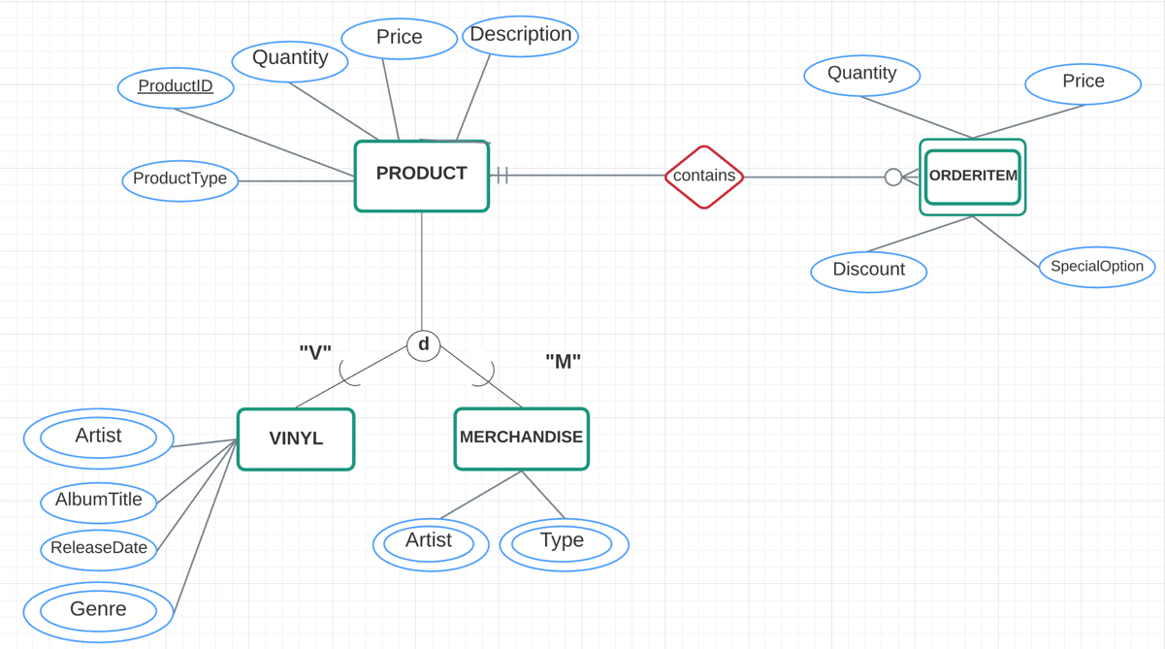 |  |  | The relationship between PRODUCT and ORDERITEM is optional zero to many, as a product may be in store without having been added to an order.  The relationship between ORDERITEM and PRODUCT is mandatory one, as each order item consists of exactly one product.

SECTION 5: BUSINESS RULES
- If product hasn’t sold within the last 2 months, put on sale
The DBMS makes it easy for the shop to track how much stock there is for each product, thus informing them on when a restock is needed. Alternatively, the store can see if a product’s stock remains unchanged for a certain amount of time, meaning it’s not being sold. The store can then make an informed decision based on this about whether or not the item should be sold at a reduced price to encourage sales.

- If employee exceeds sales target, give bonus
The DBMS provides information on each employee, including what their sales quota for the month is. It also stores which employee processed which order, making it easy to track whether or not the employee has reached their quota. This allows managers to offer bonuses to their employees if they exceed their targets, which in turn encourages hard work and motivation.

- If customer orders item for delivery, add shipping cost to order
The DBMS stores the price for each product, as well as shipping costs for given locations. If a customer orders a product online, the total cost (product + shipping) can be easily calculated from the information stored in the DBMS.

- If customer returns item within 30 days, give refund
The shops have a refund policy if an item is returned within days since it was purchased. The date purchased is stored in the database under the order details, so an employee can easily check if the purchase date was in the 30 days and can check if a refund is possible.

- If customer has an account and has made an order, send email after 2 weeks asking for review
This is something that can be easily automated through a DBMS and allows the shops to gather customer feedback. They can either use positive reviews to use in advertising, or if there are negative reviews, it allows them to see where improvement is needed.

- If customer refers another customer, offer both customers 10% discount on next order
By allowing the customer to enter the email of the friend that referred them, the DBMS can check if the entered email exists on the system and apply a discount to their account. This encourages customers to promote the business and increases website interaction.

