CT511 DATABASES: CONTINUOUS ASSESSMENT PART 2 & 3

KATIE MAHER 16426496
CIAN MAC LIATHÁIN 11476078
JOHN MURRAY 03636194
JOHN MURPHY 17354531

ROLES
Katie: Normalised CUSTOMER & EMPLOYEE table, SQL queries
Cian: Normalised PRODUCT & ORDERITEM table, SQL queries
John Murray: Normalised ORDER table, SQL queries
John Murphy: Normalised EMPLOYEE & ORDERITEM table

Map your FULL EERD to relations using the short-hand approach.
(UNDERLINE = Primary Key, YELLOW HIGHLIGHT = Foreign Key)
BUILDING(BuildingID, Address, PhoneNo)
BUILDING-UTILITY(BuildingID, Utility)
STORE(CRN, Type, Eircode, Area, BuildingID, VATNo)
COMPANY(VATNo, Name, Address, AccountNo, EmployeeID)
EMPLOYEE(EmployeeID, FirstName, LastName, Address, EmployeeType, PayType, DateHired, StoreID)
EMPLOYEE-HOURLY(EmployeeID, HourlyRate)
EMPLOYEE-SALARIED(EmployeeID Salary, StockOptions)
EMPLOYEE-SALES(EmployeeID, Quota)
EMPLOYEE-MANAGER(EmployeeID, Department)
SUPPLIER(SupplierID, Name, Address, Email)
DISTRIBUTOR(DeliveryID, Name, Address, PhoneNo, TrackingNo)
PRODUCT (ProductID, ProductType, Description, StoreID, Price, SupplierID, SupplyCost, SupplyQuantity, SupplyDate, IPAddress)
PRODUCT-VINYL(ProductID, Arist, AlbumTitle, Genre, ReleaseDate)
PRODUCT-MERCHANDISE(ProductID, Theme)
ORDER(OrderID, OrderDate, Description, OrderType, CustomerID, EmployeeID)
ORDER-ONLINE(OrderID, Address, ShippingCosts, DeliveryID)
ORDER-INSTORE(OrderID, MerchantReceipt)
ORDERITEM(OrderID, ProductID, Quantity, Price, Discount, SpecialOptions)
CUSTOMER(CustomerID, FirstName, LastName, Address, Email, DOB)
CUSTOMER-REFERRAL(CustomerID, ReferrallD).
ACCOUNT(AccountID, Email, Password, Username, CustomerID, IPAddress)
WEBSITE(IPAddress, Host, Email, Domain)

Put at least 6 rows of sample data in a minimum of 5 tables. These must be what you consider to be the most important tables.
Justify your choice of tables.
- CUSTOMER
We chose to normalise this table because the customer is the heart of the business. Everything that takes place within the company relates back to the customer, and thus the customer relation must be considered when looking at other tables relating to the business (orders, products, etc). Here is the sample CUSTOMER table (in UNF):
- EMPLOYEE
The employees are also an important consideration because they are the middlemen between the customers served and the products sold. They are an integral part in the running of the business, and therefore must be considered in the database. Here is the EMPLOYEE table:
- PRODUCT
This table is important because it’s an outline of all the products sold at the store. Keeping track of these products (their prices, quantity, etc) is vital for the running of the company. Important to keep track of fluctuating supply costs (e.g., particularly in pandemic with logistic issues). Keep track of suppliers of products to store in case of problems e.g. product discovered with damage, trace back to supplier.
- ORDER
The ORDER table is necessary to keep track of a customer’s purchase. It gives details as to which customer made the purchase, the status of the order, etc. Tracking an order is an important part of any business in order to ensure organisation.

- ORDERITEM
This is where the ORDER and the PRODUCT entities intersect. Because they are both important in their own right, it makes sense that keeping track of the order-product is important too. It allows us to see what discounts (if any) were put on the order product, the quantity of the product, etc.

Normalise each of the 5 tables through to 3NF. Ensure that at least 2 tables are not in 1NF; at least 3 tables are not in 2NF and at least 2 tables are not in 3NF. Explain as you bring them through the various forms - use the correct terminology.
- CUSTOMER
Here is the CUSTOMER table in UNF:
CustomerID | EmployeeID | FirstName | LastName | EmployeeRating | Town | County | Email | DOB
C101 | E235 | Ann | Smith | 10 | Thurles | Tipperary | a.smith03@gmail.com, asmith3947@hotmail.com | 01/06/1980
C102 | E167 | James |  | 8 | Claremorris | Mayo | j.walsh22@gmail.com | 22/10/1994
C103 | E188 | Robert | O’Hara | 8 | Athea | Limerick | r.ohara54@gmail.com | 08/12/1990
C104 | E129 | Tim | Harrison | 9 | Malahide | Dublin | t.harrison10@gmail.com, th777@outlook.com | 05/05/2000
C105 | E544 | Helen | Phillips | 7 | Tramore | Waterford | h.phillips38@gmail.com | 07/03/1985
C106 | E789 | Ben |  | 7 | Camolin | Wexford | b.mannion@gmail.com | 01/12/1995
This table is currently not in 1NF, for 2 reasons: there is missing data in the LastName field, and the email field is not atomic, as some customers have 2 emails. To bring it to 1NF, we need to fill in the missing data, and make sure each email is separate. We end up with a table such as this:
CustomerID | EmployeeID | FirstName | LastName | EmployeeRating | Town | County | Email | DOB
C101 | E235 | Ann | Smith | 10 | Thurles | Tipperary | a.smith03@gmail.com | 01/06/1980
C101 | E235 | Ann | Smith | 10 | Thurles | Tipperary | asmith3947@hotmail.com | 01/06/1980
C102 | E167 | James | Walsh | 8 | Claremorris | Mayo | j.walsh22@gmail.com | 22/10/1994
C103 | E188 | Robert | O’Hara | 8 | Athea | Limerick | r.ohara54@gmail.com | 08/12/1990
C104 | E129 | Tim | Harrison | 9 | Malahide | Dublin | t.harrison10@gmail.com | 05/05/2000
C104 | E129 | Tim | Harrison | 9 | Malahide | Dublin | th777@outlook.com | 05/05/2000
C105 | E544 | Helen | Phillips | 7 | Tramore | Waterford | h.phillips38@gmail.com | 07/03/1985
C106 | E789 | Ben | Mannion | 7 | Camolin | Wexford | b.mannion@gmail.com | 01/12/1995

Because this leads to data duplication, we then need to separate the email into its own relation, and join it to the CUSTOMER table using the CustomerID:
CUSTOMER-EMAIL
CustomerID | Email
C101 | a.smith03@gmail.com
C101 | asmith3947@hotmail.com
C102 | j.walsh22@gmail.com
C103 | r.ohara54@gmail.com
C104 | t.harrison10@gmail.com
C104 | th777@outlook.com
C105 | h.phillips38@gmail.com
C106 | b.mannion@gmail.com

CUSTOMER
CustomerID | EmployeeID | FirstName | EmployeeRating | LastName | Town | County | DOB
C101 | E235 | Ann | 10 | Smith | Thurles | Tipperary | 01/06/1980
C102 | E167 | James | 8 | Walsh | Claremorris | Mayo | 22/10/1994
C103 | E188 | Robert | 8 | O’Hara | Athea | Limerick | 08/12/1990
C104 | E129 | Tim | 9 | Harrison | Malahide | Dublin | 05/05/2000
C105 | E544 | Helen | 7 | Phillips | Tramore | Waterford | 07/03/1985
C106 | E789 | Ben | 7 | Mannion | Camolin | Wexford | 01/12/1995

2NF
To demonstrate normalisation into 2NF, I’ve added 2 new fields: EmployeeID and EmployeeRating. This is to include a system whereby customers, after being served by an employee, can give a rating on their customer service.
The table is not in 2NF because there’s 2 Primary Keys, but most fields only depend on one of the Primary Keys (CustomerID). This is an example of partial specialisation. The only field dependent on both CustomerID and EmployeeID is EmployeeRating. This is demonstrated in the functional dependency diagram below:
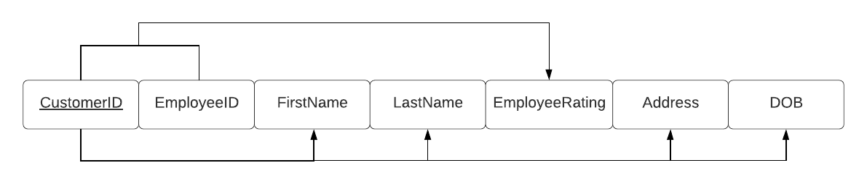
To bring such a relation into 2NF, we have to remove the partial dependencies, i.e., the customer would be its own separate relation, giving us 2 tables. This is mapped out in the short-hand approach as follows:
CUSTOMER-EMPLOYEERATING (CustomerID, EmployeeID, EmployeeRating)
CUSTOMER (CustomerID, FirstName, LastName, Town, County, Email, DOB)
Here are the resulting tables after bringing the CUSTOMER table to 2NF:
CUSTOMER
CustomerID | FirstName | LastName | Town | County | DOB
C101 | Ann | Smith | Thurles | Tipperary | 01/06/1980
C102 | James | Walsh | Claremorris | Mayo | 22/10/1994
C103 | Robert | O’Hara | Athea | Limerick | 08/12/1990
C104 | Tim | Harrison | Malahide | Dublin | 05/05/2000
C105 | Helen | Phillips | Tramore | Waterford | 07/03/1985
C106 | Ben | Mannion | Camolin | Wexford | 01/12/1995

CUSTOMER-EMPLOYEERATING
CustomerID | EmployeeID | EmployeeRating
C101 | E235 | 10
C102 | E167 | 8
C103 | E188 | 8
C104 | E129 | 9
C105 | E544 | 7
C106 | E789 | 7

3NF
We can see from the table that the customer’s address is split into 2 different fields: Town and County. This is an example of a relation that is not in 3NF, as County is dependent on Town rather than the primary key, thus making it a transitive dependency:
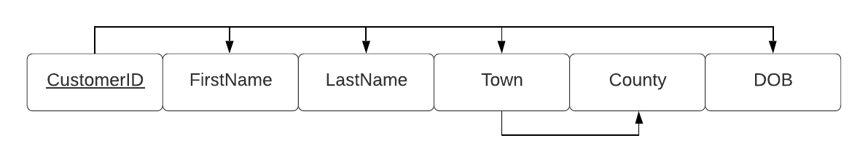
To bring this relation to 3NF, we need to remove the transitive dependency, as shown in the following short-hand approach:
CUSTOMER (CustomerID, FirstName, LastName, Town, Email, DOB)
ADDRESS (Town, County)
Town becomes a foreign key in the CUSTOMER table, and a primary key in the newly created CUSTOMER-ADDRESS table.
By assuring atomic values and removing partial and transitive dependencies, we have shown the steps of normalisation for the CUSTOMER table.
Please see the next page for the fully normalised tables.

CUSTOMER
CustomerID | FirstName | LastName | Town | DOB
C101 | Ann | Smith | Thurles | 01/06/1980
C102 | James | Walsh | Claremorris | 22/10/1994
C103 | Robert | O’Hara | Athea | 08/12/1990
C104 | Tim | Harrison | Malahide | 05/05/2000
C105 | Helen | Phillips | Tramore | 07/03/1985
C106 | Ben | Mannion | Camolin | 01/12/1995

CUSTOMER-EMAIL
CustomerID | Email
C101 | a.smith03@gmail.com
C101 | asmith3947@hotmail.com
C102 | j.walsh22@gmail.com
C103 | r.ohara54@gmail.com
C104 | t.harrison10@gmail.com
C104 | th777@outlook.com
C105 | h.phillips38@gmail.com
C106 | b.mannion@gmail.com

CUSTOMER-EMPLOYEERATING
CustomerID | EmployeeID | EmployeeRating
C101 | E235 | 10
C102 | E167 | 8
C103 | E188 | 8
C104 | E129 | 9
C105 | E544 | 7
C106 | E789 | 7

CUSTOMER-ADDRESS
Town | County
Thurles | Tipperary
Claremorris | Mayo
Athea | Limerick
Malahide | Dublin
Tramore | Waterford
Camolin | Wexford

- EMPLOYEE
TABLE IN UNF:
EmployeeID | DutyID | DutyTitle | FirstName | LastName | Address | Eircode | DateHired | Sales | Manager | PayType | StoreID
E235 | D006 | Help customers | Mary |  | Inisglas,  Crossabeg,  County Wexford | F67HJU8 | 02/04/2016 | Y | N | Hourly | S01
E167 | D003 | Close store | John | O’Connor | Main St.,  Letterkenny,  Donegal | H71EWB0 | 06/10/2019 | Y | N | Hourly | S01
E167 | D006 | Help customers | John | O’Connor | Main St.,  Letterkenny,  Donegal | H71RBO4 | 06/10/2019 | Y | N | Hourly | S01
E188 | D002 | Open store | Elizabeth |  | 50 Buttermilk Walk,  Middle St.,  Galway |  | 30/11/2015 | N | Y | Salaried | S02
E129 | D005 |  | Conor | Kent | The Halls,  Quay Street,  Galway | H91ERT3 | 18/09/2020 | Y | N | Hourly | S02
E129 | D001 |  | Conor | Kent | The Halls,  Quay Street,  Galway | H91CVG6 | 18/09/2020 | N | Y | Hourly | S02
E544 | D006 | Help customers | Lily | Jameson | 27 Victoria Place, Eyre Square,  Galway | H91JRM8 | 26/11/2018 | Y | N | Hourly | S01
E789 | D004 | Cleaning duty | Gerry |  | 49 Forster St.,  Galway,  Galway | H91PVL3 | 04/07/2019 | Y | N | Hourly | S02

1NF: This table is not in 1NF because we have gaps in the table. To comply we need to fill those gaps:
EmployeeID | DutyID | DutyTitle | FirstName | LastName | Address | Eircode | DateHired | Sales | Manager | PayType | StoreID
E235 | D006 | Help customers | Mary | O’Loughlin | Inisglas,  Crossabeg,  County Wexford | F67HJU8 | 02/04/2016 | Y | N | Hourly | S01
E167 | D003 | Close store | John | O’Connor | Main St.,  Letterkenny,  Donegal | H71EWB0 | 06/10/2019 | Y | N | Hourly | S01
E167 | D006 | Help customers | John | O’Connor | Main St.,  Letterkenny,  Donegal | H71RBO4 | 06/10/2019 | Y | N | Hourly | S01
E188 | D002 | Open store | Elizabeth | Doyle | 50 Buttermilk Walk,  Middle St.,  Galway | B92OLS5 | 30/11/2015 | N | Y | Salaried | S02
E129 | D005 | Check registers | Conor | Kent | The Halls,  Quay Street,  Galway | H91ERT3 | 18/09/2020 | Y | N | Hourly | S02
E129 | D001 | Check stock | Conor | Kent | The Halls,  Quay Street,  Galway | H91CVG6 | 18/09/2020 | N | Y | Hourly | S02
E544 | D006 | Help customers | Lily | Jameson | 27 Victoria Place, Eyre Square,  Galway | H91JRM8 | 26/11/2018 | Y | N | Hourly | S01
E789 | D004 | Cleaning duty | Gerry | McNulty | 49 Forster St.,  Galway,  Galway | H91PVL3 | 04/07/2019 | Y | N | Hourly | S02

2NF:
This table is not in 2NF because there are 2 candidate keys, EmployeeID and DutyID. The two must be used together to uniquely identify an employee’s duty, because an employee can have more than one duty. However, this leaves room for update anomalies, as when you update a certain piece of information, it needs to be updated in multiple places. As well as this, there are no attributes that depend fully on both EmployeeID and DutyID, therefore all attributes are only partially dependent.
Step 1: What are the candidate keys? EmployeeID, DutyID
Step 2: Split up candidate keys and find functional dependencies:
EmployeeID: FirstName, LastName, Address, DateHired, DOB
DutyID: DutyTitle
EmployeeID & DutyID: None
Step 3: Draw the Functional Dependency Diagram: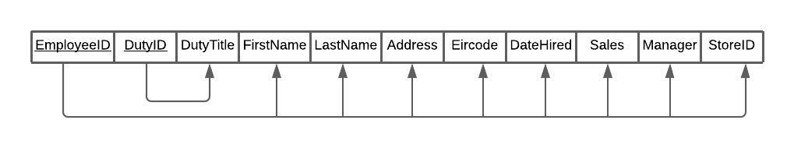
Step 4: Map functional dependencies into relations:
EMPLOYEE(EmployeeID, FirstName, LastName, Address, Sales, Manager, DateHired, StoreID)
DUTIES(DutyID, DutyTitle)
EMPLOYEE-DUTIES(EmployeeID, DutyID)
Step 5: Draw out the tables:
EMPLOYEE
EmployeeID | FirstName | LastName | Address | Eircode | DateHired | Sales | Manager | PayType | StoreID
E235 | Mary | O’Loughlin | Inisglas,  Crossabeg,  County Wexford | F67HJU8 | 02/04/2016 | Y | N | Hourly | S01
E167 | John | O’Connor | Main St.,  Letterkenny,  Donegal | H71EWB0 | 06/10/2019 | Y | N | Hourly | S01
E188 | Elizabeth | Doyle | 50 Buttermilk Walk,  Middle St.,  Galway | H71RBO4 | 30/11/2015 | N | Y | Salaried | S02
E129 | Conor | Kent | The Halls,  Quay Street,  Galway | B92OLS5 | 18/09/2020 | Y | N | Hourly | S02
E544 | Lily | Jameson | 27 Victoria Place, Eyre Square,  Galway | H91ERT3 | 26/11/2018 | Y | N | Hourly | S01
E789 | Gerry | McNulty | 49 Forster St.,  Galway,  Galway | H91CVG6 | 04/07/2019 | Y | N | Hourly | S02

DUTIES
DutyID | DutyTitle
D001 | Check stock
D002 | Open store
D003 | Close store
D004 | Cleaning duty
D005 | Check registers
D006 | Help customers

EMPLOYEE-DUTY
EmployeeID | DutyID
E235 | D006
E167 | D003
E167 | D006
E188 | D002
E129 | D005
E129 | D001
E544 | D006
E789 | D004

3NF: This table is not in 3NF because the ‘Address’ attribute depends on the Eircode.
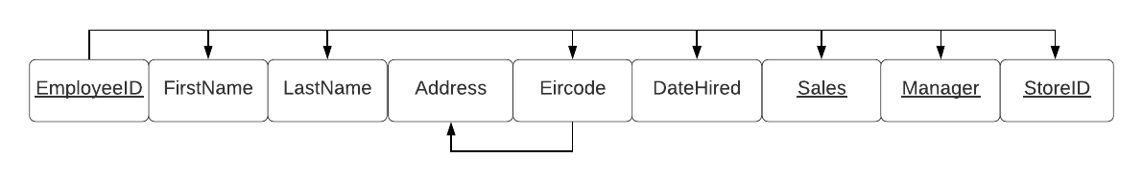
New tables:
EMPLOYEE
EmployeeID | FirstName | LastName | Eircode | Sales | Manager | DateHired | StoreID
E235 | Mary | O’Loughlin | F67HJU8 | Y | N | 02/04/2016 | S01
E167 | John | O’Connor | H71EWB0 | Y | N | 06/10/2019 | S01
E188 | Elizabeth | Doyle | H71RBO4 | N | Y | 30/11/2015 | S02
E129 | Conor | Kent | B92OLS5 | Y | N | 18/09/2020 | S02
E544 | Lily | Jameson | H91ERT3 | Y | N | 26/11/2018 | S01
E789 | Gerry | McNulty | H91CVG6 | Y | N | 04/07/2019 | S02

EMPLOYEE-ADDRESS
Eircode | Address
F67HJU8 | Inisglas,  Crossabeg,  County Wexford
H71EWB0 | Main St.,  Letterkenny,  Donegal
H71RBO4 | 50 Buttermilk Walk,  Middle St.,  Galway
B92OLS5 | The Halls,  Quay Street,  Galway
H91ERT3 | 27 Victoria Place, Eyre Square,  Galway
H91CVG6 | 49 Forster St.,  Galway,  Galway

Please see the following page for the fully normalised EMPLOYEE table.
EMPLOYEE
EmployeeID | FirstName | LastName | Eircode | DateHired | Sales | Manager | PayType | StoreID
E235 | Mary | O’Loughlin | F67HJU8 | 02/04/2016 | Y | N | Hourly | S01
E167 | John | O’Connor | H71EWB0 | 06/10/2019 | Y | N | Hourly | S01
E188 | Elizabeth | Doyle | H71RBO4 | 30/11/2015 | N | Y | Salaried | S02
E129 | Conor | Kent | B92OLS5 | 18/09/2020 | Y | N | Hourly | S02
E544 | Lily | Jameson | H91ERT3 | 26/11/2018 | Y | N | Hourly | S01
E789 | Gerry | McNulty | H91CVG6 | 04/07/2019 | Y | N | Hourly | S02

EMPLOYEE-DUTY
EmployeeID | DutyID
E235 | D006
E167 | D003
E167 | D006
E188 | D002
E129 | D005
E129 | D001
E544 | D006
E789 | D004

DUTIES
DutyID | DutyTitle
D001 | Check stock
D002 | Open store
D003 | Close store
D004 | Cleaning duty
D005 | Check registers
D006 | Help customers

EMPLOYEE-ADDRESS
Eircode | Address
F67HJU8 | Inisglas,  Crossabeg,  County Wexford
H71EWB0 | Main St.,  Letterkenny,  Donegal
H71RBO4 | 50 Buttermilk Walk,  Middle St.,  Galway
B92OLS5 | The Halls,  Quay Street,  Galway
H91ERT3 | 27 Victoria Place, Eyre Square,  Galway
H91CVG6 | 49 Forster St.,  Galway,  Galway

EMPLOYEE- HOURLY
EmployeeID | HourlyRate
E235 | 12.00
E167 | 12.00
E188 | 15.00
E129 | 12.00
E544 | 12.00
E789 | 12.00

EMPLOYEE-SALARIED
EmployeeID | Salary | StockOptions
E188 | 23,000 | N/A

EMPLOYEE-SALES
EmployeeID | Quota
E235 | 10
E167 | 15
E129 | 10
E544 | 14
E789 | 12

EMPLOYEE-MANAGER
EmployeeID | Department
E188 | Sales

- ORDERITEM
UNF
Not in 1NF due to missing data, default values will be assigned for the fields Discount, SpecialOptions and CustomerReview
OrderID | ProductID | Quantity | Discount | SpecialOptions | CustomerReview
O101 | P104 | 1 |  | Colour: Red | "I really like the colour!"
O101 | P105 | 1 | 10%
O103 | P106 | 2 |  |  | "This looks more gray than black! Not happy!!!"
O104 | P101 | 1 |  | Limited Edition
O105 | P104 | 2 |  | Colour: Black
O106 | P102 | 1 | 15% |  | "Glad I found a coupon for a discount."

1NF
OrderID | ProductID | Quantity | Discount | SpecialOptions | CustomerReview
O101 | P104 | 1 | 0 | Colour: Red | "I really like the colour!"
O101 | P105 | 1 | 10% | None | None
O103 | P104 | 2 | 0 | Colour: Black | "This looks more gray than black! Not happy!!!"
O104 | P101 | 1 | 0 | Limited Edition | None
O105 | P103 | 2 | 0 | Colour: Black | None
O106 | P102 | 1 | 15% | None | "Glad I found a coupon for a discount."

2NF and 3NF:
This table can be seen to automatically be in 2NF, with the candidate key being a composite key of (OrderID, ProductID) and no partial dependencies.

OrderID | ProductID | Quantity | Discount | SpecialOptions | CustomerReview
O101 | P104 | 1 | 0 | Colour: Red | "I really like the colour!"
O101 | P105 | 1 | 10% | None | None
O103 | P104 | 2 | 0 | Colour: Black | "This looks more gray than black! Not happy!!!"
O104 | P101 | 1 | 0 | Limited Edition | None
O105 | P103 | 2 | 0 | Colour: Black | None
O106 | P102 | 1 | 15% | None | "Glad I found a coupon for a discount."

As there are no transitive dependencies either, this table is automatically in 3NF.
- ORDER

UNF
OrderID | CustomerID | OrderDate | Description | OrderType | PaymentMethod | EmployeeID | Order Status
O101 | C106 | 05/03/2020 | T-Shirt | InStore | Cash | E544 | Completed
O102 | C103 | 07/05/2021 | Vinyl | InStore | Cash | E544 | In Process
O103 | C102 | 04/08/2021 | Mug x 2 | Online | Visa | E129 | Completed
O104 | C105 | 02/06/2019 |  | Online | Visa | E789 | Refunded
O105 | C101 | 10/04/2021 |  | InStore | Cash | E235 | Completed
O106 | C104 | 02/07/2019 | Vinyl | Online | Visa | E167 | Refunded
O107 | C102 | 04/08/2021 | Vinyl | Online | Visa | E235 | In Process

Not in 1NF due to missing values

1NF

OrderID | CustomerID | OrderDate | Description | OrderType | PaymentMethod | EmployeeID | Order Status
O101 | C106 | 05/03/2020 | T-Shirt | InStore | Cash | E544 | Completed
O102 | C103 | 07/05/2021 | Vinyl | InStore | Cash | E544 | In Process
O103 | C102 | 04/08/2021 | Mug x 2 | Online | Visa | E129 | Completed
O104 | C105 | 02/06/2019 | Vinyl | Online | Visa | E789 | Refunded
O105 | C101 | 10/04/2021 | T-Shirt x2 | InStore | Cash | E235 | Completed
O106 | C104 | 02/07/2019 | Vinyl | Online | Visa | E167 | Refunded
O107 | C102 | 04/08/2021 | Vinyl | Online | Visa | E235 | In Process

Automatically in 2NF
OrderID | CustomerID | OrderDate | Description | OrderType | PaymentMethod | EmployeeID | Order Status
O101 | C106 | 05/03/2020 | T-Shirt | InStore | Cash | E544 | Completed
O102 | C103 | 07/05/2021 | Vinyl | InStore | Cash | E544 | In Process
O103 | C102 | 04/08/2021 | Mug x 2 | Online | Visa | E129 | Completed
O104 | C105 | 02/06/2019 | Vinyl | Online | Visa | E789 | Refunded
O105 | C101 | 10/04/2021 | T-Shirt x2 | InStore | Cash | E235 | Completed
O106 | C104 | 02/07/2019 | Vinyl | Online | Visa | E167 | Refunded
O107 | C102 | 04/08/2021 | Vinyl | Online | Visa | E235 | In Process

Not in 3NF
Our stores only accept cash, and the online site only accepts Visa. The PaymentMethod relies on the OrderType attribute. This is a transitive dependency.

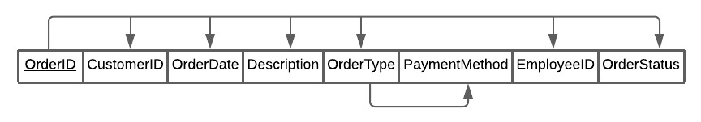

We can remove this transitive dependency by creating a separate table, ORDERTYPE, as follows:

3NF

ORDER
OrderID | CustomerID | OrderDate | Description | OrderType | EmployeeID | Order Status
O101 | C106 | 05/03/2020 | T-Shirt | InStore | E544 | Completed
O102 | C103 | 07/05/2021 | Vinyl | InStore | E544 | In Process
O103 | C102 | 04/08/2021 | Mug x 2 | Online | E129 | Completed
O104 | C105 | 02/06/2019 | Vinyl | Online | E789 | Refunded
O105 | C101 | 10/04/2021 | T-Shirt x2 | InStore | E235 | Completed
O106 | C104 | 02/07/2019 | Vinyl | Online | E167 | Refunded
O107 | C102 | 04/08/2021 | Vinyl | Online | E235 | In Process

ORDERTYPE
OrderID | OrderType | PaymentMethod
O101 | InStore | Cash
O102 | InStore | Cash
O103 | Online | Visa
O104 | Online | Visa
O105 | InStore | Cash
O106 | Online | Visa
O107 | Online | Visa

However, OrderType is actually a subtype discriminator for the Online and Instore subtypes. Therefore, we can simplify this further by splitting the subtypes into separate tables along with their other unique attributes and turning the ORDERTYPE table into an OREDER-PAYMENTMETHOD table, which identifies the payment method for each order type. Here are all the finished tables:

ORDER
OrderID | CustomerID | OrderDate | Description | OrderType | EmployeeID | Order Status
O101 | C106 | 05/03/2020 | T-Shirt | InStore | E544 | Completed
O102 | C103 | 07/05/2021 | Vinyl | InStore | E544 | In Process
O103 | C102 | 04/08/2021 | Mug x 2 | Online | E129 | Completed
O104 | C105 | 02/06/2019 | Vinyl | Online | E789 | Refunded
O105 | C101 | 10/04/2021 | T-Shirt x2 | InStore | E235 | Completed
O106 | C104 | 02/07/2019 | Vinyl | Online | E167 | Refunded
O107 | C102 | 04/08/2021 | Vinyl | Online | E235 | In Process

ORDER ONLINE
OrderID | Address | ShippingCosts | DeliveryID
O103 | Colbert St,  Athea,  Co. Limerick | € 5.99 | D1003
O104 | 45 Townyard Hse, Malahide,  Co. Dublin | € 2.99 | D1004
O106 | 123 St., Camolin, Co. Wexford | € 2.99 | D1006
O107 | 456 St., Claremorris, Co. Mayo | € 4.99 | D1005

ORDER INSTORE
OrderID | Merchant Receipt
O101 | MR00101
O102 | MR00102
O105 | MR00105

ORDER-PAYMENTMETHOD
OrderType | PaymentMethod
Instore | Cash
Online | Visa

- PRODUCT
UNF:
This table is not in 1NF, as the fields StoreID, SupplierID, SupplyCost, SupplyQuantity and
SupplyDate contain sets of values.
ProductID | ProductType | Description | StoreID | Price | SupplierID | SupplyCost | SupplyQuantity | SupplyDate
P101 | Merchandise | Hoodie | S01, S02 | €60, €65 | SU02, SU01 | €25,  €30 | 30,  20 | 2018-02-05,  2020-04-20
P102 | Vinyl | 10 inches, black | S01, S02 | €30 | SU01,  SU02 | €15,  €12 | 40,  40 | 2019-10-04,  2020-06-01
P103 | Vinyl | 12 inches, red | S02,  S02 | €40 | SU02,  SU02 | €18.50  €20.00 | 15,  5 | 2019-01-13,  2020-08-10
P104 | Merchandise | T-Shirt | S01, S02 | €25, €27.99 | SU01, SU03 | €13,  €15.99 | 50,  50 | 2020-12-10,  2021-11-17
P105 | Other | Headphones | S01 | €40 | SU01 | €20 | 45 | 2021-03-23
P106 | Merchandise | Mug | S01, S02 | €5,  €6 | SU01,  SU02 | €3,  €3.50 | 50,  40 | 2019-09-23,  2021-05-30

ProductID | ProductType | Description | StoreID | Price | SupplierID | SupplyDate | SupplyCost | SupplyQuantity
P101 | Merchandise | Hoodie | S01 | €60 | SU02 | 2018-02-05 | €25 | 30
P101 | Merchandise | Hoodie | S02 | €65 | SU01 | 2020-04-20 | €30 | 20
P102 | Vinyl | 10 inches, black | S01 | €30 | SU01 | 2019-10-04 | €15 | 40
P102 | Vinyl | 10 inches, black | S02 | €30 | SU02 | 2020-06-01 | €12 | 40
P103 | Vinyl | 12 inches, red | S02 | €40 | SU02 | 2019-01-13 | €18.50 | 15
P103 | Vinyl | 12 inches, red | S02 | €40 | SU02 | 2020-08-10 | €20.00 | 5
P104 | Merchandise | T-Shirt | S01 | €25 | SU01, SU03 | 2020-12-10 | €13 | 50
P104 | Merchandise | T-Shirt | S02 | €27.99 | SU03 | 2021-11-17 | €15.99 | 50
P105 | Other | Headphones | S01 | €40 | SU01 | 2021-03-23 | €20 | 45
P106 | Merchandise | Mug | S01 | €5 | SU01 | 2019-09-23 | €3 | 50
P106 | Merchandise | Mug | S02 | €6 | SU02 | 2021-05-30 | €3.50 | 40
1NF:
The table is now in 1NF as there are no missing/NULL values, and there is only one data point per cell

NOT IN 2NF:
The PRODUCT table is not in 2NF because there are partial dependencies:
PRODUCT(ProductID, ProductType, Description)
PRODUCT-STORE(ProductID, StoreID, Price)
PRODUCT-STORE-SUPPLIER(ProductID, StoreID, SupplierID, SupplyDate, SupplyCost, SupplyQuantity)
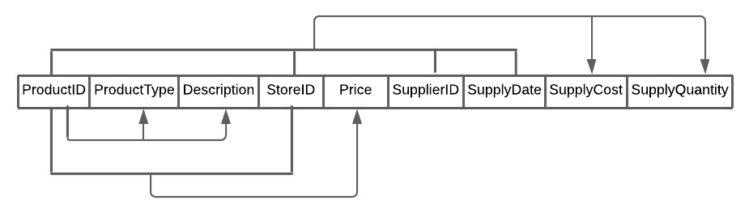

2NF:
To bring this table to 2NF, we must separate any partial dependencies into their own tables:
PRODUCT
ProductID | ProductType | Description
P101 | Merchandise | Hoodie
P102 | Vinyl | 10 inches, black
P103 | Vinyl | 12 inches, red
P104 | Merchandise | T-Shirt
P105 | Other | Headphones
P106 | Merchandise | Mug

PRODUCT-STORE
ProductID | StoreID | Price
P101 | S01 | €60
P101 | S02 | €65
P102 | S01 | €30
P103 | S01 | €40
P103 | S02 | €40
P104 | S02 | €25
P105 | S01 | €40
P106 | S01 | €5
P106 | S02 | €5

PRODUCT-STORE-SUPPLIER
ProductID | StoreID | SupplierID | SupplyDate | SupplyCost | SupplyQuantity
P101 | S01 | SU02 | 2018-02-05 | €25 | 30
P101 | S02 | SU01 | 2020-04-20 | €30 | 20
P102 | S01 | SU01 | 2019-10-04 | €15 | 40
P102 | S02 | SU02 | 2020-06-01 | €12 | 40
P103 | S02 | SU02 | 2019-01-13 | €18.50 | 15
P103 | S02 | SU02 | 2020-08-10 | €20.00 | 5
P104 | S01 | SU01 | 2020-12-10 | €13 | 50
P104 | S02 | SU03 | 2021-11-17 | €15.99 | 50
P105 | S01 | SU01 | 2021-03-23 | €20 | 45
P106 | S01 | SU01 | 2019-09-23 | €3 | 50
P106 | S02 | SU02 | 2021-05-30 | €3.50 | 40

These split PRODUCT tables brought into 2NF are also in 3NF automatically, as there are no transitive dependencies.

Subtypes:

PRODUCT-VINYL
ProductID | Artist | AlbumTitle | Genre | ReleaseDate
P102 | The Beatles | The White Album | Rock | 1965-10-02
P102 | The Beatles | The White Album | Pop | 1965-10-02
P103 | Adele | 30 | Pop | 2021-11-16

PRODUCT-MERCHANDISE
ProductID | Theme
P101 | Hits of the 90's
P104 | Boyzone
P106 | Marvel

Bring the 5 tables with their related data [you may want to add more data] into PhpMyAdmin.
Set your datatypes correctly.
Run a minimum of 8 queries on these tables. Ensure that these queries are highly relevant to your organisation.

1. QUERY JUSTIFICATION: James Walsh has requested a refund on a purchase they made on
2021-08-04. For the product to be eligible for a refund, it must be less than 30 days since the purchase was made.

SQL:
SELECT c.CustomerID, c.FirstName, c.LastName, o.OrderID, o.OrderDate, CURDATE() AS 'Current Date',
IF(DATEDIFF(now(), OrderDate) < 30, 'Refund accepted', 'Refund declined') AS 'Refund'
FROM ordertable AS o
JOIN customer AS c ON o.CustomerID = c.CustomerID
WHERE o.customerID = 'C102' AND orderID = 'O107'

OUTPUT:

2. QUERY JUSTIFICATION: Check if any customers have made more than 1 order. If they have, the store can email them, offering them a discount on their next order.

SQL:
SELECT c.*, COUNT(*) AS 'Total Orders Made'
FROM ordertable AS o
JOIN customer AS c ON c.customerid = o.customerid
GROUP BY c.customerID

OUTPUT:
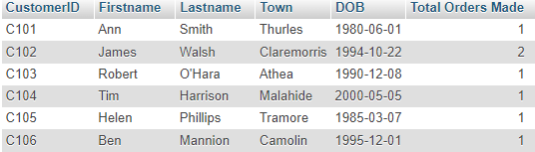

3. QUERY JUSTIFICATION: If an order is placed between Dec 15th and 22nd customers will be entitled to free express shipping so that their order is with them for Christmas.
This SQL query returns all eligible orders and it is a recurring annual query.

SQL:
SELECT `OrderID`, `OrderDate` AS 'Qualifies for Complimentary Express Shipping'
FROM `ordertable`
WHERE MONTH(OrderDate) = '12' AND DAY(OrderDate) BETWEEN '15' AND '22';

OUTPUT:

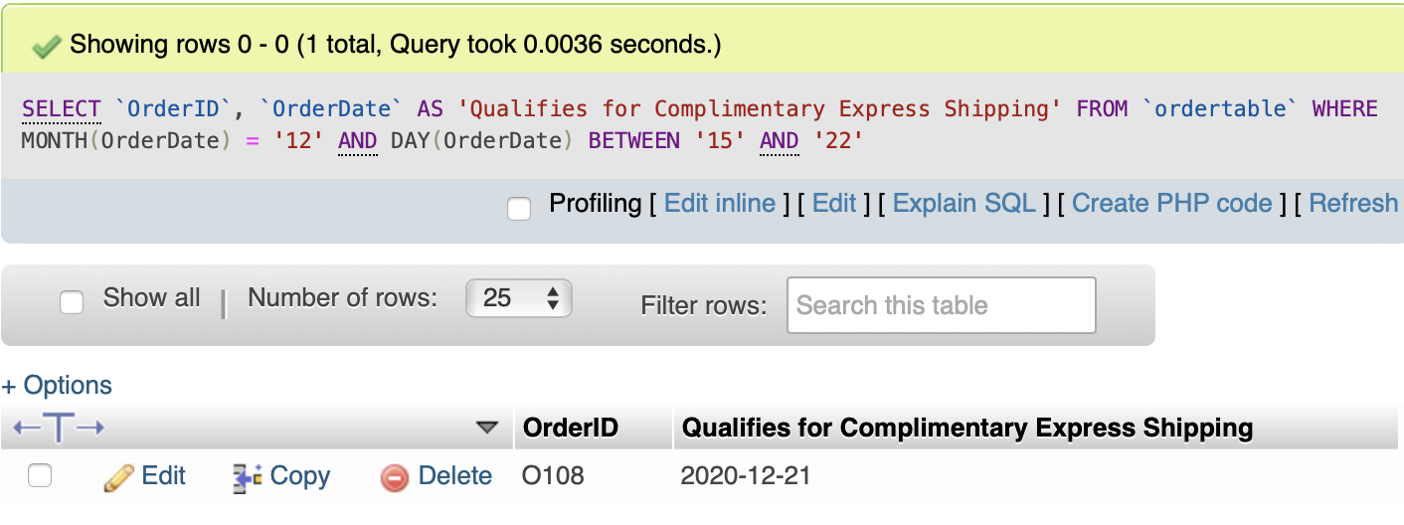

4. QUERY JUSTIFICATION: The store sometimes puts items on sale based on the decade the music was released. The store needs to be able to filter all items released within a certain decade in order to put them on sale.

SQL:
SELECT pr.ProductID AS "10% OFF ALL Music From The 60's", ps.Price - ps.Price * 0.10 AS 'Price After Discount'
FROM `product-vinyl` pr
JOIN `product-store` ps on pr.ProductID=ps.ProductID
WHERE pr.ReleaseDate BETWEEN '1960-01-01' AND '1969-12-31';
OUTPUT:
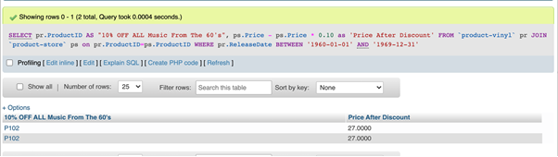

5. QUERY JUSTIFICATION: one difficulty Mom & Pop Records faced using a file based system was gathering insights from their data to improve business outcomes. This challenge is greatly improved through the use of a DBMS. This query is an example of that, where the business can identify the most popular products being sold, and this information can be used to inform business decisions such as advertisement or further stock purchase. This can be adapted further, using specified dates similar to the queries above, to show most popular items in specified time frames to help the business identify trends throughout the year.
SQL:
SELECT ProductID, SUM(Quantity) as 'Sold to Date'
FROM orderitem
GROUP BY ProductID
ORDER BY SUM(Quantity) DESC
OUTPUT:
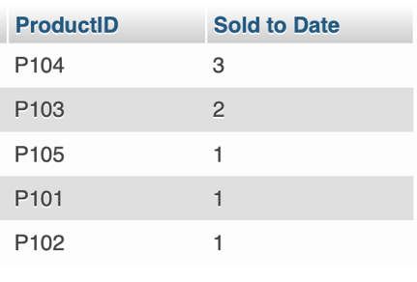
6. QUERY JUSTIFICATION: To see which products are the most and least expensive, the store wants to separate them based on whether they are ‘premium’, ‘average’, or ‘low-priced’ products. The store can then use this information in their advertising. Premium products are any products that cost over 60 euro. Average products are any products that cost between 30-60 euro. Low priced products are anything under 30 euro. The different prices depending on the store must also be accounted for.
SQL:
SELECT p.ProductID, ps.StoreID, p.ProductType, ps.Price,
(CASE
WHEN ps.price > 60 THEN 'Premium Product'
WHEN ps.price <= 60 AND ps.price > 30 THEN 'Average Product'
ELSE 'Low-Price Product'
END
) AS "Product Price Type"
FROM product AS p
JOIN `product-store` AS ps ON p.ProductID = ps.ProductID
OUTPUT:
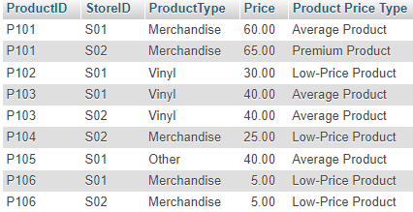
7. QUERY JUSTIFICATION: an important benefit of this database is that it can be used as part of the back-end of a webstore. The website can be designed to automatically populate relevant data from the database, with very little manpower required after the initial setup. One aspect of the webstore that can influence a customer's purchase are customer reviews. This query is an example of one that could be executed when a user loads the webpage of particular product. Relevant review data will be returned, and the webstore will display the reviewer's First name, date of purchase, and review in the potential customer's browser. If no reviews were made, the query will return the default value of 'None' and the webstore will know to display that no reviews were made for this product yet.

SQL:
SELECT customer.Firstname, ordertable.OrderDate, orderitem.CustomerReview
FROM orderitem
JOIN ordertable ON orderitem.OrderID = ordertable.OrderID
JOIN customer ON ordertable.CustomerID = customer.CustomerID
WHERE ProductID = 'P104'

OUTPUT:
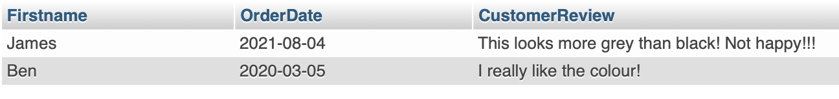

8. QUERY JUSTIFICATION: due to logistical issues related to the COVID-19 pandemic and Brexit, Mom & Pop Records have had to change suppliers of products numerous times. Each of our stores receive numerous deliveries of product from different suppliers and these vary in quantity and supply cost. Further increases in supply cost to our new Dublin store has lead to differing prices between stores. It is important for the business not only to be able to keep track of their stock, but also to make informed decisions about how changes to supply cost and price could effect their overall profit and viability. This query creates a View that displays up-to-date stock of all products accross both stores, and also calculates the gross margin based on the store's selling price minus the average supply cost of the product to that store.

SQL:
CREATE VIEW stockmargin AS
SELECT psm.ProductID, psm.StoreID,
SUM(SupplyQuantity) - IFNULL(
(SELECT SUM(Quantity) FROM orderitem
JOIN ordertable ON orderitem.OrderID = ordertable.OrderID
JOIN employee ON ordertable.EmployeeID = employee.EmployeeID
WHERE
psm.StoreID = employee.StoreID AND orderitem.ProductID = psm.`ProductID`
AND ordertable.OrderStatus IN('Completed', 'In Progress')), 0) AS 'Stock',
(SELECT `product-store`.`Price` FROM `product-store`
WHERE psm.ProductID = `product-store`.ProductID
AND psm.StoreID =`product-store`.`StoreID`)
- SUM(psm.SupplyCost * psm.SupplyQuantity) / SUM(psm.SupplyQuantity) AS 'Gross Margin'
FROM`product-store-supplier` AS psm
GROUP BY psm.ProductID, psm.StoreID
OUTPUT:
