SQL CA

Name: Cian Mac Liatháin
ID: 11476078

Question | SQL | Result
1 | SELECT CONCAT('There are ', COUNT(*), " first names containing an 'a' - grouped by gender = ", Gender) AS 'Results' FROM `employee` WHERE Fname LIKE "%a%" GROUP BY Gender | 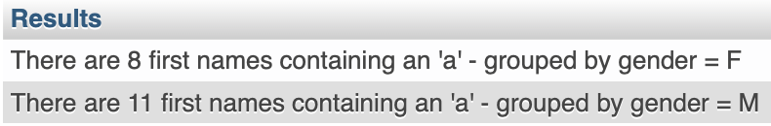
2 | SELECT CONCAT('The SQL CA is taking place on ', dayname(now()), ' the ', day(now()), 'rd of ', monthname(now())) AS 'CA' | 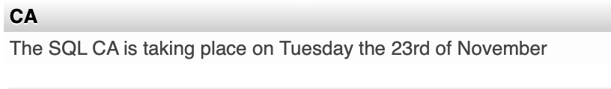
3 | SELECT COUNT(*) AS 'Number of employees' FROM `employee` WHERE Fname LIKE "E%" OR Lname LIKE "%a%"; | 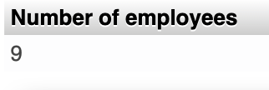
4 | SELECT CONCAT('The average salary for the ', COUNT(Position),' ', Position, ' employees is ', AVG(salary),' whilst the minimum salary is ', MIN(salary), ' and the maximum salary is ', MAX(salary), ' compared to the overall salary average of ', (SELECT AVG(salary) FROM salary)) AS 'Salary Info' FROM `salary` GROUP BY Position ORDER BY AVG(salary) DESC | 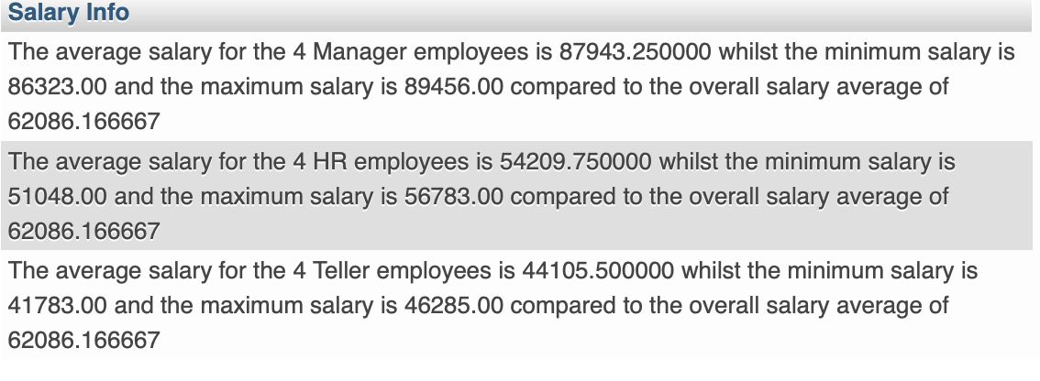
5 | SELECT Staffno, Fname, Lname, bank.Bank, bank.County, (CASE WHEN bank.County = 'Galway' THEN 'The Hooker County' WHEN bank.County = 'Mayo' THEN 'The Maritime County' WHEN bank.County = 'Tipperary' THEN 'The Premier County' ELSE 'Whatever you like yourself' END) AS 'County nicknames' FROM `employee` JOIN `bank` ON employee.Branchno = bank.Branchno ORDER BY Staffno | 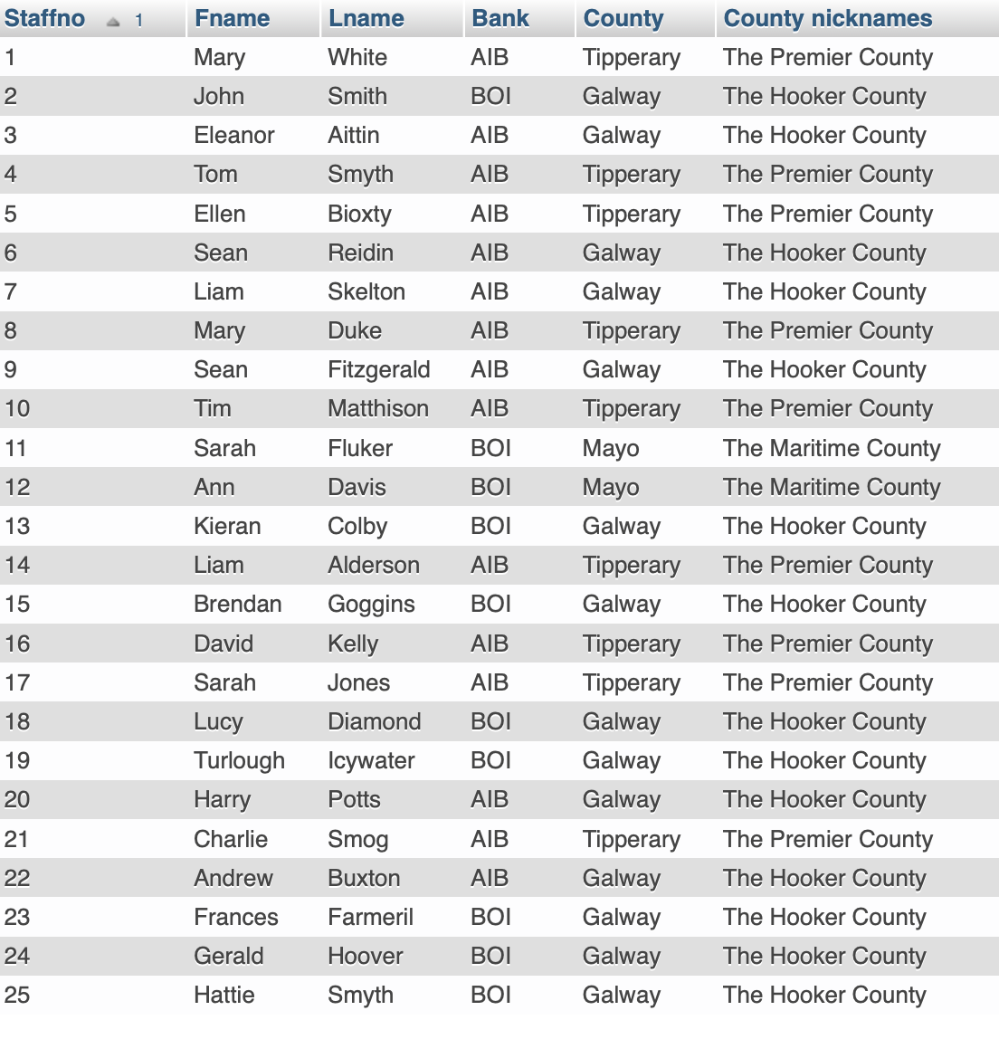
6 | SELECT * FROM employee WHERE Staffno % 3 = 0 ORDER BY DateHired DESC LIMIT 6 | 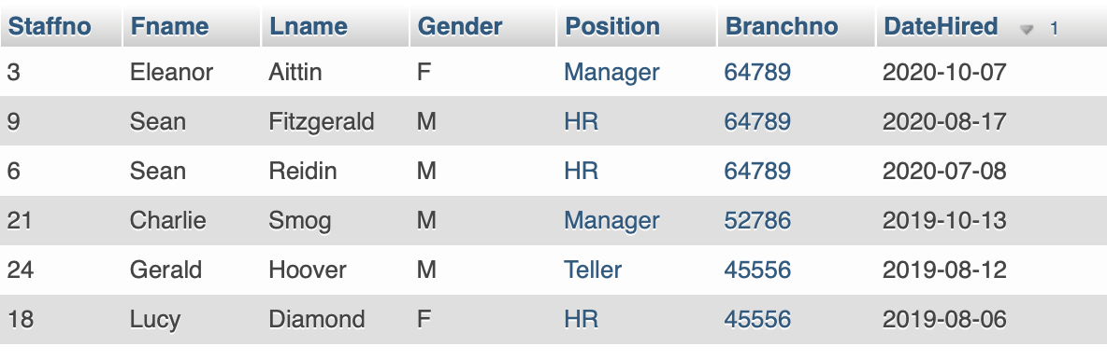
7 | SELECT Position AS 'Bank Position', SUM(salary.Salary) AS 'Salary cost across the 4 branches' FROM salary GROUP BY Position ORDER BY SUM(salary.Salary) DESC | 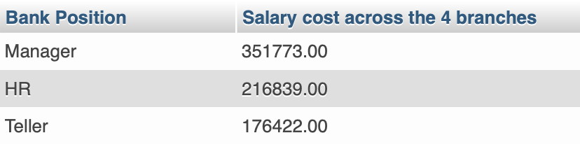
8 | SELECT CONCAT_WS(' ', Fname,Lname,'was hired in the last', datediff(now(), employee.DateHired), 'days') AS 'Most recent hires' FROM employee ORDER BY datediff(now(), employee.DateHired) ASC LIMIT 5 | 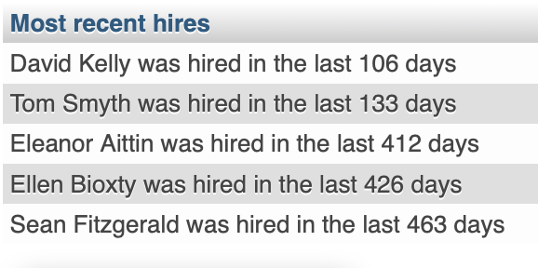
9 | SELECT Position, SUM(datediff(now(), employee.DateHired)) AS 'Recent Female hires by Position' FROM employee WHERE Gender = 'F' GROUP BY Position ORDER BY SUM(datediff(now(), employee.DateHired)) DESC | 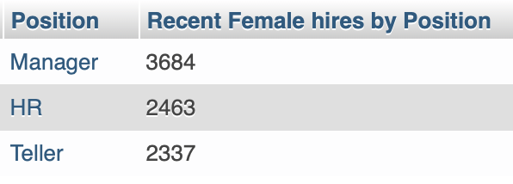
10 | SELECT Position, Gender, Branchno, COUNT(*) AS 'Number of Employees' FROM employee WHERE Branchno = 52786 OR Branchno = 64789 GROUP BY Position, Gender, Branchno | 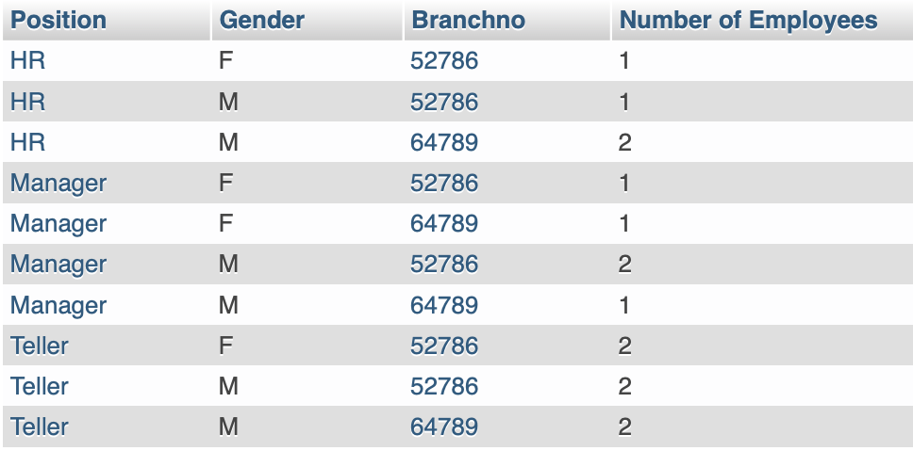
11 | SELECT Staffno, Fname, Lname, employee.Position, employee.Branchno, Bank, County, Salary FROM employee JOIN salary ON employee.Position = salary.Position AND employee.Branchno = salary.Branchno JOIN bank ON salary.Branchno = bank.Branchno ORDER BY Staffno | 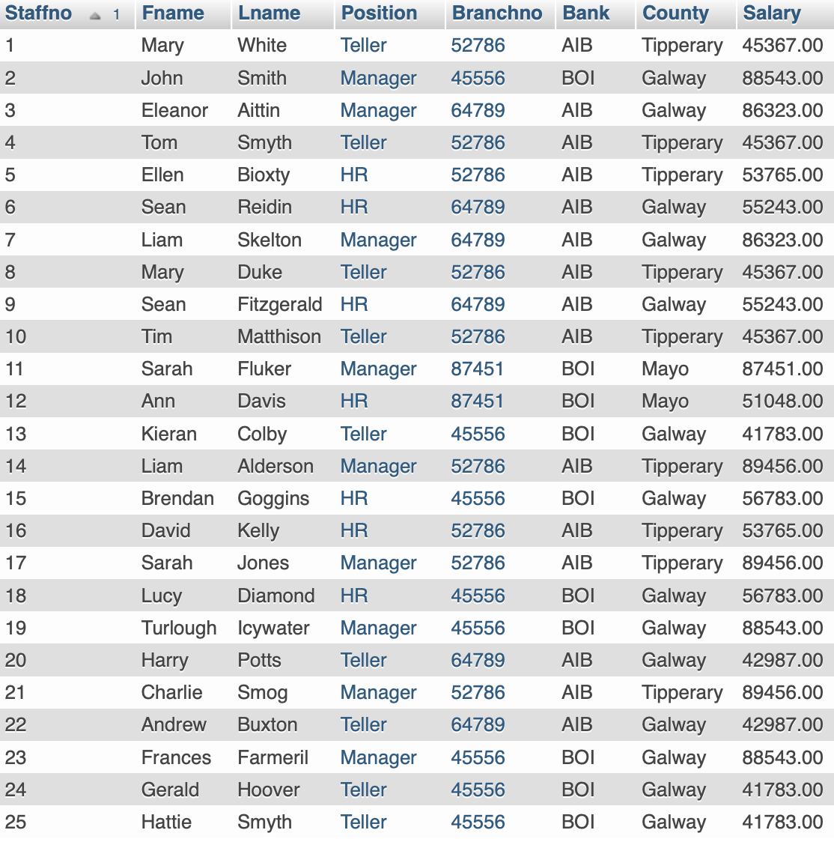
12 | SELECT CONCAT_WS(' ', Fname, Lname, 'works as a', employee.Position, 'in', Bank, County, 'at a salary of:',Salary) AS 'Employee Info' FROM employee JOIN salary ON employee.Position = salary.Position AND employee.Branchno = salary.Branchno JOIN bank ON salary.Branchno = bank.Branchno ORDER BY Staffno | 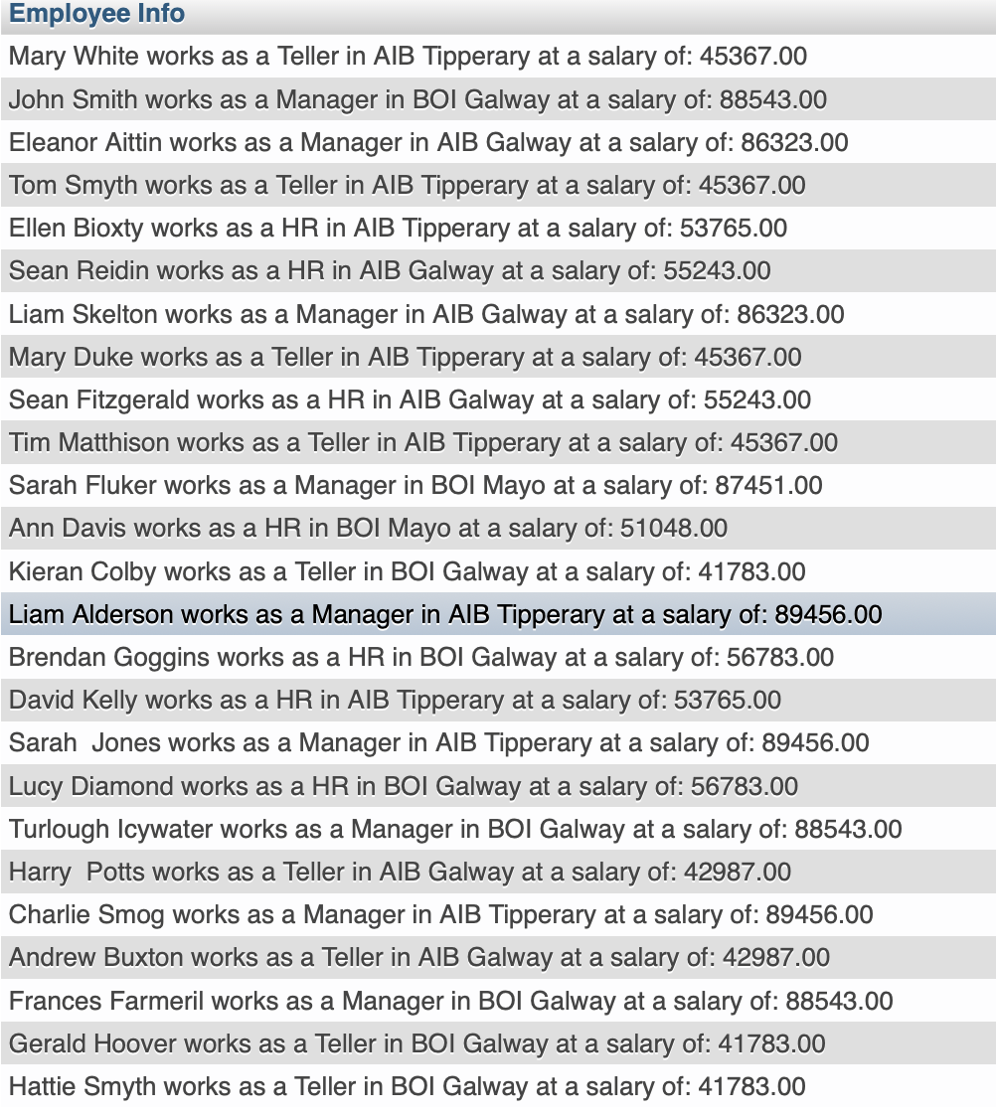
13 | SELECT Staffno, Fname, Lname, employee.Position, employee.Branchno, Bank, County, Salary, IF(salary < (SELECT AVG(Salary) FROM salary WHERE Position = employee.Position GROUP BY Position), 'Less than the average salary for this position', 'More than the average salary for this position') AS 'Salary Info' FROM employee JOIN salary ON employee.Position = salary.Position AND employee.Branchno = salary.Branchno JOIN bank ON salary.Branchno = bank.Branchno ORDER BY Staffno | 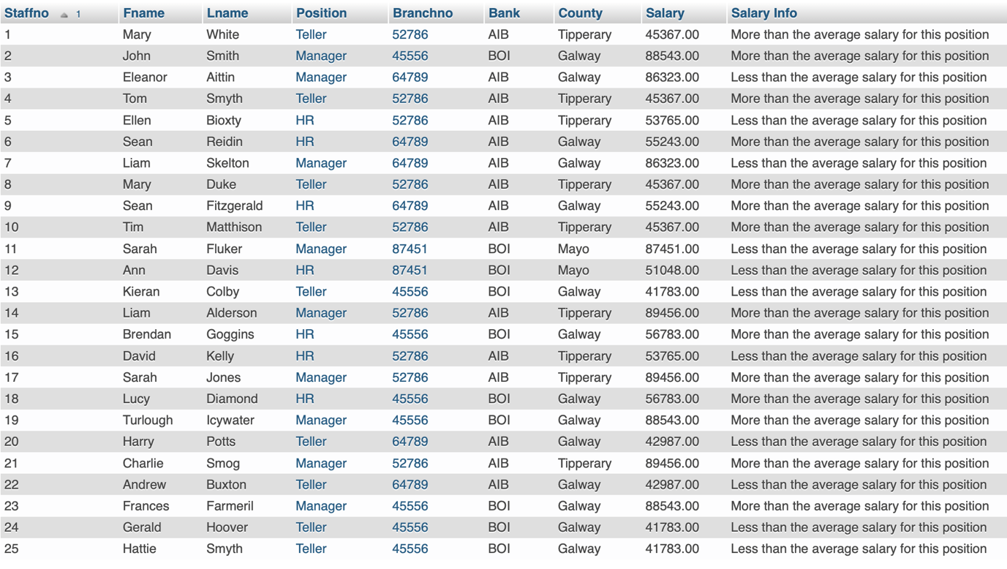
14 | SELECT Staffno, Fname, Lname, employee.Position, employee.Branchno, Bank, County, Salary, (SELECT AVG(Salary) FROM salary WHERE Position = employee.Position GROUP BY Position) AS 'Avg salary for this position', IF(salary < (SELECT AVG(Salary) FROM salary WHERE Position = employee.Position GROUP BY Position), 'Less than the average salary for this position', 'More than the average salary for this position') AS 'Salary Info' FROM employee JOIN salary ON employee.Position = salary.Position AND employee.Branchno = salary.Branchno JOIN bank ON salary.Branchno = bank.Branchno ORDER BY Staffno | 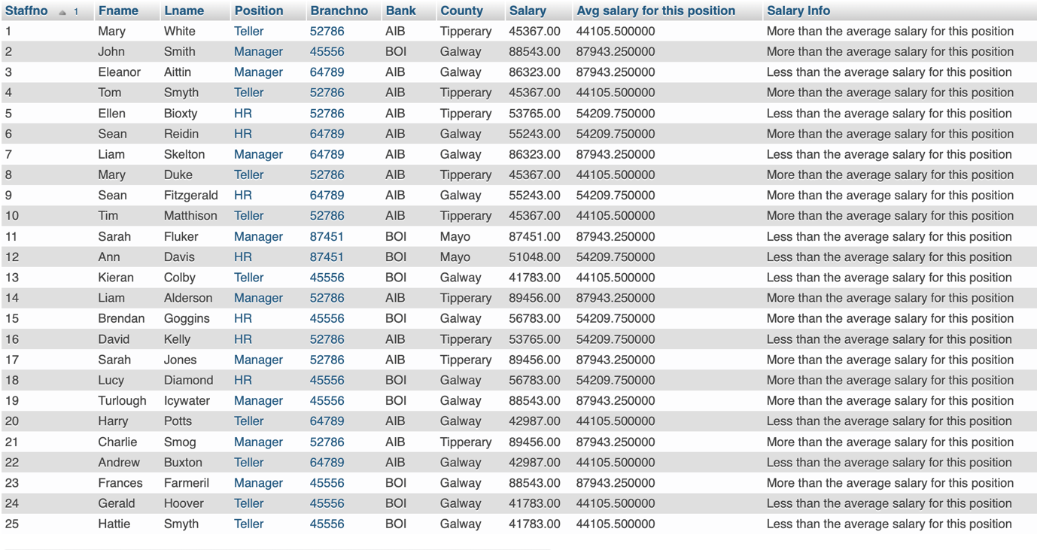
15 | SELECT Staffno, Fname, Lname, Salary FROM employee JOIN salary ON employee.Position = salary.Position AND employee.Branchno = salary.Branchno WHERE salary.Salary > ALL (SELECT AVG(Salary) FROM salary GROUP BY Branchno) ORDER BY Salary DESC, Lname | 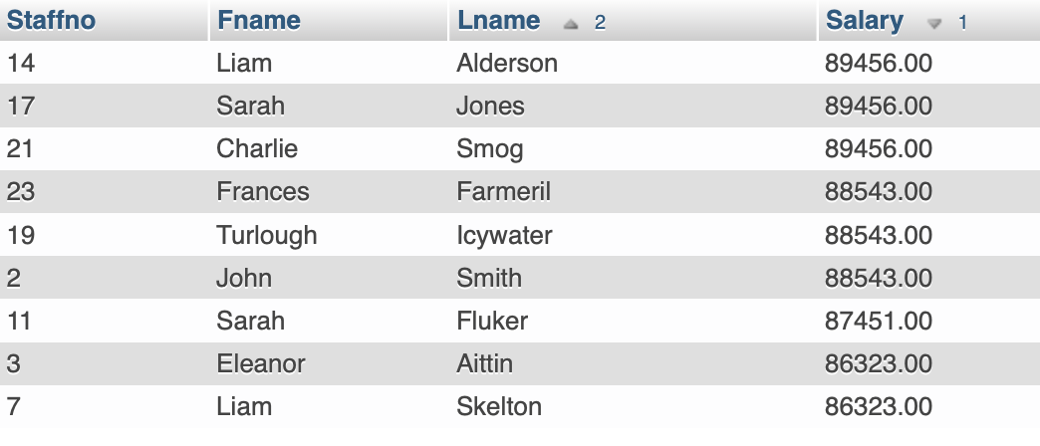
16 | SELECT Fname AS 'Name', Lname AS 'Surname', employee.Position AS 'Bank Position', CONCAT(employee.Position, ' gets a ', CASE WHEN employee.Position = 'Manager' THEN 0.05 WHEN employee.Position = 'Teller' THEN 0.3 WHEN employee.Position = 'HR' THEN 0.25 END *100, '% bonus') AS 'Bonus Scheme', Salary, salary + salary * CASE WHEN employee.Position = 'Manager' THEN 0.05 WHEN employee.Position = 'Teller' THEN 0.3 WHEN employee.Position = 'HR' THEN 0.25 END AS 'New Salary + Bonus' FROM employee JOIN salary ON employee.Position = salary.Position AND employee.Branchno = salary.Branchno WHERE employee.DateHired > '2020-01-01' | 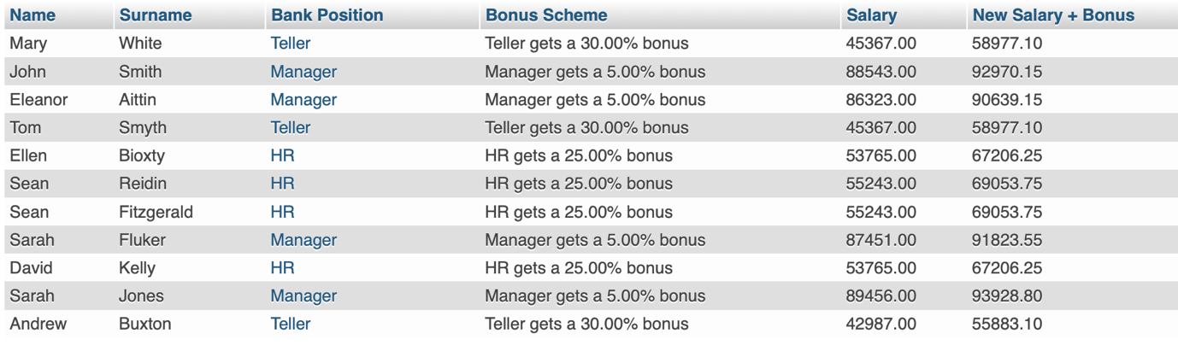
17 | SELECT employee.Fname, employee.Lname, employee.Position, employee.Branchno, Bank, County FROM employee INNER JOIN bank WHERE employee.Branchno = bank.Branchno ORDER BY bank.Bank, bank.County | 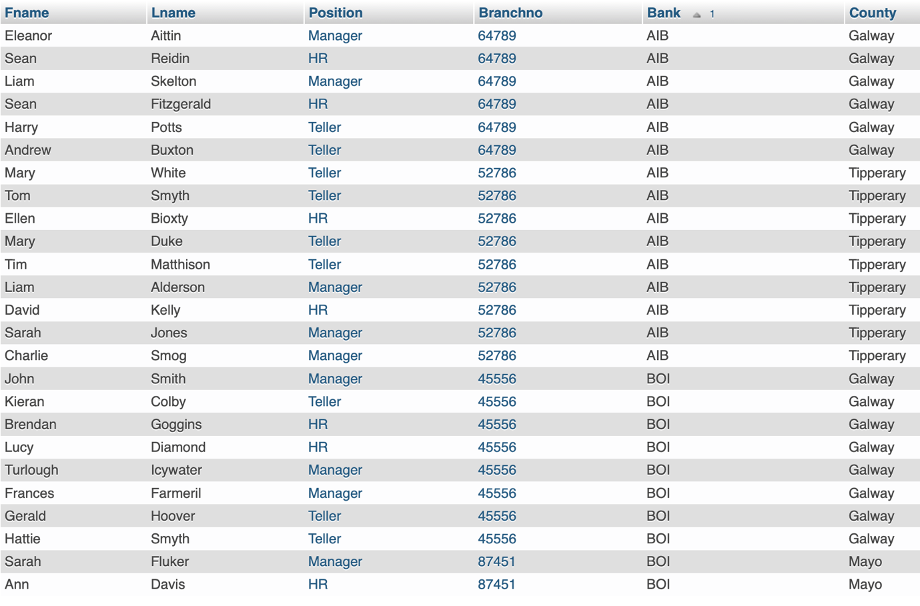
18 | SELECT Fname, Lname, employee.Position, salary.Position, employee.Branchno, salary.Salary FROM employee JOIN salary ON employee.Branchno = salary.Branchno AND employee.Position = salary.Position WHERE salary.Salary > ANY(SELECT AVG(salary.Salary) FROM salary GROUP BY salary.Branchno) AND salary.Salary < ANY(SELECT MIN(salary.Salary) FROM salary GROUP BY salary.Position) | No results found with salaries less than any of the minimum salaries categorised by position
19 | SELECT CONCAT(Fname,' ', Lname,' works at ', bank.Bank, ', ', bank.Address, ', ', bank.County) AS 'Employee Details' FROM employee JOIN bank ON employee.Branchno = bank.Branchno ORDER BY employee.Staffno | 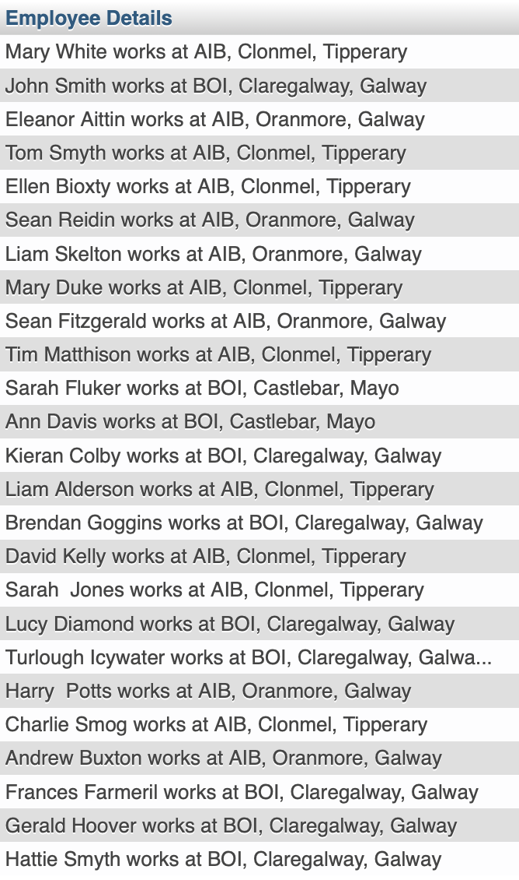
20 | SELECT Position, COUNT(*) AS 'Number of employees in this position' FROM employee GROUP BY Position HAVING COUNT(*) > 7 ORDER BY Position DESC | 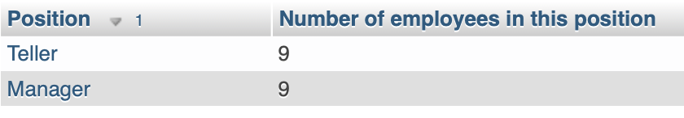
21 | SELECT employee.Fname AS 'Name', employee.Lname AS 'Surname', employee.Position, employee.Branchno, salary.Salary FROM employee JOIN salary ON employee.Position = salary.Position AND employee.Branchno = salary.Branchno WHERE salary.Salary * 1.5> ALL (SELECT AVG(salary.Salary) FROM salary GROUP BY Position) ORDER BY employee.Lname ASC | 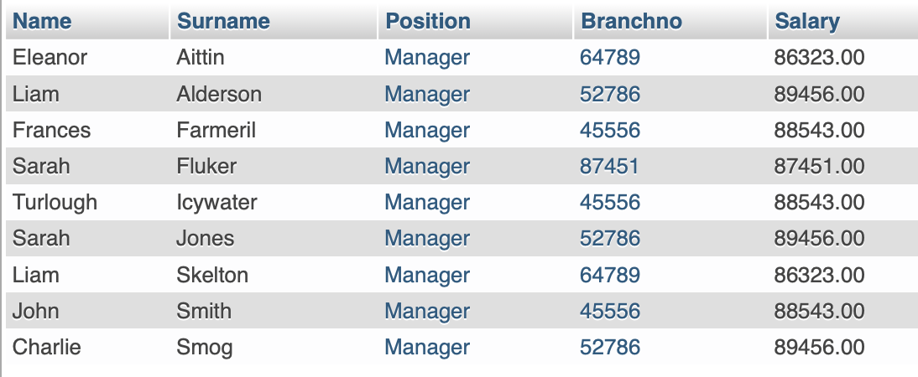
22 | SELECT employee.Lname, employee.Fname, bank.Bank, bank.County FROM employee JOIN bank ON employee.Branchno = bank.Branchno WHERE employee.Branchno NOT IN (52786, 87451) ORDER BY employee.Lname DESC | 