CT853: ALGORITHMS & LOGICAL FOUNDATIONS ASSIGNMENT TEMPLATE
NAME: Cian Mac Liatháin
STUDENT NUMBER: 11476078

QUESTION 1: | MARK
Bubble Sort is an example of an exchange sorting algorithm, where successive pairs of adjacent elements are compared and exchanged (if needed) until the entire collection of elements is sorted (Knuth, 1998).

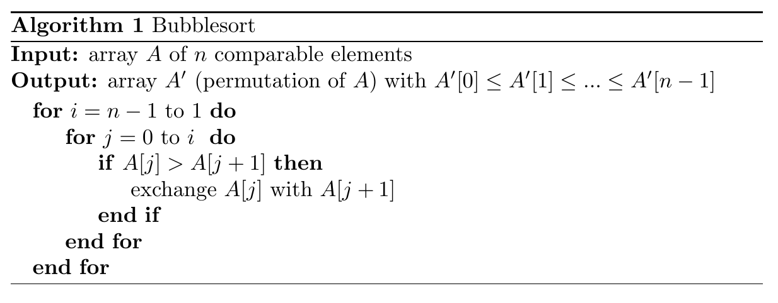
Pseudocode for Bubblesort, written in LaTeX using the algorithmic (Brito, 2009) and algpseudocode (János, 2005) packages.

The analysis of an algorithm can be broken into two subproblems: its completeness, and its complexity (Sedgewick, 2014).

Completeness

A complete algorithm is one that is guaranteed to find a solution if a solution exists, in the case of this Bubble Sort, if it is complete then it will always sort an array of comparable elements in ascending order (this can be changed to descending order by swapping the < symbol in the if statement for a > symbol). We can study the algorithm's loop invariant to prove its complexity through matheamtical induction.

From the pseudocode above, we

7,15,20,2,5

compares two adjacent elements and swaps them if necessary
inner loop gets smaller each time, as the element identified as the biggest/smallest has been brought to the end of the array and no longer needs to considered

Complexity

QUESTION 2: | MARK
Insert Code, Algorithm, Diagrams and Explanations etc HERE

mergesort halves the array until it is of size 1, and then

" Observe that the smallest overall item in two lists sorted in increasing order (as above) must sit at the top of one of the two lists. This smallest element can be removed, leaving two sorted lists behind—one slightly shorter than before. The second smallest item overall must now be atop one of these lists. Repeating this operation until both lists are empty will merge two sorted lists (with a total of n elements between them) into one, using at most n − 1 comparisons or O(n) total work." Skiena, p.129

" If we assume for simplicity that n is a power of two, the kth level consists of all the 2k calls to mergesort processing subranges of n/2k elements."

QUESTION 3: | MARK
Insert Code, Algorithm, Diagrams and Explanations etc HERE

QUESTION 4: | MARK
Insert Code, Algorithm, Diagrams and Explanations etc HERE

Explain tail-recursion
tail-recursive is a function that ends with a recursive call to itself, without any operators acting upon it (foinse)

János, S. (2005) https://texdoc.org/serve/algorithmicx/0
Brito, R. (2009) https://texdoc.org/serve/algorithms/0

