CT861 Assignment 2 - WireShark Report
Name: Cian Mac Liatháin
ID: 1146078

Part 1: Ping
1.1. Print Packets
- 2.613290 192.168.23.105 104.18.142.17 ICMP 98 Echo (ping)
request id=0xed0e, seq=0/0, ttl=64 (reply in 4)
- 2.677405 104.18.142.17 192.168.23.105 ICMP 98 Echo (ping)
reply id=0xed0e, seq=0/0, ttl=57 (request in 3)
- 3.618418 192.168.23.105 104.18.142.17 ICMP 98 Echo (ping)
request id=0xed0e, seq=1/256, ttl=64 (reply in 7)
- 3.664570 104.18.142.17 192.168.23.105 ICMP 98 Echo (ping)
reply id=0xed0e, seq=1/256, ttl=57 (request in 6)
- 4.618639 192.168.23.105 104.18.142.17 ICMP 98 Echo (ping)
request id=0xed0e, seq=2/512, ttl=64 (reply in 19)
- 4.665369 104.18.142.17 192.168.23.105 ICMP 98 Echo (ping)
reply id=0xed0e, seq=2/512, ttl=57 (request in 18)

1.2. Identify Protocols

Network protocol: Internet Communication Message Protocol (ICMP)
Data Link protocol: Ethernet II

The network layer Internet Protocol v4 destination address is a 32-bit dotted logical address that allows for communication between networks by uniquely identifying network-enabled devices. A combination of public and private IP addresses helps traffic packets through the internet in order to arrive at the correct Local Area Network. IP can change and be re-assigned, meaning that the same computer could be identified by different IP addresses but only one at a time. The data link layer Media Access Control address is a unique, static, 48-bit dashed hexadecimal physical address assigned to any network interface card upon manufacture and used within Local Area Networks to route packets to their final destination.

Part 2: Web Server
2.1. Print Packets
38 total packets, 12 shown
4 2.212491 192.168.23.105 13.248.207.191 TCP 78 51544 → 80
[SYN, ECN, CWR] Seq=0 Win=65535 Len=0 MSS=1460 WS=64 TSval=558733140 TSecr=0 SACK_PERM=1
Frame 4: 78 bytes on wire (624 bits), 78 bytes captured (624 bits) on interface en0, id 0 Ethernet II, Src: Apple_82:58:36 (3c:22:fb:82:58:36), Dst: 4a:ad:3a:02:78:6d (4a:ad:3a:
02:78:6d)
Internet Protocol Version 4, Src: 192.168.23.105, Dst: 13.248.207.191
Transmission Control Protocol, Src Port: 51544, Dst Port: 80, Seq: 0, Len: 0
6 2.466760 192.168.23.105 13.248.207.191 TCP 78 51545 → 80
[SYN, ECN, CWR] Seq=0 Win=65535 Len=0 MSS=1460 WS=64 TSval=558733393 TSecr=0 SACK_PERM=1
Frame 6: 78 bytes on wire (624 bits), 78 bytes captured (624 bits) on interface en0, id 0 Ethernet II, Src: Apple_82:58:36 (3c:22:fb:82:58:36), Dst: 4a:ad:3a:02:78:6d (4a:ad:3a:
02:78:6d)
Internet Protocol Version 4, Src: 192.168.23.105, Dst: 13.248.207.191
Transmission Control Protocol, Src Port: 51545, Dst Port: 80, Seq: 0, Len: 0

9 3.172810 13.248.207.191 192.168.23.105 TCP 74 80 → 51544
[SYN, ACK, ECN] Seq=0 Ack=1 Win=65535 Len=0 MSS=1420 SACK_PERM=1 TSval=2537925599 TSecr=558733140 WS=256
Frame 9: 74 bytes on wire (592 bits), 74 bytes captured (592 bits) on interface en0, id 0 Ethernet II, Src: 4a:ad:3a:02:78:6d (4a:ad:3a:02:78:6d), Dst: Apple_82:58:36 (3c:22:fb:
82:58:36)
Internet Protocol Version 4, Src: 13.248.207.191, Dst: 192.168.23.105
Transmission Control Protocol, Src Port: 80, Dst Port: 51544, Seq: 0, Ack: 1, Len: 0

11 3.172814 13.248.207.191 192.168.23.105 TCP 74 80 → 51545
[SYN, ACK, ECN] Seq=0 Ack=1 Win=65535 Len=0 MSS=1420 SACK_PERM=1 TSval=2537017737 TSecr=558733393 WS=256
Frame 11: 74 bytes on wire (592 bits), 74 bytes captured (592 bits) on interface en0, id 0 Ethernet II, Src: 4a:ad:3a:02:78:6d (4a:ad:3a:02:78:6d), Dst: Apple_82:58:36 (3c:22:fb:
82:58:36)
Internet Protocol Version 4, Src: 13.248.207.191, Dst: 192.168.23.105
Transmission Control Protocol, Src Port: 80, Dst Port: 51545, Seq: 0, Ack: 1, Len: 0

19 3.172982 192.168.23.105 13.248.207.191 TCP 66 51544 → 80
[ACK] Seq=1 Ack=1 Win=132352 Len=0 TSval=558734095 TSecr=2537925599
Frame 19: 66 bytes on wire (528 bits), 66 bytes captured (528 bits) on interface en0, id 0 Ethernet II, Src: Apple_82:58:36 (3c:22:fb:82:58:36), Dst: 4a:ad:3a:02:78:6d (4a:ad:3a:
02:78:6d)
Internet Protocol Version 4, Src: 192.168.23.105, Dst: 13.248.207.191
Transmission Control Protocol, Src Port: 51544, Dst Port: 80, Seq: 1, Ack: 1, Len: 0

20 3.173058 192.168.23.105 13.248.207.191 TCP 66 51545 → 80
[ACK] Seq=1 Ack=1 Win=132352 Len=0 TSval=558734095 TSecr=2537017737
Frame 20: 66 bytes on wire (528 bits), 66 bytes captured (528 bits) on interface en0, id 0 Ethernet II, Src: Apple_82:58:36 (3c:22:fb:82:58:36), Dst: 4a:ad:3a:02:78:6d (4a:ad:3a:
02:78:6d)
Internet Protocol Version 4, Src: 192.168.23.105, Dst: 13.248.207.191
Transmission Control Protocol, Src Port: 51545, Dst Port: 80, Seq: 1, Ack: 1, Len: 0

24 3.173327 192.168.23.105 13.248.207.191 HTTP 691 GET /
siteSettings.js HTTP/1.1
Frame 24: 691 bytes on wire (5528 bits), 691 bytes captured (5528 bits) on interface en0, id 0 Ethernet II, Src: Apple_82:58:36 (3c:22:fb:82:58:36), Dst: 4a:ad:3a:02:78:6d (4a:ad:3a:
02:78:6d)
Internet Protocol Version 4, Src: 192.168.23.105, Dst: 13.248.207.191
Transmission Control Protocol, Src Port: 51544, Dst Port: 80, Seq: 1, Ack: 1, Len: 625 Hypertext Transfer Protocol

29 3.239754 13.248.207.191 192.168.23.105 TCP 66 80 → 51544
[ACK] Seq=1 Ack=626 Win=251904 Len=0 TSval=2537925699 TSecr=558734095
Frame 29: 66 bytes on wire (528 bits), 66 bytes captured (528 bits) on interface en0, id 0 Ethernet II, Src: 4a:ad:3a:02:78:6d (4a:ad:3a:02:78:6d), Dst: Apple_82:58:36 (3c:22:fb:
82:58:36)
Internet Protocol Version 4, Src: 13.248.207.191, Dst: 192.168.23.105
Transmission Control Protocol, Src Port: 80, Dst Port: 51544, Seq: 1, Ack: 626, Len: 0

30 3.259459 13.248.207.191 192.168.23.105 HTTP 999 HTTP/1.1 404Not Found (text/html)
Frame 30: 999 bytes on wire (7992 bits), 999 bytes captured (7992 bits) on interface en0, id 0 Ethernet II, Src: 4a:ad:3a:02:78:6d (4a:ad:3a:02:78:6d), Dst: Apple_82:58:36 (3c:22:fb: 82:58:36)
/var/folders/w8/_v0xtss15_j5rq6cr4xsjdzm0000gn/T//wireshark_Wi-Fi_20220131154939_xIvRtG.pcapng 38 total packets, 12 shown
Internet Protocol Version 4, Src: 13.248.207.191, Dst: 192.168.23.105
Transmission Control Protocol, Src Port: 80, Dst Port: 51544, Seq: 1, Ack: 626, Len: 933 Hypertext Transfer Protocol
Line-based text data: text/html (9 lines)

32 3.259534 192.168.23.105 13.248.207.191 TCP 66 51544 → 80
[ACK] Seq=626 Ack=934 Win=131392 Len=0 TSval=558734180 TSecr=2537925699
Frame 32: 66 bytes on wire (528 bits), 66 bytes captured (528 bits) on interface en0, id 0 Ethernet II, Src: Apple_82:58:36 (3c:22:fb:82:58:36), Dst: 4a:ad:3a:02:78:6d (4a:ad:3a:
02:78:6d)
Internet Protocol Version 4, Src: 192.168.23.105, Dst: 13.248.207.191
Transmission Control Protocol, Src Port: 51544, Dst Port: 80, Seq: 626, Ack: 934, Len: 0

34 4.197127 13.248.207.191 192.168.23.105 TCP 74 [TCP
Retransmission] 80 → 51545 [SYN, ACK, ECN] Seq=0 Ack=1 Win=65535 Len=0 MSS=1420 SACK_PERM=1 TSval=2537017841 TSecr=558733393 WS=256
Frame 34: 74 bytes on wire (592 bits), 74 bytes captured (592 bits) on interface en0, id 0 Ethernet II, Src: 4a:ad:3a:02:78:6d (4a:ad:3a:02:78:6d), Dst: Apple_82:58:36 (3c:22:fb:
82:58:36)
Internet Protocol Version 4, Src: 13.248.207.191, Dst: 192.168.23.105
Transmission Control Protocol, Src Port: 80, Dst Port: 51545, Seq: 0, Ack: 1, Len: 0

35 4.197191 192.168.23.105 13.248.207.191 TCP 66 [TCP Dup ACK
20#1] 51545 → 80 [ACK] Seq=1 Ack=1 Win=132352 Len=0 TSval=558735116 TSecr=2537017737
Frame 35: 66 bytes on wire (528 bits), 66 bytes captured (528 bits) on interface en0, id 0 Ethernet II, Src: Apple_82:58:36 (3c:22:fb:82:58:36), Dst: 4a:ad:3a:02:78:6d (4a:ad:3a:
02:78:6d)
Internet Protocol Version 4, Src: 192.168.23.105, Dst: 13.248.207.191
Transmission Control Protocol, Src Port: 51545, Dst Port: 80, Seq: 1, Ack: 1, Len: 0

2.2. Identify Protocols found in filtered capture1

Application: HyperText Transfer Protocol
Transport: Transport Control Protocol
Network: Internet Protocol v4
Data Link: Ethernet II
2.3. Print TCP and IP Headers of a packet. Selected packet 24

Internet Protocol Version 4, Src: 192.168.23.105, Dst: 13.248.207.191
0100 .... = Version: 4
.... 0101 = Header Length: 20 bytes (5)
Differentiated Services Field: 0x02 (DSCP: CS0, ECN: ECT(0))
0000 00.. = Differentiated Services Codepoint: Default (0)
.... ..10 = Explicit Congestion Notification: ECN-Capable Transport codepoint '10' (2)
Total Length: 677
Identification: 0x0000 (0)
Flags: 0x4000, Don't fragment
0... .... .... .... = Reserved bit: Not set
.1.. .... .... .... = Don't fragment: Set
..0. .... .... .... = More fragments: Not set Fragment offset: 0 Time to live: 64 Protocol: TCP (6) Header checksum: 0x8288 [validation disabled] [Header checksum status: Unverified]
Source: 192.168.23.105
Destination: 13.248.207.191

The functionality of the IP header is to identify the source and destination of the packet as well as routing rules to ensure it arrives as intended. The IP header of this packet has a length of 20 bytes. For this GET request, the source IPv4 address is my laptop 192.168.23.105 and the destination address of 13.248.207.191 is the IP address of www.acadamh.ie. The 'Don't fragment' flag is set, indicating routers that this packet is not to be fragmented. The time to live of 64 indicates the limit to the number of hops the packet can take between the source and destination. The protocol number of 6 identifies TCP as the type of transport packet. The packet checksum can be used to confirm the validity of the packet and its data payload.

Transmission Control Protocol, Src Port: 51544, Dst Port: 80, Seq: 1, Ack: 1, Len: 625
Source Port: 51544
Destination Port: 80
[Stream index: 0] [TCP Segment Len: 625] Sequence number: 1 (relative sequence number) Sequence number (raw): 2179067324
[Next sequence number: 626 (relative sequence number)] Acknowledgment number: 1 (relative ack number) Acknowledgment number (raw): 3342891478 1000 .... = Header Length: 32 bytes (8)
Flags: 0x018 (PSH, ACK)
000. .... .... = Reserved: Not set
...0 .... .... = Nonce: Not set
.... 0... .... = Congestion Window Reduced (CWR): Not set .... .0.. .... = ECN-Echo: Not set
.... ..0. .... = Urgent: Not set
.... ...1 .... = Acknowledgment: Set
.... .... 1... = Push: Set
.... .... .0.. = Reset: Not set
.... .... ..0. = Syn: Not set
.... .... ...0 = Fin: Not set
[TCP Flags: ·······AP···]
Window size value: 2068
[Calculated window size: 132352]
[Window size scaling factor: 64]
Checksum: 0xf6e1 [unverified]
[Checksum Status: Unverified]
Urgent pointer: 0
Options: (12 bytes), No-Operation (NOP), No-Operation (NOP), Timestamps
TCP Option - No-Operation (NOP)
Kind: No-Operation (1)
TCP Option - No-Operation (NOP)
Kind: No-Operation (1)
TCP Option - Timestamps: TSval 558734095, TSecr 2537925599 Kind: Time Stamp Option (8)
Length: 10
Timestamp value: 558734095
Timestamp echo reply: 2537925599
[SEQ/ACK analysis] [iRTT: 0.960491000 seconds]
[Bytes in flight: 625]
[Bytes sent since last PSH flag: 625]
[Timestamps]
[Time since first frame in this TCP stream: 0.960836000 seconds] [Time since previous frame in this TCP stream: 0.000345000 seconds]
TCP payload (625 bytes)

TCP header contains data required to establish and maintain a TCP connection. To identify the type of packet and indicate what stage the TCP connection is currently in. Packets flagged as urgent (URG) should be processed immediately, acknowledge (ACK) confirm that previously sent packages have been receved, push (PSH) are passed on directly to the requesting application, reset (RST) signifies the connection is broken, synchronise (SYN) initiates a connection or finish (FIN) closes a connection. This packet has the ACK and PSH bits set.

The TCP header has a length of 32 bytes, 32 bits of this is the sequence number that helps keep packets ordered by identifying their place in the stream. This packet is identified with sequence number 2179067324, or the relative sequence number of 1 (which can be easier to use for comparison by identifying the packet in the context of this segment of the TCP conversation). Additionally, its acknowledgement number of 3342891478 identifies relatively as 1 acknowledgement packet in this segment of the TCP stream.

The source (51544) and destination (80) ports identify the processes/applications that are sending and receiving the data, ensuring that the correct data arrives at the intended process when it gets to the destination computer. Port 80 is commonly used by web servers to listen for Hypertext Transfer Protocol requests. The window size of 2068 indicates that the receiving device will accept data sizes up to 2068 bytes at any one time.

2.4 Statistics

(i) I/O Graph

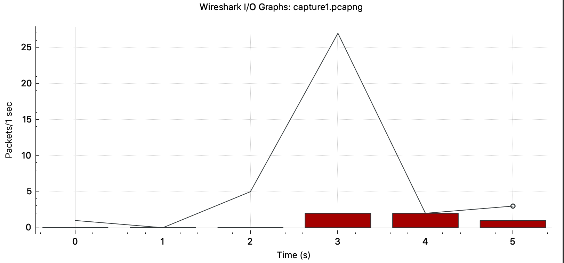
This I/O Graph shows the rate of packets sent and received per second, we can see that there were 27 packets sent within the 3rd second of the TCP conversation. Furthermore, the graph shows 5 different TCP errors, with two Reset packets received during the 3rd second, a Retransmission and its Acknowledgement in 4th second and a final Acknowledgement in the 5th second for segment that wasn't captured.

(ii) Packet Lengths

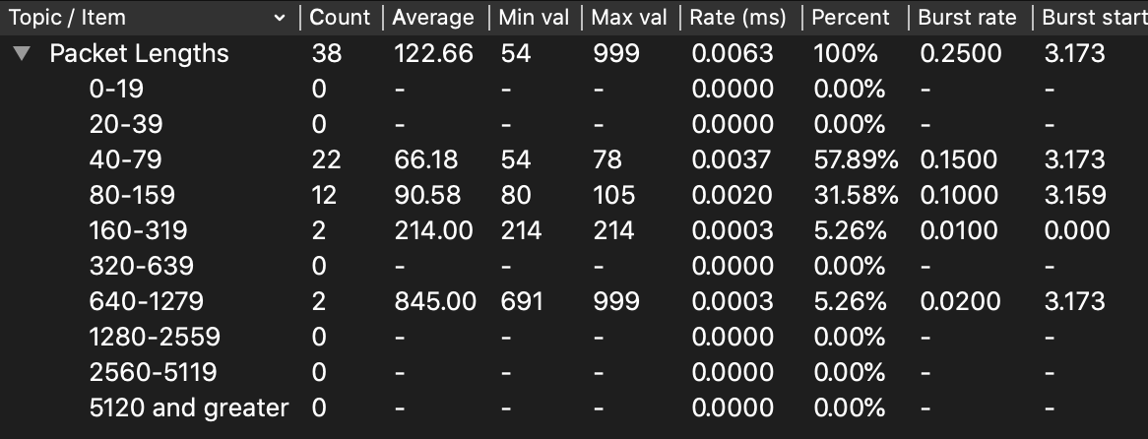

Looking at this analysis of packet lengths, we can see there were 38 packets captured in total and that most packets (22, 57.89%) were between 40-79 bytes, with the next most common size between 80-159 (12, 31.58%); 2 UDP packets were between 160-319 bytes and 2 HTTP packets were between 540-1279 bytes brought the overall average packet length to 122.66 bytes. We can see from the Burst Start that the maximum number of packets were sent at 3.173 seconds into the capture, this matches with the peak packets/sec in our IO Graph.

