Cian Kelly

SQL Final Project

SQL statements creating the schema:

CREATE TABLE `department` (

`dept_name` varchar(30) NOT NULL,

`building` varchar(30) NOT NULL,

`budget` float NOT NULL

) ENGINE=InnoDB DEFAULT CHARSET=latin1;

CREATE TABLE `course` (

`course_ID` varchar(10) NOT NULL,

`course_name` varchar(40) NOT NULL,

`dept_name` varchar(30) NOT NULL,

`credits` float NOT NULL

) ENGINE=InnoDB DEFAULT CHARSET=latin1;

CREATE TABLE `section` (

`course_ID` varchar(15) NOT NULL,

`sec_ID` varchar(10) NOT NULL,

`semester` varchar(10) NOT NULL,

`year` int(4) NOT NULL,

`building` varchar(30) NOT NULL,

`room_number` int(3) NOT NULL,

`days` varchar(7) NOT NULL,

`start_time` time NOT NULL,

`end_time` time NOT NULL,

`instructor` varchar(40) NOT NULL

) ENGINE=InnoDB DEFAULT CHARSET=latin1;

SQL statements populating the database:

INSERT INTO `department` (`dept_name`, `building`, `budget`) VALUES

('Biology', 'Gittleson', 80000),

('Computer Science', 'Adams', 100000),

('Economics', 'Barnard', 70000),

('Mathematics', 'Rosevelt', 70000),

('Physics', 'Berliner', 80000),

('Writing Studies and Rhetoric', 'Mason', 40000);

INSERT INTO `course` (`course_ID`, `course_name`, `dept_name`, `credits`) VALUES

('BIO003', 'Biology in Society', 'Biology', 3),

('BIO004', 'Human Biology', 'Biology', 4),

('CSC014', 'Discrete Structures 1', 'Computer Science', 3),

('CSC015', 'Fundamentals of CS 1', 'Computer Science', 4),

('CSC016', 'Fundamentals of CS 2', 'Computer Science', 4),

('CSC024', 'Discrete Structures 2', 'Computer Science', 3),

('CSC110', 'Intro to Computer Architecture', 'Computer Science', 3),

('CSC110A', 'Computer Architecture Lab', 'Computer Science', 1),

('CSC112', 'Computer Operating Systems', 'Computer Science', 3),

('CSC120', 'Algorithms and Data Structures', 'Computer Science', 3),

('CSC161', 'Intro to Automata Theory', 'Computer Science', 3),

('ECO001', 'Principles of Economics 1', 'Economics', 3),

('ECO125', 'Monetary Economics', 'Economics', 3),

('ECO171', 'Law and Economics', 'Economics', 3),

('MATH050', 'Precalculus', 'Mathematics', 4),

('MATH071', 'Analytic Geometry & Calculus 1', 'Mathematics', 4),

('MATH072', 'Analytic Geometry & Calculus 2', 'Mathematics', 4),

('PHYS001A', 'Elementary Physics', 'Physics', 3),

('PHYS011A', 'General Physics', 'Physics', 4),

('PHYS011B', 'General Physics Lab', 'Physics', 1),

('RHET001', 'Oral Communication', 'Writing Studies and Rhetoric', 3),

('WSC001', 'Composition 1', 'Writing Studies and Rhetoric', 3),

('WSC002', 'Composition 2', 'Writing Studies and Rhetoric', 3);

INSERT INTO `section` (`course_ID`, `sec_ID`, `semester`, `year`, `building`, `room_number`, `days`, `start_time`, `end_time`, `instructor`) VALUES

('BIO003', '01', 'Spring', 2022, 'Gittleson', 201, 'MW', '09:45:00', '11:15:00', 'Burke'),

('BIO003', '02', 'Spring', 2022, 'Gittleson', 201, 'TR', '12:45:00', '14:15:00', 'Pepitone'),

('BIO004', '01', 'Spring', 2022, 'Gittleson', 201, 'MW', '11:25:00', '13:15:00', 'Pepitone'),

('BIO004', '02', 'Spring', 2022, 'Gittleson', 202, 'TR', '11:05:00', '12:20:00', 'Burke'),

('CSC014', '01', 'Spring', 2022, 'Adams', 109, 'TR', '13:45:00', '15:30:00', 'Jeffreys'),

('CSC014', '02', 'Spring', 2022, 'Adams', 109, 'TR', '10:00:00', '11:25:00', 'Pillaipakkamnatt'),

('CSC015', '01', 'Spring', 2022, 'Adams', 103, 'MW', '13:45:00', '15:30:00', 'Jeffreys'),

('CSC015', '02', 'Spring', 2022, 'Adams', 204, 'MW', '16:30:00', '18:00:00', 'Liang'),

('CSC016', '01', 'Spring', 2022, 'Adams', 208, 'TR', '19:10:00', '20:40:00', 'Segal'),

('CSC016', '02', 'Spring', 2022, 'Adams', 206, 'MW', '16:05:00', '17:35:00', 'Doboli'),

('CSC024', '01', 'Spring', 2022, 'Adams', 103, 'TR', '16:10:00', '17:40:00', 'Jeffreys'),

('CSC024', '02', 'Spring', 2022, 'Adams', 103, 'MW', '11:05:00', '12:35:00', 'Ostheimer'),

('CSC110', '01', 'Spring', 2022, 'Adams', 201, 'MW', '14:35:00', '16:05:00', 'Ben-Avi'),

('CSC110A', '01', 'Spring', 2022, 'Adams', 101, 'MW', '11:30:00', '12:10:00', 'Ben-Avi'),

('CSC112', '01', 'Spring', 2022, 'Adams', 203, 'TR', '11:35:00', '13:05:00', 'Zavou'),

('CSC120', '01', 'Spring', 2022, 'Adams', 103, 'TR', '18:45:00', '20:15:00', 'Jeffreys'),

('CSC161', '01', 'Spring', 2022, 'Adams', 103, 'MWF', '08:00:00', '09:05:00', 'Ostheimer'),

('ECO001', '01', 'Spring', 2022, 'Barnard', 210, 'TR', '08:00:00', '09:30:00', 'Fazeli'),

('ECO001', '02', 'Spring', 2022, 'Barnard', 210, 'MW', '08:00:00', '09:30:00', 'Guttmann'),

('ECO001', '03', 'Spring', 2022, 'Barnard', 211, 'MW', '09:00:00', '10:30:00', 'DelGiudice'),

('ECO125', '01', 'Spring', 2022, 'Barnard', 110, 'TR', '12:35:00', '14:05:00', 'Guttmann'),

('ECO125', '02', 'Spring', 2022, 'Barnard', 109, 'MW', '10:05:00', '11:35:00', 'DelGiudice'),

('ECO171', '01', 'Spring', 2022, 'Barnard', 210, 'MW', '14:05:00', '15:35:00', 'Fazeli'),

('MATH050', '01', 'Spring', 2022, 'Rosevelt', 102, 'MWF', '09:30:00', '11:00:00', 'Ostrick'),

('MATH050', '02', 'Spring', 2022, 'Rosevelt', 103, 'MWF', '09:35:00', '11:05:00', 'Silberger'),

('MATH071', '01', 'Spring', 2022, 'Rosevelt', 201, 'MWF', '11:10:00', '12:40:00', 'Silberger'),

('MATH071', '02', 'Spring', 2022, 'Rosevelt', 105, 'MWF', '11:30:00', '13:00:00', 'Ismailescu'),

('MATH072', '01', 'Spring', 2022, 'Rosevelt', 105, 'MWF', '14:30:00', '16:00:00', 'Ismailescu'),

('MATH072', '02', 'Spring', 2022, 'Rosevelt', 103, 'MWF', '12:50:00', '14:20:00', 'Silberger'),

('PHYS001A', '01', 'Spring', 2022, 'Berliner', 103, 'TR', '09:35:00', '11:05:00', 'Hayon'),

('PHYS001A', '02', 'Spring', 2022, 'Berliner', 102, 'TR', '10:00:00', '11:30:00', 'Smylie'),

('PHYS011A', '01', 'Spring', 2022, 'Berliner', 102, 'MW', '16:30:00', '18:20:00', 'Hayon'),

('PHYS011A', '02', 'Spring', 2022, 'Berliner', 102, 'MW', '09:30:00', '11:20:00', 'Smylie'),

('PHYS011B', '01', 'Spring', 2022, 'Berliner', 204, 'TR', '11:40:00', '15:10:00', 'Smylie'),

('PHYS011B', '02', 'Spring', 2022, 'Berliner', 204, 'MW', '11:00:00', '14:25:00', 'Edwards'),

('RHET001', '01', 'Spring', 2022, 'Mason', 110, 'MW', '12:45:00', '14:15:00', 'Dresner'),

('WSC001', '01', 'Spring', 2022, 'Mason', 104, 'MW', '09:40:00', '11:10:00', 'Gaughan'),

('WSC001', '02', 'Spring', 2022, 'Mason', 103, 'MW', '08:00:00', '09:30:00', 'Jarvis'),

('WSC002', '01', 'Spring', 2022, 'Mason', 104, 'MW', '08:00:00', '09:30:00', 'Montemurro'),

('WSC002', '02', 'Spring', 2022, 'Mason', 108, 'TR', '08:00:00', '09:30:00', 'McDonough');

SQL report statements for reports:

1)

SELECT

*

FROM

department

NATURAL JOIN

section

ORDER BY

`section`.`instructor` ASC

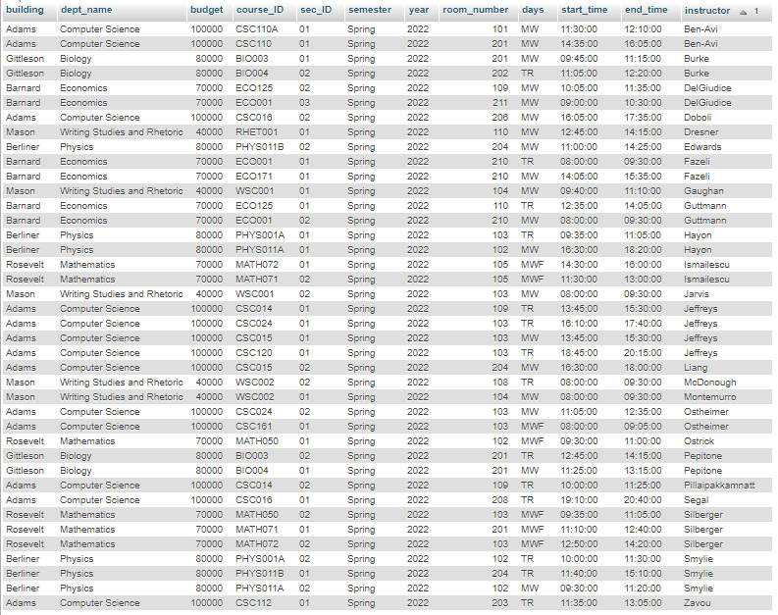Report:

2)

SELECT DISTINCT

instructor,

dept_name

FROM

department

NATURAL JOIN

section

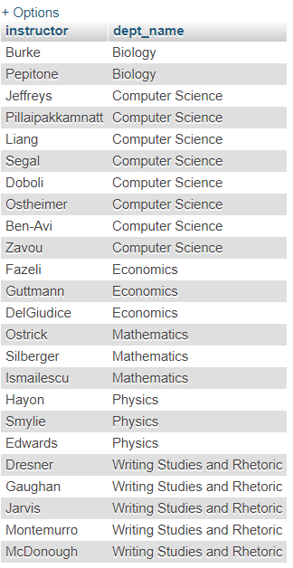Report:

3)

SELECT

course_ID,

sec_ID,

days,

start_time,

end_time

FROM

section

WHERE

course_ID LIKE '%CSC%'

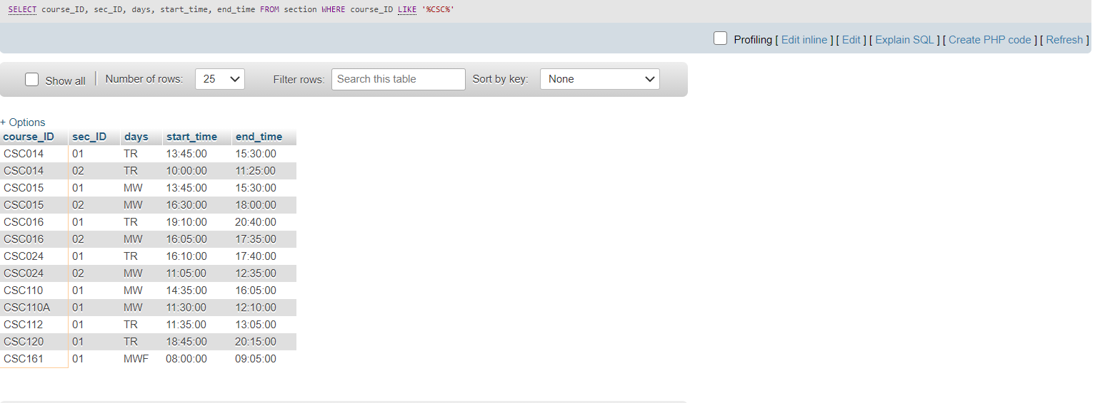Report:

4)

DELETE

sec

FROM

section sec

WHERE

(

SELECT

1

FROM

course cou

WHERE

cou.credits = 3 AND sec.days LIKE '%W%' AND cou.course_ID = sec.course_ID

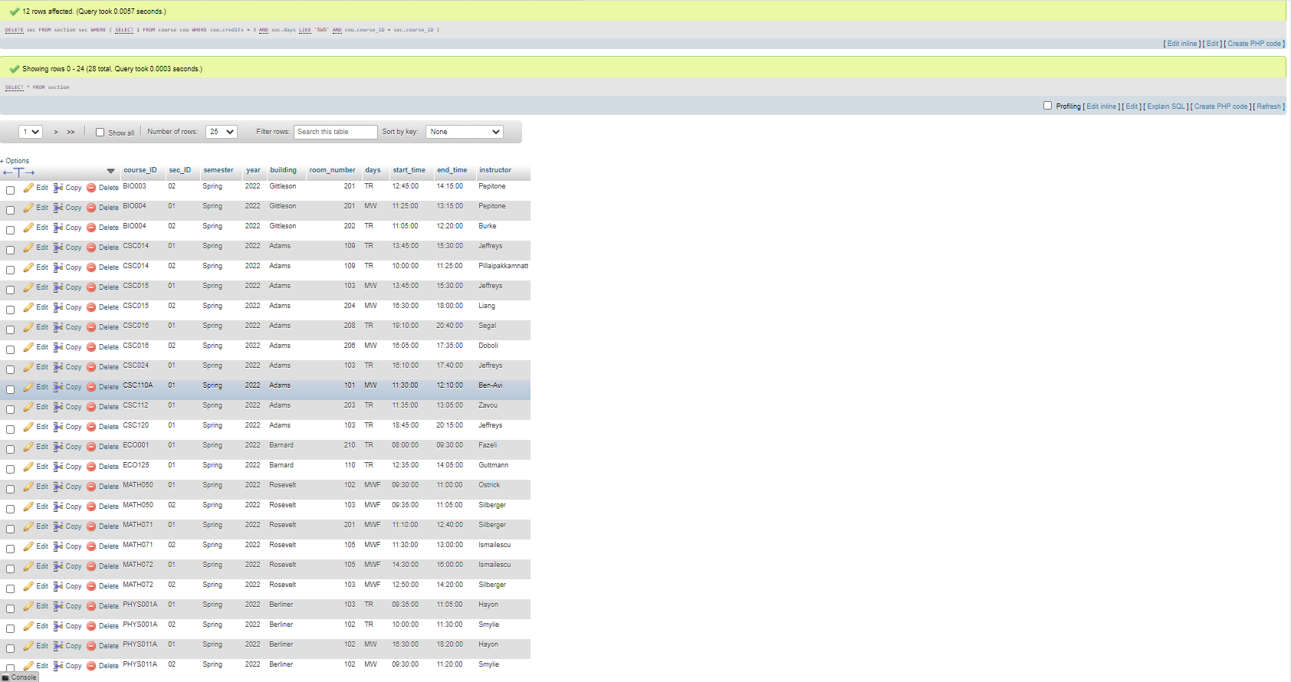Report:

5)

FOR INNER JOIN:

SELECT

section.course_ID, sec_ID, semester, year, building, room_number, days, start_time, end_time, instructor, course.course_name, course.dept_name, course.credits

FROM

section

INNER JOIN

course

ON

course.course_ID = section.course_ID

WHERE

section.course_ID LIKE '%CSC%' OR section.course_ID LIKE '%MATH%';

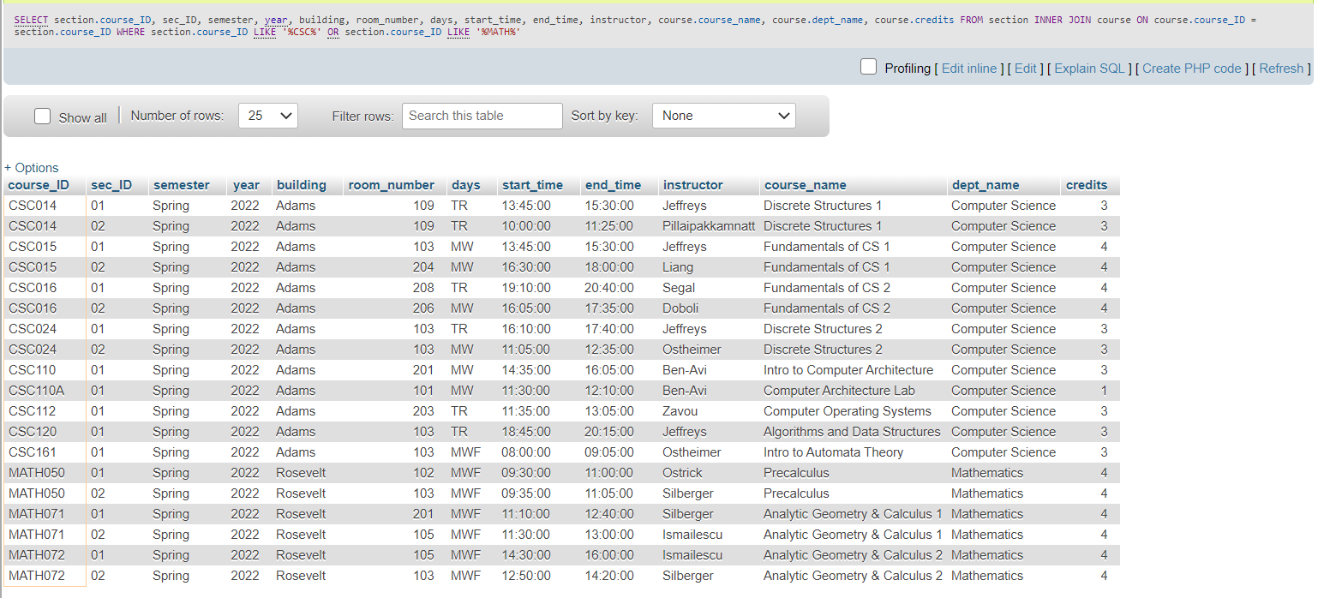Report:

FOR OUTER JOIN:

SELECT

section.course_ID, sec_ID, semester, year, building, room_number, days, start_time, end_time, instructor, course.course_name, course.dept_name, course.credits

FROM

section

LEFT JOIN

course

ON

course.course_ID = section.course_ID

WHERE

section.course_ID LIKE '%CSC%' OR section.course_ID LIKE '%MATH%'

UNION

SELECT

section.course_ID, sec_ID, semester, year, building, room_number, days, start_time, end_time, instructor, course.course_name, course.dept_name, course.credits

FROM

section

RIGHT JOIN

course

ON

course.course_ID = section.course_ID

WHERE

section.course_ID LIKE '%CSC%' OR section.course_ID LIKE '%MATH%';

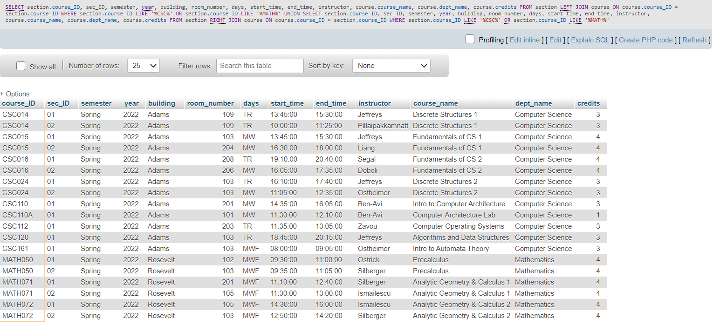Report:

There's no difference, the same results are shown in the report. This is because an outer join of these two tables would show in the database each CSC and MATH class, regardless of if it has a section or not, whereas the inner join would only show the classes that do have sections. The database created has a section for all classes though, so therefore it will only show classes that have sections, thus the outer join and inner join reports have the same results.