
TITLE PAGE
SEASCAN: A WEB-BASED SEAGRASS SPECIES IDENTIFICATION SYSTEM FOR MATI CITY USING CONVOLUTIONAL NEURAL NETWORK-BASED IMAGE RECOGNITION
INDONG, JEFFREY
LABRADOR, CHRISTIAN M.
RAMAILA, DAVE N.
A BSIT Capstone Project Proposal Submitted to the Faculty of Computing, Engineering, and Technology of the Davao Oriental State University in Partial Fulfillment of the Requirements for the Degree

BACHELOR OF SCIENCE IN INFORMATION TECHNOLOGY

APRIL 2026

TABLE OF CONTENTS
TITLE PAGE
TITLE PAGE.................................................................................................................. i
APPROVAL SHEET ..................................................................................................... ii
TABLE OF CONTENTS................................................................................................ iii
LIST OF TABLES.......................................................................................................... iv
LIST OF FIGURES........................................................................................................ v
INTRODUCTION
1.1 Rationale of the Study............................................................................................. 1
1.2 Purpose and Project Description............................................................................. 3
1.3 Objectives of the Study............................................................................................ 4
1.4 Significance of the Study ........................................................................................ 5
1.5 Scope and Limitations............................................................................................. 7
1.6 Conceptual Framework.......................................................................................... 12
1.7 Definition of Terms................................................................................................. 15
REVIEW OF RELATED LITERATURE
2.1 Literature Map........................................................................................................ 17
2.2 Related Literature.................................................................................................. 17
2.3 Related System...................................................................................................... 24
MATERIALS AND METHODS
3.1 Software Methodology........................................................................................... 33
3.2 System Planning.................................................................................................... 37
3.3 System Analysis..................................................................................................... 46
3.4 System Design....................................................................................................... 52
3.5 System Implementation..................................................................................... 74
LITERATURE CITED................................................................................................... 93
LIST OF TABLES

Table 1 Matrix Comparison of Related Systems .…………………………………...……. 32
Table 2 Total Cost of the System …………………………………………………………... 39
Table 3. Target Seagrass Species of SeaScan with Botanical
Classification Characteristics and CNN Identification Difficulty……………………..…… 54
Table 4. SeaScan CNN Training Dataset Specifications
Organized by IPOStage………………………………………………………………...……..59
Table 5. Pre-Implementation Performance Matrix CNN Classification
Metrics and Usability Evaluation …..……………………….……………………………...…63
Table 6. Participant Allocation by Target User Group………………………………..…… 78
Table 7. Risk Assessment and Mitigation Measures for Participants……………….…… 87
Table 8. Likert Scale Interpretation for the ISO/IEC 25010
User Evaluation Questionnaire……………………………..…………………………………90

LIST OF FIGURES

Figure 1 Conceptual Diagram of the Study…………………………………………...…….. 12
Figure 2 Literature Map………………………………………………………………….….... 17
Figure 3 iNaturalist……………………………………………………………………….….... 25
Figure 4 Pl@ntNet……………………………………………………………................….... 26
Figure 5 WoRMS………………………………………………..………………………..…… 27
Figure 6 GBIF……………………………………………………………………………...….. 28
Figure 7 Dugong and Seagrass Hub.………………………………………………..….…... 30
Figure 8 Modified Waterfall Methodology ………..…………………….……………….….. 34
Figure 9 Work Breakdown Structure………………………………..………….……….…... 44
Figure 10 Gantt Chart………………………………………………...………………….….... 45
Figure 11 BPMN diagram……………………..…………………………………………...… 47
Figure 12 Scanner Page…………………………………………………………………...… 68
Figure 13 Digital Library…………………………………………………………………….... 68
Figure 14 Public Viewer Page…………………………………………………...………...… 69
Figure 15 Login Modal………………………………………………………………………... 70
Figure 16 Admin Panel……………………………………………………………………….. 70
Figure 17 Researcher Panel………………………..……………………………..…………. 71

CHAPTER I
INTRODUCTION

1.1 Rationale of the Study
In coastal areas of Mati City, Davao Oriental, identifying and monitoring seagrass species remains a manual and labor-intensive process, leading to delays in conservation efforts and errors in data collection. Students, tourists, and local researchers still rely heavily on expert botanical knowledge or physical field guides that are difficult to carry and use in underwater environments (Green & Short, 2003). Seagrass meadows are disappearing at an alarming rate globally because they are not easily recognized or understood by the public (Waycott et al., 2009). In Pujada Bay, seagrass species face increasing threats from coastal development, pollution, and destructive fishing practices (Sanchez-Delute et al., 2025). Angsinco-Jimenez et al. (2003) documented nine seagrass species across three stations Taitaidaga, Lawigan, and Manguihay with percent cover ranging from 24% to 41%. Building on this baseline, Sanchez-Delute et al. (2025), in the most recent assessment of the bay, found that heavily populated sites such as Taganilao already exhibit significantly lower species richness and degraded community structure compared to undisturbed sites like Pujada Island, confirming that anthropogenic pressure is actively reshaping seagrass composition in Mati City's coastal waters. Despite this documented and ongoing biodiversity loss, the lack of accessible identification tools and updated geographic references continues to limit public awareness and community participation in conservation (Sanchez-Delute et al., 2025; DENR, 2020). Several critical research gaps remain unaddressed. First, existing plant identification applications are optimized for terrestrial plants and lack the localized data required to identify underwater seagrass species in Mati City (Wäldchen & Mäder, 2022). Second, scientific information about these species remains locked in technical journal to non-experts (Short et al., 2011). Third, Sanchez-Delute et al. (2025) relied entirely on expert-conducted manual surveys with no technology-assisted identification tool available to support community monitors between formal survey cycles, leaving residents in the most threatened coastal areas without any accessible means of recognizing or reporting ecological changes. Fourth, no existing platform provides a localized digital library specific to Mati City or the broader Davao Oriental region, leaving community members without a geographically focused reference they can realistically consult in the field. Although global platforms provide useful identification services, none integrates a Convolutional Neural Network trained on localized Mati City seagrass species within a web-based system accessible to non-expert users.
To bridge these gaps, SeaScan, a Web-Based Seagrass Species Identification System, is introduced. The system employs a Convolutional Neural Network developed using TensorFlow and Keras and trained on a localized dataset of photographs of the nine seagrass species native to the coastal waters of Mati City, enabling instant and accurate species identification from user-uploaded photographs without requiring expert botanical knowledge (Wäldchen & Mäder, 2022). Ultimately, SeaScan empowers the people of Mati City particularly communities in high-impact areas like Taganilao and Lanigan to take an active role in protecting their coastal heritage, supporting national conservation priorities under the DENR's Coastal and Marine Ecosystems Management Program (DENR, 2020).

1.2 Purpose and Project Description
The purpose of this project is to develop SeaScan, a web-based identification system designed to help students, tourists, and the local community of Mati City recognize and learn about different seagrass species. The system allows users to take or upload a photo of a seagrass plant, which the software then automatically identifies using a Convolutional Neural Network trained on a localized dataset of the nine seagrass species native to the coastal waters of Mati City. Once identified, the system provides the user with detailed information about the species, including its common name, scientific name, and its specific role in the local marine environment. Additionally, the project features a digital library where users can browse through various species and view their characteristics through a standard web browser.
What makes this project unique and innovative is the integration of a localized Convolutional Neural Network specifically trained on the nine seagrass species native to the coastal waters of Mati City. Unlike traditional paper guides or general plant identification apps that rely on global datasets and lack region-specific data, SeaScan delivers instant and accurate species identification from a simple user-uploaded photograph, paired with a curated digital library that reflects the actual biodiversity of Pujada Bay. This is highly relevant to Mati City's status as a coastal tourism and research hub, as it provides a practical and modern tool for environmental education that non-experts including students, tourists, and local fisherfolk can use without any prior marine science knowledge. By turning a complex scientific task into an accessible digital experience, the system is a beneficial tool for schools and environmental groups to promote the protection of the coastal heritage of Mati City.
The concentration of this study is the development and evaluation of a CNN-based image recognition module using MobileNetV3 with transfer learning for automated seagrass species identification, supported by a localized digital library and species distribution mapping module specifically designed for the coastal community of Mati City.
1.3 Objectives of the Study
General Objective
To develop SeaScan, a web-based seagrass species identification system that utilizes Convolutional Neural Network (CNN) through transfer learning to enhance marine environmental education and conservation efforts in Mati City.
Specific Objectives
- To construct an automated image recognition module using a fine-tuned Convolutional Neural Network (CNN) with transfer learning to identify the nine (9) specific seagrass species found within the coastal areas of Mati City from user-uploaded photographs.
- To develop a digital library that allows users to browse and search the localized seagrass species of Mati City, providing detailed species profiles that include botanical features (leaf morphology, rhizome structure, sheath characteristics, and reproductive organs), ecological roles, conservation status, geographic distribution, and GPS-Verified Station Locations (GIS) within the coastal areas of Mati City.
- To implement a species distribution mapping module that displays historically verified seagrass station data and collects GPS-tagged user-submitted sightings within the coastal areas of Mati City.
- To design a responsive web interface that ensures seamless access for students, tourists, coastal communities, fisherfolk, and local researchers using mobile or desktop browsers, and to evaluate its usability through System Usability Scale (SUS) testing and an ISO/IEC 25010-based user evaluation questionnaire administered to forty (40) consenting adult participants aged 18 years or older, ten (10) from each of the four target user groups of SeaScan, selected through purposive quota sampling as described in Section 3.5.2.2, with the system required to achieve a minimum SUS score of 70 out of 100 to confirm that the interface is immediately accessible and operable by non-expert coastal community members without prior training or instruction.
- To evaluate the system's CNN-based identification performance using standard classification metrics namely Accuracy, Precision, Recall, and F1-Score reported per species class and visualized through a Confusion Matrix to identify misclassification patterns across the nine (9) seagrass species, and to assess overall user experience through usability testing to ensure the system effectively meets the needs of the local community.
User Evaluation (based on ISO 25010 standards)
The user evaluation will be conducted in accordance with the ISO/IEC 25010 software product quality model (ISO, 2023), focusing on the functional suitability, performance efficiency, usability, reliability, and security of SeaScan. Forty (40) adult participants, ten (10) each from the students, tourists, fisherfolk and coastal community members, and local researchers of Mati City, will evaluate the system through actual usage testing of its core features followed by an expert-validated questionnaire rated on a 5-point Likert scale. The System Usability Scale (SUS) will also be administered to confirm that the system reaches the usability target of 70 out of 100 set in Objective 4. The evaluation aims to determine how effectively, efficiently, and reliably SeaScan meets the needs of its users, and its procedures are detailed in Section 3.5.2.2.

1.4 Significance of the Study
The development of SeaScan is both timely and relevant as coastal tourism in Mati City continues to grow, increasing the need for digital tools that promote environmental literacy. By providing a modern alternative to traditional, paper-based identification methods, this study offers a practical solution to the lack of public awareness regarding marine biodiversity.
Students and Educators. The system serves as an interactive learning tool that simplifies complex marine biology concepts. Students will benefit from the CNN-powered image recognition and digital library features, which make the study of seagrass more engaging and accessible compared to traditional textbook illustrations and printed field guides. By allowing students to instantly identify species from a photograph and explore detailed ecological profiles, SeaScan transforms fieldwork and classroom learning into a hands-on digital experience.
Tourists. Visitors to Mati City's famous beaches will have a more meaningful experience by using the system to identify the marine life they encounter. This fosters a culture of responsible tourism, where visitors are informed about the ecosystem they are visiting.
Coastal Communities and Fisherfolk. Local fishermen and coastal residents of Mati City who directly interact with seagrass ecosystems on a daily basis stand to benefit significantly from SeaScan. The system enables them to identify and report seagrass species encountered within their fishing grounds, raising awareness on the critical ecological importance of seagrass meadows as nursery habitats for fish and other marine organisms that sustain their livelihoods. By providing an accessible and easy-to-use identification tool, SeaScan empowers coastal communities to become active community-based environmental monitors, contributing valuable ground-level observations that complement formal scientific surveys and support the long-term conservation of Mati City's coastal ecosystems.
Local Researchers. The study assists researchers by providing a centralized digital library of localized seagrass species. This reduces the time spent on manual identification and helps in gathering preliminary data for more extensive marine studies. Sanchez-Delute et al. (2025) demonstrated that seagrass assessments in Pujada Bay currently depend on visiting researchers and institutional surveys, resulting in infrequent data collection and long gaps in monitoring records. SeaScan addresses this gap by enabling local researchers and environmental officers including those from the DENR-CENRO and the City Environment and Research Development Department of Mati, institutions directly involved in the Sanchez-Delute et al. (2025) study, to conduct preliminary species identification and GPS-tagged sighting submissions independently, extending the reach of formal monitoring programs between survey cycles.
Future Researchers. This project serves as a valuable reference for future IT students and developers interested in combining Convolutional Neural Network technology with environmental conservation. It provides a foundation for expanding the system to include other marine species or integrating more advanced spatial mapping technologies. This project will also serve as a reference for future developers who wish to extend similar CNN-based solutions to other marine species in the Philippines.
1.5 Scope and Limitations
Scope
The project is focused on the development and implementation of SeaScan, a secure, web-based identification and educational platform for seagrass species found in the coastal areas of Mati City, Davao Oriental.
- The general purpose of the project is to provide an automated identification tool using a fine-tuned Convolutional Neural Network (CNN) with transfer learning and a digital library specifically tailored for the nine (9) seagrass species native to the surrounding coastal waters of Mati City. (These species are: Cymodocea rotundata, Cymodocea serrulata, Enhalus acoroides, Halodule pinifolia, Halodule uninervis, Halophila minor, Halophila ovalis, Syringodium isoetifolium, and Thalassia hemprichii).
- The system will feature a centralized Digital Library specifically containing the nine (9) seagrass species native to the coastal areas of Mati City, providing users with organized and accessible species information including scientific names, common names, botanical features (leaf morphology, rhizome structure, sheath characteristics, and reproductive organs), ecological roles, conservation status, geographic distribution, and GPS-Verified Station Locations (GIS) within the coastal areas of Mati City.
- The primary feature is a CNN-powered Image Recognition module that analyzes user-uploaded photographs to automatically identify which of the nine (9) specific seagrass species is present in the image, along with a detailed species profile containing its botanical characteristics (leaf morphology, rhizome structure, sheath characteristics, and reproductive organs), ecological importance, and conservation information.
- The system incorporates a Species Distribution Mapping module that displays historically verified seagrass station data drawn from two peer-reviewed sources. Primary baseline coordinates are drawn from Angsinco-Jimenez et al. (2003), which documented seagrass presence at Lawigan, Taitaidaga, and Manguihay, as well as neighboring sites including Dacab-Mamali, Macarnbol, Juanivan Island-Taganilao, Pujada Island, Bobon, and Sandigan-Dahican. These are supplemented by the updated station data from Sanchez-Delute et al. (2025), which assessed three sites with varying levels of human disturbance: Taganilao, Lawigan, and Pujada Island. Together, these two sources provide SeaScan's distribution map with a comprehensive, multi-decade baseline of verified seagrass locations across Pujada Bay, onto which GPS-tagged user-submitted sightings are layered to support ongoing community-based monitoring.
- The species distribution mapping module supports the documentation of species richness within the coastal areas of Mati City by identifying, cataloguing, and mapping all nine (9) known seagrass species across verified coastal stations. GPS-tagged user-submitted sightings layered onto the distribution map contribute to an ongoing record of species occurrence across different locations, providing supplementary data that can reflect the relative richness of seagrass species per coastal zone over time.
- The system's CNN-based identification performance will be evaluated using standard classification metrics namely Accuracy, Precision, Recall, and F1-Score reported per species class and visualized through a Confusion Matrix to identify misclassification patterns across the nine (9) seagrass species.
- The application is web-based, allowing for cross-platform accessibility via standard mobile and desktop browsers without the need for a separate app installation.
Limitations
The following factors are constraints or boundaries beyond the researchers' control that define the limits of the project.
- The accuracy of the CNN-based automated identification is highly dependent on the quality and clarity of the image uploaded. Low-resolution, blurry, or poorly lit photographs may result in incorrect or failed identification, as the model relies on clear visual features such as leaf morphology, rhizome structure, sheath characteristics, and reproductive organs for accurate classification.
- The CNN image recognition module is strictly trained to identify only the nine (9) seagrass species native to the coastal areas of Mati City. Photographs of seagrass species from other regions, terrestrial plants, or unrelated marine organisms will not be accurately classified by the system.
- The system requires an active internet connection to access cloud-based CNN processing, meaning it cannot operate in offline mode. Users in areas with weak or no internet connectivity may experience reduced performance or inability to access the system.
- The digital library and identification database are strictly limited to the nine (9) seagrass species found within the local geography of Mati City and Pujada Bay. The system does not cover terrestrial plants, other marine organisms, or seagrass species from other regions of the Philippines or abroad.
- The system does not include physical hardware for underwater monitoring and relies entirely on user-provided photographs taken above or below the water surface using a standard mobile or desktop device camera. Specialized underwater photography equipment is not required but may improve identification accuracy.
- The system accepts only individual still images in standard digital formats for species identification. It does not support video footage, bulk image uploads, drone imagery, or satellite-derived photographs as input sources.
- The system interface and all educational content are presented in the English language only. It does not currently support Filipino, Bisaya, or other regional languages, which may limit accessibility for some local users.
- The user management feature supports predefined roles for students, tourists, researchers, and administrators. However, the system does not include a community-based data contribution or citizen science feature that would allow general users to submit new species observations or photos for potential database expansion and validation.
- The species distribution mapping module displays GPS-tagged user-submitted sightings as community-sourced observations only. These submissions are not scientifically verified or validated by expert researchers and should not be treated as formal ecological survey data. They serve solely as supplementary reference points to support preliminary monitoring between formal survey cycles.
- The CNN model's identification performance is dependent on the volume, diversity, and balance of the training dataset. Species with fewer available training images may yield lower Precision, Recall, and F1-Score compared to species with a larger and more varied image dataset, which may result in unequal identification performance across the nine (9) seagrass species.
- The system does not directly measure or calculate population density of seagrass species, as SeaScan relies entirely on user-uploaded photographs for species identification rather than conducting formal quantitative field surveys. While accumulated GPS-tagged sightings may indirectly reflect the frequency of species occurrence per location, this data is insufficient to serve as a scientifically valid measure of population density. Formal density assessments require standardized field methodologies such as quadrat sampling, which is beyond the scope of this system.

1.6 Conceptual Framework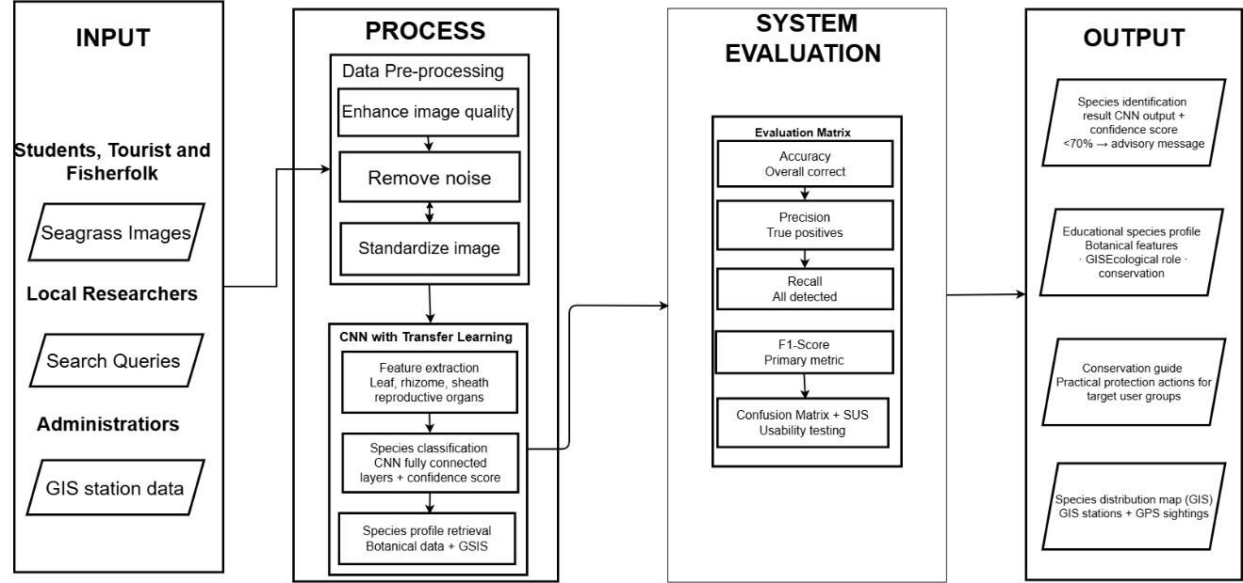
Figure 1 Conceptual Diagram of the Study
The framework of this study uses the Input-Process-Output (IPO) model to illustrate how SeaScan transforms user-provided seagrass images and search queries into a functional identification and educational experience. This framework traces the complete journey of user-submitted data, from initial image capture through CNN-based intelligent processing to the delivery of educational outputs tailored for the coastal community of Mati City.
The Input stage identifies the essential data provided by the user to initiate the system's functions. The primary actors in this stage are the target users of the system including students, tourists, coastal communities and fisherfolk, and local researchers who interact with SeaScan through a standard web browser on either a mobile or desktop device. These users provide two types of inputs into the system. The first is Captured Seagrass Images, which are photographs of seagrass plants taken using a mobile or desktop device camera and uploaded directly into the system for CNN-based species identification. The second is Search Queries, which are text-based requests entered by the user to browse or search the digital library for specific information.
Both inputs are received and stored in the central system database, which serves as the foundational repository that connects the input stage to the processing pipeline and holds all localized species data for the nine (9) seagrass species native to the coastal waters of Mati City. This database includes comprehensive information for each species, such as botanical features, ecological roles, conservation status, geographic distribution, and GPS-Verified Station Locations (GIS) within Pujada Bay, drawn from Angsinco-Jimenez et al. (2003) and Sanchez-Delute et al. (2025). The complete specification of these target species and their classification characteristics is presented in Chapter III.
The Process stage transforms these inputs into actionable results through two sequential phases. The first phase, Data Pre-processing, prepares each user-uploaded image for accurate analysis by correcting common field-photography issues such as poor lighting and visual noise, and by standardizing the image into the format required by the system's classification model. The second phase, Data Processing, applies a fine-tuned Convolutional Neural Network (CNN) with transfer learning to analyze the botanical characteristics of the seagrass in the image, classify it against the nine (9) known species, and retrieve the corresponding species profile from the database for the user. The complete technical specifications of this CNN model, the training dataset, and the preprocessing pipeline are detailed in Chapter III, Materials and Methods.
Prior to delivering outputs to the user, the system's identification performance is evaluated against a defined set of classification and usability benchmarks to ensure SeaScan is both accurate and accessible for non-expert users. The complete evaluation criteria, metrics, and pre-implementation targets are presented in Chapter III.
The Output stage delivers the results of this process directly to the user interface. The Species Identification Result presents the CNN model's classification output, displaying the identified seagrass species along with a confidence score and a prompt directing the user to the full species profile within the digital library. The Educational Species Profile presents comprehensive information about the identified species, including its botanical features, ecological role, conservation status, geographic distribution, and verified field survey locations within Pujada Bay. The Conservation Guide provides practical, accessible information on how the identified species contributes to the health of the local marine ecosystem and what actions users can take to help protect it. The Species Distribution Map presents an interactive geographic visualization of verified seagrass station locations overlaid with GPS-tagged community-submitted sightings, allowing users to view the spatial distribution of seagrass species richness across Pujada Bay and contribute new observations that supplement formal monitoring records between survey cycles.
Together, these four outputs transform a simple image upload or map interaction into a comprehensive, scientifically grounded, and educationally meaningful experience that promotes marine environmental literacy and supports community-based conservation efforts among the people of Mati City.

Definition of Terms

Convolutional Neural Network (CNN) | A class of deep learning algorithms used in SeaScan to automatically detect and classify visual patterns in user-uploaded seagrass photographs, enabling species identification without manual feature extraction.
Database | A structured collection of data where all identified species information, scientific names, localized descriptions, and user history are stored for retrieval.
Deep Learning | A specialized subset of machine learning used in SeaScan in which the Convolutional Neural Network learns to extract and classify visual features from seagrass photographs through multiple layers of computation, enabling the system to distinguish between the nine (9) seagrass species native to the coastal waters of Mati City without requiring manual feature extraction.
Digital Library | A searchable archive within the system that organizes and manages a localized collection of seagrass data, images, and conservation status for users to browse.
Image Recognition | The automated process used by the system to identify the specific species of a seagrass plant from a user-uploaded photograph.
MobileNetV3 | The specific pre-trained Convolutional Neural Network architecture selected for SeaScan's transfer learning pipeline. MobileNetV3 is a lightweight deep learning model pre-trained on the ImageNet dataset and fine-tuned on a localized dataset of the nine (9) seagrass species native to the coastal waters of Mati City, selected for its balance of classification accuracy and browser-compatible model size when converted to TensorFlow.js format
Seagrass | The primary biological subject of the study; underwater flowering plants native to the coastal waters of Mati City that the system is designed to identify and monitor.
Species Distribution Mapping | A feature of the system that displays historically verified GPS-tagged seagrass station locations from peer-reviewed sources, supplemented by user-submitted sighting data, to visualize the geographic distribution of seagrass species across the coastal areas of Mati City.
Supabase | An open-source backend-as-a-service platform built on PostgreSQL that provides SeaScan with integrated database management, user authentication, role-based access control, and file storage within a single platform.

CHAPTER II
REVIEW OF RELATED LITERATURE

2.1 Literature Map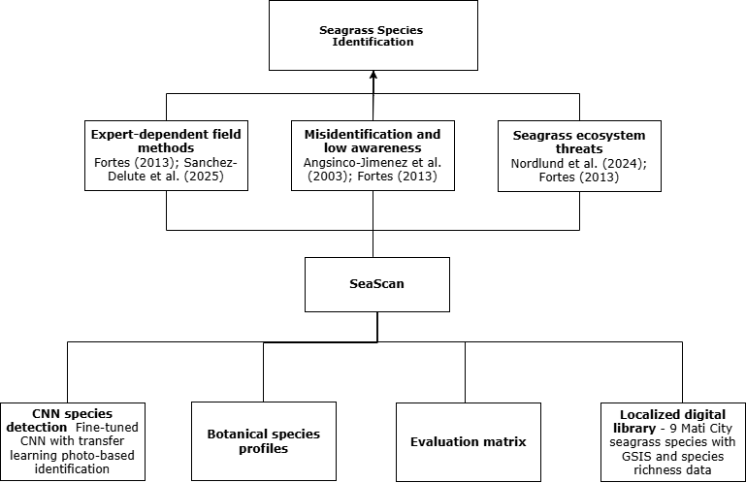
Figure 2 Literature Map

2.2 Related Literature
Seagrass Species Detection
Seagrass meadows are among the most ecologically significant coastal ecosystems in the world, providing critical habitat for marine life, sustaining local fisheries, and contributing to blue carbon storage. However, the ability to accurately detect and identify seagrass species remains a fundamental challenge that undermines conservation and monitoring efforts globally. Nordlund et al. (2024) conducted a global assessment and found that seagrass ecosystems face mounting pressure from coastal development, sedimentation, destructive fishing, and climate change, with the highest risks concentrated in areas that lack organized monitoring and species detection systems. The core of this problem lies not only in the physical threats to seagrass beds but in the persistent inability of coastal communities, local governments, and non-expert users to correctly identify the species present in their waters a gap that makes it impossible to track changes, assess health, or respond to decline in a timely manner.
In the Philippines, this detection problem is particularly acute. Fortes (2013) documented that seagrass meadows remain poorly monitored and that the country lacks a national early warning system for seagrass degradation, despite hosting some of the most biodiverse seagrass beds in the entire Coral Triangle. Angsinco-Jimenez et al. (2003) found that most coastal community members in the Philippines could not distinguish between seagrass species, with many confusing seagrasses with seaweeds or other marine plants entirely. Fortes (2013) further noted that the Philippines hosts a wide variety of seagrass species, each with different ecological roles and conservation needs, meaning that the inability to tell them apart leads directly to poor management decisions. In areas like Mati City in Davao Oriental, where fishing communities depend heavily on coastal resources, the absence of a regular and accessible species detection method leaves ecosystem changes undetected and unrecorded.
The Limitations of Expert-Dependent Identification
A key reason why seagrass species detection has remained inaccessible to local communities is the heavy reliance on expert-dependent identification methods. Fortes (2013) explained that accurate seagrass species identification requires trained marine taxonomists, which most local government units and coastal communities do not have access to. Sanchez-Delute et al. (2025) found that seagrass assessments in Philippine coastal municipalities are mostly conducted by visiting researchers rather than local monitors, which means data collection is infrequent and unsustained. This creates long gaps in records and prevents communities from tracking changes over time. Their study in Pujada Bay relied entirely on manual transect-quadrat field sampling and expert-conducted surveys methods that require trained personnel, specialized equipment, and institutional funding yet had no technology-assisted identification tool to support community monitors in tracking species composition changes between formal survey cycles. This finding directly supports the need for an automated, accessible detection system that empowers local users to contribute meaningful identification data without requiring the expertise or resources that formal ecological surveys demand.
Current Approaches to Automated Species Detection
Several digital platforms and approaches have been developed to address biodiversity monitoring, and some have been considered for application to seagrass identification. The most commonly used approaches rely on crowd-sourced community validation or deep learning-based image recognition, where users submit photographs and the system either routes them to expert reviewers or processes them through a trained classification model. Some platforms also function as taxonomic reference databases or biodiversity occurrence registries, providing species names, classifications, and distribution records that researchers can consult.
Citizen science platforms that use community validation allow a wide base of users to contribute observations and receive identifications from naturalists and volunteers. These platforms benefit from a large and active user community and cover a broad range of taxa. Deep learning platforms, on the other hand, use Convolutional Neural Networks (CNN) trained on large datasets of species photographs to identify organisms automatically. These CNN-based systems have shown strong classification performance in identifying terrestrial plant species and represent a significant improvement over manual field guide method. Taxonomic databases provide standardized scientific names and classification hierarchies, while biodiversity occurrence systems aggregate georeferenced records from various institutions and citizen scientists around the world. Conservation portals compile educational materials, monitoring guidance, and policy resources for practitioners working in specific ecosystems.
Gaps in Existing Detection Systems
Despite the availability of these tools, they share several critical limitations that prevent them from being effective for seagrass species detection in contexts like Mati City. Wäldchen and Mäder (2022) reviewed automated species identification systems and found that machine learning models trained on globally aggregated or temperate-region datasets consistently perform poorly when applied to tropical species. Goëau et al. (2025) confirmed this, showing that regional specialization of training data significantly improves identification accuracy for species that are underrepresented in global datasets. Since Philippine seagrass species are rarely included in the training data of existing platforms, identifications made through these systems are unreliable for local use.
Beyond accuracy, existing platforms also lack real-time mobile identification suited for field conditions. Wäldchen and Mäder (2022) noted that CNN-based identification performance drops further in aquatic environments where image quality and lighting conditions differ significantly from terrestrial photography. Goëau et al. (2025) observed that many platforms are not optimized for the low-latency, on-device inference that field users need when operating in remote or coastal areas without stable internet access. This means that even if a user could submit a photograph, they may not receive a reliable result quickly enough to be useful during an actual survey or monitoring activity.
Another critical gap is the absence of localized educational content and conservation guidance accessible to non-expert users in the field. Short et al. (2011) noted that scientific information about seagrass species remains largely confined to technical journals and institutional databases that are inaccessible to the general public. Community members, students, and tourists who encounter seagrass in coastal areas have no readily available digital resource that connects species detection results with practical conservation awareness tailored to their local environment. None of the currently available platforms provide a geographically focused educational profile that links an identification result directly to locally relevant ecological roles, botanical features, and conservation actions.
Finally, no existing platform provides a localized digital library specific to Mati City or the broader Davao Oriental region. Sanchez-Delute et al. (2025) and Fortes (2013) both emphasized that locally curated species inventories are essential for community-based monitoring because they allow users to focus on the species, they are actually likely to encounter. Global databases cover thousands of species from across the world, which can be overwhelming and unhelpful for a local monitor trying to identify what is in front of them. The absence of a geographically focused reference library means that even a motivated community member in Mati City has no locally relevant resource to consult, no GPS-verified station data to reference, and no record of the species richness within their own coastal zone.
How These Gaps Lead to the Proposed System
These gaps taken together make it clear that existing methods are not sufficient to address the seagrass species detection needs of monitoring communities in Mati City. The over-reliance on expert knowledge, the inaccuracy of globally trained CNN models for local tropical species, the lack of real-time field identification tools, and the unavailability of locally curated digital references all point to the same conclusion: a system specifically built for this context is necessary.
To address these gaps, this project proposes SeaScan, an integrated seagrass species identification system designed specifically for Mati City. The system uses a fine-tuned Convolutional Neural Network (CNN) with transfer learning, trained on photographs of the nine (9) Philippine seagrass species documented within the coastal areas of Mati City, allowing for accurate photo-based detection of the species most likely to be found in local waters. Unlike existing platforms whose models are trained on global datasets, SeaScan's CNN is built around the specific species composition of Mati City, directly responding to the localization gap identified by Wäldchen and Mäder (2022) and Goëau et al. (2025). The system is also optimized for real-time mobile inference, enabling users to receive identification results quickly even in field conditions.
To address the educational content gap, SeaScan incorporates a curated digital library of the nine (9) seagrass species documented in Mati City, providing local users with a focused and relevant reference that global platforms do not offer. Each species entry is paired with detailed botanical features including leaf morphology, rhizome structure, sheath characteristics, and reproductive organs, alongside ecological profiles, conservation status, geographic distribution, and GPS-Verified Station Locations (GIS) drawn from Angsinco-Jimenez et al. (2003) and Sanchez-Delute et al. (2025). This directly responds to the finding of Short et al. (2011) that scientific seagrass information remains inaccessible to non-expert users. Because all of these capabilities are absent from existing methods, SeaScan is not a duplication of current tools but a necessary and targeted response to documented, unmet needs in the seagrass monitoring community of Mati City.
Synthesis
The review of related literature was conducted to understand how seagrass species detection is currently being handled and what limitations remain in the tools and methods available today. The central problem identified across the literature is the persistent gap between the need for accurate, accessible, and localized seagrass species detection and the tools currently available to address it. Different platforms use different approaches including crowd-sourced validation, CNN-based image recognition, taxonomic reference databases, biodiversity occurrence records, and conservation portals but none of these fully address the detection needs of a coastal community like Mati City. The lack of locally trained CNN models, real-time field identification tools, species-specific botanical reference data, and geographically focused digital libraries means that existing systems leave significant gaps affecting both the accuracy and accessibility of seagrass species detection for non-expert users.
The review also helped clarify the broader ecological and social context of the problem. Seagrass ecosystems in the Philippines are under serious threat, and the communities most affected by their decline particularly fisherfolk, students, and local researchers in coastal municipalities are often the least equipped to monitor them. The findings show that while some tools exist, they were not designed with local species composition, field conditions, or community users in mind, and their limitations have real consequences for ecosystem monitoring and management. These insights guided the development of SeaScan, which aims to move beyond what existing platforms offer by providing a system that is accurate for Philippine seagrass species, accessible in field conditions, grounded in locally verified distribution data, and tailored to the specific seagrass biodiversity and conservation needs of Mati City.

2.3 Related System
Several systems currently exist that address either biodiversity identification or marine data management, but none integrate a locally trained Convolutional Neural Network (CNN) specifically designed for seagrass species detection in Mati City. Reviewing these systems highlights their strengths as well as the specific capabilities that SeaScan provides that existing platforms do not.

iNaturalist
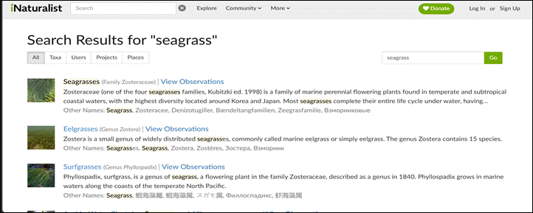
Figure 3 iNaturalist mobile application interface for species identification.
iNaturalist is a globally recognized crowdsourcing platform that enables users to upload photographs of plants and animals for species identification. It employs a combination of deep learning-based image recognition and a large community of expert volunteers who verify and confirm observations, creating one of the world's largest biodiversity observation databases. The platform is accessible via both mobile app and web interface and supports real-time sharing of sightings worldwide, including records from the Philippines (iNaturalist, 2026).
While iNaturalist provides strong community-driven identification, it presents several critical limitations when applied to seagrass species detection in Mati City. Its image recognition model is trained on a globally aggregated dataset that does not include the nine (9) localized seagrass species native to the coastal areas of Mati City, making its identifications unreliable for local use. It does not provide a dedicated digital library containing detailed botanical features such as leaf morphology, rhizome structure, sheath characteristics, and reproductive organs specific to Mati City seagrass species. It also does not provide GPS-Verified Station Locations (GIS) drawn from locally verified field surveys, nor does it support species richness documentation within a defined coastal zone. In contrast, SeaScan addresses all of these gaps by providing a fine-tuned CNN with transfer learning trained specifically on Mati City seagrass species, a localized digital library with complete botanical profiles and GIS data, and a species distribution mapping module grounded in peer-reviewed local survey data.
Pl@ntNet

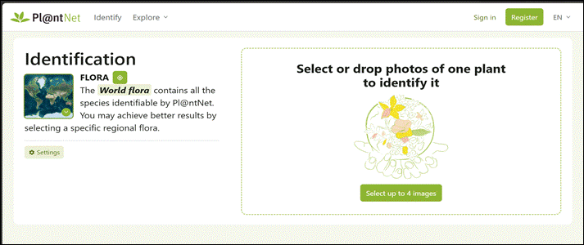
Figure 4 Pl@ntNet web interface for botanical recognition.
Pl@ntNet is a research and educational web-based platform that uses deep learning algorithms to identify plants from user-uploaded photographs. It operates through an intuitive web interface and mobile application, allowing users to search and contribute to a growing database of plant observations across different regions. The system is widely used for botanical identification and supports multiple languages for broader accessibility (Affouard et al., 2023).
Despite its strong performance in terrestrial plant identification, Pl@ntNet presents significant limitations for seagrass species detection. Its CNN model is trained primarily on terrestrial plant datasets and does not include Philippine seagrass species, making it incapable of reliably classifying the nine (9) seagrass species found in the coastal waters of Mati City. It does not provide localized botanical reference data including leaf morphology, rhizome structure, sheath characteristics, and reproductive organs for marine angiosperms, nor does it offer GPS-verified station locations or a species distribution mapping module for any coastal zone. It also does not produce classification performance metrics such as Precision, Recall, F1-Score, or a Confusion Matrix that would allow users to understand the reliability of its identifications per species. SeaScan directly addresses these limitations through a CNN model fine-tuned on locally collected seagrass photographs, a botanical species profile library specific to Mati City, and a transparent evaluation matrix that reports identification performance per species class.

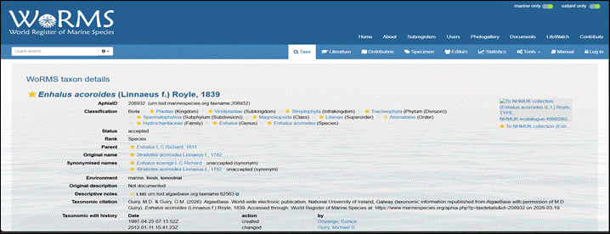
World Register of Marine Species (WoRMS)
Figure 5 WoRMS taxonomic database for marine species classification.
The World Register of Marine Species (WoRMS) is the most authoritative global taxonomic database for marine organisms. It provides standardized scientific names, classifications, and detailed taxonomic information for all known seagrass species and other marine life. The platform is freely accessible online and serves as a primary reference for researchers and institutions worldwide (WoRMS Editorial Board, 2026).
While WoRMS offers accurate and comprehensive global taxonomic data, it lacks several capabilities that are essential for community-based seagrass species detection in Mati City. It does not include a CNN-based image recognition module that allows users to upload photographs for automated species identification. Its taxonomic entries do not provide localized botanical feature descriptions such as leaf morphology, rhizome structure, sheath characteristics, and reproductive organs presented in a format accessible to non-expert users such as students, tourists, and fisherfolk. It does not provide GPS-Verified Station Locations (GIS) specific to the coastal zones of Mati City and Pujada Bay, nor does it support species richness documentation at the local level. SeaScan complements the global taxonomic foundation that WoRMS provides by delivering all of these locally focused capabilities within a single integrated web-based platform designed for non-expert users in Mati City.

Global Biodiversity Information Facility (GBIF)
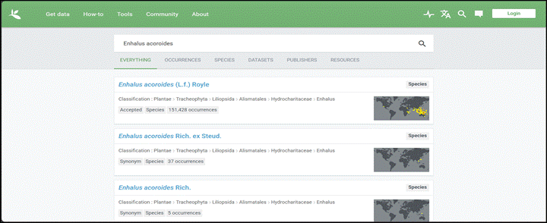Figure 6 GBIF occurrence map showing global seagrass distribution.
The Global Biodiversity Information Facility (GBIF) is an international open-access network that aggregates and provides biodiversity occurrence data from institutions and researchers around the world. It features interactive maps showing global and regional species distributions, including seagrass records, and allows users to download datasets for research and analysis (GBIF, 2026).
Although GBIF is a powerful resource for accessing global distribution data, it presents critical gaps when considered for seagrass species detection in Mati City. It does not provide a CNN-based image recognition module for automated photo-based species identification, meaning users cannot upload a photograph and receive an identification result. Its occurrence records for Philippine seagrass species are sparse and not locally curated, and it does not provide species-specific botanical feature descriptions accessible to non-expert field users. It does not offer GPS-verified station locations drawn from locally conducted surveys such as those of Angsinco-Jimenez et al. (2003) and Sanchez-Delute et al. (2025), nor does it present species richness data at the coastal zone level for Mati City. SeaScan addresses these gaps by providing a locally trained CNN identification module, a curated botanical reference library, and a species distribution mapping module anchored in verified local field survey data from Pujada Bay.

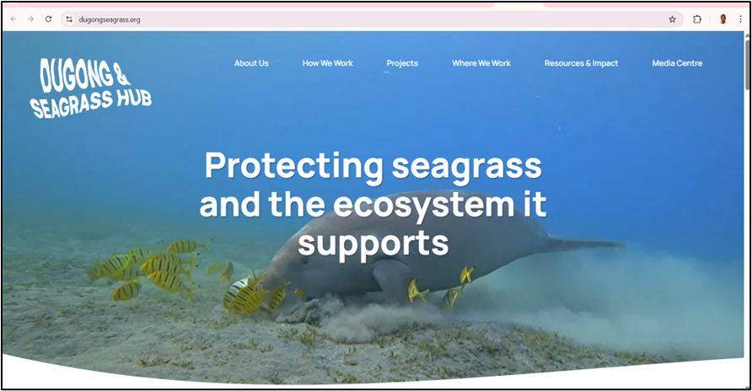
Dugong & Seagrass Hub
Figure 7 Dugong & Seagrass Hub.
The Dugong and Seagrass Hub are an international online knowledge-sharing platform developed to support seagrass and dugong conservation across more than 40 range states, including the Philippines. It serves as a central web hub where conservation practitioners, researchers, and coastal communities can access practical tools, guides, manuals, highlighted projects, and lessons learned from various seagrass conservation initiatives. The platform features sections such as Tools, Resources, and Highlighted Projects, including the Seagrass Ecosystem Services Project that involves the Philippines, along with an interactive Dugong and Seagrass Research Toolkit for selecting research methodologies. It aims to facilitate knowledge exchange and capacity building for seagrass protection and management (CMS Dugong MoU Secretariat, 2026).
While the Dugong and Seagrass Hub provide valuable conservation resources and institutional knowledge, it lacks the core technical and localized capabilities that SeaScan offers. It does not include a CNN-based image recognition module that allows users to upload photographs for automated seagrass species identification. It does not provide a localized digital library containing species-specific botanical features such as leaf morphology, rhizome structure, sheath characteristics, and reproductive organs for the nine (9) seagrass species of Mati City. It does not offer GPS-Verified Station Locations (GIS) drawn from local field surveys in Pujada Bay, nor does it support community-based species sighting submissions with GPS tagging. Its resources are aimed primarily at conservation practitioners and institutional researchers rather than non-expert users such as students, tourists, and fisherfolk who encounter seagrass in everyday coastal activities. SeaScan addresses all of these gaps by providing an integrated, web-based identification and educational platform specifically designed for the seagrass biodiversity and community needs of Mati City.

Table 1. Matrix Comparison of Related Systems
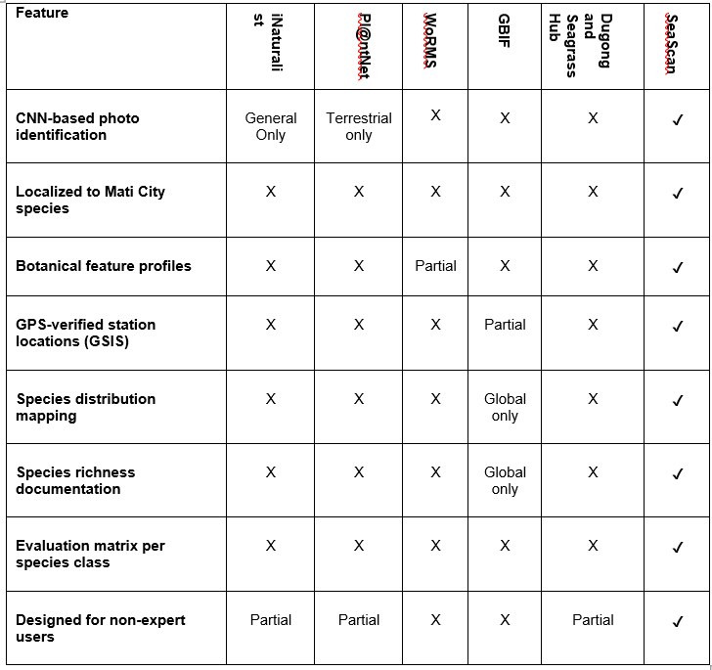

CHAPTER III
MATERIALS AND METHODS

3.1 Software Methodology
For the development of SeaScan, the Modified Waterfall methodology is applied as the overall project-level framework, with the PADIM framework consisting of Planning, Analysis, Design, Implementation, and Maintenance applied within each phase to ensure structured thinking and systematic execution. In the development of a web-based system with complex features such as a Convolutional Neural Network (CNN) image recognition module and a localized seagrass species database, these components may appear functional in theory but require structured planning, thorough analysis, and systematic testing during actual implementation (Bassil, 2012; Petersen et al., 2009). The Modified Waterfall methodology organizes development into seven sequential phases System Requirements, Software Requirements, Analysis, Program Design, Coding, Testing, and Operations where each phase must be substantially completed before proceeding to the next. Unlike the traditional Waterfall model, the Modified Waterfall allows the development team to return to a previous phase when issues are discovered during testing or implementation, making it more adaptive to the technical refinements that CNN model training and digital library content development require (Laanti et al., 2019). This sequential yet flexible structure is particularly well suited for systems that incorporate machine learning components, where the outcomes of testing phases directly inform the need to revisit earlier design and coding decisions (Amershi et al., 2019). The PADIM framework complements this structure by providing a consistent operational guide within each phase, ensuring that every stage of development is approached through deliberate planning, evidence-based analysis, systematic design, careful implementation, and thorough maintenance before progression to the next phase (Jabbar et al., 2023).
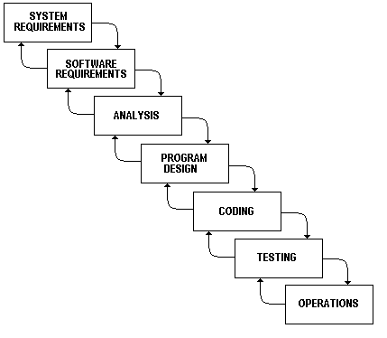
Figure 8 Modified Waterfall Methodology (Bhanu Sridhar)

The choice of Modified Waterfall for this project is justified by its structured, phase-driven nature and its suitability for developing a technically defined web application with clearly scoped requirements. The Modified Waterfall model is best suited for projects where the system requirements are well understood at the outset but where individual components such as machine learning models and database integrations may require revisiting earlier phases based on testing outcomes (Petersen et al., 2009). This structured yet flexible approach is highly suitable for SeaScan, where the CNN-based image recognition module and the localized species database require systematic development and evaluation rather than continuous iterative sprints. Within each phase of the Modified Waterfall cycle, the PADIM framework is applied as the phase-level operational guide. In the Planning stage of each phase, goals and tasks for that specific phase are identified and prioritized. The Analysis stage involves reviewing requirements, data sources, and feedback relevant to that phase. The Design stage translates analysis findings into concrete plans, wireframes, or model configurations. The Implementation stage executes the planned activities, whether that involves coding a module, populating the database, or training the CNN model. The Maintenance stage ensures that outputs from each phase are reviewed, refined, and documented before the team proceeds to the next phase of the Modified Waterfall cycle. The seven phases of the Modified Waterfall methodology as applied to SeaScan are described as follows.

The first three phases of the Modified Waterfall cycle establish the foundation of the SeaScan system. In the System Requirements phase, the nine (9) seagrass species native to the coastal areas of Mati City are confirmed based on Angsinco-Jimenez et al. (2003) and Sanchez-Delute et al. (2025), and the target users including students, tourists, coastal communities and fisherfolk, local researchers, and administrators are defined along with their respective roles and access levels. The Software Requirements phase translates these goals into specific functional and non-functional requirements for the four core modules: the CNN-based image recognition module, the digital library with botanical species profiles and GPS-Verified Station Locations (GIS), the species distribution mapping module, and the user management system. The evaluation criteria are also formally defined in this phase, establishing that CNN identification performance will be measured using Accuracy, Precision, Recall, and F1-Score reported per species class and visualized through a Confusion Matrix, while the System Usability Scale (SUS) is defined as the instrument for evaluating overall user experience. The Analysis phase then examines all inputs and data sources that will shape SeaScan's development, including the botanical features of all nine (9) species leaf morphology, rhizome structure, sheath characteristics, and reproductive organs the GIS station data from both peer-reviewed sources, the CNN training dataset requirements in terms of image volume and class balance, and the gaps identified from reviewing existing related systems.

The remaining four phases cover the design, development, evaluation, and deployment of SeaScan. In the Program Design phase, the CNN model architecture is specified using a transfer learning approach with a three-step pre-processing pipeline consisting of image quality enhancement, noise filtering, and visual standardization, while the database schema, responsive web interface wireframes, and species distribution mapping module layout are also designed. The Coding phase implements all designed components, including the fine-tuned CNN model trained on localized seagrass photographs, the digital library populated with complete botanical profiles and GIS data, the mapping module with pre-loaded peer-reviewed station coordinates and GPS-tagged sighting submission, and the integrated responsive web interface with role-based user management. The Testing phase evaluates the system using the defined evaluation matrix Accuracy, Precision, Recall, F1-Score per species class, and a Confusion Matrix alongside SUS usability testing and cross-platform functional testing across mobile and desktop browsers, with the Modified Waterfall framework allowing the team to return to earlier phases if critical issues are identified. Finally, the Operations phase covers the deployment of SeaScan as a live web-based platform, the ongoing collection of community GPS-tagged sightings, and the continuous maintenance of the system and its documentation as a reference for future researchers and developers seeking to extend SeaScan's capabilities beyond Mati City.

3.2 System Planning
The planning stage laid the foundation for the successful development of SeaScan: A Web-Based Seagrass Species Identification System for Mati City. The project was conceptualized during consultations with the Vice President for Research, Innovation, and Extension, along with faculty members from the University Marine Science Research Laboratory at Davao Oriental State University. These engagements highlighted the persistent challenges of manual seagrass species detection and the urgent need for a more accessible and technology-driven solution. Initial discussions revealed the significant gap between scientific knowledge and public participation in coastal conservation, particularly among students, tourists, coastal communities, fisherfolk, and local researchers. The team conducted a thorough review of related literature and existing systems to identify gaps, after which the project scope, objectives, and technical requirements were carefully defined. This systematic planning process ensured that SeaScan is relevant, feasible, and directly aligned with the educational and conservation needs of Mati City.

Feasibility Study
The feasibility study evaluates whether SeaScan could be realistically developed, implemented, and sustained within the constraints of a BSIT capstone project. The assessment covered three major dimensions: operational feasibility, economic feasibility, and technical feasibility. Results confirmed that the project is not only viable but also highly beneficial for promoting marine environmental literacy in Mati City.

Operational Feasibility
SeaScan is operationally feasible based on consultations with the Vice President for Research, Innovation, and Extension and faculty members from the University Marine Science Research Laboratory at Davao Oriental State University. These experts confirmed that the system would be readily accepted by students, tourists, coastal communities and fisherfolk, local researchers, and environmental officers in Mati City. They emphasized that the combination of CNN-based image recognition using transfer learning and a localized digital library containing detailed botanical species profiles including leaf morphology, rhizome structure, sheath characteristics, and reproductive organs would make learning about seagrass species more engaging and accessible compared to traditional manual methods and printed field guides. The Vice President and laboratory faculty noted that SeaScan directly addresses the current lack of modern digital tools for marine environmental education and seagrass species detection in the region, particularly in Mati City. Furthermore, they expressed strong support for the project, stating that it would significantly contribute to their efforts in promoting coastal conservation and environmental literacy among the local community, and that the GPS-Verified Station Locations (GIS) and species distribution mapping module would provide valuable supplementary data between formal scientific survey cycles.

Economic Feasibility
Cost
Table 2. Total Cost of the System
Category | Item | Estimated Cost
1.Requirements Gathering | - | ₱0.00
2. System Design | - | ₱0.00
3. Implementation | CNN training dataset preparation and field photography of nine (9) seagrass species in the coastal areas of Mati City | ₱5,000.00
3. Implementation | Digital library content preparation (botanical profiles, GIS data, ecological roles, conservation status) | ₱2,000.00
3. Implementation | Web development tools, frameworks, and cloud-based CNN training via Google Colab | ₱0.00
4. Testing | Testing devices, internet subscription, and SUS usability testing materials | ₱2,000.00
5. Deployment | - | ₱0.00
6. Maintenance | Annual Updates and Bug Fixes | ₱3,000.00
7. Miscellaneous | Printing and Documentation | ₱1,500.00
TOTAL |  | ₱13,500.00

Table 2 presents the estimated development and operational costs for SeaScan across seven cost categories. The Requirements Gathering and System Design phases incur no direct financial cost as all planning, literature review, peer-reviewed source acquisition, and UI/UX wireframing activities are carried out using freely available tools such as Figma, draw.io, and GitHub, alongside the publicly accessible research of Angsinco-Jimenez et al. (2003) and Sanchez-Delute et al. (2025). The Implementation phase represents the largest cost component of the project, amounting to ₱7,000.00, which covers field photography and CNN training dataset preparation (₱5,000.00) for the nine (9) seagrass species native to the coastal areas of Mati City, and digital library content preparation including botanical profiles, GIS station data, ecological roles, and conservation status (₱2,000.00). All web development frameworks, programming tools, and cloud-based CNN training via Google Colab are entirely free and open-source, contributing ₱0.00 to the implementation cost. The Testing phase is estimated at ₱2,000.00, covering testing devices, internet subscription, and System Usability Scale (SUS) usability testing materials administered to target users. The Deployment phase incurs no cost as SeaScan is hosted on free-tier cloud platforms. The Maintenance phase is estimated at ₱3,000.00 to cover annual updates, bug fixes, digital library content updates, and CNN model retraining as needed. Miscellaneous expenses for printing and documentation are estimated at ₱1,500.00. The total estimated cost for the development and first-year operation of SeaScan amounts to ₱13,500.00, reflecting the cost-efficient and resource-conscious nature of the project as a BSIT capstone study where the majority of technologies used are freely available and open-source.

Technical Feasibility
SeaScan is technically feasible given the available hardware, software, and technical capabilities of the development team. The researchers utilize personal laptops and desktop computers with adequate processing power for coding, CNN model training, and digital library content development. The system is developed using open-source and freely accessible tools including React.js for the responsive web interface, TensorFlow and Keras for the fine-tuned Convolutional Neural Network (CNN) image recognition module with transfer learning, and Python Flask for the backend API and server-side logic. Cloud platforms such as Google Colaboratory will be used for training the CNN model on the localized seagrass dataset, with model checkpointing implemented at regular intervals to prevent loss of training progress in the event of session interruptions. As a contingency, Kaggle Notebooks will serve as an alternative free GPU environment should Google Colaboratory's session limitations prove insufficient for the training requirements of the localized nine-species dataset.
The system adopts Supabase as its primary database and backend service platform, providing a fully managed PostgreSQL relational database, built-in user authentication, role-based access control through Row Level Security policies, and file storage all within a single integrated platform. This consolidation significantly reduces infrastructure complexity for the development team by eliminating the need to separately configure and maintain a standalone database server, authentication middleware, and file management service. Supabase integrates seamlessly with both the React.js frontend through its JavaScript client library and the Python Flask backend through its RESTful API, ensuring smooth data flow across all layers of the system architecture. The database will store all nine (9) seagrass species profiles including botanical features such as leaf morphology, rhizome structure, sheath characteristics, and reproductive organs, alongside ecological roles, conservation status, geographic distribution, and GPS-Verified Station Locations (GIS) drawn from Angsinco-Jimenez et al. (2003) and Sanchez-Delute et al. (2025).
For image storage and management, the system will utilize either Supabase Storage or Cloudinary depending on preprocessing requirements identified during the implementation phase. Cloudinary provides additional image transformation capabilities such as automatic compression, format conversion, and brightness adjustment that may be applied to user-uploaded photographs before they are passed to the CNN model for analysis. The CNN model will be developed using a transfer learning approach, fine-tuning a pre-trained deep learning architecture on a localized dataset of photographs of the nine (9) seagrass species native to the coastal waters of Mati City. The training dataset will be prepared through field photography conducted in the coastal areas of Mati City, supplemented by image augmentation techniques to ensure sufficient volume and class balance across all nine species.
Once trained, the CNN model will be converted and deployed using TensorFlow.js, enabling real-time in-browser inference without requiring a dedicated server call for every identification request. To ensure the model is lightweight enough for browser deployment, quantization techniques will be applied during the conversion process to reduce model file size and improve inference speed with minimal impact on classification accuracy. CNN identification performance will be evaluated using Accuracy, Precision, Recall, and F1-Score reported per species class, and visualized through a Confusion Matrix to identify misclassification patterns across all nine (9) seagrass species. The frontend will be deployed on Vercel, a hosting platform optimized for React.js applications, while the Python Flask backend will be hosted on Render, a cloud platform supporting Python web services. This separation of hosting environments allows each layer of the system to be independently scaled and maintained.
The chosen technologies align well with the team's skills in web development, JavaScript frameworks, and machine learning with transfer learning. With guidance from faculty members of the University Marine Science Research Laboratory at Davao Oriental State University and self-directed study, the researchers are equipped to implement all core features of SeaScan successfully. Since the system is entirely web-based and focused only on the nine (9) seagrass species native to the coastal waters of Mati City, its complexity remains manageable within the available resources and capstone timeline. Therefore, SeaScan can be realistically developed and deployed using the current technical setup.

Work Breakdown Structure (WBS)
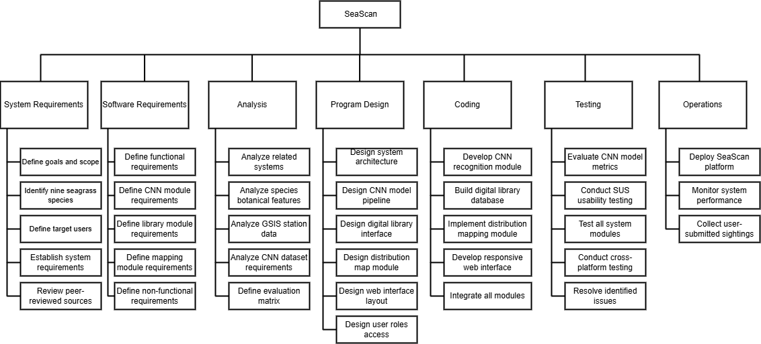
The Work Breakdown Structure (WBS) of SeaScan shows the project’s main phases and tasks, organizing the development process from planning to deployment for better tracking and management.

Figure 9 Work Breakdown Structure

Gantt Chart
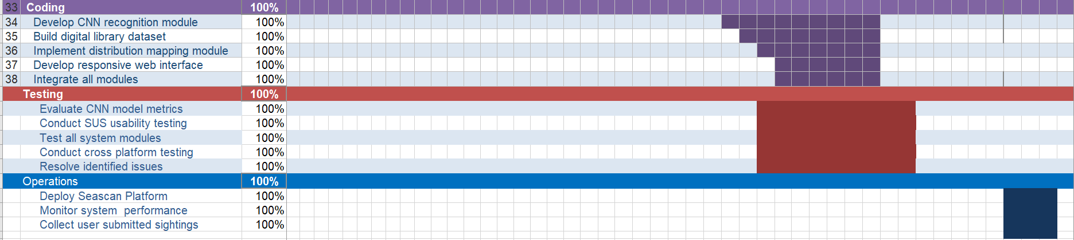
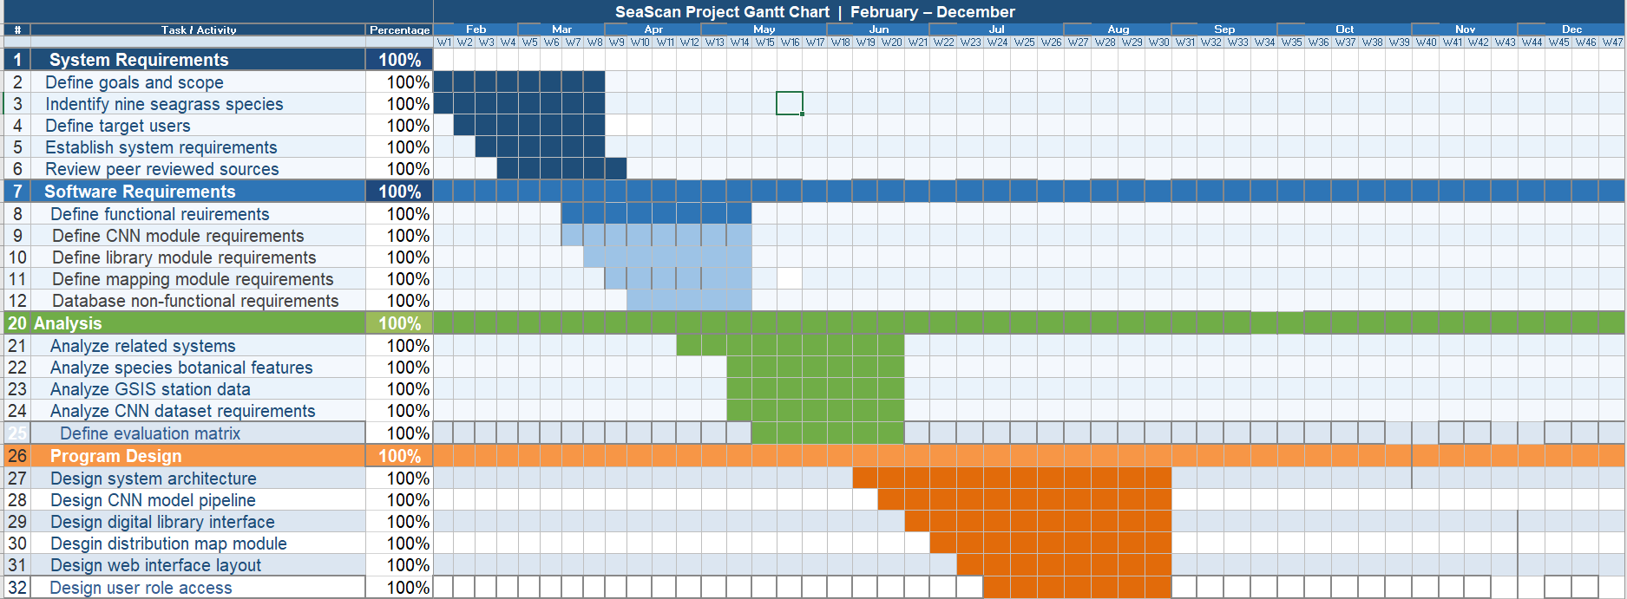

Figure 10 Gantt Chart
The Gantt Chart in Figure 10 illustrates the overall project schedule for the development of SeaScan from February to December 2026. It follows the seven sequential phases of the Modified Waterfall methodology adopted in this study: (1) System Requirements, (2) Software Requirements, (3) Analysis, (4) Program Design, (5) Coding, (6) Testing, and (7) Operations.
The chart clearly shows that the project begins with an intensive two-month Requirements phase in February and March, followed by a comprehensive Analysis phase that runs until mid-year. The Program Design phase spans April to June, while the core Coding and system development activities are concentrated from June to August. Rigorous Testing and evaluation, including CNN model performance assessment and System Usability Scale (SUS) testing, are scheduled from August to October, with participant recruitment and user evaluation commencing only after the DOrSU-UREB Ethical Clearance has been issued. Finally, the Operations phase covering deployment, launch, monitoring, and maintenance extends from October to December 2026.
This structured timeline ensures systematic progression while allowing flexibility to revisit earlier phases, when necessary, particularly during model training and integration. The Gantt Chart serves as a vital project management tool that aligns all development activities with the defined scope, objectives, and deliverables of the SeaScan system.

3.3 System Analysis

Description of the Current System
Currently, there is no existing digital or technology-assisted system for identifying seagrass species in Mati City, Davao Oriental. The identification of seagrass in Mati City and its surrounding coastal areas depends entirely on a manual process that anyone who encounters seagrass in the coastal environment may attempt to carry out. This includes students on field trips, tourists visiting the bay, local fisherfolk, and researchers conducting coastal observations. However, when the person cannot independently confirm the species, the process escalates to the involvement of a trained Marine Researcher. The Business Process Model and Notation (BPMN) diagram shown in Figure 11 illustrates how this two-stage manual identification process currently operates.
BPMN of the current system
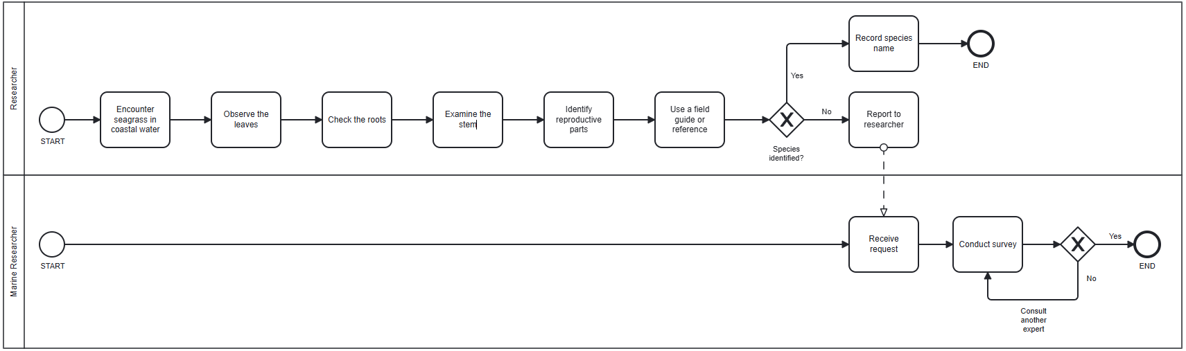
Figure 11 BPMN diagram of the current manual seagrass identification process.
Requirements Specification
This section defines the specific features and qualities that SeaScan must possess to effectively address the identified problems in seagrass species identification and marine environmental education in Mati City.
1. Functional Requirements
The system shall provide the following core functionalities:
- The system shall allow users to upload or capture photographs of seagrass using a mobile or desktop device camera.
- The system shall automatically identify seagrass species using a fine-tuned Convolutional Neural Network (CNN) with transfer learning from user-uploaded photographs.
- The system shall display detailed information about the identified species, including scientific name, common name, botanical features such as leaf morphology, rhizome structure, sheath characteristics, and reproductive organs, ecological role, conservation status, geographic distribution, and GPS-Verified Station Locations (GIS) within the coastal areas of Mati City.
- The system shall provide a digital library where users can browse, search, and view the nine (9) localized seagrass species found in the coastal areas of Mati City.
- The system shall generate user-friendly educational content and conservation tips for each identified species.
- The system shall support multiple user roles students, tourists, researchers, and administrators with appropriate access levels enforced through role-based access control.
- The system shall display a numerical confidence score alongside every CNN identification result. For identifications with a confidence level below 70%, the system shall present a clearly visible advisory message recommending that the user retake the photograph under better lighting conditions or consult a marine science expert.
- The system shall implement a species distribution mapping module that displays historically verified GPS-tagged seagrass station locations drawn from Angsinco-Jimenez et al. (2003) and Sanchez-Delute et al. (2025), and accepts GPS-tagged user-submitted sightings to support community-based monitoring within the coastal areas of Mati City.
2. Non-Functional Requirements
These define the quality attributes, constraints, and performance standards of the system.
A. Performance
- The system shall respond to image upload and CNN-based identification requests within five seconds.
B. Reliability
- The CNN-based identification module shall achieve at least 85% overall accuracy in seagrass species identification under normal field conditions, as measured by the Accuracy, Precision, Recall, and F1-Score evaluation matrix reported per species class.
- The system shall remain consistently accessible to users at all times, including during peak coastal tourism periods in Mati City.
- The system shall perform regular backups of species records and user data to prevent data loss.
C. Portability and Compatibility
- The system shall be accessible via standard web browsers on both desktop and mobile devices without requiring additional software installation.
- The system shall be compatible with modern web browsers including Chrome, Firefox, Safari, and Edge.
D. Usability
- The system shall maintain a responsive and user-friendly interface across different screen sizes suitable for students, tourists, coastal communities, fisherfolk, and local researchers.
- The system shall achieve a System Usability Scale (SUS) score of at least 70 out of 100, indicating an acceptable level of usability among the target users of Mati City.
E. Security
- The system shall implement secure user data handling and protect uploaded images and personal information from unauthorized access.
- The system shall enforce role-based access controls to prevent unauthorized modification or deletion of species records and administrative data.

F. Scalability
- The system shall be designed to handle at least 500 concurrent users during peak usage periods without degradation in performance.
Proposed Solution
SeaScan addresses the core problems identified in Chapter I manual and error-prone seagrass identification, lack of accessible educational tools, and limited public awareness in Mati City by providing an integrated, modern, and user-friendly web-based platform. Unlike traditional field guides and general plant identification apps that are either impractical in underwater environments or lack region-specific data, SeaScan employs a fine-tuned Convolutional Neural Network (CNN) with transfer learning, trained specifically on the nine (9) seagrass species native to the coastal waters of Mati City, to deliver accurate and instant species identification from a simple user-uploaded photograph.
By allowing users to simply take or upload a photograph of a seagrass plant, the CNN module instantly identifies the species and retrieves a comprehensive educational species profile containing botanical features, ecological roles, conservation status, geographic distribution, and GPS-Verified Station Locations (GIS). This transforms passive observation into an engaging, hands-on learning experience without disturbing the actual marine environment. The localized digital library focused on Mati City seagrass species ensures relevance to the local context, while the responsive web-based design makes the system easily accessible to students, tourists, researchers, coastal communities, fisherfolk, and environmental officers without requiring any prior marine science knowledge.
In the end, SeaScan bridges the gap between scientific knowledge and community participation, enhances marine environmental literacy, promotes responsible tourism, and supports conservation efforts in Mati City by empowering users with an accurate, accessible, and locally grounded CNN-based tool for seagrass species identification and education.
3.4 System Design
This section describes the technologies, development tools, algorithms, and application programming interfaces (APIs) used in the development of the SeaScan system. The development process focuses on creating a web-based digital platform that supports accurate CNN-based seagrass species identification and accessible marine educational content delivery, while ensuring data security, user authentication, and organized access to seagrass species data.
System Architecture and Development Tools
This section describes the complete set of technologies, frameworks, tools, and platforms used in the development of SeaScan. The system is built around a layered web-based architecture that integrates a responsive frontend interface, a CNN-powered image recognition module, a structured database for species and user data management, and a species distribution mapping module for visualizing historically verified and community-submitted seagrass sighting data.
Frontend Development
The frontend of SeaScan will be developed using React.js, a component-based JavaScript library widely used for building dynamic and responsive web user interfaces. React.js will be selected for its ability to efficiently update and render components in response to user interactions, making it well-suited for a system that requires real-time feedback such as instant CNN-based species identification results and dynamic digital library browsing (Meta Open Source, 2024). The responsive design ensures that the system is accessible across both mobile and desktop browsers without requiring any additional software installation, directly supporting the accessibility requirements defined in the system's non-functional requirements.
CNN-Based Image Recognition
The image recognition module of SeaScan is built on a fine-tuned Convolutional Neural Network (CNN) with transfer learning as the primary classification algorithm. Transfer learning is applied using MobileNetV3, a lightweight pre-trained architecture selected for its proven performance on image classification tasks and its suitability for browser-based inference via TensorFlow.js (Howard et al., 2019). This approach is adopted because training a CNN from scratch on a small localized dataset is prone to overfitting and poor generalization; transfer learning addresses this by leveraging feature representations already learned from large-scale image datasets and refining them for the target species (Pan & Yang, 2010).
Target Species and Classification Difficulty
The CNN is fine-tuned to identify the nine (9) seagrass species native to the coastal waters of Mati City. Table 3 presents the complete list of target species, together with their key botanical classification characteristics and anticipated CNN identification difficulty tier, established from the botanical literature and the species composition documented by Angsinco-Jimenez et al. (2003) and Sanchez-Delute et al. (2025).
Table 3. Target Seagrass Species of SeaScan with Botanical Classification Characteristics and CNN Identification Difficulty
Classification Difficulty | Moderate similar to C. serrulata | Moderate similar to C. rotundata | Easy distinctly large | Hard similar to H. uninervis | Hard similar to H. pinifolia | Hard similar to H. ovalis | Hard similar to H. minor | Easy unique leaf shape | Moderate distinctive venation
Primary Distinguishing Feature | Smooth rounded leaf tip | Serrated leaf tip | Largest leaf width among all 9 species | Narrowest leaf among Halodule species | Slightly wider leaf than H. pinifolia | Smaller overall leaf size | Larger overall leaf size | Only species with cylindrical leaves | Cross-veins visible on leaf surface
Lead Tip | Rounded, smooth margin | Serrated/toothed margin | Rounded | Tridentate (3-pointed) | Tridentate (3-pointed) | Rounded | Rounded | Pointed | Rounded
Leaf Width | 4–9 mm | 4–9 mm | 10–20 mm | 0.5–1 mm | 1–3 mm | 4–8 mm wide | 8–20 mm | 1–2 mm diameter | 4–10 mm
Leaf Shape | Flat, ribbon-like | Flat, ribbon-like | Flat, ribbon-like | Needle-like | Needle-like | Oval | Oval | Cylindrical/tubular | Flat, ribbon-like
Common Name | Round-leaf cymodocea | Serrated cymodocea | Tape seagrass | Narrow shoal grass | Wide shoal grass | Small halophila | Paddle weed | Cylindrical seagrass | Turtle grass
Species | Cymodocea rotundata | Cymodocea serrulata | Enhalus acoroides | Halodule pinifolia | Halodule uninervis | Halophila minor | Halophila ovalis | Syringodium isoetifolium | Thalassia hemprichii

CNN difficulty tiers are based on morphological similarity between species pairs. Easy-tier species are morphologically unique and visually distinguishable. Moderate-tier species share general leaf form with other species but have distinguishing tip or venation features. Hard-tier species form morphologically similar pairs Halodule pinifolia versus Halodule uninervis, differentiated primarily by leaf width, and Halophila minor versus Halophila ovalis, differentiated primarily by leaf size and are anticipated to produce the lowest per-class F1-Scores in the CNN evaluation.
SeaScan's CNN model identifies seagrass species by extracting and analyzing botanical visual features from user-uploaded photographs through its convolutional layers. The primary classification signal is leaf shape, which distinguishes flat ribbon-like leaves in Cymodocea rotundata, Cymodocea serrulata, Enhalus acoroides, and Thalassia hemprichii; oval leaves in Halophila minor and Halophila ovalis; needle-like leaves in Halodule pinifolia and Halodule uninervis; and the unique cylindrical leaves of Syringodium isoetifolium. Secondary botanical features including leaf width and length, leaf tip morphology, vein pattern, leaf texture and surface color, and sheath and rhizome structure are then used to confirm and refine the classification result, particularly for morphologically similar species pairs. Halodule pinifolia and Halodule uninervis are differentiated primarily by leaf width, while Halophila minor and Halophila ovalis are differentiated primarily by leaf size. Because these distinguishing botanical features are subtle, noise filtering and contrast enhancement are applied during preprocessing to sharpen the fine structural details the CNN depends on to accurately resolve these difficult classifications.

Dataset Collection and Preparation
The training dataset is prepared through field photography conducted at verified coastal stations in Pujada Bay, including Lawigan, Taganilao, and Pujada Island, targeting all nine (9) native seagrass species during the defined collection period. Every photograph undergoes initial quality screening to discard images with excessive blur, poor lighting, or severe background obstruction. All photographs are labeled by a marine science expert from Davao Oriental State University, with ambiguous images excluded entirely to ensure clean ground truth data.
To ensure sufficient volume and class balance, image augmentation techniques are applied, including rotations, horizontal and vertical flips, brightness adjustments, and zoom variations, improving the model's robustness to real-world variation in user-submitted photographs. The augmented dataset is then divided into training, validation, and test subsets using a stratified 70/15/15 split to preserve class distribution across all three subsets, ensuring that each species class is proportionally represented in every phase of evaluation. Augmentation is applied exclusively to the training subset after splitting to prevent test set contamination and to ensure that evaluation reflects real-world field photography conditions. Table 4 presents the complete dataset specifications organized by IPO stage.
Table 4. SeaScan CNN Training Dataset Specifications Organized by IPO Stage
IPO Stage | Parameter | Specification
INPUT | Target species classes | 9 seagrass species native to the coastal waters of Mati City (see Table 3)
INPUT | Photography device | Standard mobile or desktop device camera
INPUT | Capture resolution | Minimum 1080p (1920 × 1080 pixels) at time of field photography
INPUT | Image format | JPEG / PNG
INPUT | Collection locations (GIS) | Lawigan, Taganilao, Pujada Island verified coastal stations, Pujada Bay, Mati City
INPUT | Collection period (time-bounded) | June - August 2026
INPUT | Minimum images per class (before augmentation) | 700 photographs (easy tier) · 1000 photographs (moderate tier) · 1200 photographs (hard tier)
INPUT | Labeling authority | Marine science expert, Davao Oriental State University
INPUT | Exclusion criteria | Images with excessive blur, poor lighting, severe background obstruction, or ambiguous species identity
PROCESS | Augmentation techniques | Rotations (±30°), horizontal and vertical flips, brightness adjustments (±20°), zoom variations (±15%)
PROCESS | Target images per class (after augmentation) | 600–1,200 images per species depending on difficulty tier
PROCESS | Total estimated dataset size (post-augmentation) | 5,400–10,800 images across all 9 species classes
PROCESS | Dataset split ratio | 70% Training / 15% Validation / 15% Testing augmentation applied to training subset only after splitting
PROCESS | Split method | Stratified preserves class distribution across all three subsets
PROCESS | Preprocessing pipeline | Image Quality Enhancement → Noise Filtering → Visual Standardization
PROCESS | Model input resolution | 224 × 224 pixels MobileNetV3 input requirement after Visual Standardization
PROCESS | Color space | RGB (3-channel) preserves leaf color, texture, and surface features used for species classification
PROCESS | CNN input dimensions | 224 × 224 × 3 (height × width × RGB channels)
PROCESS | CNN architecture | MobileNetV3 with transfer learning  Phase 1: frozen base layers; Phase 2: gradual unfreezing at reduced learning rate
OUTPUT | CNN evaluation metrics | Accuracy, Precision, Recall, F1-Score per class minimum ≥ 85% per class (see Table 5)
OUTPUT | Confusion Matrix | 9×9 diagonal dominance required across all 9 classes
OUTPUT | Usability evaluation | SUS score ≥ 70 / 100 — 40 adult participants, 10 from each of the 4 target user groups
OUTPUT | Species Distribution Map (GIS) | Interactive map of verified GIS stations overlaid with GPS-tagged community sightings

Preprocessing Pipeline
Prior to entering the model, every image whether part of the training dataset or submitted live by a user passes through a three-step preprocessing pipeline applied in sequence. Image Quality Enhancement corrects issues related to lighting, brightness, and contrast that commonly occur in field and underwater photography, ensuring that the botanical features of the seagrass are clearly visible for classification. Noise Filtering removes visual distortions, artifacts, and irrelevant background elements such as sand, water debris, and other marine organisms that could interfere with the accurate detection of botanical features such as leaf morphology and rhizome structure. Visual Standardization then normalizes the image to a consistent format, resolution of 224 × 224 pixels, and RGB color profile required by the MobileNetV3 input layer, ensuring uniform input dimensions for the transfer learning model. This preprocessing pipeline is applied consistently during both model training and live user inference to ensure uniform input conditions regardless of camera quality or environmental lighting at the time of capture.
Model Architecture and Training
MobileNetV3 is fine-tuned on the localized dataset of the nine (9) seagrass species through a two-phase training procedure. In Phase 1, the base layers of MobileNetV3 are frozen and only the top classification layers are trained, allowing the model to quickly adapt its output to the nine-class seagrass classification task without disrupting the pre-trained feature representations. In Phase 2, the upper base layers are gradually unfrozen and fine-tuned at a reduced learning rate, enabling the model to adapt its deeper feature representations to the specific morphological characteristics of Philippine seagrass species.
During Feature Extraction, the CNN analyzes the structural and visual botanical characteristics of the seagrass in the image, extracting identifiable features including leaf morphology, rhizome structure, sheath characteristics, reproductive organs, vein patterns, and overall growth form through its convolutional layers. During Species Classification, the extracted features are passed through the fully connected layers of the CNN, which compares them against the learned patterns of all nine (9) seagrass species to produce a classification result with a corresponding confidence score. Following successful classification, Species Profile Retrieval is performed, wherein the system automatically retrieves the corresponding species profile from the database and prepares the relevant educational content for display to the user.
The CNN model is developed and fine-tuned using TensorFlow and Keras (Abadi et al., 2016). Model training is performed using Google Colaboratory, with early stopping implemented to prevent overfitting and model checkpointing applied at regular intervals to preserve the best-performing model weights in the event of session interruptions (Bisong, 2019). As a contingency, Kaggle Notebooks will serve as an alternative free GPU environment should Google Colaboratory's session limitations prove insufficient for the training requirements of the localized nine-species dataset. Once trained, the CNN model is converted and deployed using TensorFlow.js with quantization applied to reduce model file size and improve browser inference speed with minimal impact on classification accuracy (Smilkov et al., 2019).
Evaluation Methodology
CNN identification performance is evaluated using Accuracy, Precision, Recall, and F1-Score, reported per species class, and visualized through a 9×9 Confusion Matrix to identify misclassification patterns across all nine (9) seagrass species. Table 5 presents the complete pre-implementation performance matrix, including the mathematical equations and minimum acceptable thresholds for each metric.
Table 5. Pre-Implementation Performance Matrix CNN Classification Metrics and Usability Evaluation
Metric | Definition | Equation | Pre-Implementation Target
Accuracy | Overall percentage of correct identifications out of all predictions across the entire test set. | (TP + TN) ÷ (TP + TN + FP + FN) | Supplementary metric. ≥ 85% overall
Precision | Out of all instances the model predicted as a species, the proportion that were actually that species. | TP ÷ (TP + FP) | Expected higher for easy-tier species. ≥ 85% per class
Recall | Out of all actual instances of a species in the test set, the proportion the model successfully identified. | TP ÷ (TP + FN) | Anticipated lowest for hard-tier species: H. pinifolia, H. uninervis, H. minor. ≥ 85% per class
F1-Score (Primary) | Harmonic mean of Precision and Recall per class. Penalizes models that perform well on common classes but poorly on rare ones. | 2 × (P × R) ÷ (P + R) | Primary metric accounts for dataset imbalance. ≥ 85% per class
Confusion Matrix | 9×9 table rows = actual species, columns = predicted species. Diagonal = correct identifications; off-diagonal = misclassification pairs. | Not computable before training. Predicted highest confusion: H. pinifolia vs H. uninervis (leaf width); H. minor vs H. ovalis (leaf size); C. rotundata vs C. serrulata (leaf tip) | Diagonal dominance across all 9 classes
SUS Score | 10-item questionnaire scored 0–100. Odd items: position − 1; Even items: 5 − position; Sum × 2.5 = final score. | Administered to 40 adult participants (10 per target user group; see Section 3.5.2.2) after completing 3 core system tasks

Each metric is computed from four outcome categories generated for every species class during testing: True Positive (TP), an image correctly identified as the target species; True Negative (TN), an image correctly identified as not the target species; False Positive (FP), an image incorrectly identified as the target species; and False Negative (FN), an image of the target species the model failed to identify. Accuracy is computed as (TP + TN) ÷ (TP + TN + FP + FN), representing the overall proportion of correct predictions across the entire test set. Precision is computed as TP ÷ (TP + FP), measuring how trustworthy a positive identification is. Recall is computed as TP ÷ (TP + FN), measuring how many actual instances of a species the model successfully detects. The F1-Score, designated as the primary evaluation metric for SeaScan, is computed as 2 × (P × R) ÷ (P + R), where P and R denote the Precision and Recall values for the corresponding species class.
A minimum threshold of 85% is established for Accuracy, Precision, Recall, and F1-Score per species class, consistent with the system's non-functional requirements. Accuracy is treated as a supplementary indicator of overall model performance, while the F1-Score is designated as the primary evaluation metric because it accounts for potential dataset imbalance across the nine species classes by balancing Precision and Recall into a single per-class score. Based on the botanical classification characteristics described above, the three hard-tier species Halodule pinifolia, Halodule uninervis, and Halophila minor are anticipated to produce the lowest per-class F1-Scores due to the subtle visual differences between morphologically similar pairs and the expected imbalance in their training image counts relative to other classes. The Confusion Matrix is expected to reveal the highest misclassification values in the off-diagonal cells corresponding to three specific species pairs: Halodule pinifolia versus Halodule uninervis, differentiated primarily by leaf width; Halophila minor versus Halophila ovalis, differentiated primarily by leaf size; and Cymodocea rotundata versus Cymodocea serrulata, differentiated primarily by leaf tip serration. These anticipated misclassification patterns will guide post-training dataset augmentation and model refinement decisions before final deployment.
The System Usability Scale (SUS) is used separately to evaluate the overall user experience of SeaScan, measuring the system's effectiveness, efficiency, and user satisfaction among the target users of Mati City, with a minimum threshold of 70 out of 100 required for deployment. Only the user evaluation, which uses the SUS together with an ISO/IEC 25010-based questionnaire, involves human participants; the CNN classification metrics above are computed solely from a held-out set of seagrass photographs. The participants, sampling, consent, data handling, and analysis procedures for the user evaluation are detailed in Section 3.5.2.2.
Backend Development
The backend of SeaScan will be developed using Python Flask, a lightweight web framework that handles server-side logic, processes API requests from the frontend, manages communication between the CNN model and the database, and serves identification results back to the user interface (Grinberg, 2018). Flask is chosen over Node.js for its seamless compatibility with TensorFlow and Python-based machine learning libraries, making it the more practical choice for a system whose core functionality depends on CNN-based processing. User authentication and role-based access control are managed through Supabase Auth, which handles session token generation and validation using industry-standard JSON Web Token protocols. Access permissions for the four user roles students, tourists, researchers, and administrators are enforced at the database level through Supabase's Row Level Security policies, eliminating the need for separately configured authentication middleware in the Flask backend (Supabase, 2024; Jones et al., 2015).

Database
Supabase was selected over traditional standalone database solutions for four key reasons. First, it provides a fully managed PostgreSQL database with an intuitive web-based dashboard, eliminating the need for manual database server setup and maintenance. Second, Supabase offers built-in authentication and role-based access control, allowing the system to manage the four user roles without requiring a separately configured authentication system. Third, Supabase provides real-time database subscriptions, enabling the system to push live updates to connected clients when species records or identification data are modified. Fourth, Supabase includes built-in storage buckets for managing uploaded images, which can serve as an alternative or complement to Cloudinary for handling user-submitted photographs. Species information including scientific names, common names, botanical features such as leaf morphology, rhizome structure, sheath characteristics, and reproductive organs, ecological roles, conservation status, geographic distribution, and GPS-Verified Station Locations (GIS) drawn from Angsinco-Jimenez et al. (2003) and Sanchez-Delute et al. (2025) are organized in clearly defined PostgreSQL tables within Supabase that support fast querying and retrieval for both the digital library and the CNN identification results display (Supabase, 2024).
Image Storage
User-uploaded photographs submitted for CNN-based species identification will be stored and managed using either Supabase Storage or Cloudinary, depending on preprocessing requirements identified during the implementation phase. Supabase Storage provides integrated file management directly within the system's database platform, simplifying the overall architecture. Cloudinary will be utilized if its additional image transformation capabilities including automatic compression, format conversion, and brightness adjustment are determined to be necessary for optimizing photographs before they are passed to the CNN model for analysis (Cloudinary, 2024).
Botanical Classification Characteristics of Species
SeaScan's CNN model will identify seagrass species by extracting and analyzing botanical visual features from user-uploaded photographs through its convolutional layers. The primary classification signal is leaf shape, which distinguishes flat ribbon-like leaves in Cymodocea rotundata, Cymodocea serrulata, Enhalus acoroides, and Thalassia hemprichii; oval leaves in Halophila minor and Halophila ovalis; needle-like leaves in Halodule pinifolia and Halodule uninervis; and the unique cylindrical leaves of Syringodium isoetifolium. Secondary botanical features including leaf width and length, leaf tip morphology, vein pattern, leaf texture and surface color, and sheath and rhizome structure are then used to confirm and refine the classification result, particularly for morphologically similar species pairs. Halodule pinifolia and Halodule uninervis will be differentiated primarily by leaf width, while Halophila minor and Halophila ovalis will be differentiated primarily by leaf size. Because these distinguishing botanical features are subtle, noise filtering and contrast enhancement will be applied during preprocessing to sharpen the fine structural details the CNN depends on to accurately resolve these difficult classifications. The CNN model's ability to correctly distinguish between these nine (9) species will be evaluated using Accuracy, Precision, Recall, and F1-Score reported per species class, with a Confusion Matrix generated to identify which species pairs are most frequently misclassified and to guide further dataset augmentation and model refinement.

Hosting and Deployment
The SeaScan frontend will be deployed using Vercel, a cloud hosting platform optimized for React.js applications that provides fast content delivery and automatic scaling (Vercel, 2024). The Python Flask backend will be hosted on Render, a cloud platform that supports Python web services and provides a reliable environment for serving API requests and CNN model inference at scale (Render, 2024). This separation of frontend and backend hosting ensures that each layer of the system can be independently scaled and maintained.

System Interface Design (Mock up)
To guide the development of the SeaScan System, mockups will be created to provide a realistic visual representation of the system interface, including key pages such as the landing page, administrator dashboard, core function hub, administration page, and researcher’s page. These mockups present the design layout, color scheme, typography, images, and interactive elements, enabling the development team to assess usability, interface consistency, and overall functionality before implementation. By serving as a reference for developers, the mockups will ensure that the system is user-friendly, well-organized, and suitable for delivering species identification and marine educational content to its target users, while reducing potential usability issues and improving the efficiency of the interface design process.
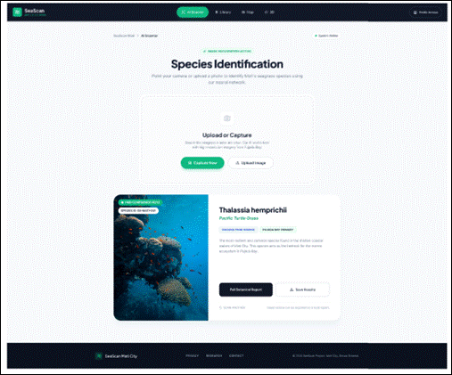
Figure 12 Scanner Page
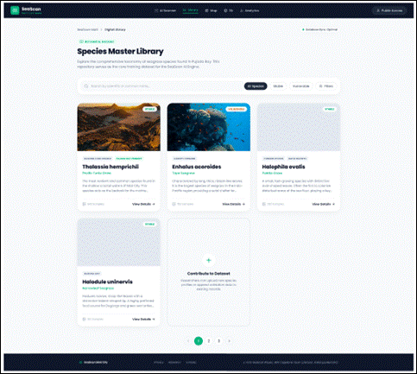
Figure 13 Digital Library
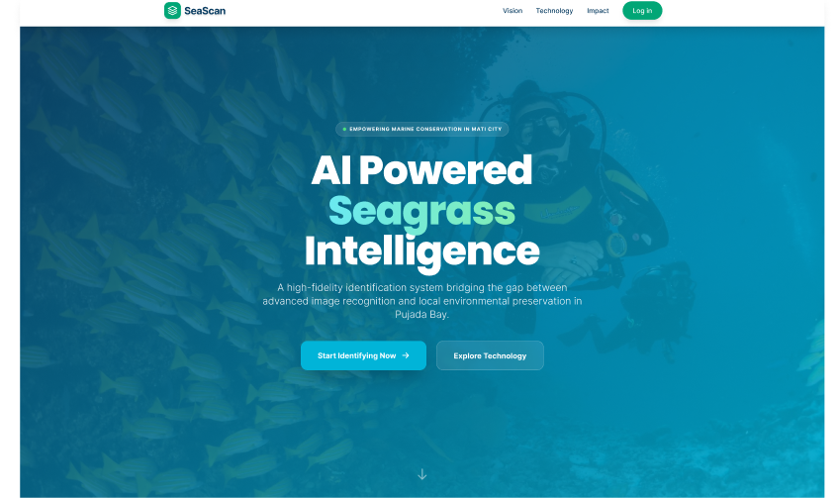
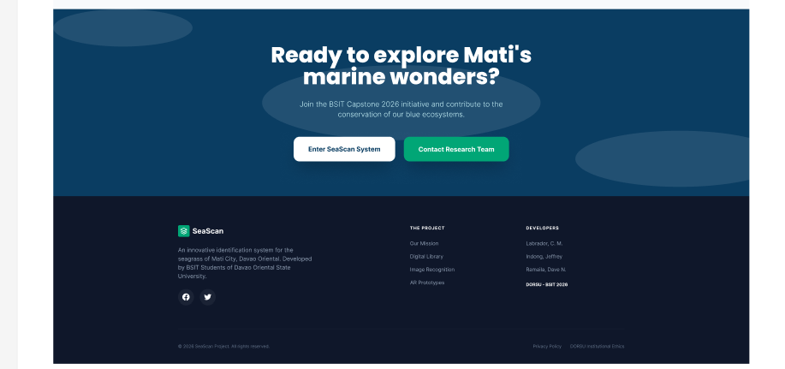
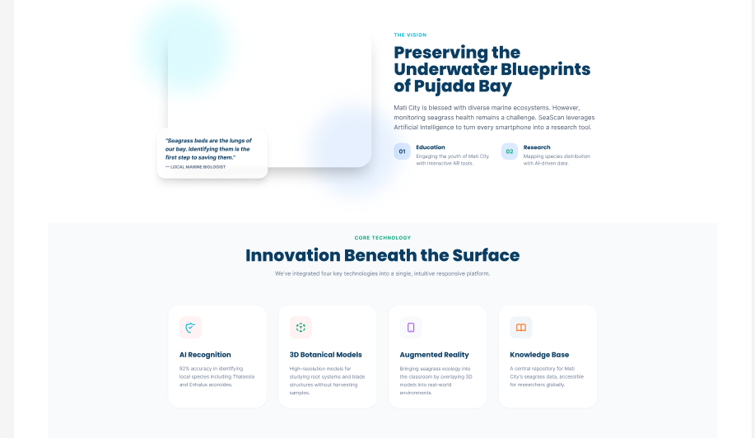
Figure 14 Public Viewer Page
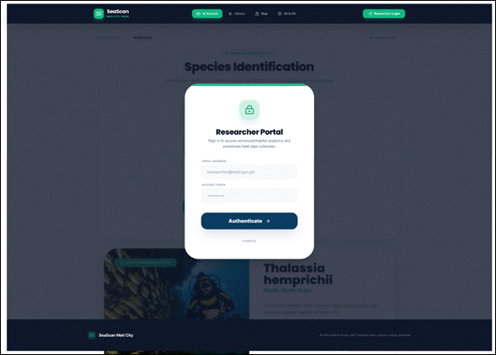
Figure 15 Login Modal
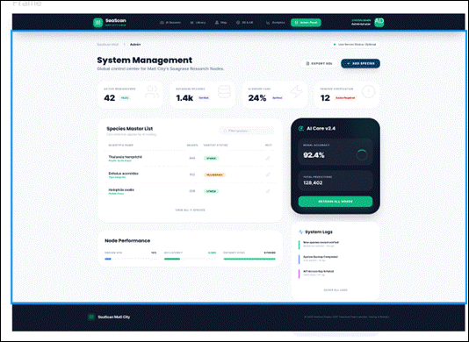
Figure 16 Admin Panel
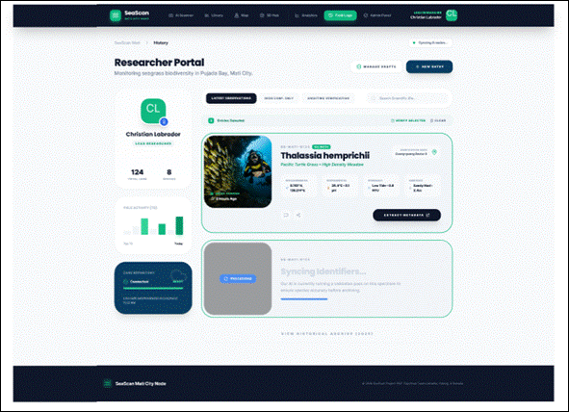
Figure 17 Researcher Panel

3.5 System Implementation
System Implementation covers the processes that will turn the SeaScan design into a working web-based system: developing and integrating the modules, testing the system technically and with its intended users, deploying it for actual use, and maintaining it after deployment. This stage translates the system design described in Section 3.4 into a functional product through systematic coding, module integration, and validation to ensure that all functional and non-functional requirements are met. The following subsections describe the system development, testing, deployment, and maintenance procedures that will be carried out in this study.
3.5.1 System Development
SeaScan will be developed using React.js for the responsive frontend, Python Flask for the backend, TensorFlow and Keras for the CNN model, Supabase (PostgreSQL) for the database and authentication, and Supabase Storage or Cloudinary for image storage, as described in Section 3.4. The CNN model will be trained in Google Colab using transfer learning on MobileNetV3 with the localized training dataset in Table 4, and the trained model will be exported and loaded by the Flask backend for inference. Development will follow the Coding phase of the Modified Waterfall methodology and will proceed module by module: user management and role-based access will be built first, followed by the CNN-based image recognition module, the digital library, and the species distribution mapping module.
The frontend and backend will communicate through RESTful API endpoints that receive uploaded photographs, return identification results, and retrieve species profiles and station data from the database. Security will be addressed through Supabase Auth with JSON Web Tokens, Row Level Security policies for each user role, input validation on every upload, and HTTPS on all hosted services. Source code will be managed in a GitHub repository with clear commit messages and consistent naming conventions so that the system can be maintained and extended by future developers.
3.5.2 System Testing
System testing will verify that SeaScan works correctly and will evaluate it both technically and with its intended users. The discussion is divided into two parts: technical testing, which does not involve human participants, and user testing and evaluation, which involves human participants and is therefore described in full detail. No user testing will begin until the DOrSU University Research Ethics Board (DOrSU-UREB) has issued the Ethical Clearance.
3.5.2.1 Technical Testing
Technical testing will ensure that the system functions correctly before it is presented to users. Unit testing will check individual functions and modules, such as image upload validation, the preprocessing pipeline, the identification API endpoint, and database queries for species profiles. Integration testing will check that the modules work correctly when combined, such as the flow from photo upload to CNN prediction to the display of the matching species profile, and the submission of a GPS-tagged sighting to the distribution map. System testing will evaluate SeaScan as a whole against the functional and non-functional requirements in Section 3.3, including cross-platform testing on mobile and desktop browsers.
The CNN model will be evaluated separately using Accuracy, Precision, Recall, and F1-Score per species class and a Confusion Matrix, as defined in Table 5. These metrics will be computed only from a held-out test set of seagrass photographs that the model did not see during training. This part of the evaluation does not involve human participants. A summary of test cases and results will be presented in Chapter IV, and the full test case results will be placed in the Appendices.
3.5.2.2 User Testing and Evaluation
User testing and evaluation will be conducted through User Acceptance Testing (UAT) with the intended users of SeaScan. The evaluation will use two instruments: a user evaluation questionnaire based on the ISO/IEC 25010 software product quality model (International Organization for Standardization [ISO], 2023), as required by the BSIT Capstone Project and Research Guidelines, and the System Usability Scale (SUS) (Brooke, 1996), which provides the usability benchmark of 70 stated in Objective 4. This is the only part of the study that involves human participants. The procedures below follow the National Ethical Guidelines for Research Involving Human Participants 2022 (Philippine Health Research Ethics Board [PHREB], 2022) and the Data Privacy Act of 2012 (Republic Act No. 10173).
Research Design
The user evaluation will use a descriptive, cross-sectional design with task-based usability testing. Each participant will complete one supervised session in which he or she performs three core tasks on SeaScan and then answers the ISO/IEC 25010 user evaluation questionnaire, the SUS, and two open-ended feedback questions. The design is mainly quantitative (questionnaire ratings, SUS scores, task completion, time on task, and errors), with a small qualitative component (open-ended feedback) that will help explain the scores and identify specific improvements to the interface.
Participants and Sample Size
The main evaluation will involve forty (40) adult participants, ten (10) from each of the four target user groups of SeaScan: (1) college students, (2) tourists, (3) fisherfolk and coastal community members, and (4) local researchers. This number is consistent with the forty (40) participants stated in DOrSU-UREB Form 11 and replaces the "minimum of 20 participants" stated in the earlier version of this manuscript. The change has been applied to Objective 4 (Section 1.3), Table 4, and Table 5. In addition, a separate group of forty (40) adult participants, ten (10) from each user group, will take part only in the pilot test of the questionnaire, as described under Research Instruments. The pilot participants will not be included in the main evaluation, so the total number of human participants is eighty (80).
The sample size is based on the following reasons. First, Tullis and Stetson (2004) found that the SUS produces reliable results with about 12 to 14 participants, so 40 participants is enough to produce a stable overall estimate with a reasonably narrow confidence interval. Second, the study aims to confirm that SeaScan is usable by each of its intended user groups, especially non-expert coastal community members, which requires enough people in every group to report group-level results. Ten (10) participants per group allows descriptive group-level reporting and an exploratory comparison between groups. Third, an equal allocation keeps any single group, especially students who are easier for the researchers to reach, from dominating the results. Slovin's formula is not used because it requires a known total population, and there is no complete list of the tourists, fisherfolk, and local researchers who may use SeaScan. For the pilot test, a sample of at least 30 is recommended when estimating the reliability of a newly developed scale (Johanson & Brooks, 2010); forty (40) participants, ten (10) per group, meets this recommendation and ensures that the wording and translations of the questionnaire are checked by members of every user group. The study does not recruit more participants than this because larger samples would add little precision while placing an unnecessary time burden on more people. The allocation is shown in Table 6.

Table 6. Participant Allocation by Target User Group
Target User Group | Operational Definition (summary) | Main (n) | Pilot (n) | Recruitment Venue
College students | Enrolled DOrSU college students aged 18+ from programs related to marine, fisheries, or environmental science; BSIT/FACET students are excluded | 10 | 10 | DOrSU Main Campus, through posted announcements
Tourists | Non-residents of Mati City aged 18+ visiting for leisure at the time of recruitment | 10 | 10 | Coastal tourism sites in Mati City (e.g., Dahican), with permission from the establishment
Fisherfolk / coastal community members | Residents of a coastal barangay of Mati City for at least one (1) year, aged 18+, engaged in a coastal livelihood | 10 | 10 | Coastal barangays near the documented seagrass stations, through the barangay and fisherfolk association
Local researchers | Adults who have conducted, assisted, or supervised marine/coastal research or monitoring in Davao Oriental within the past three (3) years | 10 | 10 | DOrSU research units, DENR-CENRO Mati, City Environment and Research Development Department
Total |  | 40 | 40

Sampling Method
The study will use purposive quota sampling, a non-probability method, in line with the BSIT Capstone Project and Research Guidelines, which require purposive sampling of respondents who are directly involved in the processes the system supports. Purposive sampling is appropriate because the evaluation aims to measure the quality and usability of SeaScan among the specific people it is designed for, not among the general population. A quota of ten (10) per group is set so that all four user groups are equally represented. Probability sampling is not practical because there is no complete sampling frame of tourists, fisherfolk, or local researchers in Mati City. Within each quota, eligible volunteers who give informed consent will be enrolled in the order they come forward until the quota is filled. Recruitment for every group will be spread across more than one day and, where possible, more than one site, so that the sample is not drawn only from people the researchers already know or can easily reach. Selection is based only on membership in an intended user group and on the inclusion and exclusion criteria below, which makes the selection equitable and directly related to the intended users of SeaScan.
Inclusion Criteria
A person may take part in the study if he or she meets all of the criteria listed below. These criteria ensure that every participant is a competent adult who belongs to the intended users of SeaScan and can complete the evaluation tasks.
a. is eighteen (18) years of age or older at the time of consent;
b. belongs to one of the four target user groups as defined below;
c. is able to use a mobile phone or computer web browser, that is, can open a website, tap or click buttons, and select a photo with little or no help (owning a device is not required because the researchers will provide one);
d. can read and understand English, Filipino, or Bisaya, the languages in which the consent form and instruments will be available; and
e. voluntarily gives written informed consent.
The four target user groups are operationally defined as follows. These definitions will be used to confirm group membership during recruitment.
1. College student — a currently enrolled DOrSU college student, aged 18 years or older, from a program related to marine biology, fisheries, or environmental science. Students of the BSIT program and of the Faculty of Computing, Engineering, and Technology (FACET) are excluded so that no participant is a classmate of, or under the academic authority of, the researchers, their adviser, or the panel members.
2. Tourist — a person aged 18 years or older who does not reside in Mati City and is visiting Mati City for leisure at the time of recruitment.
3. Fisherfolk or coastal community member — a person aged 18 years or older who has lived for at least one (1) year in a coastal barangay of Mati City along Pujada Bay or the Dahican coast and who is engaged in fishing, gleaning, seaweed farming, or another livelihood that takes place in the coastal or nearshore area, as confirmed by self-report or by membership in a local fisherfolk association.
4. Local researcher — a person aged 18 years or older who, within the past three (3) years, has conducted, assisted in, or supervised marine, coastal, or biodiversity research or monitoring in Davao Oriental. Examples include faculty and research staff of DOrSU marine and environmental programs, personnel of DENR-CENRO Mati and the City Environment and Research Development Department, and graduate students conducting coastal research.
Exclusion Criteria
A person will not be included in the study if any of the criteria below applies. Each criterion has a stated methodological or ethical reason, and no one will be excluded for any other reason.
a. The person is younger than 18 years old. Only adults who can give their own consent are included (see Protection of Vulnerable Participants).
b. The person does not belong to any of the four target user groups. The evaluation is meant to measure quality and usability for the intended users of SeaScan only.
c. The person cannot give valid informed consent, for example because he or she cannot understand the consent information after it has been explained in his or her preferred language.
d. The person cannot complete the required system-testing tasks even with the device and basic help provided. The SUS and the ISO/IEC 25010 questionnaire measure a user's own experience of operating the system, so the tasks must be performed by the participant.
e. The person took part in the pilot test, contributed to the design or dataset of SeaScan, served as an expert validator of the instruments, or is a member of the research team, a relative of a researcher, the research adviser, or a panel member. Prior exposure or a personal relationship could bias the evaluation.
f. The person is a student of the BSIT program or of FACET, to avoid any perceived academic pressure or relationship with the researchers, their adviser, or panel members.
Recruitment Procedure and Voluntary Participation
All recruitment will be done directly by the three student researchers, who hold no academic, employment, or community authority over any potential participant. The research adviser and other faculty members will not recruit, select, or encourage students to join. Potential participants will be approached as described below.
1. Students: With the permission of the concerned department chair, a printed and online announcement describing the study will be posted. The announcement will not be made inside classes or by instructors. Interested students will contact the researchers on their own.
2. Tourists: With permission from the management of the tourism establishment, the researchers will politely approach adult visitors in common areas at times that do not disrupt their activities, give a short verbal description of the study, and accept a refusal without further persuasion.
3. Fisherfolk and coastal community members: The researchers will first pay a courtesy call to the barangay captain and the fisherfolk association president to request permission. These officials will only share information about the study and will not select, assign, or pressure members to participate. Interested residents will come forward on their own.
4. Local researchers: A formal letter of invitation will be sent to the concerned offices and units. Interested individuals will reply directly to the researchers, and office heads will not be asked to assign staff to participate.
In all groups, participation is completely voluntary. Refusing to participate or withdrawing at any time will have no effect on a person's grades, academic standing, employment, access to services, relationship with DOrSU, or participation in any barangay, fisherfolk association, or government community program. No one will be promised any benefit from such programs in exchange for participation. Participants will receive no monetary payment; a light snack will be offered to every person who attends a session as a token of appreciation, whether or not he or she completes it.
Informed Consent Procedure
Before any data are collected, a researcher will explain the Informed Consent Form (ICF) to each potential participant in English, Filipino, or Bisaya, according to the person's preference. The explanation will cover the purpose of the study, what the participant will be asked to do, the expected duration, possible risks and discomforts, how data will be protected, and the right to refuse or withdraw. The person will be given enough time to read the form and ask questions and will be told that there is no need to decide immediately. A person who agrees will sign the ICF and receive a copy. Age will be confirmed by self-declaration on the ICF. No data will be recorded from anyone who has not signed the ICF, and the same procedure applies to pilot test participants.
Research Instruments
Four instruments will be used in each session. Copies of the final instruments will be placed in the Appendices as the Survey User Evaluation Questionnaire.
1. Participant Profile Sheet — records the participant code, user group, age bracket, sex (optional), and self-rated familiarity with smartphones and web browsers. Names are not recorded on this sheet.
2. Task Scenario Sheet and Observation Checklist — lists three core tasks: (1) identify a seagrass species by uploading a prepared photograph in the Scanner page; (2) find and open a species profile in the Digital Library; and (3) view the species distribution map and submit a sample sighting using a preset demonstration location. For each task, the researcher records whether it was completed, the time taken, and the number of errors or requests for help.
3. ISO/IEC 25010 User Evaluation Questionnaire — a researcher-made questionnaire based on the ISO/IEC 25010 product quality model (ISO, 2023), with items grouped under five quality characteristics relevant to SeaScan: Functional Suitability (for example, the system correctly identifies and describes seagrass species), Performance Efficiency (for example, results are displayed quickly), Usability or Interaction Capability (for example, the interface is easy to learn and use), Reliability (for example, the system works without errors or crashes), and Security (for example, user data and accounts are protected). Each item is rated on a 5-point Likert scale: 5 – Strongly Agree, 4 – Agree, 3 – Neutral, 2 – Disagree, and 1 – Strongly Disagree.
4. System Usability Scale (SUS) and Open-ended Feedback — the standard 10-item SUS rated on a 5-point scale (Brooke, 1996), followed by two open-ended questions: "What did you like most about using SeaScan?" and "What was difficult or confusing, and how could it be improved?"
The ISO/IEC 25010 questionnaire will undergo expert validation by three (3) validators, consisting of IT professionals or faculty members with expertise in software evaluation, including the research adviser. The validators will rate each item for clarity, relevance, and accuracy using an Expert Evaluation Form, and items will be revised or removed based on their comments. Filipino and Bisaya versions of the questionnaire and the SUS will be translated, back-translated, and checked against the English version. The validated instruments will then be pilot tested with forty (40) participants, ten (10) from each user group, who are separate from the main evaluation participants, meet the same inclusion criteria, and give informed consent. Pilot participants will follow the same session procedure, using SeaScan before answering the questionnaire, and will also be asked whether any item or instruction was unclear. The internal consistency of each quality characteristic and of the whole questionnaire will be computed from the pilot data using Cronbach's alpha, with a value of at least 0.70 considered acceptable; items that lower reliability or are reported as unclear will be revised or removed. The pilot test will also check the translations, the session flow, and the time needed. Pilot data will be used only to refine the instruments and will not be included in the evaluation results. Cronbach's alpha will be computed again from the main evaluation data to confirm the reliability of the final questionnaire.
Administration Procedure and Duration of Participation
Each participant will take part in one session only, with no follow-up. Sessions will be held on land in a quiet and safe place convenient to the participant, such as a room at the DOrSU campus, the barangay hall, or the lobby of a tourism establishment. Participants will not be asked to enter the water or collect photographs in the field. All seagrass images used in the tasks will come from a prepared set of photographs provided by the researchers. A researcher-provided smartphone and laptop with generic test accounts will be used. The session will run as follows: (1) welcome, explanation of the study, and informed consent, about 10 minutes; (2) participant profile sheet, about 3 minutes; (3) the three core tasks, about 15 to 20 minutes; (4) the ISO/IEC 25010 questionnaire, about 10 minutes; (5) the SUS and open-ended feedback, about 5 to 10 minutes; and (6) a short debriefing. The total time is about 45 to 60 minutes, with short breaks allowed at any point. To reduce researcher influence, instructions will be read from a standard script, the researchers will not comment on the participant's performance, and completed questionnaires will be placed by the participant in a closed envelope or box.
Protection of Vulnerable Participants
Only competent adults aged 18 years or older will participate. No minors will be recruited; the "students" group refers only to college students aged 18 years or older. Because no minors are involved, parental or guardian permission and assent are not required. Some fisherfolk and coastal community members may be economically vulnerable or less familiar with technology. To protect them, sessions will be scheduled at times that do not interfere with fishing or other livelihood activities, materials will be available in Bisaya, community officials will not take part in selecting participants, and the researchers will make clear that the session tests the system, not the person. Students will be protected by excluding BSIT/FACET students and by keeping the research adviser and faculty out of recruitment. No participant should feel obliged to join because of academic standing, a relationship with faculty, or access to services.
Risk Assessment
The study involves no more than minimal risk. Participants will only use a website for about 45 to 60 minutes and answer short questionnaires. No physical, invasive, field-based, or in-water activities are involved, so risks related to coastal or marine environments do not apply. The foreseeable risks and the measures to minimize them are summarized in Table 7.

Table 7. Risk Assessment and Mitigation Measures for Participants
Possible Risk or Discomfort | Likelihood / Severity | Mitigation Measures
Eye strain or tiredness from screen use | Low / Minor | Session limited to about 60 minutes; short breaks allowed at any time; screen brightness and text size adjustable
Mild anxiety or embarrassment about technology skills | Low / Minor | Participants are told that the system, not the person, is being tested; no right or wrong answers; researchers do not comment on performance
Breach of privacy or confidentiality | Low / Moderate | No names on instruments; participant codes used; consent forms stored separately; access limited to the research team and adviser; secure storage and disposal
Loss of time or income (especially fisherfolk) | Low / Minor | Sessions scheduled at the participant's convenience and outside livelihood hours; held near the participant's residence
Inconvenience to tourists during their visit | Low / Minor | Session held in a quiet common area; tourists may decline or stop at any time

If a participant shows discomfort or distress during the session, the researcher will pause or end the session. There are no direct benefits to participants, but they may learn about the seagrass species of Mati City, and their feedback will help improve a tool intended for the local community.
Data Collected, Confidentiality, and Data Management
The study will collect only the data produced by the instruments described above: profile information (user group, age bracket, optional sex, and device familiarity), task results, questionnaire and SUS responses, and open-ended feedback. No photographs, audio, or video of participants will be taken; any photo documentation of the testing venue required for the Appendices will not show participants' faces. Participants will use generic test accounts, so no personal information will be entered into SeaScan. The photographs uploaded during testing come from the researchers' prepared set and contain no personal information; location metadata (EXIF data) will be removed from these images, and the sighting task will use a preset demonstration location rather than the participant's actual GPS location. Data and images produced during the evaluation sessions will not be used for CNN training and will be deleted from the SeaScan database after the evaluation.
Each participant will be identified only by a code (for example, ST-01 for students, TR-01 for tourists, FF-01 for fisherfolk, and LR-01 for researchers). Signed consent forms, which contain names, will be stored separately from the coded response sheets. Paper records will be kept in a locked cabinet, and electronic files will be stored in a password-protected, encrypted folder. Only the three researchers and the research adviser will have access. Results will be reported only in aggregate, and no individual will be identifiable in any report or presentation. All research records will be kept for three (3) years after the completion of the study, or longer if required by DOrSU policy. After that period, paper records will be shredded and electronic files permanently deleted.
Withdrawal Criteria and Handling of Incomplete Data
Participation is voluntary, and a participant may withdraw at any time, before, during, or after the session, without giving a reason and without any penalty or loss of benefits. If a participant withdraws, he or she will be asked whether the data already collected may be kept. If the participant asks that the data be removed, all records linked to his or her code will be deleted or shredded. Removal is possible until the data are aggregated at the end of data analysis, after which individual responses can no longer be identified; this will be explained in the ICF. A participant may also be withdrawn by the researchers if he or she shows distress or is found not to meet the eligibility criteria.
An SUS form with any unanswered item will not be used to compute an SUS score, because the score requires all ten items. For the ISO/IEC 25010 questionnaire, each item mean will be computed from the participants who answered that item, and the number of missing responses will be reported. For partially completed testing sessions, data from completed tasks will be kept unless the participant asks for their removal. A withdrawn or incomplete participant may be replaced by another eligible volunteer from the same user group to maintain the quota of ten (10), and the number of withdrawals and incomplete responses will be reported.
Data Analysis Plan
The collected responses will be analyzed statistically using descriptive and inferential statistics. The ISO/IEC 25010 questionnaire will be analyzed using the weighted mean, its corresponding scale designation and descriptive interpretation, and the standard deviation for each item, each quality characteristic, and the overall rating, for all participants and for each user group. The weighted mean will be interpreted using the scale in Table 8, and an overall weighted mean of at least 3.41 (Agree / Acceptable) will indicate that SeaScan is acceptable to its users. A standard deviation of 1.00 or below will be interpreted as homogeneous responses, meaning that the weighted mean represents the choices of most participants well, while a value above 1.00 will be interpreted as heterogeneous responses, meaning that the participants' ratings varied widely.

Table 8. Likert Scale Interpretation for the ISO/IEC 25010 User Evaluation Questionnaire
Scale | Mean Range | Designation | Descriptive Interpretation
5 | 4.21 – 5.00 | Strongly Agree | Highly Acceptable
4 | 3.41 – 4.20 | Agree | Acceptable
3 | 2.61 – 3.40 | Neutral | Moderately Acceptable
2 | 1.81 – 2.60 | Disagree | Slightly Acceptable
1 | 1.00 – 1.80 | Strongly Disagree | Not Acceptable

SUS responses will be scored following Brooke (1996): for odd-numbered items, 1 is subtracted from the response; for even-numbered items, the response is subtracted from 5; and the adjusted values are summed and multiplied by 2.5 to give a score from 0 to 100. The mean, standard deviation, median, minimum, maximum, and 95% confidence interval of the SUS score will be reported for all 40 participants and for each user group, and the scores will be interpreted using the grading scales summarized by Lewis (2018). Normality will be checked with the Shapiro-Wilk test, and a one-sample t-test (α = 0.05) will determine whether the mean SUS score is significantly higher than the benchmark of 70 (Sauro & Lewis, 2016); if the data are not normally distributed, the Wilcoxon signed-rank test will be used instead. As an exploratory analysis, one-way ANOVA, or the Kruskal-Wallis test if its assumptions are not met, will compare SUS scores and overall questionnaire ratings across the four user groups to identify any group that found the system harder to use.
Task performance will be summarized as the completion rate (%), mean time on task, and mean number of errors or requests for help for each task and user group. Responses to the open-ended questions will be analyzed using thematic analysis (Braun & Clarke, 2022): the responses will be read, coded, grouped into themes, and summarized with their frequencies. Analyses will be performed using Microsoft Excel and Python (SciPy). The results will determine whether SeaScan meets the SUS target of 70 and the acceptability threshold of the ISO/IEC 25010 evaluation, and they will guide final refinements before deployment.
Disclosure of Potential Conflicts of Interest
The researchers declare that they have no financial, commercial, or personal conflict of interest in this study. The study is self-funded by the researchers (Table 2) and receives no funding from any company or organization. The researchers have no financial relationship with any of the platforms or service providers used to build SeaScan, and SeaScan is a non-commercial academic project. Because the researchers are evaluating a system they developed, there is a possible bias in favor of positive results. To reduce this bias, the study uses standardized and expert-validated instruments, scripted instructions, participant-sealed questionnaires, and the exclusion of anyone with a personal or academic relationship with the research team.
3.5.3 System Deployment
After user testing and final refinements, SeaScan will be deployed on cloud platforms as described in Section 3.4: the React.js frontend on Vercel, the Python Flask backend and CNN model on Render, and the database, authentication, and image storage on Supabase. Deployment will involve setting the environment variables and credentials on each platform, migrating the database schema and loading the nine (9) species profiles and the GPS-verified station data, uploading the trained CNN model, and creating the administrator and researcher accounts. Deployment will start with a limited pilot release to a small group of users before the system is opened to the public, so that stability can be checked and initial feedback gathered.
A short orientation will be given to the administrator and researcher account holders on managing species records and reviewing submitted sightings. A User Manual describing how to use the Scanner, the Digital Library, and the distribution map will be prepared and placed in the Appendices. After deployment, the researchers will monitor the system for errors and downtime, check response times of the identification feature, and keep regular backups of the database, which marks the transition to the maintenance phase.
3.5.4 System Maintenance
After deployment, errors and bugs will be reported by users through a feedback link in the system and by administrators directly to the developers. Reported issues will be logged and tracked in the GitHub repository and resolved according to their severity. System updates will include adding or correcting species information in the digital library, fixing security vulnerabilities, improving performance, and retraining the CNN model when new validated photographs become available. User support will be provided through the User Manual, a short frequently asked questions (FAQ) page, and a contact email for the development team.
The database will be backed up weekly by exporting it to a secure cloud storage folder maintained by the researchers, and the system will be restored from the latest backup in case of failure. For sustainability, the researchers will maintain SeaScan during its first year of operation, as covered by the maintenance budget in Table 2. Before graduation, the researchers will seek to endorse the system, its source code, and its documentation to a DOrSU unit or partner office involved in marine conservation in Mati City, subject to the agreement of that office, so that SeaScan remains available for long-term use.

LITERATURE CITED
Abadi, M., Barham, P., Chen, J., Chen, Z., Davis, A., Dean, J., Devin, M., Ghemawat, S., Irving, G., Isard, M., Kudlur, M., Levenberg, J., Monga, R., Moore, S., Murray, D. G., Steiner, B., Tucker, P., Vasudevan, V., Warden, P., ... Zheng, X. (2016). TensorFlow: A system for large-scale machine learning. Proceedings of the 12th USENIX Symposium on Operating Systems Design and Implementation, 265–283. https://www.tensorflow.org
Affouard, A., et al. (2023). Pl@ntNet: A collaborative platform for plant identification and biodiversity monitoring. Biodiversity Information Science and Standards. https://www.plantnet.org/
Amershi, S., Begel, A., Bird, C., DeLine, R., Gall, H., Kamar, E., Nagappan, N., Nushi, B., & Zimmermann, T. (2019). Software engineering for machine learning: A case study. Proceedings of the 41st International Conference on Software Engineering: Software Engineering in Practice, 291–300.
Angsinco-Jimenez, L., Nogodula, R., & Tans, D. (2003). Assessment of seagrass and macrobenthic algae in Pujada Bay, Mati, Davao Oriental. Davao Research Journal, 6(1). https://doi.org/10.59120/drj.v6i1.46
Bassil, Y. (2012). A simulation model for the waterfall software development life cycle. International Journal of Engineering and Technology, 2(5), 1–7.
Bisong, E. (2019). Google Colaboratory. In Building machine learning and deep learning models on Google Cloud Platform (pp. 59–64). Apress. https://doi.org/10.1007/978-1-4842-4470-8_7
Braun, V., & Clarke, V. (2022). Thematic analysis: A practical guide. SAGE Publications.
Brooke, J. (1996). SUS: A "quick and dirty" usability scale. In P. W. Jordan, B. Thomas, B. A. Weerdmeester, & I. L. McClelland (Eds.), Usability evaluation in industry (pp. 189–194). Taylor & Francis.
Cloudinary. (2024). Cloudinary media management platform. https://cloudinary.com
CMS Dugong MoU Secretariat. (2026). Dugong & seagrass hub. https://www.dugongseagrass.org/
Department of Environment and Natural Resources. (2020). Scaling up of coastal and marine ecosystems management program. Biodiversity Management Bureau. https://denr.gov.ph/wp-content/uploads/2023/05/Scaling_Up_of_Coastal_and_Marine_Ecosystems.pdf
Fauville, G., Stenliden, L., Mäkitalo, Å., & Lantz-Andersson, A. (2025). A deep dive into extended reality for marine education and ocean literacy. Ocean and Society, 2, Article 10714. https://doi.org/10.17645/oas.10714
Fortes, M. D. (2013). A review: Biodiversity, distribution and conservation of Philippine seagrasses. Philippine Journal of Science, 142(Special Issue), 95–111. https://www.apn-gcr.org/publication/a-review-biodiversity-distribution-and-conservation-of-philippine-seagrasses/
Global Biodiversity Information Facility. (2026). GBIF: The global biodiversity information facility. https://www.gbif.org/
Goëau, H., Bonnet, P., & Joly, A. (2025). PlantCLEF and Pl@ntNet advancements in automated plant identification. Pl@ntNet Consortium. https://www.plantnet.org/
Green, E. P., & Short, F. T. (Eds.). (2003). World atlas of seagrasses. University of California Press. https://archive.org/details/worldatlasofseag03gree
Grinberg, M. (2018). Flask web development: Developing web applications with Python (2nd ed.). O'Reilly Media.
Howard, A., Sandler, M., Chu, G., Chen, L. C., Chen, B., Tan, M., Wang, W., Zhu, Y., Pang, R., Vasudevan, V., Le, Q. V., & Adam, H. (2019). Searching for MobileNetV3. Proceedings of the IEEE/CVF International Conference on Computer Vision, 1314–1324. https://doi.org/10.1109/ICCV.2019.00140
iNaturalist. (2026). iNaturalist: Explore the world of nature. https://www.inaturalist.org/
International Organization for Standardization. (2023). Systems and software engineering — Systems and software Quality Requirements and Evaluation (SQuaRE) — Product quality model (ISO/IEC Standard No. 25010:2023). https://www.iso.org/standard/78176.html
Jabbar, M. A., Samreen, S., & Aluvalu, R. (2023). A systematic framework for software development lifecycle management in web-based applications. Journal of Software Engineering and Applications, 16(1), 1–15.
Johanson, G. A., & Brooks, G. P. (2010). Initial scale development: Sample size for pilot studies. Educational and Psychological Measurement, 70(3), 394–400. https://doi.org/10.1177/0013164409355692
Jones, M., Bradley, J., & Sakimura, N. (2015). JSON Web Token (JWT) (RFC 7519). Internet Engineering Task Force. https://datatracker.ietf.org/doc/html/rfc7519
Laanti, M., Similä, J., & Abrahamsson, P. (2019). Definitions of agile software development and agility: A systematic literature review. In International Conference on Agile Software Development (pp. 335–348).
LeCun, Y., Bengio, Y., & Hinton, G. (2015). Deep learning. Nature, 521(7553), 436–444. https://doi.org/10.1038/nature14539
Lewis, J. R. (2018). The System Usability Scale: Past, present, and future. International Journal of Human–Computer Interaction, 34(7), 577–590. https://doi.org/10.1080/10447318.2018.1455307
Meta Open Source. (2024). React: The library for web and native user interfaces. https://react.dev

Nordlund, L. M., et al. (2024). One hundred priority questions for advancing seagrass conservation in Europe. Plants, People, Planet, 6(3), 587–603. https://doi.org/10.1002/ppp3.10486
Petersen, K., Wohlin, C., & Baca, D. (2009). The waterfall model in large-scale development. Lecture Notes in Business Information Processing, 32, 386–400.
Pl@ntNet Consortium / CIRAD-INRAE-INRIA-IRD. (2009). Pl@ntNet plant identification. https://identify.plantnet.org/
Philippine Health Research Ethics Board. (2022). National ethical guidelines for research involving human participants 2022. Philippine Council for Health Research and Development.
Republic of the Philippines. (2012). Republic Act No. 10173: Data Privacy Act of 2012. Official Gazette.
Sanchez-Delute, C. C., Atoy, S. E. B., & Ybañez, C. O., Jr. (2025). Seagrass ecosystems in Pujada Bay, Davao Oriental, Philippines: Evaluating the impact of anthropogenic pressures on species richness. Academia Journal of Biology, 47(3), 13–26. https://doi.org/10.15625/2615-9023/22573
Sauro, J., & Lewis, J. R. (2016). Quantifying the user experience: Practical statistics for user research (2nd ed.). Morgan Kaufmann.
Short, F. T., et al. (2011). Extinction risk assessment of the world's seagrass species. Biological Conservation, 144(7), 1961–1971. https://doi.org/10.1016/j.biocon.2011.04.010
Smilkov, D., et al. (2019). TensorFlow.js: Machine learning for the web and beyond. Proceedings of the 2nd SysML Conference. https://arxiv.org/abs/1901.05350
Supabase. (2024). Supabase: The open-source Firebase alternative. https://supabase.com
Tullis, T. S., & Stetson, J. N. (2004). A comparison of questionnaires for assessing website usability. Proceedings of the Usability Professionals Association (UPA) 2004 Conference, Minneapolis, MN.
Vercel. (2024). Vercel deployment and hosting platform. https://vercel.com
Wäldchen, J., & Mäder, P. (2022). Towards more effective identification keys: From paper to pixels and beyond. People and Nature, 4(5), 1142–1155. https://doi.org/10.1002/pan3.10405
Waycott, M., et al. (2009). Accelerating loss of seagrasses across the globe threatens coastal ecosystems. Proceedings of the National Academy of Sciences, 106(30), 12377–12381. https://doi.org/10.1073/pnas.0905620106
WoRMS Editorial Board. (2026). World register of marine species. Flanders Marine Institute. https://www.marinespecies.org/

