

**Higher Diploma in Science**

**in Computer Science (Level 8)**

**Year 1**

**June Onsite 2019**

**Programme Handbook**

**June 13th/14th**

**Location: WIT Arena**

**Department of Mathematics & Computing**

**School of Lifelong Learning & Education**

**Waterford Institute *of* Technology**



**Table of Contents**

Welcome to the June ICT Skills Onsite 3

Agenda 4

Panel Presenter Biographies 7

Brian Robinson – Dataworks 8

Sandra Whelan – VR Education Plc 9

Padraig O’Scanaill – Fundrecs 10

Maeve Carey: DistilledSCH (Brands: Adverts, Daft & Donedeal) 11

John Rellis – Servisbot 12

Shane McCormack - Sunlife Financial 13

Rory O’Connor – Scurri 14

Staff Contact Details 15

## Welcome to the June ICT Skills Onsite

Welcome to the June on site – and we are delighted to host you in person after all the ‘virtual’ interactions to date. With a significant set of learning completed and assessed, we can start to look forward to the next stage on our journey.

This two day event will serve a dual purpose: preview modules from Semester 2; and start the process of introducing you to some of our industry partners. In addition, we are taking the opportunity of taking you deeper into git and GitHub – via a workshop in conjunction with one of our industry partners.

All the material from the workshop & presentations will be on our course web as usual:

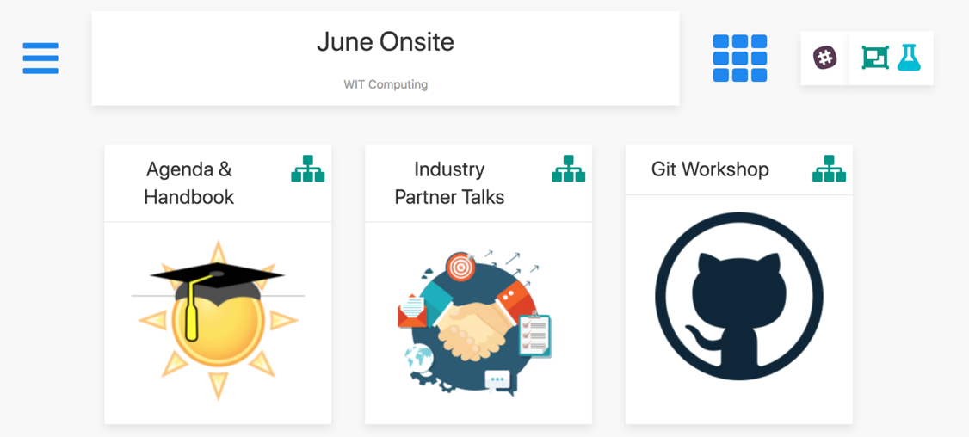

In addition, introductory content associated with the new modules will be hosted in new course webs:

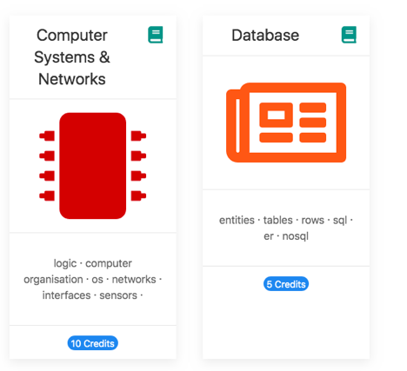

We hope the experience will be rewarding and the content stimulating, you take the opportunity to meet your fellow students in person and also relax and enjoy the content + the location (we are very proud of our new Greenway!).

This handbook provides the agenda + details on our industry panel session on Friday.

Best of Luck

Eamonn de Leastar, Colm Dunphy, Joan Mangan, June, 2019

## **Agenda**

|  |  |  |
| --- | --- | --- |
| Thursday June 13 | | |
|  |  | |
| 9.00 | **Welcome, Agenda,**  **Work Placement brief** Eamonn de Leastar, Colm Dunphy  Joan Mangan | Semester 2 Preview  Work placement |
|  |  |  |
| 9.30 | Computer Systems & Networks  Frank Walsh, Caroline Cahill | Workshop 1 |
|  |  |  |
| 10.30 | Coffee Break |  |
|  |  |  |
| 11.00 | Computer Systems & Networks  Frank Walsh, Caroline Cahill | Workshop 1 |
|  |  |  |
| 12.00 | Greenway Walk | |  | | --- | |  | | |
|
|  |  |  |
| 13.00 | Lunch |  |
|  |  |  |
| 14.00 | GIT Workshop  Redhat  Aiden /Ger |  |
| 17.00 | Finish |  |

|  |  |  |  |
| --- | --- | --- | --- |
| Friday June 14 | | | |
|  |  | | |
| 9.00 | Data Science  Bernard Butler | | TSSG |
|  |  | |  |
| 10.00 | Database  Mary Lyng, Roseanne Birney | | Workshop 2 |
|  |  | |  |
| 11.00 | Coffee Break | |  |
|  |  | |  |
| 11.15 | Database  Mary Lyng, Roseanne Birney | | Workshop 2 |
|  |  | |  |
| 12.00 | Manage to Learn!  Greenway events  Laura Mc G | |  |
| 13.00 | Lunch | |  |
|  |  | |  |
| 14.00 |  | | Employer Partners Panel Discussion |
|  |  | |
|  |  | |
|  |  | |
|  |  | |
|  |  | |
|  |  | |
|  |  | |
|  | |
| 16.00 | Finish | | Travel | The Three Ninjas |

**Panel Discussion; ‘Transitioning to a Career in Technology’**

|  |  |  |
| --- | --- | --- |
| Presenter | Organisation | Organisation website |
| Brian Robinson | **Dataworks** | [www.dataworks.ie](http://www.dataworks.ie/) |
| Sandra Whelan | **VR Education** | **https://immersivevreducation.com/** |
| Padraig O Scanaill | **Fundrecs** | [**https://www.fundrecs.com/**](https://www.fundrecs.com/) |
| Maeve Carey | **Distilled** | **http://distilledsch.ie/** |
| John Rellis | **Servisbot** | **https://servisbot.com/** |
| Rory O’Connor | **Scurri** | **https://www.scurri.com/** |
| Shane McCormack | **Sunlife TBC** | <https://www.cgmllc.net/> |
|  |  |  |

## Panel Presenter Biographies



** **

## Brian Robinson – Dataworks

**Title:**  Chief Technical Officer

**Company Profile:** Dataworks provides software solutions and validation services to clients in the Life Sciences Sector. Many of our software solutions focus on the Digital Transformation of paper-based Batch Record systems to fully computerised systems. We also help our clients to use the data captured in their new and existing systems to support Continuous Improvement projects so they have a better view of the manufacturing process and more information to support better decision making – real-time KPIs. Dataworks also offer validation services from lab equipment to lab systems through to MES and ERP. We validate equipment, automation and software systems. Dataworks offers outsourced managed services where we provide front line and remote support on software systems – both ones we have developed for the clients, and ones which we may not have developed, but which are based on technology platforms that we work with on a daily basis e.g. MS .NET, SQL Server, MS Dynamics, etc.

**Specialties:** Software Development, Software Validations, Continuous Improvement through the application of technology, Business Process Automation, Digital Transformation, Data Visualisation, Data Analytics

**Personal Profile:**  Brian has an honours degree in Electronic Engineering from Trinity College Dublin and a Masters in Enterprise Software Development from Waterford Institute of Technology. He founded Dataworks in 1995 with his business partner Liam Curham. As the company grew, Brian has gone from Designing and Developing Software Systems for SME’s to giving Strategic, Technical and Operational direction to a thirty-five strong workforce that deliver solutions to some of the biggest names in the Pharmaceutical and Medical Device sector in the World.

**Contact Details:**

**Address:** Unit 4i, Six Cross Roads Business Park, Waterford, Ireland

**Phone:** +353 51 878 555

**email:** [brobinson@dataworks.ie](mailto:brobinson@dataworks.ie) **Web:** [www.dataworks.ie](http://www.dataworks.ie/)

## Sandra Whelan – VR Education Plc

**Title: Co- Director/Founder**

**Company Profile:**

VR Education founded in 2014 and headquartered in Waterford is a multi-award winning virtual/augmented reality (VR/AR) software firm dedicated to changing how educational content and corporate training are provided and consumed globally. Dual listing on the London Stock Exchange AIM and Irish Stock Exchange ESM, VR Education is at the forefront of virtual and augmented reality in the education and simulated training space. Their award-winning ENGAGE platform allows educators and corporate trainers to share their own content in a virtual setting, inspiring students whether in a classroom, lecture theatre, operating theatre or on the surface of Mars. (www.engagevr.io) VR Education has also won global accolades for its showcase experiences, Apollo 11 VR, Titanic VR and 1943:Berlin Blitz. VR Education works with leading institutes and universities including, but not limited to, University of Oxford, Royal College of Surgeons and the BBC.

**Personal Profile:**

Sandra Whelan is Chief Operating Officer at VR Education. Sandra also worked as a Senior Editor and Content Creator for a top ranked virtual reality website, where she developed a strong rapport with key software developers in the industry. Sandra also has significant experience working with large corporations’ contract management and accounts management.

Additionally, Sandra was a judging panel member for the Waterford Local Enterprise Irelands Best Young Entrepreneur Competition in 2017 and 2019, where she judged finalists for three National Category Awards; ‘Best Business Idea’, ‘Best Start Up Business’ and ‘Best Established Business’.

In March of 2018, Sandra and her team successfully listed VR Education Holdings on the London and Irish Stock Exchange.

Following this, Sandra and her husband were the recipients of The Irish Times Business People of the Month Award for March 2018 and finalists for the Entrepreneur of the Year Awards 2018 under the Emerging Category.

**Email: sandra@immersivevreducation.com**

**Web:** [**http://www.vreducationholdings.com/index.asp**](http://www.vreducationholdings.com/index.asp)



## Padraig O’Scanaill – Fundrecs

**Title: Director/Founder @ Fundrecs**

**Company Profile:**

Fund Recs was founded in 2013 when the company founders were approached by a large bank to develop a new reconciliation platform for it's Fund Administration unit. With over 25 years operational and technology experience between them the team are building a platform to transform how data is managed, processed and leveraged by the Funds Industry.

Fund Recs recently launched [VELOCITY](https://www.fundrecs.com/velocity.html) platform for Fund Administrators empowers Administrators to process valuations faster and with increased oversight. Taking the latest technology and approaches from the best loved consumer software applications, the Fund Recs team are combining consumer user experience and interfaces with enterprise accuracy, security and availability.

The team at Fund Recs believes that the software we use in day-to-day business activities should be as well designed and easy to use as the consumer applications we enjoy every day in our personal life.  By combining ease of use with powerful processing, flexible data import and key Industry knowledge we have set out on our mission towards developing the most efficient, powerful and cost effective reconciliation software available.

**Personal Profile:**

Padraig has over 12 years’ experience as a Software Engineer and Web Developer. Padraig has a BSc, (Hons) Information Technology & Telecommunications from the University of Limerick and obtained a postgraduate diploma in Computing and Web Application Development through the Graduate Initial Fidelity Training (GIFT*) program at Fidelity Ireland.

Padraig's past roles have included Software Engineer at Cashbooks Limited and as a Java and Oracle Developer at Fidelity Investments.

Padraig is one of the 3 founders of Fund Recs. He manages a team of 8 developers in the Waterford office.

**Contact Details:**

**Email: padraig@fundrecs.com**

**Web:** [**https://www.fundrecs.com/**](https://www.fundrecs.com/)

**Contact Details:**

**Address:** ArcLabs Research & Innovation Building, WIT West Campus, Carriganore, Co. Waterford

**Web:** <https://www.fundrecs.com>



## Maeve Carey: DistilledSCH (Brands: Adverts, Daft & Donedeal)

**Title: Head of Biz Ops**

**Company Profile:**

DistilledSCH is the leader in online marketplaces in Ireland. In July 2015, the Irish owned company *Distilled Media* and the group *Schibsted Media Group -* the Oslo listed international media group and leading player within online marketplaces globally - announced the establishment of a combined business. It became known as *DistilledSCH* and is now Ireland's leading online media company. The company is located in Dublin, Waterford and Wexford.

Distilled SCH makes up three highly successful Irish online marketplaces.

**1/ DoneDeal.ie** is one of Ireland’s largest classifieds websites and is the number one destination to buy and sell cars online

**2/ Daft.ie** is the leading real estate website and app in Ireland

**3/ Adverts.ie** is a mobile-first platform for buying and selling goods and services. With a focus on community, it offers buyers and sellers alike with a unique, trusted approach to buying and selling online

The company is located in Dublin, Waterford and Wexford.

**Personal Profile:**

**Email:**

**Address:**

**Web:** [**http://distilledsch.ie/**](http://distilledsch.ie/)

** **

## John Rellis – Servisbot

**Title: Team Lead at ServisBot**

**Company Profile:**

ServisBot provides a Conversational Artificial Intelligence (AI) Platform for businesses to build natural language solutions, virtual assistants and chatbots that transform customer and employee engagement across multiple digital channels and across many different journeys.

Chatbot and natural language solutions now enable people to search for knowledge, raise tickets, query transactions, renew memberships, book travel, schedule appointments, transfer money, and engage across multiple journeys. This is what is known as Conversational AI, and it is the key to advance automation and self-service for customers and employees.

**Personal Profile:**

John started working in tech after graduating from WIT in 2007 and is now Team Lead of the Core Services Team in ServisBot. The Core Services Team’s primary focus is the development and management of “Serverless” MicroServices on a fully native AWS stack to serve ServisBot’s Conversational AI platform to the world.

**Address:** ArcLabs, WIT West Campus, Carriganore, Waterford.

**Web:** https://servisbot.com/

**Email:**  john.rellis@servisbot.com

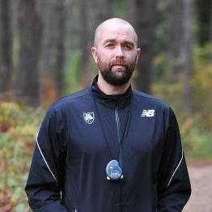

## Shane McCormack - Sunlife Financial

**Title: Director of Application Development**

**Company Profile:**

Sun Life Financial, is a leading global financial services organisation with 150 yrs experience. We provide a diverse range of wealth accumulation and insurance products. You'll find us just about everywhere including Canada, the U.S., the U.K., Ireland, Hong Kong, the Philippines, Japan, Indonesia, India, China, Australia, Singapore, Vietnam, Malaysia and Bermuda.

In Ireland, Sun Life Financial is based in the vibrant city of Waterford in the sunny South East. Employing 310 people (at December 31, 2014), our Waterford office provides software development, business administration and technical service desk services to our North American and International divisions.

**Personal Profile:**

Shane has over 14 years of industry experience in the J2EE world in both the telecommunications and financial sector. Specialties: Java 1-8, J2EE, JPA, Hibernate, Spring, MQ Series, SQL, JSP, Drools, Flex, CF, UML....,

Shane graduated with a bachelor degree in Information Technology and Telecommunications from University of Limerick in 200, and he was further awarded a **MSc in Telecommunications and Software** at Waterford Institute of Technology in 2003.

Other qualifications: PRINCE 1 certification in Project Management.

**Email:** [**Shane.McCormack@sunlife.com**](mailto:Shane.McCormack@sunlife.com)

**Web:** [**https://www.linkedin.com/in/shane-mccormack-88b7b112/?ppe=1**](https://www.linkedin.com/in/shane-mccormack-88b7b112/?ppe=1)

## Rory O’Connor – Scurri

**CEO / Founder**

**Personal Profile:**

Rory O’Connor, is the founder and CEO of Scurri. Since launch Rory has focused on

building and leading an impressive team of highly experienced technologists and advisors.

Rory has won significant investment for the software business, raising over €7 million

investment from private individuals, business angel investors and Enterprise Ireland.

Prior to founding Scurri in 2010, he worked in various roles in Waterford Wedgwood, in

sales, marketing and strategic project roles including being part of the team that delivered a €10m SAP implementation.

Rory subsequently worked as a change management consultant with clients such as

Heineken, Intel, Ogilvy and Siemens and as a project manager with AOL broadband.

Rory has a number of business qualification including holding an MBA from Henley

Management College.

**Company Profile:**

Scurri connects and optimises your online ordering, shipping and delivery. It’s a dynamic platform & API designed to be  simple, effective & adaptable to your needs. Scurri adds value at multiple stages along the eCommerce journey: from helping get the purchase over the line in the basket, to selecting the most effective delivery option for each package, creating accurate labels, tracking the packages, and running analytics to deliver insight to support process improvement. Fuelled by the growth in online shopping in the UK and Ireland, Scurri was founded in 2010 and the technology now manages millions of parcel deliveries for ecommerce merchants including eBay, Vision Direct, Gousto, Gymshark and Ocado to name a few and are integrated with delivery partners such as UPS, Royal Mail, DHL, TNT, DPD, Yodel and many more.

**Contact Details:** [**+353 51 596044**](tel:+35351596044) **info@scurri.co.uk**

**Address:        Common Quay Street, Wexford town, Co.Wexford**

**Web:**             www.scurri.com

## Staff Contact Details

**Joan Mangan Eamonn de Leastar/Colm Dunphy**

ICT Skills Programme Coordinator Course Leader – HDIP in Science in Comp. Science

School of Lifelong Learning & Education Department of Maths & Computing

Waterford Institute of Technology Waterford Institute of Technology

Cork Road Cork Road

Waterford Waterford

**Tel:** 051-302849

**Email:** [jmangan@wit.ie](mailto:jmangan@wit.ie) **Email:** [edeleastar@wit.ie](mailto:edeleastar@wit.ie) cdunphy@wit.ie

**Web:** [www.wit.ie](http://www.wit.ie) **Web:** [www.wit.ie](http://www.wit.ie)



 



