Q1.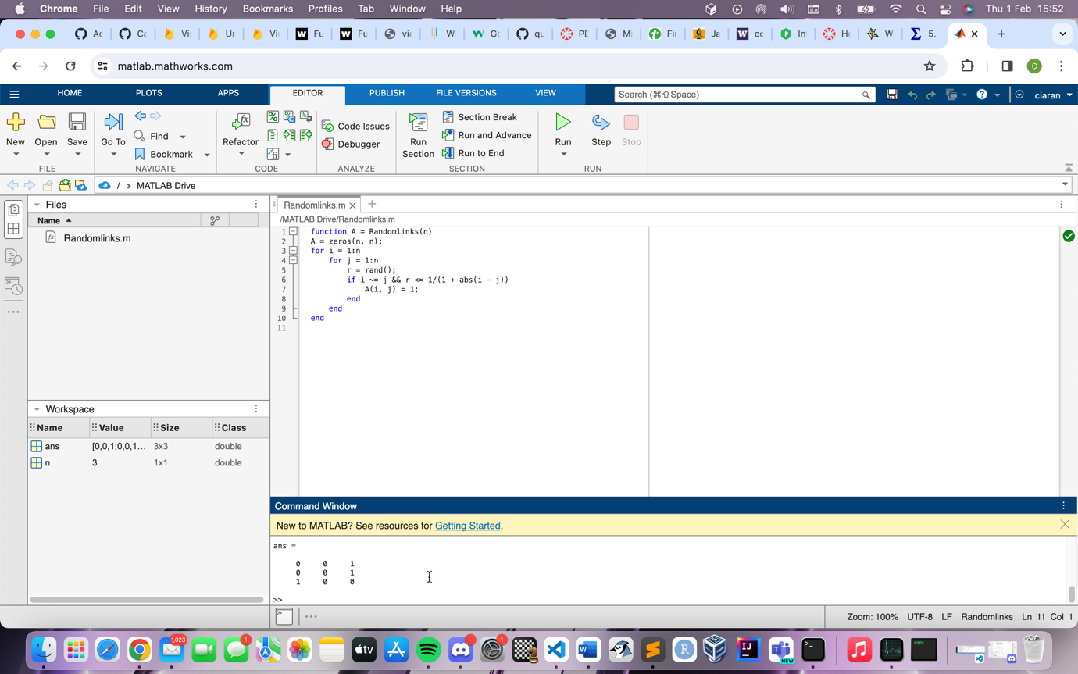


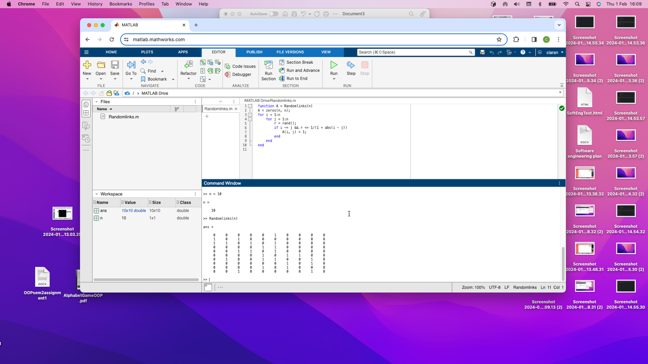

This function takes in a parameter ‘n’ and returns an nxn matrix. It first initializes the array with all elements set as 0. Then it uses nested loops to iterate over each element of the matrix and for ‘I’ and ‘j’ generates a number between 0 and 1. It will then set the corresponding elelemnt of A to 1 based on the probability of the Reciprocal of the absolout difference between I and j.

Q2.
function [minValue, maxValue] = MinMax(matrix)
[rows, cols] = size(matrix);
minValue = matrix(1, 1);
maxValue = matrix(1, 1);
for i = 1:rows
for j = 1:cols
if matrix(i, j) < minValue
minValue = matrix(i, j);
end
if matrix(i, j) > maxValue
maxValue = matrix(i, j);
end
end
end
end

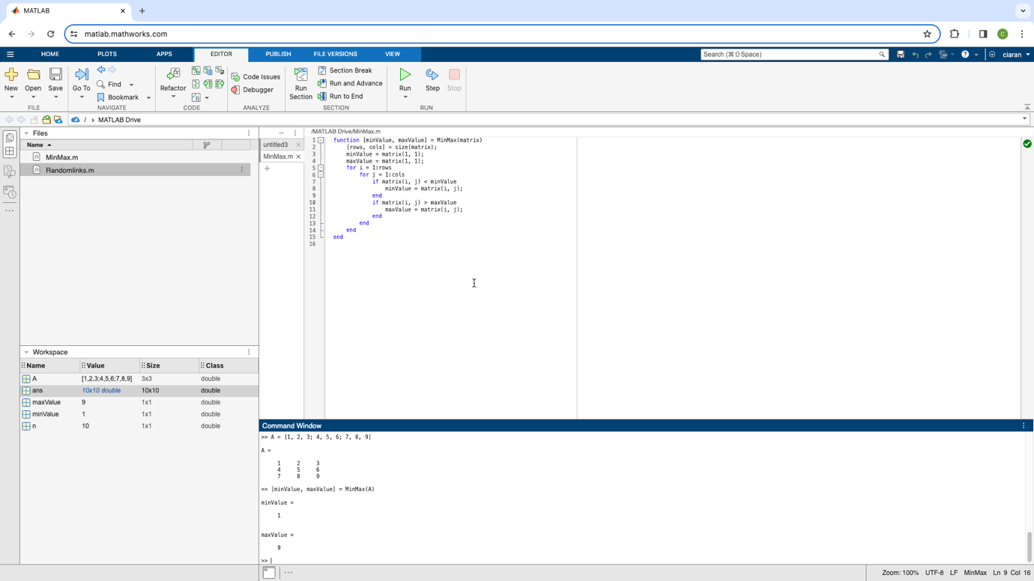

Q3.
function dice = roll_2_dice(N, seed)
rng(seed);

dice = zeros(1, N) %initializing the vector

for i = 1:N %generate random int between 1 and 6 N times
dice1 = randi([1, 6]);
dice2 = randi([1, 6]);
dice(i) = dice1 + dice2;
end
end

