Matlab exam:

Q1.
function [grades] = create_grades(students, subjects, lwr, upr, rand)
rng(rand);
grades = randi([lwr, upr], students, subjects);
end
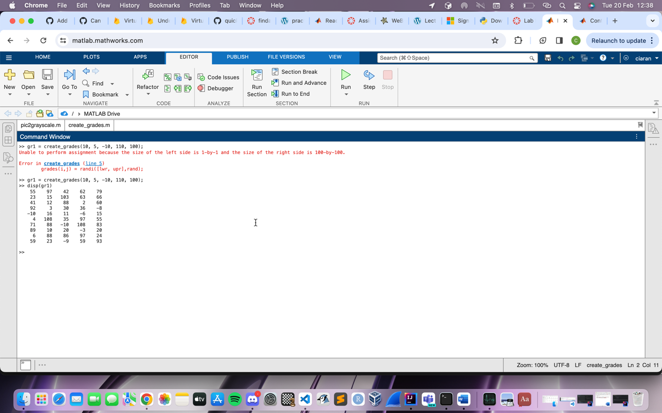

Q2.

function [cleanGrades] = clean_grades(grades)
[row, col] = size(grades);
cleanGrades = zeros(row, col);
for i=1:row
for j=1:col
if grades(i, j) > 100
cleanGrades(i, j) = 0;
elseif grades(i, j) < 0
cleanGrades(i, j) = 0;
else
cleanGrades(i, j) = grades(i, j);
end
end
end
end

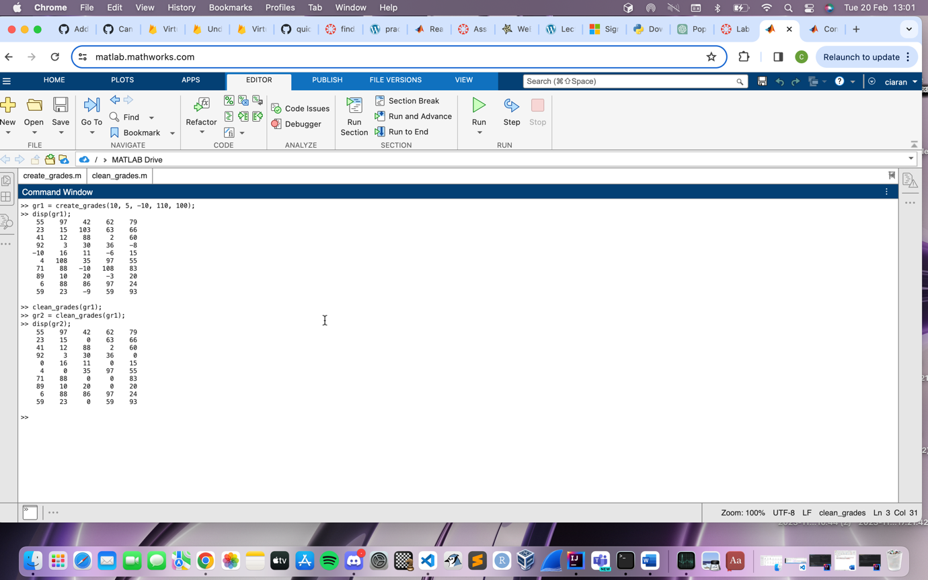

Q3.

function [final_array] = fill_estimates(cleaned_array)
[rows, cols] = size(cleaned_array);
colums[];
nonzerocolums[];
for (i=1:cols)
colums[]; = cleaned_array(:, cols);
nonzerocolums = colums(colums ~= 0);
meanGrade = mean(nonzerocolums);

end

-was unable to finish this question.

