3k running assignment
Ciaran Gray, id= 22427722
16 November, 2023

Inference and linear regression for 3 km Running Times based on laboratory testing

Study Description:
Sixteen well-trained male middle and long distance runners performed independently a 3 km time trial and a number of running tests in the laboratory.
One of the tests was running velocity at a blood lactate concentration of 4 mmol/L (v4mM), measured in km/hr. For background knowledge to understand something about the study, it requires considerable physical effort to achieve a blood lactate concentration of 4 mmol/L in well-trained athletes (if you want to know more about blood lactate and athletic performance here is a reference https://www.trainingpeaks.com/blog/what-is-lactate-and-lactate-threshold/).
Other tests were running velocity at Lactate Threshold (vTlac), and at VO2 max (V02Max) both measured in km/hr. In addition, a measure of running economy, oxygen uptake (measured in ml/kg/min) at running speeds of 14.5km/hr and 16.1 km/hr were measured and the variable names are Rel.14.5 and Rel.16.1.
All the laboratory testing took place on a motorised treadmill, and distance running performance was determined by 3 km time trials on an indoor 200m track, 3k time in minutes was recorded as Running.Time.
Based on data on other populations, the sports scientist doing the study wants to know what evidence the sample provides that the mean 3k running time in this population is different to 10 minutes 12 seconds (10.2 minutes), and also wants to estimate a plausible interval for the population mean 3k running time. The sports scientist also wants to estimate the 3k time below which the fastest 10% of the population times lie. Finally, the sports scientist wants to investigate if it is possible to predict 3k running time from running velocity at a blood lactate concentration of 4 mmol/L.

Aims:
To investigate the following:
- Is the population mean 3k running time different to 10 minutes 12 seconds (ie as decimal 10.2 minutes)? What is a plausible range in which the population mean 3k time is likely to lie? And what time are we confident that the top 10% of the population 3k times will be faster than?
- Can we use linear regression to predict 3 km running time in minutes (Running.Time) from running speed at lactate 4 mmol/L in km per hour (v4mM)?
It is decided in advance that the acceptable significance level for hypothesis testing is $α$ = 0.05.
# load required libraries
library(tidyverse)
library(infer)
library(tolerance)

Read the data and see a few rows
running = read.csv("3krunning.csv", header = TRUE)
head(running)
## Running.Time v4mM vTlac Rel.14.5 Rel.16.1 VO2Max
## 1 8.23 20.4 19.5 47.1 52.4 23.4
## 2 8.30 19.5 18.2 48.1 60.0 23.5
## 3 8.62 19.0 17.3 50.3 56.8 22.0
## 4 8.82 18.9 17.8 51.8 56.1 23.0
## 5 9.18 17.8 16.5 48.7 54.1 21.5
## 6 9.23 17.2 15.6 50.5 59.6 20.5

Summary Statistics
Shown below are summary statistics for some of the columns in the dataset.
running %>% summarise(
count = n(),
meantime = mean(Running.Time),
sdtime = sd(Running.Time),
meanv4mM = mean(v4mM),
sdv4mM = sd(v4mM),
meanRel14.5 = mean(Rel.14.5),
sdRel14.5 = sd(Rel.14.5),
)
## count meantime sdtime meanv4mM sdv4mM meanRel14.5 sdRel14.5
## 1 16 9.458125 0.744269 17.06875 1.848141 51.59375 3.289877

Hypothesis test and confidence interval for mean 3k time

Task 1: Write the null and alternative hypotheses and significance level of the test (text, 1 sentence)
i.e. the hypothesis test for Aim (1), first sentence.
5 marks
The null hypotheses H0 is that the mean 3K time is equal to 10.2 minutes, and the alternative hypothesis H1 is that the mean 3K time is not equal to 10.2 minutes. The significance level is 0.05. #### Task 2): Appropriate statistical test and assumptions
- What statistical test is appropriate to test the Task 1 hypotheses? State the assumptions needed for the test to be valid, and how they could be justified in this study. (1-2 sentences).
A one-sample t-test would be appropriate because we are comparing a sample mean to a hypothesized population mean. The assumptions needed for this test to be valid are normality, based on the central limit theory as all the participants share common physical attributes, and random sampling of observations, as the middle and long-distance runners chosen for this study increase the liklihood that the sample reflects the diversity of the population.
- Comment on the output of the R code below in relation to an assumption for the test (1 sentence)
running %>% ggplot(aes(x =Running.Time, y = "" )) + geom_boxplot() + labs(title = "Boxplot of 3k running times in sample")
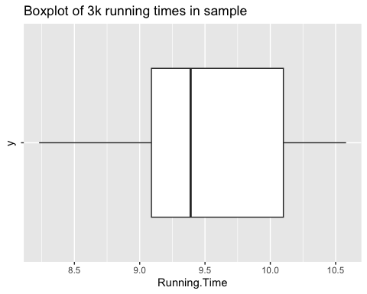
10 marks
From assessing the data from the box plot it seems as though the middle quartile leans to the right hand side of the graph, implying the data is left-skewed, therefore our assumption that the data possesses normality still applies as the central limit theorem applies here.

Task 3: Carry out the hypothesis test and estimate a 95% confidence interval for the true mean 3k time
The code below does a two-sided t test for the null hypothesis that the true mean Rel.14.5 is equal to 50. Adapt the code below to carry out the hypothesis test from Task 1.
running %>% dplyr::select(Running.Time) %>% t.test(mu = 10.2)
##
## One Sample t-test
##
## data: .
## t = -3.9871, df = 15, p-value = 0.00119
## alternative hypothesis: true mean is not equal to 10.2
## 95 percent confidence interval:
## 9.061532 9.854718
## sample estimates:
## mean of x
## 9.458125
5 marks

Task 4: Interpret (a) the results of the hypothesis test (b) the 95% confidence interval from Task 3
Note: you need to interpret the results after you have adapted the code in Task 3. You will not get marks for this question if you intepret the hypothesis test for the Rel.14.5 variable. (1-2 sentences)
5 marks a) The p-value for this test is 0.00119, which is less than the signifigance level of 0.05, therefore we can reject the null hypothesis and assume that the population mean 3k running time is not 10.2 minutes.
- the 95% confidence interval lies between 9.061532 and 9.854718, the sample mean of 10.2 does not lie within this interval, therefore we can once again reject the null hypothesis and assume the population mean 3k running time is not 10.2 minutes.

Task 5: A bootstrap 95% confidence interval for the mean 3k time
The code below estimates a 90% confidence interval for the mean 3k time using the bootstrap method. Change the number of bootstrap replications to 1000, and change the confidence level to 95%.
set.seed(123456789) # this is for replicable simulations - do not change this
boot <- running %>%
specify(response = Running.Time) %>%
generate(reps = 1000, type = 'bootstrap') %>%
calculate(stat = 'mean')
### Produce the 90% bootstrap confidence interval
### using the generated bootstrap distribution of the sample statistic
get_ci(boot, level = 0.95)
## # A tibble: 1 × 2
## lower_ci upper_ci
## <dbl> <dbl>
## 1 9.10 9.80
### plot the histogram of bootstrap statistics
### and shading the bootstrap confidence interval.
boot %>%
visualize(method = "simulation") +
shade_confidence_interval(get_ci(boot))+
xlab("Bootstrap Mean")+
ylab("Frequency")
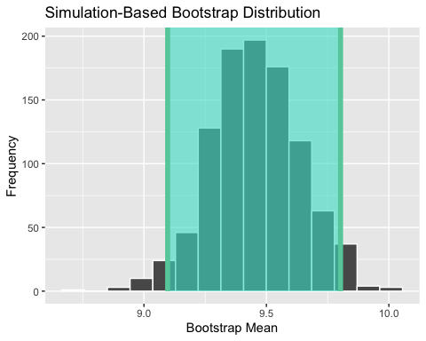
5 marks

Task 6: Compare the 95% confidence interval using the t distribution with the bootstrap 95% CI
(1-2 sentences)
The 2 sets of intervals are very close in value which would indicate that there is a good agreement between the boostrap and t distribution methods for estimating the confidence inteval in which the population mean lies.
5 marks

Task 7: A tolerance interval for the range in which we are 95% confident 90% of the population of 3k times will lie.
- The code below estimates a tolerance interval for the range in which we are 95% confident 95% of the population of 3k times will lie. Adapt the code to estimate a tolerance interval for the range in which we are 95% confident 90% of the population of 3k times will lie.
- The men’s world record for the 3k is 7 mins 20.67 seconds by Daniel Komen of Kenya in 1996. Using your adapted tolerance interval, state the running time you are 95% confident that the fastest 10% of our study population will achieve. (1 sentence)
normtol.int(running$Running.Time, alpha = 0.05, P = 0.90, side = 2)
## alpha P x.bar 2-sided.lower 2-sided.upper
## 1 0.05 0.9 9.458125 7.635421 11.28083
- We are 95% confident that the fastest 10% of the study population will achive a running time faster than the lower bound of the tolerance interval, 7.635421 minutes.
5 marks

Linear Regression

Task 8: Labelled scatterplot with smooth of Running.Time versus v4mM
- The code below makes a scatterplot with smooth of Running.Time versus Rel.14.5. Adapt the code to make a scatterplot with smooth of Running.Time versus v4mM. Remember to update the title, axis labels, and units.
- What does the smoother suggest regarding the suitability of a simple linear regression model for the relationship between Running.Time and v4mM? (1 sentence)
running %>% ggplot(aes(x = v4mM, y = Running.Time)) + geom_point() + geom_smooth() + labs(title = "Scatterplot with smooth for 3k time versus running velocity at a blood lactate concentration of 4 mmol/L", x = " lactate 4 mmol/L in km per hour(km/h)", y = "3k time (minutes)")
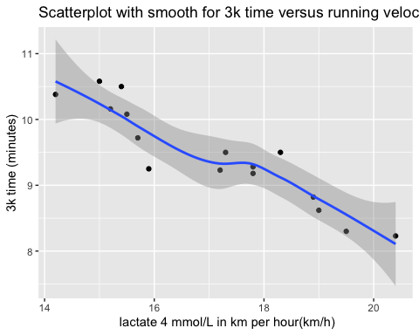
5 marks

Task 9: Correlation coefficient between v4mM and Running.Time
- The code below calculates the sample correlation coefficient between Running.Time and Rel.14.5. Change to code to calculate the sample correlation coefficient between Running.Time and v4mM.
running %>% dplyr::select (Running.Time, v4mM) %>% cor()
## Running.Time v4mM
## Running.Time 1.000000 -0.925857
## v4mM -0.925857 1.000000
- Interpret the relationship between Running.Time and v4mM, referring to the relevant scatterplot and correlation coefficient.
From analyzing the scatterplot and the pearson’s correlation coefficient between the running time and running velocity at a blood lactate concentration of 4 mmol/L its clear there is a strong inverse relationship between the 2, as seen from the correlation coefficient of -0.925857, and it seems from the scatterplot that those who run their 3k’s in a slower time tend to have a lower running velocity at a blood lactate concentrate of 4 mmol/L, in contrast those who run faster 3k’s have a higher running velocity at a blood lactate concentrate of 4 mmol/L. This indicates that there is indeed a strong relationship between these two factors. 10 marks

Task 10: Line of best fit for the linear relationship between 3 km running time and v4mM in the sample.
- The code below calculates the simple linear regression for Running.Time versus Rel.14.5. Change the code to produce the simple linear regression for Running.Time versus v4mM.
lm1<-lm(Running.Time ~ v4mM, data = running)
lm1
##
## Call:
## lm(formula = Running.Time ~ v4mM, data = running)
##
## Coefficients:
## (Intercept) v4mM
## 15.8223 -0.3729
5 marks

Task 11: Write down the equation of the line of best fit from for the simple linear regression of Running.Time on v4mM and provide an interpretation of the slope and intercept. Does the intercept have a physically meaningful interpretation?
(2-3 sentences)
The formula for the line of best fit is: Responce Variable = intercept + slope x Explanitory variable, which in our case is: Running.Time = 15.8223 + (-0.3729) x v4mM
The intercept does not have a physically meaningful interpretation as v4mM will never be equal to 0 in a real life running scenario.
10 marks

Task 12: Predict the running time (i.e. Running.Time) when running speed at blood lactate concentration 4 mmol/litre (i.e. v4mM) is 18.9 km per hour.
The code below predicts Running.Time when Rel.14.5 = 48 ml/kg/min from the linear regression model of Running.Time on Rel.14.5. It also shows the first few rows of the dataset.
- Adapt the code to predict Running.Time when v4mM=18.9 km/hr from a linear regression of Running.Time on v4mM.
- Why is the predicted running time at v4mM=18.9 different to 8.82, the observed running time when v4mM is 18.9 km/hr? - see observation 4 in the dataset. What is the value of the residual for this observation?
(1-2 sentences)
lm1<-lm(Running.Time ~ v4mM, data = running)
newdata <-data.frame(v4mM = 18.9)
predict(lm1, newdata = newdata)
## 1
## 8.775336
head(running)
## Running.Time v4mM vTlac Rel.14.5 Rel.16.1 VO2Max
## 1 8.23 20.4 19.5 47.1 52.4 23.4
## 2 8.30 19.5 18.2 48.1 60.0 23.5
## 3 8.62 19.0 17.3 50.3 56.8 22.0
## 4 8.82 18.9 17.8 51.8 56.1 23.0
## 5 9.18 17.8 16.5 48.7 54.1 21.5
## 6 9.23 17.2 15.6 50.5 59.6 20.5
- The running time at v4mM = 18.9 is different from 8.82 because there is a linear relationship assumed between “Running.Time” and v4mM, but the real data possibly contains some variability that is not accounted for.
The residual for this observation is 0.044664. 10 marks

Task 13: Predict the running time (i.e. Running.Time) when v4mM is 2.6 km per hour. Explain if you have any concern related to this prediction.
- Write code in the chunk below to predict Running.Time when v4mM= 2.6 km/hr. (Hint: copy and adapt the relevant code from the chunk above)
- Do you have any concern about this prediction, and if so why? (1 sentence)
lm1<-lm(Running.Time ~ v4mM, data = running)
newdata <-data.frame(v4mM = 2.6)
predict(lm1, newdata = newdata)
## 1
## 14.85286
head(running)
## Running.Time v4mM vTlac Rel.14.5 Rel.16.1 VO2Max
## 1 8.23 20.4 19.5 47.1 52.4 23.4
## 2 8.30 19.5 18.2 48.1 60.0 23.5
## 3 8.62 19.0 17.3 50.3 56.8 22.0
## 4 8.82 18.9 17.8 51.8 56.1 23.0
## 5 9.18 17.8 16.5 48.7 54.1 21.5
## 6 9.23 17.2 15.6 50.5 59.6 20.5
- I do have concerns about this prediction as the linear regression model is based on the observed data within the range of v4mM values in the dataset, and using values beyond this range could potentially give inaccurate predictions as the assumed linear relationship may not still be correct for values outside this range. 10 marks

Overall Conclusion and presentation

Task 14: State your overall conclusions in relation to the two main aims of the study (3-4 sentences for each)
Aim (1) From the hypothesis test, confidence intervals for the true mean, and tolerance interval.
Overrall, I conclude that we can reject the null hypothesis that the true mean is equal to 10.2, and accept the alternative hypothesis that it is not equal to 10.2. We can accept this based on our results of the hypothesis test, which show that the p-value 0.00119 assosiated with the test statistic of -3.9871 and 15 degrees of freedom is less than the signifigance level of 0.05. The results of the interpretation of the confidence interval of the true mean, where we used both a bootstrapping method which gave us 9.096812 - 9.802625 and t distribution method which gave us 9.061532 - 9.854718, we are 95% sure this is a plausable interval in which the population mean 3k running time will lie. We are also 95% sure that the top 10% of running times will be faster than 7.635421, using the accepted tolerance interval.
5 marks
Aim (2) From fitting a linear model for the relationship between 3k running time and the running speed at blood lactate concentration 4 mmol/litre.
The linear regression between a 3k running time and running velocity at blood lactate concentration 4 mmol/L proved to have a strong relationship for the values given in this data set, as seen from the correlation coefficient of -0.925857, which shows a strong inverce linear relationship. The equation of the line of best fit is Running.Time = 15.8223 - 0.3729 x v4mM, which indicates on average a unit increase of v4mM is associated with a faster, decrease in 0.3729 units in running time. However, the intercept of 15.82 minutes indicates that a runner would complete a 3k run when their running velocity at blood lactate concentration 4 mmol/litre is 0, which is unlikely to apply in real life scenarios. For this reason, I would say that the regression analysis supports the use of v4mM as a predictor for 3k running time only for the data range given in this data set, and can prove to be inaccurate to predict the running time using v4mM for values outside this data range.
5 marks

Task 15: Knit your .Rmd file to Word and submit the resulting Word document (alternatively knit to html, save the html as a pdf and submit the pdf). Make sure you have edited the .Rmd to include your own name and student ID.
If you submit an .Rmd file you will lose 20 marks, and if you submit a file missing your name and/or ID you will lose 10 marks.

