Check what is installed in the virtual environment and install the beautifulsoup4 and requests packages using the package management tool pip:

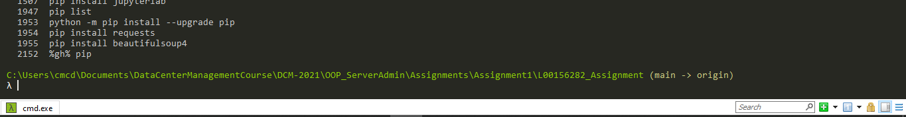

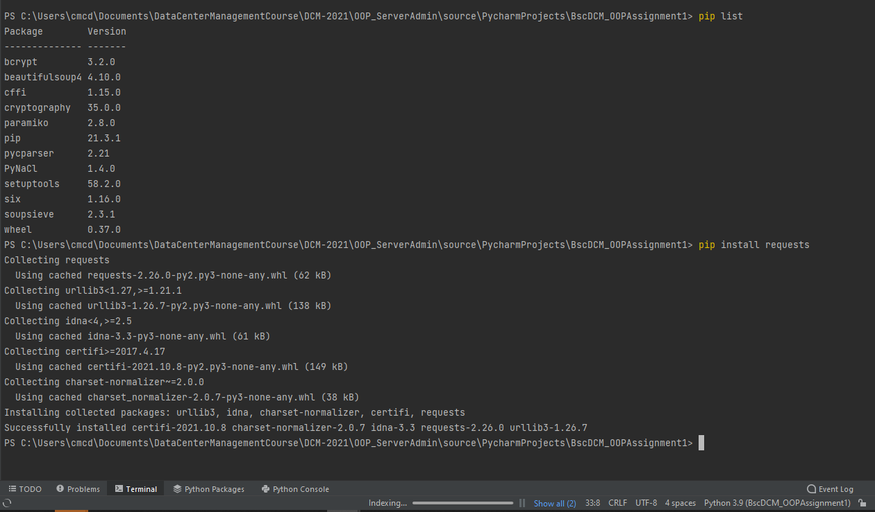

I have chosen to break the 3 components of this question into separate functions and call them from the main method, passing the soup object each time. I have also designed it so that an end user can hard code an IP address or, by removing the hardcoded IP address, be prompted to enter an IP address in the console. If an end user decides to enter an IP address, then I have directed it to the ‘format_url’ function where it is checked that it is prepended with either the http or https protocol, and if this is not present then http:// will be prepended:

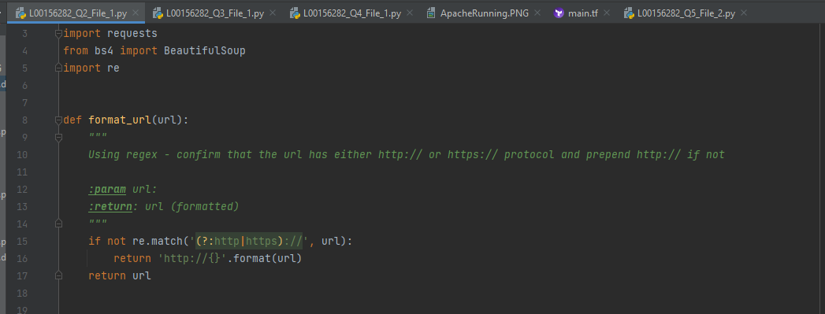

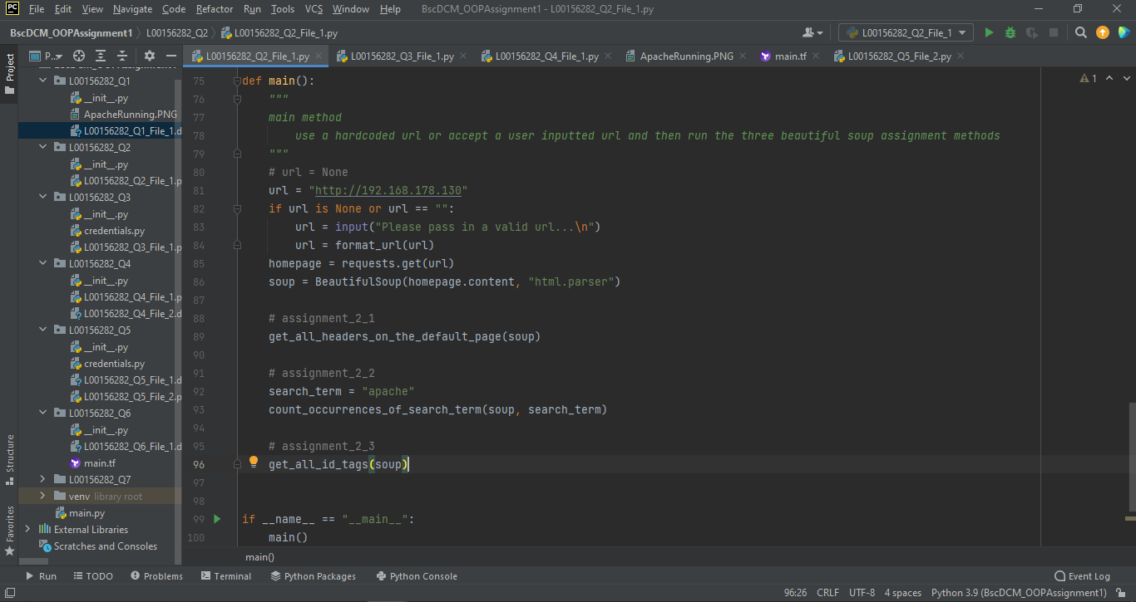

I have named the three functions

get_all_headers_on_the_default_page accepts the ‘soup’ object and looks to match on ‘class’ to return page and section headers. I then join these two lists and iterate through them, printing out the actual text from each header.

count_occurrences_of_search_term accepts the ‘soup’ and a string ‘search_term’. The function will then do a case insensitive search for the ‘search_term’ and output the number of times it appears on the selected webpage.

get_all_id_tags function accepts the ‘soup’ object as well and searches for all tags that have an ‘ID’, and prints these out to the console.

Here are the results of running the code against the Apache server run on the Ubuntu VM:

