Show listening ports on VM:

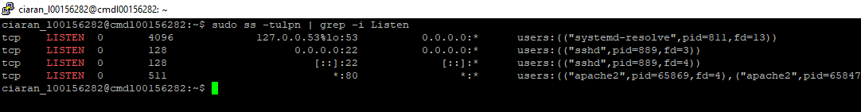

Run port scan using a dictionary to match port number and protocol:

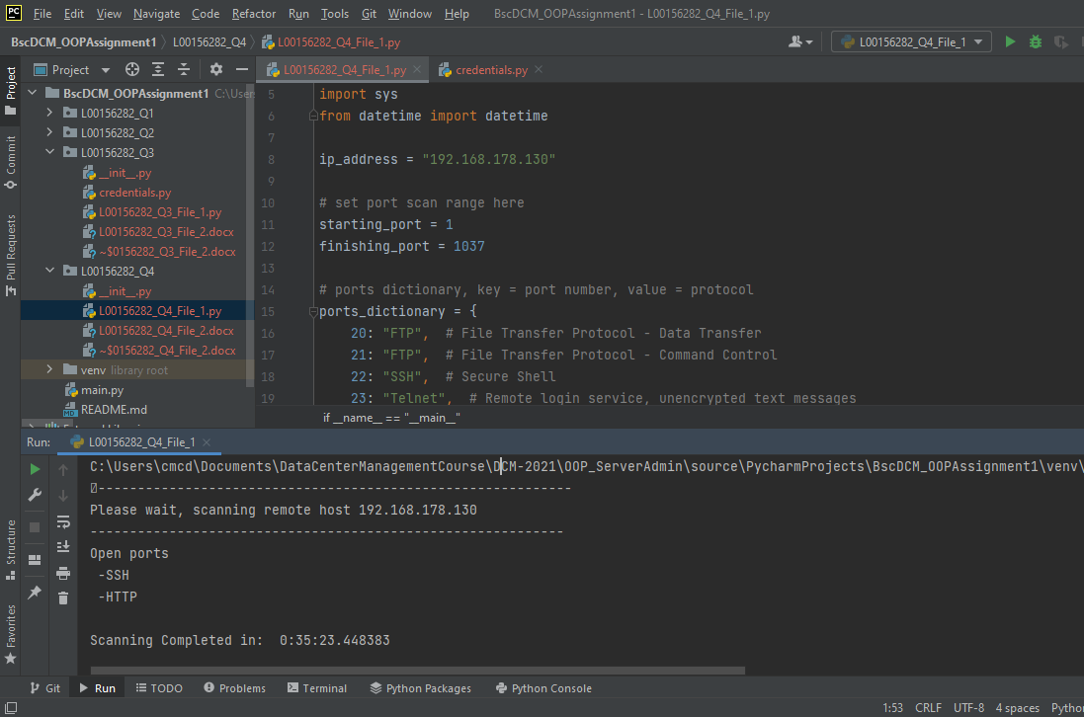

Dictionary of port numbers and protocols:

