Curl was already installed on the Ubuntu VM so I uninstalled before proceeding, see below:

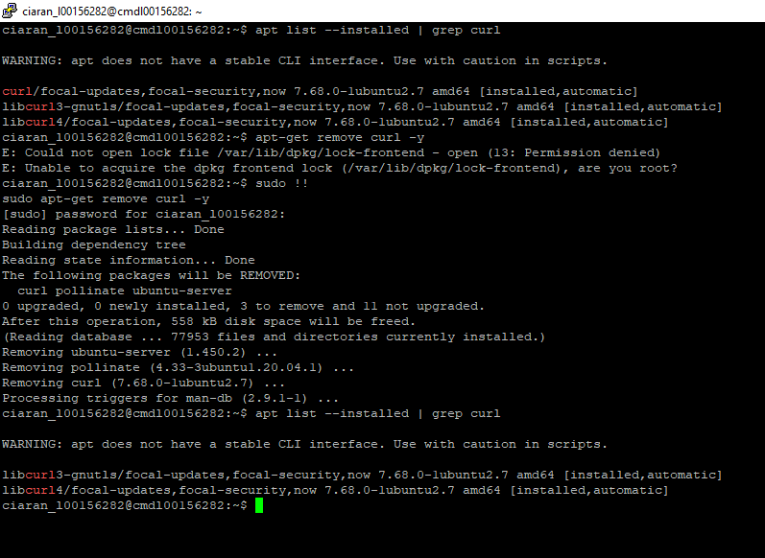

This shows that there are no folders or files created on the VM yet, other than the ‘connection.txt’ file from a previous question:

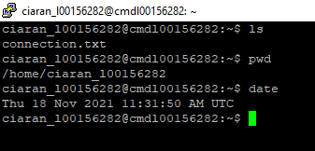

Commands run:

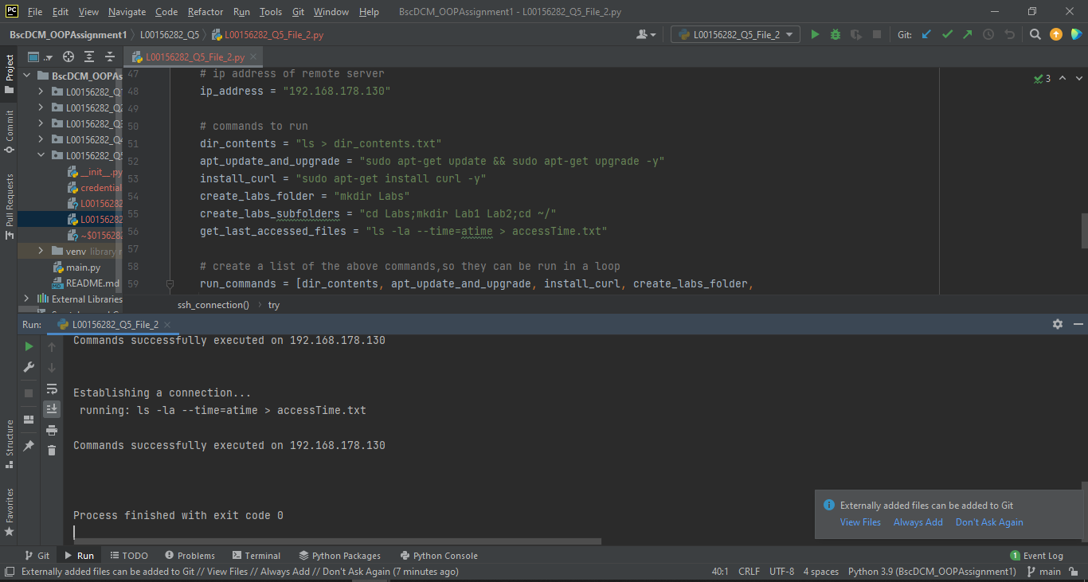

After running the script:

