20/03/2017

ASSIGNMENT TITLE: 4 DIGIT DIGITAL COMBINATION LOCK

Student Name: Ciara Power

student number: 20072488

Embedded Systems Assignment 1

Table of Contents

System Description 2

Inputs 2

Outputs 2

Normal Operation 3

Error Handling 3

Event Response List 4

Statechart 5

Next-State Table 6

Outline Architecture 7

General Structure 8

Complete List of Apps Used 8

App Configuration 9

Digital_IO: Button_1/ Button_2/ Button_3/ Button_4/ Button_Reset 9

Digital_IO: Lock_LED/ Error_LED 9

Timer: Minutes_Timer 10

Timer: Seconds_Timer 10

Timer: Debounce_Timer 11

Counter: PushButton_Count 11

Interrupt: Minutes_Timer 12

Interrupt: Seconds_Timer 12

Pin Allocation 13

Source Code Files Appendix 14

File: Main.c 14

# System Description

This assignment involves developing a digital combination lock for the XMC1100 micro controller using applications such as “DAVE”, “KEIL”, and “MICRIUM µC PROBE”.

The lock is a 4 digit combination lock, and will use inputs and outputs from the microcontroller pins, with some inputs set up in the Probe tool.

## Inputs

The inputs are as follows:

* **4 numeric pushbutton inputs -**

These inputs are set up in the Probe Tool. Each button corresponds to a number – 1,2,3,4. These are used to enter in combination sequences. Each button input is 0 while not being pressed, and are put to 1 when being pressed. They become 0 once again when the user releases the button.

* **1 reset pushbutton input –**

This input is set up in the Probe tool also. As with the numeric pushbutton inputs, it is 1 when being pressed, and 0 when released.

All of the above pushbutton inputs are connected to Digital I/O input pins on the microcontroller. Each pushbutton input needs to be debounced for 20ms when activated also.

## Outputs

The outputs are as follows:

* **A lock output –**

This output is connected to P1.0 on the microcontroller, which is the red LED found on the top-left of the chip. This is at logic 1 (LED ON) when the lock is activated, and logic 0 (LED OFF) when the lock is open.

* **An error output –**

This output is connected to P1.1 on the microcontroller, which is the red LED found on the top-right of the chip. This goes to logic 1 (LED ON) in various error situations, and is at logic 0 (LED OFF) otherwise.

## Normal Operation

* The lock is initially open, and reset to the default combination.
* The default combination for the lock initially is 1234.
* When the lock is open, if the correct 4 digit combination sequence is entered, the lock will close.
* When the lock is closed, if the correct 4 digit combination sequence is entered, the lock will open.
* To set a new combination for the lock, press the RESET button (putting the lock into RESET MODE), followed by the new 4 digit combination. When the new combination is entered, the lock will stay in its current state (open/closed).
* The lock output is activated (logic 1) when the lock is closed, otherwise logic 0.

## Error Handling

* If a full 4 digit combination sequence is not entered within 10 seconds, the user input sequence is disregarded and the lock returns to an idle state.
* If an invalid combination is entered, the error output LED flashes for 1 second (a single flash).
* If more than 3 unsuccessful combination sequences are entered within 1 minute, then the error output LED flashes 3 times (1 second each time), and any further attempts are prevented for 5 minutes.

# Event Response List

|  |  |  |
| --- | --- | --- |
| EVENTS | | RESPONSE |
| 0 | No buttons pressed AND unlocked | Lock moves to the Open Idle state |
| 1 | RESET button pressed | Lock moves to the Reset Mode state |
| 2 | 4 buttons pressed in reset mode | Lock moves to the Reset Entries Mode state |
| 3 | Numeric button pressed | Lock moves to the Entered Add state |
| 4 | Numeric button put into entered combo AND unlocked | Lock moves to the Open Idle state |
| 5 | Entered combo is correct | Lock moves to the Reset Error Mode state |
| 6 | Numeric button pressed put into saved combo | Lock moves to the Reset Mode state |
| 7 | 4 buttons pressed | Lock moves to the Check Combo Mode state |
| 8 | Entered combo checked and is incorrect | Lock moves to the Error Mode state |
| 9 | 4 errors AND 5 Min Timer has not started | Lock moves to the Entry Lock Mode state |
| 10 | 5 Min Timer Completes | Lock moves to the Reset Error Mode state |
| 11 | No buttons pressed AND locked | Lock moves to the Locked Idle state |
| 12 | 10 Second Timer Completes | Lock moves to the Reset Entries Mode state |
| 13 | 1 Min Timer Completes | Lock moves to the Reset Error Mode state |
| 14 | Numeric button put into entered combo AND locked | Lock moves to the Locked Idle state |

# Statechart

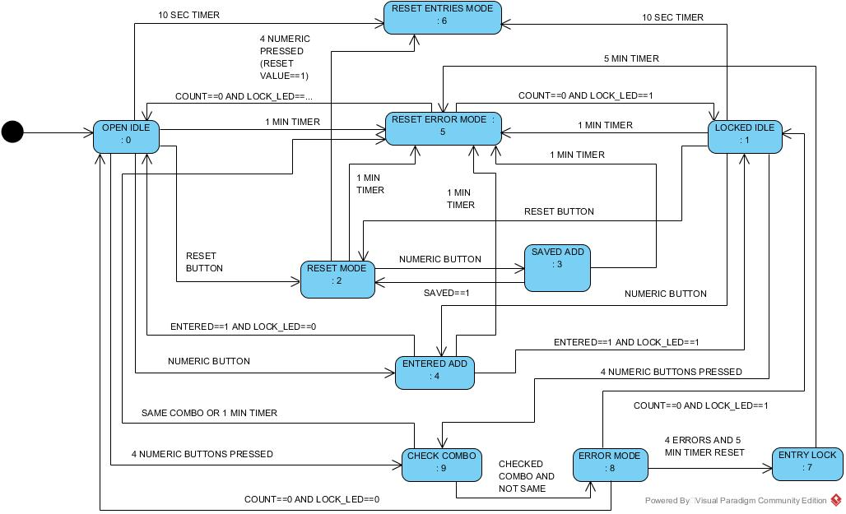

# Next-State Table

|  |  |  |  |  |  |  |  |  |  |  |  |  |  |  |  |
| --- | --- | --- | --- | --- | --- | --- | --- | --- | --- | --- | --- | --- | --- | --- | --- |
|  | 0 | 1 | 2 | 3 | 4 | 5 | 6 | 7 | 8 | 9 | 10 | 11 | 12 | 13 | 14 |
| Open Idle: **0** | -1 | 2 | -1 | 4 | -1 | -1 | -1 | 9 | -1 | -1 | -1 | -1 | 6 | 5 | -1 |
| Locked Idle: **1** | -1 | 2 | -1 | 4 | -1 | -1 | -1 | 9 | -1 | -1 | -1 | -1 | 6 | 5 | -1 |
| Reset Mode: **2** | -1 | -1 | 6 | 3 | -1 | -1 | -1 | -1 | -1 | -1 | -1 | -1 | -1 | 5 | -1 |
| Saved Add: **3**  **CURRENT STATE** | -1 | -1 | -1 | -1 | -1 | -1 | 2 | -1 | -1 | -1 | -1 | -1 | -1 | 5 | -1 |
| Entered Add: **4** | -1 | -1 | -1 | -1 | 0 | -1 | -1 | -1 | -1 | -1 | -1 | -1 | -1 | 5 | 1 |
| Reset Error Mode: **5** | 0 | -1 | -1 | -1 | -1 | -1 | -1 | -1 | -1 | -1 | -1 | 1 | -1 | -1 | -1 |
| Reset Entries Mode: **6** | 0 | -1 | -1 | -1 | -1 | -1 | -1 | -1 | -1 | -1 | -1 | 1 | -1 | 5 | -1 |
| Entry Lock: **7** | -1 | -1 | -1 | -1 | -1 | -1 | -1 | -1 | -1 | -1 | 5 | -1 | -1 | -1 | -1 |
| Error Mode: **8** | 0 | -1 | -1 | -1 | -1 | -1 | -1 | -1 | -1 | 7 | -1 | 1 | -1 | -1 | -1 |
| Check Combo: **9** | -1 | -1 | -1 | -1 | -1 | 5 | -1 | -1 | 8 | -1 | -1 | -1 | -1 | 5 | -1 |

**EVENTS**

# Outline Architecture

## General Structure

* There is 3 timers used in this state machine, all connected to the CCU4. The Minutes and Seconds timers are connected to an interrupt.
* There is a counter to count the High-Low transitions of a Digital IO App, which is high when any of the numeric pushbuttons are high.
* There is 4 numeric pushbutton Digital IO Apps, and a reset pushbutton Digital IO App, not connected to any other apps.
* There is 2 Digital IO Apps configured as outputs for the LED lights on the microcontroller, also not connected to any other apps.
* There is a PushButton_Pressed Digital IO app which acts as an input to the Counter mentioned above. The Counter can only take one input, but for this system there is 4 button inputs that need to be counted, so this extra Digital IO app enables the counter to increment. This is set to high after all input debouncing, when the system detects a high-low transition of an input (can be any of the numeric button input pins). This enables the counter to increment for each button press.

### Complete List of Apps Used

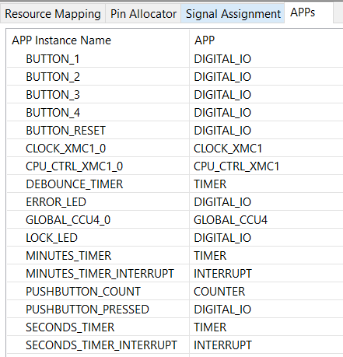

## App Configuration

### Digital_IO: Button_1/ Button_2/ Button_3/ Button_4/ Button_Reset

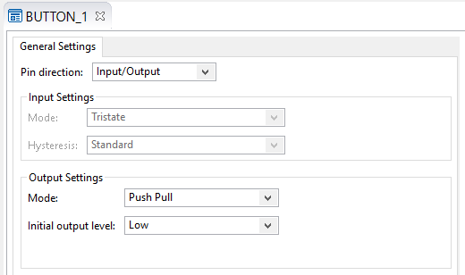

The Digital IO Apps for the listed Buttons are set up as Input/Outputs. This is to enable the pins to be set to High/Low. The Initial Output Level is set to Low, as the buttons are not being pressed upon initialisation.

### Digital_IO: Lock_LED/ Error_LED

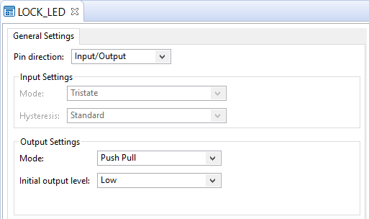

The Digital IO Apps for the listed LEDs are set up as Input/Outputs. This is to enable the pins to be set to High/Low. The Initial Output Level is set to Low for both LEDs, as the Lock is unlocked, and no errors have occurred upon initialisation.

Digital_IO: Pushbutton_Pressed

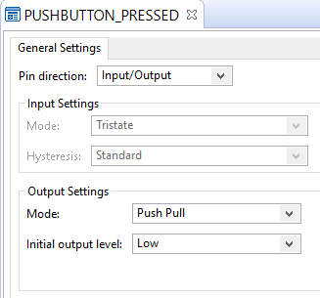

The Digital IO App for Pushbutton_Pressed is set up as an Input/Output. This is to enable the pin to be set to High/Low. The Initial Output Level is set to Low, as the buttons are not being pressed upon initialisation. This acts as the input for the Counter app used to count numeric button presses.

### Timer: Minutes_Timer

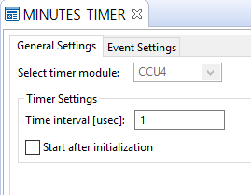

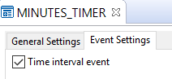The Minutes_Timer is configured initially to have a time interval of 1µsec, because the interval is manually set in the code before each use. This timer has an event after each interval is reached. It is used to time the 5 minute lockdown interval when more than three incorrect combinations are entered, and also to time the 1 minute interval within which no more than 3 incorrect combinations can be input.

### Timer: Seconds_Timer

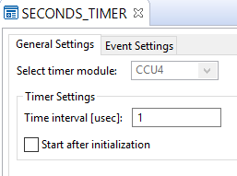

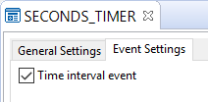The Seconds_Timer is configured initially to have a time interval of 1µsec, because the interval is manually set in the code before each use. This timer has an event after each interval is reached. It is used to time the 10 sec interval within which the user must enter a full 4-digit combination sequence, and also to time the 1 second interval used for the error LED flashes.

### Timer: Debounce_Timer

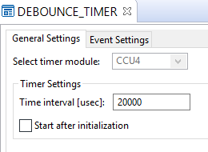The Debounce_Timer is configured initially to have a time interval of 20000µsec, because the specified debounce time interval is 20ms. This timer does not have an event after the interval is reached. It is used to time an interval when a button input is set to high, so that any noise that transitions the pin input to high is filtered out. If the input is still high after the debounce time interval, then it is not noise being detected, the button is being pressed down, and the relevant actions for a high pushbutton pin input can take place.

### Counter: PushButton_Count

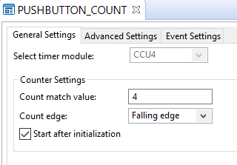

The PushButton_Count is configured to count the falling edge of the Digital_IO PushButton_Pressed App, which is high when a numeric button is pressed. The count match value is 4, but the count match interrupt is not used in this app. It starts after initialisation as the lock is initially available to read user pushbutton inputs.

### Interrupt: Minutes_Timer

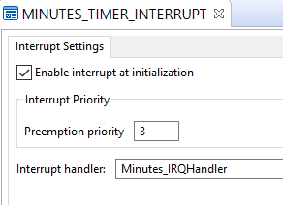

The Minutes_Timer_Interrupt has an input from the Minutes_Timer output. This interrupt is enabled at initialisation, which means it can interrupt the program at any stage when the program is running, without being manually started in the code. The method that deals with this interrupt is the Minutes_IRQHandler.

### Interrupt: Seconds_Timer

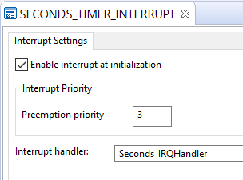

The Seconds_Timer_Interrupt has an input from the Seconds_Timer output. This interrupt is enabled at initialisation, which means it can interrupt the program at any stage when the program is running, without being manually started in the code. The method that deals with this interrupt is the Seconds_IRQHandler.

## Pin Allocation

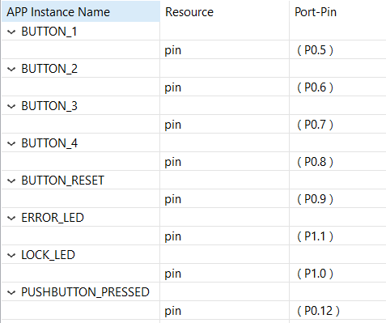The table below shows the microcontroller pin allocation for each app in this state machine design.

The ports assigned for the pushbutton inputs were any available ports on the microcontroller suitable for input/output functionality.

The ERROR_LED and LOCK_LED are assigned to ports P1.1 and P1.0, respectively. These ports are hardware assigned, as this is where the LED lights on the microcontroller are found.

The PUSHBUTTON_PRESSED app is assigned to port P0.12. This is the app acting as the input for the counter, which is set to high when any of the numeric button inputs are detected as high after a debounce period.

# Source Code Files Appendix

## File: Main.c

/*

* main.c

*

* Created on: 2017 Feb 28 23:59:24

* Author: Ciara Power

*/

**#include** <DAVE.h> //Declarations from DAVE Code Generation (includes SFR declaration)

int32_t button1=0; // buttons for GUI

int32_t button2=0;

int32_t button3=0;

int32_t button4=0;

int32_t reset=0;

int32_t count; //variables for GUI

int32_t locked=0; // either 1 for locked, or 0 for unlocked, used for GUI bitmap of lock

int32_t resetValue=0; // either 1 for in reset mode or 0 for not in reset mode, used in GUI

int32_t errorCount=0; //how many errors have occurred

int32_t errorFlashCount=0; //how many flashes have occurred of the error LED( ON/OFF is 2 "flashes")

int32_t thirtySecCount=0; // how many 30 sec intervals have passed on minutes_timer

**int** saved_combo[4]={1,2,3,4}; //the combination saved on lock

**int** entered_combo[4]; //user entry

//table for events and next states

**int** nsTable[10][20]={{-1,2,-1,4,-1,-1,-1,9,-1,-1,-1,-1,6,5,-1}, {-1,2,-1,4,-1,-1,-1,9,-1,-1,-1,-1,6,5,-1},

{-1,-1,6,3,-1,-1,-1,-1,-1,-1,-1,-1,-1,5,-1},

{-1,-1,-1,-1,-1,-1,2,-1,-1,-1,-1,-1,-1,5,-1},

{-1,-1,-1,-1,0,-1,-1,-1,-1,-1,-1,-1,-1,5,1},

{0,-1,-1,-1,-1,-1,-1,-1,-1,-1,-1,1,-1,-1,-1},

{0,-1,-1,-1,-1,-1,-1,-1,-1,-1,-1,1,-1,5,-1},

{-1,-1,-1,-1,-1,-1,-1,-1,-1,-1,5,-1,-1,-1,-1},

{0,-1,-1,-1,-1,-1,-1,-1,-1,7,-1,1,-1,-1,-1},

{-1,-1,-1,-1,-1,5,-1,-1,8,-1,-1,-1,-1,5,-1}};

**int** currentState=0;

**int** event;

**int** entered=0; // variable to indicate if user entry button value was entered into entered_combo array

**int** saved=0; // variable to indicate if user entry button value was entered into saved_combo array

**int** same=0; // entered_combo and saved_combo comparison variable

**int** checked=0; //if entered_combo was checked against saved_combo

**int** tenSecTimer=0; // if tenSecTimer has completed this equals 1

/**

* @brief main() - Application entry point

*

* <b>Details of function</b><br>

* This routine is the application entry point. It is invoked by the device startup code. It is responsible for

* invoking the APP initialization dispatcher routine - DAVE_Init() and hosting the place-holder for user application

* code.

*/

**int** **getEvent**(){ //method to get the event number occurred

**if** (thirtySecCount<10 && errorFlashCount==8) **return** NULL; // while in state of user entry lock stay in same state

**else** **if**(thirtySecCount==10) **return** 10; // 5 minutes has passed

// 4 errors and 5 min timer hasnt started yet

**else** **if**(errorCount==4 && thirtySecCount==0) **return** 9;

// 1 minute has passed and less than 4 errors

**else** **if**((thirtySecCount==2) && (errorCount!=4)) **return** 13;

**else** **if**(tenSecTimer==1) **return** 12; // if 10 secs have passed

**else** **if**(DIGITAL_IO_GetInput(&BUTTON_1)==1 || DIGITAL_IO_GetInput(&BUTTON_2)==1 || DIGITAL_IO_GetInput(&BUTTON_3)==1 || DIGITAL_IO_GetInput(&BUTTON_4)==1) **return** 3; //button pressed

**else** **if**(same==4) **return** 5; //same combinations

//not same combinations after they've been checked

**else** **if**(same!=4 && checked==1) **return** 8;

// the user entry button value was put into saved_combo array

**else** **if**(saved==1) **return** 6;

// reset button was pressed

**else** **if**(DIGITAL_IO_GetInput(&BUTTON_RESET)==1) { COUNTER_ResetCounter(&PUSHBUTTON_COUNT); **return** 1;}

**else** **if**((COUNTER_GetCurrentCount(&PUSHBUTTON_COUNT)==4) && (resetValue==1)) **return** 2; // 4 buttons were entered while in reset mode

// user entry button value was entered into entered_combo array and unlocked

**else** **if**(entered==1 && DIGITAL_IO_GetInput(&LOCK_LED)==0 ) **return** 4;

// user entry button value was entered into entered_combo array and locked

**else** **if**(entered==1 && DIGITAL_IO_GetInput(&LOCK_LED)==1) **return** 14;

// if 4 buttons were entered

**else** **if**(COUNTER_GetCurrentCount(&PUSHBUTTON_COUNT)==4) **return** 7;

// if no buttons entered and unlocked

**else** **if**(COUNTER_GetCurrentCount(&PUSHBUTTON_COUNT)==0 && DIGITAL_IO_GetInput(&LOCK_LED)==0) **return** 0;

// if no buttons entered and locked

**else** **if**(COUNTER_GetCurrentCount(&PUSHBUTTON_COUNT)==0 && DIGITAL_IO_GetInput(&LOCK_LED)==1) **return** 11;

**else** **return** NULL; // if none of the above events occurred

}

//gets next state with the given state and event that has occurred

**int** **getNextState**(**int** currentState,**int** nsTable[10][20],**int** event){

**if** (nsTable[currentState][event] != -1)

**return** nsTable[currentState][event];

// state can transition to a next state with the current event

**else** **return** currentState;

// current state doesnt have entry for current event so stay in current state

}

**void** **combosEqual**() //test if enetered_combo == saved_combo

{

same=0;

**for**(**int** i=0;i<4;i++){

**if**(saved_combo[i]==entered_combo[i]){

same++;

//if combos are the same this variable will end up to be 4

}

}

checked=1; //combo was checked

}

**void** **openIdleMode**(){

DIGITAL_IO_SetOutputLow(&LOCK_LED); //unlocked

resetValue=0; // resetMode is off

locked=0; //unlocked

entered=0; //item not just entered into combo

same=0; // combos similarity reset to 0

}

**void** **lockedIdleMode**(){

DIGITAL_IO_SetOutputHigh(&LOCK_LED); //locked

locked=1; //locked

entered=0; // item not just entered into combo

resetValue=0; // resetMode is off

same=0; // combos similarity reset to 0

}

**void** **resetMode**(){

resetValue=1; //in reset mode

saved=0; // item was not just added into saved_combo

}

**void** **savedAddMode**(){

// digital io that will increment counter

DIGITAL_IO_SetOutputHigh(&PUSHBUTTON_PRESSED);

count=COUNTER_GetCurrentCount(&PUSHBUTTON_COUNT);// to display count on gui

**if**(DIGITAL_IO_GetInput(&BUTTON_1)==1){

saved_combo[count]=1;

}

**else** **if**(DIGITAL_IO_GetInput(&BUTTON_2)==1){

saved_combo[count]=2;

}

**else** **if**(DIGITAL_IO_GetInput(&BUTTON_3)==1){

saved_combo[count]=3;

}

**else** **if**(DIGITAL_IO_GetInput(&BUTTON_4)==1){

saved_combo[count]=4;

}

saved=1; //item just added to saved_combo

}

**void** **enteredAddMode**(){

// digital io that will increment counter

DIGITAL_IO_SetOutputHigh(&PUSHBUTTON_PRESSED);

count=COUNTER_GetCurrentCount(&PUSHBUTTON_COUNT);// to display count on gui

// if its the first button pressed, start the 10 second timer for user input

**if**(count==0){

TIMER_SetTimeInterval(&SECONDS_TIMER,1000000000);

TIMER_Start(&SECONDS_TIMER);

}

**if**(DIGITAL_IO_GetInput(&BUTTON_1)==1){

entered_combo[count]=1;

}

**else** **if**(DIGITAL_IO_GetInput(&BUTTON_2)==1){

entered_combo[count]=2;

}

**else** **if**(DIGITAL_IO_GetInput(&BUTTON_3)==1){

entered_combo[count]=3;

}

**else** **if**(DIGITAL_IO_GetInput(&BUTTON_4)==1){

entered_combo[count]=4;

}

entered=1; // item just added to entered_combo

}

**void** **resetEntriesMode**(){

COUNTER_ResetCounter(&PUSHBUTTON_COUNT);

count=COUNTER_GetCurrentCount(&PUSHBUTTON_COUNT);

// reset the ten second timer variable indicating it has/hasnt completed

tenSecTimer=0;

**if**(same==4) // if combos were just checked and found the same

{

checked=0; // reset to unchecked

}

}

**void** **resetErrorMode**(){

**if** (same==4){ // if combos were checked and are the same

resetEntriesMode(); //reset entries

}

same=0;

errorCount=0;

errorFlashCount=0;

// the 1 minute timer is reset , so this variable counting 30 sec intervals is reset too

thirtySecCount=0;

}

**void** **entryLockMode**(){

// this is <8 when the errors entered has not reached 4 yet

**while**(errorFlashCount<8);

// if no 30 secs have passed in minutes_timer

**if** (thirtySecCount==0){

//start the timer for 30 secs TIMER_SetTimeInterval(&MINUTES_TIMER,3000000000);

TIMER_Start(&MINUTES_TIMER);

}

}

**void** **errorMode**(){

checked=0;

errorCount++;

DIGITAL_IO_SetOutputHigh(&ERROR_LED); // turn on error LED

TIMER_SetTimeInterval(&SECONDS_TIMER,100000000); //start 1 sec timer

TIMER_Start(&SECONDS_TIMER);

**if**(errorCount==1){ // if first error, start the minute timer at 30 secs

TIMER_SetTimeInterval(&MINUTES_TIMER,3000000000);

TIMER_Start(&MINUTES_TIMER);

}

}

**void** **checkComboMode**(){

TIMER_Stop(&SECONDS_TIMER); // stop the 10 sec user input timer

TIMER_Clear(&SECONDS_TIMER);

TIMER_ClearEvent(&SECONDS_TIMER);

combosEqual(); //check if equal

resetEntriesMode(); //reset entries

**if**(same==4){ //if same

DIGITAL_IO_ToggleOutput(&LOCK_LED);

}

}

**void** **debounceTimer**(**void**){

TIMER_Start(&DEBOUNCE_TIMER);

//stays here while timer is actively timing (20ms)

**while**(!TIMER_GetInterruptStatus(&DEBOUNCE_TIMER));

TIMER_ClearEvent(&DEBOUNCE_TIMER);

TIMER_Clear(&DEBOUNCE_TIMER);

}

**void** Minutes_IRQHandler(**void**){

// if less than 5 mins have passed OR 1 minute has passed AND total error flashes havent occured

**if**(thirtySecCount>=10 || (thirtySecCount==2 && errorFlashCount!=8))){

TIMER_Stop(&MINUTES_TIMER);

TIMER_Clear(&MINUTES_TIMER);

TIMER_ClearEvent(&MINUTES_TIMER);

}

**else**{

thirtySecCount++;

**if**(thirtySecCount==2 && errorFlashCount!=8){

TIMER_Stop(&MINUTES_TIMER);

TIMER_Clear(&MINUTES_TIMER);

TIMER_ClearEvent(&MINUTES_TIMER);

}

}

}

**void** Seconds_IRQHandler(**void**){

// error light is on and not all erros have occured

**if**(DIGITAL_IO_GetInput(&ERROR_LED)==1 && errorCount<4){

TIMER_Stop(&SECONDS_TIMER);

TIMER_Clear(&SECONDS_TIMER);

TIMER_ClearEvent(&SECONDS_TIMER);

errorFlashCount++;

DIGITAL_IO_ToggleOutput(&ERROR_LED);

}

**else** **if**(errorCount==4){ //all errors have occured

DIGITAL_IO_ToggleOutput(&ERROR_LED);

errorFlashCount++;

**if** (errorFlashCount==8){ // all error flashes have occured

TIMER_Stop(&SECONDS_TIMER);

TIMER_Clear(&SECONDS_TIMER);

TIMER_ClearEvent(&SECONDS_TIMER);

}

}

// 10 secs have passed ( nothing to do with error timing) so timer is stopped

**else**{

TIMER_Stop(&SECONDS_TIMER);

TIMER_Clear(&SECONDS_TIMER);

TIMER_ClearEvent(&SECONDS_TIMER);

tenSecTimer=1; // variable for 10 secs set to 1

}

}

**int** **main**(**void**)

{

DAVE_STATUS_t status;

status = DAVE_Init(); /* Initialization of DAVE APPs */

**if**(status != *DAVE_STATUS_SUCCESS*)

{

/* Placeholder for error handler code. The while loop below can be replaced with an user error handler. */

XMC_DEBUG("DAVE APPs initialization failed\n");

**while**(1U)

{

}

}

/* Placeholder for user application code. The while loop below can be replaced with user application code. */

**while**(1U)

{ //check each gui button and set pin high for each if pressed, and debounce

**if**(button1==1){

DIGITAL_IO_SetOutputHigh(&BUTTON_1);

debounceTimer();

}

**else** **if**(button2==1){

DIGITAL_IO_SetOutputHigh(&BUTTON_2);

debounceTimer();

}

**else** **if** (button3==1 ){

DIGITAL_IO_SetOutputHigh(&BUTTON_3);

debounceTimer();

}

**else** **if**(button4==1){

DIGITAL_IO_SetOutputHigh(&BUTTON_4);

debounceTimer();

}

**else** **if**(reset==1){

DIGITAL_IO_SetOutputHigh(&BUTTON_RESET);

debounceTimer();

}

**else**{ //if no button on gui is being pressed, make sure all pins are low and update count on gui

DIGITAL_IO_SetOutputLow(&BUTTON_RESET);

DIGITAL_IO_SetOutputLow(&BUTTON_1);

DIGITAL_IO_SetOutputLow(&BUTTON_2);

DIGITAL_IO_SetOutputLow(&BUTTON_3);

DIGITAL_IO_SetOutputLow(&BUTTON_4);

DIGITAL_IO_SetOutputLow(&PUSHBUTTON_PRESSED);

count=COUNTER_GetCurrentCount(&PUSHBUTTON_COUNT);

}

event=getEvent();

currentState=getNextState(currentState,nsTable,event);

// jump to the next current state

**if**(currentState==0) openIdleMode();

**else** **if**(currentState==1) lockedIdleMode();

**else** **if**(currentState==2) resetMode();

**else** **if**(currentState==3) savedAddMode();

**else** **if**(currentState==4) enteredAddMode();

**else** **if**(currentState==5) resetErrorMode();

**else** **if**(currentState==6) resetEntriesMode();

**else** **if**(currentState==7) entryLockMode();

**else** **if**(currentState==8) errorMode();

**else** **if**(currentState==9) checkComboMode();

}

}