# **Mathematical Methods**

Scilab Midterm Assignment



**Student Name:** Ciara Power

**Student Number:** 20072488

### Assignment Outline

Produce Scilab code to take in the data representing any system of three linear equations in three unknowns and to output the solution.

Submit:

* Code
* Output

### Solution

#### Code:

------------------------------------------------------------------------------------------------------------------------------------------------------

function []=linSystemThreeUnknowns()

disp('Program to solve linear system of three equations')

disp('Equations are in the form a1x1+a2x2+a3x3= b , where -a- values are a row of the coefficients matrix,and -b- is a row of the right hand column of the system')

A=input('Enter matrix of coefficients: ')

b=input('Enter right hand column matrix: ')

disp('Matrix of coefficients:')

disp(A)

disp('Right hand column matrix:')

disp(b)

disp('The three solutions for this system are:')

sol=linsolve(A,-b)

disp('x1 = '+string(sol(1,1)))

disp('x2 = '+string(sol(2,1)))

disp('x3 = '+string(sol(3,1)))

endfunction

------------------------------------------------------------------------------------------------------------------------------------------------------

The linsolve(A,-b) Scilab function uses elimination to reduce the matrix to get values for the three unknowns. The b vector is negated here because the equation is originally in the form a1x1+a2x2+a3x3= b 🡺 a1x1+a2x2+a3x3 – b=0, whereas linsolve(A,b) is originally implemented for the equation in form a1x1+a2x2+a3x3 + b= 0.

#### Output:

The following example of the program output uses the linear system of equations:

$$0x_{1}+3x_{2}-x_{3}=19$$

$$-3x_{1}+x_{2}-2x_{3}=-9$$

$$-x_{1}+3x_{2}-2x_{3}=17$$

Where the data is entered in matrix form:

Matrix of coefficients A= $\begin{matrix}0 & 3 & -1 \\ -3 & 1 & -2 \\ -1 & 3 & -2\end{matrix}$

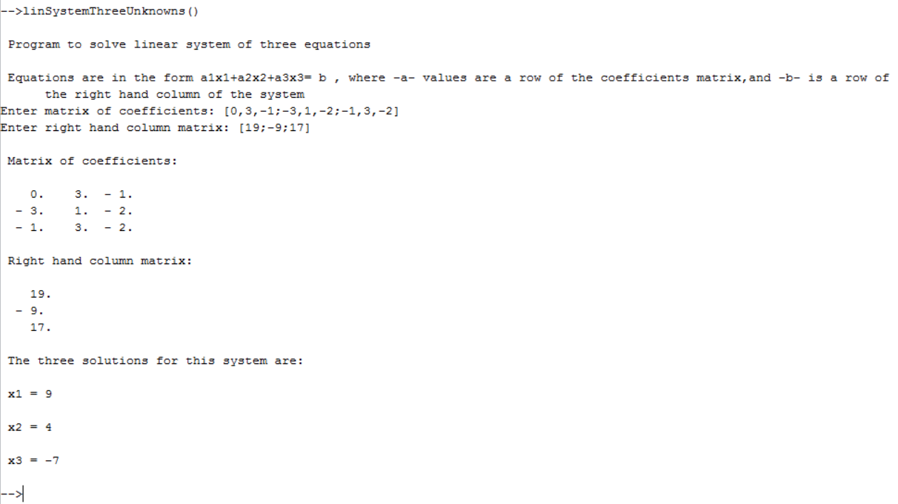Matrix for right hand column= $\begin{matrix}19 \\ -9 \\ 17\end{matrix}$