**User Modeling - Info beads**

**Task 1**

**301721759**

**052971694**

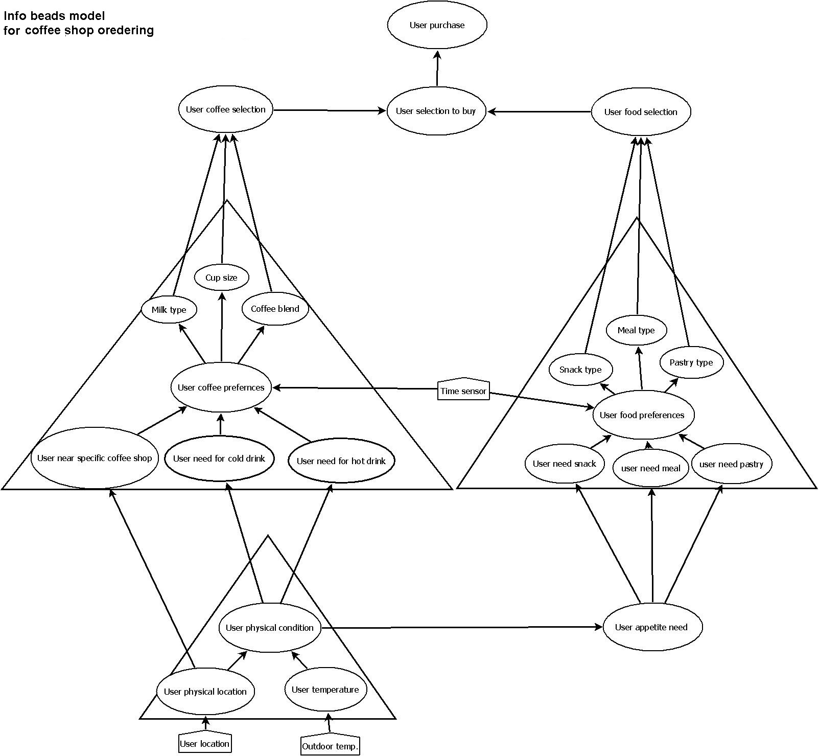

**Info beads user model explication**

The following scheme describes the main process and usage of physical parameters, for coffee shop ordering.

There are 3 input parameters that been used:

1. User location
2. Outdoor temperature
3. Time sensor

These 3 parameters will help the system predicting user needs and potential order.

The user physical location and outdoor temperature parameters will help identify user physical condition, as described in the lower left info-pendant (triangle).

Outdoor temperature as a predictor for drink type (hot / cold), is described by the relationship between the 3 beads – User physical condition – User need for hot drink – User need for cold drink.

As well as user need for drink, the physical condition of the user have an impact on user hunger, as described by the relation between the bead – User physical condition and User apatite need.

The time sensor input will have an impact on user preferences as described in the two main info-pendants. The time factor helps predicting the food type the user might add to the order, as well as the drink type.

Main impact of the time factor will have on the size of the meal (breakfast/ launch / dinner) and its ingredients, and the drink type / size.

The whole process then drains to the order closure.