KARPAGAM COLLEGE OF ENGINEERING
Rediscover | Refine | Redefine
Accredited by NAAC with 'A+' Grade | Autonomous Institution | Affiliated to Anna University
ACADEMIC YEAR: 2026-27
ASSIGNMENT FRONT SHEET
Name of the Student: | Cibi K.
Register Number: | 717825F112
Course Code & Title: | 23CSR306 JAVA PROGRAMMING
Year / Dept. / Sem / Section: | II / IT / III / A
Assignment: | II – OOP Mini Project (any one of 35)
Specification No. & Title: | Specification 2: Library Management System
GitHub Repository Link: | https://github.com/cibi-k/LibraryManagementSystem-JAVA
Date of Issue: | 06-10-2026
Date of Submission:

Marks Details
CO / K Level | Maximum Marks | Marks Obtained
CO4 / K3 | 50
CO5 / K3 | 50
Total | 100

Course In-charge Signature: _______________________

Rubrics for Assignment Evaluation
Assignment Number: | II | Date: | 06-10-2026
Course Code & Title: | 23CSR306 Java Programming | Specification No. & Title: | Specification 2: Library Management System
Register Number: | 717825F112 | Name of the Student: | Cibi K.

Marks for each criterion = Level (1 – 5) × Weightage. Total: 100 (CO4: 50 + CO5: 50).
Criterion | CO | Wt. | Exemplary (5) | Excellent (4) | Adequate (3) | Average (2) | Inadequate (1) | Max
Program Correctness & Business Rules | CO4 | 4 | All menu options work; every business rule enforced correctly. | All options work; minor gaps in one rule. | Main flow works; some rules missing. | Partially working; several rules not handled. | Does not run or most features missing. | 20
Input Validation & Exception Handling | CO4 | 3 | All inputs validated; custom exceptions; program never crashes. | Most inputs validated with try-catch. | Basic validation; some invalid inputs not handled. | Little validation; crashes on bad input. | No validation or exception handling. | 15
Menu-driven Interface & Expected Outputs | CO4 | 3 | Clear menu; all expected outputs (receipts/status) shown neatly. | Clear menu; most expected outputs shown. | Menu works; outputs basic or incomplete. | Menu unclear; few outputs shown. | No proper menu or outputs. | 15
OOP Design (Encapsulation, Inheritance, Aggregation, Polymorphism) | CO5 | 4 | All four concepts applied meaningfully; all required classes present. | Concepts applied well; minor design gaps. | Classes present; concepts used in a basic way. | Weak design; some required classes missing. | No OOP design; mostly procedural. | 20
Code Quality & Package Structure | CO5 | 2 | Clean packages, naming, indentation and comments. | Good structure with few lapses. | Acceptable structure; average readability. | Poor naming / structure. | Single file; unreadable code. | 10
GitHub Repository & README | CO5 | 1 | Complete code with clear README (problem, run steps, name, roll no.). | Complete code; README missing minor details. | Code present; README incomplete. | Partial code; no README. | No repository. | 5
Viva / Explanation | CO5 | 3 | Explains design, rules and code clearly; answers all questions. | Explains well; answers most questions. | Explains main logic; answers some questions. | Limited explanation of own code. | Unable to explain code. | 15

CO4 Total (Criteria 1 – 3): 50 | CO5 Total (Criteria 4 – 7): 50 | Total Marks: 100
Signature of the Evaluator with date: _______________________________

Department of Computer Science and Engineering
Reg. No: 717825F112 Name: Cibi K. Assignment II Report
23CSR306 JAVA PROGRAMMING
Assignment – II Submission Template
Specification No. & Title: Specification 2: Library Management System
1. Assignment Question
Specification 2: Library Management System
Problem Statement: Design and implement a Java console application for a Library Management System that manages books, members, borrowing, and returns. The system should follow object-oriented principles and ensure proper tracking of availability.
Class Requirements: Book, Author, Member, PremiumMember, BorrowTransaction, ReturnTransaction, Library
Business Rules:
1. Books can only be borrowed if they are available in stock.
2. When borrowed, stock reduces; when returned, stock updates.
3. Premium members may borrow more books and for longer duration.
4. Fines are applied for late returns.
5. Borrowing and returning transactions must link directly to books.
Menu Options: Add Book / Add Member / Borrow Book / Return Book / Display Available Books / Exit
Expected Output:
• Show borrow/return receipt.
• Display updated stock after each transaction.
• Show fines (if applicable).

2. Java Source Code
(Complete source code organized package by package – model, service, util, exception, main, test. Font: Consolas, 9.5 pt, syntax preserved)
File: src/com/library/model/Author.java
package com.library.model;
import java.util.Objects;
/**
* Represents an author of a book in the Library Management System.
* Demonstrates Encapsulation with private attributes and accessor methods.
*
* Course: 23CSR306 - Java Programming
* Student: Cibi K. (Reg. No: 717825F112)
*/
public class Author {
private String name;
private String email;
/**
* Default constructor.
*/
public Author() {
}
/**
* Parameterized constructor to initialize author details.
*
* @param name Author's full name
* @param email Author's contact email
*/
public Author(String name, String email) {
setName(name);
setEmail(email);
}
public String getName() {
return name;
}
public void setName(String name) {
if (name == null || name.trim().isEmpty()) {
throw new IllegalArgumentException("Author name cannot be null or empty.");
}
this.name = name.trim();
}
public String getEmail() {
return email;
}
public void setEmail(String email) {
this.email = (email != null) ? email.trim() : "";
}
@Override
public boolean equals(Object o) {
if (this == o) return true;
if (o == null || getClass() != o.getClass()) return false;
Author author = (Author) o;
return Objects.equals(name, author.name);
}
@Override
public int hashCode() {
return Objects.hash(name);
}
@Override
public String toString() {
if (email != null && !email.isEmpty()) {
return name + " (" + email + ")";
}
return name;
}
}
File: src/com/library/model/Book.java
package com.library.model;
import java.util.Objects;
/**
* Represents a Book in the Library Management System.
* Demonstrates:
* - Encapsulation (private fields, controlled mutators with business rule validation)
* - Aggregation (Book HAS-A Author)
*
* Course: 23CSR306 - Java Programming
* Student: Cibi K. (Reg. No: 717825F112)
*/
public class Book {
private String bookId;
private String title;
private Author author;
private String isbn;
private int totalCopies;
private int availableCopies;
/**
* Default constructor.
*/
public Book() {
}
/**
* Parameterized constructor.
*
* @param bookId Unique identifier for the book
* @param title Title of the book
* @param author Author of the book (Aggregation)
* @param isbn ISBN code of the book
* @param totalCopies Total inventory copies in the library
*/
public Book(String bookId, String title, Author author, String isbn, int totalCopies) {
setBookId(bookId);
setTitle(title);
setAuthor(author);
setIsbn(isbn);
if (totalCopies <= 0) {
throw new IllegalArgumentException("Total copies must be greater than zero.");
}
this.totalCopies = totalCopies;
this.availableCopies = totalCopies;
}
public String getBookId() {
return bookId;
}
public void setBookId(String bookId) {
if (bookId == null || bookId.trim().isEmpty()) {
throw new IllegalArgumentException("Book ID cannot be null or empty.");
}
this.bookId = bookId.trim().toUpperCase();
}
public String getTitle() {
return title;
}
public void setTitle(String title) {
if (title == null || title.trim().isEmpty()) {
throw new IllegalArgumentException("Title cannot be null or empty.");
}
this.title = title.trim();
}
public Author getAuthor() {
return author;
}
public void setAuthor(Author author) {
if (author == null) {
throw new IllegalArgumentException("Author cannot be null.");
}
this.author = author;
}
public String getIsbn() {
return isbn;
}
public void setIsbn(String isbn) {
this.isbn = (isbn != null) ? isbn.trim() : "N/A";
}
public int getTotalCopies() {
return totalCopies;
}
public void setTotalCopies(int totalCopies) {
if (totalCopies < 0) {
throw new IllegalArgumentException("Total copies cannot be negative.");
}
this.totalCopies = totalCopies;
}
public int getAvailableCopies() {
return availableCopies;
}
public void setAvailableCopies(int availableCopies) {
if (availableCopies < 0 || availableCopies > totalCopies) {
throw new IllegalArgumentException("Available copies must be between 0 and total copies (" + totalCopies + ").");
}
this.availableCopies = availableCopies;
}
/**
* Checks if at least one copy of this book is available for borrowing.
*
* @return true if availableCopies > 0, false otherwise
*/
public boolean isAvailable() {
return availableCopies > 0;
}
/**
* Decreases the available copies by 1 when borrowed.
* Enforces Business Rule 1 & 2: Books can only be borrowed if available, stock reduces on borrow.
*
* @return true if borrow operation succeeded
*/
public boolean borrowCopy() {
if (availableCopies > 0) {
availableCopies--;
return true;
}
return false;
}
/**
* Increases the available copies by 1 when returned.
* Enforces Business Rule 2: Stock updates when returned.
*
* @return true if return operation succeeded
*/
public boolean returnCopy() {
if (availableCopies < totalCopies) {
availableCopies++;
return true;
}
return false;
}
@Override
public boolean equals(Object o) {
if (this == o) return true;
if (o == null || getClass() != o.getClass()) return false;
Book book = (Book) o;
return Objects.equals(bookId, book.bookId);
}
@Override
public int hashCode() {
return Objects.hash(bookId);
}
@Override
public String toString() {
return String.format("[%s] \"%s\" by %s | ISBN: %s | Available: %d/%d",
bookId, title, (author != null ? author.getName() : "Unknown"), isbn, availableCopies, totalCopies);
}
}
File: src/com/library/model/Member.java
package com.library.model;
import java.util.Objects;
/**
* Base Member class representing a regular library member.
* Demonstrates:
* - Encapsulation (private fields and data integrity)
* - Base class for Inheritance (extended by PremiumMember)
* - Dynamic polymorphism through overridable borrowing privilege methods
*
* Course: 23CSR306 - Java Programming
* Student: Cibi K. (Reg. No: 717825F112)
*/
public class Member {
// Encapsulated fields
private String memberId;
private String name;
private String phone;
private int currentlyBorrowedCount;
// Constants for Regular Membership policy
public static final int REGULAR_MAX_BOOKS = 3;
public static final int REGULAR_BORROW_DAYS = 14;
public static final double REGULAR_DAILY_FINE = 5.00; // Rs. 5 per day
/**
* Default constructor.
*/
public Member() {
this.currentlyBorrowedCount = 0;
}
/**
* Parameterized constructor.
*
* @param memberId Unique member identifier
* @param name Full name of the member
* @param phone Contact phone number
*/
public Member(String memberId, String name, String phone) {
setMemberId(memberId);
setName(name);
setPhone(phone);
this.currentlyBorrowedCount = 0;
}
public String getMemberId() {
return memberId;
}
public void setMemberId(String memberId) {
if (memberId == null || memberId.trim().isEmpty()) {
throw new IllegalArgumentException("Member ID cannot be null or empty.");
}
this.memberId = memberId.trim().toUpperCase();
}
public String getName() {
return name;
}
public void setName(String name) {
if (name == null || name.trim().isEmpty()) {
throw new IllegalArgumentException("Member name cannot be null or empty.");
}
this.name = name.trim();
}
public String getPhone() {
return phone;
}
public void setPhone(String phone) {
this.phone = (phone != null) ? phone.trim() : "N/A";
}
public int getCurrentlyBorrowedCount() {
return currentlyBorrowedCount;
}
public void setCurrentlyBorrowedCount(int count) {
if (count < 0) {
throw new IllegalArgumentException("Borrowed count cannot be negative.");
}
this.currentlyBorrowedCount = count;
}
/**
* Increments the count of currently borrowed books.
*/
public void incrementBorrowedCount() {
this.currentlyBorrowedCount++;
}
/**
* Decrements the count of currently borrowed books.
*/
public void decrementBorrowedCount() {
if (this.currentlyBorrowedCount > 0) {
this.currentlyBorrowedCount--;
}
}
// ==========================================================
// POLYMORPHIC PRIVILEGE METHODS (Overridden in PremiumMember)
// ==========================================================
/**
* Maximum number of books allowed to be borrowed concurrently.
*
* @return 3 for regular members
*/
public int getMaxBooksAllowed() {
return REGULAR_MAX_BOOKS;
}
/**
* Number of allowed loan days for borrowed books.
*
* @return 14 days for regular members
*/
public int getBorrowDurationDays() {
return REGULAR_BORROW_DAYS;
}
/**
* Fine rate per day overdue in Rupees.
*
* @return 5.00 for regular members
*/
public double getDailyFineRate() {
return REGULAR_DAILY_FINE;
}
/**
* Returns the description of the membership tier.
*
* @return "Regular Member"
*/
public String getMembershipType() {
return "Regular Member";
}
/**
* Checks if the member has reached their borrowing limit.
*
* @return true if currently borrowed books < max allowed
*/
public boolean canBorrow() {
return currentlyBorrowedCount < getMaxBooksAllowed();
}
@Override
public boolean equals(Object o) {
if (this == o) return true;
if (o == null || getClass() != o.getClass()) return false;
Member member = (Member) o;
return Objects.equals(memberId, member.memberId);
}
@Override
public int hashCode() {
return Objects.hash(memberId);
}
@Override
public String toString() {
return String.format("[%s] %s (%s) | Contact: %s | Borrowed: %d/%d books",
memberId, name, getMembershipType(), phone, currentlyBorrowedCount, getMaxBooksAllowed());
}
}
File: src/com/library/model/PremiumMember.java
package com.library.model;
/**
* Represents a Premium Member in the Library Management System.
* Demonstrates:
* - Inheritance (extends Member)
* - Polymorphism (overrides getMaxBooksAllowed, getBorrowDurationDays, getDailyFineRate)
* - Enforces Business Rule 3: Premium members may borrow more books and for longer duration.
*
* Course: 23CSR306 - Java Programming
* Student: Cibi K. (Reg. No: 717825F112)
*/
public class PremiumMember extends Member {
private String membershipTier; // e.g. Gold, Platinum, VIP
// Constants for Premium Membership policy
public static final int PREMIUM_MAX_BOOKS = 6; // Double borrowing capacity
public static final int PREMIUM_BORROW_DAYS = 30; // Extended loan duration
public static final double PREMIUM_DAILY_FINE = 2.00; // Discounted fine rate (Rs. 2/day)
/**
* Default constructor.
*/
public PremiumMember() {
super();
this.membershipTier = "Gold";
}
/**
* Parameterized constructor.
*
* @param memberId Unique member identifier
* @param name Full name of the member
* @param phone Contact phone number
* @param membershipTier Tier designation (e.g. "Gold", "Platinum", "VIP")
*/
public PremiumMember(String memberId, String name, String phone, String membershipTier) {
super(memberId, name, phone);
setMembershipTier(membershipTier);
}
public String getMembershipTier() {
return membershipTier;
}
public void setMembershipTier(String membershipTier) {
if (membershipTier == null || membershipTier.trim().isEmpty()) {
this.membershipTier = "Gold";
} else {
this.membershipTier = membershipTier.trim();
}
}
// ==========================================================
// POLYMORPHIC OVERRIDES (Business Rule 3: Premium Privileges)
// ==========================================================
/**
* Overridden borrowing limit: Premium members can borrow up to 6 books.
*/
@Override
public int getMaxBooksAllowed() {
return PREMIUM_MAX_BOOKS;
}
/**
* Overridden loan duration: Premium members receive 30 days loan period.
*/
@Override
public int getBorrowDurationDays() {
return PREMIUM_BORROW_DAYS;
}
/**
* Overridden daily fine rate: Discounted rate of Rs. 2.00 per overdue day.
*/
@Override
public double getDailyFineRate() {
return PREMIUM_DAILY_FINE;
}
/**
* Overridden membership description.
*/
@Override
public String getMembershipType() {
return "Premium Member [" + membershipTier + "]";
}
@Override
public String toString() {
return String.format("[%s] %s (%s) | Contact: %s | Borrowed: %d/%d books (Loan: %d days, Fine: Rs.%.2f/day)",
getMemberId(), getName(), getMembershipType(), getPhone(),
getCurrentlyBorrowedCount(), getMaxBooksAllowed(),
getBorrowDurationDays(), getDailyFineRate());
}
}
File: src/com/library/model/BorrowTransaction.java
package com.library.model;
import java.time.LocalDate;
import java.time.format.DateTimeFormatter;
import java.util.Objects;
/**
* Represents a borrowing transaction in the Library Management System.
* Enforces Business Rule 5: Borrowing transactions must link directly to books.
* Demonstrates Aggregation/Association (holds direct references to Book and Member).
*
* Course: 23CSR306 - Java Programming
* Student: Cibi K. (Reg. No: 717825F112)
*/
public class BorrowTransaction {
private String transactionId;
private Book book; // Direct link to Book (Business Rule 5)
private Member member; // Direct link to Member
private LocalDate borrowDate;
private LocalDate dueDate;
private boolean returned;
private static final DateTimeFormatter DATE_FORMATTER = DateTimeFormatter.ofPattern("dd-MM-yyyy");
/**
* Default constructor.
*/
public BorrowTransaction() {
}
/**
* Parameterized constructor.
*
* @param transactionId Unique transaction ID
* @param book The book being borrowed (direct reference)
* @param member The member borrowing the book (direct reference)
* @param borrowDate Date of borrow
*/
public BorrowTransaction(String transactionId, Book book, Member member, LocalDate borrowDate) {
if (transactionId == null || transactionId.trim().isEmpty()) {
throw new IllegalArgumentException("Transaction ID cannot be null or empty.");
}
if (book == null) {
throw new IllegalArgumentException("Book reference cannot be null.");
}
if (member == null) {
throw new IllegalArgumentException("Member reference cannot be null.");
}
if (borrowDate == null) {
throw new IllegalArgumentException("Borrow date cannot be null.");
}
this.transactionId = transactionId.trim();
this.book = book;
this.member = member;
this.borrowDate = borrowDate;
// Due date is determined polymorphically by the member's allowed duration
this.dueDate = borrowDate.plusDays(member.getBorrowDurationDays());
this.returned = false;
}
public String getTransactionId() {
return transactionId;
}
public Book getBook() {
return book;
}
public Member getMember() {
return member;
}
public LocalDate getBorrowDate() {
return borrowDate;
}
public LocalDate getDueDate() {
return dueDate;
}
public boolean isReturned() {
return returned;
}
public void setReturned(boolean returned) {
this.returned = returned;
}
/**
* Generates a formal borrow receipt for the transaction.
* Fulfills Expected Output: Show borrow receipt with updated stock.
*
* @return Formatted receipt string
*/
public String generateReceipt() {
StringBuilder sb = new StringBuilder();
sb.append("============================================================\n");
sb.append(" OFFICIAL BORROW RECEIPT \n");
sb.append("============================================================\n");
sb.append(String.format(" Transaction ID : %s\n", transactionId));
sb.append(String.format(" Borrow Date : %s\n", borrowDate.format(DATE_FORMATTER)));
sb.append(String.format(" Due Date : %s (%d days allowed)\n",
dueDate.format(DATE_FORMATTER), member.getBorrowDurationDays()));
sb.append("------------------------------------------------------------\n");
sb.append(" MEMBER DETAILS:\n");
sb.append(String.format(" Member ID : %s\n", member.getMemberId()));
sb.append(String.format(" Member Name : %s\n", member.getName()));
sb.append(String.format(" Membership Tier : %s\n", member.getMembershipType()));
sb.append(String.format(" Active Borrows : %d / %d books\n",
member.getCurrentlyBorrowedCount(), member.getMaxBooksAllowed()));
sb.append("------------------------------------------------------------\n");
sb.append(" BOOK DETAILS:\n");
sb.append(String.format(" Book ID : %s\n", book.getBookId()));
sb.append(String.format(" Title : %s\n", book.getTitle()));
sb.append(String.format(" Author : %s\n", book.getAuthor().getName()));
sb.append(String.format(" ISBN : %s\n", book.getIsbn()));
sb.append(String.format(" Updated Stock : %d available (Total: %d)\n",
book.getAvailableCopies(), book.getTotalCopies()));
sb.append("============================================================\n");
return sb.toString();
}
@Override
public boolean equals(Object o) {
if (this == o) return true;
if (o == null || getClass() != o.getClass()) return false;
BorrowTransaction that = (BorrowTransaction) o;
return Objects.equals(transactionId, that.transactionId);
}
@Override
public int hashCode() {
return Objects.hash(transactionId);
}
@Override
public String toString() {
return String.format("[%s] Book: %s (%s) | Member: %s (%s) | Due: %s | Status: %s",
transactionId, book.getTitle(), book.getBookId(),
member.getName(), member.getMemberId(),
dueDate.format(DATE_FORMATTER), (returned ? "RETURNED" : "ACTIVE"));
}
}
File: src/com/library/model/ReturnTransaction.java
package com.library.model;
import java.time.LocalDate;
import java.time.format.DateTimeFormatter;
import java.time.temporal.ChronoUnit;
import java.util.Objects;
/**
* Represents a return transaction in the Library Management System.
* Enforces:
* - Business Rule 4: Fines are applied for late returns.
* - Business Rule 5: Returning transactions must link directly to books.
* Demonstrates Aggregation and Polymorphic Fine Calculation.
*
* Course: 23CSR306 - Java Programming
* Student: Cibi K. (Reg. No: 717825F112)
*/
public class ReturnTransaction {
private String returnTransactionId;
private BorrowTransaction borrowTransaction; // Direct link to borrow record & book
private LocalDate returnDate;
private long daysOverdue;
private double fineAmount;
private static final DateTimeFormatter DATE_FORMATTER = DateTimeFormatter.ofPattern("dd-MM-yyyy");
/**
* Default constructor.
*/
public ReturnTransaction() {
}
/**
* Parameterized constructor.
* Automatically computes overdue days and applies member-specific fine rate.
*
* @param returnTransactionId Unique return transaction identifier
* @param borrowTransaction The linked active borrow transaction
* @param returnDate Actual date the book is returned
*/
public ReturnTransaction(String returnTransactionId, BorrowTransaction borrowTransaction, LocalDate returnDate) {
if (returnTransactionId == null || returnTransactionId.trim().isEmpty()) {
throw new IllegalArgumentException("Return Transaction ID cannot be null or empty.");
}
if (borrowTransaction == null) {
throw new IllegalArgumentException("Borrow transaction reference cannot be null.");
}
if (returnDate == null) {
throw new IllegalArgumentException("Return date cannot be null.");
}
this.returnTransactionId = returnTransactionId.trim();
this.borrowTransaction = borrowTransaction;
this.returnDate = returnDate;
// Calculate overdue days
LocalDate dueDate = borrowTransaction.getDueDate();
if (returnDate.isAfter(dueDate)) {
this.daysOverdue = ChronoUnit.DAYS.between(dueDate, returnDate);
// Polymorphic fine calculation based on member's rate
this.fineAmount = this.daysOverdue * borrowTransaction.getMember().getDailyFineRate();
} else {
this.daysOverdue = 0;
this.fineAmount = 0.00;
}
}
public String getReturnTransactionId() {
return returnTransactionId;
}
public BorrowTransaction getBorrowTransaction() {
return borrowTransaction;
}
public Book getBook() {
return borrowTransaction.getBook();
}
public Member getMember() {
return borrowTransaction.getMember();
}
public LocalDate getReturnDate() {
return returnDate;
}
public long getDaysOverdue() {
return daysOverdue;
}
public double getFineAmount() {
return fineAmount;
}
public boolean hasFine() {
return fineAmount > 0;
}
/**
* Generates a formal return receipt.
* Fulfills Expected Outputs: Show return receipt, updated stock, and fines (if applicable).
*
* @return Formatted receipt string
*/
public String generateReceipt() {
Book book = getBook();
Member member = getMember();
StringBuilder sb = new StringBuilder();
sb.append("============================================================\n");
sb.append(" OFFICIAL RETURN RECEIPT \n");
sb.append("============================================================\n");
sb.append(String.format(" Return Txn ID : %s\n", returnTransactionId));
sb.append(String.format(" Original Borrow Txn: %s\n", borrowTransaction.getTransactionId()));
sb.append(String.format(" Return Date : %s\n", returnDate.format(DATE_FORMATTER)));
sb.append(String.format(" Scheduled Due Date : %s\n", borrowTransaction.getDueDate().format(DATE_FORMATTER)));
sb.append("------------------------------------------------------------\n");
sb.append(" MEMBER DETAILS:\n");
sb.append(String.format(" Member ID : %s\n", member.getMemberId()));
sb.append(String.format(" Member Name : %s\n", member.getName()));
sb.append(String.format(" Membership Tier : %s\n", member.getMembershipType()));
sb.append(String.format(" Remaining Borrows : %d / %d books\n",
member.getCurrentlyBorrowedCount(), member.getMaxBooksAllowed()));
sb.append("------------------------------------------------------------\n");
sb.append(" BOOK DETAILS:\n");
sb.append(String.format(" Book ID : %s\n", book.getBookId()));
sb.append(String.format(" Title : %s\n", book.getTitle()));
sb.append(String.format(" Author : %s\n", book.getAuthor().getName()));
sb.append(String.format(" Updated Stock : %d available (Total: %d)\n",
book.getAvailableCopies(), book.getTotalCopies()));
sb.append("------------------------------------------------------------\n");
sb.append(" FINE ASSESSMENT:\n");
if (daysOverdue > 0) {
sb.append(String.format(" Overdue Duration : %d day(s) late\n", daysOverdue));
sb.append(String.format(" Daily Fine Rate : Rs. %.2f/day\n", member.getDailyFineRate()));
sb.append(String.format(" Total Fine Due : Rs. %.2f [APPLIED]\n", fineAmount));
} else {
sb.append(" Overdue Duration : 0 days (Returned on time)\n");
sb.append(" Total Fine Due : Rs. 0.00 (No fine applicable)\n");
}
sb.append("============================================================\n");
return sb.toString();
}
@Override
public boolean equals(Object o) {
if (this == o) return true;
if (o == null || getClass() != o.getClass()) return false;
ReturnTransaction that = (ReturnTransaction) o;
return Objects.equals(returnTransactionId, that.returnTransactionId);
}
@Override
public int hashCode() {
return Objects.hash(returnTransactionId);
}
@Override
public String toString() {
return String.format("[%s] Book: %s | Member: %s | Fine: Rs.%.2f (%d days overdue)",
returnTransactionId, getBook().getTitle(), getMember().getName(), fineAmount, daysOverdue);
}
}
File: src/com/library/exception/LibraryException.java
package com.library.exception;
/**
* Base checked exception for Library Management System domain errors.
*
* Course: 23CSR306 - Java Programming
* Student: Cibi K. (Reg. No: 717825F112)
*/
public class LibraryException extends Exception {
public LibraryException(String message) {
super(message);
}
public LibraryException(String message, Throwable cause) {
super(message, cause);
}
}
File: src/com/library/exception/BookNotFoundException.java
package com.library.exception;
/**
* Thrown when a requested book identifier cannot be found in the library catalog.
*
* Course: 23CSR306 - Java Programming
* Student: Cibi K. (Reg. No: 717825F112)
*/
public class BookNotFoundException extends LibraryException {
public BookNotFoundException(String message) {
super(message);
}
}
File: src/com/library/exception/MemberNotFoundException.java
package com.library.exception;
/**
* Thrown when a requested member identifier cannot be found in the library registry.
*
* Course: 23CSR306 - Java Programming
* Student: Cibi K. (Reg. No: 717825F112)
*/
public class MemberNotFoundException extends LibraryException {
public MemberNotFoundException(String message) {
super(message);
}
}
File: src/com/library/exception/InsufficientStockException.java
package com.library.exception;
/**
* Thrown when a member attempts to borrow a book with zero available stock.
* Enforces Business Rule 1: Books can only be borrowed if available in stock.
*
* Course: 23CSR306 - Java Programming
* Student: Cibi K. (Reg. No: 717825F112)
*/
public class InsufficientStockException extends LibraryException {
public InsufficientStockException(String message) {
super(message);
}
}
File: src/com/library/exception/BorrowLimitExceededException.java
package com.library.exception;
/**
* Thrown when a member attempts to borrow more books than permitted by their membership tier.
* Enforces Business Rule 3: Tier borrowing quotas.
*
* Course: 23CSR306 - Java Programming
* Student: Cibi K. (Reg. No: 717825F112)
*/
public class BorrowLimitExceededException extends LibraryException {
public BorrowLimitExceededException(String message) {
super(message);
}
}
File: src/com/library/exception/InvalidTransactionException.java
package com.library.exception;
/**
* Thrown when an invalid transaction state or operation is attempted (e.g., returning a book
* that was never borrowed or already returned).
*
* Course: 23CSR306 - Java Programming
* Student: Cibi K. (Reg. No: 717825F112)
*/
public class InvalidTransactionException extends LibraryException {
public InvalidTransactionException(String message) {
super(message);
}
}
File: src/com/library/exception/DuplicateEntityException.java
package com.library.exception;
/**
* Thrown when attempting to register a book or member with an ID that already exists.
*
* Course: 23CSR306 - Java Programming
* Student: Cibi K. (Reg. No: 717825F112)
*/
public class DuplicateEntityException extends LibraryException {
public DuplicateEntityException(String message) {
super(message);
}
}
File: src/com/library/service/Library.java
package com.library.service;
import com.library.exception.*;
import com.library.model.*;
import java.time.LocalDate;
import java.util.*;
import java.util.concurrent.atomic.AtomicInteger;
import java.util.stream.Collectors;
/**
* Service orchestrator and central repository for the Library Management System.
* Enforces all core business rules:
* 1. Books can only be borrowed if they are available in stock.
* 2. When borrowed, stock reduces; when returned, stock updates.
* 3. Premium members may borrow more books and for longer duration.
* 4. Fines are applied for late returns.
* 5. Borrowing and returning transactions must link directly to books.
*
* Course: 23CSR306 - Java Programming
* Student: Cibi K. (Reg. No: 717825F112)
*/
public class Library {
private String libraryName;
private final Map<String, Book> books;
private final Map<String, Member> members;
private final Map<String, BorrowTransaction> borrowTransactions;
private final List<ReturnTransaction> returnTransactions;
private final AtomicInteger borrowSeq = new AtomicInteger(1000);
private final AtomicInteger returnSeq = new AtomicInteger(5000);
/**
* Default constructor initializing empty collections.
*/
public Library() {
this("Central University Library");
}
/**
* Parameterized constructor.
*
* @param libraryName Name of the library institution
*/
public Library(String libraryName) {
this.libraryName = libraryName;
this.books = new LinkedHashMap<>();
this.members = new LinkedHashMap<>();
this.borrowTransactions = new LinkedHashMap<>();
this.returnTransactions = new ArrayList<>();
}
public String getLibraryName() {
return libraryName;
}
public void setLibraryName(String libraryName) {
this.libraryName = libraryName;
}
// ==========================================================
// 1. BOOK MANAGEMENT
// ==========================================================
/**
* Adds a new book to the library catalog.
* Validates uniqueness of Book ID.
*
* @param book The book entity to register
* @throws DuplicateEntityException If book ID already exists
*/
public synchronized void addBook(Book book) throws DuplicateEntityException {
if (book == null) {
throw new IllegalArgumentException("Book object cannot be null.");
}
String id = book.getBookId().toUpperCase();
if (books.containsKey(id)) {
throw new DuplicateEntityException("A book with ID '" + id + "' already exists in the catalog.");
}
books.put(id, book);
}
/**
* Finds a book by its unique ID.
*
* @param bookId Unique book ID
* @return The Book instance, or null if not found
*/
public Book findBookById(String bookId) {
if (bookId == null) return null;
return books.get(bookId.trim().toUpperCase());
}
/**
* Retrieves all books currently registered in the catalog.
*
* @return List of all books
*/
public List<Book> getAllBooks() {
return new ArrayList<>(books.values());
}
/**
* Retrieves all books with at least 1 copy available in stock.
* Fulfills Menu Option: Display Available Books.
*
* @return List of currently available books
*/
public List<Book> getAvailableBooks() {
return books.values().stream()
.filter(Book::isAvailable)
.collect(Collectors.toList());
}
// ==========================================================
// 2. MEMBER MANAGEMENT
// ==========================================================
/**
* Registers a new member (Regular or Premium) into the library registry.
* Validates uniqueness of Member ID.
*
* @param member The member entity to register
* @throws DuplicateEntityException If member ID already exists
*/
public synchronized void addMember(Member member) throws DuplicateEntityException {
if (member == null) {
throw new IllegalArgumentException("Member object cannot be null.");
}
String id = member.getMemberId().toUpperCase();
if (members.containsKey(id)) {
throw new DuplicateEntityException("A member with ID '" + id + "' is already registered.");
}
members.put(id, member);
}
/**
* Finds a member by unique Member ID.
*
* @param memberId Unique member identifier
* @return The Member instance, or null if not found
*/
public Member findMemberById(String memberId) {
if (memberId == null) return null;
return members.get(memberId.trim().toUpperCase());
}
/**
* Retrieves all members registered in the library.
*
* @return List of all members
*/
public List<Member> getAllMembers() {
return new ArrayList<>(members.values());
}
// ==========================================================
// 3. BORROWING PROCESS (Business Rules 1, 2, 3, 5)
// ==========================================================
/**
* Processes borrowing of a book by a member.
* Enforces:
* - Member existence
* - Member borrowing limit (polymorphic quota check)
* - Book existence
* - Book stock availability (stock > 0)
* - Stock reduction
* - Transaction generation directly linked to Book and Member
*
* @param memberId Borrowing member's identifier
* @param bookId Identifier of the requested book
* @param borrowDate Date of borrow transaction
* @return The completed BorrowTransaction
* @throws MemberNotFoundException if member does not exist
* @throws BookNotFoundException if book does not exist
* @throws BorrowLimitExceededException if member reached max book quota
* @throws InsufficientStockException if book has 0 available copies
*/
public synchronized BorrowTransaction borrowBook(String memberId, String bookId, LocalDate borrowDate)
throws MemberNotFoundException, BookNotFoundException,
BorrowLimitExceededException, InsufficientStockException {
// Validate member
Member member = findMemberById(memberId);
if (member == null) {
throw new MemberNotFoundException("Member with ID '" + memberId + "' does not exist.");
}
// Validate borrowing quota (Polymorphic: 3 for Regular, 6 for Premium)
if (!member.canBorrow()) {
throw new BorrowLimitExceededException(String.format(
"Borrowing limit reached: %s '%s' has already borrowed %d/%d books.",
member.getMembershipType(), member.getName(),
member.getCurrentlyBorrowedCount(), member.getMaxBooksAllowed()));
}
// Validate book
Book book = findBookById(bookId);
if (book == null) {
throw new BookNotFoundException("Book with ID '" + bookId + "' does not exist in catalog.");
}
// Validate stock availability (Business Rule 1)
if (!book.isAvailable()) {
throw new InsufficientStockException(String.format(
"Book \"%s\" (ID: %s) is currently OUT OF STOCK (Available: 0/%d).",
book.getTitle(), book.getBookId(), book.getTotalCopies()));
}
// Reduce stock (Business Rule 2)
book.borrowCopy();
// Increment member's borrow count
member.incrementBorrowedCount();
// Generate linked transaction (Business Rule 5)
String txnId = "TXN-" + borrowSeq.incrementAndGet();
BorrowTransaction transaction = new BorrowTransaction(txnId, book, member, borrowDate);
borrowTransactions.put(txnId, transaction);
return transaction;
}
// ==========================================================
// 4. RETURNING PROCESS (Business Rules 2, 4, 5)
// ==========================================================
/**
* Processes return of a borrowed book using its transaction ID.
* Enforces:
* - Identification of actual outstanding borrow record
* - Rejection of unborrowed or already returned transactions
* - Overdue fine calculation based on member policy
* - Stock restoration
* - Member quota restoration
*
* @param transactionId Unique borrow transaction identifier
* @param returnDate Date when the book is returned
* @return The completed ReturnTransaction
* @throws InvalidTransactionException if transaction not found or already returned
*/
public synchronized ReturnTransaction returnBook(String transactionId, LocalDate returnDate)
throws InvalidTransactionException {
if (transactionId == null || transactionId.trim().isEmpty()) {
throw new IllegalArgumentException("Transaction ID cannot be null or empty.");
}
BorrowTransaction borrowTxn = borrowTransactions.get(transactionId.trim());
if (borrowTxn == null) {
throw new InvalidTransactionException("Borrow transaction '" + transactionId + "' was not found.");
}
if (borrowTxn.isReturned()) {
throw new InvalidTransactionException("Book for transaction '" + transactionId + "' has already been returned.");
}
// Mark borrow transaction as returned
borrowTxn.setReturned(true);
// Update book stock (Business Rule 2)
Book book = borrowTxn.getBook();
book.returnCopy();
// Decrement member's active borrow count
Member member = borrowTxn.getMember();
member.decrementBorrowedCount();
// Generate return record and compute fine (Business Rule 4 & 5)
String retTxnId = "RET-" + returnSeq.incrementAndGet();
ReturnTransaction returnTxn = new ReturnTransaction(retTxnId, borrowTxn, returnDate);
returnTransactions.add(returnTxn);
return returnTxn;
}
/**
* Convenient helper to return a book by Member ID and Book ID.
* Finds the active borrow transaction for this member and book combination.
*
* @param memberId ID of the member returning
* @param bookId ID of the book being returned
* @param returnDate Actual date of return
* @return The completed ReturnTransaction
* @throws InvalidTransactionException if no active borrow record exists
*/
public synchronized ReturnTransaction returnBookByMemberAndBook(String memberId, String bookId, LocalDate returnDate)
throws InvalidTransactionException {
BorrowTransaction activeTxn = borrowTransactions.values().stream()
.filter(t -> !t.isReturned()
&& t.getMember().getMemberId().equalsIgnoreCase(memberId.trim())
&& t.getBook().getBookId().equalsIgnoreCase(bookId.trim()))
.findFirst()
.orElseThrow(() -> new InvalidTransactionException(String.format(
"No active borrowing record found for Member ID '%s' and Book ID '%s'.",
memberId, bookId)));
return returnBook(activeTxn.getTransactionId(), returnDate);
}
/**
* Retrieves all active (unreturned) borrow transactions.
*
* @return List of active borrow transactions
*/
public List<BorrowTransaction> getActiveBorrowTransactions() {
return borrowTransactions.values().stream()
.filter(t -> !t.isReturned())
.collect(Collectors.toList());
}
/**
* Retrieves all borrow transactions history.
*
* @return List of all borrow transactions
*/
public List<BorrowTransaction> getAllBorrowTransactions() {
return new ArrayList<>(borrowTransactions.values());
}
/**
* Retrieves all return transactions history.
*
* @return List of return transactions
*/
public List<ReturnTransaction> getAllReturnTransactions() {
return new ArrayList<>(returnTransactions);
}
// ==========================================================
// 5. SAMPLE DATA PRE-POPULATION
// ==========================================================
/**
* Pre-populates the library with realistic books and members
* for immediate demonstration and testing.
*/
public void seedInitialData() {
try {
// Authors
Author author1 = new Author("James Gosling", "james@java.org");
Author author2 = new Author("Robert C. Martin", "unclebob@cleancoder.com");
Author author3 = new Author("Joshua Bloch", "bloch@effectivejava.com");
Author author4 = new Author("Erich Gamma", "gamma@designpatterns.org");
// Books (Variety of stock counts including 1 copy to easily demo out-of-stock)
addBook(new Book("BK-101", "Effective Java", author3, "978-0134685991", 2));
addBook(new Book("BK-102", "Clean Code: A Handbook of Agile Craftsmanship", author2, "978-0132350884", 3));
addBook(new Book("BK-103", "Design Patterns: Elements of Reusable Object-Oriented Software", author4, "978-0201633610", 1));
addBook(new Book("BK-104", "The Java Programming Language", author1, "978-0321349804", 4));
// Members (Regular and Premium)
addMember(new Member("MEM-001", "Cibi K.", "9876543210"));
addMember(new Member("MEM-002", "Dinesh Kumar", "9876543211"));
addMember(new PremiumMember("PREM-001", "Ananya Sharma", "9876543212", "Platinum"));
addMember(new PremiumMember("PREM-002", "Rahul Menon", "9876543213", "Gold"));
} catch (DuplicateEntityException e) {
// Should not happen with hardcoded seed data
System.err.println("Seed data error: " + e.getMessage());
}
}
}
File: src/com/library/util/ValidationUtil.java
package com.library.util;
import java.time.LocalDate;
import java.time.format.DateTimeFormatter;
import java.time.format.DateTimeParseException;
import java.util.Scanner;
/**
* Utility class providing robust console input validation and formatting helpers.
* Ensures the console application never crashes unexpectedly on malformed user input.
*
* Course: 23CSR306 - Java Programming
* Student: Cibi K. (Reg. No: 717825F112)
*/
public final class ValidationUtil {
public static final DateTimeFormatter DATE_FORMATTER = DateTimeFormatter.ofPattern("dd-MM-yyyy");
private ValidationUtil() {
// Prevent instantiation
}
/**
* Reads a non-empty string from the scanner.
*
* @param scanner Scanner instance
* @param prompt User prompt message
* @return Validated non-empty trimmed string
*/
public static String readNonEmptyString(Scanner scanner, String prompt) {
while (true) {
System.out.print(prompt);
String line = scanner.nextLine();
if (line != null && !line.trim().isEmpty()) {
return line.trim();
}
System.out.println(" [!] Error: Input cannot be blank. Please try again.");
}
}
/**
* Reads an integer within a specified range [min, max].
*
* @param scanner Scanner instance
* @param prompt User prompt message
* @param min Minimum allowed value
* @param max Maximum allowed value
* @return Validated integer
*/
public static int readIntInRange(Scanner scanner, String prompt, int min, int max) {
while (true) {
System.out.print(prompt);
String input = scanner.nextLine().trim();
try {
int value = Integer.parseInt(input);
if (value >= min && value <= max) {
return value;
}
System.out.printf(" [!] Error: Value must be between %d and %d.%n", min, max);
} catch (NumberFormatException e) {
System.out.println(" [!] Error: Please enter a valid whole number.");
}
}
}
/**
* Reads a strictly positive integer (> 0).
*
* @param scanner Scanner instance
* @param prompt User prompt message
* @return Validated positive integer
*/
public static int readPositiveInt(Scanner scanner, String prompt) {
while (true) {
System.out.print(prompt);
String input = scanner.nextLine().trim();
try {
int value = Integer.parseInt(input);
if (value > 0) {
return value;
}
System.out.println(" [!] Error: Number must be greater than zero.");
} catch (NumberFormatException e) {
System.out.println(" [!] Error: Please enter a valid numeric value.");
}
}
}
/**
* Reads a date in dd-MM-yyyy format, or defaults to today if user presses Enter.
*
* @param scanner Scanner instance
* @param prompt User prompt message
* @return Parsed LocalDate
*/
public static LocalDate readDateWithDefaultToday(Scanner scanner, String prompt) {
while (true) {
System.out.print(prompt);
String input = scanner.nextLine().trim();
if (input.isEmpty()) {
return LocalDate.now();
}
try {
return LocalDate.parse(input, DATE_FORMATTER);
} catch (DateTimeParseException e) {
System.out.println(" [!] Error: Invalid date format. Use dd-MM-yyyy (e.g., 25-10-2026), or press Enter for today.");
}
}
}
}
File: src/com/library/main/Main.java
package com.library.main;
import com.library.exception.*;
import com.library.model.*;
import com.library.service.Library;
import com.library.util.ValidationUtil;
import java.time.LocalDate;
import java.util.List;
import java.util.Scanner;
/**
* Entry point for the Library Management System console application.
* Fulfills all Specification 2 requirements:
* - Menu Options:
* 1. Add Book
* 2. Add Member
* 3. Borrow Book
* 4. Return Book
* 5. Display Available Books
* 6. Exit
* - Expected Outputs:
* - Show borrow/return receipt.
* - Display updated stock after each transaction.
* - Show fines (if applicable).
*
* Course: 23CSR306 - Java Programming
* Student: Cibi K. (Reg. No: 717825F112)
*/
public class Main {
private static final Library library = new Library("Karpagam College Central Library");
public static void main(String[] args) {
// Pre-populate with initial demonstration catalog and members
library.seedInitialData();
Scanner scanner = new Scanner(System.in);
boolean running = true;
printHeader();
while (running) {
printMenu();
int choice = ValidationUtil.readIntInRange(scanner, "Enter your choice [1-6]: ", 1, 6);
System.out.println();
switch (choice) {
case 1 -> handleAddBook(scanner);
case 2 -> handleAddMember(scanner);
case 3 -> handleBorrowBook(scanner);
case 4 -> handleReturnBook(scanner);
case 5 -> handleDisplayAvailableBooks();
case 6 -> {
running = false;
handleExit();
}
default -> System.out.println(" [!] Invalid choice. Please try again.");
}
System.out.println();
}
scanner.close();
}
private static void printHeader() {
System.out.println("================================================================================");
System.out.println(" 23CSR306 JAVA PROGRAMMING - ASSIGNMENT II ");
System.out.println(" SPECIFICATION 2: LIBRARY MANAGEMENT SYSTEM ");
System.out.println(" Student: Cibi K. | Register Number: 717825F112 ");
System.out.println("================================================================================");
}
private static void printMenu() {
System.out.println("--------------------------------------------------------------------------------");
System.out.println(" MAIN MENU OPTIONS ");
System.out.println("--------------------------------------------------------------------------------");
System.out.println(" 1. Add Book");
System.out.println(" 2. Add Member");
System.out.println(" 3. Borrow Book");
System.out.println(" 4. Return Book");
System.out.println(" 5. Display Available Books");
System.out.println(" 6. Exit");
System.out.println("--------------------------------------------------------------------------------");
}
/**
* Menu Option 1: Add Book
*/
private static void handleAddBook(Scanner scanner) {
System.out.println(">>> [1. ADD NEW BOOK]");
String bookId = ValidationUtil.readNonEmptyString(scanner, "Enter Book ID (e.g. BK-105): ");
String title = ValidationUtil.readNonEmptyString(scanner, "Enter Book Title: ");
String authorName = ValidationUtil.readNonEmptyString(scanner, "Enter Author Name: ");
System.out.print("Enter Author Email (optional, press Enter to skip): ");
String authorEmail = scanner.nextLine().trim();
String isbn = ValidationUtil.readNonEmptyString(scanner, "Enter ISBN: ");
int totalCopies = ValidationUtil.readPositiveInt(scanner, "Enter Total Copies (Stock): ");
try {
Author author = new Author(authorName, authorEmail);
Book book = new Book(bookId, title, author, isbn, totalCopies);
library.addBook(book);
System.out.println("\n [SUCCESS] Book added successfully to the library catalog!");
System.out.printf(" Added: %s | Total Stock: %d copies%n", book.getTitle(), book.getTotalCopies());
} catch (DuplicateEntityException | IllegalArgumentException e) {
System.out.println("\n [FAILED TO ADD BOOK] " + e.getMessage());
}
}
/**
* Menu Option 2: Add Member
*/
private static void handleAddMember(Scanner scanner) {
System.out.println(">>> [2. ADD NEW MEMBER]");
String memberId = ValidationUtil.readNonEmptyString(scanner, "Enter Member ID (e.g. MEM-003 or PREM-003): ");
String name = ValidationUtil.readNonEmptyString(scanner, "Enter Member Name: ");
String phone = ValidationUtil.readNonEmptyString(scanner, "Enter Contact Phone: ");
System.out.println("Select Membership Type:");
System.out.println(" 1. Regular Member (Max: 3 books, Loan: 14 days, Fine: Rs. 5.00/day)");
System.out.println(" 2. Premium Member (Max: 6 books, Loan: 30 days, Fine: Rs. 2.00/day)");
int typeChoice = ValidationUtil.readIntInRange(scanner, "Select [1 or 2]: ", 1, 2);
try {
Member member;
if (typeChoice == 2) {
String tier = ValidationUtil.readNonEmptyString(scanner, "Enter Premium Tier (e.g. Gold, Platinum, VIP): ");
member = new PremiumMember(memberId, name, phone, tier);
} else {
member = new Member(memberId, name, phone);
}
library.addMember(member);
System.out.println("\n [SUCCESS] Member successfully registered in the system!");
System.out.printf(" Registered: %s as %s%n", member.getName(), member.getMembershipType());
} catch (DuplicateEntityException | IllegalArgumentException e) {
System.out.println("\n [FAILED TO ADD MEMBER] " + e.getMessage());
}
}
/**
* Menu Option 3: Borrow Book
*/
private static void handleBorrowBook(Scanner scanner) {
System.out.println(">>> [3. BORROW BOOK]");
String memberId = ValidationUtil.readNonEmptyString(scanner, "Enter Member ID: ");
String bookId = ValidationUtil.readNonEmptyString(scanner, "Enter Book ID: ");
LocalDate borrowDate = ValidationUtil.readDateWithDefaultToday(
scanner, "Enter Borrow Date (dd-MM-yyyy, or press Enter for today): ");
try {
BorrowTransaction transaction = library.borrowBook(memberId, bookId, borrowDate);
System.out.println("\n [SUCCESS] Book borrowing transaction approved!\n");
// Fulfills Expected Output 1: Show borrow receipt & updated stock
System.out.print(transaction.generateReceipt());
} catch (MemberNotFoundException | BookNotFoundException |
BorrowLimitExceededException | InsufficientStockException e) {
System.out.println("\n [BORROW TRANSACTION REJECTED]");
System.out.println(" Reason: " + e.getMessage());
} catch (Exception e) {
System.out.println("\n [UNEXPECTED ERROR] " + e.getMessage());
}
}
/**
* Menu Option 4: Return Book
*/
private static void handleReturnBook(Scanner scanner) {
System.out.println(">>> [4. RETURN BOOK]");
System.out.println("Return Options:");
System.out.println(" 1. Return using Transaction ID (e.g. TXN-1001)");
System.out.println(" 2. Return using Member ID and Book ID");
int retMode = ValidationUtil.readIntInRange(scanner, "Select mode [1 or 2]: ", 1, 2);
try {
ReturnTransaction returnTxn;
if (retMode == 1) {
String txnId = ValidationUtil.readNonEmptyString(scanner, "Enter Transaction ID: ");
LocalDate returnDate = ValidationUtil.readDateWithDefaultToday(
scanner, "Enter Return Date (dd-MM-yyyy, or press Enter for today): ");
returnTxn = library.returnBook(txnId, returnDate);
} else {
String memberId = ValidationUtil.readNonEmptyString(scanner, "Enter Member ID: ");
String bookId = ValidationUtil.readNonEmptyString(scanner, "Enter Book ID: ");
LocalDate returnDate = ValidationUtil.readDateWithDefaultToday(
scanner, "Enter Return Date (dd-MM-yyyy, or press Enter for today): ");
returnTxn = library.returnBookByMemberAndBook(memberId, bookId, returnDate);
}
System.out.println("\n [SUCCESS] Book return processed successfully!\n");
// Fulfills Expected Output: Show return receipt, updated stock, and fines (if applicable)
System.out.print(returnTxn.generateReceipt());
} catch (InvalidTransactionException e) {
System.out.println("\n [RETURN TRANSACTION REJECTED]");
System.out.println(" Reason: " + e.getMessage());
} catch (Exception e) {
System.out.println("\n [UNEXPECTED ERROR] " + e.getMessage());
}
}
/**
* Menu Option 5: Display Available Books
*/
private static void handleDisplayAvailableBooks() {
System.out.println(">>> [5. DISPLAY AVAILABLE BOOKS]");
List<Book> availableBooks = library.getAvailableBooks();
if (availableBooks.isEmpty()) {
System.out.println(" [!] No books are currently available in stock.");
return;
}
System.out.println("-----------------------------------------------------------------------------------------------------------------");
System.out.printf("| %-8s | %-42s | %-22s | %-15s | %-5s | %-5s |%n",
"BOOK ID", "TITLE", "AUTHOR", "ISBN", "AVAIL", "TOTAL");
System.out.println("-----------------------------------------------------------------------------------------------------------------");
for (Book b : availableBooks) {
System.out.printf("| %-8s | %-42.42s | %-22.22s | %-15s | %-5d | %-5d |%n",
b.getBookId(),
b.getTitle(),
b.getAuthor() != null ? b.getAuthor().getName() : "Unknown",
b.getIsbn(),
b.getAvailableCopies(),
b.getTotalCopies());
}
System.out.println("-----------------------------------------------------------------------------------------------------------------");
System.out.printf(" Total Available Titles: %d%n", availableBooks.size());
}
/**
* Menu Option 6: Exit
*/
private static void handleExit() {
System.out.println("================================================================================");
System.out.println(" Thank you for using the Library Management System. Have a productive day! ");
System.out.println("================================================================================");
}
}
File: src/com/library/test/LibrarySystemTest.java
package com.library.test;
import com.library.exception.*;
import com.library.model.*;
import com.library.service.Library;
import java.time.LocalDate;
import java.util.List;
/**
* Automated Test Suite executing and verifying all 17 required scenarios
* for Specification 2: Library Management System.
*
* Course: 23CSR306 - Java Programming
* Student: Cibi K. (Reg. No: 717825F112)
*/
public class LibrarySystemTest {
private static int totalPassed = 0;
private static int totalFailed = 0;
public static void main(String[] args) {
System.out.println("================================================================================");
System.out.println(" LIBRARY MANAGEMENT SYSTEM - AUTOMATED VERIFICATION SUITE ");
System.out.println(" Student: Cibi K. | Register Number: 717825F112 ");
System.out.println("================================================================================\n");
Library library = new Library("Karpagam Central Library Test");
// Test 1: Application starts and initializes cleanly
testCase(1, "Application initializes and starts cleanly", () -> {
return library != null && library.getAllBooks().isEmpty();
});
// Test 2: Add a valid book
Author author1 = new Author("Robert C. Martin", "unclebob@cleancoder.com");
Book book1 = new Book("BK-201", "Clean Architecture", author1, "978-0134494164", 2);
testCase(2, "Add a valid book to library catalog", () -> {
try {
library.addBook(book1);
Book retrieved = library.findBookById("BK-201");
return retrieved != null && retrieved.getTotalCopies() == 2 && retrieved.getAvailableCopies() == 2;
} catch (Exception e) {
return false;
}
});
// Test 3: Add a regular member
Member regMember = new Member("MEM-101", "Cibi K.", "9876543210");
testCase(3, "Add a regular member to library registry", () -> {
try {
library.addMember(regMember);
Member retrieved = library.findMemberById("MEM-101");
return retrieved != null && retrieved.getMaxBooksAllowed() == 3
&& retrieved.getBorrowDurationDays() == 14
&& retrieved.getDailyFineRate() == 5.0;
} catch (Exception e) {
return false;
}
});
// Test 4: Add a premium member
PremiumMember premMember = new PremiumMember("PREM-101", "Ananya Sharma", "9876543212", "Platinum");
testCase(4, "Add a premium member and verify tier attributes", () -> {
try {
library.addMember(premMember);
Member retrieved = library.findMemberById("PREM-101");
return retrieved != null && retrieved instanceof PremiumMember
&& retrieved.getMaxBooksAllowed() == 6
&& retrieved.getBorrowDurationDays() == 30
&& retrieved.getDailyFineRate() == 2.0;
} catch (Exception e) {
return false;
}
});
// Test 5: Borrow a book successfully
final BorrowTransaction[] txnHolder = new BorrowTransaction[1];
LocalDate borrowDate = LocalDate.of(2026, 10, 1);
testCase(5, "Borrow a book successfully and generate receipt", () -> {
try {
txnHolder[0] = library.borrowBook("MEM-101", "BK-201", borrowDate);
return txnHolder[0] != null
&& txnHolder[0].getBook().getBookId().equals("BK-201")
&& txnHolder[0].getMember().getMemberId().equals("MEM-101")
&& !txnHolder[0].isReturned();
} catch (Exception e) {
return false;
}
});
// Test 6: Verify that stock decreases after borrowing
testCase(6, "Verify stock decreases from 2 to 1 after borrowing", () -> {
Book b = library.findBookById("BK-201");
return b.getAvailableCopies() == 1 && b.getTotalCopies() == 2;
});
// Test 7: Attempt to borrow when stock is unavailable
Book singleCopyBook = new Book("BK-202", "Refactoring", author1, "978-0201485677", 1);
testCase(7, "Attempt to borrow when stock is unavailable (throws InsufficientStockException)", () -> {
try {
library.addBook(singleCopyBook);
library.borrowBook("PREM-101", "BK-202", borrowDate); // now 0 copies left
// Second borrow should fail
library.borrowBook("MEM-101", "BK-202", borrowDate);
return false; // Should not reach here
} catch (InsufficientStockException e) {
return true; // Expected
} catch (Exception e) {
return false;
}
});
// Test 8: Attempt to borrow with an invalid member ID
testCase(8, "Attempt to borrow with invalid member ID (throws MemberNotFoundException)", () -> {
try {
library.borrowBook("NON_EXISTENT_MEM", "BK-201", borrowDate);
return false;
} catch (MemberNotFoundException e) {
return true; // Expected
} catch (Exception e) {
return false;
}
});
// Test 9: Attempt to exceed a regular member's borrowing limit (limit = 3)
testCase(9, "Attempt to exceed regular member's borrowing limit (3 books)", () -> {
try {
Book b3 = new Book("BK-203", "Java Concurrency in Practice", author1, "978-0321349606", 5);
Book b4 = new Book("BK-204", "Head First Java", author1, "978-0596009205", 5);
Book b5 = new Book("BK-205", "Core Java Volume I", author1, "978-0135166307", 5);
library.addBook(b3);
library.addBook(b4);
library.addBook(b5);
// MEM-101 currently has 1 book (BK-201). Borrow 2 more:
library.borrowBook("MEM-101", "BK-203", borrowDate);
library.borrowBook("MEM-101", "BK-204", borrowDate);
// Total borrowed = 3. Now attempt 4th book:
library.borrowBook("MEM-101", "BK-205", borrowDate);
return false; // Should have thrown exception
} catch (BorrowLimitExceededException e) {
return true; // Expected
} catch (Exception e) {
return false;
}
});
// Test 10: Demonstrate premium-member borrowing privileges (higher limit = 6, 30 days)
testCase(10, "Demonstrate premium-member borrowing privileges (quota 6 & 30 days loan)", () -> {
try {
// PREM-101 has 1 book (BK-202). Can borrow multiple books past regular limit of 3
library.borrowBook("PREM-101", "BK-203", borrowDate);
library.borrowBook("PREM-101", "BK-204", borrowDate);
BorrowTransaction t4 = library.borrowBook("PREM-101", "BK-205", borrowDate);
// Check due date is 30 days after borrow date
boolean correctDueDate = t4.getDueDate().equals(borrowDate.plusDays(30));
return premMember.getCurrentlyBorrowedCount() == 4 && correctDueDate;
} catch (Exception e) {
return false;
}
});
// Test 11: Return a borrowed book successfully
final ReturnTransaction[] retHolder = new ReturnTransaction[1];
LocalDate onTimeReturnDate = LocalDate.of(2026, 10, 10); // Borrowed on Oct 1, due Oct 15
testCase(11, "Return a borrowed book on time successfully", () -> {
try {
retHolder[0] = library.returnBook(txnHolder[0].getTransactionId(), onTimeReturnDate);
return retHolder[0] != null && retHolder[0].getDaysOverdue() == 0 && retHolder[0].getFineAmount() == 0.0;
} catch (Exception e) {
return false;
}
});
// Test 12: Verify that stock increases after return
testCase(12, "Verify that stock increases back to 2 after return", () -> {
Book b = library.findBookById("BK-201");
return b.getAvailableCopies() == 2;
});
// Test 13: Demonstrate an overdue return and fine calculation
testCase(13, "Demonstrate overdue return and fine calculation (polymorphic rate)", () -> {
try {
// Borrow BK-201 on Oct 1, regular member due date is Oct 15 (14 days)
BorrowTransaction overdueBorrow = library.borrowBook("MEM-101", "BK-201", LocalDate.of(2026, 10, 1));
// Return on Oct 20 (5 days overdue)
LocalDate lateReturnDate = LocalDate.of(2026, 10, 20);
ReturnTransaction retTxn = library.returnBook(overdueBorrow.getTransactionId(), lateReturnDate);
// Overdue days = 5, Daily rate for regular member = Rs. 5.00 -> Fine = Rs. 25.00
return retTxn.getDaysOverdue() == 5 && Math.abs(retTxn.getFineAmount() - 25.00) < 0.001;
} catch (Exception e) {
return false;
}
});
// Test 14: Attempt to return a book without a valid outstanding borrowing transaction
testCase(14, "Attempt to return unborrowed/already returned transaction (throws InvalidTransactionException)", () -> {
try {
// Attempt to return already returned transaction
library.returnBook(txnHolder[0].getTransactionId(), onTimeReturnDate);
return false;
} catch (InvalidTransactionException e) {
return true; // Expected
} catch (Exception e) {
return false;
}
});
// Test 15: Input validation / duplicate ID protection
testCase(15, "Prevent duplicate book or member IDs without crashing", () -> {
try {
library.addBook(new Book("BK-201", "Duplicate Test", author1, "000-000", 1));
return false;
} catch (DuplicateEntityException e) {
return true; // Expected
} catch (Exception e) {
return false;
}
});
// Test 16: Display available books list
testCase(16, "Retrieve and verify available books list", () -> {
List<Book> available = library.getAvailableBooks();
return !available.isEmpty() && available.stream().allMatch(Book::isAvailable);
});
// Test 17: Application clean shutdown and integrity
testCase(17, "Verify state integrity across entities and clean termination", () -> {
boolean booksConsistent = library.getAllBooks().stream()
.allMatch(b -> b.getAvailableCopies() <= b.getTotalCopies() && b.getAvailableCopies() >= 0);
boolean membersConsistent = library.getAllMembers().stream()
.allMatch(m -> m.getCurrentlyBorrowedCount() >= 0 && m.getCurrentlyBorrowedCount() <= m.getMaxBooksAllowed());
return booksConsistent && membersConsistent;
});
System.out.println("--------------------------------------------------------------------------------");
System.out.printf("TOTAL TESTS RUN : 17 | PASSED: %d | FAILED: %d%n", totalPassed, totalFailed);
System.out.println("================================================================================");
}
private static void testCase(int num, String description, TestCaseAction action) {
try {
boolean pass = action.run();
if (pass) {
totalPassed++;
System.out.printf("Test %02d: [PASS] %s%n", num, description);
} else {
totalFailed++;
System.out.printf("Test %02d: [FAIL] %s%n", num, description);
}
} catch (Exception e) {
totalFailed++;
System.out.printf("Test %02d: [FAIL] %s (Exception: %s)%n", num, description, e.getMessage());
}
}
@FunctionalInterface
interface TestCaseAction {
boolean run() throws Exception;
}
}

3. Execution Output Screenshots
Execution outputs captured directly from program execution in the project environment. Each screenshot verifies key requirements from Specification 2, including Main Menu display, Input Validation, Borrowing Receipt, Updated Stock, and Late Fine calculation.

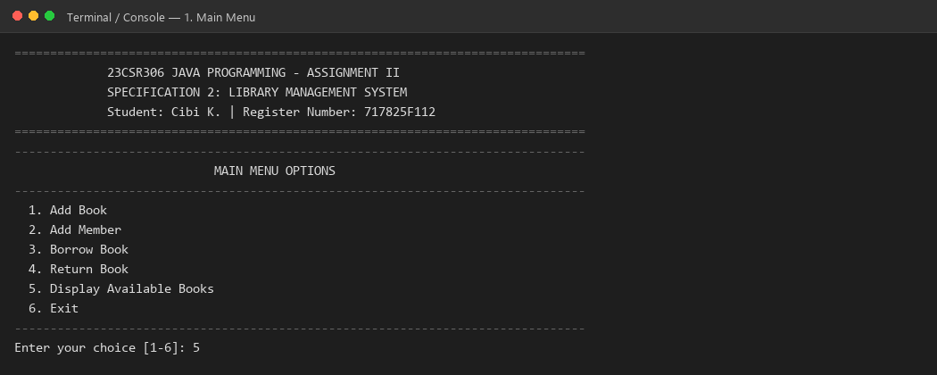
Figure 1: Main menu display showing all 6 required options and header details.

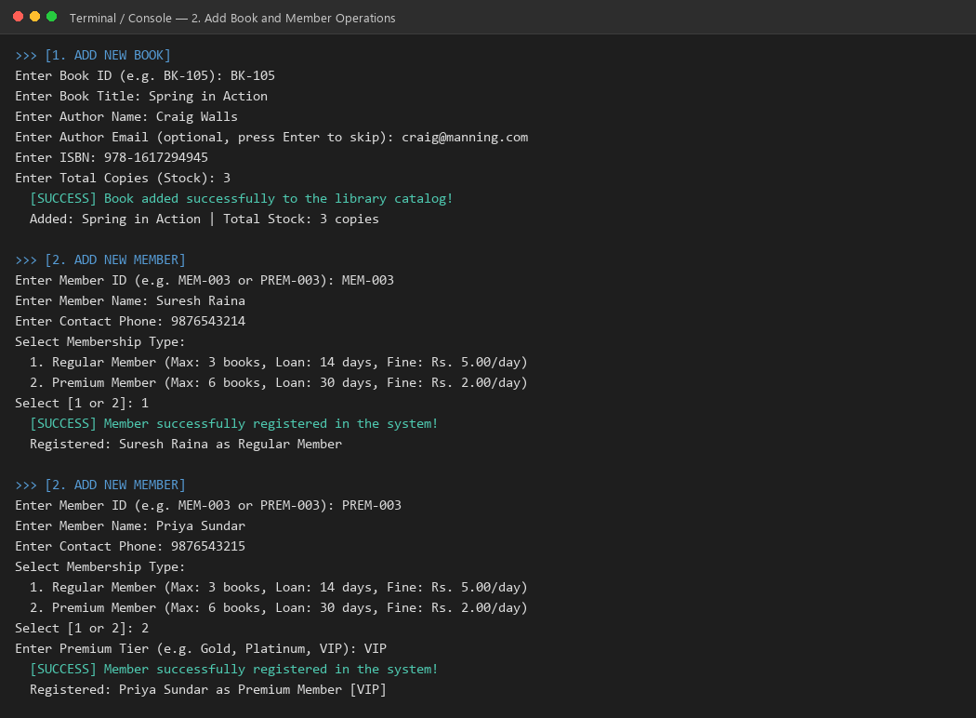
Figure 2: Successfully adding new Book (BK-105) and registering Regular and Premium members.

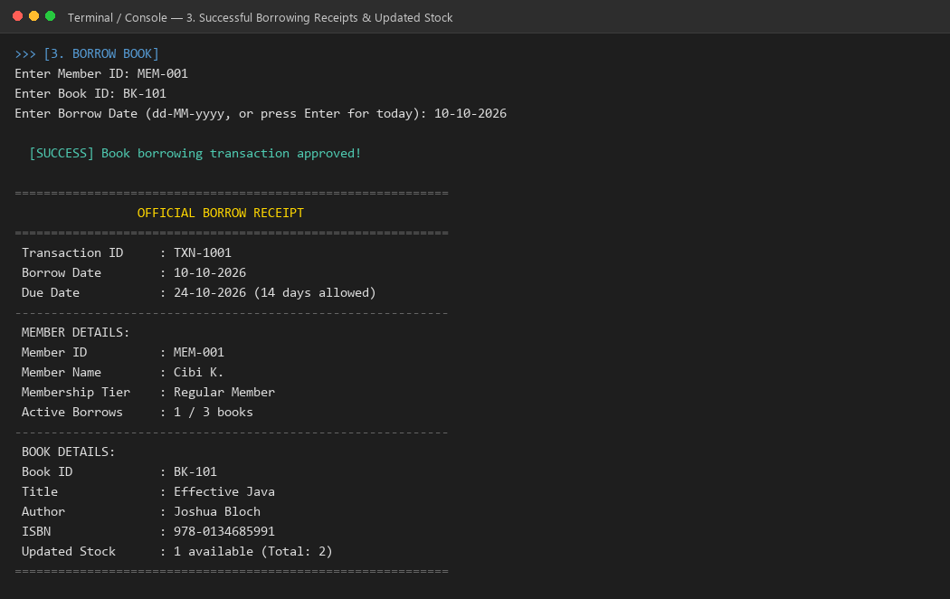
Figure 3: Official borrow receipt generation showing 14-day due date and immediately updated stock (2 -> 1).

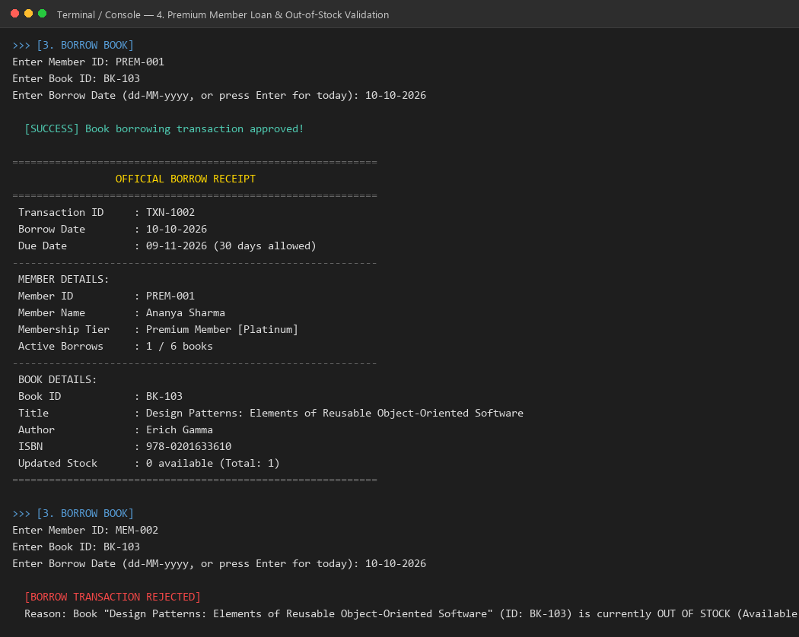
Figure 4: Premium member extended loan (30 days) and rejection of borrowing when book stock is 0/1.

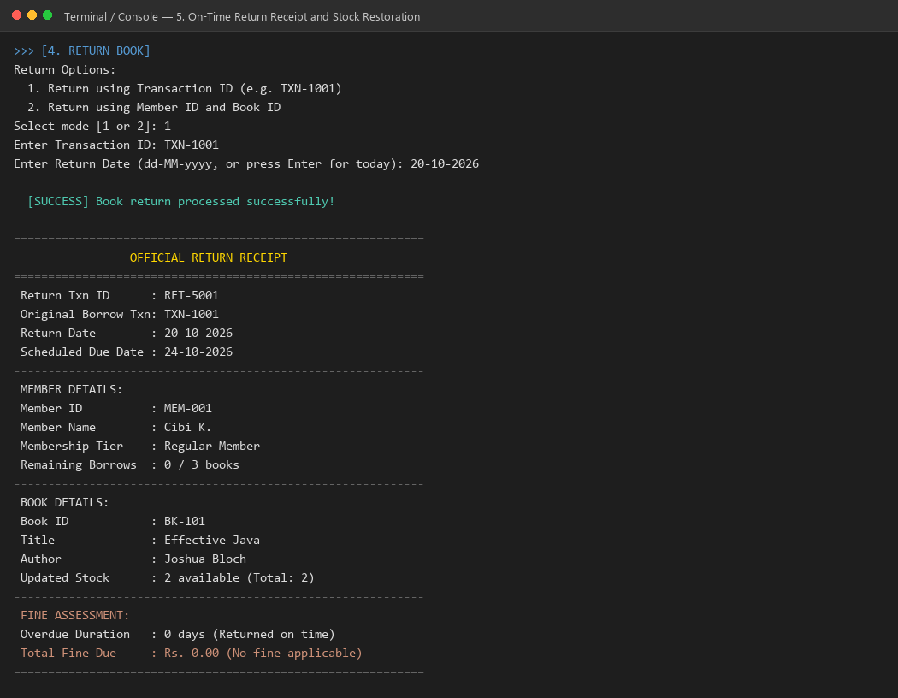
Figure 5: On-time book return receipt, stock restored (1 -> 2), with zero fine (Rs. 0.00).

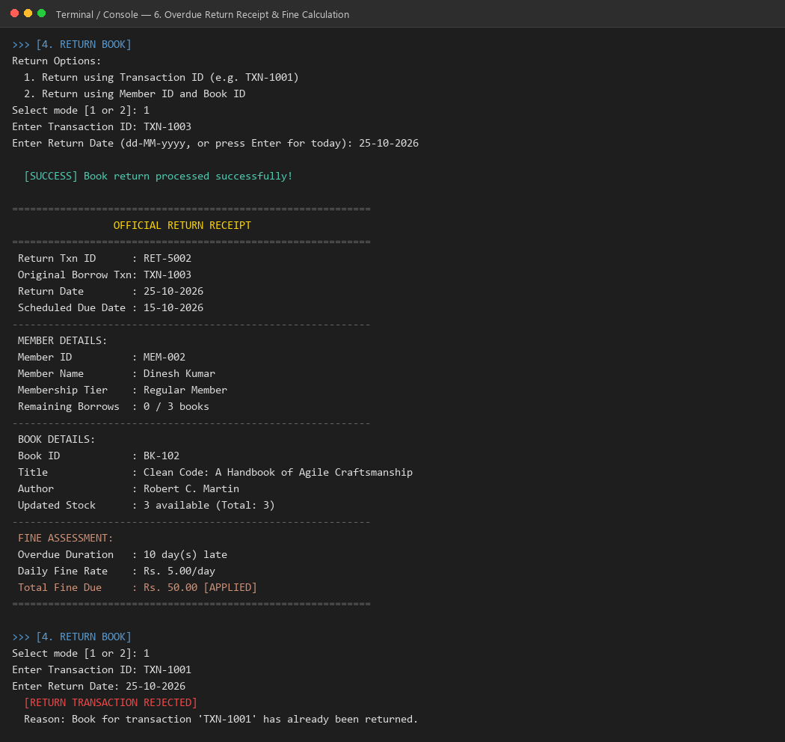
Figure 6: Return receipt showing overdue fine calculation (10 days @ Rs.5/day = Rs.50.00) and unborrowed/duplicate return rejection.

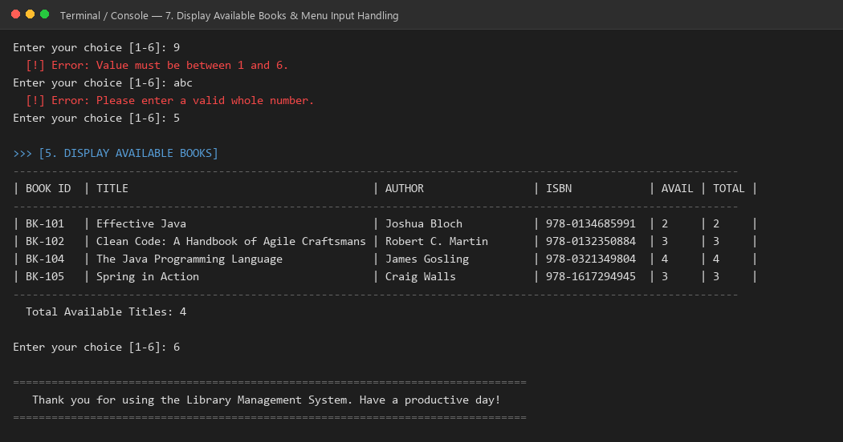
Figure 7: Display Available Books table and validation handling of invalid menu choices without crashing.
Note on Capturing in Eclipse IDE:
To reproduce and capture these identical console outputs directly inside Eclipse IDE:
1. Import project via File -> Import... -> General -> Existing Projects into Workspace.
2. Run Main.java by right-clicking -> Run As -> Java Application.
3. Execute the respective menu commands (1 through 6) in the Eclipse Console tab at the bottom.
4. Use Alt + PrtScn or Windows Snipping Tool (Win + Shift + S) to capture the Eclipse Console window.

4. GitHub Repository Link
Repository URL: | https://github.com/cibi-k/LibraryManagementSystem-JAVA
Repository Name: | LibraryManagementSystem-JAVA
Author / Student: | Cibi K. (Register No: 717825F112)
Branch: | main
README.md Contents: | Problem statement, business rules, OOP architecture, JDK 17 setup, Eclipse import steps, CLI commands, verified 17-scenario test matrix, fine & loan policies.

