Improving Customer Satisfaction With Source-Aware AI Food Explanations: Design and Evaluation of What’sOnMyFood
Caleb Barranco
Computer Science Master of Science, Full Sail University
Advisor: Dr. Andreas Marpaung
2026
Abstract— This study examines whether experience with AI-generated explanations can improve satisfaction and intention to recommend a food-information application. Forty adult Android users rated What’sOnMyFood, Yuka, Open Food Facts, and Bobby Approved. A four-item experience index combined ratings of usefulness, completeness, ease of use, and decision confidence as satisfaction-related indicators. What’sOnMyFood had a median experience index of 4.75 out of 5 and a median recommendation rating of 5. It was the first choice of 32 of the 40 participants (80.0%). Exploratory paired comparisons favored What’sOnMyFood over each comparison application for both outcomes after adjustment for six comparisons (all adjusted p < .001). These findings are consistent with H1 and H2. The study compared What’sOnMyFood, which provided AI-generated explanations, with three applications used without such explanations. Notably, Open Food Facts received the lowest median experience index while also serving as an underlying product-data source for What’sOnMyFood. This pattern suggests that explanations and information presentation may add value beyond access to product data alone. However, the comparison does not establish that AI explanations alone caused the observed differences.
Index Terms- expectancy-disconfirmation, explainable AI, food scanning, large language models, source quality, trust calibration, user satisfaction.

I. INTRODUCTION

A. Problem Definition
A shopper usually scans a packaged food because a decision must be made now. The person may want to understand added sugar, sodium, additives, allergens, or a product claim. Food-information applications can help, but finding a product does not guarantee that its record is complete or that its results are easy to interpret. Open Food Facts, for example, is a collaborative database that exposes ingredients and nutritional values through its API [1]. Its coverage is valuable, although a record can still be incomplete for a particular product at a particular time.
The project addresses the gap between product recognition and useful explanation. A static result may identify the product but still show missing fields or a request for later human review. What’sOnMyFood is designed to continue through a controlled fallback path: use cached data when appropriate, query ranked product sources, capture ingredient-label text, apply deterministic rules, retrieve missing ingredient context, and ask a protected LLM to explain only the evidence supplied to it [2]. The LLM is an explanation layer, not the sole decision engine.
The central problem is therefore not simply whether an AI response sounds helpful. A fluent explanation can increase satisfaction while still containing an unsupported claim. NIST describes this risk as confabulation: generative systems can present false content confidently, which can lead users to act on it [3]. A complete evaluation should consider both the user’s experience and the system’s factual accuracy. The present study evaluates user experience and proposes a separate framework for assessing explanation accuracy.

B. Research Questions
The primary research question is: Can an AI explanation improve satisfaction with a food-information application? The study examines this question through users’ experiences with What’sOnMyFood and three comparison applications. A related question asks whether the AI-explanation experience is accompanied by greater intention to recommend the application.
A separate reliability question asks how user trust in an explanation compares with the explanation’s factual accuracy. This thesis describes a trust–accuracy assessment framework and explains the app’s source-quality process. The completed survey measures perceptions, not independently reviewed explanation accuracy.

C. Hypotheses and Available Evidence
H1—User satisfaction: Participants will report higher satisfaction after an AI-assisted experience than after an experience without AI assistance. Here, AI assistance means receiving AI-generated explanations of food-product findings. The survey provides satisfaction-related ratings of usefulness, completeness, ease of understanding, and decision confidence. Their equal-weight average is an exploratory experience index, not a validated satisfaction scale or a direct overall satisfaction question. Trust is analyzed separately.
H2—Word-of-mouth intention: Participants will report a stronger intention to recommend the application after an AI-assisted experience than after an experience without AI assistance. Recommendation is a separate outcome because satisfaction and word of mouth are related but not identical [4], [5]. The five-point recommendation item measures stated intention, not actual referrals. These original hypotheses retain the with-versus-without-AI comparison. The four-application survey provides exploratory evidence from app comparisons, but does not isolate the contribution of AI explanations.

D. Motivation and Contribution
The practical audience is adult Android users who need understandable food information while comparing products. The contribution is a working design that connects deterministic findings, plain-language explanation, and visible references, together with a complete 40-session evaluation of that experience. A separate accuracy-assessment plan addresses whether helpful explanations stay within the evidence. It keeps satisfaction and factual reliability distinct.
What’sOnMyFood was the first choice of 32 of 40 participants (80.0%) in the completed evaluation. Participants valued ingredient explanations and references, while also requesting shorter summaries and clearer displays [6]. Paired analyses support more favorable experience and recommendation ratings in this sample. They do not establish factual accuracy or an AI-only causal benefit. What’sOnMyFood was evaluated as a beta prototype.

II. BACKGROUND AND RELATED WORK

A. Why Expectancy-Disconfirmation Theory
Expectancy-disconfirmation theory (EDT) provides a useful framework because it explains satisfaction in relation to what users expect and what they experience. It separates initial expectations, perceived performance, whether performance falls short of or exceeds expectations, and resulting satisfaction [7], [8]. This framework gives a literature-based reason to study explanations that help users understand food information. The 40-participant study found higher satisfaction-related experience and recommendation-intention ratings for What’sOnMyFood than for the three comparison applications used without AI explanations. These findings provide evidence consistent with H1 and H2 and support the value of the AI-assisted application experience. However, the study does not isolate the contribution of AI explanations from other differences between the applications. The study collected evaluations after application use without first asking participants to provide explicit expectation ratings. This approach is consistent with research showing that stating expectations beforehand can influence subsequent satisfaction evaluations [9]. It avoided that particular form of prompting, although the study did not establish whether bias was reduced. Consequently, expectations and disconfirmation were not directly measured.
EDT has substantial empirical support. A meta-analysis of 150 records and 58,597 observations reported a strong relationship between disconfirmation and satisfaction (r = .61 across 137 studies) and between perceived performance and satisfaction (r = .63) [8]. In information systems, Bhattacherjee adapted the theory to explain satisfaction and continued technology use [10]. Brown, Venkatesh, and Goyal also showed in a field study of 1,113 participants that both the direction and size of the gap between expectation and experience matter in technology use [11]. These findings support examining expectations and experience explicitly.
EDT offers a mechanism for a later extension of the research. Users could rate expected usefulness, clarity, completeness, and decision support before a task, then rate their experience afterward and state whether it was worse than, equal to, or better than expected. Those measurements would allow a direct test of disconfirmation and satisfaction.
Wong, Hickson, and McPherson also connect expectations with perceived experience in hearing-aid satisfaction [12]. This provides a health-technology parallel, not a sample-size requirement for the present study.
EDT is especially useful for an AI explanation study because perceived satisfaction and factual correctness can differ. In a study of 181 people evaluating AI classifier explanations, Riveiro and Thill found that participants reported greater satisfaction when the system produced the output they expected, even when both the expected answer and the AI answer were wrong [13]. This finding explains why EDT should be combined with the proposed claim-level accuracy review. EDT measures how expectations shape the user's experience; the independent accuracy score and trust-versus-accuracy matrix determine whether that positive experience is supported by correct information.
The related literature also cautions against treating EDT as a guaranteed effect. Grimmelikhuijsen and Porumbescu’s experimental replications found that disconfirmation needed further testing and that perceived performance could affect satisfaction directly [14]. Pal et al. applied an extended expectation-confirmation model to sustained smartwatch use, providing a technology-use connection [15]. This thesis therefore uses EDT to organize the questions, while keeping expectations, perceived experience, satisfaction, and factual performance distinct.

B. Explanations, Trust, and Food Decisions
Research on food recommenders indicates that explanation interfaces can improve understanding and a sense of control, but the effects depend on design and context. A real-world food recommender study used multiple design and deployment phases and measured understanding, trust, and user perceptions rather than assuming that an explanation was beneficial [16]. This supports evaluating the explanation as a user-interface feature, not only as generated text.
Explanation quality cannot be reduced to how persuasive the explanation appears. Wang and Yin identify three useful goals for AI explanations: improve understanding, communicate uncertainty, and support calibrated trust [17]. Their experiments also show that common explanations do not always achieve those goals, especially when people have limited domain knowledge. Food-health interpretation is exactly such a setting for many shoppers. The app should therefore show evidence and uncertainty while also measuring whether trust is deserved.

C. Hallucination and Trust Calibration
LLM hallucination is a direct threat to the study's validity and to the application's safety. NIST recommends that generative-AI systems be evaluated for validity, reliability, and confabulation risk throughout the lifecycle [3]. FActScore provides a useful methodological idea: split an output into atomic factual claims and calculate the share supported by a reliable source [18]. The proposed accuracy assessment adapts that idea to short food explanations and adds labels for contradiction, partial support, unverifiable language, and important omissions.
Trust calibration compares perceived reliability with actual reliability. Okamura and Yamada describe over-trust as trusting or relying on a system more than its performance justifies, and under-trust as discounting a system that performs well [19]. The survey measures application-level trust on a five-point scale. A later explanation-level assessment could also ask whether the participant would rely on a specific explanation to buy, avoid, or investigate a product further.

D. Source Quality Is Not Explanation Accuracy
The app already provides a deterministic source-quality estimate. That estimate answers, 'How suitable is this reference for checking the explanation?' It does not answer, 'Is every generated claim correct?' This distinction follows the broader literature on health-information quality. QUEST uses explicit weighted criteria for rapid online health-information review [20]. The Online Quality Assessment Tool was developed specifically for online nutrition information and emphasizes objective criteria and reliability [21]. DISCERN demonstrates the value and limits of structured ratings for consumer health information [22], while GRADE separates quality of evidence from the strength of a recommendation [23].
Source quality, explanation accuracy, and user trust therefore need separate measurements. A source can be authoritative but only loosely related to a claim. An explanation can cite a strong source and still overstate what it says. A user can trust either a correct or an incorrect explanation. The current survey measures perceived trust and the helpfulness of source references; independent explanation accuracy remains a planned measurement.

III. METHODOLOGY

A. Implemented Architecture
The system described here is What’sOnMyFood beta 1.11.0 release candidate 1, the build evaluated in this study. The Android application uses CameraX and Google ML Kit for barcode and ingredient-label capture. ML Kit supports on-device barcode decoding [24]. Room stores cached product records, pantry membership, analysis fields, and saved explanations [2], [25]. A protected Node.js backend keeps model credentials and AI requests outside the mobile client. Findings in this paper are bounded to this study build; subsequent product changes are not treated as evaluated features.
A scan follows a source-aware pipeline. The repository first checks the local cache. It then queries product sources and scores usable responses by fields such as product identity, country relevance, ingredient presence, nutrition fields, brand, image, and quantity. Open Food Facts is the primary open source, with other providers used as fallbacks [1], [2]. If ingredients are missing, the app can use ingredient-label OCR or a retrieval endpoint. Retrieval-augmented generation is intended to connect generated language with external evidence [26].
The deterministic rule engine evaluates the normalized ingredients and nutrition fields. It produces repeatable findings for additives, added sugars, oils, sodium, preservatives, processing indicators, and positive ingredients. The LLM receives structured product context, rule findings, and source status through the protected backend. If the LLM is unavailable or returns an invalid response, the app continues to show product details and rule-based findings. This fallback is important because an explanation service should not become a single point of failure.
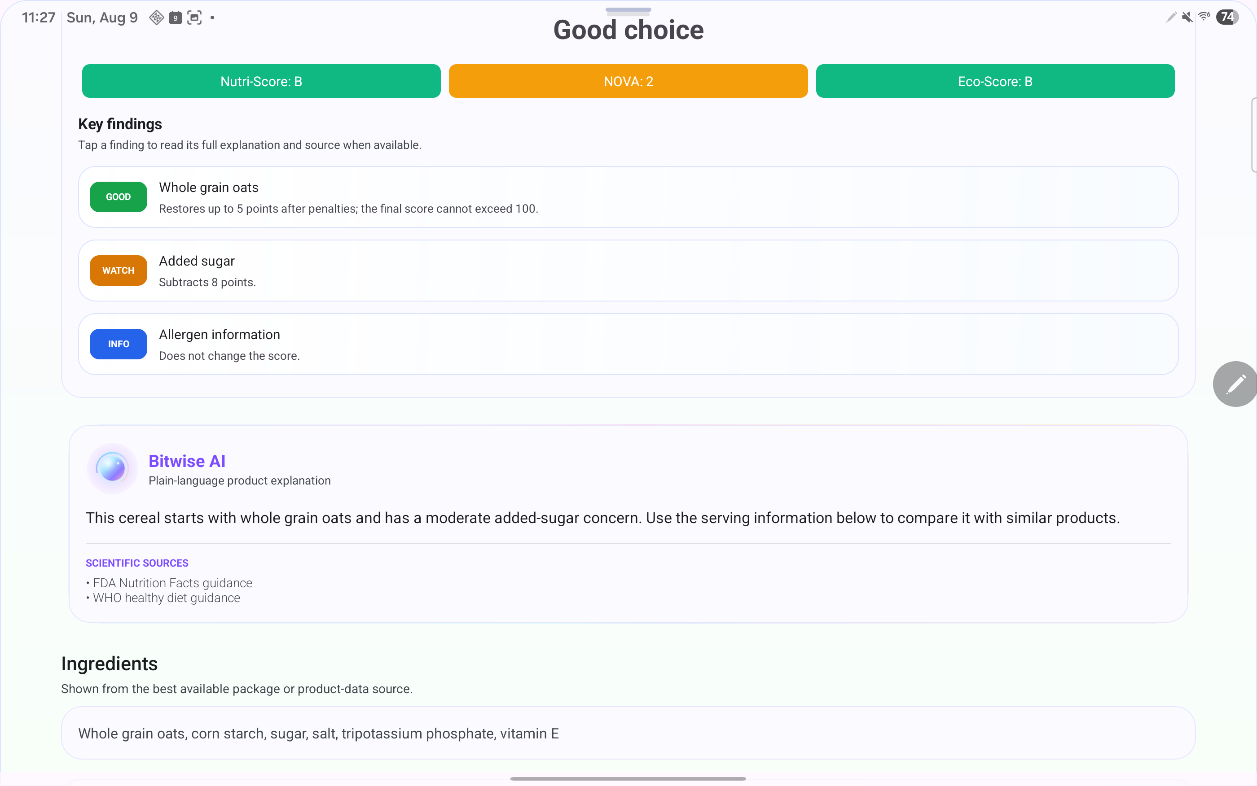
Fig. 1. Historical development preview of findings, the Bitwise explanation area, and sources, August 2026. Test-product fixture, not a participant-session capture or evidence of a live model response.

B. Source Verification in the Study Build
The source-verification feature displays references with a deterministic source-quality estimate [27]. The documented backend method, source_quality_v1, scores metadata already in memory after explanation generation, without another model call or network lookup. The five components in Table I total at most 99 points. In the evaluated build, raw scores were displayed without rescaling on a 0–100 interface scale: Very strong (90–100), Strong (75–89), Moderate (60–74), and Limited (0–59). Processing time was not measured in the survey.
TABLE I
SERVER-SIDE SOURCE-QUALITY SCORE
Component | Max | Purpose
Publisher authority | 30 | Institutional responsibility and expertise
Evidence orientation | 24 | Research or public-health evidence context
Claim/topic match | 25 | Fit between source and product issue
Retrieval status | 12 | Grounded retrieval versus curated source
HTTPS transport | 8 | Secure source delivery, not truth

Publisher authority uses normalized host matching. Named public-health authorities such as FDA, NIH/NCBI, CDC, USDA, WHO, EFSA, and Cochrane receive the highest authority value. Research repositories, journals, universities, and recognized health organizations receive values based on explicit categories. Claim matching uses the detected nutrition topic, such as added sugar, sodium, oils, or additives. Retrieval status distinguishes a source actually retrieved during grounding from a curated reference. HTTPS contributes only eight points because secure transport does not prove that content is accurate [27].
The Android client provides a fallback for older cached results, local rule sources, and explanations without server verification metadata. Its documented maximum is 92 points: authority (30), evidence orientation (24), title or URL relevance (20), traceability (10), and HTTPS (8). The client displays a valid server score when available and otherwise computes the local estimate. The interface presents the source link, score, category, and a disclaimer that the estimate is not the probability that every claim is true [27].
The normalized implementation converts both source-quality paths to a common display scale using round(raw points × 100 / raw maximum), bounded to 0–100. The raw maximum is 99 for the server and 92 for the local fallback. The backend identifies normalized scores as source_quality_v2; the Android client rescales saved source_quality_v1 scores and applies the quality bands after normalization [40]. Normalization aligns the displayed ranges; it does not validate the scoring weights or establish that the two methods measure quality equally well.
The benefit is a reproducible explanation of why a reference receives a particular quality category. The score remains a heuristic rather than a validated measure of truth. It does not inspect the full article for author credentials, conflicts of interest, publication date, study design, retractions, or risk of bias, and it does not check whether the generated wording faithfully represents the source. QUEST, OQAT, DISCERN, and GRADE inform the distinction between information quality and stronger evidential claims; their validation results do not transfer to the app’s custom scoring method [20], [21], [22], [23]. Here, source verification refers to scientific and health-information references, not certification of a product’s dietary or Non-GMO status.
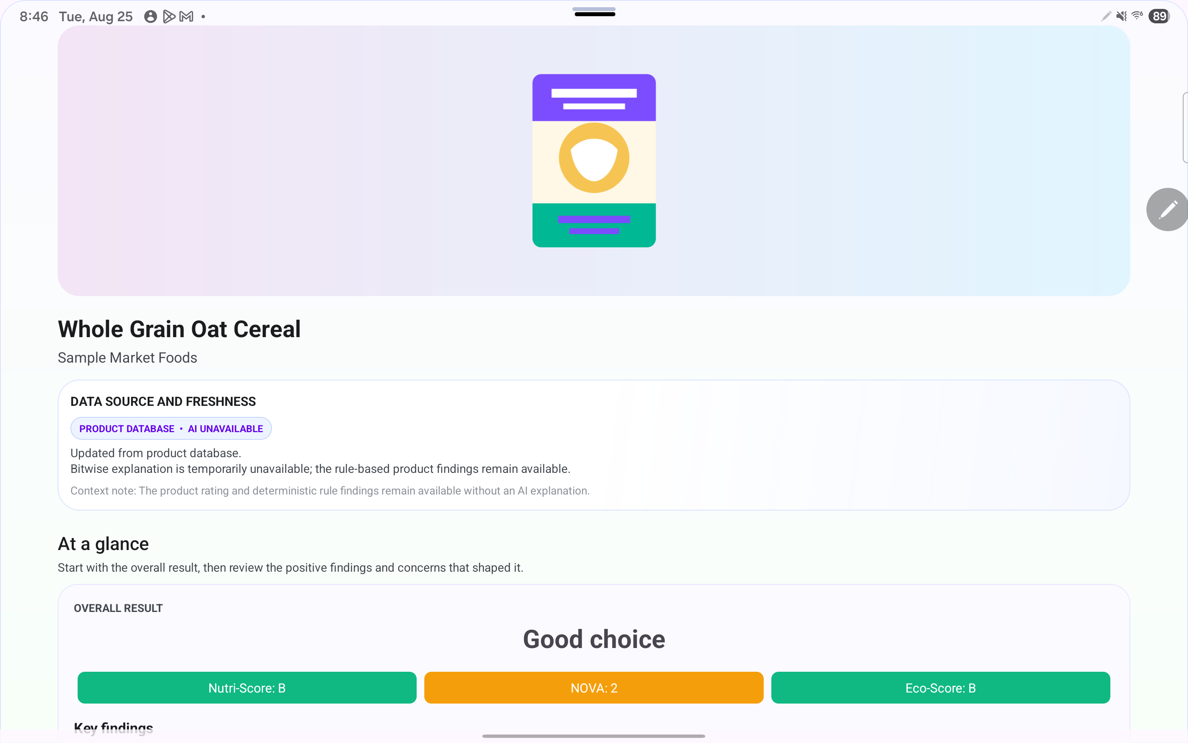
Fig. 2. Controlled AI-unavailable preview in v0.31.0-rc1, August 2026. Product findings remain available. This historical test capture is not evidence from the final study.

C. Proposed Claim-Level Accuracy Assessment
Each explanation will be split into short, independently checkable claims. For example, 'This product is high in sodium and may contribute to exceeding a daily limit' contains at least two claims: a product-specific sodium classification and a general health-context statement. Each claim will be labeled Supported, partly supported, Contradicted, Unsupported or unverifiable, or Not applicable. Reviewers will check the original product label, normalized record, deterministic rule output, and authoritative references. A missing decision-relevant fact will be recorded as an omission.
A critical contradiction involving an allergen, nutrient value, or unsafe medical statement overrides the numeric score and classifies the response as inaccurate. The method adapts FActScore’s claim-level approach [18]. Two trained reviewers will score independently, with disagreements adjudicated. Cohen’s kappa will describe agreement on claim labels and an intraclass correlation will describe agreement on numeric scores.
For each explanation, weighted claim support is 100 × (supported claims + 0.5 × partly supported claims) / all assessable factual claims. Contradicted and unsupported factual claims remain in the denominator with zero credit. Non-factual or genuinely inapplicable statements are excluded with a recorded reason. An explanation with no assessable factual claims receives no accuracy percentage. Omissions are reported separately so that a short but incomplete answer cannot be described as comprehensive merely because its few claims are supported.

D. Trust-Versus-Accuracy Matrix
The assessment compares claim-level accuracy with user trust for the same explanation. High trust is defined as 4 or 5 on the five-point scale; ratings of 1–3 form the lower-trust group. For the primary matrix, high accuracy requires at least 90% weighted claim support and no critical error. This is an engineering threshold, not a clinically validated boundary. Continuous scores and sensitivity analyses at nearby thresholds will accompany the matrix. Satisfaction is retained as a separate outcome and summarized within each cell. The application-level survey cannot populate this matrix because it has no independently reviewed explanation-level accuracy scores.
TABLE II
TRUST-VERSUS-ACCURACY INTERPRETATION
Actual performance | Lower trust (1–3) | High trust (4-5)
High accuracy | Under-trust: useful output is discounted | Calibrated trust: desired state
Low accuracy | Calibrated skepticism: error is recognized | Over-trust: highest-risk state

The matrix identifies explanations that receive high trust despite low accuracy. High satisfaction in that cell would not make the explanation reliable. The report will show the number and percentage of reviewed explanations in each cell, together with the median satisfaction rating and critical-error count. Repeated ratings from one participant will be identified. A numerical gap between rescaled trust and claim support, if reported, will be exploratory because the measures have different meanings.
Source-quality validation is a separate check. Reviewers will compare the app’s category with an independent assessment of source authority, evidence type, relevance to the actual claim, publication currency, and whether the cited page supports the wording. The analysis will report agreement and examples of misleadingly high scores. The custom source score will remain labeled an estimate unless that validation supports a stronger interpretation [20], [21], [22], [23].

E. Plan to Add the Assessment to the App
The accuracy system will be added in stages so that research instrumentation does not disrupt the shopping flow or expose personal data. The proposed implementation plan is shown in Table III.
TABLE III
ACCURACY-ASSESSMENT IMPLEMENTATION PLAN
Stage | App/backend change | Acceptance check
1. Identify | Return response ID, model, prompt, and source-method versions | Version and evidence context can be traced
2. Capture | Save privacy-safe audit record in Room and backend logs | No name, image, credential, or medical detail
3. Ask | Collect trust, satisfaction, and reliance after the result | Trust is stored separately from accuracy
4. Review | Reviewer tool labels atomic claims and omissions | Two blinded ratings plus adjudication
5. Analyze | Export de-identified matrix and calibration metrics | Report counts and exploratory calibration gaps
6. Guard | Flag risky versions or disable AI for failing scenarios | Critical-error and over-trust thresholds trigger action

A proposed Room entity, Ai Explanation Audit Record, would store a random audit identifier, a hashed or study-coded product identifier, response and version metadata, source-verification version, user trust, satisfaction, reliance choice, and later reviewer accuracy fields. The raw product image, full prompt, credentials, participant name, and personal health information would not be stored. Records created offline would queue until the approved research export is available.
The backend would return response_id, model_version, prompt_version, evidence_snapshot_id, and source_quality_method with each explanation. A review interface would show the explanation beside its evidence snapshot so that two reviewers could label claims. A future release gate could flag model or prompt versions that produce critical contradictions or excessive high-trust/low-accuracy responses. These audit functions and thresholds remain proposed work; limits should be agreed with the advisor before a new confirmatory data collection.

F. Comparative Survey Design
The final analysis includes all 40 submissions in 09212026_survey_40.xlsx [6]. The workbook records collection dates from August 28 through September 21, 2026. Each respondent rated What’sOnMyFood, Yuka, Open Food Facts, and Bobby Approved, making this a within-participant app comparison. The supplied study description identifies What’sOnMyFood beta 1.11.0 release candidate 1; individual build identifiers were not recorded in the workbook. Differences may reflect explanation quality, interface design, coverage, scoring, and familiarity together. The target of 40 submitted sessions is complete.
The accompanying test procedure specifies 20 fixed products, consistent task wording, counterbalanced application order, and 45–60-minute sessions [28]. Its supplied revision is version 1.2, dated September 8, 2026. Twenty survey responses precede that date and 20 are dated September 8 or later. The workbook has no application-order assignments, product-level task logs, or objective completion times. Therefore, the analysis does not assume that every protocol control was documented for every session.

G. Participants, Recruitment, and Sample Size
All 40 respondents recorded consent and reported an Android phone or tablet. Ten were aged 18–24, 14 were 25–34, nine were 35–44, six were 45–54, and one was 55 or older. Recruitment was through work or coworkers (23, 57.5%), church or community settings (7, 17.5%), other channels (8, 20.0%), and students or classmates (2, 5.0%). Twenty-eight had previously used at least one of the listed food-information applications. These are the reported channels; the workbook does not identify Facebook advertising or Google Console as verified recruitment sources. This is a convenience sample, not a representative sample of shoppers.
I chose a target of 40 participants for a focused, exploratory evaluation, using earlier expectations-and-satisfaction research as a practical precedent. Shepperd, Sweeny, and Cherry used 42 restaurant hosts and hostesses in Study 4 to examine their predictions about customer reactions to waiting times [29]. Grimmelikhuijsen and Porumbescu used a 40-person pilot before larger experiments with 309, 173, and 165 participants [14]. In a technology setting, Pal, Funilkul, and Vanijja studied 42 participants ethnographically before testing their expectation-confirmation model with 312 smartwatch users [15]. These small-study stages support evaluating experiences with roughly 40 people. They do not establish statistical power for this thesis or make the different study designs equivalent.
The final sample meets the practical target of 40 submitted sessions. The analysis retains all responses and reports item-specific denominators when an answer is missing or a ranking is invalid. Prior small-study precedents explain the feasible scope of this exploratory evaluation; they are not an a priori power calculation [30]. No claim of population representativeness follows from meeting the target.

H. Data Preparation and Analysis
Numeric ratings and text-labeled values were mapped to their leading scale values. Higher ratings indicate more favorable evaluations; rank 1 indicates the most preferred application. No missing rating was imputed and no participant was removed. Bobby Approved has one missing ease rating (P10) and concern-highlight rating (P24). Open Food Facts has one missing summary rating (P29) and source rating (P31). What’sOnMyFood has one missing marketplace rating (P34). These items use n = 39. P4 repeated rank 4 and omitted rank 2, so only that complete ranking was excluded, leaving 39 valid complete rankings. P4 still supplied one unambiguous first choice, so descriptive first-choice counts include all 40 participants. No rank values were repaired. P5’s numeric issue-description entry was not used as narrative evidence.
Individual ordinal items are summarized with medians, ranges, and response counts [31]. The exploratory experience index averages usefulness, completeness, ease, and decision confidence within each participant, requiring all four items. Trust remains separate. The index is a practical summary of satisfaction-related experience and is not a validated satisfaction scale. Comments were reviewed descriptively for recurring concerns and contrasting experiences, informed by thematic-analysis guidance [32]. Codes P1–P40 follow workbook row order. No independent qualitative coding agreement or saturation is claimed.
One written preference conflicts with its structured ranking (P28). Structured ratings and ranks are analyzed as entered, and the comment is described separately. No answer was changed to agree with the preferred interpretation. Missing optional background answers are not interpreted as negative responses, and participants’ personal health details are omitted from the thesis.

I. Study Validation and Hypothesis Assessment
Validation begins with checking the dataset and whether each measure addresses the research question. The workbook contains 40 nonempty consented responses, no exact duplicate rows or timestamps, and usable ratings within the expected scales. These checks do not independently prove that every record represents a different person. The analysis retains the repeated-measures structure: one participant contributes ratings for several apps, not several independent participants. The same rules for missing data and invalid rankings apply to every application.
Table IV maps the original hypotheses to the measurements collected. H1 is assessed through an exploratory index of satisfaction-related experience and supporting participant comments. H2 is assessed through the recommendation-intention item. Participants rated one application providing AI-generated explanations and three applications used without such explanations. The paired tests assess differences between these application experiences, while recognizing that interface design, information coverage, and other features may also contribute to the results.
TABLE IV
MEASURES USED TO ASSESS THE RESEARCH QUESTIONS
Measure | Survey evidence | Interpretation
Application | Four app ratings per person | Paired comparison
Experience | Mean of four items | H1 proxy
Recommend | One item, 1–5 | H2 intention
Trust | One item, 1–5 | Perception only

J. Statistical Tests and Separate Accuracy Review
Exploratory Friedman tests compare the four applications while keeping ratings paired within participants [33]. Follow-up exact two-sided sign tests compare What’sOnMyFood with each other app for the experience index and recommendation [34]. The sign test counts higher and lower paired scores; ties remain in the descriptive results but do not enter its binomial denominator. Holm adjustment is applied across all six follow-up tests at a familywise level of .05 [35]. Tests were selected during final analysis and are not presented as preregistered confirmation. Higher, equal, and lower counts, paired differences, and uncertainty intervals supplement p values.
The notebooks reproduce the data checks, descriptive summaries, tests, and figures. Individual confidence intervals describe uncertainty and are not simultaneous six-comparison intervals. A larger confirmatory study should use a validated satisfaction measure, planned effect size, and a design-specific sample calculation [36], [37], [38], [30]. Independent explanation accuracy remains a separate task: reviewers would assess frozen explanations against product evidence and sources while blinded to user ratings. That review was not supplied with this survey and is not inferred from favorable satisfaction or trust.

K. Consent and Research Data
The Institutional Review Board (IRB) office at Full Sail University determined that this study qualified as a low-risk, exempt usability project for classroom purposes. All workbook respondents selected the consent option. This investigation reports aggregate findings and uses participant codes for illustrative comments. The documented procedure specifies advisor and institutional authorization, participant codes, and limits on collected data [28]. Further controlled testing and audit instrumentation should be assessed against the scope of the institutional determination and the documented research protocol. Research exports should exclude credentials, unnecessary personal identifiers, product images, and medical details. Source links and explanations support investigation; their presence does not establish clinical or allergy-safety validation.

IV. PRESENTATION OF WORK AND FINDINGS

A. Completed Work and Study Context
The completed contribution includes the Android product-information workflow, deterministic findings, AI explanation layer, source-quality display, and 40-session comparative survey. The earlier proposal describes a separate ten-person formative pilot [39]. It is background only: those participants and earlier subsets of the present survey are not added to the final sample. All numerical findings below are recalculated from the 40-response workbook [6].

B. Application Experience and Recommendation
What’sOnMyFood had median ratings of 5 for usefulness, ease, decision confidence, and recommendation, 4.5 for completeness, and 4 for trust. All 40 participants selected either 4 or 5 on each of these six items. Table V compares the same measures across applications. Trust is reported separately because a favorable perception is not an independent accuracy check.
TABLE V
APPLICATION RATINGS AS MEDIAN [RANGE]
Measure | WOMF | Yuka | OFF | Bobby
Usefulness | 5 [4–5] | 4 [2–5] | 4 [2–5] | 4 [2–5]
Completeness | 4.5 [4–5] | 4 [3–5] | 3 [1–5] | 3 [2–5]
Ease | 5 [4–5] | 4.5 [3–5] | 3 [2–4] | 4 [2–5]
Decision confidence | 5 [4–5] | 4 [2–5] | 3 [2–5] | 4 [2–5]
Trust | 4 [4–5] | 4 [3–5] | 4 [3–5] | 3 [2–5]
Recommend | 5 [4–5] | 4 [2–5] | 3 [1–4] | 3 [1–5]
WOMF = What’sOnMyFood; OFF = Open Food Facts; Bobby = Bobby Approved. Five-point scales, higher is more favorable. Each item uses n = 40 except Bobby ease (n = 39). Brackets show the observed minimum and maximum.
The experience index follows the same pattern (Table VI). The median was 4.75 for What’sOnMyFood, 4.25 for Yuka, 3.25 for Open Food Facts, and 3.75 for Bobby Approved. Bobby Approved uses 39 complete records because one ease rating is missing. The index summarizes satisfaction-related experience.
TABLE VI
EXPLORATORY FOUR-ITEM EXPERIENCE INDEX
Application | n | Median [range]
What’sOnMyFood | 40 | 4.75 [4.00–5.00]
Yuka | 40 | 4.25 [2.50–5.00]
Open Food Facts | 40 | 3.25 [2.00–4.25]
Bobby Approved | 39 | 3.75 [2.50–4.75]
Twenty-nine of 40 participants (72.5%) gave What’sOnMyFood a recommendation rating of 5; the other 11 gave it a 4. The median was 5 and the descriptive mean was 4.725. Recommendation is assessed separately from the experience index and represents stated willingness to recommend, not observed word-of-mouth behavior.

C. Overall Preference
All 40 participants supplied one unambiguous first choice. What’sOnMyFood received 32 first-choice selections (80.0%), Yuka six (15.0%), and Bobby Approved two (5.0%). Open Food Facts received none. Fig. 3 shows these counts. P4’s repeated lower rank does not change the identifiable first choice and is not repaired for this summary.
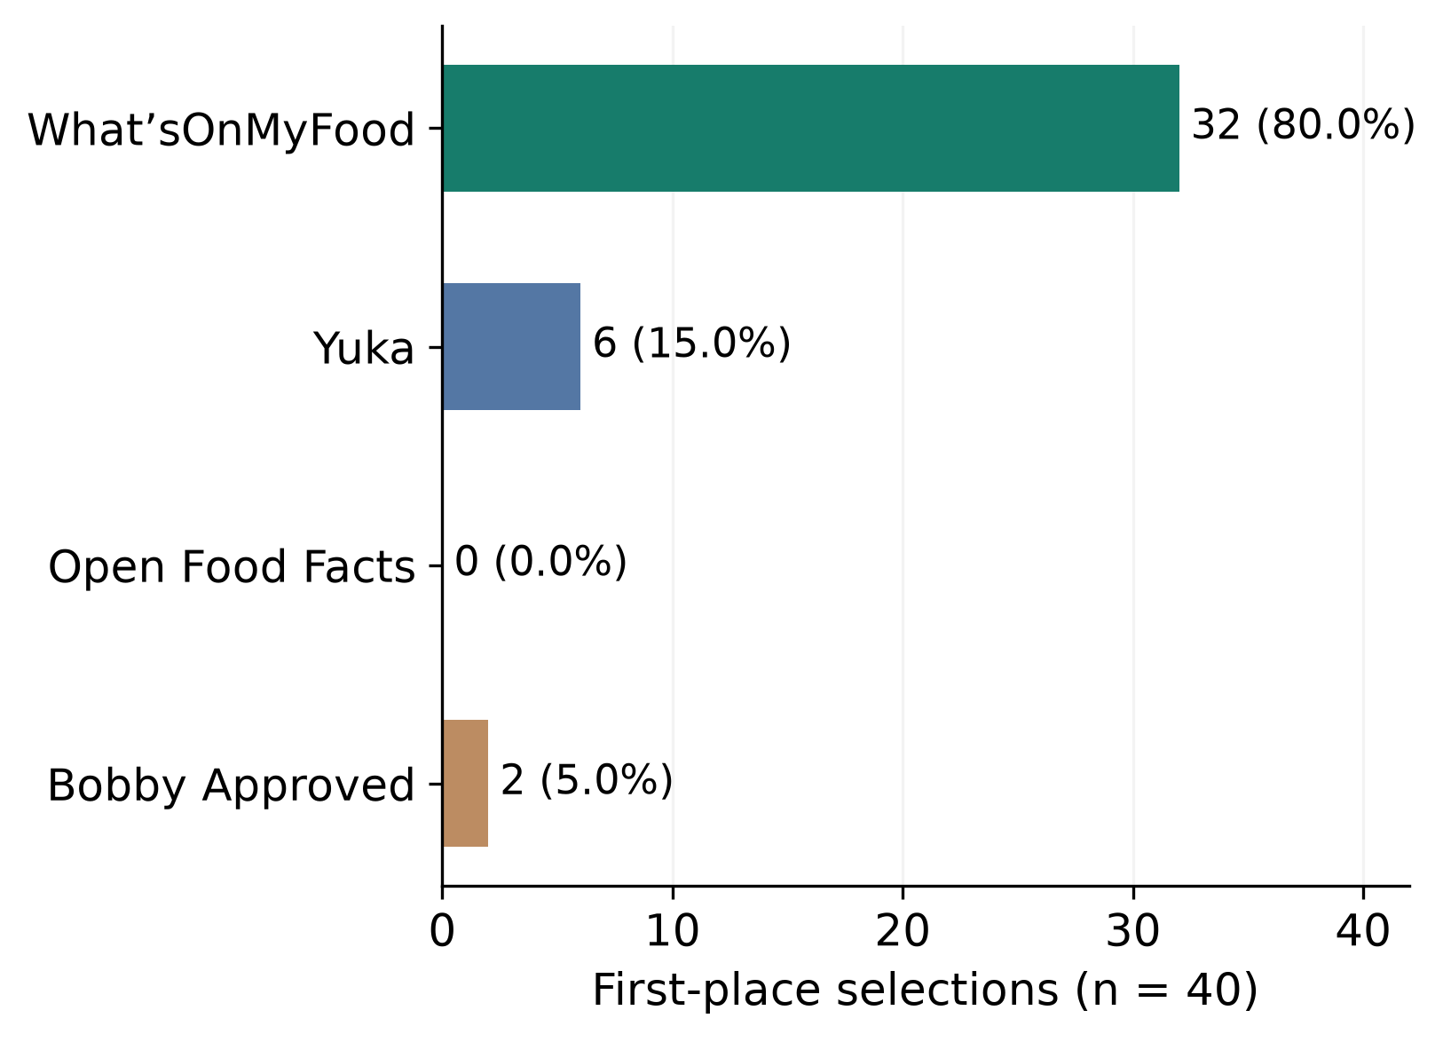
Fig. 3. First-choice preferences from all 40 participants. Each response contains exactly one rank 1. A repeated lower rank affects only analyses requiring a valid complete ranking. Source: final survey [6].
Analyses of complete rankings retain 39 valid responses: What’sOnMyFood ranked first 31 times (79.5%) and second eight times (20.5%), never third or fourth. These full-ranking results are distinct from the 40-person first-choice summary. P28’s written preference favors Yuka, although its structured ranking puts What’sOnMyFood first. Both answers remain unchanged and the inconsistency is reported.

D. Which Features Participants Valued
Ingredient information received 32 maximum ratings out of 40 (80.0%); source references received 28 (70.0%). Rating or summary received 27, scanning 28, and nutrition information 22. Table VII summarizes all seven features. These findings connect the application’s appeal to understandable ingredient information and access to supporting references.
TABLE VII
WHAT’SONMYFOOD FEATURE HELPFULNESS
Feature | Median [range] | Rated 5
Scanning / search | 5 [4–5] | 28/40
Ingredient information | 5 [4–5] | 32/40
Nutrition information | 5 [4–5] | 22/40
Rating / summary | 5 [4–5] | 27/40
Source references | 5 [4–5] | 28/40
Concern highlights | 4.5 [3–5] | 20/40
Price / marketplace | 3 [2–5] | 1/39
Five-point helpfulness scales. Items use n = 40 except What’sOnMyFood price or marketplace (n = 39). The last column is the count rated 5 divided by usable answers. Helpfulness of references does not measure their correctness.
What’sOnMyFood’s price or marketplace item had a median of 3; Bobby Approved’s corresponding median was 5, with 29 of 40 selecting 5. Yuka’s scanning median was 5. The preferred overall application did not lead on every feature.

E. What the Comments Explain
The comments help connect these ratings to the thesis problem. Participants described value in explanations that connected ingredient details to a reason they could understand. P16 emphasized ordinary language, P17 valued the connection between ingredients and the explanation, and P18 described the information as less intimidating. P4 valued saving an explanation, while P6 and P7 highlighted ingredient-label scanning. These accounts suggest that the benefit came from making information usable.
Access to evidence mattered alongside readability. P5 described the sources, explanation, and warnings as “really on point.” P19, P23, and P24 emphasized references or the ability to check them. P13 also valued the percentage beside sources but called it “porcentages of accuracy.” That wording is especially relevant: it suggests that the intended source-quality signal can be interpreted as a statement about factual accuracy. One comment establishes a usability concern worth testing, not its prevalence across all users.
Several comments also describe friction in What’sOnMyFood. P2 reported that an AI explanation was unavailable on the first attempt and worked on a second attempt. P8 reported a wait of approximately 20–30 seconds; this is a participant estimate, not a timed performance result. P16, P18, and P24 wanted a shorter opening explanation, and P23 found the display busy on a phone. The findings therefore support concise summaries and reliable access to detail, rather than assuming that longer explanations always improve satisfaction.
Comments about other applications often concerned missing data or unexplained judgments. P2 and P4 found multiple Open Food Facts scores difficult to interpret, while P1 and P7 encountered incomplete information. P3 questioned the basis of Bobby Approved’s approval labels. Later respondents likewise asked for clearer reasons behind ratings and warnings. These are reports of the user experience; disagreement with an app’s score is not by itself proof of a factual error.
Preference was not uniform. P3, P20, P25, P29, P34, and P38 ranked Yuka first; P10 and P37 ranked Bobby Approved first. Their comments valued familiarity, speed, or a simpler interface. P34 valued the AI explanation but preferred Yuka’s familiar workflow. P28 also described preferring Yuka, although its structured ranking puts What’sOnMyFood first. Details were useful without being every shopper’s first priority.
The final four responses preserve that contrast. P37 preferred Bobby Approved’s speed and simplicity, and P38 preferred Yuka’s immediately understandable experience. P39 and P40 ranked What’sOnMyFood first and valued ingredient explanations that reduced the need for further searching. These comments help explain favorable ratings while showing that the explanation experience was not unanimously preferred. They do not establish changes in diet or purchasing behavior.

F. Reported Issues and the Meaning of Verification
Twenty-four participants (60.0%) answered Yes to the item about incorrect, unsupported, confusing, or source-related information; eight answered No and eight were unsure. The question covers all four applications and several different problems. It is not a What’sOnMyFood hallucination rate or a count of verified factual errors. Comments include missing information, unavailable explanations, unclear scoring, and disagreement about assessments.

G. Discussion and Significance
The final data provide exploratory evidence consistent with H1 and H2. What’sOnMyFood received higher satisfaction-related experience scores and higher recommendation ratings than each comparator in the paired analyses. Comments connect its appeal to understandable explanations and accessible sources. The study compared What’sOnMyFood, which provided AI-generated explanations, with three applications used without such explanations. This comparison evaluated complete application experiences and did not isolate AI explanations from other differences between the applications.
The source-verification finding adds practical refinement to the thesis. Participants valued references, yet one interpreted the quality percentage as accuracy. Showing evidence can support informed trust only if users understand what the signal means. A clearer label such as “Source quality estimate,” a brief explanation of its inputs, and a distinction between retrieved and curated references deserve testing. The wording should avoid suggesting that a high score certifies the product or proves the AI explanation correct.
Design improvements should preserve the depth users valued while making the first screen easier to read. A concise opening summary, visible access to the full explanation and references, and clear loading or retry states address the reported friction. These are implications of the comments, not changes evaluated in beta 1.11.0 release candidate 1. The next research step is to examine whether these improvements retain the perceived benefit while improving comprehension of uncertainty and source quality.

H. Limitations and Threats to Validity
The convenience sample is small and concentrated in workplace and community recruitment. Workplace participants came from different departments and teams rather than the researcher’s own team, as reported in the study description. Familiarity, recruitment relationships, and participation in a researcher-led evaluation may affect responses. Twenty responses predate the supplied protocol revision, and order assignments were not recorded. These limits prevent a causal or population-wide interpretation.
All six core What’sOnMyFood ratings are 4 or 5, producing a ceiling pattern. Missing items, one invalid complete ranking, and P28’s ranking/comment inconsistency remain visible in the analysis. The four-item index is unvalidated and lacks a direct overall-satisfaction item. Recommendation is an intention, waiting times in comments are estimates, and the workbook does not document individual app versions. The survey contains no independently reviewed explanation-error rate, source-score validation, or matched trust–accuracy observations. Completing 40 sessions does not remove these measurement limits.
Accuracy review requires written rubric, independent ratings, and adjudication of claim boundaries and partial support. Source reputation and the proposed 90% claim-support threshold do not establish clinical safety. Product-specific findings must remain limited to the evidence reviewed, the study build, and the tested population.

I. Results for H1 and H2
Table VIII reports the paired comparisons. In all six tests, more participants rated What’sOnMyFood higher than lower, and every Holm-adjusted p value was below .001. The smallest separation was against Yuka: 30 higher, three equal, and seven lower experience scores, and 23 higher, 12 equal, and five lower recommendation scores. Statistical significance describes the sampled differences; it does not by itself validate the experience index or identify their cause.
The omnibus Friedman results were Q(3) = 74.14 for the experience index (39 complete participants, Kendall’s W = .634) and Q(3) = 67.39 for recommendation (40 participants, W = .562). Within-participant permutation checks with 100,000 relabelings supported both differences (Monte Carlo p ≈ .00001 for each). These checks preserve the paired structure but cannot remove unrecorded order or familiarity effects.
TABLE VIII
PAIRED COMPARISONS WITH WHAT’SONMYFOOD
Outcome / comparator | n | Higher / equal / lower | Median Δ | Adj. p
Exp. / Yuka | 40 | 30 / 3 / 7 | 0.5 | < .001
Exp. / OFF | 40 | 40 / 0 / 0 | 1.25 | < .001
Exp. / Bobby | 39 | 33 / 4 / 2 | 1 | < .001
Rec. / Yuka | 40 | 23 / 12 / 5 | 1 | < .001
Rec. / OFF | 40 | 39 / 1 / 0 | 2 | < .001
Rec. / Bobby | 40 | 35 / 3 / 2 | 2 | < .001
Exp. = experience index; Rec. = recommendation; OFF = Open Food Facts. Higher/equal/lower refers to What’sOnMyFood versus its comparator. Δ is the within-person score difference. Adjusted p values use two-sided exact sign tests and Holm correction across six comparisons.
For H1, participants generally rated the AI-explanation application experience more favorably on satisfaction-related indicators. For H2, they reported higher intention to recommend the application. The distributions in Figs. 4 and 6 and the paired directions in Figs. 5 and 7 show this pattern, including ties and less favorable ratings. The findings provide exploratory evidence consistent with H1 and H2. They do not isolate the contribution of AI explanations, establish change in a validated satisfaction score, or demonstrate actual referrals.
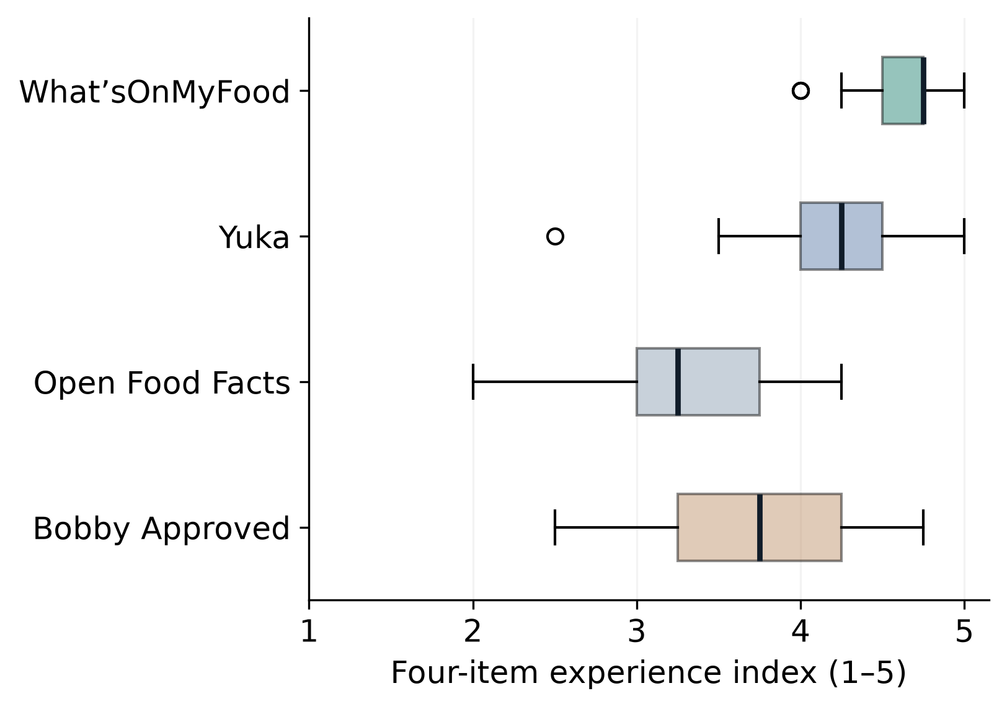
Fig. 4. Satisfaction-related experience index across applications. Each person’s index averages four ratings. Trust is excluded. The index is exploratory; source: final survey [6].
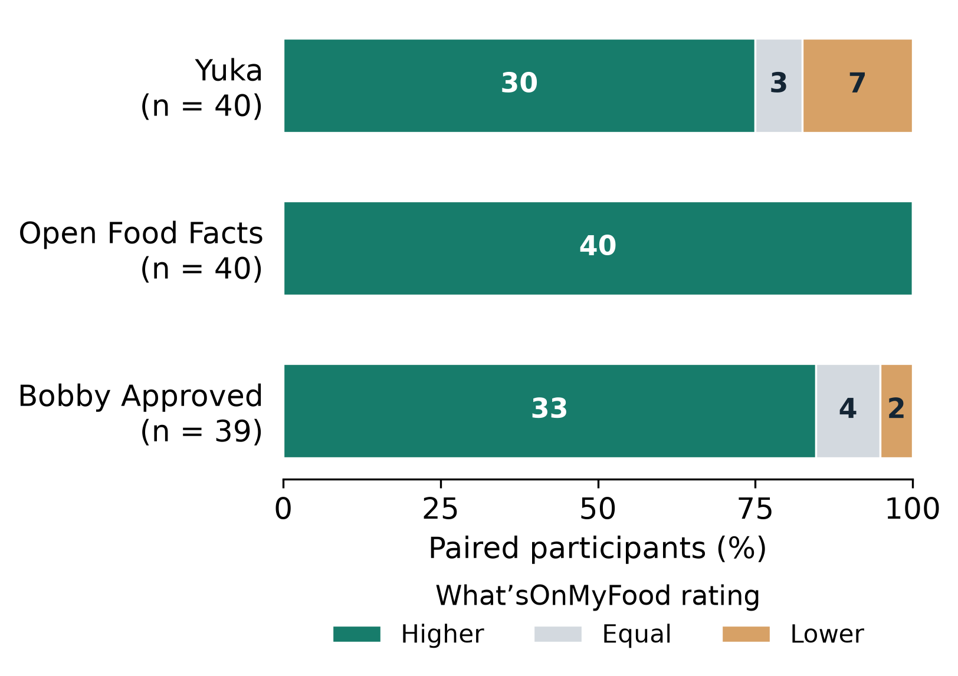
Fig. 5. Paired satisfaction-related experience ratings. Bars show the percentage rating What’sOnMyFood higher, equal, or lower than each comparator; labels show counts. Yuka and Open Food Facts use 40 pairs, Bobby Approved 39. This comparison provides evidence consistent with H1 through satisfaction-related experience ratings, without isolating the contribution of AI explanations. Source: final survey [6].
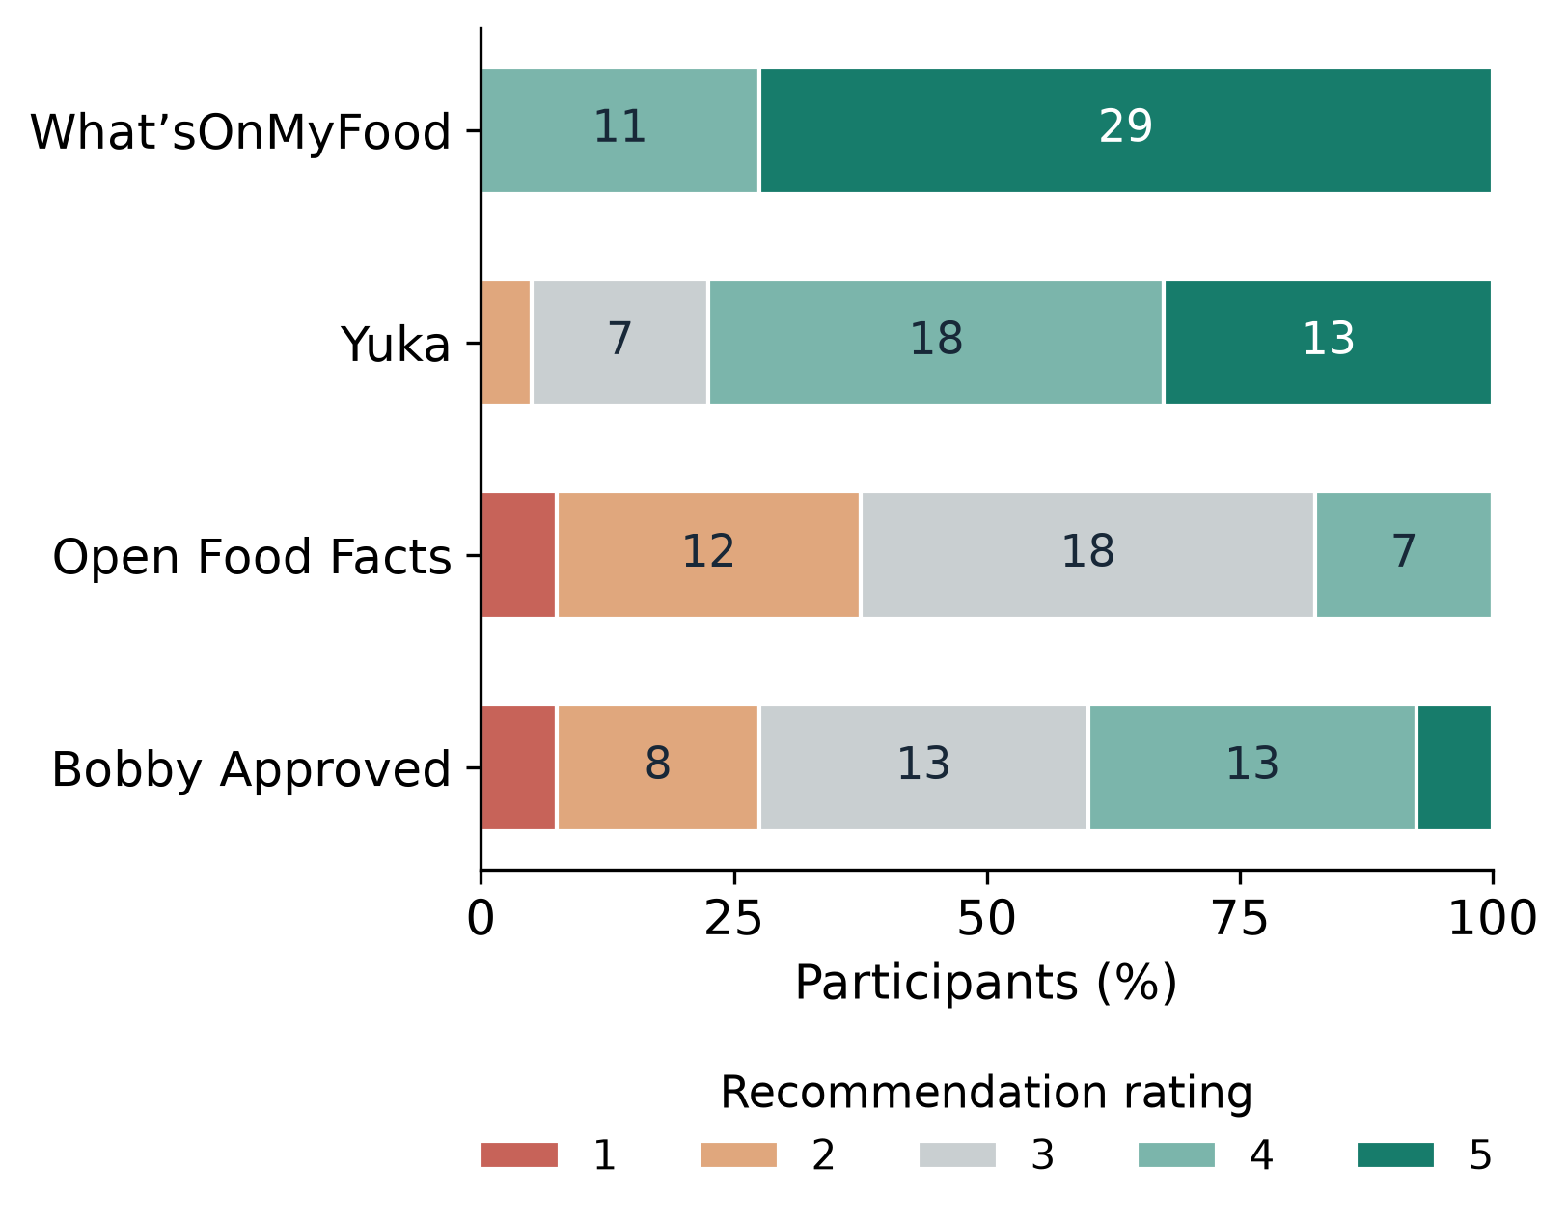
Fig. 6. Recommendation ratings after the app experiences. These are intentions, not observed referrals. Source: final survey [6].
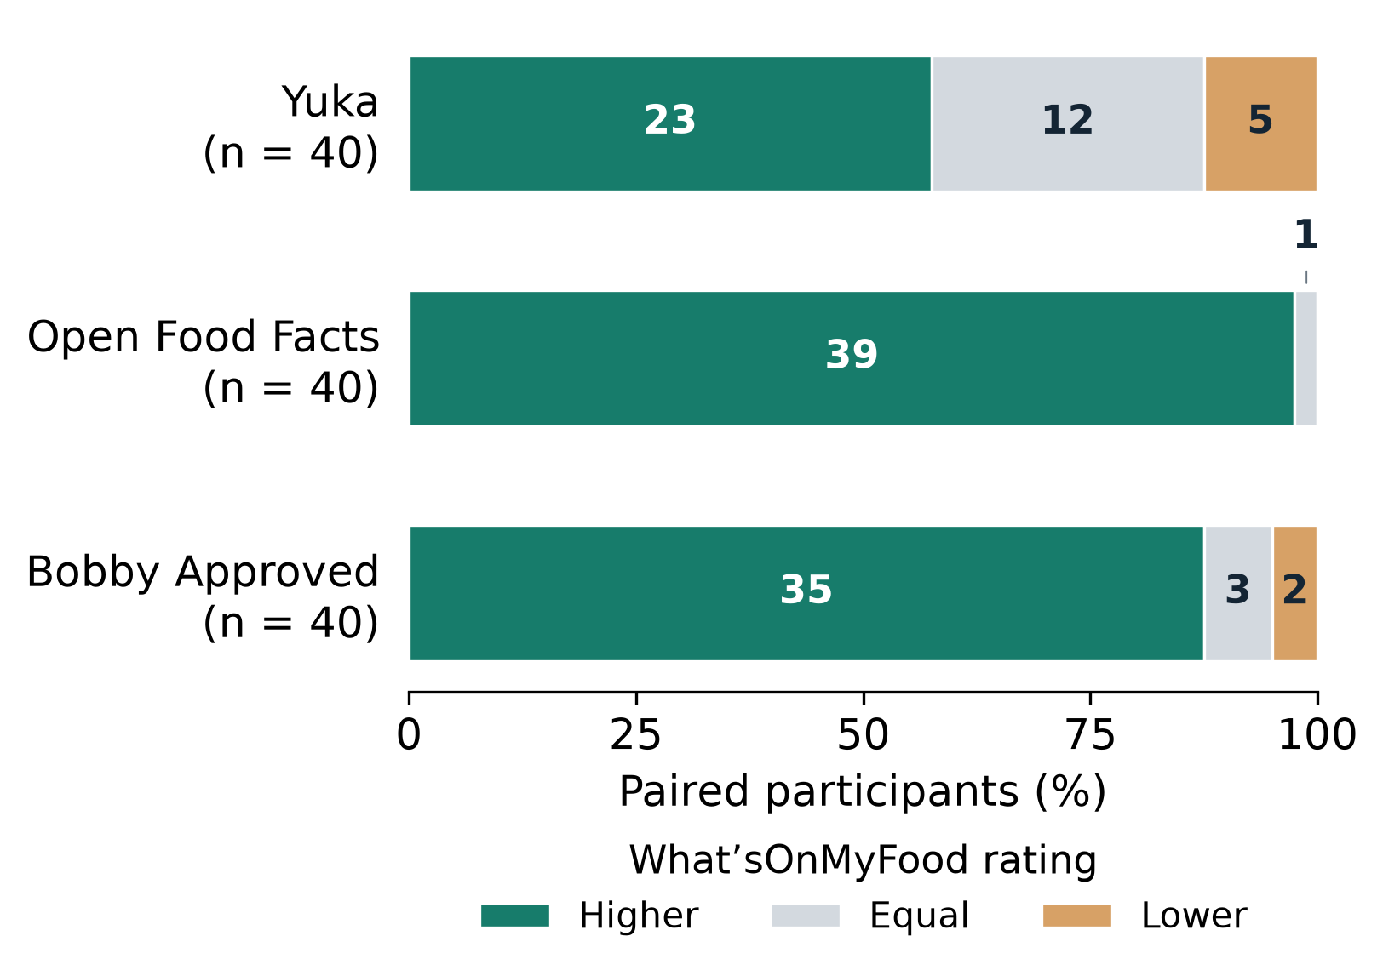
Fig. 7. Paired recommendation ratings for What’sOnMyFood versus each comparator, with 40 pairs per comparison. Bars show higher, equal, or lower ratings; labels show counts. These recommendation-intention ratings provide evidence consistent with H2. The comparison involved applications used with and without AI explanations, while other application differences remained uncontrolled. Source: final survey [6].
For the closest comparator, Yuka, the mean paired difference was 0.41 index points (exploratory percentile-bootstrap 95% interval 0.26–0.56) and 0.68 recommendation points (0.38–1.00). These intervals resample the 40 paired participants with replacement. The empirical bootstrap distributions were computed exactly from the observed paired differences; the bounds are their 2.5th and 97.5th percentiles, so no random seed or simulated resample count is required. The intervals are not adjusted for all six comparisons. Because individual ratings are ordinal, sign-test directions and response counts are the primary comparison; mean differences are descriptive summaries.

J. Validation Findings and Accuracy Boundaries
The completed validation checks cover record counts, consent, rating ranges, missingness, duplicate records, ranking consistency, and agreement between calculations and reported figures. A separate exact-binomial calculation reproduced the six sign-test results. These are data-quality and statistical checks, not independent replication of the study. Table IX states which questions the final dataset can answer.
TABLE IX
SCOPE OF THE COMPLETED VALIDATION
Question | Evidence | Conclusion
H1 satisfaction | Four-item proxy and paired app tests | Supporting evidence from satisfaction-related indicators
H2 intention | Recommendation item and paired app tests | Supporting evidence from recommendation-intention ratings
Source score | Implemented heuristic | Not independently validated
No independent claim-level reviews were supplied with the survey. Consequently, explanation accuracy, reviewer agreement, critical-error frequency, source-score agreement, and the high-trust/low-accuracy rate are not estimable from these records. They are recorded as not measured instead of filled with zeros or simulated results. The conceptual matrix in Table II and implementation plan in Table III remain available for future assessment.
The accuracy framework requires the saved explanation and evidence for the same encounter as the user’s trust and satisfaction ratings. Application-level trust cannot be assigned to a matrix cell without a corresponding independently reviewed explanation. The source-quality estimate also cannot substitute for that review.
EDT remains a literature-supported explanation for why expectations and perceived performance may affect satisfaction. Because the survey did not collect expectations or disconfirmation, it does not test that mechanism. A future extension can add those measures alongside a validated satisfaction scale and explanation-level accuracy review without changing the central research question about satisfaction.

K. Conclusions
The completed 40-session study provides exploratory evidence consistent with H1 and H2. The study compared What’sOnMyFood, which provided AI-generated explanations, with three applications used without such explanations. This comparison evaluated complete application experiences and did not isolate AI explanations from other differences between the applications. What’sOnMyFood was the first choice of 32 of 40 participants (80.0%), and paired experience and recommendation comparisons favored it over each other app. Users also identified a need for shorter summaries and a clearer distinction between source quality and accuracy. The contribution is a working application and evidence of a favorable user experience, not proof that every explanation is correct or that AI alone caused the observed differences.

V. REFERENCES
[1] Open Food Facts, "Introduction to Open Food Facts API documentation," 2026. [Online]. Available: https://openfoodfacts.github.io/openfoodfacts-server/api/.
[2] C. Barranco, "What’sOnMyFood: High-level software design document," Full Sail University, ver. 0.1, Jul. 2026, unpublished.
[3] C. Autio et al., Artificial Intelligence Risk Management Framework: Generative Artificial Intelligence Profile, NIST AI 600-1, National Institute of Standards and Technology, 2024, doi: 10.6028/NIST.AI.600-1.
[4] E. W. Anderson, "Customer satisfaction and word of mouth," Journal of Service Research, vol. 1, no. 1, pp. 5-17, 1998, doi: 10.1177/109467059800100102.
[5] K. Nam, J. Baker, N. Ahmad, and J. Goo, "Determinants of writing positive and negative electronic word-of-mouth: Empirical evidence for two types of expectation confirmation," Decision Support Systems, vol. 129, art. 113168, 2020, doi: 10.1016/j.dss.2019.113168.
[6] C. Barranco, “09212026_survey_40,” final user-research survey workbook, 40 submitted sessions, recorded Aug. 28–Sep. 21, 2026, unpublished.
[7] R. L. Oliver, "A cognitive model of the antecedents and consequences of satisfaction decisions," Journal of Marketing Research, vol. 17, no. 4, pp. 460-469, 1980, doi: 10.1177/002224378001700405.
[8] T. Schiebler, N. Lee, and F. C. Brodbeck, "Expectancy-disconfirmation and consumer satisfaction: A meta-analysis," Journal of the Academy of Marketing Science, vol. 54, pp. 91-112, 2026, doi: 10.1007/s11747-024-01078-x.
[9] C. Ofir and I. Simonson, “The effect of stating expectations on customer satisfaction and shopping experience,” Journal of Marketing Research, vol. 44, no. 1, pp. 164–174, Feb. 2007, doi: 10.1509/jmkr.44.1.164.
[10] A. Bhattacherjee, "Understanding information systems continuance: An expectation-confirmation model," MIS Quarterly, vol. 25, no. 3, pp. 351-370, 2001, doi: 10.2307/3250921.
[11] S. A. Brown, V. Venkatesh, and S. Goyal, "Expectation confirmation in technology use," Information Systems Research, vol. 23, no. 2, pp. 474-487, 2012, doi: 10.1287/isre.1110.0357.
[12] L. L. N. Wong, L. Hickson, and B. McPherson, "Satisfaction with hearing aids: A consumer research perspective," International Journal of Audiology, vol. 48, no. 7, pp. 405-427, 2009, doi: 10.1080/14992020802716760.
[13] M. Riveiro and S. Thill, "That's (not) the output I expected! On the role of end user expectations in creating explanations of AI systems," Artificial Intelligence, vol. 298, art. 103507, 2021, doi: 10.1016/j.artint.2021.103507.
[14] S. Grimmelikhuijsen and G. A. Porumbescu, “Reconsidering the expectancy disconfirmation model. Three experimental replications,” Public Management Review, vol. 19, no. 9, pp. 1272–1292, 2017, doi: 10.1080/14719037.2017.1282000.
[15] D. Pal, S. Funilkul, and V. Vanijja, “The future of smartwatches: Assessing the end-users’ continuous usage using an extended expectation-confirmation model,” Universal Access in the Information Society, vol. 19, no. 2, pp. 261–281, 2020, doi: 10.1007/s10209-018-0639-z.
[16] R. De Croon, D. Segovia-Lizano, P. Finglas, V. Vanden Abeele, and K. Verbert, "An explanation interface for healthy food recommendations in a real-life workplace deployment: User-centered design study," JMIR mHealth and uHealth, vol. 13, e51271, 2025, doi: 10.2196/51271.
[17] X. Wang and M. Yin, "Effects of explanations in AI-assisted decision making: Principles and comparisons," ACM Transactions on Interactive Intelligent Systems, vol. 12, no. 4, art. 27, pp. 1-36, 2022, doi: 10.1145/3519266.
[18] S. Min et al., "FActScore: Fine-grained atomic evaluation of factual precision in long form text generation," in Proc. EMNLP, 2023, pp. 12076-12100, doi: 10.18653/v1/2023.emnlp-main.741.
[19] K. Okamura and S. Yamada, "Adaptive trust calibration for human-AI collaboration," PLOS ONE, vol. 15, no. 2, e0229132, 2020, doi: 10.1371/journal.pone.0229132.
[20] J. M. Robillard, J. H. Jun, J. A. Lai, and T. L. Feng, "The QUEST for quality online health information: Validation of a short quantitative tool," BMC Medical Informatics and Decision Making, vol. 18, art. 87, 2018, doi: 10.1186/s12911-018-0668-9.
[21] C. H. Ellis, J. B. Moore, P. Ho, and C. E. L. Evans, "Development and validation of a quality assessment tool to assess online nutrition information," Digital Health, vol. 9, 2023, doi: 10.1177/20552076231187249.
[22] D. Charnock, S. Shepperd, G. Needham, and R. Gann, "DISCERN: An instrument for judging the quality of written consumer health information on treatment choices," Journal of Epidemiology and Community Health, vol. 53, no. 2, pp. 105-111, 1999, doi: 10.1136/jech.53.2.105.
[23] G. H. Guyatt et al., "GRADE: An emerging consensus on rating quality of evidence and strength of recommendations," BMJ, vol. 336, pp. 924-926, 2008, doi: 10.1136/bmj.39489.470347.AD.
[24] Google, "Scan barcodes with ML Kit on Android," Google for Developers, 2026. [Online]. Available: https://developers.google.com/ml-kit/vision/barcode-scanning/android.
[25] Android Developers, "Save data in a local database using Room," 2026. [Online]. Available: https://developer.android.com/training/data-storage/room.
[26] P. Lewis et al., "Retrieval-augmented generation for knowledge-intensive NLP tasks," in Advances in Neural Information Processing Systems, vol. 33, 2020.
[27] C. Barranco, “Scientific source quality verification method,” What’sOnMyFood project technical paper, supplied as WhatsOnMyFood_Source_Quality_Verification_Paper_Ready.docx, 2026, unpublished.
[28] C. Barranco, “Standardized comparative usability protocol for four food-information applications,” Food Nutrition Application User Test Procedure, Full Sail University, protocol ver. 1.2, Sep. 8, 2026, unpublished.
[29] J. A. Shepperd, K. Sweeny, and L. C. Cherry, “Influencing audience satisfaction by manipulating expectations,” Social Influence, vol. 2, no. 2, pp. 98–111, 2007, doi: 10.1080/15534510601095772.
[30] D. Lakens, “Sample size justification,” Collabra: Psychology, vol. 8, no. 1, Art. no. 33267, 2022, doi: 10.1525/collabra.33267.
[31] G. M. Sullivan and A. R. Artino, Jr., “Analyzing and interpreting data from Likert-type scales,” Journal of Graduate Medical Education, vol. 5, no. 4, pp. 541–542, 2013, doi: 10.4300/JGME-5-4-18.
[32] V. Braun and V. Clarke, “Using thematic analysis in psychology,” Qualitative Research in Psychology, vol. 3, no. 2, pp. 77–101, 2006, doi: 10.1191/1478088706qp063oa.
[33] M. Friedman, “The use of ranks to avoid the assumption of normality implicit in the analysis of variance,” Journal of the American Statistical Association, vol. 32, no. 200, pp. 675–701, 1937, doi: 10.1080/01621459.1937.10503522.
[34] W. J. Dixon and A. M. Mood, “The statistical sign test,” Journal of the American Statistical Association, vol. 41, no. 236, pp. 557–566, 1946, doi: 10.1080/01621459.1946.10501898.
[35] S. Holm, “A simple sequentially rejective multiple test procedure,” Scandinavian Journal of Statistics, vol. 6, no. 2, pp. 65–70, 1979, doi: 10.2307/4615733.
[36] F. Faul, E. Erdfelder, A.-G. Lang, and A. Buchner, "G*Power 3: A flexible statistical power analysis program for the social, behavioral, and biomedical sciences," Behavior Research Methods, vol. 39, no. 2, pp. 175-191, 2007, doi: 10.3758/BF03193146.
[37] J. Z. Zheng, Y. Li, T. Lin, A. Estrada, X. Lu, and C. Feng, "Sample size calculations for comparing groups with continuous outcomes," Shanghai Archives of Psychiatry, vol. 29, no. 4, pp. 250-256, 2017, doi: 10.11919/j.issn.1002-0829.217101.
[38] K. Caine, "Local standards for sample size at CHI," in Proc. 2016 CHI Conf. Human Factors in Computing Systems, pp. 981-992, 2016, doi: 10.1145/2858036.2858498.
[39] C. Barranco, "Improving customer satisfaction through AI food analysis," M.S. proposal presentation, Full Sail University, Jul. 2026.
[40] C. Barranco, “Scientific source quality verification,” What’sOnMyFood project testing documentation, 2026, unpublished.

