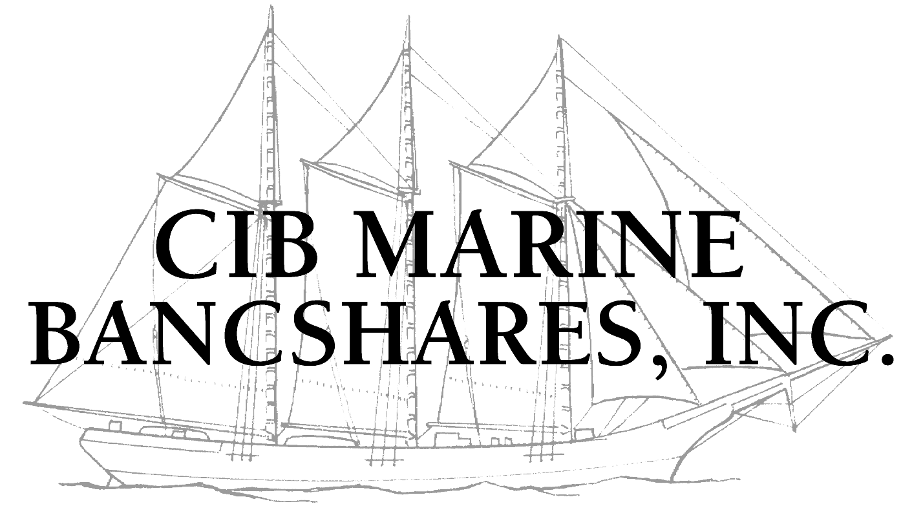

July 19, 2007

Dear Shareholder,

On behalf of the Board of Directors of CIB Marine Bancshares, Inc., I would like to take this opportunity to introduce myself, and to provide you with an update on recent developments.

On March 2, 2007, I succeeded Stanley J. Calderon as President and CEO of CIB Marine, and Stan succeeded W. Scott Blake as Chairman of the Board. Mr. Blake, who served as Chairman for three years, continues to serve on the Board of Directors, Executive Committee, Executive Loan Committee, and as Chairman of Marine Bank. We wish to thank Scott for his past service to CIB Marine as Chairman. Mr. Calderon continues to assist the subsidiary banks with commercial banking activities, advising CIB Marine on various matters, and serving on the Boards of CIB Marine and its banking subsidiaries, and CIB Marine’s Executive Committee and Executive Loan Committee.

2005 Audit / SEC Filings

We are happy to report that the audit of the 2005 financial statements of CIB Marine Bancshares, Inc. is now complete. On July 18, 2007, CIB Marine filed its Annual Report on Form 10-K for the period ended December 31, 2005, and its Quarterly Reports on Form 10-Q for the periods ended March 31, June 30, and September 30, 2005 with the Securities and Exchange Commission (SEC). You may access the 2005 Form 10-K, and the Forms 10-Q on the SEC’s website at www.sec.gov, or on CIB Marine’s website at www.cibmarine.com/financial_info/sec_filings.asp, or by requesting a copy of the 131-page Form 10-K from Angela Blair, Investor Relations Manager, at the contact information provided on the insert to this letter.

We will be disappointed if we are unable to complete the audit of the 2006 financial statements and the filing of the related Form 10-K and Forms 10-Q during the fourth quarter of 2007. After such filing, CIB Marine will hold an Annual Meeting of Shareholders if permissible under applicable regulations. We will keep you advised as to the timing of the meeting and additional details.

2005 Financial Results

During 2005, CIB Marine had a net loss of $11.7 million as compared to a net loss of $17.3 million in 2004. Total assets were $1.1 billion at December 31, 2005 as compared to $1.4 billion at December 31, 2004. For additional information regarding CIB Marine’s financial results for 2005, please refer to our above-referenced Form 10-K.

Efforts to Return to Profitability

CIB Marine has taken a number of steps to return the Company to profitability, including:

- Top-Line Revenue Growth:
  - Attracting six experienced commercial bankers in the following strategic markets to grow top-line revenue: Boca Raton, Coral Gables, Champaign, Milwaukee (2), and Scottsdale;
  - Expanding our commercial, consumer, mortgage lending and private banking products;
  - Purchasing pools of prime home equity loans from unaffiliated financial institutions;
- Expense Management: We continue to identify significant opportunities to reduce overhead and other expenses, including the planned outsourcing of a substantial portion of our data processing in the later part of 2007;

- Trust Preferred Securities: The Company is evaluating various alternatives to reduce the financing costs represented by the $60 million in Trust Preferred Securities; and

- Client Focus and Process Simplification: As we work our way back to profitability, we are reviewing all of our procedures to make it easier for our clients to do business with us, and for our colleagues to do their jobs. The elimination of complexity will also assist us in finding additional cost savings while simultaneously allowing us to become more flexible, nimble and responsive in meeting the needs of our clients.

Shareholder Liquidity

We receive regular calls from shareholders inquiring about the value of their shares of the common stock of CIB Marine, and their ability to buy or sell shares of CIB Marine stock. We are aware that limited trades of CIB Marine stock have and continue to occur in the over-the-counter market and are reported on the Pink Sheets (www.pinksheets.com, trading symbol: CIBH). We are prohibited from expressing an opinion as to whether the trades reported on Pink Sheets reflect fair market value. We are also prohibited from finding buyers or sellers for our shareholders or recommending a broker. We can only suggest that shareholders seeking additional information regarding Pink Sheets or their ability to buy or sell shares via the over-the-counter market should contact their broker or financial advisor for assistance.

As always, we appreciate your support and will continue to keep you informed of our progress.

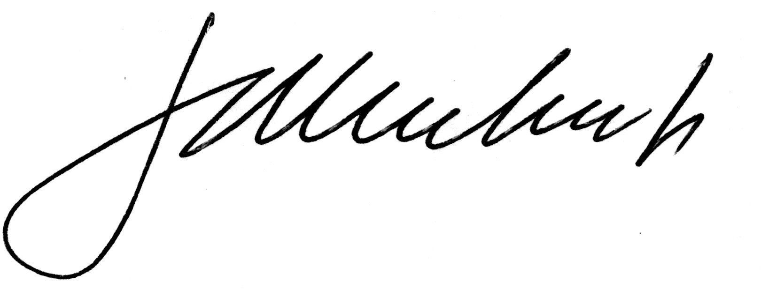
Sincerely,

John P. Hickey, Jr.
President and CEO

This letter contains forward-looking information. Actual results could differ materially from those indicated by such information. Information regarding risk factors and other cautionary information is available in Item 1A. of CIB Marine’s Annual Report on Form 10-K for the period ended December 31, 2005.

