Application Project Hoksotin

Application Report

Kari Aliranta
Jaakko Leppäkangas
Janne Pesonen
Atte Rautio

Version 0.0.1
Public
2013-05-13

University of Jyväskylä
Deparment of Mathematical Information Technology
Jyväskylä
Finland

Acceptor | Date | Signature | Clarified signature
Manager | _._.2013
Customer | _._.2013
Supervisor | _._.2013

Document Info
Authors
- Kari Aliranta (KA) kari.p.aliranta@student.jyu.fi 358405736683

Document name: Hoksotin project, Application report
Page count: ***Korjaa manuaalisesti lopussa***

Abstract: The Hoksotin project developed a prototype graphical frontend for integrating the applications and command line scripts used in MEG data analysis. This document describes the backgrounds of the software as well as presents the user interface and the application structure. Programming and testing practices are also presented. The realization of the functional requirements and other objectives and also advices for future developers are described.

Keywords: Application structure, future development, magnetoencephalography, MEG, MNE, Python, PyQt, testing ***lisää tähän***

History of changes
Version | Date | Modifications | Committers
0.0.1 | 2013-05-13 | Started writing the document | KA
0.0.2 | 2013-05-15 | Introduction section written | KA
0.0.3 | 2013-05-16 | Terminology section written | KA
0.0.4 | 2013-05-24 | Most of the text in the UI section written | KA
0.1.0 | 2013-05-27 | Clarified the UI section and added a figure | KA
0.1.1. | 2013-05-28 | Added more figures to the the UI section | KA
0.1.2 | 2013-05-30 | Tweaked styles | KA

Project Information
The Hoksotin project created a prototype user interface for preprosessing, analyzing and visualizing MEG data.

Project members:
Aliranta Kari | kari.p.aliranta@student.jyu.fi | 358405736683
Leppäkangas Jaakko | jaeilepp@student.jyu.fi | 358445508574
Pesonen Janne | janne.o.pesonen@student.jyu.fi | 358400894370
Rautio Atte | atte.m.rautio@student.jyu.fi | 358408409084

Representatives of the customer:
Parviainen Tiina | tiina.m.parviainen@jyu.fi | 358408053533

Supervisors:
Santanen Jukka Pekka | jukka-pekka.santanen@mit.jyu.fi | 358408053299
Puoliväli Tuomas | tuomas.a.b.puolivali@student.jyu.fi

General contact information for the project:
Mailing lists | hoksotin@korppi.jyu.fi
Mailing list archives | ***mistä tämä?

Contents
1 Introduction 1
2 Terminology Related to the Domain and the Application 2
2.1 Domain Terminology 2
2.2 Terminology Related to the Application and its Development 3
3 Background of MEG Data Analysis 4
4 The User Interface of the Application 5
4.1 Choosing a Workspace and Creating an Experiment 5
4.2 The Main Window of The Application 7
4.2.1 Menu Bar 8
4.3 Raw Tab 9
4.4 Preprocessing Tab 9
4.4.1 MaxFilter 10
4.4.2 Calculate ECG Projections 10
4.4.3 Calculate EOG Projections 13
4.5 Epoching tab 13
4.5.1 Event Selection Dialog 13
4.5.2 Epoch Creation Dialog 14
4.6 Averaging Tab 15
4.7 TFR Tab 15
4.7.1 TFR Vizualization 15
4.7.2 TFR Topology Vizualization 15

Introduction
MEG (magnetoencephalography) is a method of measuring magnetic fields caused by electrical activity in the brain. By analyzing the data accumulated by the measurements, the type and location of the the brain activity can be discerned. In a common type of MEG experiment setting the test subject is given sensory input, i.e. shown pictures or played sounds to, and the activity of the subjects brain is measured by the equipment.
The data accumulated by the measuring instruments needs to be preprocessed and analyzed in order to yield useful information. Presently, there are pieces of software capable of doing this processing and analyzing, but they don't always integrate well with each other nor are always very usable. Specifically, they don't make the process very clear for a still learning, non-expert user, and are occasionally burdensome to use for an advanced user, too.
The Hoksotin project developed a prototype graphical frontend for integrating the applications and command line scripts used in MEG data analysis. The main backend for the frontend is the open source MNE software package, which is hosted at the Martinos Center for Biomedical Imaging at Harvard-MIT. The prototype has an option to handle part of the preprocessing using MaxFilter software by Elekta Neuromag, a manufacturer of MEG equipment. The frontend is programmed with Python 2.7 and uses PyQt4 as the graphical user interface library.
This application report mainly describes the solutions for the requirements described in the requirements definition document***viite. The user interface, internal structure, testing, known defects and possible future development path are also covered.
Chapter 2 describes the terminology related to the domain and the developed application. Chapter 3 elaborates on the background of the application and the process it is designed to facilitate. Chapter 4 is dedicated to the user interface of the application, whereas chapter 5 descibes the internal (class) structure of the application. The programming guidelines of the project are briefly outlined in chapter 6, and chapter 7 describes testing guidelines and results of testing. Chapter 8 is a reflective chapter about the attained and unattained goals of the project, the known shortcomings and possible future paths of development. The last chapter is dedicated for the installation instructions of the application.

Terminology Related to the Domain and the Application

Domain Terminology
Artefact | is a disturbance in the measured MEG signal caused by electrical activity originating from outside the brain.
ECG channel | i.e. electrocardiogram channel, is a channel in the measured MEG data, dedicated to measuring the electrical activity of the heart. Used later to filter the data in order the remove the disturbances caused by the said electrical activity.
EEG | i.e. electroencephalography. A techique for measuring the electrical activity of the brain directly via electrodes measuring the electrical currents reaching the surface of the skull.
EOG channel | i.e. electrooculogram channel, is a channel in the measured MEG data, dedicated to measuring the electrical activity caused by blinking the eyes. Used later to filter the data in order the remove the disturbances caused by the said electrical activity.
Epoch | is a timesclice of MEG data. Generally defined to begin a few hundred milliseconds before an event and to end a few hundred milliseconds after the said event.
Event | is a point in time in the signal data, corresponding to a single trigger point on the trigger channel. Not all triggers are chosen as basis for events in a given experiment. Epochs are derived from events.
MC | i.e. Motion Correction, is an MEG data preprocessing technique used for countering the disturbances in the signal caused by the movements of subject's head during the measurement.
MEG | i.e. magnetoencephalography, is a technique for measuring the electrical activity of the brain by measuring the magnetic fields caused by the said electrical activity.
MEG channel | is a portion of MEG signal, measured by a single SQUID sensor.
Preprocessing | is the first phase in analyzing the MEG data, consisting of filtering out the unwanted disturbances. Generally includes SSS and possibly tSSS and/or MC. May also include filtering based on the data in the ECG and EOG channels.
Raw file | is the first file generated from the information measured by the MEG measuring equipment. It includes unprocessed signal and trigger information. The Meggie application understands only binary raw file format of type fiff.
SQUID | i.e. Superconducting Quantum Interference Device, is a single sensor responsible for a single channel in the MEG signal. Contemporary MEG equipment includes hundreds of individual SQUIDS.
SSS | i.e. Signal Space Separation, is a signal data preprosessing technique used to distinguish: 1) signal data originating from the brain and 2) the noise from outside the MEG equipment and 3) the noise caused by MEG equipment itself, e.g. the SQUIDS.
Stimulus | is a specifically defined outside input to the test subject, the brain response to which is monitored with the MEG equipment. Often a sound, picture or a sequence of these. Often used interchangeably with the word trigger, even thought trigger is a technical term related to the trigger channel, and may or may not correspond to a stimulus.
Trigger channel | is an MEG-channel with temporal information about triggers. Triggers may correspond to stimuli, or they may be other time points of importance in the experiment (e.g. test subject clicking a button).
TSSS | i.e.Temporal Signal Space Separation, an extension of SSS. It is used for removal of disturbances originating from inside the test subjects body, e.g. pacemakers or braces.

Terminology Related to the Application and its Development
Agile software development | is a collection of values and methods for software development, based on the Agile manifesto. The manifesto stresses the ability to react fast to the changes in the requirements, direct communication between the customer and the developers and keeping the software always runnable even when on development (in order to be always testable by the customer).
Eclipse | is an open source software platform used for various applications, most notably those related to software development. An Eclipse plugin for Python development, know as Pydev, is also available and was used for the development of Meggie.
EPD | i.e. Enthought Python Distribution, is a tailored Python distribution for scientific computing, released by Enthough Inc. Includes libraries for data analysis and visualization. Recently renamed to Enthought Canopy.
Maxfilter | is a commercial software by Elekta Neuromag, a manufacturer of MEG equipment. Designed for preprosessing of MEG signal data. Includes SSS , tSSS and MC filtering capabilities. Written in C.
MNE | is an open source MNE software package, hosted at the Martinos Center for Biomedical Imaging at Harvard-MIT. Used for analyzing and visualizing MEG and EEG data. Includes Python modules (MNE-Python).
PyDoc | is a tool for generating class documentation for applications written in Python.
PyQt | i.e. Python bindings for the Qt graphical interface toolkit. It is available as free software and is hosted by Riverbank Computing.
Python | is an open source programming language, suitable for object-oriented programming paradigm, among others.
YouSource | is a web-based source code collaboration system developed in the University of Jyväskylä. It uses Git as the version control system.

Background of MEG Data Analysis

***Tähän laajennettu yleisselitys ja yksinkertaisen analyysiketjun kulku

The User Interface of the Application
The user interface of the Meggie application uses PyQt4 as the user interface library, allowing the usage of most Qt widgets. This in turn allows the application to integrate with the (Qt) theme of the desktop environment in use.
Presently, the user interface only represents preprocessing and analysis of a single raw file at a time. This representation is called experiment. See page ***sivu monen filun lataamiselle ja batchille*** for possible future development paths related to multiple raw file loading and batch processing.
PLEASE NOTE: this description assumes the reader is familiar with the basics of MEG data analysis. Additionally, many of the dialogs of the application pass the values of their fields directly to Mne-Python. In these cases, the descriptions for these fields follow the Mne-python reference guide, currently found at http://martinos.org/mne/python_reference.html .

Choosing a Workspace and Creating an Experiment
When the application is launched, the user is presented with an empty window with toolbar options allowing the creation of a new experiment or loading a pre-existing one:
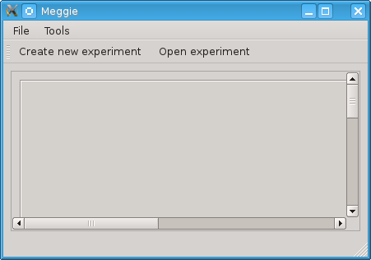Figure 1: main window without an experiment loaded

Should the user choose the option Create new experiment, the application prompts the user to choose a workspace directory for the application (see figure 2). This only happens once, subsequently the application will use the chosen directory.
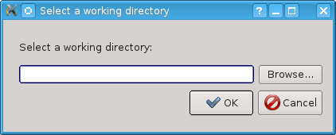Figure 2: Workspace chooser dialog
After the workspace has been chosen, the the user is required to click the Create new experiment button again to actually create a new experiment. The user is then presented the following dialog:
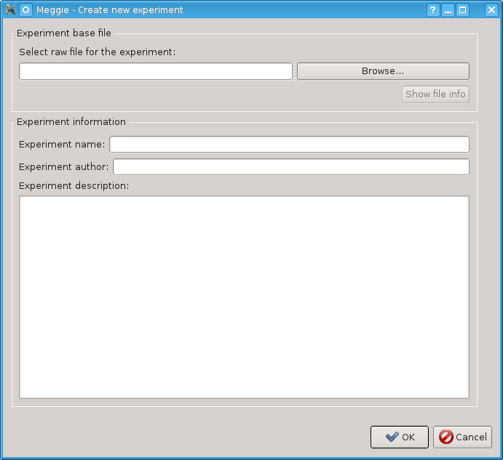Figure 3: Experiment creation dialog

The dialog is rather self-explanatory, except for the textbox and a button to choose the experiment raw file. The Browse button opens a standard file chooser dialog which allows the user to navigate to the desired file, whereas the textbox allow the direct input of the absolute path to the desired file. After clicking the OK button, the user is taken to the main window populated with information about the raw file loaded

The Main Window of The Application
The main window of the application includes the menu bar and a tab area. The tab area represents the different phases of MEG data analysis as tabs.
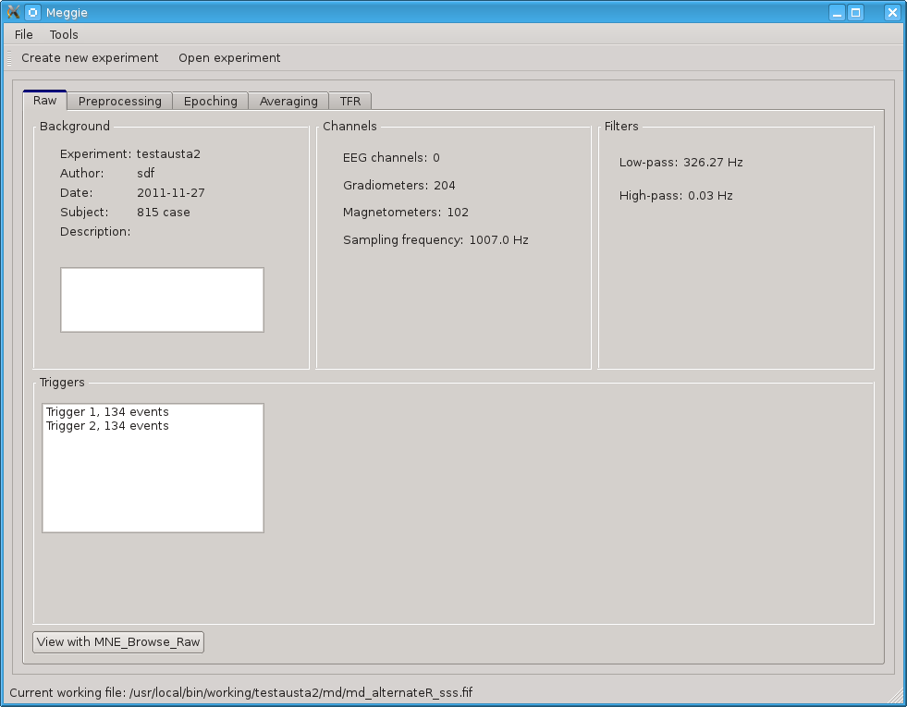Figure 4: Main window, raw tab active

Menu Bar
The menu bar has the following menus:
File Menu
The file menu includes shortcuts to create new experiment and an option to open experiment. These work exactly the the same way as their siblings described in chapter 4.1. Additionally, the menu includes an option to set workspace. Clicking this option opens the workspace chooser dialog illustrated in Figure 2. The file menu also has an option to show the About dialog, including the license information about the application.
Tools Menu
Tools has a single option, Preferences. Preferences dialog currently includes a simple list of equipment calibration files provided by the MaxFilter program, ordered by the location of the equipment. The user can then choose the desired calibration file for the the experiment. If MaxFilter is not available, the dialog simply shows an empty list.
Status Bar
***working file***

Raw Tab
The raw tab is the default tab to be shown after the creation or opening of an experiment. shows basic information about the raw file of the experiment. This information includes experiment information set by the user at the time of creation and information read from the raw file info fields themselves (with mne.raw.info). The raw file can also be viewed with an external browser (View with MNE_browse_raw). See Figure 4 for visual details.

Preprocessing Tab
The preprocessing tab includes options to apply MaxFilter (SSS, tSSS, MC) to the raw file. It also allows calculating SSP/PCA projections for ECG and EOG artifacts and viewing the magnitude spectrum. The options already completed are indicated by the green checkmarks in the Preprocessing steps completed box.

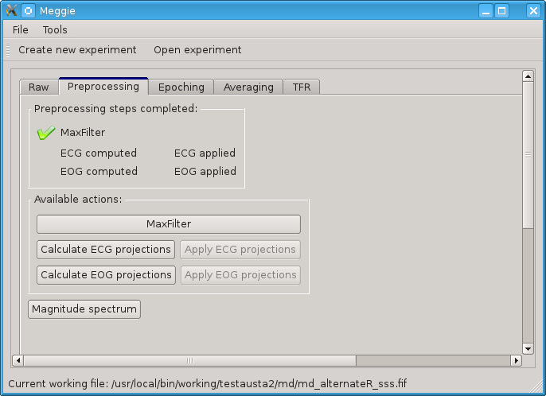Figure 5: Main window, with preprocessing tab active

MaxFilter
Opens a dialog which includes parameters to call the proprietary MaxFilter program with. For parameters and their descriptions, see the MaxFilter manual.

Calculate ECG Projections
Opens the dialog for calculating ECG-projections for the raw file.
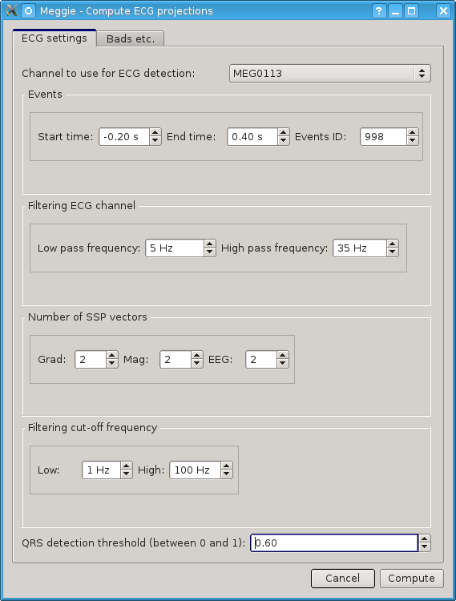Figure 6: Dialog for computing ECG projections, first page

The following options on first page of the dialog may not be wholly self-evident:
- Start time, End time and Event ID: Time before and after the events in seconds, and ID to use for these events.
- Number of SSP vectors, per type of sensor.

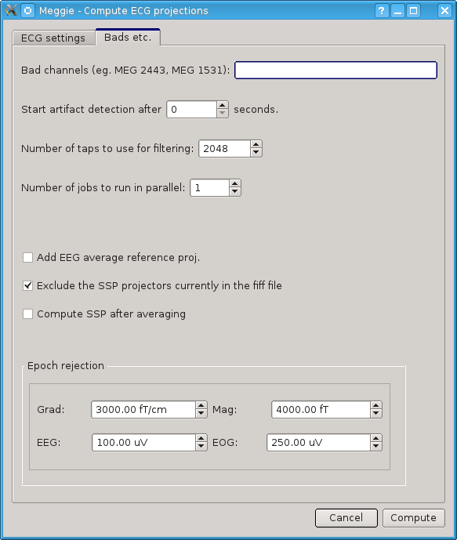Figure 7: Dialog for computing ECG projections, second page

The second page of the dialog has the following non-self-evident options:
- Number of jobs to run in parallel:higher number of jobs allows the usage of multiple processor cores. Allows faster computation, but may prevent the use of computer for other tasks during the computation. Not recommended to exceed the number of processor cores in the CPU.
- Epoch rejection parameters: see chapter 4.5.2 (Epoch Creation Dialog) for details

Calculate EOG Projections
Opens the dialog for calculating EOG-projections for the raw file. Almost identical to the Calculate ECG projections dialog, except for the slightly different default values.

Epoching tab
Epoching tab includes a simple list of epoch collections created by picking events from the raw file. The actual creation of epoch collections is initiated by clicking the Create an epoch collection button. The epoch collection list created in this tab will also be shown in the subsequent tabs.
After clicking the Create an epoch collection button, the user is presented with a dialog allowing the picking of events from the raw file by event ID, the event selection dialog.

Event Selection Dialog
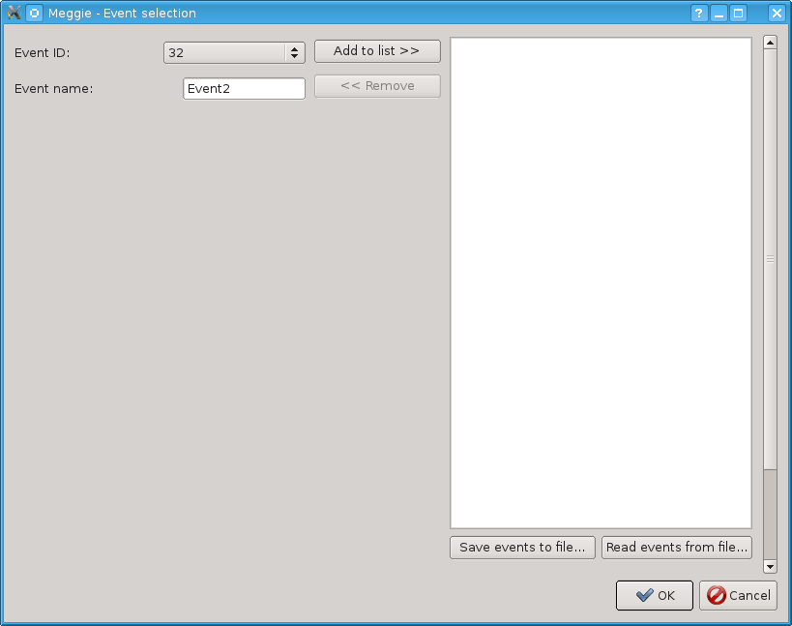Figure 8: Event selection dialog

The Add to list button adds all events with the selected event ID to the list on the right, whereas the Remove button removes a single selected event from the list. The Save events button saves the list into the subject directory in xls-format, and Read events button reads an xls-formatted file into the list (after clearing the list first). This allows more fine-grained editing of list via editors capable of editing xls-formatted files.

Clicking the OK button in the event selection dialog, the user is represented with the epoch creation dialog. This dialog allows the actual forming of epochs from the events selected.

Epoch Creation Dialog
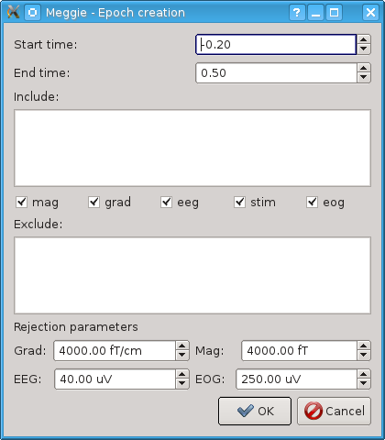Figure 9: Epoch creation dialog
The dialog has the following options:
  - Start time and end time: define the time window for the epochs in milliseconds before the events (start time) and after them (end time).
  - Include list: channel numbers to include, separated by commas, in addition to channels chosen with include checkboxes (below). Could be used to choose single channels from channel types not included by checkboxes. Example input: MEG1451,EEG006 ***Tarkista tämä***
  - Include checkboxes (mag, grad, eeg, stim, eog): checking these includes all channels of checked types in the epoching, and excludes all channels not checked.
  - Exclude list: channel types and numbers to exclude, separated by commas, exactly in the same way as in the include list. Could be used to exclude specific channels from channels types chosen by checking the include checkboxes.
  - Rejection parameters: if a peak-to-peak amplitude of a corresponding channel during an epoch exceeds the values given in these fields, don't include the epoch in the epoch collection.

Averaging Tab
Averaging tab includes the epoch collection list created in the epoching tab (see chapter 4.5 ) and a single button to average selected epoch collection. Clicking the button averages the selected epoch collection and visualizes the result as a 2D sensor topology.

TFR Tab

TFR Vizualization

TFR Topology Vizualization

***Lukuun 8
In a future version, the experiment would preferably be able to hold several subject. This in turn would allow batch processing of several subject files in the same experiment based on a template derived from processing a single subject file.

***Tarkista ***-tähdet ja Meggie-viittaukset

