Application Project Hoksotin

Application Report

Kari Aliranta
Jaakko Leppäkangas
Janne Pesonen
Atte Rautio

Version 0.0.1
Public
2013-05-13

University of Jyväskylä
Deparment of Computer Science and Information Systems
Jyväskylä
Finland

Acceptor | Date | Signature | Clarified signature
Project lead

Orderer

Supervisor

Document info
Authors

History of changes
Version | Date | Change message | Committers
0.0.1 | 2013-05-13 | Started writing the document | KA
0.0.2 | 2013-05-15 | Introduction section written | KA
0.0.3 | 2013-05-16 | Terminology section written | KA
0.0.4 | 2013-05-24 | Most of the text in the UI section written | KA
0.1.0 | 2013-05-27 | Clarified the UI section and added a picture | KA

Information about the project

Project Hoksotin created a prototype user interface for preprosessing, analyzing and visualizing MEG (magnetoencephalography) data.

Programmers:
Name | Email address | Telephone number
Aliranta Kari | kari.p.aliranta@student.jyu.fi | 358405736683
Leppäkangas Jaakko | jaeilepp@student.jyu.fi | 358445508574
Pesonen Janne | janne.o.pesonen@student.jyu.fi | 358400894370
Rautio Atte | atte.m.rautio@student.jyu.fi | 358408409084

Orderers presentatives:

Name | Email address | Telephone number
Parviainen Tiina | tiina.m.parviainen@jyu.fi | 358408053533
Puoliväli Tuomas | tuomas.a.b.puolivali@student.jyu.fi

Supervisors:

Name | Email address | Telephone number
Santanen Jukka Pekka | jukka-pekka.santanen@mit.jyu.fi | 358408053299
Puoliväli Tuomas | tuomas.a.b.puolivali@student.jyu.fi

General contact information for the project:

Mailing lists | hoksotin@korppi.jyu.fi
Mailing list archives | ***mistä tämä?

Sisältö
1 Introduction viii
2 Terminology related to the domain and the application ix
2.1 Domain terminology ix
2.2 Terminology related to the application and its development x
3 Background of MEG data analysis xii
4 The user interface of the Meggie application xiii
4.1 Choosing a workspace and creating an experiment xiii
4.2 The main window of Meggie after an experiment has been created or opened xvi
4.2.1 Menu bar xvii
4.2.2 Raw tab xviii
4.2.3 Preprocessing tab xviii
4.2.4 Epoching tab and epoch creation dialogs xix

Introduction
MEG (magnetoencephalography) is a method of measuring magnetic fields caused by electrical activity in the brain. By analyzing the data accumulated by the measurements, the type and location of the the brain activity can be discerned. In a common type of MEG experiment setting the test subject is given sensory input, i.e. shown pictures or played sounds to, and the activity of the subjects brain is measured by the equipment.
The data accumulated by the measuring instruments needs to be preprocessed and analyzed in order to yield useful information. Presently, there are pieces of software capable of doing this processing and analyzing, but they don't always integrate well with each other nor are always very usable. Specifically, they don't make the process very clear for a still learning, non-expert user, and are occasionally burdensome to use for an advanced user, too.
The Hoksotin project consisted of designing and programming a prototype graphical frontend for integrating the applications and command line scripts used in MEG data analysis. The main backend for the frontend is the open source MNE software package, which is hosted at the Martinos Center for Biomedical Imaging at Harvard-MIT. The prototype has an option to handle part of the preprocessing using MaxFilter software by Elekta Neuromag, a manufacturer of MEG equipment. The frontend is programmed with Python 2.7 and uses PyQt4 as the graphical user interface library.
This application report mainly describes the solutions for the requirements described in the requirements definition document***viite. The user interface, internal structure, testing, known defects and possible future development path are also covered.
Chapter 2 describes the terminology related to the domain and the developed application. Chapter 3 elaborates on the background of the application and the process it is designed to facilitate. Chapter 4 is dedicated to the user interface of the application, whereas chapter 5 descibes the internal (class) structure of the application. The programming guidelines of the project are briefly outlined in chapter 6, and chapter 7 describes testing guidelines and results of testing. Chapter 8 is a reflective chapter about the attained and unattained goals of the project, the known shortcomings and possible future paths of development. The last chapter is dedicated for the installation instructions of the application.

Terminology related to the domain and the application

Domain terminology
artefact | A disturbance in the measured MEG signal caused by electrical activity originating from outside the brain.
ECG(electrocardiogram) channel | A channel in the measured MEG data, dedicated to measuring the electrical activity of the heart. Used later to filter the data in order the remove the disturbances caused by the said electrical activity.
EEG | Electroencephalography. A techique for measuring the electrical activity of the brain directly via electrodes measuring the electrical currents reaching the surface of the skull.
EOG(electrooculogram) channel | A channel in the measured MEG data, dedicated to measuring the electrical activity caused by blinking the eyes. Used later to filter the data in order the remove the disturbances caused by the said electrical activity.
epoch | A timesclice of MEG data, generally defined to begin a few hundred milliseconds before an event. Generally defined to end a few hundred milliseconds after the said event.
event | A point in time in the signal data, corresponding to a single trigger point on the trigger channel. Not all triggers are chosen as basis for events in a given experiment. Epochs are derived from events.
MC | Motion Correction. An MEG data preprocessing technique used for countering the disturbances in the signal caused by the movements of subject's head during the measurement.
MEG | Magnetoencephalography. A technique for measuring the electrical activity of the brain by measuring the magnetic fields caused by the said electrical activity.
MEG channel | A portion of MEG signal, measured by a single SQUID sensor.
preprocessing | The first phase in analyzing the MEG data, consisting of filtering out the unwanted disturbances. Generally includes SSS and possibly tSSS and/or MC. May also include filtering based on the data in the ECG and EOG channels.
SQUID | Superconducting Quantum Interference Device. A single sensor responsible for a single channel in the MEG signal. Contemporary MEG equipment includes hundreds of individual SQUIDS.
SSS | Signal space separation, a signal data preprosessing technique used to distinguish the following from each other: 1) signal data originating from the brain and 2) the noise from outside the MEG equipment and 3) the noise caused by MEG equipment itself, e.g. the SQUIDS
stimulus | A specifically defined outside input to the test subject, the brain response to which is monitored with the MEG equipment. Often a sound, picture or a sequence of these. Often used interchangeably with the word trigger, even thought trigger is a technical term related to the trigger channel, and may or may not correspond to a stimulus.
trigger channel | An MEG-channel with temporal information about triggers. Triggers may correspond to stimuli, or they may be other time points of importance in the experiment (e.g. test subject clicking a button).
TSSS | Temporal Signal Space Separation, an extension of SSS. Used for removal of disturbances originating from inside the test subjects body, e.g. pacemakers or braces.

Terminology related to the application and its development
Agile software development | A collection of values and methods for software development, based on the Agile manifesto. The manifesto stresses the ability to react fast to the changes in the requirements, direct communication between the orderer and the developers and keeping the software always runnable even when on development (in order to be always testable by the orderer).
Eclipse | An open source software platform used for various applications, most notably those related to software development. An Eclipse plugin for Python development, know as Pydev, is also available and was used for the development of Meggie.
EPD | Enthought Python Distribution, a tailored Python distribution for scientific computing, released by Enthough Inc. Includes libraries for data analysis and visualization. Recently renamed to Enthought Canopy.
Maxfilter | A closed source software by Electa Neuromag, a manufacturer of MEG equipment. Designed for preprosessing of MEG signal data. Includes SSS , tSSS and MC filtering capabilities. Written in C.
MNE | An open source MNE software package, hosted at the Martinos Center for Biomedical Imaging at Harvard-MIT. Used for analyzing and visualizing MEG (and EEG) data. Includes Python modules (MNE-Python).
PyDoc | A tool for generating class documentation for applications written in Python.
PyQt | Python bindings for the Qt graphical interface toolkit. Available as free software, hosted by Riverbank Computing.
Python | An open source programming language, suitable for object-oriented programming paradigm, among others.
YouSource | A web-based source code collaboration system developed in the University of Jyväskylä. Uses git as the version control system.

Background of MEG data analysis

***Tähän laajennettu yleisselitys ja yksinkertaisen analyysiketjun kulku

The user interface of the Meggie application
The user interface of the Meggie application uses PyQt4 as the user interface library, allowing the usage of most Qt widgets. This in turn allows the application to integrate with the (Qt) theme of the desktop environment in use.
Presently, the user interface only represents preprocessing and analysis of a single raw file at a time. This representation is called experiment. See page ***sivu monen filun lataamiselle ja batchille*** for possible future development paths related to multiple raw file loading and batch processing.

Choosing a workspace and creating an experiment
When the application is launched, the user is presented with an empty window with toolbar options allowing the creation of a new experiment or loading a pre-existing one:
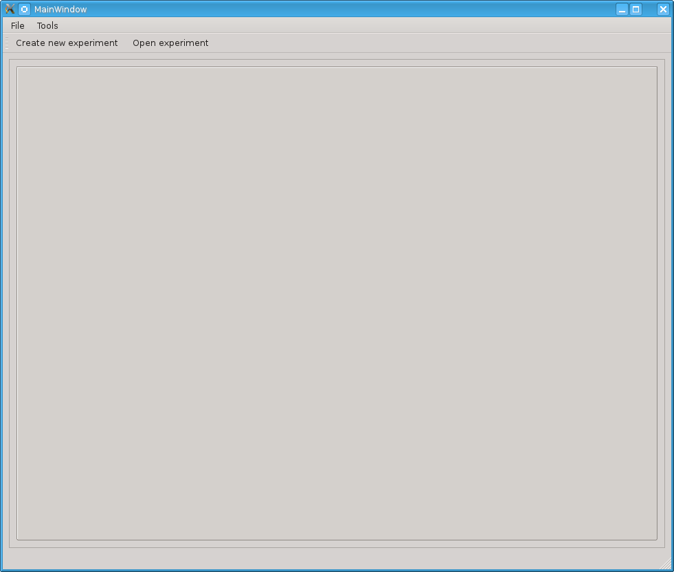Illustration 1: Empty main window

Should the user choose the option Create new experiment, the application prompts the user to choose a workspace directory for the application. This only happens once, subsequently the application will use the chosen directory. The workspace concept is modeled after Eclipse Java IDE, and the workspace directory should be changeable in a future version of Meggie.

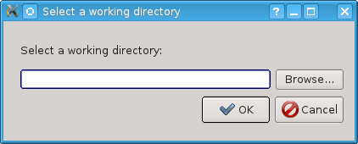Illustration 2: Workspace chooser dialog

After the workspace has been chosen, the the user is required to click the Create new experiment button again to actually create a new experiment. The user is then represented the following dialog:
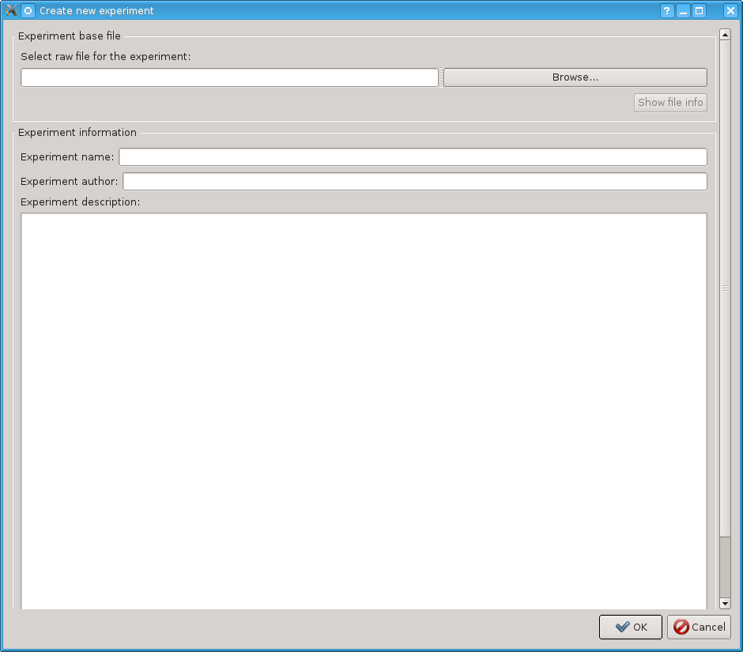Illustration 3: Experiment creation dialog

The dialog is rather self-explanatory, except for the textbox and a button to choose the experiment raw file. The button opens a standard file chooser dialog which allows the user to navigate to the desired file, whereas the textbox allow the direct input of the absolute path to the desired file.

The main window of Meggie after an experiment has been created or opened
The main window of the application includes the menu bar and a tab are. The tab area represents the different phases of MEG data analysis as tabs.

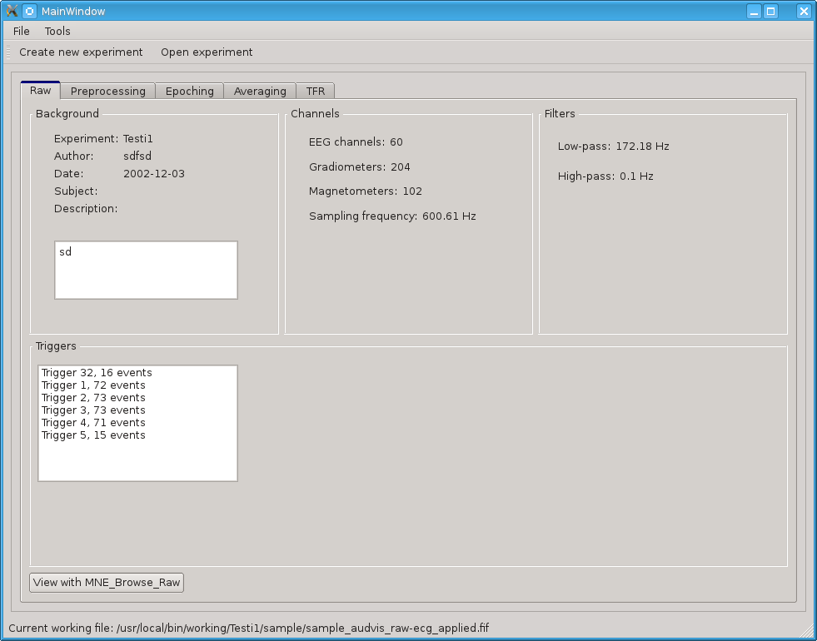Illustration 4: Main window, raw tab active

Menu bar
The menu bar has the following menus:
File menu
The file menu includes shortcuts to create a new experiment and an option to open an experiment. These work exactly the the same way as their siblings described in chapter 4.1. Additionally, the menu includes an option to change workspace. Clicking this option opens the workspace chooser dialog illustrated in Illustration 2.
Tools menu
Tools has a single option, that of Preferences. Preferences dialog currently includes a simple list of equipment calibration files provided by the MaxFilter program, ordered by the location of the equipment. The user can then choose the desired calibration file for the the experiment. If MaxFilter is not available, the dialog simply shows an empty list. ***tähän kuva kalibraatiofilulistasta, jos joskus saadaan se MaxFilter johonkin asennettua***

Raw tab
The raw tab shows basic information about the raw file of the experiment. This information includes experiment information set by the user at the time of creation, and information read from the raw file info fields themselves (with mne.raw.info). The raw file can also be viewed with an external browser (View with MNE_browse_raw). See Illustration 4 for visual details.

Preprocessing tab
The preprocessing tab includes options to apply MaxFilter (SSS, tSSS, MC) to the raw file. It also allows calculating SSP/PCA projections for ECG and EOG artifacts and viewing the magnitude spectrum.
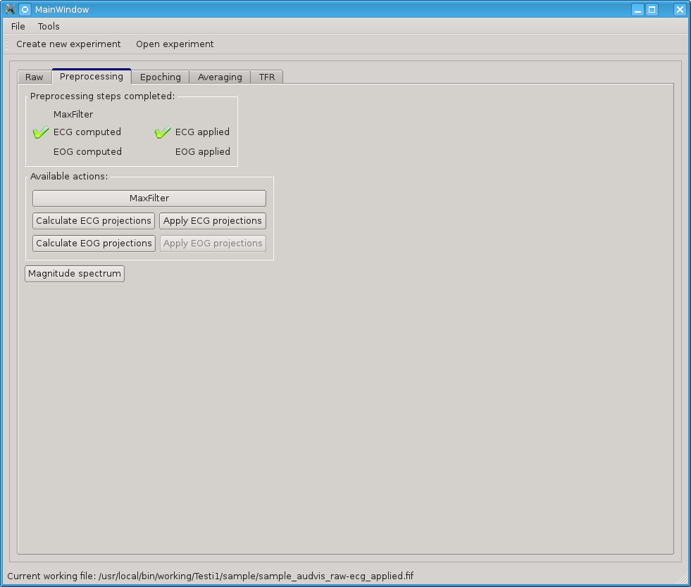Illustration 5: Main window, with preprocessing tab active
MaxFilter
Calls the proprietary MaxFilter program with the parameters in the opening MaxFilter dialog. For parameters and their descriptions, see the MaxFilter manual.
Calculate ECG projections
Open the following dialog for calculating ECG-projections for the file:
***ECG-dialogi

Calculate EOG projections

Epoching tab and epoch creation dialogs
Epoching tab includes a simple list of epoch collections created by picking events from the raw file. The actual creation of epoch collections is initiated by clicking the “Create an epoch collection” button. The epoch collection list created in this tab will also be shown in the subsequent tabs.

After clicking the “Create epoch collection” button, the user is represented with a dialog allowing the picking of events from the raw file by event ID:

***event-dialogikuva (event selection dialog)

The Add to list button adds all events with the selected event ID to the list on the right, whereas the Remove button removes a single selected event from the list. The Save events button saves the list into the subject directory in xls-format, and Read events button reads an xls-formatted file into the list (after clearing the list first). This allows more fine-grained editing of list via editors capable of editing xls-formatted files.

Clicking the OK button in the event selection dialog, the user is represented with an event filtering dialog. This dialog allows the actual forming of epochs from the events selected.

***event filtering dialog

The dialog has the following options:
  - Start time and end time: define the time window for the epochs in milliseconds before the events (start time) and after them (end time).
  - Include list: channel numbers to include, separated by commas, in addition to channels chosen with include checkboxes (below). Could be used to choose single channels from channel types not included by checkboxes. Example input: MEG1451,EEG006 ***Tarkista tämä***
  - Include checkboxes (mag, grad, eeg, stim, eog): checking these includes all channels of checked types in the epoching, and excludes all channels not checked.
  - Exclude list: channel types and numbers to exclude, separated by commas, exactly in the same way as in the include list. Could be used to exclude specific channels from channels types chosen by checking the include checkboxes.
  - Rejection parameters: if a peak-to-peak amplitude of a corresponding channel during an epoch exceeds the values given in these fields, don't include the epoch in the epoch collection.

***Lukuun 8
In a future version, the experiment would preferably be able to hold several subject. This in turn would allow batch processing of several subject files in the same experiment based on a template derived from processing a single subject file.

***Tarkista ***-tähdet ja Meggie-viittaukset

