第一章 Spark简介
What is Apache Spark?
Apache Spark is a processing system that makes working with big data simple.
It is a group of much more than a programming paradigm but an ecosystem of a
variety of packages, libraries, and systems built on top of the Core of Spark.
Spark Core consists of two APIs. The Unstructured and Structured APIs. The
Unstructured API is Spark’s lower level set of APIs including Resilient
Distributed Datasets (RDDs), Accumulators, and Broadcast variables. The
Structured API consists of DataFrames, Datasets, Spark SQL and is the
interface that most users should use. The difference between the two is that one
is optimized to work with structured data in a spreadsheet-like interface while
the other is meant for manipulation of raw java objects. Outside of Spark Core
sit a variety of tools, libraries, and languages like MLlib for performing
machine learning, the GraphX module for performing graph processing, and
SparkR for working with Spark clusters from the R langauge.
We will cover all of these tools in due time however this chapter will cover
the cornerstone concepts you need to write Spark programs and understand. We
will frequently return to these cornerstone concepts throughout the book.

Apache Spark是什么?
Apache Spark是一个处理大数据的处理系统。它不仅仅是一个编程范式，而是一个生态系统。各种各样的软件包、库和系统建立在Spark的核心之上。
Spark Core由两个api组成。非结构化和结构化的api。非结构化API是Spark的底层API集，包括弹性分布式数据集(RDDs)、累加器和广播变量。结构化API包括DataFrames、dataset、Spark SQL，以及大多数用户应该使用的接口。两者之间的区别在于，一个是优化的，可以在一个扩展型接口中处理结构化数据，而另一个则是用于处理原生java对象。在Spark Core之外，有各种各样的工具、库和诸如MLlib之类的语言，用于执行机器学习、图形处理的GraphX模块和用于处理来自R语言的Spark集群的SparkR。
我们将在适当的时候介绍所有这些工具，但是这一章将涵盖您需要编写Spark程序和理解的基础概念。我们将经常在书中回顾这些基础概念。

Spark’s Basic Architecture
Typically when you think of a “computer” you think about one machine sitting on your desk at home or at work. This machine works perfectly well for watching movies, or working with spreadsheet software but as many users likely experienced at some point, there are somethings that your computer is not powerful enough to perform. One particularly challenging area is data processing. Single machines simply cannot have enough power and resources to perform computations on huge amounts of information (or the user may not have time to wait for the computation to finish). A cluster, or group of machines, pools the resources of many machines together. Now a group of machines alone is not powerful, you need a framework to coordinate work across them. Spark is a tool for just that, managing and coordinating the resources of a cluster of computers.
In order to understand how to use Spark, let’s take a little time and understand the basics of Spark’s architecture.

Spark的基本架构
通常，当你想到“计算机”时，你会想到一台机器放在家里或工作的桌子上。这台机器很适合看电影，或者使用电子表格软件，但许多用户可能在某一时刻经历过，有些东西你的电脑不够强大，无法执行。一个特别具有挑战性的领域是数据处理。单个机器没有足够的能力和资源来执行大量信息的计算(或者用户可能没有时间等待计算完成)。集群，或一组机器，将许多机器的资源聚集在一起。现在，一组机器本身并不强大，您需要一个框架来协调它们之间的工作。Spark是一种工具，用于管理和协调集群计算机的资源。
为了了解如何使用Spark，让我们花一点时间了解Spark的基本架构。

Spark Applications
Spark Applications consist of a driver process and a set of executor processes. The driver process, Figure 1-2, sits on the driver node and is responsible for three things: maintaining information about the Spark application, responding to a user’s program, and analyzing, distributing, and scheduling work across the executors. As suggested by figure 1-1, the driver process is absolutely essential - it’s the heart of a Spark Application and maintains all relevant information during the lifetime of the application.
An executor is responsible for two things: executing code assigned to it by the driver and reporting the state of the computation back to the driver node.
The last piece relevant piece for us is the cluster manager. The cluster manager controls physical machines and allocates resources to Spark applications.This can be one of several core cluster managers: Spark’s standalone cluster manager, YARN, or Mesos. This means that there can be multiple Spark applications running on a cluster at the same time.

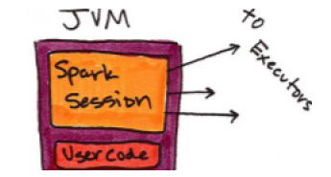
图1 - 1

Spark的应用程序
Spark应用程序由driver进程和一组executor进程组成。driver（图1 – 2）位于driver node上，它负责三件事:维护Spark应用程序的信息，响应用户的程序，分析、分发和调度执行器上的工作。正如图1 - 1所示，driver是绝对必要的——它是Spark应用程序的核心，并在应用程序的生命周期内维护所有相关信息。executor负责两件事:执行由驱动程序分配给它的代码，并将计算状态报告回driver node。
最后一个相关的组件是集群管理器（cluster managers）。集群管理器控制物理机器并分配资源给Spark应用程序。集群管理器可以使用这几个核心集群管理器:Spark的独立集群管理器、YARN或Mesos。这意味着可以同时在一个集群上运行多个Spark应用程序。

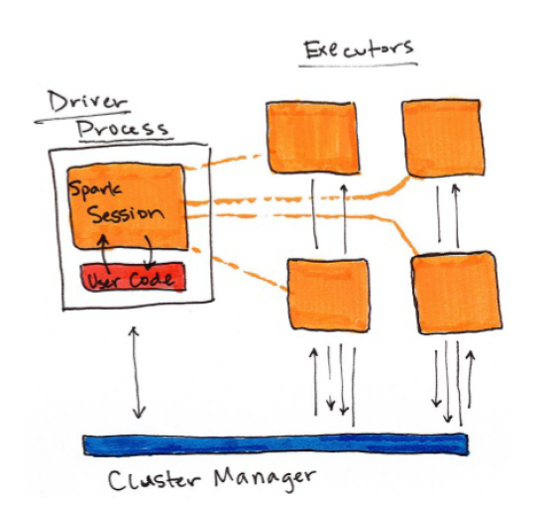
图 1 – 2

Figure 1-1 shows, on the left, our driver and on the right the four worker nodes on the right.
NOTE:
Spark, in addition to its cluster mode, also has a local mode. Remember how the driver and executors are processes? This means that Spark does not dictate where these processes live. In local mode, these processes run on your individual computer instead of a cluster. See figure 1-3 for a high level diagram of this architecture. This is the easiest way to get started with Spark and what the demonstrations in this book should run on.

图1 - 1显示在左边，我们的驱动和右边的四个工作节点。
注意:
Spark除了集群模式之外，也有本地模式。还记得driver和executors是如何交互的吗?这意味着Spark不指示这些进程的位置。在本地模式中，这些进程运行在您的个人计算机而不是集群上。图1 - 3为该体系结构的高层图。这是运行Spark最简单的途径，本书的示例将在本地模式上运行。

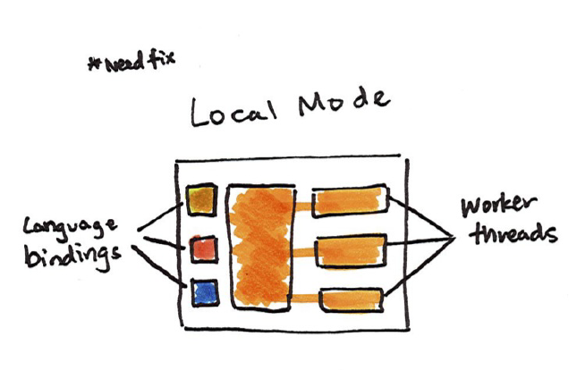
Using Spark from Scala, Java, SQL,
Python, or R
As you likely noticed in the previous figures, Spark works with multiple languages. These language APIs allow you to run Spark code from another language. When using the Structured APIs, code written in any of Spark’s supported languages should perform the same, there are some caveats to this but in general this is the case. Before diving into the details, let’s just touch a bit on each of these langauges and their integration with Spark.
Scala
Spark is primarily written in Scala, making it Spark’s “default” language. This book will include examples of Scala where ever there are code samples.
Python
Python supports nearly everything that Scala supports. This book will include Python API examples wherever possible.
Java
Even though Spark is written in Scala, Spark’s authors have been careful to ensure that you can write Spark code in Java. This book will focus primarily on Scala but will provide Java examples where relevant.
SQL
Spark supports user code written in ANSI 2003 Compliant SQL. This makes it easy for analysts and non-programmers to leverage the big data powers of Spark. This book will include numerous SQL examples.
R
Spark supports the execution of R code through a project called SparkR. We will cover this in the Ecosystem section of the book along with other interesting projects that aim to do the same thing like Sparklyr.

使用Scala,Java,SQL,Python或R
正如您在前面的图中可能注意到的那样，Spark可以使用多种语言。这些语言api允许您从其他语言运行Spark。当使用结构化的api时，任何由Spark支持的语言编写的代码都应该执行相同的操作，但总的来说，这是一个问题。在深入了解细节之前，让我们稍微了解一下这些langauges及其与Spark的集成。
Scala
Spark主要是用Scala编写的，这使它成为Spark的“默认”语言。这本书将包括Scala的例子，那里有代码示例。
Python
Python支持Scala支持的几乎所有东西。本书将尽可能包含Python API示例。
Java
尽管Spark是在Scala中编写的，Spark的作者们还是小心翼翼地确保您可以在Java中编写Spark代码。本书将主要关注Scala，但将提供与之相关的Java示例。
SQL
Spark支持使用ANSI 2003兼容的SQL编写的用户代码。这使得分析师和非程序员更容易利用Spark的大数据能力。这本书将包含许多SQL示例。
R
Spark支持通过一个名为SparkR的项目执行R代码。我们将在这本书的生态系统部分和其他一些有趣的项目一起讨论这个问题，这些项目的目的是做类似Sparklyr的事情。

Key Concepts
Now we have not exhaustively explored every detail about Spark’s architecture because at this point it’s not necessary to get us closer to running our own Spark code.
The key points are that: Spark has some cluster manager that maintains an understanding of the resources available.
The driver process is responsible for executing our driver program’s commands accross the executors in order to complete our task.
There are two modes that you can use, cluster mode (on multiple machines) and local mode (on a single machine).

关键概念
现在我们还没有详尽地探究Spark的架构的每一个细节，因为现在更深入的了解我们运行在Spark上的代码是没有必要的。
要点是:
·Spark有一些集群管理器，这些集群管理器知道集群上有哪些资源可用。
·driver通过调度executor执行我们的应用程序的命令，以完成我们的任务。
·有两种模式可以使用，集群模式(在多个机器上)和本地模式(在一台机器上)。

Starting Spark
Now in the previous chapter we talked about what you need to do to get started with Spark by setting your Java, Scala, and Python versions. Now it’s time to start Spark’s local mode, this means running ./bin/spark-shell. Once you start that you will see a console, into which you can enter commands. If you would like to work in Python you would run ./bin/pyspark.

开始Spark
在前面的章节中，我们讨论了如何通过设置Java、Scala和Python版本来启动Spark。现在是启动Spark本地模式的时候了，这意味着运行。/ bin/ Spark - shell。一旦开始，您将看到一个控制台，您可以在其中输入命令。如果你想在Python里工作，你就会运行。/ bin/ pyspark。

