第一章 Spark简介
What is Apache Spark?
Apache Spark is a processing system that makes working with big data simple.
It is a group of much more than a programming paradigm but an ecosystem of a
variety of packages, libraries, and systems built on top of the Core of Spark.
Spark Core consists of two APIs. The Unstructured and Structured APIs. The
Unstructured API is Spark’s lower level set of APIs including Resilient
Distributed Datasets (RDDs), Accumulators, and Broadcast variables. The
Structured API consists of DataFrames, Datasets, Spark SQL and is the
interface that most users should use. The difference between the two is that one
is optimized to work with structured data in a spreadsheet-like interface while
the other is meant for manipulation of raw java objects. Outside of Spark Core
sit a variety of tools, libraries, and languages like MLlib for performing
machine learning, the GraphX module for performing graph processing, and
SparkR for working with Spark clusters from the R langauge.
We will cover all of these tools in due time however this chapter will cover
the cornerstone concepts you need to write Spark programs and understand. We
will frequently return to these cornerstone concepts throughout the book.

Apache Spark是什么?
Apache Spark是一个处理大数据的处理系统。它不仅仅是一个编程范式，而是一个生态系统。各种各样的软件包、库和系统建立在Spark的核心之上。
Spark Core由两个api组成。非结构化和结构化的api。非结构化API是Spark的底层API集，包括弹性分布式数据集(RDDs)、累加器和广播变量。结构化API包括DataFrames、Dataset、Spark SQL，以及大多数用户应该使用的接口。两者之间的区别在于，一个是优化的，可以在一个扩展型接口中处理结构化数据，而另一个则是用于处理原生java对象。在Spark Core之外，有各种各样的工具、库和诸如MLlib之类的语言，用于执行机器学习、图形处理的GraphX模块和用于处理来自R语言的Spark集群的SparkR。
我们将在适当的时候介绍所有这些工具，但是这一章将涵盖您需要编写Spark程序和理解的基础概念。我们将经常在书中回顾这些基础概念。

Spark’s Basic Architecture
Typically when you think of a “computer” you think about one machine sitting on your desk at home or at work. This machine works perfectly well for watching movies, or working with spreadsheet software but as many users likely experienced at some point, there are somethings that your computer is not powerful enough to perform. One particularly challenging area is data processing. Single machines simply cannot have enough power and resources to perform computations on huge amounts of information (or the user may not have time to wait for the computation to finish). A cluster, or group of machines, pools the resources of many machines together. Now a group of machines alone is not powerful, you need a framework to coordinate work across them. Spark is a tool for just that, managing and coordinating the resources of a cluster of computers.
In order to understand how to use Spark, let’s take a little time and understand the basics of Spark’s architecture.

Spark的基本架构
通常，当你想到“计算机”时，你会想到一台机器放在家里或工作的桌子上。这台机器很适合看电影，或者使用电子表格软件，但许多用户可能在某一时刻经历过，有些东西你的电脑不够强大，无法执行。一个特别具有挑战性的领域是数据处理。单个机器没有足够的能力和资源来执行大量信息的计算(或者用户可能没有时间等待计算完成)。集群，或一组机器，将许多机器的资源聚集在一起。现在，一组机器本身并不强大，您需要一个框架来协调它们之间的工作。Spark是一种工具，用于管理和协调集群计算机的资源。
为了了解如何使用Spark，让我们花一点时间了解Spark的基本架构。

Spark Applications
Spark Applications consist of a driver process and a set of executor processes. The driver process, Figure 1-2, sits on the driver node and is responsible for three things: maintaining information about the Spark application, responding to a user’s program, and analyzing, distributing, and scheduling work across the executors. As suggested by figure 1-1, the driver process is absolutely essential - it’s the heart of a Spark Application and maintains all relevant information during the lifetime of the application.
An executor is responsible for two things: executing code assigned to it by the driver and reporting the state of the computation back to the driver node.
The last piece relevant piece for us is the cluster manager. The cluster manager controls physical machines and allocates resources to Spark applications.This can be one of several core cluster managers: Spark’s standalone cluster manager, YARN, or Mesos. This means that there can be multiple Spark applications running on a cluster at the same time.

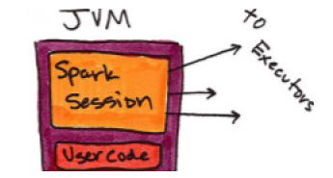
图1 - 1

Spark的应用程序
Spark应用程序由driver进程和一组executor进程组成。driver（图1 – 2）位于driver node上，它负责三件事:维护Spark应用程序的信息，响应用户的程序，分析、分发和调度执行器上的工作。正如图1 - 1所示，driver是绝对必要的——它是Spark应用程序的核心，并在应用程序的生命周期内维护所有相关信息。executor负责两件事:执行由驱动程序分配给它的代码，并将计算状态报告回driver node。
最后一个相关的组件是集群管理器（cluster managers）。集群管理器控制物理机器并分配资源给Spark应用程序。集群管理器可以使用这几个核心集群管理器:Spark的独立集群管理器、YARN或Mesos。这意味着可以同时在一个集群上运行多个Spark应用程序。

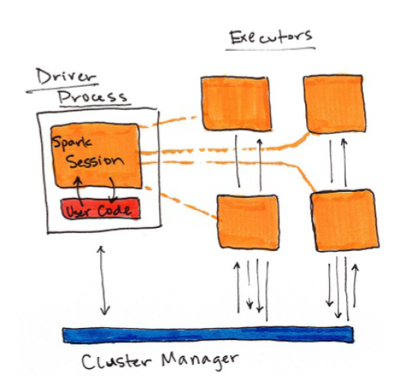
图 1 – 2

Figure 1-1 shows, on the left, our driver and on the right the four worker nodes on the right.
NOTE:
Spark, in addition to its cluster mode, also has a local mode. Remember how the driver and executors are processes? This means that Spark does not dictate where these processes live. In local mode, these processes run on your individual computer instead of a cluster. See figure 1-3 for a high level diagram of this architecture. This is the easiest way to get started with Spark and what the demonstrations in this book should run on.

图1 - 1显示在左边，我们的驱动和右边的四个工作节点。
注意:
Spark除了集群模式之外，也有本地模式。还记得driver和executors是如何交互的吗?这意味着Spark不指示这些进程的位置。在本地模式中，这些进程运行在您的个人计算机而不是集群上。图1 - 3为该体系结构的高层图。这是运行Spark最简单的途径，本书的示例将在本地模式上运行。

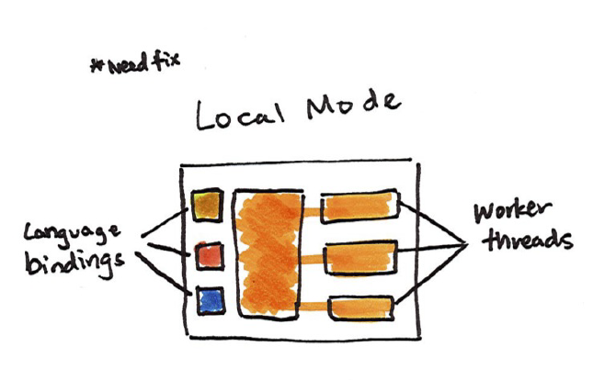
Using Spark from Scala, Java, SQL,
Python, or R
As you likely noticed in the previous figures, Spark works with multiple languages. These language APIs allow you to run Spark code from another language. When using the Structured APIs, code written in any of Spark’s supported languages should perform the same, there are some caveats to this but in general this is the case. Before diving into the details, let’s just touch a bit on each of these langauges and their integration with Spark.
Scala
Spark is primarily written in Scala, making it Spark’s “default” language. This book will include examples of Scala where ever there are code samples.
Python
Python supports nearly everything that Scala supports. This book will include Python API examples wherever possible.
Java
Even though Spark is written in Scala, Spark’s authors have been careful to ensure that you can write Spark code in Java. This book will focus primarily on Scala but will provide Java examples where relevant.
SQL
Spark supports user code written in ANSI 2003 Compliant SQL. This makes it easy for analysts and non-programmers to leverage the big data powers of Spark. This book will include numerous SQL examples.
R
Spark supports the execution of R code through a project called SparkR. We will cover this in the Ecosystem section of the book along with other interesting projects that aim to do the same thing like Sparklyr.

使用Scala,Java,SQL,Python或R
正如您在前面的图中可能注意到的那样，Spark可以使用多种语言。这些语言api允许您从其他语言运行Spark。当使用结构化的api时，任何由Spark支持的语言编写的代码都应该执行相同的操作，但总的来说，这是一个问题。在深入了解细节之前，让我们稍微了解一下这些langauges及其与Spark的集成。
Scala
Spark主要是用Scala编写的，这使它成为Spark的“默认”语言。这本书将包括Scala的例子，那里有代码示例。
Python
Python支持Scala支持的几乎所有东西。本书将尽可能包含Python API示例。
Java
尽管Spark是在Scala中编写的，Spark的作者们还是小心翼翼地确保您可以在Java中编写Spark代码。本书将主要关注Scala，但将提供与之相关的Java示例。
SQL
Spark支持使用ANSI 2003兼容的SQL编写的用户代码。这使得分析师和非程序员更容易利用Spark的大数据能力。这本书将包含许多SQL示例。
R
Spark支持通过一个名为SparkR的项目执行R代码。我们将在这本书的生态系统部分和其他一些有趣的项目一起讨论这个问题，这些项目的目的是做类似Sparklyr的事情。

Key Concepts
Now we have not exhaustively explored every detail about Spark’s architecture because at this point it’s not necessary to get us closer to running our own Spark code.
The key points are that: Spark has some cluster manager that maintains an understanding of the resources available.
The driver process is responsible for executing our driver program’s commands accross the executors in order to complete our task.
There are two modes that you can use, cluster mode (on multiple machines) and local mode (on a single machine).

关键概念
现在我们还没有详尽地探究Spark的架构的每一个细节，因为现在更深入的了解我们运行在Spark上的代码是没有必要的。
要点是:
·Spark有一些集群管理器，这些集群管理器知道集群上有哪些资源可用。
·driver通过调度executor执行我们的应用程序的命令，以完成我们的任务。
·有两种模式可以使用，集群模式(在多个机器上)和本地模式(在一台机器上)。

Starting Spark
Now in the previous chapter we talked about what you need to do to get started with Spark by setting your Java, Scala, and Python versions. Now it’s time to start Spark’s local mode, this means running ./bin/spark-shell. Once you start that you will see a console, into which you can enter commands. If you would like to work in Python you would run ./bin/pyspark.

开始Spark
在前面的章节中，我们讨论了为了启动通过Java，Scala和Python设置的Spark版本需要做什么。现在是启动Spark本地模式的时候了，这意味着运行./bin/spark-shell。一旦开始，您将看到一个控制台，您可以在其中输入命令。如果你想在Python里工作，你就会运行./bin/pyspark。

SparkSession
From the beginning of this chapter we know that we leverage a driver process
to maintain our Spark Application. This driver process manifests itself to the
user as something called the SparkSession. The SparkSession instance is the
entrance point to executing code in Spark, in any language, and is the userfacing
part of a Spark Application. In Scala and Python the variable is
available as spark when you start up the Spark console. Let’s go ahead and
look at the SparkSession in both Scala and/or Python.
%scala
spark
%python
spark
In Scala, you should see something like:
res0: org.apache.spark.sql.SparkSession = org.apache.spark.sql.SparkSession@In Python you’ll see something like:
<pyspark.sql.session.SparkSession at 0x7efda4c1ccd0>
Now you need to understand how to submit commands to the SparkSession.
Let’s do that by performing one of the simplest tasks that we can - creating a
range of numbers. This range of numbers is just like a named column in a
spreadsheet.
%scala
val myRange = spark.range(1000).toDF("number")
%python
myRange = spark.range(1000).toDF("number")
You just ran your first Spark code! We created a DataFrame with one column
containing 1000 rows with values from 0 to 999. This range of number
represents a distributed collection. Running on a cluster, each part of this
range of numbers would exist on a different executor. You’ll notice that the
value of myRange is a DataFrame, let’s introduce DataFrames!

DataFrames
A DataFrame is a table of data with rows and columns. We call the list of columns and their types a schema. A simple analogy would be a spreadsheet with named columns. The fundamental difference is that while a spreadsheet sits on one computer in one specific location, a Spark DataFrame can span potentially thousands of computers. The reason for putting the data on more than one computer should be intuitive: either the data is too large to fit on one machine or it would simply take too long to perform that computation on one machine.
The DataFrame concept is not unique to Spark. The R Language has a similar concept as do certain libraries in the Python programming language. However, Python/R DataFrames (with some exceptions) exist on one machine rather than multiple machines. This limits what you can do with a given DataFrame in python and R to the resources that exist on that specific machine. However, since Spark has language interfaces for both Python and R, it’s quite easy to convert to Pandas (Python) DataFrames to Spark DataFrames and R DataFrames to Spark DataFrames (in R).
Note
Spark has several core abstractions: Datasets, DataFrames, SQL Tables, and Resilient Distributed Datasets (RDDs). These abstractions all represent distributed collections of data however they have different interfaces for working with that data. The easiest and most efficient are DataFrames, which are available in all languages. We cover Datasets in Section II, Chapter 8 and RDDs in depth in Section III Chapter 2 and 3. The following concepts apply to all of the core abstractions.

DataFrames
DataFrame是带有行和列的数据表。我们将列及其类型称为模式。一个简单的类比就是一个有命名列的电子表格。最根本的区别是，电子表格位于一台计算机上的特定位置，但Spark DataFrame可以跨越数千台计算机。将数据放到多个计算机上的原因应该是直观的:要么数据太大，要么无法装入一台机器，要么就是在一台机器上运算花费过多的时间。
DataFrame的概念并不仅存在于Spark。R语言具有类似于Python编程语言中的某些库的概念。然而，Python /R DataFrames(有一些例外)存在于一台机器上，而不是多台机器上。这限制了你只能用python和R中的DataFrame来处理单个特定机器上的资源。但是，由于Spark具有Python和R的语言接口，因此将Pandas（Python）DataFrames转换为Spark DataFrames和将R DataFrames转换为Spark DataFrames（R）非常容易。
Note
Spark有几个核心抽象:数据集（Datasets）、DataFrames、SQL表和弹性分布式数据集(RDDs)。这些抽象都代表了数据的分布式集合，但是它们与这些数据有不同的接口。最简单和最有效的是DataFrames，它可用于所有语言。我们在第二章、第八章和第三章第三章的深度介绍了数据集。以下概念适用于所有核心抽象。

Partitions
In order to leverage the the resources of the machines in cluster, Spark breaks up the data into chunks, called partitions. A partition is a collection of rows that sit on one physical machine in our cluster. A DataFrame consists of zero or more partitions.

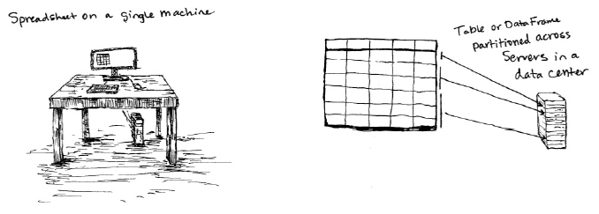
When we perform some computation, Spark will operate on each partition in parallel unless an operation calls for a shuffle, where multiple partitions need to share data. Think about it this way, if you need to run some errands you typically have to do those one by one, or serially. What if you could instead give one errand to a worker who would then complete that task and then report back to you? In that scenario, the key is to break up errands efficiently so that you can get as much work done in as little time as possible. In the Spark world an “errand” is equivalent to computation + data and a “worker” is equivalent to an executor. Now with DataFrames, we do not manipulate partitions individually, Spark gives us the DataFrame interface for doing that. Now when we ran the above code, you’ll notice there was no list of numbers, only a type signature. This is because Spark organizes computation into two categories, transformations and actions. When we create a DataFrame, we perform a transformation.

分区
为了利用集群中的机器资源，Spark将数据分解成块，称为分区。分区是集群中的一个物理机器上的行集合。DataFrame由零个或多个分区组成。
当我们执行一些计算时，Spark将并行地在每个分区上运行，除非操作中调用了shuffle，如排序操作等，shuffle需要在多个分区间共享数据。考虑这样一种情况，你需要运行一些任务，你通常必须逐一或连续地执行这些任务（errand）。如果你可以给一个工作人员一个任务，然后完成这个任务，然后向你汇报工作，那该怎么办?在这种情况下，关键是要有效地分解任务，以便在尽可能少的时间内完成大量的工作。在Spark世界中，“errand”相当于计算+数据，而“worker”相当于executor。
现在有了DataFrames，我们不需要逐个操作分区，Spark给我们提供了DataFrame接口。现在，当我们运行上面的代码时（spark.range(1000).toDF("number")），您会注意到没有数字集合，只有一个类型签名。这是因为Spark将计算组织为两个类别、转换和行动。当我们创建DataFrame时，我们只执行一个转换，数字集合并没有被加载。

Transformations
In Spark, the core data structures are immutable meaning they cannot be changed once created. This might seem like a strange concept at first, if you cannot change it, how are you supposed to use it? In order to “change” a DataFrame you will have to instruct Spark how you would like to modify the DataFrame you have into the one that you want. These instructions are called transformations. Transformations are how you, as user, specify how you would like to transform the DataFrame you currently have to the DataFrame that you want to have. Let’s show an example. To computer whether or not a number is divisible by two, we use the modulo operation to see the remainder left over from dividing one number by another. We can use this operation to perform a transformation from our current DataFrame to a DataFrame that only contains numbers divisible by two. To do this, we perform the modulo operation on each row in the data and filter out the results that do not result in zero. We can specify this filter using a where clause.
%scala
val divisBy2 = myRange.where("number % 2 = 0")
%python
divisBy2 = myRange.where("number % 2 = 0")
Note
Now if you worked with any relational databases in the past, this should feel quite familiar. You might say, aha! I know the exact expression I should use if this was a table.
SELECT * FROM myRange WHERE number % 2 = 0
When we get to the next part of this chapter to discuss Spark SQL, you will find out that this expression is perfectly valid. We’ll show you how to turn any DataFrame into a table.
These operations create a new DataFrame but do not execute any computation.
The reason for this is that DataFrame transformations do not trigger Spark to execute your code, they are lazily evaluated.

转换
在Spark中，核心数据结构（指的是数据集（Datasets）、DataFrames、SQL表和弹性分布式数据集(RDDs)）是不可变的，这意味着它们不能在创建后更改。乍一看，这似乎是个奇怪的概念，如果你不能改变它，你该如何使用它呢?为了“改变”一个DataFrame，您必须指示Spark您想要如何修改您想要的DataFrame。这些指令叫做转换。转换就是你如何以用户的身份指定如何将当前拥有的DataFrame转换为你想要的DataFrame。举个例子，为了计算一个数是否可以被二整除，我们使用模运算来查看余数。我们可以使用此操作来执行从当前DataFrame到仅包含可被2整除的数据的DataFrame的转换。为此，我们对数据中的每一行执行模操作，并过滤掉不产生零的结果。我们可以使用where子句指定此过滤器。
% scala
val divisBy2 = myRange.where(“number % 2 = 0”)
% python
divisBy2 = myRange.where(“number % 2 = 0”)
Note
现在，如果您在过去使用任何关系数据库，这应该会很熟悉。你可能会说,啊哈!如果这是一个表，我知道应该用什么表达式。
从myRange选择*，其中number % 2 = 0
当我们进入本章的下一部分讨论Spark SQL时，您会发现这个表达式是完全有效的。我们将向您展示如何将任何DataFrame转换为表。
这些操作创建一个新的DataFrame，但不执行任何计算。
这样做的原因是，DataFrame转换不会触发Spark执行您的代码，它们被惰性计算。

Lazy Evaluation
Lazy evaulation means that Spark will wait until the very last moment to execute your transformations. In Spark, instead of modifying the data quickly, we build up a plan of the transformations that we would like to apply. Spark, by waiting for the last minute to execute your code, can try and make this plan run as efficiently as possible across the cluster.

惰性计算（Lazy Evaluation）
惰性计算意味着Spark将等到最后一刻执行转换。 在Spark中，我们不是快速修改数据，而是建立一个我们想要应用的转换计划。 通过等待最后一分钟来执行代码，Spark可以尝试使这个计划在集群中尽可能高效地运行。

Actions
To trigger the computation, we run an action. An action instructs Spark to compute a result from a series of transformations. The simplest action is count which gives us the total number of records in the DataFrame.
%scala
divisBy2.count()
%python
divisBy2.count()
We now see a result! There are 500 number divisible by two from o to 999 (big surprise!). Now count is not the only action. There are three kinds of actions: actions to view data in the console, actions to collect data to native objects in the respective language, and actions to write to output data sources.

动作
为了触发计算，我们运行一个动作。一个动作指示Spark从一系列转换中计算结果。最简单的操作是count，它给出了DataFrame中记录的总数。
% scala
divisBy2.count()
% python
divisBy2.count()
我们现在看到了结果!从0到999有500个数字可以被2整除。现在count并不是唯一的动作。有三种操作:在控制台中查看数据的操作、将数据收集到相应语言中的原生对象的操作，以及输出到数据源的操作。
Spark UI
During Spark’s execution of the previous code block, users can monitor the
progress of their job through the Spark UI. The Spark UI is available on port
4040 of the driver node. If you are running in local mode this will just be the
http://localhost:4040. The Spark UI maintains information on the state of
our Spark jobs, environment, and cluster state. It’s very useful, especially for
tuning and debugging. In this case, we can see one Spark job with one stage
and nine tasks were executed.
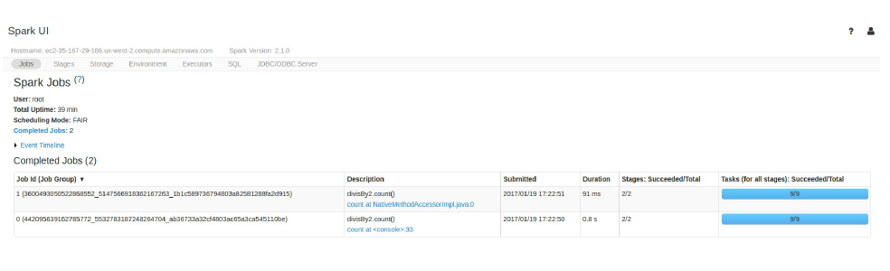
In this chapter we will avoid the details of Spark jobs and the Spark UI, at this
point you should understand that a Spark job represents a set of transformations
triggered by an individual action. We talk in depth about the Spark UI and the
breakdown of a Spark job in Section IV.

在Spark执行前一个代码块期间，用户可以通过Spark UI监视他们的工作进度。Spark UI在驱动节点的4040端口上可用。如果在本地模式下运行，则这将是http://localhost:4040。Spark UI维护关于我们的Spark作业、环境和集群状态的信息。它非常有用，特别是对于调优和调试。在这种情况下，我们可以看到一个有一个阶段的Spark作业和9个任务被执行。
在本章中，我们将避免Spark作业和Spark UI的细节，此时，您应该理解Spark作业代表了由单个动作触发的一组转换。我们深入讨论了Spark UI和在第四节中的Spark作业的分解。

A Basic Transformation Data Flow
In the previous example, we created a DataFrame from a range of data.
Interesting, but not exactly applicable to industry problems. Let’s create some DataFrames with real data in order to better understand how they work. We’ll be using some flight data from the United States Bureau of Transportation statistics.
We touched briefly on the SparkSession as the interface the entry point to performing work on the Spark cluster. the SparkSession can do much more than simply parallelize an array it can create DataFrames directly from a file or set of files. In this case, we will create our DataFrames from a JavaScript Object Notation (JSON) file that contains some summary flight information as collected by the United States Bureau of Transport Statistics. In the folder provided, you’ll see that we have one file per year.

一个基本的转换数据流
在前面的示例中，我们从一系列数据创建了DataFrame。
有趣，但不完全适用于行业问题。让我们用真实的数据创建一些DataFrames，以便更好地理解它们是如何工作的。我们将使用美国运输统计局的一些飞行数据。
我们在SparkSession上做了简单的接触，作为入口点来执行Spark集群上的工作。SparkSession可以做的不仅仅是简单地并行化一个数组，它可以直接从文件或文件集创建DataFrames。在本例中，我们将从一个JavaScript对象表示法(JSON)文件创建我们的DataFrames文件，该文件包含由美国运输统计局收集的一些汇总飞行信息。在提供的文件夹中，您将看到我们每年有一个文件。

%fs ls /mnt/defg/chapter-1-data/json/
This file has one JSON object per line and is typically refered to as linedelimited JSON.
%fs head /mnt/defg/chapter-1-data/json/2015-summary.json
What we’ll do is start with one specific year and then work up to a larger set of data. Let’s go ahead and create a DataFrame from 2015. To do this we will use the DataFrameReader (via spark.read) interface, specify the format and the path.

% fs ls / mnt / defg / chapter-1-data / json /
这个文件每一行有一个JSON对象，通常被称为linedelimited JSON。
% f头/ mnt / defg / chapter-1-data / json / 2015 - summary.json
我们要做的是，从一个特定的年份开始，然后处理一组更大的数据。让我们从2015年开始创建一个DataFrame。为此，我们将使用DataFrameReader(通过spark . read)接口，指定格式和路径。
%scala
val flightData2015 = spark
.read
.json("/mnt/defg/chapter-1-data/json/2015-summary.json")
%python
flightData2015 = spark\
.read\
https://www.iteblog.com
.json("/mnt/defg/chapter-1-data/json/2015-summary.json")
flightData2015
You’ll see that our two DataFrames (in Scala and Python) each have a set of columns with an unspecified number of rows. Let’s take a peek at the data with a new action, take, which allows us to view the first couple of rows in our DataFrame. Figure 1-7 illustrates the conceptual actions that we perform in the process. We lazily create the DataFrame then call an action to take the first two values.

% scala
val flightData2015 =spark
.read
. json("/mnt/defg/chapter-1-data/json/2015-summary.json")
% python
flightData2015 =spark\
.read \
. json("/mnt/defg/chapter-1-data/json/2015-summary.json")
flightData2015
您将看到，我们的两个DataFrames(在Scala和Python中)都有一组列，其中行数不详。让我们以一个新的操作来查看数据，它允许我们查看DataFrame中的前几行。图1 - 7演示了我们在流程中执行的概念性操作。我们延迟创建DataFrame然后调用一个动作来执行前两个值。
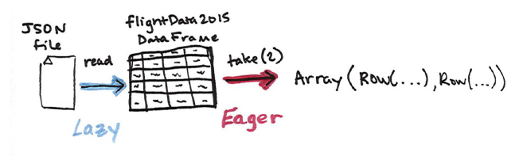
图 1 – 7

%scala
flightData2015.take(2)
%python
flightData2015.take(2)
Remember how we talked about Spark building up a plan, this is not just a conceptual tool, this is actually what happens under the hood. We can see the actual plan built by Spark by running the explain method.
flightData2015.explain()
%python
flightData2015.explain()
Congratulations, you’ve just read your first explain plan! This particular plan just describes reading data from a certain location however as we continue, you will start to notice patterns in the explain plans. Without going into too much detail at this point, the explain plan represents the logical combination of transformations Spark will run on the cluster. We can use this to make sure that our code is as optimized as possible. We will not cover that in this chapter, but will touch on it in the optimization chapter.
Now in order to gain a better understanding of transformations and plans, let’s create a slightly more complicated plan. We will specify an intermediate step which will be to sort the DataFrame by the values in the first column. We can tell from our DataFrame’s column types that it’s a string so we know that it will sort the data from A to Z.

% scala
flightData2015.take(2)
% python
flightData2015.take(2)
记住我们是如何讨论Spark构建计划的，这不仅仅是概念上的工具，这实际上是在hood下发生的事情。通过运行explain方法，我们可以看到Spark构建的实际计划。
flightData2015.explain()
% python
flightData2015.explain()
恭喜你，你刚读了你的第一个解释计划!这个特别的计划只是描述了从某个位置读取数据，但是随着我们继续，你将会注意到解释计划中的模式。在这一点上没有太多细节，解释计划代表转换Spark在集群上运行的逻辑组合。我们可以使用它来确保代码尽可能的优化。我们将不会在本章中讨论它，但将在优化章节中涉及它。
现在为了更好地理解转换和计划，让我们创建一个稍微复杂一点的计划。我们将指定一个中间步骤，它将按照第一列中的值对DataFrame进行排序。我们可以从DataFrame的列类型中看出它是一个字符串，因此我们知道它会将数据从A排序到Z。

Note
Remember, we cannot modify this DataFrame by specifying the sort transformation, we can only create a new DataFrame by transforming that previous DataFrame. We can see that even though we’re seeming to ask for computation to be completed Spark doesn’t yet execute this command, we’re just building up a plan. The illustration in figure 1-8 represents the spark plan we see in the explain plan for that DataFrame.

Note
请记住，我们不能通过指定排序转换来修改这个DataFrame，我们只能通过转换以前的DataFrame来创建新的DataFrame。我们可以看到，即使我们似乎要求计算完成，Spark还没有执行这个命令，我们只是在构建一个计划。图1 - 8中的插图表示我们在该DataFrame的解释计划中看到的spark计划。
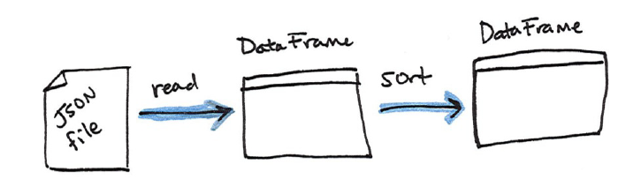
图 1 - 8

%scala
val sortedFlightData2015 = flightData2015.sort("count")
sortedFlightData2015.explain()
%python
sortedFlightData2015 = flightData2015.sort("count")
sortedFlightData2015.explain()
Now, just like we did before, we can specify an action in order to kick off this plan.
%scala
sortedFlightData2015.take(2)
%python
sortedFlightData2015.take(2)
The conceptual plan that we executed previously is illustrated in Figure-9.

% scala
val sortedFlightData2015 = flightData2015.sort("count")
sortedFlightData2015.explain()
% python
sortedFlightData2015 = flightData2015.sort("count")
sortedFlightData2015.explain()
现在，就像我们之前做的那样，我们可以指定一个动作来启动这个计划。
% scala
sortedFlightData2015.take(2)
% python
sortedFlightData2015.take(2)
我们之前执行的概念性计划以数字9表示。
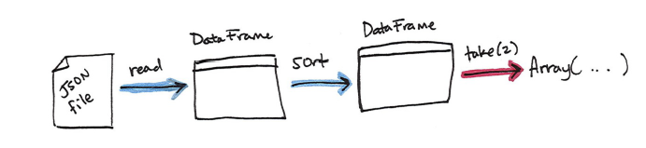
图 1 – 9

Now this planning process is essentially defining lineage for the DataFrame so that at any given point in time Spark knows how to recompute any partition of a given DataFrame all the way back to a robust data source be it a file or database. Now that we performed this action, remember that we can navigate to the Spark UI (port 4040) and see the information about this jobs stages and tasks.
Now hopefully you have grasped the basics but let’s just reinforce some of the core concepts with another data pipeline. We’re going to be using the same flight data used except that this time we’ll be using a copy of the data in comma seperated value (CSV) format.
If you look at the previous code, you’ll notice that the column names appeared in our results. That’s because each line is a json object that has a defined structure or schema. As mentioned, the schema defines the column names and types. This is a term that is used in the database world to describe what types are in every column of a table and it’s no different in Spark. In this case the schema defines ORIGIN_COUNTRY_NAME to be a string. JSON and CSVs qualify as semi-structured data formats and Spark supports a range of data sources in its APIs and ecosystem.
Let’s go ahead and define our DataFrame just like we did before however this time we’re going to specify an option for our DataFrameReader. Options allow you to control how you read in a given file format and tell Spark to take advantage of some of the structures or information available in the files. In this case we’re going to use two popular options inferSchema and header.
%scala
val flightData2015 = spark.read
.option("inferSchema", "true")
.option("header", "true")
.csv("/mnt/defg/chapter-1-data/csv/2015-summary.csv")
flightData2015
%python
flightData2015 = spark.read\
.option("inferSchema", "true")\
.option("header", "true")\
.csv("/mnt/defg/chapter-1-data/csv/2015-summary.csv")
flightData2015
After running the code you should notice that we’ve basically arrived at the same DataFrame that we had when we read in our data from json with the correct looking column names and types. However, we had to be more explicit when it came to reading in the CSV file as opposed to json because json
provides a bit more structure than CSVs because JSON has a notion of types.
Looking at them, the header option should feel like it makes sense. The first row in our csv file is the header (column names) and because CSV files are not guaranteed to have this information we must specify it manually. The inferSchema option might feel a bit more unfamiliar. JSON objects provides
a bit more structure than csvs because JSON has a notion of types. We can get past this by infering the schema of the csv file we are reading in. Now it cannot do this magically, it must scan (read in) some of the data in order to infer this, but this saves us from having to specify the types for each column manually at the risk of Spark potentially making an errorneous guess as to what the type for
a column should be.
A discerning reader might notice that the schema returned by our CSV reader does not exactly match that of the json reader.
val csvSchema = spark.read.format("csv")
.option("inferSchema", "true")
.option("header", "true")
.load("/mnt/defg/chapter-1-data/csv/2015-summary.csv")
.schema
val jsonSchema = spark
.read.format("json")
.load("/mnt/defg/chapter-1-data/json/2015-summary.json")
.schema
println(csvSchema)
println(jsonSchema)
%python
csvSchema = spark.read.format("csv")\
.option("inferSchema", "true")\
.option("header", "true")\
.load("/mnt/defg/chapter-1-data/csv/2015-summary.csv")\
.schema
jsonSchema = spark.read.format("json")\
.load("/mnt/defg/chapter-1-data/json/2015-summary.json")\
.schema
print(csvSchema)
print(jsonSchema)
The csv schema:
StructType(StructField(DEST_COUNTRY_NAME,StringType,true),
StructField(ORIGIN_COUNTRY_NAME,StringType,true),
StructField(count,IntegerType,true))
The JSON schema:
StructType(StructField(DEST_COUNTRY_NAME,StringType,true),
StructField(ORIGIN_COUNTRY_NAME,StringType,true),
StructField(count,LongType,true))
For our purposes the difference between a LongType and an IntegerType is of little consequence however this may be of greater significance in production scenarios. Naturally we can always explicitly set a schema (rather than inferring it) when we read in data as well. These are just a few of the options we have when we read in data, to learn more about these options see the chapter on reading and writing data.
%scala
val flightData2015 = spark.read
.schema(jsonSchema)
.option("header", "true")
.csv("/mnt/defg/chapter-1-data/csv/2015-summary.csv")
%python
flightData2015 = spark.read\
.schema(jsonSchema)\
.option("header", "true")\
.csv("/mnt/defg/chapter-1-data/csv/2015-summary.csv")

现在这个计划过程实质上是为DataFrame定义了谱系，因此在任何给定的时间点，Spark都知道如何重新计算给定的DataFrame的任何分区，然后返回到一个健壮的数据源，即它是一个文件或数据库。现在我们执行了此操作，请记住，我们可以导航到Spark UI(端口4040)，并查看关于这个作业的阶段和任务的信息。
现在，希望你已经掌握了基本知识，但是我们只是用另一个数据管道来强化一些核心概念。我们将使用相同的航班数据，除了这次我们将使用逗号分隔值（CSV）格式的数据副本。
如果您查看前面的代码，您会注意到列名出现在我们的结果中。这是因为每一行都是一个具有定义的结构或模式的json对象。如前所述，模式定义了列名和类型。这是一个在数据库世界中使用的术语，用于描述表格的每一列中的哪些类型，在Spark中没有什么不同。在这种情况下，模式将ORIGIN_COUNTRY_NAME定义为一个字符串。 JSON和CSV符合半结构化数据格式，Spark在其API和生态系统中支持一系列数据源。
让我们继续前进，并像以前那样定义我们的DataFrame，但是这次我们将为DataFrameReader指定一个选项。选项允许你控制你如何阅读给定的文件格式，并告诉Spark利用文件中可用的一些结构或信息。在这种情况下，我们将使用两个常用的选项inferSchema和标题。
%scala
val flightData2015 = spark.read
.option("inferSchema", "true")
.option("header", "true")
.csv("/mnt/defg/chapter-1-data/csv/2015-summary.csv")
flightData2015
%python
flightData2015 = spark.read\
.option("inferSchema", "true")\
.option("header", "true")\
.csv("/mnt/defg/chapter-1-data/csv/2015-summary.csv")
flightData2015
运行代码之后，你应该注意到我们已经基本到达了与从正确的列名和类型的正确的json读取数据时所用的DataFrame。但是，当读取CSV文件时，我们必须更加明确，而不是json，因为json提供了比CSV更多的结构，因为JSON具有类型的概念。
看着他们，标题选项应该觉得是有道理的。我们的csv文件的第一行是标题（列名），因为CSV文件不能保证有这个信息，我们必须手动指定它。 inferSchema选项可能会感觉有点不熟悉。 JSON对象比csvs提供更多的结构，因为JSON有一个类型的概念。我们可以通过推断我们正在阅读的csv文件的模式来解决这个问题。现在，它不能够神奇地做到这一点，它必须扫描（读入）一些数据以推断这一点，但是这使我们无需指定在Spark的风险下手动设置每个列的类型可能会错误地猜测列的类型应该是什么。
一个挑剔的读者可能会注意到，我们的CSV阅读器返回的模式不完全匹配的JSON阅读器。
val csvSchema = spark.read.format("csv")
.option("inferSchema", "true")
.option("header", "true")
.load("/mnt/defg/chapter-1-data/csv/2015-summary.csv")
.schema
val jsonSchema = spark
.read.format("json")
.load("/mnt/defg/chapter-1-data/json/2015-summary.json")
.schema
println(csvSchema)
println(jsonSchema)
%python
csvSchema = spark.read.format("csv")\
.option("inferSchema", "true")\
.option("header", "true")\
.load("/mnt/defg/chapter-1-data/csv/2015-summary.csv")\
.schema
jsonSchema = spark.read.format("json")\
.load("/mnt/defg/chapter-1-data/json/2015-summary.json")\
.schema
print(csvSchema)
print(jsonSchema)
The csv schema:
StructType(StructField(DEST_COUNTRY_NAME,StringType,true),
StructField(ORIGIN_COUNTRY_NAME,StringType,true),
StructField(count,IntegerType,true))
The JSON schema:
StructType(StructField(DEST_COUNTRY_NAME,StringType,true),
StructField(ORIGIN_COUNTRY_NAME,StringType,true),
StructField(count,LongType,true))
就我们的目的而言，LongType和IntegerType之间的区别并不重要，但是这在生产场景中可能更重要。 当然，当我们读取数据时，我们总是可以明确地设定一个模式（而不是推断它）。 这些只是我们阅读数据时的几个选项，要了解更多关于这些选项的信息，请参阅关于读取和写入数据的章节。
%scala
val flightData2015 = spark.read
.schema(jsonSchema)
.option("header", "true")
.csv("/mnt/defg/chapter-1-data/csv/2015-summary.csv")
%python
flightData2015 = spark.read\
.schema(jsonSchema)\
.option("header", "true")\
.csv("/mnt/defg/chapter-1-data/csv/2015-summary.csv")

DataFrames and SQL
Spark provides another way to query and operate on our DataFrames, and that’s with SQL! Spark SQL allows you as a user to register any DataFrame as a table or view (a temporary table) and query it using pure SQL. There is no performance difference between writing SQL queries or writing DataFrame code, they both “compile” to the same underlying plan that we specify in DataFrame code.
Any DataFrame can be made into a table or view with one simple method call.
%scala
flightData2015.createOrReplaceTempView("flight_data_2015")
%python
flightData2015.createOrReplaceTempView("flight_data_2015")
Now we can query our data in SQL. To execute a SQL query, we’ll use the spark.sql function (remember spark is our SparkSession variable?) that conveniently, returns a new DataFrame. While this may seem a bit circular in logic - that a SQL query against a DataFrame returns another DataFrame, it’s actually quite powerful. As a user, you can specify transformations in the manner most convenient to you at any given point in time and not have to trade any efficiency to do so! To understand that this is happening, let’s take a look at two explain plans.
Vi%scala
val sqlWay = spark.sql("""
SELECT DEST_COUNTRY_NAME, count(1)
FROM flight_data_2015
GROUP BY DEST_COUNTRY_NAME
""")
val dataFrameWay = flightData2015
.groupBy('DEST_COUNTRY_NAME)
.count()
sqlWay.explain
dataFrameWay.explain
%python
sqlWay = spark.sql("""
SELECT DEST_COUNTRY_NAME, count(1)
FROM flight_data_2015
GROUP BY DEST_COUNTRY_NAME
""")
dataFrameWay = flightData2015\
.groupBy("DEST_COUNTRY_NAME")\
.count()
sqlWay.explain()
dataFrameWay.explain()
We can see that these plans compile to the exact same underlying plan!
To reinforce the tools available to us, let’s pull out some interesting stats from our data. Our first question will use our first imported function, the max function, to find out what the maximum number of flights to and from any given location are. This just scans each value in relevant column the DataFrame and sees if it’s bigger than the previous values that have been seen. This is a transformation, as we are effectively filtering down to one row. Let’s see what that looks like.
// scala or python
spark.sql("SELECT max(count) from flight_data_2015").take(1)
%scala
import org.apache.spark.sql.functions.max
flightData2015.select(max("count")).take(1)
%python
from pyspark.sql.functions import max
flightData2015.select(max("count")).take(1)
Let’s move onto something a bit more complicated. What are the top five destination countries in the data set? This is a our first multi-transformation query so we’ll take it step by step. We will start with a fairly straightforward SQL aggregation.
%scala
val maxSql = spark.sql("""
SELECT DEST_COUNTRY_NAME, sum(count) as destination_total
FROM flight_data_2015
GROUP BY DEST_COUNTRY_NAME
ORDER BY sum(count) DESC
LIMIT 5""")
maxSql.collect()
%python
maxSql = spark.sql("""
SELECT DEST_COUNTRY_NAME, sum(count) as destination_total
FROM flight_data_2015
GROUP BY DEST_COUNTRY_NAME
ORDER BY sum(count) DESC
LIMIT 5""")
maxSql.collect()
Now let’s move to the DataFrame syntax that is semantically similar but slightly different in implementation and ordering. But, as we mentioned, the underlying plans for both of them are the same. Let’s execute the queries and see their results as a sanity check.
%scala
import org.apache.spark.sql.functions.desc
flightData2015
.groupBy("DEST_COUNTRY_NAME")
.sum("count")
.withColumnRenamed("sum(count)", "destination_total")
.sort(desc("destination_total"))
.limit(5)
.collect()
%python
from pyspark.sql.functions import desc
flightData2015\
.groupBy("DEST_COUNTRY_NAME")\
.sum("count")\
.withColumnRenamed("sum(count)", "destination_total")\
.sort(desc("destination_total"))\
.limit(5)\
.collect()
Now there are 7 steps that take us all the way back to the source data.
Illustrated below are the set of steps that we perform in “code”. The true execution plan (the one visible in explain) will differ from what we have below because of optimizations in physical execution, however the illustration is as good of a starting point as any. With Spark, we are always building up a
directed acyclic graph of transformations resulting in immutable objects that we can subsequently call an action on to see a result.

DataFrames和SQL
Spark提供了另一种查询和操作我们的DataFrames的方法，这就是SQL !Spark SQL允许用户将任何DataFrame注册为表或视图(临时表)，并使用纯SQL查询它。在编写SQL查询或编写DataFrame代码之间没有性能差异，它们都“编译”到我们在DataFrame代码中指定的相同的底层计划。
任何DataFrame都可以通过一个简单的方法调用被制成表或视图。
% scala
flightData2015.createOrReplaceTempView("flight_data_2015")
% python
flightData2015.createOrReplaceTempView("flight_data_2015")
现在，我们可以用SQL查询我们的数据。要执行SQL查询，我们将使用spark.sql函数(记住spark是我们的SparkSession变量)，它可以方便地返回一个新的DataFrame。虽然这在逻辑上看起来有点循环——针对DataFrame的SQL查询将返回另一个DataFrame，但它实际上相当强大。作为一个用户，您可以在任何给定的时间点对您最方便的方式指定转换，而不必损失任何效率!为了理解这一点，让我们来看看两个解释计划。
Vi%scala
val sqlWay = spark.sql("""
SELECT DEST_COUNTRY_NAME, count(1)
FROM flight_data_2015
GROUP BY DEST_COUNTRY_NAME
""")
val dataFrameWay = flightData2015
.groupBy('DEST_COUNTRY_NAME)
.count()
sqlWay.explain
dataFrameWay.explain
%python
sqlWay = spark.sql("""
SELECT DEST_COUNTRY_NAME, count(1)
FROM flight_data_2015
GROUP BY DEST_COUNTRY_NAME
""")
dataFrameWay = flightData2015\
.groupBy("DEST_COUNTRY_NAME")\
.count()
sqlWay.explain()
dataFrameWay.explain()
我们可以看到，这些计划被编译成完全相同的底层计划!
为了加强对我们可用的工具，让我们从我们的数据中提取一些有趣的数据。我们的第一个问题将使用我们的第一个导入函数，max函数，来找出从任意给定位置的最大航班数。这只是扫描相关列中的每个值，并查看其是否大于已看到的前值。这是一个转换，因为我们有效地过滤掉了一行。让我们看看这是什么样子。
// scala or python
spark.sql("SELECT max(count) from flight_data_2015").take(1)
%scala
import org.apache.spark.sql.functions.max
flightData2015.select(max("count")).take(1)
%python
from pyspark.sql.functions import max
flightData2015.select(max("count")).take(1)
让我们看一些更复杂的东西。数据集中的前五个目的地国家是什么?这是我们的第一个多转换查询，所以我们会一步一步来。我们将从一个相当简单的SQL聚合开始。
%scala
val maxSql = spark.sql("""
SELECT DEST_COUNTRY_NAME, sum(count) as destination_total
FROM flight_data_2015
GROUP BY DEST_COUNTRY_NAME
ORDER BY sum(count) DESC
LIMIT 5""")
maxSql.collect()
%python
maxSql = spark.sql("""
SELECT DEST_COUNTRY_NAME, sum(count) as destination_total
FROM flight_data_2015
GROUP BY DEST_COUNTRY_NAME
ORDER BY sum(count) DESC
LIMIT 5""")
maxSql.collect()
现在我们来看一下DataFrame的语法，它在语义上是相似的，但是在排序的实现上略有不同。但是，正如我们所提到的，两者的基本计划都是一样的。让我们执行这些查询并将其结果视为一个完整性检查。
%scala
import org.apache.spark.sql.functions.desc
flightData2015
.groupBy("DEST_COUNTRY_NAME")
.sum("count")
.withColumnRenamed("sum(count)", "destination_total")
.sort(desc("destination_total"))
.limit(5)
.collect()
%python
from pyspark.sql.functions import desc
flightData2015\
.groupBy("DEST_COUNTRY_NAME")\
.sum("count")\
.withColumnRenamed("sum(count)", "destination_total")\
.sort(desc("destination_total"))\
.limit(5)\
.collect()
我们得到源数据经历了7个步骤。下面的插图是我们在“代码”中执行的一系列步骤。真正的执行计划（解释中可见的执行计划）将与下面的执行计划有所不同，因为在物理执行方面进行了优化，不过这不影响这张插图作为一个好的开始。使用Spark，我们总是在构建一个有向无环转换图，产生不可变的数据对象，我们随后可以对这个对调用一个动作来查看结果。

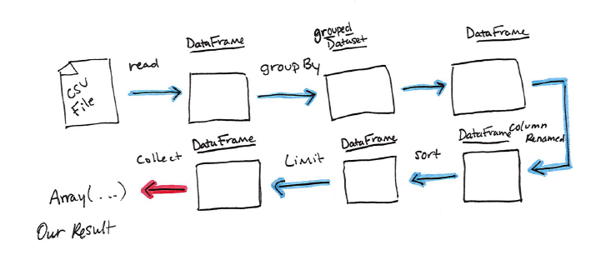
The first step is to read in the data. We defined the DataFrame previously but, as a reminder, Spark does not actually read it in until an action is called on that DataFrame or one derived from the original DataFrame.
The second step is our grouping, technically when we call “groupBy” we end up with a RelationalGroupedDataset which is a fancy name for a DataFrame that has a grouping specified but needs a user to specify an aggregation before it can be queried further. We can see this by trying to perform an action on it (which will not work). We still haven’t performed any computation (besides relational algebra) - we’re simply passing along information about the layout of the data.
Therefore the third step is to specify the aggregation. Let’s use the sum aggregation method. This takes as input a column expression or simply, a column name. The result of the sum method call is a new dataFrame. You’ll see that it has a new schema but that it does know the type of each column. It’s important to reinforce (again!) that no computation has been performed. This is
simply another transformation that we’ve expressed and Spark is simply able to trace the type information we have supplied.
The fourth step is a simple renaming, we use the withColumnRenamed method that takes two arguments, the original column name and the new column name.
Of course, this doesn’t perform computation - this is just another transformation!
The fifth step sorts the data such that if we were to take results off of the top of the DataFrame, they would be the largest values found in the destination_total column.
You likely noticed that we had to import a function to do this, the desc function. You might also notice that desc does not return a string but a Column.
In general, many DataFrame methods will accept Strings (as column names) or Column types or expressions. Columns and expressions are actually the exact same thing The final step is just a limit. This just specifies that we only want five values.
This is just like a filter except that it filters by position (lazily) instead of by value. It’s safe to say that it basically just specifies a DataFrame of a certain size.
The last step is our action! Now we actually begin the process of collecting the results of our DataFrame above and Spark will give us back a list or array in the language that we’re executing. Now to reinforce all of this, let’s look at the explain plan for the above query.
flightData2015
.groupBy("DEST_COUNTRY_NAME")
.sum("count")
.withColumnRenamed("sum(count)", "destination_total")
.sort(desc("destination_total"))
.limit(5)
.explain()
== Physical Plan ==
//some plan
While this explain plan doesn’t match our exact “conceptual plan” all of the pieces are there. You can see the limit statement as well as the orderBy (in the first line). You can also see how our aggregation happens in two phases, in the partial_sum calls. This is because summing a list of numbers is commutative and Spark can perform the sum, partition by partition. Of course we can see how we read in the DataFrame as well.
You are now equipped with the Spark knowledge to writing your own Spark code. In the next chapter we will explore some of Spark’s more advanced features.

第一步是读取数据。我们之前定义了DataFrame，但是作为一个提醒，在DataFrame上调用一个动作或者从原始的DataFrame派生一个动作之前，Spark实际上并没有读取数据。
第二步是我们的分组，从技术上来说，当我们调用“groupBy”时，我们最终会得到一个RelationalGroupedDataset，它是一个有指定分组的DataFrame的fancy name，但需要一个用户来指定一个聚合，然后才能进一步查询。我们可以通过尝试对它执行一个行动来了解这一点(这不会起作用)。我们还没有执行任何计算(除了关系代数)——我们只是传递有关数据布局的信息。
因此，第三步是指定聚合。让我们使用sum聚合方法。这需要输入一个列表达式或简单的列名。sum方法调用的结果是一个新的DataFrame。您将看到它有一个新的模式，但是它知道每个列的类型。再次强调没有进行任何计算，这很重要。这只是我们所表达的另一个转换，Spark只是能够跟踪我们提供的类型信息。
当然，这并没有执行计算——这只是另一个转换!
第五个步骤对数据进行排序，如果我们将结果从DataFrame的顶部取出，它们将是在destination_total列中找到的最大值。
你可能注意到我们必须导入一个函数来做这个，desc函数。您可能还会注意到，desc并没有返回一个字符串，而是返回一个列。
通常，许多DataFrame方法将接受字符串(作为列名称)或列类型或表达式。列和表达式实际上是一样的，最后一步只是一个limit。它只是指定我们只需要5个值。
这就像一个过滤器，只是它按位置(惰性地)过滤，而不是按值过滤。可以肯定地说，它基本上只是指定了某个大小的DataFrame。
最后一步是行动!现在，我们实际上开始收集上面的DataFrame的结果，Spark将用我们正在执行的语言返回一个列表或数组。现在为了加深印象，让我们看一下上述查询的解释计划。
flightData2015
.groupBy("DEST_COUNTRY_NAME")
.sum("count")
.withColumnRenamed("sum(count)", "destination_total")
.sort(desc("destination_total"))
.limit(5)
.explain()
== Physical Plan ==
//some plan
虽然这个解释计划不符合我们的“概念计划”（指插图），但所有的部分都在那里。您可以看到极限语句以及orderBy(在第一行)。您还可以看到在partial_sum调用中，我们的聚合是如何在两个阶段发生的。这是因为求和的数字是可交换的，Spark可以执行求和，用分区划分。当然，我们也可以看到我们在DataFrame上的阅读方式。
您现在已经具备了编写自己的Spark代码的Spark知识。在下一章中，我们将探讨Spark的一些高级特性。

