第二章 结构化API概述

Spark’s Structured APIs
For our purposes there is a spectrum of types of data. The two extremes of the spectrum are structured and unstructured. Structured and semi-structured data refer to to data that have structure that a computer can understand relatively easily. Unstructured data, like a poem or prose, is much harder to a computer to understand. Spark’s Structured APIs allow for transformations and actions on structured and semi-structured data.

Spark的结构化的API
对我们的目的来说，有一系列的数据类型。这个系列的两个极端是结构化和非结构化的。结构化和半结构化数据是指计算机能够相对容易地理解的数据结构。非结构化的数据，就像一首诗或散文一样，很难让计算机理解。Spark的结构化API允许对结构化和半结构化数据进行转换和操作。
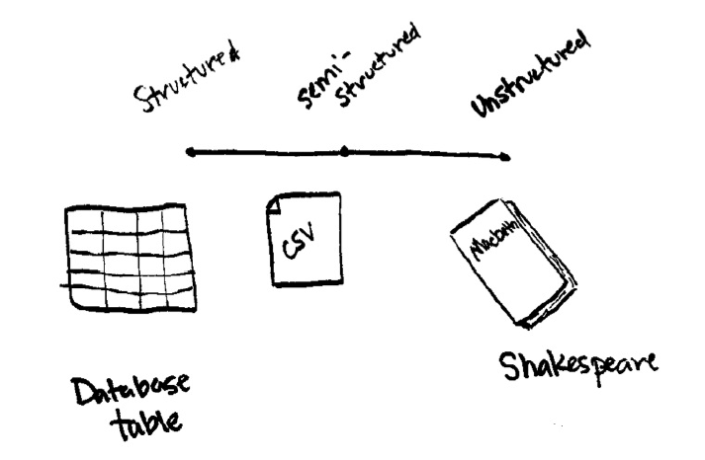
The Structured APIs specifically refer to operations on DataFrames, Datasets, and in Spark SQL and were created as a high level interface for users to manipulate big data. This section will cover all the principles of the Structured APIs. Although distinct in the book, the vast majority of these user-facing operations apply to both batch as well as streaming computation.
The Structured API is the fundamental abstraction that you will leverage to write your data flows. Thus far in this book we have taken a tutorial-based approach, meandering our way through much of what Spark has to offer. In this section, we will perform a deeper dive into the Structured APIs. This introductory chapter will introduce the fundamental concepts that you should understand: the typed and untyped APIs (and their differences); how to work with different kinds of data using the structured APIs; and deep dives into different data flows with Spark.
BOX
Before proceeding, let’s review the fundamental concepts and definitions that we covered in the previous section. Spark is a distributed programming model where the user specifies transformations, which build up a directed-acyclic-graph of instructions, and actions, which begin the process of executing that graph of instructions, as a single job, by breaking it down into stages and tasks to execute across the cluster. The way we store data on which to perform transformations and actions are DataFrames and Datasets. To create a new DataFrame or Dataset, you call a transformation. To start computation or convert to native language types, you call an action.

结构化API具体指的是DataFrames、Datasets和Spark SQL的操作，并被构建为高层次的接口供用户操作数据。本节将涵盖结构化API的所有概念。尽管有所不同，但是这些用户操作中绝大多数都同时适用于批处理和流式计算。
结构化API是您将用来编写数据流的基本抽象。到目前为止，在这本书中，我们采用了一种基于教程的方法，讲述了Spark提供的大部分方法。在本节中，我们将进一步深入研究结构化api。这个介绍章节将介绍您应该理解的基本概念:类型化和非类型化的API(及其差异);如何使用结构化api处理不同类型的数据;深入理解Spark的不同数据流。
BOX
在继续之前，让我们回顾一下前一节讨论的基本概念和定义。Spark是一种分布式编程模型，用户在其中指定一些转换指令（这些指令被转换为有向无环图）和一些行动指令（将会开启进程去执行指令图）作为一次作业，Spark将作业分解为多个阶段和任务，以便在集群中执行。我们执行转换和动作的数据存储在DataFrames和Datasets中。要创建新的DataFrame或Dataset，请调用转换。要开始计算或转换为原生语言类型，您需要调用一个动作。

DataFrames and Datasets
In Section I, we talked all about DataFrames. Spark has two notions of “structured” data structures: DataFrames and Datasets. We will touch on the (nuanced) differences shortly but let’s define what they both represent first.
To the user, DataFrames and Datasets are (distributed) tables with rows and columns. Each column must have the same number of rows as all the other columns (although you can use null to specify the lack of a value) and columns have type information that tells the user what exists in each column.
To Spark, DataFrames and Datasets represent by immutable, lazily evaluated plans that specify how to perform a series of transformations to generate the correct output. When we perform an action on a DataFrame we instruct Spark to perform the actual transformations that represent that DataFrame. These represent plans of how to manipulate rows and columns to compute the user’s desired result. Let’s go over rows and column to more precisely define those concepts.

DataFrames和数据集
在第一部分中，我们讨论了关于DataFrames的全部内容。Spark有两种“结构化”数据结构的概念:DataFrames和Datasets。我们将很快触及(细微的)差别，但让我们定义它们首先代表什么。
对于用户来说，DataFrames和Datasets是带有行和列的(分布式)表。每一列必须与所有其他列的行数相同(尽管可以使用null来指定值的缺失)，并且列有类型信息，告诉用户每个列中存在什么。
对于Spark，DataFrames和Datasets通过不可变的，惰性计算的计划来表示如何执行一系列转换来生成正确的结果。当我们在DataFrame上执行一个行动操作时，Spark才执行DataFrame的实际转换。这些代表了如何操作行和列来计算用户期望结果的计划。让我们通过行和列来更精确地定义这些概念。

Schemas
One core concept that differentiates the Structured APIs from the lower level APIs is the concept of a schema. A schema defines the column names and types of a DataFrame. Users can define schemas manually or users can read a schema from a data source (often called schema on read). Now that we know what defines DataFrames and Datasets and how they get their structure, via a Schema, let’s see an overview of all of the types.

模式（Schemas）
将结构化api与低级api区分开来的一个核心概念是模式的概念。模式定义了DataFrame的列名和类型。用户可以手动定义模式，或者用户可以从数据源读取模式(通常称为“读时模式”)。现在我们已经知道什么定义了DataFrames和Datasets，以及它们如何通过一个模式来获得它们的结构，让我们来看看所有类型的概述。

Overview of Structured Spark Types
Spark is effectively a programming language of its own. When you perform operations with Spark, it maintains its own type information throughout the process. This allows it to perform a wide variety of optimizations during the execution process. These types correspond to the types that Spark connects to in each of Scala, Java, Python, SQL, and R. Even if we use Spark’s Structured APIs from Python, the majority of our manipulations will operate strictly on Spark types, not Python types. For example, the below code does not perform addition in Scala or Python, it actually performs addition purely in Spark.
%scala
val df = spark.range(500).toDF("number")
df.select(df.col("number") + 10)
// org.apache.spark.sql.DataFrame = [(number + 10): bigint]
%python
df = spark.range(500).toDF("number")
df.select(df["number"] + 10)
# DataFrame[(number + 10): bigint]
This is because, as mentioned, Spark maintains its own type information, stored as a schema, and through some magic in each languages bindings, can convert an expression in one language to Spark’s representation of that.
NOTE
There are two distinct APIs within the In the Structured APIs. There is the API that goes across languages, more commonly referred to as the DataFrame or “untyped API”. THe second API is the “typed API” or “Dataset API”, that is only available to JVM based languages (Scala and Java). This is a bit of a misnomer because the “untyped API” does have types but it only operates on Spark types at run time. The “typed API” allows you to define your own types to represent each record in your dataset with “case classes or Java Beans” and types are checked at compile time. Each record (or row) in the “untyped API” consists of a Row object that are available across languages and still have types, but only Spark types, not native types. The “typed API” is covered in the Datasets Chapter at the end of Section II. The majority of Section II will cover the “untyped API” however all of this still applies to the “typed API”.
Notice how the following code produces a Dataset of type Long, but also has an internal Spark type (bigint).
%scala
spark.range(500)
Notice how the following code produces a DataFrame with an internal Spark
type (bigint).
%python
spark.range(500)

结构Spark类型的概述
Spark实际上是一种自己的编程语言。当您使用Spark执行操作时，它在整个过程中维护自己的类型信息。这允许它在执行过程中执行各种各样的优化。这些类型对应于Spark在Scala，Java，Python，SQL和R中的每个类型。即我们使用Python的Spark结构化api，我们大多数操作将严格按照Spark类型操作，而不是Python类型。例如，下面的代码不会在Scala或Python中执行加法，它实际上只在Spark中执行加法。
%scala
val df = spark.range(500).toDF("number")
df.select(df.col("number") + 10)
// org.apache.spark.sql.DataFrame = [(number + 10): bigint]
%python
df = spark.range(500).toDF("number")
df.select(df["number"] + 10)
# DataFrame[(number + 10): bigint]
这是因为，正如前面提到的，Spark用模式来维护自己的类型信息，并且通过每种语言绑定中的某种魔法，可以将一种语言的表达式转换为Spark的表示形式。
Note
在结构化API中有两个不同的API。有一个跨语言的API，通常被称为DataFrame或“非类型化的API”。第二个API是“类型化的API”或“Dataset API”，只适用于基于JVM的语言(Scala和Java)。这有点用词不当，因为“非类型化API”确实有类型，但它只在运行时对Spark类型进行操作。“类型化API”允许您定义您自己的类型，以在您的数据集中以“case class或Java Bean”来表示每个记录，并且在编译时检查类型。“非类型化API””中的每个记录（或行）都由一个Row对象组成，这些Row对象可以跨语言使用，并且仍然有类型，但只有Spark类型，而不是原生类型。 “类型化的API”在第二部分末尾的“Dataset”一章中进行了介绍。第二部分的大部分内容将涵盖“非类型化API”，但所有这些仍然适用于“类型化API”。
注意下面的代码如何生成Long类型的数据集，但也有一个内部Spark类型(bigint)。
%scala
spark.range(500)
注意以下代码如何使用内部Spark类型(bigint)生成DataFrame。
%python
spark.range(500)

Columns
For now, all you need to understand about columns is that they can represent a simple type like an integer or string, a complex types like an array or map, or a null value. Spark tracks all of this type information to you and has a variety of ways that you can transform columns. Columns are discussed extensively in the next chapter but for the most part you can think about Spark Column types as columns in a table.

列
现在，关于列你需要了解的是，他们可以表示一个简单的类型，如一个整数或字符串，或表示一个复杂的类型，如数组或映射，或空值。 Spark跟踪所有这些类型的信息，并有多种方式对列进行转换。 列将在下一章中详细讨论，但大多数情况下，您可以将Spark列类型视为表中的列。

Rows
There are two ways of getting data into Spark, through Rows and Encoders.
Row objects are the most general way of getting data into, and out of, Spark and are available in all languages. Each record in a DataFrame must be of Row type as we can see when we collect the following DataFrames.
%scala
spark.range(2).toDF().collect()
%python
spark.range(2).collect()

行
Spark有两种获取数据的途径，分别是通过Row和Encoder对象。
Row对象是获取数据的最一般的方式，并且在所有语言中都可以使用。DataFrame中的每个记录都必须是行类型，正如我们在收集下列DataFrames时所能看到的那样。
% scala
spark.range(2).toDF().collect()
% python
spark.range(2).collect()

Spark Value Types
On the next page you will find a large table of all Spark types along with the corresponding language specific types. Caveats and details are included for the reader as well to make it easier to reference.
To work with the correct Scala types:
import org.apache.spark.sql.types._
val b = ByteType()
To work with the correct Java types you should use the factory methods in the following package:
import org.apache.spark.sql.types.DataTypes;
ByteType x = DataTypes.ByteType();
Python types at time have certain requirements (like the listed requirement for ByteType below.To work with the correct Python types:
from pyspark.sql.types import *
b = byteType()
SparkType ScalaValueType ScalaAPI
ByteType Byte ByteType
ShortType Short ShortType
IntegerType Int IntegerType
LongType Long LongType
FloatType Float FloatType
DoubleType Double DoubleType
DecimalType java.math.BigDecimal DecimalType
StringType String StringType
BinaryType Array[Byte] BinaryType
TimestampType java.sql.Timestamp TimestampType
DateType java.sql.Date DateType
ArrayType scala.collection.Seq ArrayType(elementType, [valueContainsNull]) **
MapType scala.collection.Map MapType(keyType, valueType, [valueContainsNull]) **
StructType org.apache.spark.sql.Row StructType(Seq(StructFields))*
StructField StructField with DataType contents StructField(name, dataType, nullable)
Numbers will be converted to 1-byte signed integer numbers at runtime.
Make sure that numbers are within the range of -128 to 127.
Numbers will be converted to 2-byte signed integer numbers at runtime. Please make sure that numbers are within the range of -32768 to 32767.
Numbers will be converted to 8-byte signed integer numbers at runtime. Please make sure that numbers are within the range of -9223372036854775808 to 9223372036854775807.
Otherwise, please convert data to decimal.Decimal and use DecimalType.
valueContainsNull is true by default.
No two fields can have the same name.

Spark Value Type
在下一页中，您将找到所有Spark类型以及相应的语言特定类型的表。还有一些附加说明和详细信息，便于读者参考。
要使用正确的Scala类型:
import org.apache.spark.sql.types._
val b = ByteType()
要使用正确的Java类型，您应该在以下包中使用工厂方法:
import org.apache.spark.sql.types.DataTypes;
ByteType x = DataTypes.ByteType();
Python类型在时间上有一定的要求(比如下面的ByteType列出的要求)。要使用正确的Python类型:
from pyspark.sql.types import *
b = byteType()

SparkType ScalaValueType ScalaAPI
ByteType Byte ByteType
ShortType Short ShortType
IntegerType Int IntegerType
LongType Long LongType
FloatType Float FloatType
DoubleType Double DoubleType
DecimalType java.math.BigDecimal DecimalType
StringType String StringType
BinaryType Array[Byte] BinaryType
TimestampType java.sql.Timestamp TimestampType
DateType java.sql.Date DateType
ArrayType scala.collection.Seq ArrayType(elementType, [valueContainsNull]) **
MapType scala.collection.Map MapType(keyType, valueType, [valueContainsNull]) **
StructType org.apache.spark.sql.Row StructType(Seq(StructFields))*
StructField StructField with DataType contents StructField(name, dataType, nullable)

Data Types
Spark SQL and DataFrames support the following data types:
- Numeric types
  - ByteType: Represents 1-byte signed integer numbers. The range of numbers is from -128 to 127.
  - ShortType: Represents 2-byte signed integer numbers. The range of numbers is from -32768 to 32767.
  - IntegerType: Represents 4-byte signed integer numbers. The range of numbers is from -2147483648 to 2147483647.
  - LongType: Represents 8-byte signed integer numbers. The range of numbers is from -9223372036854775808 to 9223372036854775807.
  - FloatType: Represents 4-byte single-precision floating point numbers.
  - DoubleType: Represents 8-byte double-precision floating point numbers.
  - DecimalType: Represents arbitrary-precision signed decimal numbers. Backed internally by java.math.BigDecimal. A BigDecimal consists of an arbitrary precision integer unscaled value and a 32-bit integer scale.
- String type
  - StringType: Represents character string values.
- Binary type
  - BinaryType: Represents byte sequence values.
- Boolean type
  - BooleanType: Represents boolean values.
- Datetime type
  - TimestampType: Represents values comprising values of fields year, month, day, hour, minute, and second.
  - DateType: Represents values comprising values of fields year, month, day.
- Complex types
  - ArrayType(elementType, containsNull): Represents values comprising a sequence of elements with the type of elementType.containsNull is used to indicate if elements in a ArrayType value can have null values.
  - MapType(keyType, valueType, valueContainsNull): Represents values comprising a set of key-value pairs. The data type of keys are described by keyType and the data type of values are described by valueType. For a MapType value, keys are not allowed to have nullvalues. valueContainsNull is used to indicate if values of a MapType value can have null values.
  - StructType(fields): Represents values with the structure described by a sequence of StructFields (fields).
    - StructField(name, dataType, nullable): Represents a field in a StructType. The name of a field is indicated by name. The data type of a field is indicated by dataType. nullable is used to indicate if values of this fields can have null values.
以上类型描述来自官方文档，以替代Spark权威指南中对应部分。

http://spark.apache.org/docs/latest/sql-programming-guide.html#untyped-user-defined-aggregate-functions
--> Reference --> Data Types

Encoders
Using Spark from Scala and Java allows you to define your own JVM types to use in place of Rows that consist of the above data types. To do this, we use an Encoder. Encoders are only available in Scala, with case classes, and Java, with JavaBeans. For some types, like Long, Spark already includes an Encoder. For instance we can collect a Dataset of type Long and get native Scala types back. We will cover encoders in the Datasets chapter.
spark.range(2).collect()

Encoders
使用Scala和Java的Spark，您可以定义自己的JVM类型，以替代包含上述数据类型的Row类。为此，我们使用Encoder。Encoder只能在Scala中的case class和Java的JavaBean上使用。对于某些类型，比如Long，Spark已经包含了Encoder。例如，我们可以收集Long类型的Dataset，并返回本地的Scala类型。我们将在Datasets的章节中讨论Encoder。
spark.range(2).collect()

Overview of Spark Execution
In order to help you understand (and potentially debug) the process of writing and executing code on clusters, let’s walk through the execution of a single structured API query from user code to executed code. As an overview the steps are:
1. Write DataFrame/Dataset/SQL Code
2. If valid code, Spark converts this to a Logical Plan
3. Spark transforms this Logical Plan to a Physical Plan
4. Spark then executes this Physical Plan on the cluster
To execute code, we have to write code. This code is then submitted to Spark either through the console or via a submitted job. This code then passes through the Catalyst Optimizer which decides how the code should be executed and lays out a plan for doing so, before finally the code is run and the result is returned to the user.

Overview of Spark Execution
为了帮助您理解(并可能调试)在集群上编写和执行代码的过程，let’s walk through the execution of a single structured API query from user code to executed code.作为概述，步骤是:
1 .编写DataFrame /Dataset/ SQL代码
2。如果是有效的代码，Spark将其转换为一个逻辑计划
3 .Spark将此逻辑计划转换为物理计划
4。Spark在集群上执行这个物理计划
要执行代码，我们必须编写代码。然后，通过控制台或通过一个作业来提交此代码。然后，该代码经过Catalyst优化器，该优化器决定如何执行代码，并为此制定计划，最后运行代码并将结果返回给用户。
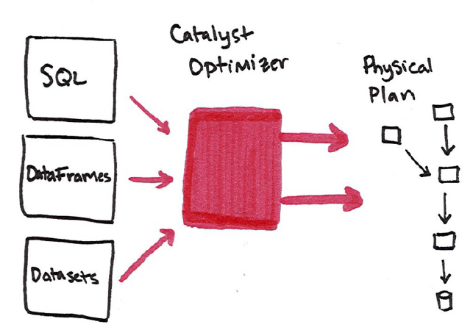

Logical Planning
The first phase of execution is meant to take user code and convert it into a logical plan. This process in illustrated in the next figure.

逻辑计划
执行的第一个阶段是将用户代码转换成逻辑计划。在下一个图中说明了这个过程。
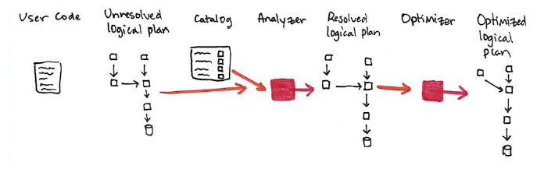
This logical plan only represents a set of abstract transformations that do not refer to executors or drivers, it’s purely to convert the user’s set of expressions into the most optimized version. It does this by converting user code into an unresolved logical plan. This unresolved because while your code may be valid, the tables or columns that it refers to may or may not exist. Spark uses the catalog, a repository of all table and DataFrame information, in order to resolve columns and tables in the analyzer. The analyzer may reject the unresolved logical plan if it the required table or column name does not exist in the catalog. If it can resolve it, this result is passed through the optimizer, a collection of rules, which attempts to optimize the logical plan by pushing down predicates or selections.

这个逻辑计划仅代表一组抽象的转换操作，不涉及executor或driver，它纯粹是将用户的表达式转换成最优的版本。它是通过将用户代码转换成未执行的逻辑计划来实现的。这个未执行是因为，虽然代码可能是有效的，但它引用的表或列可能不存在。Spark使用一个存放所有表和DataFrame信息的目录（catalog）、以解析分析器中的列和表。如果目录中不存在所需的表或列名，分析器可能会拒绝未执行的逻辑计划。如果它能够执行这个计划，那么这个结果就会通过优化器(一组规则)传递，这些规则试图通过按谓词推入（pushing down predicates ，应该是和SQL优化相关的概念）或选择（selection）来优化逻辑计划。

Physical Planning
After successfully creating an optimized logical plan, Spark then begins the physical planning process. The physical plan, often called a Spark plan, specifies how the logical plan will execute on the cluster by generating different physical execution strategies and comparing them through a cost model. An example of the cost comparison might be choosing how to perform a given join by looking at the physical attributes of a given table (how big the table is or how big its partitions are.)

物理规划
在成功地创建了一个优化的逻辑计划之后，Spark就开始了物理计划过程。物理计划(通常称为Spark plan)通过生成不同的物理执行策略并通过成本模型进行比较这些不同的执行策略，来指定逻辑计划在集群上的执行方式。成本比较的一个例子是选择通过查看给定表的物理属性来执行给定的连接操作(表的大小或其分区有多大)。

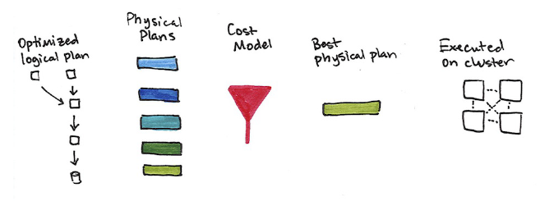
Physical planning results in a series of RDDs and transformations. This result is why you may have heard Spark referred to as a compiler, it takes queries in DataFrames, Datasets, and SQL and compiles them into RDD transformations for you.

物理计划产生了一系列的RDD（这是因为RDD是不可变的，每一次转换会生成新的RDD）和转换。 这个结果就是为什么你可能听说Spark被称为编译器，它需要在DataFrames，Datasets和SQL中进行查询，并将它们编译为RDD转换。

Execution
Upon selecting a physical plan, Spark runs all of this code over RDDs, the lower-level programming interface of Spark covered in Part III. Spark performs further optimizations by, at runtime, generating native Java Bytecode that can remove whole tasks or stages during execution. Finally the result is returned to the user.

执行
在选择物理计划之后，Spark将所有这些代码运行在第三部分所述的Spark的底层编程接口RDD上。 Spark在运行时执行进一步的优化，生成本地Java字节码，可以在执行期间删除整个任务或阶段。 最后将结果返回给用户。

