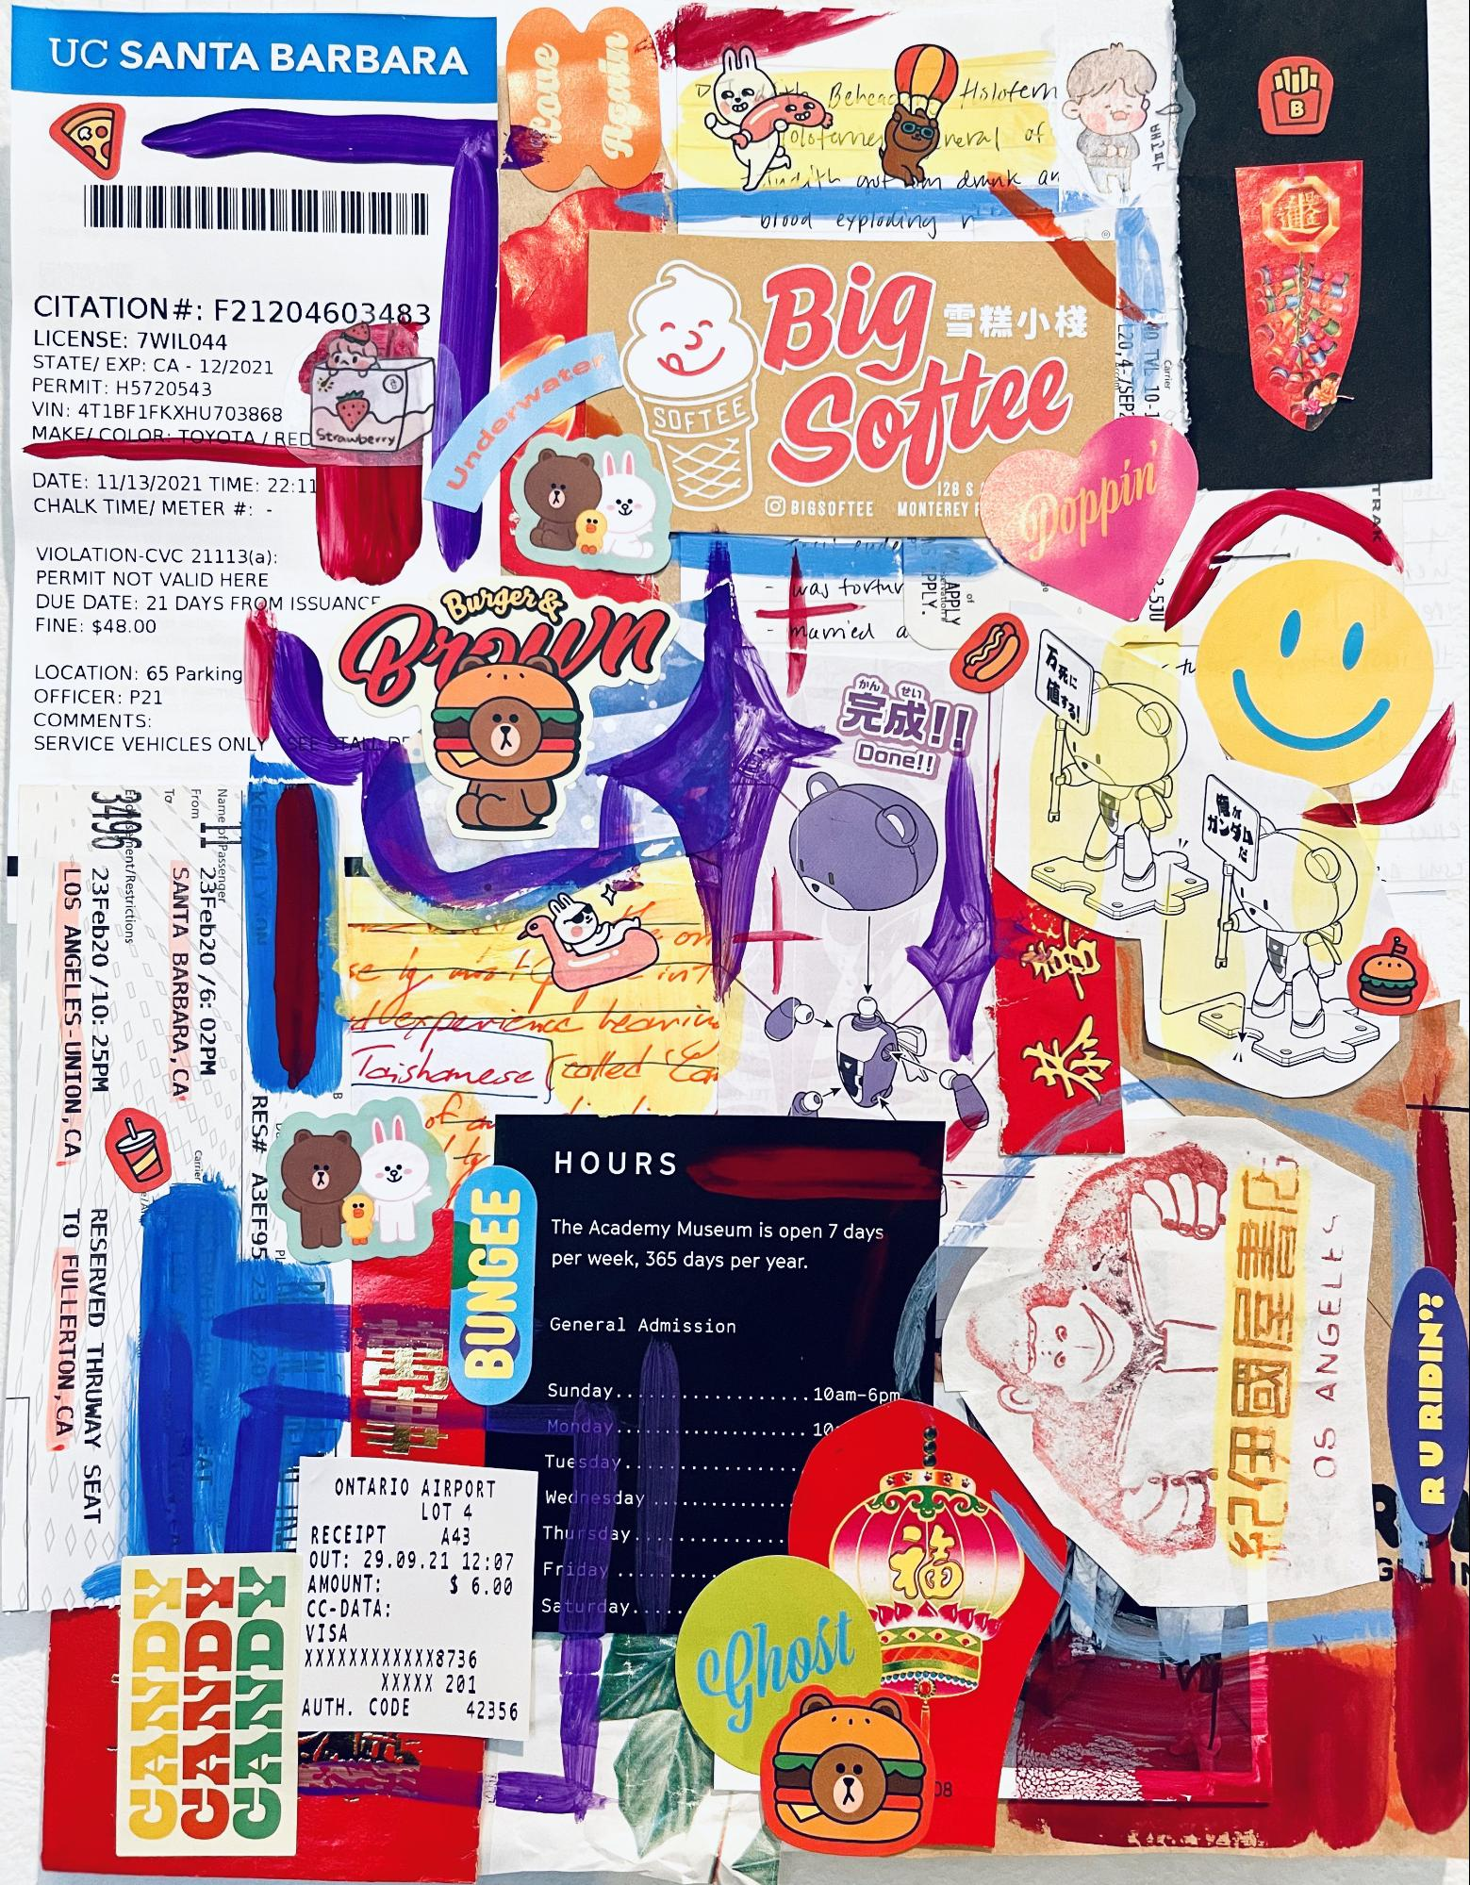

UC SANTA BARBARA

*60*

the Beheach ☆ Polofernes

Hsloten neral of

**BO**

배고파

kort

th anten drunk

an

*οι ουο*

*έγριαλινικη*

γ

CITATION#: F21204603483 LICENSE: 7 WIL044 STATE) EXP: CA - 12/2021 PERMIT: 15720543 VIN: 4T1BF1FKXHU703868 MAKELCOLOR: TOYOTA RED Strawberry

*BUG =*

L20,4-7SEP 80 TVL 10-1

Carrier

*FEE*

*Soitee*

DATE: 11/13/2021 TIME: 22:11 CHALK TIME/ METER #: -

128 S © BIGSOFTEE MONTEREY I

TRAK

VIOLATION-CVC 21113(a): PERMIT NOT VALID HERE DUE DATE: 21 DAYS FROM ISSUANCE FINE: $48.00

- was tortur

PPLY. APPLY

of

2-5JU

mamed

**「かん**

**tin**

LOCATION: 65 Parking OFFICER: P21 COMMENTS: SERVICE VEHICLES ONLY SENS

**Done!!**

From

A

Name þf Passenger

KEE JALLE

ON

fent/Restrictions

23 Feb20 /10: 25PM LOS ANGELES - UNION, CA,

=

SANTA BARBARA, CA 23 Feb20 /6:02PM

rania

*COM*

namese (totes

Carrier

HOURS

**RES# A3EF95 23**

***AR***

The Academy Museum is open 7 days per week, 365 days per year.

BUNGEE WAT

PLES

TO FULLERTON, CA RESERVED THRUWAY SEAT

General Admission

DE 24

57139NV SO

. . . . . . . . 10am-6pm

Sunday.. Monday.....

**RU RIDIN?**

.......10

Tuesday....

Wednesday ..

*CR*

Thursday..!

**.**

**.**

**.**

Friday ....

ONTARIO AIRPORT

*LOT 4 RECEIPT A43 OUT: 29.09.21 12:07 AMOUNT: $ 6.00 CC-DATA: VISA XXXXXXXXXXXX8736*

*XXXXX 201 AUTH. CODE 42356*

Saturday....

CANDY CANDY