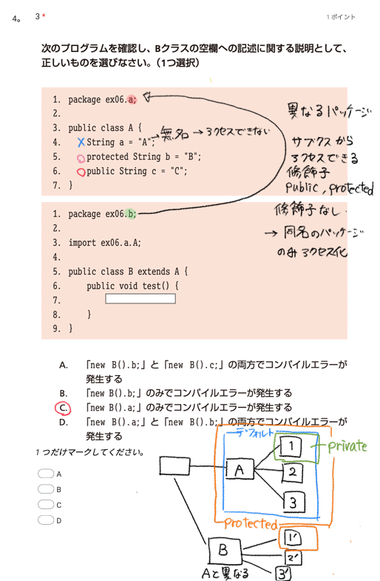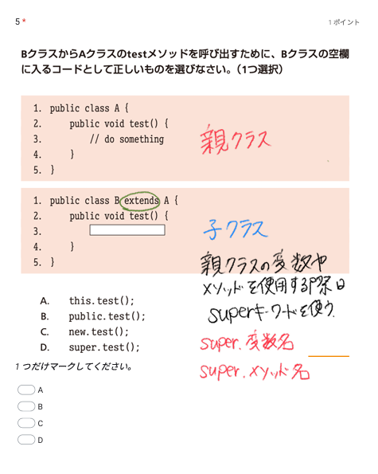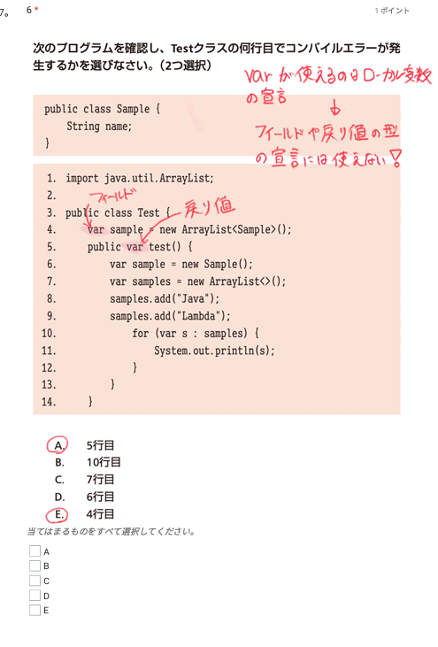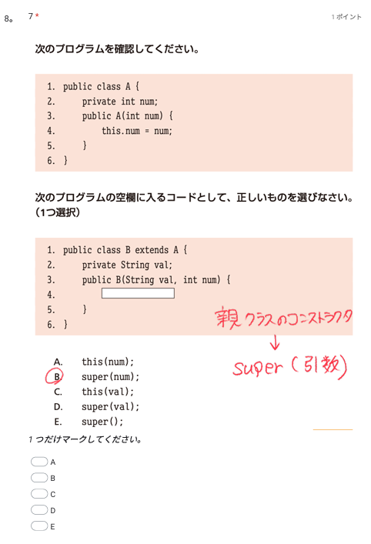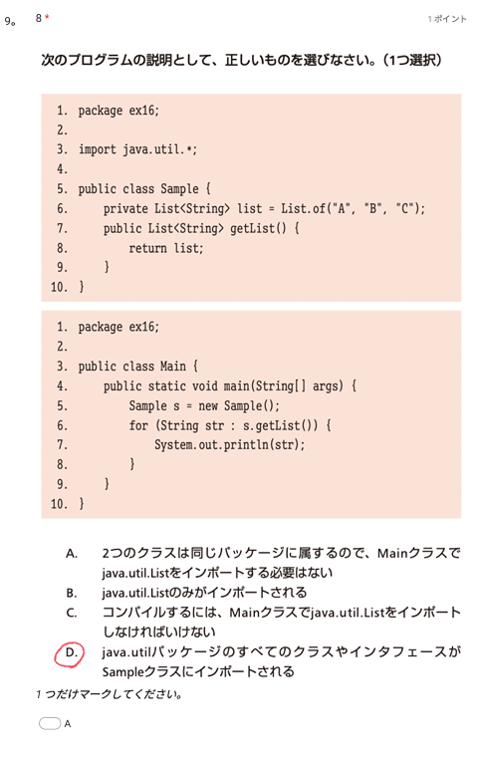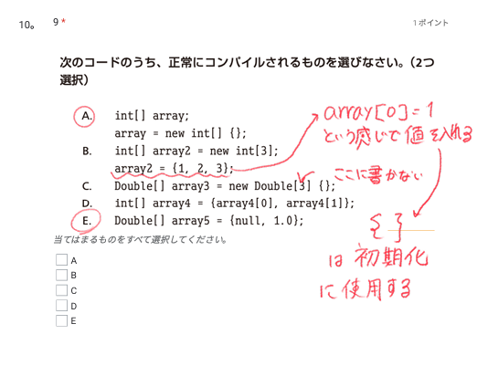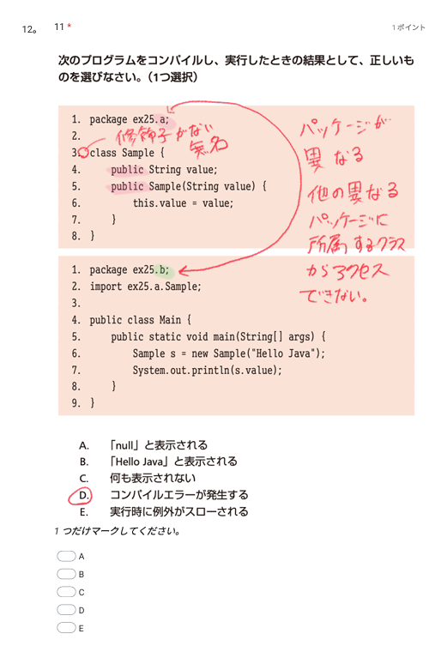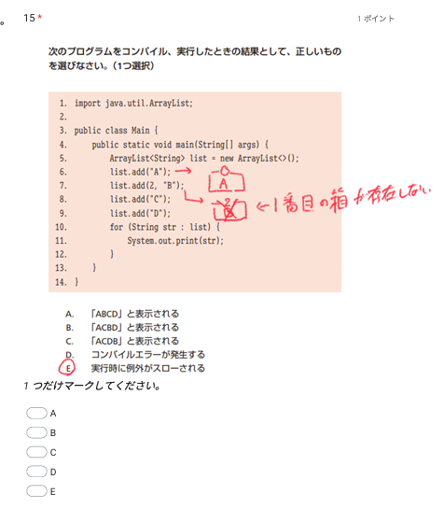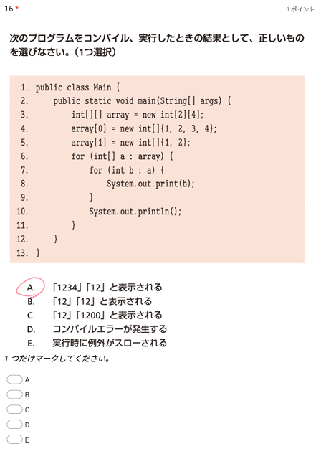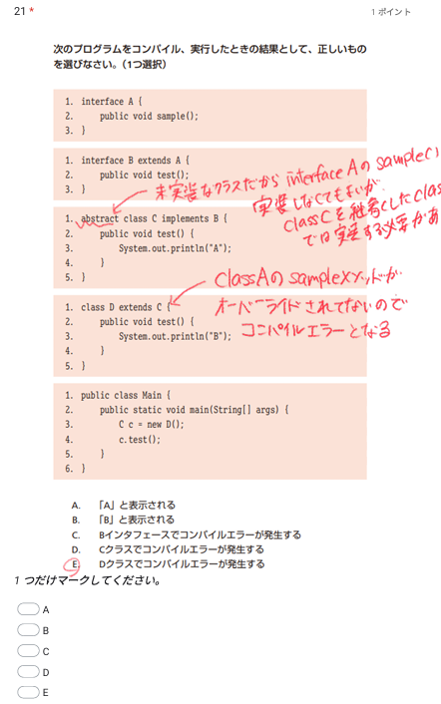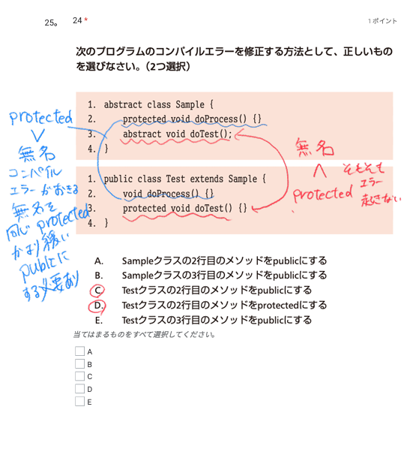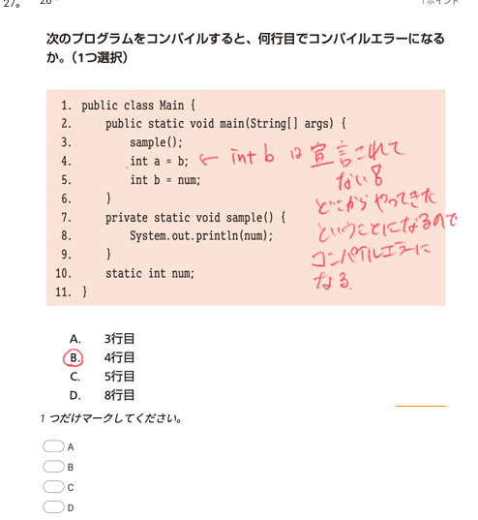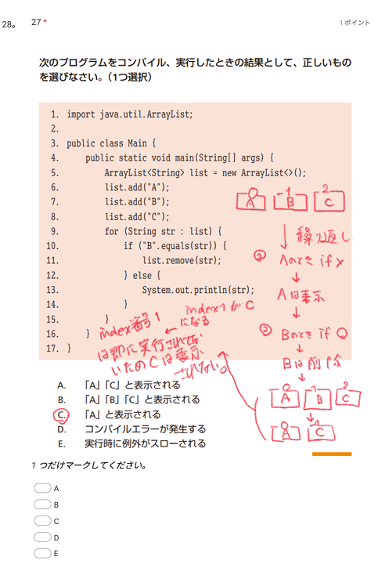

P1
import java.util.ArrayList;
import java.util.List;
import java.util.stream.Collectors;

public class Main {

public static void main(String[] args) {
List<Student>student = new ArrayList<>();
student.add(new Student("Alice",15,60));
student.add(new Student("Takuya",12,90));
student.add(new Student("Ryo",25,34));
student.add(new Student("Suzanu",18,20));

System.out.println(
student.stream()
.filter(e->e.getScore()<60)
.sorted((s1,s2)->s2.getScore()-s1.getScore())
.collect(Collectors.toList())
);
}
}
public class Student {

private String name;
private int age;
private int score;

public Student(String name, int age, int score) {
this.name = name;
this.age = age;
this.score = score;
}

public String getName() {
return name;
}
public void setName(String name) {
this.name = name;
}

public int getAge() {
return age;
}

public void setAge(int age) {
this.age = age;
}

public int getScore() {
return score;
}

public void setScore(int score) {
this.score = score;
}

@Override
public String toString() {
return "Student [name=" + name + ", age=" + age + ", score=" + score + "]";
}

}

P2
import java.io.BufferedReader;
import java.io.BufferedWriter;
import java.io.File;
import java.io.FileNotFoundException;
import java.io.FileReader;
import java.io.FileWriter;
import java.io.IOException;

public class Main {

public static void main(String[] args) {
File file = new File("nikujaga.txt");

if(!file.exists()) {
try {
file.createNewFile();
} catch (IOException e) {
e.printStackTrace();
}
}else {
System.out.println(file.length());
}

try ( // ファイルに接続する Writer を作成する
FileWriter fileWriter = new FileWriter(file);
BufferedWriter writer = new BufferedWriter(fileWriter)
) {
// 文字列をファイルに出力する
writer.write("carrot");
writer.newLine();
writer.write("potato");
writer.newLine();
writer.write("meat");
writer.newLine();
writer.write("onion");
writer.newLine();
} catch (FileNotFoundException e) {
System.out.println("Cannot open file: " + file);
} catch (IOException e) {
System.out.println("Cannot write file: " + file);
}

try ( // ファイルに接続する Reader を作成する
FileReader fileReader = new FileReader(file);
BufferedReader reader = new BufferedReader(fileReader)
) {
String line = reader.readLine();
while(line != null) {
System.out.println(line);
line = reader.readLine();
}
} catch (FileNotFoundException e) {
System.out.println("Cannot open file: " + file);
} catch (IOException e) {
System.out.println("Cannot read file: " + file);
}

}

}

