Machine Learning Programming Assignment 4
Comp540 Spring 2015 due 20 March 2015 at 8 pm

Introduction

Net ID:mw56&hz32

In this problem, you will implement one-vs-all logistic regression and neural networks to recognize hand-written digits. To get started, please download the code base pa5.zip from Owlspace. When you unzip the archive, you will see the following files.

Problem 1: Multi-class classification (20 points)

Once you are done, ex4.m will call your predictOneVsAll function using the learned value of Θ. You should see that the training set accuracy is about 95.96%

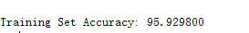

Problem 2: Neural networks (10 points)

Once you are done, ex4 nn.m will call your predict function using the loaded set of parameters for
Theta1 and Theta2. You should see that the accuracy is about 97.52%.
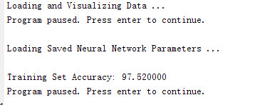

Problem 3: Neural network learning (30 points)

Once you are done, ex4 nnlearn.m will call your nnCostFunction using the loaded set of param- eters for Theta1 and Theta2. You should see that the cost is about 0.287629.

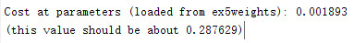

Regularized cost function (5 points)

Once you are done, ex4 nnlearn.m will call your nnCostFunction using the loaded set of parameters for Theta1 and Theta2, and λ = 1. You should see that the cost is about 0.383770.

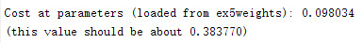

Backpropagation

In this part of the exercise, you will implement the backpropagation algorithm to compute the gradient for the neural network cost function. You will need to complete the nnCostFunction.m so that it returns an appropriate value for grad. Once you have computed the gradient, you

Sigmoid gradient (5 points)

To help you get started with this part of the exercise, you will first implement the sigmoid gradient function. The gradient for the sigmoid function can be computed as

where

gg(z) =
d
dz g(z) = g(z)(1 − g(z))

1

sigmoid(z) = g(z) =

1 + e−z

When you are done, try testing a few values by calling sigmoidGradient(z) at the Matlab com- mand line. For large values (both positive and negative) of z, the gradient should be close to
0. When z = 0, the gradient should be exactly 0.25. Your code should also work with vectors and matrices. For a matrix, your function should perform the sigmoid gradient function on every element.
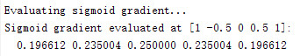

Random initialization

When training neural networks, it is important to randomly initialize the parameters for symmetry breaking. One effective strategy for random initialization is to randomly select values for Θ(l) uniformly in the range [−Einit, +Einit]. You should use Einit = 0.12. This range of values ensures that the parameters are kept small and makes the learning more efficient. We have implemented this procedure in randInitializeWeights.m.

The backpropagation algorithm (10 points)

. If your backpropagation implementation is correct, you should see a relative difference that is less than 1e-9.

Regularized neural networks (5 points)

After you have successfully implemeted the backpropagation algorithm, you will add regularization to the gradient. To account for regularization, it turns out that you can add this as an additional term after computing the gradients using backpropagation.
Specifically, after you have computed ∆(l) using backpropagation, you should add regularization
ij

Note that you should not be regularizing the first column of Θ(l) which is used for the bias term. Now modify your code that computes grad in nnCostFunction to account for regularization. After
you are done, the ex4 nnlearn.m script will proceed to run gradient checking on your implemen-
tation. If your code is correct, you should expect to see a relative difference that is less than
1e-9.
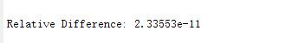

Cost at (fixed) debugging parameters (w/ lambda = 10): 0.576051
(this value should be about 0.576051)

Learning parameters using fmincg

After you have successfully implemented the neural network cost function and gradient computa- tion, the next step of the ex4 nnlearn.m script will use fmincg to learn a good set parameters. After the training completes, the ex4 nnlearn.m script will proceed to report the training accuracy of your classifier by computing the percentage of examples it got correct. If your implementation is correct, you should see a reported training accuracy of about 95.3% (this may vary by about 1% due to the random initialization). It is possible to get higher training accuracies by training theneural network for more iterations. We encourage you to try training the neural network for mo1r1e iterations (e.g., set MaxIter to 400) and also vary the regularization parameter λ. With the right learning settings, it is possible to get the neural network to perfectly fit the training set.

Lamba=0.1 MaxIter=50
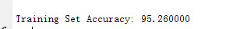

Visualizing the hidden layer

One way to understand what your neural network is learning is to visualize what the representations captured by the hidden units. Informally, given a particular hidden unit, one way to visualize what it computes is to find an input x that will cause it to activate (that is, to have an activation value a(l) close to 1). For the neural network you trained, notice that the ith row of Θ(1) is a 401-dimensional vector that represents the parameter for the ith hidden unit. If we discard the bias term, we get a 400 dimensional vector that represents the weights from each input pixel to the hidden unit. Thus, one way to visualize the representation captured by the hidden unit is to reshape this 400 dimensional vector into a 20 × 20 image and display it. The next step of ex4 nnlearn.m does this by using the displayData function and it will show you an image (similar to Figure 3) with 25 units, each corresponding to one hidden unit in the network. In your trained network, you should find that the hidden units corresponds roughly to detectors that look for strokes and other patterns in the input.
i

Varying λ and Maxiter

Now you can try out different learning settings for the neural network to see how the performance of the neural network varies with the regularization parameter λ and number of training steps (the MaxIter option when using fmincg). Neural networks are very powerful models that can form highly complex decision boundaries. Without regularization, it is possible for a neural network to overfit a training set so that it obtains close to 100% accuracy on the training set but does not as well on new examples that it has not seen before. You can set the regularization λ to a smaller value and the MaxIter parameter to a higher number of iterations to see this for youself. You will also be able to see for yourself the changes in the visualizations of the hidden units when you change the learning parameters λ and MaxIter.

Lamba=0.01 MaxIter =100

Training Set Accuracy: 99.180000

Lamba=0.001 MaxIter =150
Training Set Accuracy: 99.480000

What to turn in

Please zip up all the files in the archive (including files that you did not modify) and submit it as pa4 netid.zip on Owlspace before the deadline. Include a PDF file in the archive that presents your plots and your discussion of results from the problems above.

Acknowledgment

These problems are from Andrew Ng’s exercise on logistic regression and neural nets.
12

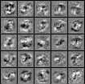

Figure 3: Visualization of hidden units

