Stagnone di Marsala — Digital Twin
Internal technical progress report — v1

Compiled on: 2026-04-15
Cicero Martins Jr — Università degli Studi di Palermo

Scope: 3D coupled wave-hydrodynamic modeling (D-Flow FM + SWAN) of a shallow hypersaline Mediterranean lagoon, deployed as a digital twin on the EDITO Datalab.

Table of contents
[In Word: Insert → Table of Contents → Automatic Table 1. Right-click → Update Field after editing.]

1. Executive summary
This report documents ~2 weeks of work building a 3D coupled wave-hydrodynamic digital twin of the Stagnone di Marsala lagoon (Sicily, Italy), targeting the EDITO Datalab for production runs.

Problem
The Stagnone di Marsala is a shallow (0.5–2 m) hypersaline (~42 psu) Mediterranean lagoon supporting Posidonia/Cymodocea seagrass meadows. Despite microtidal forcing, the lagoon exhibits significant vertical flow structure driven by wind — a feature that demands 3D modeling. Previous work had a modelbuilder-generated configuration that did not run; open questions about residence time, inlet exchange, seagrass drag, and turbidity plumes from adjacent canals motivate this digital twin.

Approach
Starting from the Model B reference (dfm_tools modelbuilder), we progressively built three model versions: v01 (baseline, fixed to run), v02 (calibration corrections for datum, drying, wind), v03 (waves, residence-time tracer, hypersaline initial condition). Work is organized across 13 operational Jupyter notebooks covering mesh evaluation, in-situ QC, satellite roughness, model build, calibration, diagnostics, particle tracking, residence time, and EDITO post-processing.

Current status
v01 complete locally. v02 running on EDITO (after a local power-outage incident prompted migration). v03 built and pending v02 validation. EDITO workflow operational: S3 upload of inputs (~140 MB), container-based execution via delft3dfm_run_docker (2D3D-HMWQ variant), streaming post-processing via s3fs (no 16 GB map.nc download required).

Next steps
Validate v02 outputs; build v03 and run short sanity check; download extended CMEMS/ERA5 for the ≥30-day residence-time run; verify pod CPU allocation for parallel (nPart=4) execution on EDITO; run particle tracking against the July 2025 drifter campaign; tune wind drag if surface drift is underpredicted.

2. Introduction

2.1 Site description
The Stagnone di Marsala is a shallow coastal lagoon on Sicily's western coast (center ~37.86°N, 12.46°E), with an area of ~12 km² and water depths of 0.5–2 m. The tidal range is microtidal (~0.2–0.3 m). Two inlets connect the lagoon to the open Mediterranean: Boca Nord (shallow, ~0.3 m) and Boca Sud (deeper, ~1.5 m). The lagoon is a protected area with extensive seagrass cover (Posidonia oceanica and Cymodocea nodosa) and is characterized as hypersaline: interior salinity ~42 psu vs offshore Mediterranean ~37.5 psu. Despite its shallow depth, significant vertical flow structure is observed — wind-driven surface currents contrasting with bottom currents (evidenced by plant orientation).

2.2 Research questions
The digital twin is designed to address five interconnected questions:
- What is the 3D vertical flow structure of the lagoon, and how is it driven by wind forcing?
- What is the characteristic residence time of lagoon water, and how does it vary with wind regimes?
- How do the two inlets exchange water with the open Mediterranean, and what is the role of the hypersaline gradient?
- How do seagrass beds modify bottom friction and wave attenuation, and what does this imply for sediment transport?
- How do episodic turbidity plumes (from the Trapani salt pans and airport canals) propagate through the lagoon?

2.3 Planned publications
Five Q1 journal papers are planned, organized around the research questions:
# | Title | Target journals
Paper 1 | 3D hydrodynamic modeling of a shallow Mediterranean seagrass lagoon: vertical flow structure under wind forcing | Estuarine, Coastal and Shelf Science / Continental Shelf Research
Paper 2 | Satellite-derived bottom roughness for shallow lagoon modeling: seagrass classification to Manning coefficients | Remote Sensing of Environment / Ecological Modelling
Paper 3 | Coupled wave-hydrodynamic modeling in a seagrass lagoon: wave-vegetation interaction and turbidity implications | Ocean Modelling / Coastal Engineering
Paper 4 | Multi-source bathymetry fusion for vegetated shallow lagoons | Remote Sensing / Journal of Coastal Research
Paper 5 | A digital twin framework for protected Mediterranean lagoons on the EDITO platform | Environmental Modelling & Software / Science of the Total Environment

3. Methodology

3.1 Architecture
The digital twin couples a 3D D-Flow FM (flexible-mesh, unstructured) hydrodynamic core with a SWAN spectral wave model. Components communicate via DIMR (Delft Integrated Model Runner). Forcing and boundary data come from CMEMS (ocean), ERA5 (atmosphere), TPXO8 (tides), and in-situ stations (3 water-level + 2 wind). Validation uses the same in-situ network plus July 2025 Stokes drifter deploys and Sentinel-2 satellite imagery.

3.2 Reference models
Two pre-existing model configurations served as starting points:
Model A (simple, oldModel/input/):
Lagoon-only model, boundaries at the inlets driven by in-situ water levels. CRS UTM Zone 32 (EPSG:32632). 5 sigma layers, k-epsilon, no salinity/temperature, no waves. 8 polygon friction zones (Manning n=0.05). Status: was running; limitation is reliance on inlet measurements rather than offshore forcing.
Model B (modelbuilder-based, oldModel/Stagnone_py_lagoon3D.dsproj_data/):
Generated with dfm_tools modelbuilder, offshore boundary ~10-15 km west, 49 boundary points. WGS84 (EPSG:4326), 10 sigma layers, k-epsilon, salinity + temperature enabled, CMEMS boundary conditions (WL + tidal TPXO8 + S/T + velocity), ERA5 meteo. 19 observation points. Period: July 1–10, 2025. Status: not running — priority target for v01.

3.3 Model version comparison
Feature | v01 | v02 | v03
Datum offset (WL BC) | 0.0 m | +0.42 m | +0.42 m
Obs points BS / AE | drying issues | always-wet cells | always-wet cells
Central 3D obs | none | C1, C2, C3 added | C1, C2, C3 added
Wind forcing | ERA5 only | blended ERA5 + in-situ | blended ERA5 + in-situ
Initial salinity | uniform 37.5 psu | uniform 37.5 psu | 42 psu interior, 37.5 offshore
Passive tracer | no | no | yes (residence time)
SWAN wave coupling | no | no | yes
Simulation period | Jul 1–10 (9 d) | 9 d | ≥30 d (pending BC download)

3.4 Data inputs
Input | Source / properties
Mesh | Stagnone_dxy01_15m_net.nc from Model B, 25,358 faces, WGS84, hand-refined lagoon margins
Bathymetry | 2006 XYZ survey (189K points, 20 m grid, Sicily coast) + GEBCO offshore
In-situ WL | BocaNord (37.905°N, 12.457°E), BocaSud (37.847°N, 12.449°E), AltaVilaEst (37.890°N, 12.447°E); 10-min UTC
In-situ wind | AltaVilaEst + Mulino stations; 3 m anemometer height, converted to 10 m via log profile (factor ~1.18)
Drifters | 12 Stokes drifter deploys, July 8–9 2025, surface positions in UTM Zone 32N
CMEMS | MEDSEA_MULTIYEAR_PHY_006_004: WL, T, S, velocity at boundary
ERA5 | u10n, v10n, msl, chnk (Charnock parameter)
Tides | TPXO8 harmonics at boundary
Satellite | Sentinel-2 L2A for seagrass classification (notebook 03)
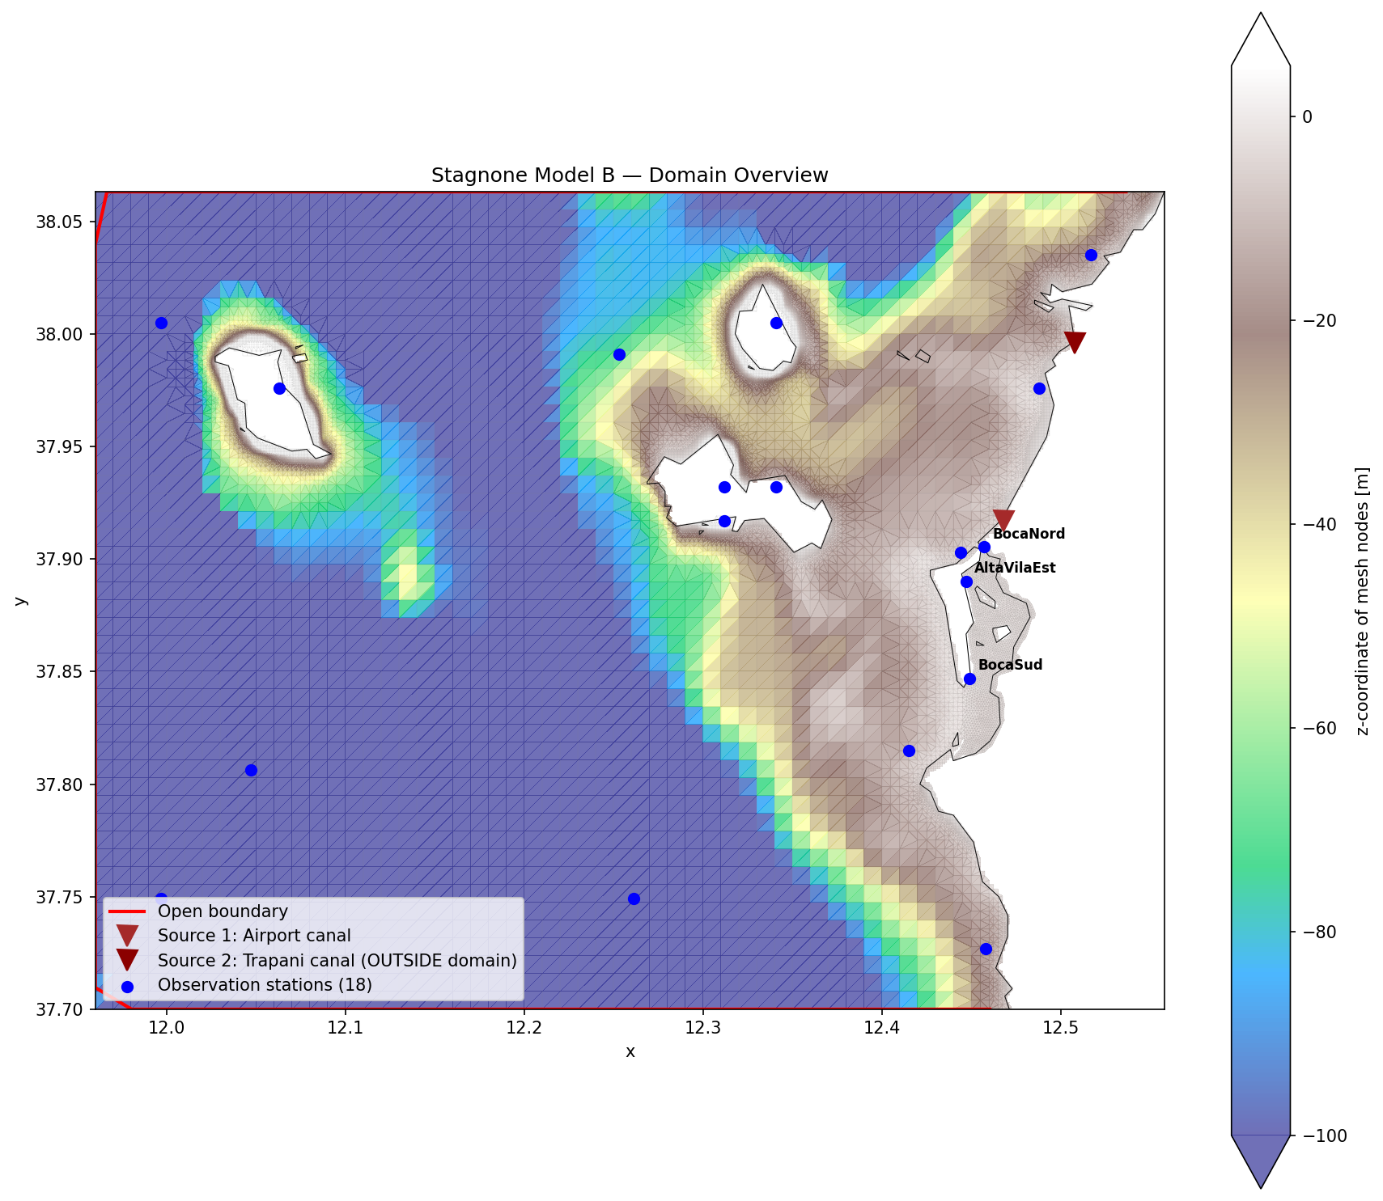
Figure: Model domain and mesh overview (v01, 25k faces).

4. Implementation

4.1 Notebook catalog
The project workflow is organized in 13 Jupyter notebooks:
Notebook | Title / purpose | Cells
01_domain_mesh.ipynb | 01 — Stagnone di Marsala: Domain & Mesh Evaluation | 15
03_satellite_roughness.ipynb | 03 — Satellite-Derived Bottom Roughness from Seagrass Classification | 22
04_hydro_model_3d.ipynb | 04 — Stagnone di Marsala: 3D Hydrodynamic Model Setup | 23
05_wave_coupling.ipynb | 05 — SWAN Wave Coupling via DIMR | 19
06_insitu_data.ipynb | 06 — Stagnone di Marsala: In-Situ Data Processing & QC | 18
08_postprocessing.ipynb | 08 — Stagnone di Marsala: Model Output Postprocessing | 24
09_diagnostics.ipynb | 09 — Model Diagnostics (no re-run needed) | 22
10_build_v02.ipynb | 10 — Build v02 model configuration | 20
11_blended_wind.ipynb | 11 — Blended Wind Forcing (ERA5 + in-situ stations) | 21
12_particle_tracking.ipynb | 12 — Particle tracking vs. July 2025 drifter deploys | 19
13_residence_time.ipynb | 13 — Residence time of Stagnone lagoon water | 18
14_build_v03.ipynb | 14 — Build v03 model configuration | 31
15_edito_postprocess_setup.ipynb | 15 — EDITO JupyterLab post-processing setup | 14

4.2 Model B fixes — getting v01 to run
The modelbuilder-generated Model B did not run out of the box. Five issues were identified and fixed in notebook 04 to produce a running v01:
Issue | Original value | Fix
Missing output file names | HisFile and MapFile were blank | Specified output NetCDF filenames
Background vertical viscosity too small | Vicoww = Dicoww = 5e-5 | Raised to 1e-4 for numerical stability in shallow cells
Initial temperature wrong | 6 °C (wrong for July Mediterranean) | Set to 24 °C
Initial salinity low | 30 psu | Set to 37.5 psu (offshore Med summer)
Unsupported keywords | Umodlin, EffectSpiral, WaveNikuradse, S1incinterval | Stripped from MDU before hydrolib-core load

4.3 v01 diagnostics — four calibration findings
After v01 completed its 9-day run, notebooks 08–09 produced diagnostics that revealed four systematic issues driving v02 changes:
1. Systematic negative datum bias: the model under-predicted water level at all three stations by ~0.4 m, consistent across the run. Root cause: the constant WL boundary had no offset to align the model datum to the observed MSL reference.
2. Amplitude flattening at BocaSud and AltaVilaEst: the model time series at these stations showed damped tidal amplitude compared to observations. Root cause: both obs points fell in cells that dried intermittently, so the model time series was contaminated by drying artifacts.
3. ERA5 wind underpredicted at lagoon scale: ERA5 wind magnitude was systematically lower than in-situ observations at AE and Mulino. Root cause: ERA5 grid (~25 km) does not resolve coastal/topographic effects.
4. Missing central observation points: the 19 obs points in Model B did not cover the lagoon interior adequately to evaluate 3D vertical structure — the wind-driven surface/bottom contrast that motivates the 3D approach.
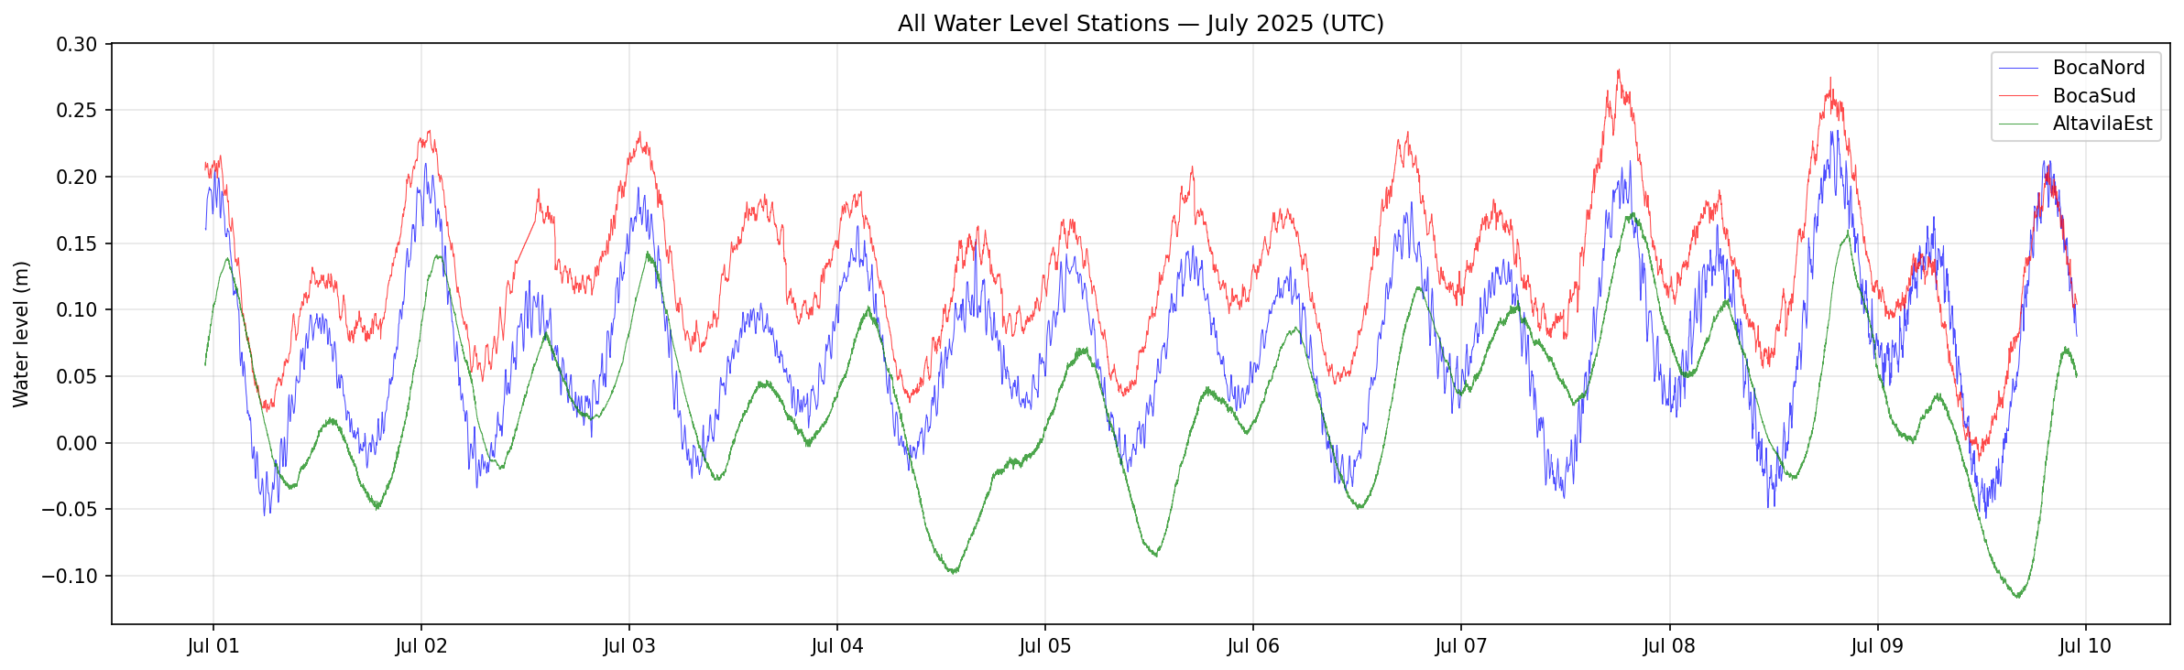
Figure: v01 water-level comparison at BN/BS/AE stations, showing the ~0.4 m datum bias and amplitude damping.
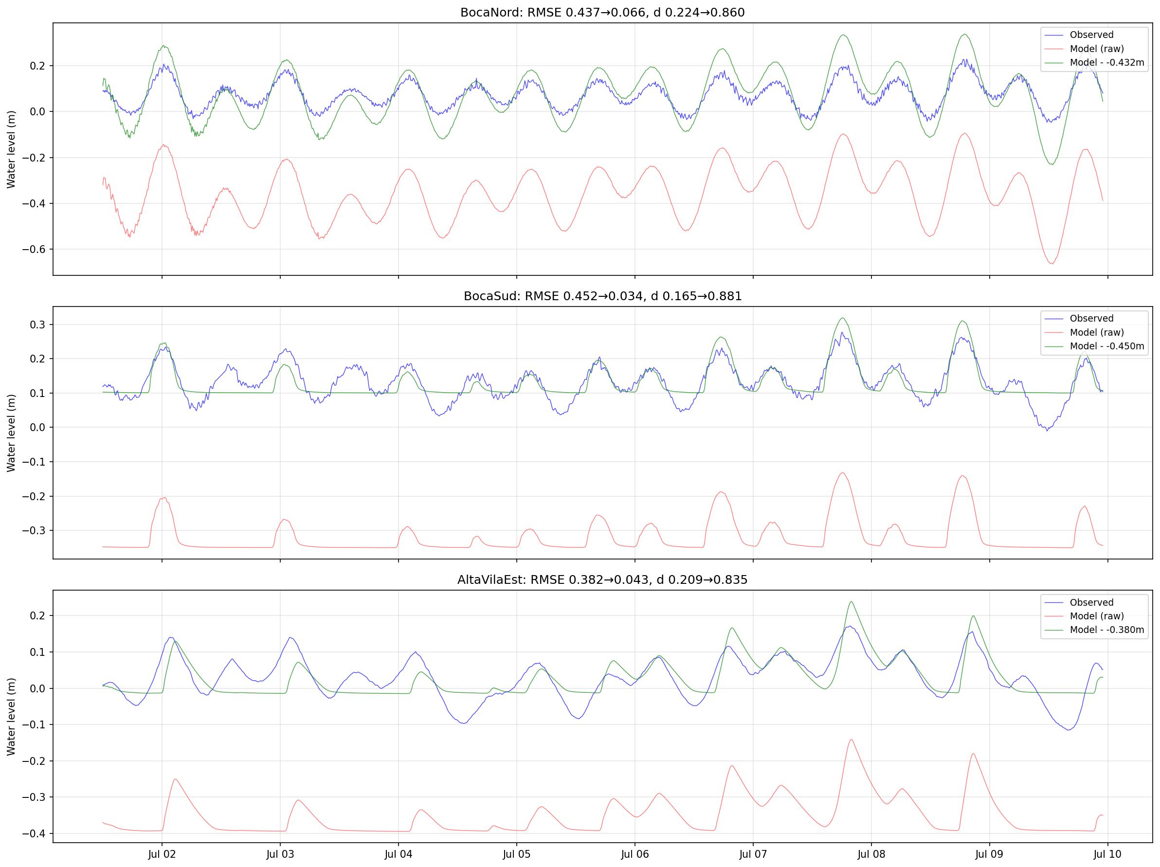
Figure: Datum-offset correction test (notebook 09): applying the mean bias as a constant offset removes the systematic under-prediction.

4.4 v02 changes — four fixes
Change | Implementation
Datum offset | Set constant WL boundary to +0.4208 m (mean v01 bias across BN/BS/AE)
Replacement obs cells | Moved BocaSud and AltaVilaEst obs to deepest always-wet cells within 500 m (min depth > 0.15 m)
Central 3D obs | Added C1 (12.455, 37.870), C2 (12.460, 37.890, user-adjusted), C3 (12.458, 37.855)
Blended wind | ERA5 outside lagoon + IDW of AE + Mulino inside; inner radius 3 km, outer 8 km, 500 m output grid
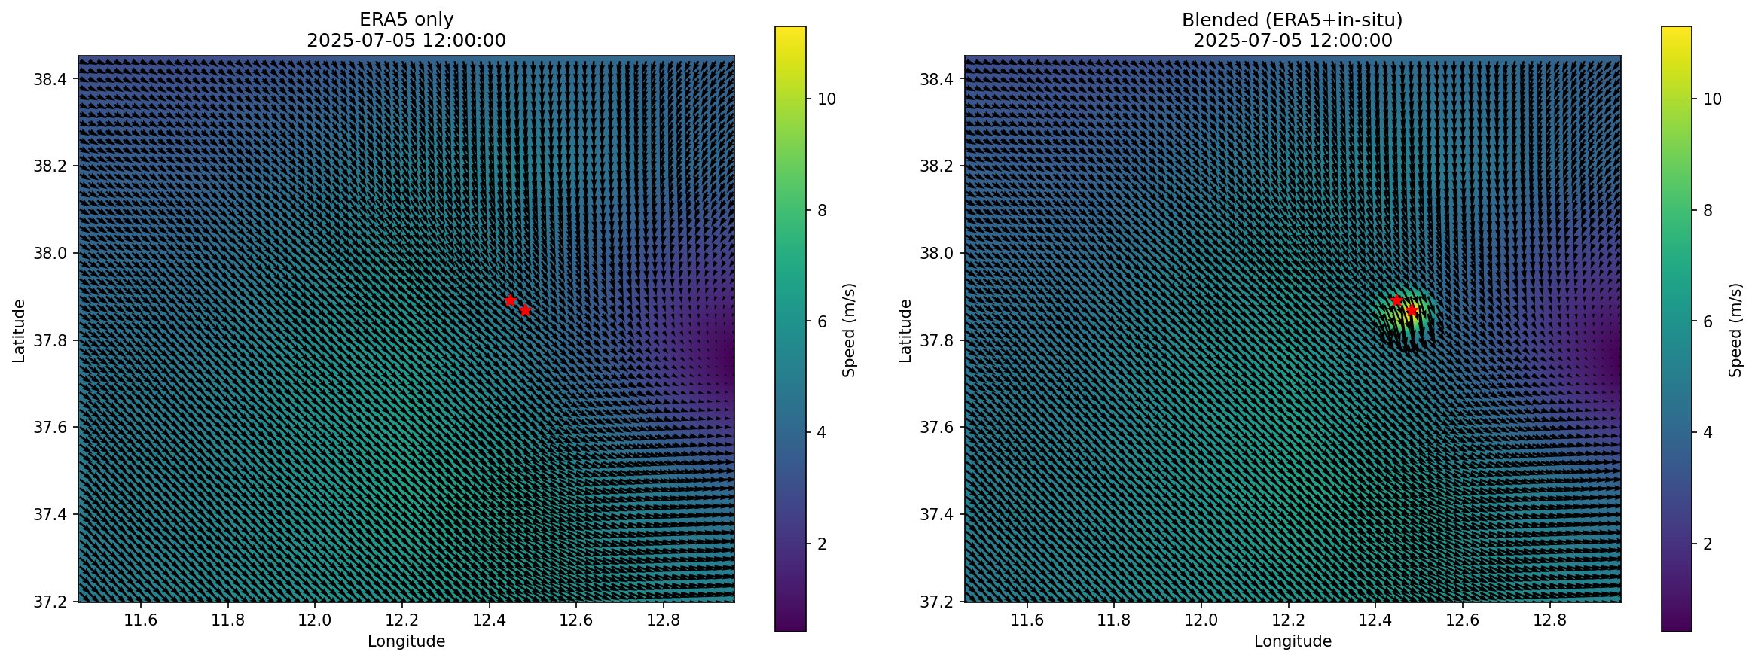
Figure: Snapshot of blended wind field (notebook 11): ERA5 offshore + in-situ stations inside the lagoon via IDW, with smooth transition band.
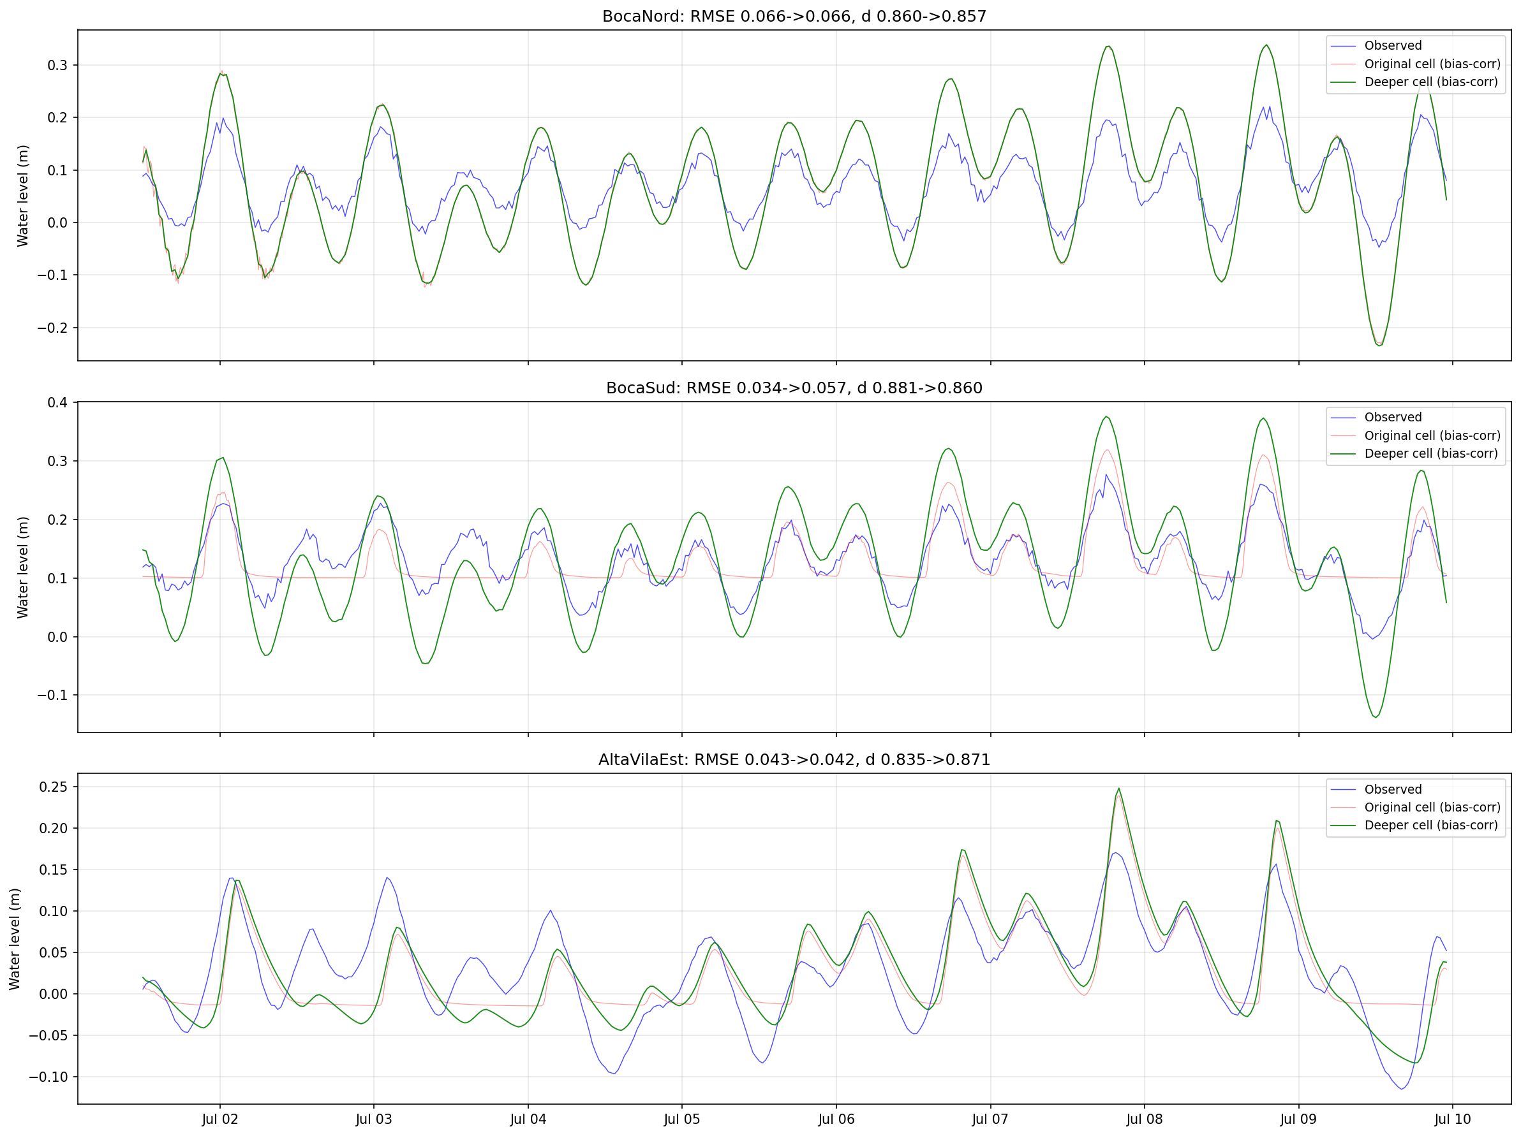
Figure: Replacement cells for BS/AE obs points (notebook 10): dry-cell analysis identifies deepest always-wet neighbors within 500 m.

4.5 v03 design
v03 layers four additional corrections on v02. Built end-to-end in notebook 14:
- Hypersaline initial salinity: 42 psu inside the lagoon polygon, 37.5 psu outside. The polygon was extracted authoritatively from the oldModel/Stagnone_justLagoon mesh (hand-drawn), reprojected from EPSG:3857 to WGS84 — 82 simplified vertices.
- Passive residence-time tracer "lagoon_tracer": initial value 1.0 inside lagoon / 0.0 outside, Dirichlet=0 at the open ocean boundary. Decay of the spatial mean yields the e-folding residence time.
- SWAN wave coupling activated (Wavemodelnr=3). Notebook 05 supplies the mdw, grid, and dimr_config with both FM and Wave components.
- Extended simulation period: requires downloading CMEMS + ERA5 for at least 30 days to capture full tracer decay. Currently blocked pending data download.

4.6 EDITO deployment
The EDITO Datalab hosts the delft3dfm_run_docker process (variant "2D3D-HMWQ") which accepts a model folder at s3://<user-bucket>/DFM_INPUT/ and writes outputs to s3://<user-bucket>/DFM_OUTPUT/. User quota: 32 GiB RAM, 8 CPU, 50 GiB storage.
A Python sync script (scripts/edito_sync.py) handles: listing buckets, cleaning old outputs, uploading model inputs (~140 MB), uploading project code, downloading results. Credentials come from .env (gitignored) with values from the EDITO storage settings page.
Critical gotcha (documented in memory/feedback_edito_run_model_sh.md):
Every uploaded model must include run_model.sh at its root with LF line endings. Missing it produces a misleading Kubernetes error ("MountVolume.SetUp failed ... kube-root-ca.crt not registered") that looks like an infrastructure problem but is actually the container failing to find its entrypoint. The v02 upload initially failed here; after adding the dfm_tools modelbuilder-style shell script, the run started immediately.
Post-processing on EDITO uses JupyterLab from the service catalog. Notebook 15 demonstrates streaming the 16 GB map.nc via s3fs + xarray.open_dataset with chunked reads — critical to avoid downloading large files within quota.

5. Preliminary results

5.1 v01 validation
v01 completed its 9-day simulation (July 1–10, 2025) locally in ~4 hours of wall-clock time. Water-level comparison at the three in-situ stations (BN/BS/AE) revealed the systematic bias and amplitude issues addressed in v02.
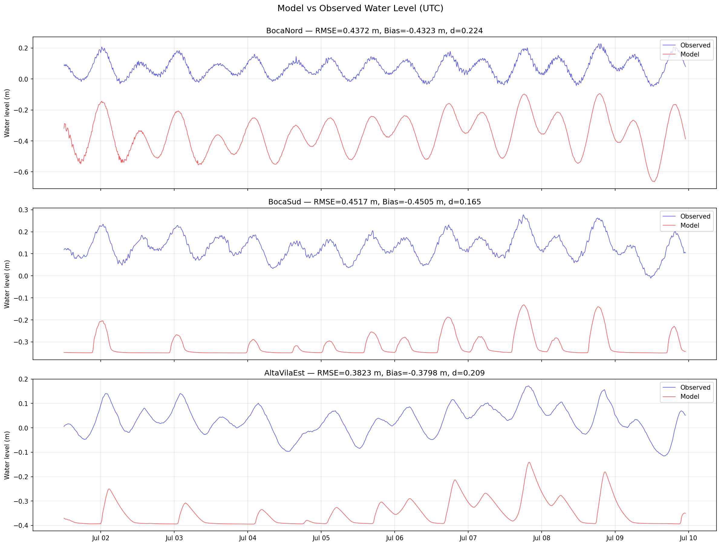
Figure: v01 time series vs observations at BN/BS/AE (notebook 08). The ~0.4 m offset and amplitude damping at BS/AE drove the v02 fixes.
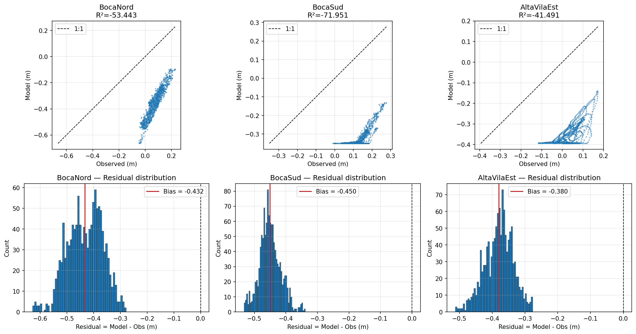
Figure: v01 scatter comparison at the three stations. Points cluster below the 1:1 line consistent with negative bias.

5.2 v02 partial results (local)
v02 completed approximately 70% of its 9-day run locally before a power outage interrupted execution (stop at simulated day 6, ~July 7 08:00 UTC). The outputs through that point are intact: 912 time steps in his.nc (10-min interval), 305 snapshots in map.nc (30-min interval). The final map.nc snapshot has a corrupted timestamp from the partial write — dropped in post-processing.
This partial run is usable for WL validation and v01 comparison, but does not cover the July 8–9 drifter campaign window needed for particle-tracking validation.

5.3 v02 on EDITO
After the power-outage incident, v02 was migrated to EDITO. Upload path: 140 MB of inputs to s3://oidc-cmartinsjr/DFM_INPUT/ via boto3. The run is currently executing; expected wall-clock ~2-3 hours for the full 9-day window on EDITO's provisioned resources.

5.4 Wind blending
The ERA5+in-situ wind blend (notebook 11) produces a composite field used from v02 onward. Inside a 3 km radius of each in-situ station, the IDW interpolation of station observations dominates; between 3 and 8 km, a smooth weight transitions back to ERA5; beyond 8 km, ERA5 is used directly. Grid resolution of the blended product: 500 m.
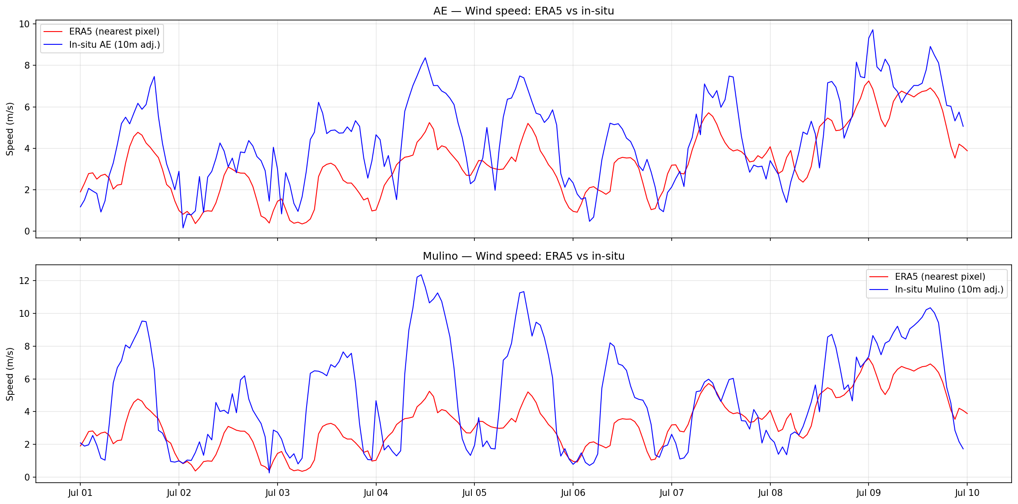
Figure: Comparison of ERA5 and in-situ wind at AE station (notebook 11). ERA5 systematically underpredicts wind speed inside the lagoon at the ~25 km grid scale.

6. Research extensions

6.1 Particle tracking — July 2025 drifter campaign
In July 2025, 12 Stokes drifter deploys were performed in the lagoon. Positions were recorded every few minutes in UTM Zone 32N. Notebook 12 builds the pipeline to reproduce these deploys via Lagrangian particle tracking driven by the v02 (or later) velocity field.
The chosen execution path is OpenDrift offline, reading v02 map.nc and seeding particles at each deploy's first valid observation. Skill metrics per drifter: haversine endpoint separation, path-length ratio, mean heading bias, and Liu & Weisberg (2011) trajectory skill score. D-Flow FM's built-in particle module is a fallback if surface drift requires same-numerics consistency.
Notebook 12 execution is gated on v02 validation — the current v02 partial output stops before the July 8–9 campaign window.

6.2 Residence time
A core research question is the lagoon's water residence time. Notebook 13 implements the primary method — an Eulerian passive tracer initialized to 1 inside the lagoon, 0 outside, with Dirichlet=0 at the open boundary. The spatial mean inside the lagoon decays exponentially; the e-folding time is the bulk residence timescale. Per-cell fits produce spatial maps of local residence time.
Literature review supports this as the standard approach for wind-dominated lagoons (García-Oliva 2019 for Mar Menor; Cucco & Umgiesser 2006 for Venice; Ferrarin 2013 for Sacca di Goro). A Knudsen salt-balance estimate τ = V·ΔS / (E·S) serves as an independent bulk sanity check for the hypersaline case. The gold-standard CART age tracer (Deleersnijder/Delhez) is a future extension requiring two coupled user tracers.
Execution requires extending the simulation to ≥30 days (otherwise the tracer barely starts decaying). This is gated on downloading extended CMEMS + ERA5 data.

6.3 Feedback loop — hypersaline correction
An important diagnostic finding drove v03 design: v01 and v02 both had uniform initial salinity of 37.5 psu and CMEMS boundary at similar values — meaning the lagoon interior was modeled as hyposaline, the opposite of the observed hypersaline state (~42 psu). This has three consequences that v03 must address:
- Density-driven exchange at the inlets is inverted in v01/v02 — bottom outflow (denser hypersaline water leaving) is missing.
- Salinity cannot serve as a natural diagnostic tracer for residence time until the gradient is correctly represented.
- Any coupled biogeochemistry or seagrass dynamics downstream start from a wrong baseline.
The v03 fix (notebook 14) applies a polygon-masked initial field: 42 psu inside the authoritative lagoon polygon (extracted from oldModel/Stagnone_justLagoon), 37.5 psu outside. An ERA5 evaporation forcing term is pending to close the steady-state salt balance.

7. Current status and next steps

7.1 Status snapshot
Component | Status | Notes
v01 baseline | Complete | 9-day run, 4 h wall-clock locally
v02 (local) | Interrupted at 70% | Power outage; partial output intact (6.3 d)
v02 (EDITO) | Running | After run_model.sh fix; full 9-d expected
v03 build | Complete (notebook 14) | Pending v02 validation before launch
EDITO workflow | Operational | S3 sync script + JupyterLab post-processing
Notebook 12 (particles) | Framework ready | Gated on v02 or later with July 8-9 window
Notebook 13 (residence) | Methodology + stub ready | Gated on v03 with ≥30-day BC
Notebook 15 (EDITO post) | Complete | Validated streaming of map.nc via s3fs

7.2 Immediate next steps
- Monitor v02 completion on EDITO; inspect outputs vs v01 reference.
- If v02 validates cleanly: run notebook 14 to rebuild v03 with current polygon, upload via edito_sync.py, launch delft3dfm_run_docker.
- Resolve pod CPU allocation for nPart=4 (check Datalab UI advanced options, else use Process API).
- Download extended CMEMS + ERA5 (Jul 1 – Aug 15 2025) for the residence-time run.
- Run notebook 15 post-processing on v02 outputs; produce v01 vs v02 comparison figures.
- Execute particle-tracking notebook 12 against v02 (or v03) outputs covering the drifter campaign.

7.3 Known risks
Risk | Mitigation / monitoring
Hypersaline shock | Sharp 42→37.5 psu transition at inlets may trigger numerical overshoots; mitigation is polygon buffer widening if needed
Evaporation double-counting | With Temperature=3 already computing latent flux, adding an explicit ERA5 evaporation forcing risks double-counting mass loss; verify convention in D-Flow FM 1.2.x release notes before committing
EDITO parallel CPU | Pod default may be <4 CPUs; running nPart=4 MPI procs under CPU contention is slower than nPart=1
EDITO credentials expiring mid-run | STS tokens typically expire in 24 h; long runs are unaffected (container has its own mount) but the post-processing JupyterLab may need renewal
Storage quota | v03 ≥30-day map.nc could be 50–90 GB; within 50 GiB limit only with reduced output frequency or selective variable subset

8. References
Site-specific literature (in reference/papers/):
- Ciraolo G. & De Marchis M. (2009). Stagnone di Marsala modeling. Journal of Coastal Research.
- Ciraolo G. et al. (2009). Particle tracking in aquatic vegetation meadows. [Referenced for Lagrangian methodology in seagrass environments.]
- Di Marca G. et al. (2009). Turbidity dynamics at Stagnone di Marsala.
- Emanuele et al. (2024). Water quality / hydrodynamic review (Water, 16, 2602).
Methodology references:
- Deleersnijder E. & Delhez E.J.M. (2004). Residence time in semi-enclosed marine systems. JMS.
- Cucco A. & Umgiesser G. (2006). Modeling the Venice Lagoon residence time. JMS.
- Ferrarin C. et al. (2013). Sacca di Goro transport timescales.
- García-Oliva M. et al. (2019). Mar Menor hydrodynamic modeling under wind forcing. Ocean & Coastal Management.
- Liu Y. & Weisberg R.H. (2011). Evaluation of trajectory model predictions. Lagrangian skill score.
- Viero D.P. & Defina A. (2016). Water age in wind-driven lagoons: ensemble methodology. Advances in Water Resources.
Technical / software references:
- Deltares (2026). Delft3D FM Suite 2026.01 HMWQ release notes. Deltares Open Source.
- Deltares. dfm_tools Python package — https://github.com/Deltares/dfm_tools
- Deltares. hydrolib-core 1.0.0 — MDU / ext / BC file parser.
- Delft3D User Days 2025 break-out session materials (in reference/).

Appendix A — Complete notebook catalog
File | Title | Purpose (from first markdown cell)
01_domain_mesh.ipynb | 01 — Stagnone di Marsala: Domain & Mesh Evaluation | This notebook evaluates the Model B mesh (`Stagnone_dxy01_15m_net.nc`), assesses boundary adequacy, and determines if domain extension is needed for the turbidity modeling component. **Key question...
03_satellite_roughness.ipynb | 03 — Satellite-Derived Bottom Roughness from Seagrass Classification | This notebook classifies aquatic vegetation from Sentinel-2 imagery and converts the classification to a spatially varying Manning roughness map for Delft3D FM. **Pipeline:**
04_hydro_model_3d.ipynb | 04 — Stagnone di Marsala: 3D Hydrodynamic Model Setup | This notebook fixes the Model B configuration (`stagnone_py_lagoon3D`) to create a running 3D D-Flow FM model. **Model B issues identified:** 1. AngLat=0, AngLon=0 → Coriolis OFF (should be ~37.86°...
05_wave_coupling.ipynb | 05 — SWAN Wave Coupling via DIMR | Couple SWAN wave model with the existing D-Flow FM 3D hydrodynamic model to include: - Wind-generated waves inside the lagoon (fetch-limited) - Offshore swell entering through BocaNord and BocaSud
06_insitu_data.ipynb | 06 — Stagnone di Marsala: In-Situ Data Processing & QC | This notebook loads, cleans, and visualizes the in-situ monitoring data for model calibration/validation. **Water Level Stations (3):** - BocaNord (BN): Northern inlet, 37.905°N 12.457°E — 3 min sa...
08_postprocessing.ipynb | 08 — Stagnone di Marsala: Model Output Postprocessing | Compare model output at observation points with in-situ measurements: - BocaNord (BN): northern inlet - BocaSud (BS): southern inlet
09_diagnostics.ipynb | 09 — Model Diagnostics (no re-run needed) | Post-processing tests to evaluate the v01 model without re-running: 1. **Datum bias offset** — compute mean bias and apply correction to see amplitude fit 2. **Drying check** — verify if BS and AE ...
10_build_v02.ipynb | 10 — Build v02 model configuration | Apply v01 lessons to a new model configuration: 1. **Datum offset**: apply the mean bias to `waterlevelbnd_constant_*.bc` to correct model low-bias 2. **Replacement obs points for BS and AE**: move...
11_blended_wind.ipynb | 11 — Blended Wind Forcing (ERA5 + in-situ stations) | ERA5 resolution is ~30 km, so only ~1 pixel covers the Stagnone lagoon → local wind effects (channeling by Isola Lunga, topographic modifications) are lost. **Blending strategy:** 1. Build a finer ...
12_particle_tracking.ipynb | 12 — Particle tracking vs. July 2025 drifter deploys | **Goal:** reproduce the 12 Stokes-drifter deploys from the July 2025 field campaign with a Lagrangian particle tracking run driven by the v02 (or later) D-Flow FM velocity field, then score skill p...
13_residence_time.ipynb | 13 — Residence time of Stagnone lagoon water | **Research question:** how long does water stay inside the lagoon? **Approach** (literature brief in `memory/project_residence_time.md`): 1. **Primary method — Eulerian passive tracer:** set tracer...
14_build_v03.ipynb | 14 — Build v03 model configuration | v03 = v02 + four upgrades, consolidated in one authoritative build notebook. Notebooks 05 (wave coupling) and 13 (tracer setup recipe) are superseded for v03 *building* but remain the reference for...
15_edito_postprocess_setup.ipynb | 15 — EDITO JupyterLab post-processing setup | **Run this notebook inside JupyterLab launched from the EDITO Datalab service catalog.** It validates S3 access to your personal bucket and demonstrates how to open the v02 outputs *without downloa...

Appendix B — EDITO operational workflow
Short operational guide. Full context in `memory/reference_edito.md`.

Setup (once)
1. Fill `.env` with temporary credentials from https://datalab.dive.edito.eu/account/storage.
2. `pip install boto3` in `dfm_tools_env`.

Run cycle (per model version)
python scripts/edito_sync.py clean-output --yes
python scripts/edito_sync.py clean-input --yes

python scripts/edito_sync.py upload --model-dir model/dflowfm_v02

python scripts/edito_sync.py sync-code

python scripts/edito_sync.py download-his

Gotchas discovered
- **`run_model.sh` must be present** at the model root with LF endings. Missing it produces a misleading `kube-root-ca.crt not registered` Kubernetes error that looks like infra but is actually the entrypoint missing. See `memory/feedback_edito_run_model_sh.md`.
- **Parallel runs** (`nPart > 1`) need `<process></process>` tag inside `<component>` in `dimr_config.xml` AND pod CPU request ≥ `nPart`.
- **Credentials expire** (usually 24h session). When `upload` fails with 403, refresh `.env` from the EDITO storage settings page.
- **Never re-upload while a run is active** — overwrites files being read by the pod.
- **Never download `map.nc` locally** — use s3fs streaming from EDITO JupyterLab (notebook 15).

Cost / storage strategy
- Keep only **1 model version's output** in `DFM_OUTPUT/` at a time.
- Clean between versions to stay under 50 GiB quota.
- Push analysis artefacts (CSV, PNG) to a separate `RESULTS/` prefix instead of leaving them in `DFM_OUTPUT/`.

Appendix C — Project memory (lessons learned)

Project scope and publications plan
Source: memory/project_stagnone_dt.md
Digital twin for Stagnone di Marsala, shallow protected Mediterranean lagoon (~12 km2, 0.5-2m) in western Sicily.
Why:** Significant vertical flow structure (wind surface vs bottom currents despite shallowness). Understand 3D hydrodynamics, turbidity, seagrass dynamics. Generate Q1 publications.
How to apply:**
- Two reference models in oldModel/:
- Model A (input/): lagoon-only, UTM32, 5 sigma, no S/T, no waves — was running
- Model B (Stagnone_py_lagoon3D): dfm_tools modelbuilder-based, WGS84, 10 sigma, S/T enabled, CMEMS+TPXO BC, ERA5 forcing — NOT running (missing output files, wrong init temp, BC operand issues)
- Priority: Fix Model B first, then enhance
- Two external turbidity sources from canals: Airport canal (37.917N, 12.468E → Invaso Rubino) and Trapani canal (37.996N, 12.508E → Invaso Balata, OUTSIDE current domain)
- Domain may need northward extension to ~38.01N for turbidity source 2
- PlanetScope images in reference/planet_turbidity/ show turbidity patterns
- 5 planned Q1 publications

v01 calibration findings
Source: memory/project_v01_calibration_notes.md
First 3D model run completed 2026-04-14. Comparison with in-situ water levels at BocaNord/BocaSud/AltaVilaEst revealed four issues:
1. Systematic negative bias (model < observed)**
- Likely datum/reference mismatch between CMEMS zos (MDT-referenced) and in-situ (local benchmark)
- Fix: apply constant offset via waterlevelbnd_constant_*.bc or subtract computed mean bias
2. Amplitude flattening at BocaSud and AltaVilaEst**
- BocaNord matches timing well but over-amplifies
- BS and AE appear attenuated — suspected drying or near-margin mesh resolution issue
- Check: bedlevel + waterdepth time series at obs points
3. Wind underrepresented inside lagoon**
- ERA5 at ~30km resolution can't capture local wind channeling by Isola Lunga
- Fix: blend in-situ wind (AE + Mulino stations) for inside-lagoon, keep ERA5 offshore
- Similar to bathymetry fusion approach
4. Wrong location for 3D vertical structure evaluation**
- AltaVilaEst is too close to eastern shore (shallow, wind-dominated)
- Better central locations for vertical shear analysis:
- ~37.87N 12.455E (near Mozia, 1.5-2m)
- ~37.88N 12.465E (between Mozia and mainland)
- Would need to add obs points and re-run, or extract from _map.nc (22.8GB)
How to apply:** These are the first calibration priorities when returning to the model. Address datum offset first (simplest fix, likely large impact), then mesh/obs-point issues, then wind blending.

July 2025 drifter campaign
Source: memory/project_particle_tracking.md
Fact:** July 2025 field campaign included ~12 Stokes drifter deploys inside Stagnone lagoon, recording surface positions periodically. Raw data in `polished_data2.csv` (columns: Data Date, sea surface temp, x_coord, y_coord [UTM32N, EPSG:32632], source ID, deploy number). Rows with deploy="altri" are drift-between-deploys / anomalies — exclude for per-deploy reproduction. Deploy IDs 1–12 correspond to the 12 campaign deploys.
Why:** Drifter tracks give direct Lagrangian validation of surface currents — the 3D model's surface layer must reproduce drifter trajectories (magnitude + direction). This is a primary calibration target alongside WL stations and a core Paper 1 result.
How to apply:** Use D-Flow FM particle tracking module (or offline PART) driven by v02/v03 velocity fields. For each deploy: release at (x0, y0, t0) in model coordinates (convert UTM32N → WGS84 if needed), track until simulated drifter exits or campaign timestamp ends. Compare modeled vs observed trajectory — skill metrics: endpoint separation, path length ratio, mean direction bias. Coordinate columns are UTM32N so convert to WGS84 for the WGS84 v02 mesh.

Residence-time research question
Source: memory/project_residence_time.md
Fact:** Residence time of water inside Stagnone lagoon is a core research question. Two candidate approaches: (A) Lagrangian particle tracking — seed lagoon, measure time for all/90% of particles to exit; (B) Passive tracer / age tracer — set high initial concentration inside, track equilibration. User open to both; explicitly asked for literature consultation.
Why:** Residence time controls biogeochemistry, water quality, seagrass health, and turbidity plume persistence. Essential for Paper 1 (3D hydrodynamics) and Paper 5 (digital twin scenarios). Hypersaline nature (~42 ppt inside vs ~37.5 ppt outside) means salinity itself could serve as a diagnostic tracer — but only if evaporation flux is correctly resolved.
How to apply:** First get v02 salinity field correct (current salinity bug — see feedback_salinity_bc). Then test method (B) passive tracer first (simpler in Delft3D FM via sediment/tracer module), validate against particle tracking (A) in a follow-up experiment. Expect residence times of days-to-weeks based on microtidal + small inlet cross-sections. Check age tracer (CART methodology) if native Delft3D FM support exists.

Hypersaline salinity correction
Source: memory/feedback_salinity_bc.md
Rule:** Stagnone di Marsala is **hypersaline**: interior salinity ~42 ppt (literature), offshore Mediterranean ~37.5 ppt. Evaporation > freshwater input + restricted exchange through two shallow inlets drives the positive salinity anomaly. Future model configurations (v03+) must reproduce this: initial salinity inside lagoon should be set to ~42 ppt (not 37.5), and evaporation flux must be resolved (ERA5 evaporation field or heat-flux-driven computation via `Temperature=3` already active).
Why:** User identified that v01/v02 show lagoon salinity *lower* than offshore — physically wrong. Currently `InitialSalinity=37.5` is applied uniformly, and the CMEMS BC brings in ~37.5-38 ppt, while inside the lagoon evaporation should push it higher. Without correct salinity contrast, (a) density-driven exchange at the inlets is wrong, (b) salinity can't serve as a natural residence-time tracer, (c) biogeochemistry/seagrass modules would start from wrong baseline.
How to apply:** For v03+ setup: (1) set `InitialSalinity=42.0` via a polygon-masked initial field (lagoon interior) with `InitialSalinity=37.5` offshore, using `initialFields.ini` not a scalar; (2) verify ERA5 evaporation is ingested (may need to add `e` field to meteo); (3) after a spin-up run, check that inlet cross-section shows outflow at bottom (denser hypersaline) / inflow at surface (lighter Mediterranean) — inverse estuarine circulation. This is a known feature of Mediterranean coastal salinas.

EDITO run_model.sh requirement
Source: memory/feedback_edito_run_model_sh.md
Rule:** any model folder uploaded to `s3://oidc-cmartinsjr/DFM_INPUT/` for `delft3dfm_run_docker` **must include a Linux `run_model.sh`** at the root. Without it, the pod fails with a misleading `MountVolume.SetUp failed ... kube-root-ca.crt not registered` + `Job has reached backoff limit` — which LOOKS like EDITO infra but is actually the container failing to find the entry script.
Why:** the EDITO `delft3dfm_run_docker` service is a thin wrapper that mounts the S3 bucket and runs `bash run_model.sh`. The modelbuilder service auto-generates this file (template in `dfm_tools.modelbuilder.generate_docker_file`), so if the model comes from modelbuilder it's present by default — but **if you build the model by other means (e.g. hand-edited from an old project), you must add `run_model.sh` yourself**.
How to apply:** for any v0X model uploaded to EDITO, verify `run_model.sh` is present with LF line endings and the standard template (nproc=1 for simple runs):
```bash
#!/bin/bash
set -e
nPart=1
dimrFile=dimr_config.xml
mduFolder=.
PROCESSSTR="$(seq -s " " 0 $((nPart-1)))"
sed -i "s/\(<process.*>\)[^<>]*\(<\/process.*\)/\1$PROCESSSTR\2/" $dimrFile
mduFile=<THE_MDU_NAME>.mdu
if [ "$nPart" == "1" ]; then
run_dimr.sh -m $dimrFile
else
pushd $mduFolder
run_dflowfm.sh --partition:ndomains=$nPart:icgsolver=6 $mduFile
popd
run_dimr.sh -c $nPart -m $dimrFile
fi
```
For parallel runs (v03 long), bump `nPart` to 4 or 8 (EDITO quota). Requires `<process></process>` tag inside `<component>` in `dimr_config.xml` so the sed can inject process IDs. **Also verify pod CPU allocation** — default `delft3dfm_run_docker` request may be <1 CPU; for nPart=4 need `resources.requests.cpu >= 4000m` (set via Process API if UI doesn't expose it, or check if UI has advanced/resources panel). Running 4 MPI procs on <4 CPUs is slower than nPart=1 due to contention.

EDITO Datalab account and quotas
Source: memory/reference_edito.md
Account:** active EDITO Datalab account, already ran a test successfully.
Resource quotas (as of 2026-04-14):**
- RAM: 32 GiB max
- CPU: 8 cores max
- Storage: 50 GiB max (20 GiB / 40% used at time of check — likely test-run outputs)
- Pods: 50 max
- GPU: 0 (no GPU quota)
Delft3D FM service:** uses `delft3dfm_run_docker` from the EDITO Datalab **Process Catalog**, variant labelled **"Delft3D FM 2D3D-HMWQ"** (Hydrodynamics, Morphology, Waves, Water Quality — supports SWAN, so valid for v03 wave coupling too).
Storage strategy implication:** Stagnone v02 `map.nc` alone is ~16 GB; v03 long run (≥30 days) would be 50-90 GB. Must keep only `his.nc` (~30 MB) locally, stream `map.nc` via xarray chunks or delete after each analysis pass. Clean test-run outputs before new runs if they occupy quota.

