Clifford's Tower 1263: Game Engines, Visualisation and Archaeology.

*Tara Copplestone (@gamingarchaeo)*

I am an archaeologist. Admittedly an archaeologist who has studied in computer science and played my fair share of games, but an archaeologist none the less. Before beginning this project I had played around in blender for less hours than could be counted on one hand and had never touched either GIMP or Unity. But being an intrepid individual I decided to throw myself in at the deep end.

2 weeks.

3 programs.

$0 budget.

1 archaeological reconstruction.

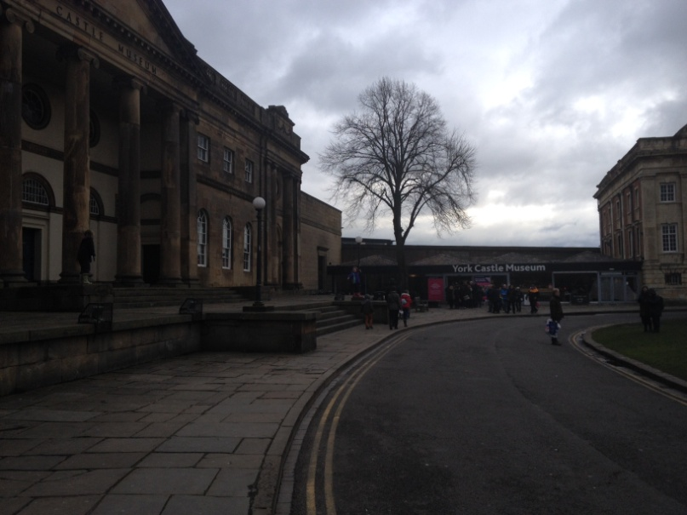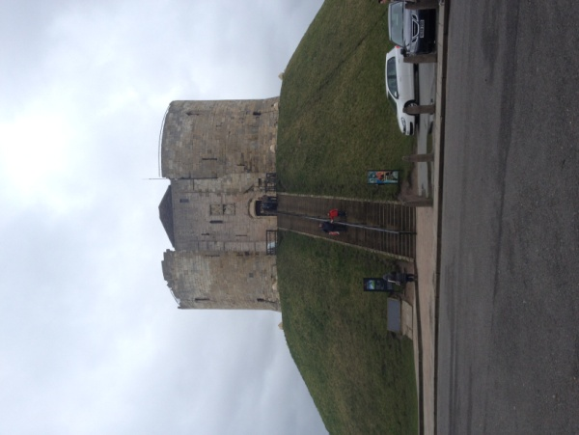The project was conceived of as a way to afford the viewer an experience of the Clifford's Tower precinct (York) as it may have been following one of its many refurbishment phases in 1263. As it stands now it is almost impossible to get a handle on how the area may have looked - the tower is dilapidated, evidence of the bailey all but gone, the river has been re-routed meaning there is no longer a moat and modern interventions have virtually taken over the entire surrounding landscape.

*Image 1 (left) and Image 2 (right): Demonstrating the area as it appears now. The moat has been exchanged for a car-park whilst the museum buildings stand where the bailey once was.*

Days 1-3

The first days of the project were dedicated to a rollercoaster ride between valiant optimism regarding the expansive scope of the project and copious 2am panic sessions after failed renders, incompatible scripts and launch crashes. Regardless I pushed on and by the end of the three days I had the bare, un-textured meshes of the keep made in blender, and the surrounding landscape ported into Unity and converted from a digital elevation model into a terrain (A process of layered displacements which was far more complicated than originally anticipated).

None the less by the end of the three days there was a ground to walk on. A tower to look at and there was even a skybox. It was basic, and quite frankly hideous, but I loved it all the same. There was something so satisfying in going from complete novice to having something tangible to look at and walk around in.

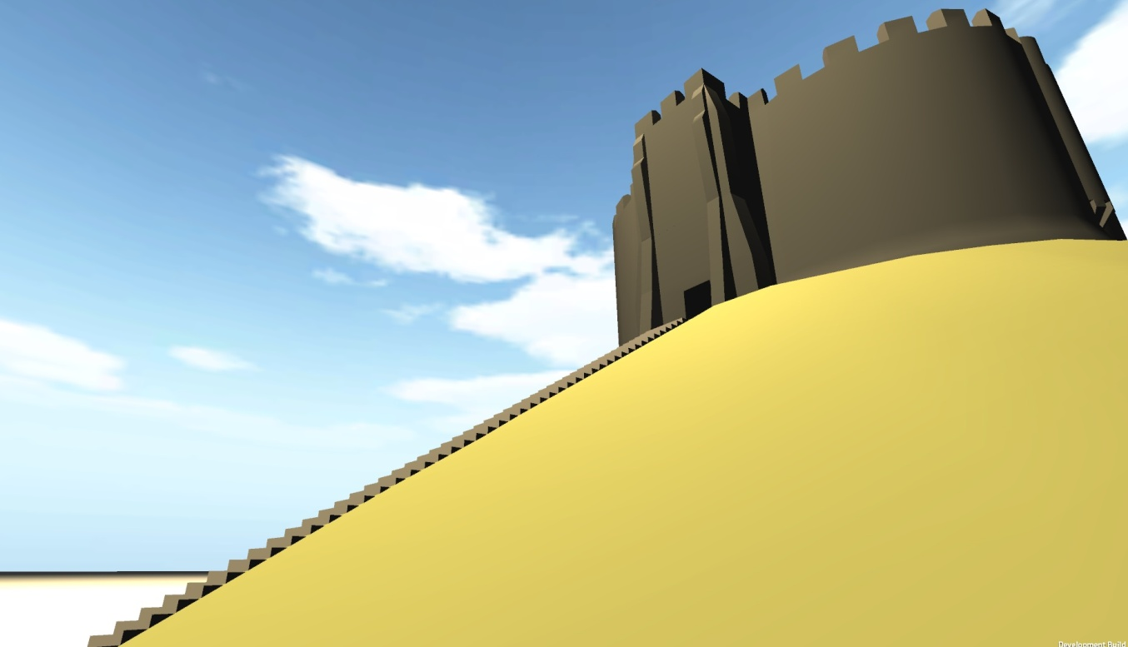

*Image 3: Early work of the Tower and its surrounding land-form*

Days 4-7

Becoming more confident with blender meant becoming more ambitious. Over these days the asset list went from 1 terrain and 3 models, to 3 terrains and somewhere in the region of 38 models. The scene was now reasonably populated, albeit in various grey-scales. Looking at a plain landscape filled with grey models became tiresome after a short period so environmental variables such as trees, grass and shrubberies were added, and attempts at texturing began in earnest. Early attempts at texturing took the form of plastering of a single low-resolution texture over the entire surface (cringe) producing a stretched, pixelated effect, so this technique was abandoned rapidly in favour of UV unwrapping.

Days 8-11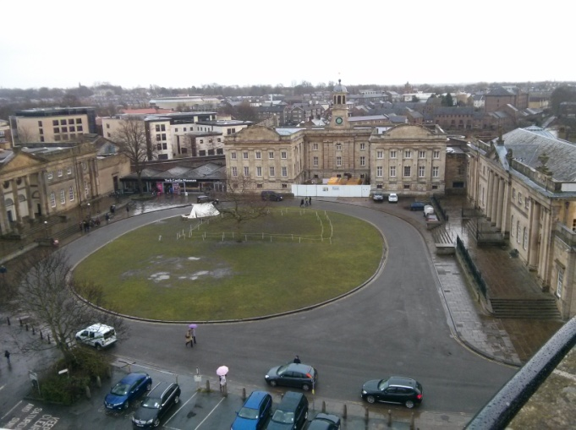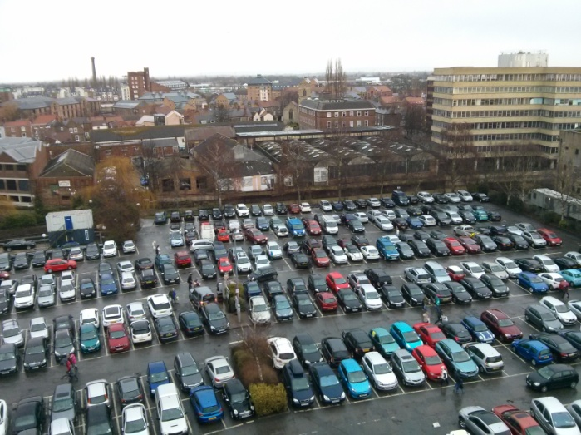

*Image 4 (left) and Image 5 (right) demonstrating the modern interventions around the tower.*

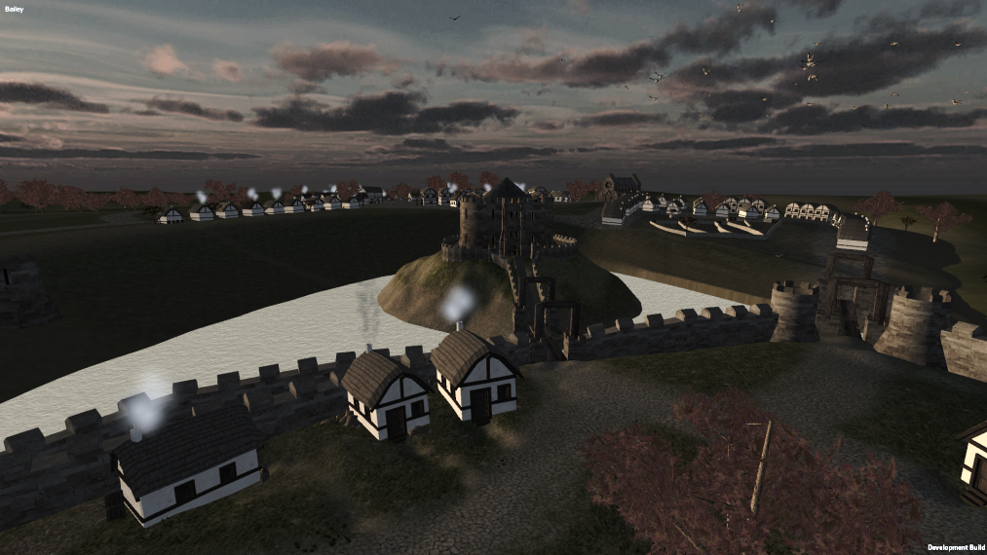Days 8 through 11 saw a return to the site to gather some more overview photographs before returning to finish up texturing and lighting the model as well as scripting a basic interface. Constant reference to the Unity forums was required throughout this time as GUI elements are handled in a somewhat round-about fashion. Several late nights, fuelled by coffee later and I had scraped together an interface which allowed the user to alternate between 3 start points - getting an overview perspective from each of them before being dropped into the scene, which by this stage was visually all but finished.

*Image 6: By the end of day 11 there was a working model, complete with textures, skybox, lighting and even particle effects.*

Days 12-14

Most sane people would have called it a day at this point, happy to have an interactive visual reconstruction. But where's the fun in that? By this stage I had already learnt how to do basic modelling, attempted texturing, created a unity scene, and scripted GUI elements, so why not go the final leg and add sound events. Subsequently footfalls were implemented, water noises added and a variety of household and environment sounds created for on-event criteria - the result was that whilst the modelling is certainly primitive and the texturing laughable at points the overall impression is not altogether too bad. It certainly serves the purpose of drawing attention to how different the landscape and structures are from 1263 to the modern day.

Thoughts on the outcome

Visualisation is a powerful force in archaeology and culture-heritage - both for academic research and public engagement. The work I did on the Tower precinct helped to contextualise and test a multitude of conflicting sources about the appearance of the area in 1263, as modelling a scene in 3D forces you to think about the practicalities of space as well as the manner in which physics will act upon a subject.

Moreover the outcome represents a valuable window into a potential past that is simply not visible or accessible in its modern context. Producing outcomes such as Clifford's Tower allow people in the wider public to experience an archaeological record which would otherwise be unobtainable and therefore overlooked.

Lessons learnt

Firstly, my personal inexperience is evident in the outcome, but so is exponential improvement, even over such a short period of time - I imagine that if I were to create the Tower again I could produce a vastly superior outcome by building better workflows and methodologies. A key part of the improvement was using the variety of incredible online resources and adapting them to suit my specific needs - there is an absolute wealth of talented people who have produced incredibly helpful resources for beginners so there really is no excuse for not giving it a go.

Secondly, there was a lot of trial, error and failure but it was only through those failures that I learned what was good or bad, and built better understandings of technical methodology and best practice. There are certainly large gaps in the literature at present for archaeology specific projects, which is a little scary, but the old adage of nothing ventured, nothing gained is quite appropriate here - for more progress to be made, we need to be willing to fail, and then learn from those failures.

Future thoughts

Archaeological visualisation is a relatively emergent sub-section of the wider anthropological discipline, and as such there is a long way to go before a collective understanding of how best to leverage these powerful tools is achieved. At the moment, so many of the reconstructions we observe on sites, or in museums, are created by contractors who are 3D designers rather than archaeologists. Whilst this is by no means bad, it does mean that the archaeologists working on interpretations of the site never engage with the valuable process of construction and may never understand the available scope for outcomes. To this end learning the skills to create basic game visualisations helps to create a network for understanding - so even if us heritage professionals continue to outsource to more skilled individuals we will do so with a basic understanding of the work-flows, pitfalls and potentials, as well as providing a common ground for the exchange of ideas. The learning curve on programs like blender and unity may be steep at first but with a little dedication and determination you can easily produce valuable results, and if those working in the discipline continue to share their processes and outcomes we will only move forward faster.

Conclusions

This short article may not have broken any new ground theoretically, or contributed a new workflow to the discipline of 3D modelling and game design, but it has demonstrated what is possible to produce in freely available software from scratch in 14 days. Moreover it has shown that to move archaeological reconstruction and culture-heritage visualisation forward we need to develop understandings by digging in and trying our hand at creating models ourselves, as well as pursing the active dissemination and discussion of our processes and outcomes.

My short time working on this project has given me the bug to pursue it further - I look forward to further developing my own skills and hopefully making contributions to the understanding of practices, protocols and workflows as applicable to archaeology and culture-heritage, as well as observing what other heritage professionals contribute and produce.