Structural Design With SystemC

Introduction
This tutorial presents a way of using SystemC for structural design. It starts by implementing the NAND gate and then, using only the NAND gate, building the rest of the blocks used in digital design.
Currently we stop at T-flipflop, however, in the future more blocks might be added. This is not a tutorial about learning SystemC, various pointers will be given in time for great tutorials that can be found online.

Directory structure, compiling and running
The directory structure is kept very simple so that the user can follow the design easily. The root directory is called structural_sc. All the digital blocks are implemented only in header files and they belong to the directory named common. Each digital block might have multiple versions, each with its own name. Every digital block has a test directory, named after the digital lock tested (e.g. nand_gate for testing the nand gate digital block). To build a specific block run the following command in the test directory :
#cd tflipflpop
# g++ -g -O -I. -I /home/USER_NAME/systemc/include/ -L. -L /home/USER_NAME/systemc/lib-linux64/ -o t_flipflop_test.exe t_flipflop_test.cpp -lsystemc -lm
From the above command it is supposed that the systemc 2.3 library is installed in the directory /home/USER_NAME/systemc on a linux 64 bit machine.
The executable *.exe produces a trace file that contains the input and output signals of the block under test. It can be visualized with and VCD waveform viewer (like gtkwave). To run the test:
# ./t_flipflop_test.exe

The NAND gate
Few versions of the nand gare are implemented in the nand.h file. The ideal nand gate with two inputs is named Nand2Ideal. Its testbench is in nand_gate/nand_test.cpp file and consists of a test generator TestGenerator that issues all four combinations for the two inputs. The same test generator is used to test all the nand gates, the DUT must be an instance of the nand gate that has to be tested. The inputs and outputs of the nand gate are traced in traces.vcd file. For detailed explanations about how Nand2Ideal and its testbench are implemented please see the excellent tutorial from Doulos (http://www.doulos.com/knowhow/systemc/tutorial/). The Nand2WithDelay and Nand3WithDelay are used in building the latches and flipflops presented in this tutorial. They have a “hardwired” delay of 100 ps for both propagation times, low-to-high and high-to-low. The fourth gate is Nand2WithTwoOut and this served for building and experimental latch that was exposing a port instead of a signal to the outside world. This nand gate has two output ports and uses sc_port as output port. More details will come later. Finally the last nand gate is named Nand and has a programmable number of inputs as a constructor parameter and same “hardwired” delay like Nand2WithDelay gate.

The SetReset latch

The SetReset latch and its TestGenerator are shown in Fig.1.

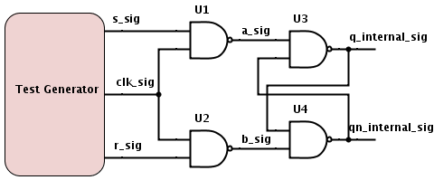

Fig. 1

The SetReset latch is implented with Nand2WithDelay gates and because of that it does not have output ports. The testbench traces the q_internal_sig for its output.

The Set latch

The Set latch and its TestGenerator are shown in Fig. 2.

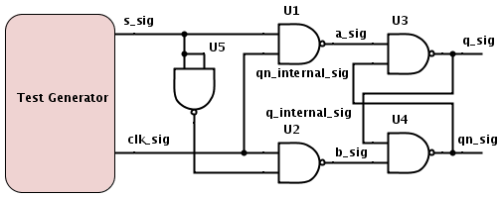

Fig. 2

This latch has three implementations. In SLatchV0 version the Nand2WithDelay gates were used, same like for SetReset latch. In the SLatchV1 the Nand2WithDelay were used with one extra method, WriteOutPort(), that helped to introduce the output ports q_out and qn_out. The third version of the latch is SlatchWithTwoOut that used for implementation the Nand2WithTwoOut gates. This implementation did not need the extra method as the previous implementation for having q_out and qn_out ports.

The D flipflop
The Dflipflop has multiple implementations too. Two of them are master and slave and the other two are optimized implementations. The master and slave DflipFlop schematic is shown in Fig.3.
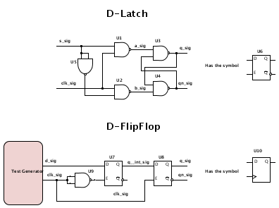

Fig. 3

The first version of the master slave DflipFlop is called DflipFlopFast and uses the SLatchV0. It runs faster than the DflipFlopMasterSlave that uses the SLatchV1 because does not have the extra methods used by the SLatchV1 latches.
The versions DflipFlop and DFlipFlop are the fastest, they are using six nand gates instead of eleven like the master slave flipflop. The DflipFlopR version is the flipflop with reset and its the version that is used for all the coming digital blocks.

The T flipflop
The TflipFlop schematic and testbench are shown in Fig.4.

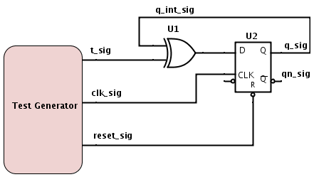

Fig. 4

