Week 1 housing forecasting exercise answers
This submission follows all seven numbered exercises in the supplied teaching module. Each exercise includes the requested model, numerical results and interpretation. The three final interpretation questions are answered after Exercise 7. All numbers come from the local housing database and the reproducible Week 1 run.

Data and evaluation dates
The primary raw training window begins in 2015-01. We use 13 monthly validation origins from 2020-12 through 2021-12 and 30 later test origins from 2022-12 through 2025-05. Validation outcomes through the longest horizon are available by the first test origin. The 3-, 6- and 12-month targets are identical across candidate models and eligible counties. Tables below report test errors unless labeled validation.
Geography | Variable | Observed first month | Observed last month | Missing months | Study status
Los Angeles County | zhvi | 2000-01 | 2026-08 | 0 | evaluated
Orange County | zhvi | 2000-01 | 2026-08 | 0 | evaluated
Riverside County | zhvi | 2000-01 | 2026-08 | 0 | evaluated
San Diego County | zhvi | 2000-01 | 2026-08 | 0 | evaluated
California | zhvi | Unavailable | Unavailable | N/A | insufficient coverage for fixed calendar
Los Angeles County | zori_smoothed_sa | 2015-01 | 2026-08 | 0 | evaluated
Los Angeles County | active_inventory | 2012-01 | 2026-05 | 0 | evaluated
Los Angeles County | permits_total | 2000-01 | 2026-06 | 0 | evaluated

We forecast log growth and recover price/rent levels by compounding the predicted changes. Consequently, MAE and RMSE in the price and rent tables are in USD and USD per month, respectively. They measure errors in recovered levels. MAPE compares errors relative to each observed level. These retrospective backtests use revised, provider-smoothed histories. Publication dates and historical release vintages have not been reconstructed.
The introductory level AR(1) estimates $P_{t}$ = a + b $P_{t−1}$ + $e_{t}$; a trending or nonstationary price level can give a high fitted R squared without good forecasts. The growth AR(1) instead models $g_{t}$ = a + b $g_{t−1}$ + $e_{t}$. Recover a horizon-h level as P_hat_(t+h) = $P_{t}$ × exp[(g_hat_(t+1) + … + g_hat_(t+h)) / 100]. Lag length counts past predictors; horizon counts months ahead. For example, AR(3) can produce a 12-month forecast by recursion. More lags can capture dynamics but estimate more parameters from the available sample. These introductory models and comparisons are included below.

Exercise 1 Lag length comparison
1.1 Estimate AR(1), AR(3), and AR(6) for monthly LA County ZHVI log growth using a consistent sample.
Let $P_{t}$ be LA County ZHVI and $g_{t}$ = 100 × [ln($P_{t}$) − ln($P_{t−1}$)]. For AR(p), the LHS is $g_{t}$ and the RHS contains an intercept and each separate lag $g_{t−1}$, …, $g_{t−p}$, for p equal to 1, 3 and 6. All three models retain six growth observations for initialization so that their fitted response months coincide.
1.2 Record the LHS, every RHS lag, coefficients, number of observations, and training dates.
The following regression snapshot uses information through 2022-12, the first test origin. Training RMSE is in percentage points of monthly log growth. The coefficients table includes every estimated RHS term. The complete origin-by-origin fits are in regressions.csv.
Model | Raw start | First fitted month | Last fitted month | N | Training RMSE | R squared
Growth AR(1) | 2015-01 | 2015-08 | 2022-12 | 89 | 0.4749 | 0.7412
Growth AR(3) | 2015-01 | 2015-08 | 2022-12 | 89 | 0.3098 | 0.8899
Growth AR(6) | 2015-01 | 2015-08 | 2022-12 | 89 | 0.2995 | 0.8971

Model | Raw start | Term | Coefficient
Growth AR(1) | 2015-01 | intercept | 0.080553
Growth AR(1) | 2015-01 | log_growth_pct_lag_1 | 0.864224
Growth AR(3) | 2015-01 | intercept | 0.161995
Growth AR(3) | 2015-01 | log_growth_pct_lag_1 | 1.486184
Growth AR(3) | 2015-01 | log_growth_pct_lag_2 | -0.705458
Growth AR(3) | 2015-01 | log_growth_pct_lag_3 | -0.036958
Growth AR(6) | 2015-01 | intercept | 0.145308
Growth AR(6) | 2015-01 | log_growth_pct_lag_1 | 1.507184
Growth AR(6) | 2015-01 | log_growth_pct_lag_2 | -0.765025
Growth AR(6) | 2015-01 | log_growth_pct_lag_3 | -0.039902
Growth AR(6) | 2015-01 | log_growth_pct_lag_4 | 0.287202
Growth AR(6) | 2015-01 | log_growth_pct_lag_5 | -0.446009
Growth AR(6) | 2015-01 | log_growth_pct_lag_6 | 0.226295

1.3 Forecast the same later observations and compare 3-, 6-, and 12-month accuracy.
Recovered home-value accuracy is measured in dollars on the same test dates.
Specification | 3m MAE | 3m RMSE | 6m MAE | 6m RMSE | 12m MAE | 12m RMSE
Growth AR(1) | 12,228.86 | 14,938.09 | 29,022.62 | 35,224.48 | 46,040.24 | 54,855.57
Growth AR(3) | 8,688.48 | 11,761.14 | 20,828.75 | 25,910.80 | 41,226.46 | 47,851.26
Growth AR(6) | 8,270.45 | 11,589.69 | 20,149.91 | 25,467.32 | 40,337.34 | 46,322.93

1.4a Which model fits training data best?
Growth AR(6) has the lowest training RMSE in this common-sample snapshot. The three rows above use identical fitted response months, so their training errors are comparable.
1.4b Does it forecast best?
Among these three growth models, the lowest test RMSE comes from Growth AR(6) at all three horizons. The best-fitting model therefore also forecasts best in this comparison. This is a comparison using realized test outcomes. Exercise 3 separately evaluates the specifications that earlier validation data selected.
1.4c Does this change by horizon?
The winning lag length stays the same at all three horizons. The benchmark comparison can still change with horizon. The following table states directly whether the best growth AR beats no change at each horizon.
Horizon | Best growth AR | Growth AR RMSE | No-change RMSE | Growth AR beats no change
3 | Growth AR(6) | 11,590 | 18,241 | Yes
6 | Growth AR(6) | 25,467 | 27,766 | Yes
12 | Growth AR(6) | 46,323 | 31,587 | No

Exercise 2 Window sensitivity
2.1 Keep AR(3), the outcome, and evaluation dates unchanged. Change only the training start.
Hold the LHS, AR(3) lag terms, expanding-window ends and all target dates fixed. Change only the first raw observation to each of the three dates below. The same seven-month growth/lag initialization applies to every start.
2.2 How do the fitted coefficients and forecast errors compare across samples?
Model | Raw start | First fitted month | Last fitted month | N | Training RMSE | R squared
Growth AR(3) | 2010-01 | 2010-08 | 2022-12 | 149 | 0.3079 | 0.8942
Growth AR(3) | 2015-01 | 2015-08 | 2022-12 | 89 | 0.3098 | 0.8899
Growth AR(3) | 2019-01 | 2019-08 | 2022-12 | 41 | 0.2322 | 0.8998

Model | Raw start | Term | Coefficient
Growth AR(3) | 2010-01 | intercept | 0.101827
Growth AR(3) | 2010-01 | log_growth_pct_lag_1 | 1.498180
Growth AR(3) | 2010-01 | log_growth_pct_lag_2 | -0.672246
Growth AR(3) | 2010-01 | log_growth_pct_lag_3 | -0.016983
Growth AR(3) | 2015-01 | intercept | 0.161995
Growth AR(3) | 2015-01 | log_growth_pct_lag_1 | 1.486184
Growth AR(3) | 2015-01 | log_growth_pct_lag_2 | -0.705458
Growth AR(3) | 2015-01 | log_growth_pct_lag_3 | -0.036958
Growth AR(3) | 2019-01 | intercept | 0.144346
Growth AR(3) | 2019-01 | log_growth_pct_lag_1 | 1.609759
Growth AR(3) | 2019-01 | log_growth_pct_lag_2 | -0.900912
Growth AR(3) | 2019-01 | log_growth_pct_lag_3 | 0.092455

Specification | 3m MAE | 3m RMSE | 6m MAE | 6m RMSE | 12m MAE | 12m RMSE
Start 2010-01 | 8,266.22 | 10,897.42 | 20,033.29 | 23,468.57 | 35,898.57 | 41,868.88
Start 2015-01 | 8,688.48 | 11,761.14 | 20,828.75 | 25,910.80 | 41,226.46 | 47,851.26
Start 2019-01 | 9,259.44 | 12,104.06 | 23,958.41 | 27,720.22 | 44,483.04 | 48,775.77

Six-month RMSE is $23,469, $25,911, $27,720 as the training start moves through the dates shown. The first-lag coefficients are 1.498, 1.486, 1.610, and the second-lag coefficients are -0.672, -0.705, -0.901. The recent window gives a stronger immediate response and a larger subsequent reversal in this run. Its smaller training error does not translate into the smallest test error.
2.3 Why can periods covering COVID-era dynamics or mortgage-rate changes produce different coefficients?
The latest window starts in 2019-01 and has only 17 fitted responses at the first validation origin. Pandemic-era changes in demand, available supply and prices therefore receive greater weight. Mortgage rates affect borrowing costs and purchasing power, which can change how price growth persists or reverses. An AR model summarizes those relationships through its lag coefficients. Changing the period changes the mixture of market conditions being summarized. These univariate regressions do not identify the separate causal effect of COVID or mortgage rates.
2.4 What is the difference between an expanding and a rolling window?
An expanding window fixes the start and advances the end. A rolling window advances both boundaries to retain a fixed length.

Exercise 3 Expanding window backtest
3.1 Select an initial training period of at least five years.
The initial raw window is 2015-01 through 2020-12, 72 consecutive monthly levels. It exceeds five years and has no missing months. The log difference and common lag initialization reduce the number of fitted responses, as recorded in the regression table.
3.2 Estimate AR(1) and forecast 3, 6, and 12 months ahead.
At the initial 2020-12 origin, retain the monthly levels from 2015-01 through that origin. Construct only backward differences and lags. Estimate each AR model, predict the next month, then feed predicted growth into subsequent unavailable lags. Compound each path from the observed origin level and retain the 3-, 6- and 12-month predictions. For a concrete example, the first test origin gives the following AR(1) forecasts in dollars.
Origin | Horizon | Target month | Forecast | Actual | Forecast minus actual
2022-12 | 3 | 2023-03 | 835,059 | 806,698 | 28,361
2022-12 | 6 | 2023-06 | 838,665 | 811,396 | 27,269
2022-12 | 12 | 2023-12 | 856,695 | 871,662 | -14,967

3.3 Advance the origin by one month, re-estimate, and repeat until the test period ends.
The test loop starts at 2022-12, advances one calendar month at a time and ends at 2025-05. It produces 30 forecasts for each model and horizon. Each new fit uses the expanded history through its own origin.
3.4 Apply the same procedure to AR(3), AR(6), and a naive benchmark.
AR(3) and AR(6) use the same response months and forecast origins as AR(1). The no-change benchmark predicts the last observed home value at every horizon. All four are scored on identical observed targets.
3.5 Plot predicted versus actual home values and calculate MAE and RMSE separately by horizon.
For each horizon, error = forecast − actual, MAE = mean absolute error, and RMSE = square root of mean squared error. The same procedure covers AR(1/3/6) and no change. The table below contains the requested horizon-specific scores, plus the introductory benchmarks.
Specification | 3m MAE | 3m RMSE | 6m MAE | 6m RMSE | 12m MAE | 12m RMSE
Growth AR(1) | 12,228.86 | 14,938.09 | 29,022.62 | 35,224.48 | 46,040.24 | 54,855.57
Growth AR(3) | 8,688.48 | 11,761.14 | 20,828.75 | 25,910.80 | 41,226.46 | 47,851.26
Growth AR(6) | 8,270.45 | 11,589.69 | 20,149.91 | 25,467.32 | 40,337.34 | 46,322.93
No change | 15,192.22 | 18,240.87 | 21,830.33 | 27,766.25 | 25,687.90 | 31,586.51
Seasonal naive | 30,206.78 | 34,589.33 | 28,500.14 | 33,290.32 | 25,687.90 | 31,586.51
Level AR(1) | 16,359.78 | 20,146.64 | 25,371.51 | 30,159.69 | 34,671.27 | 39,236.12
ARIMA(0,1,1) | 13,375.20 | 15,832.61 | 21,084.70 | 26,773.47 | 25,505.82 | 31,379.58

The level AR(1) directly regresses $P_{t}$ on an intercept and $P_{t−1}$. The introductory ARIMA(0,1,1) uses log prices, no drift, and a moving-average term in the differenced series. The seasonal benchmark repeats the corresponding month one year earlier.
The benchmark fit snapshot below also uses the 2022-12 origin. Level AR(1) training RMSE is in dollars. ARIMA innovation RMSE is in percentage points of monthly log growth, and OLS R squared does not apply to that conditional innovation fit.
Model | Raw start | First fitted month | Last fitted month | N | Training RMSE | R squared
Level AR(1) | 2015-01 | 2015-04 | 2022-12 | 93 | 5587.3974 | 0.9977
ARIMA(0,1,1) | 2015-01 | 2015-02 | 2022-12 | 95 | 0.6224 | N/A

Model | Raw start | Term | Coefficient
Level AR(1) | 2015-01 | intercept | -1299.260338
Level AR(1) | 2015-01 | level_lag_1 | 1.008247
ARIMA(0,1,1) | 2015-01 | innovation_lag_1 | 0.889753

Observed values and each lag model at three horizons
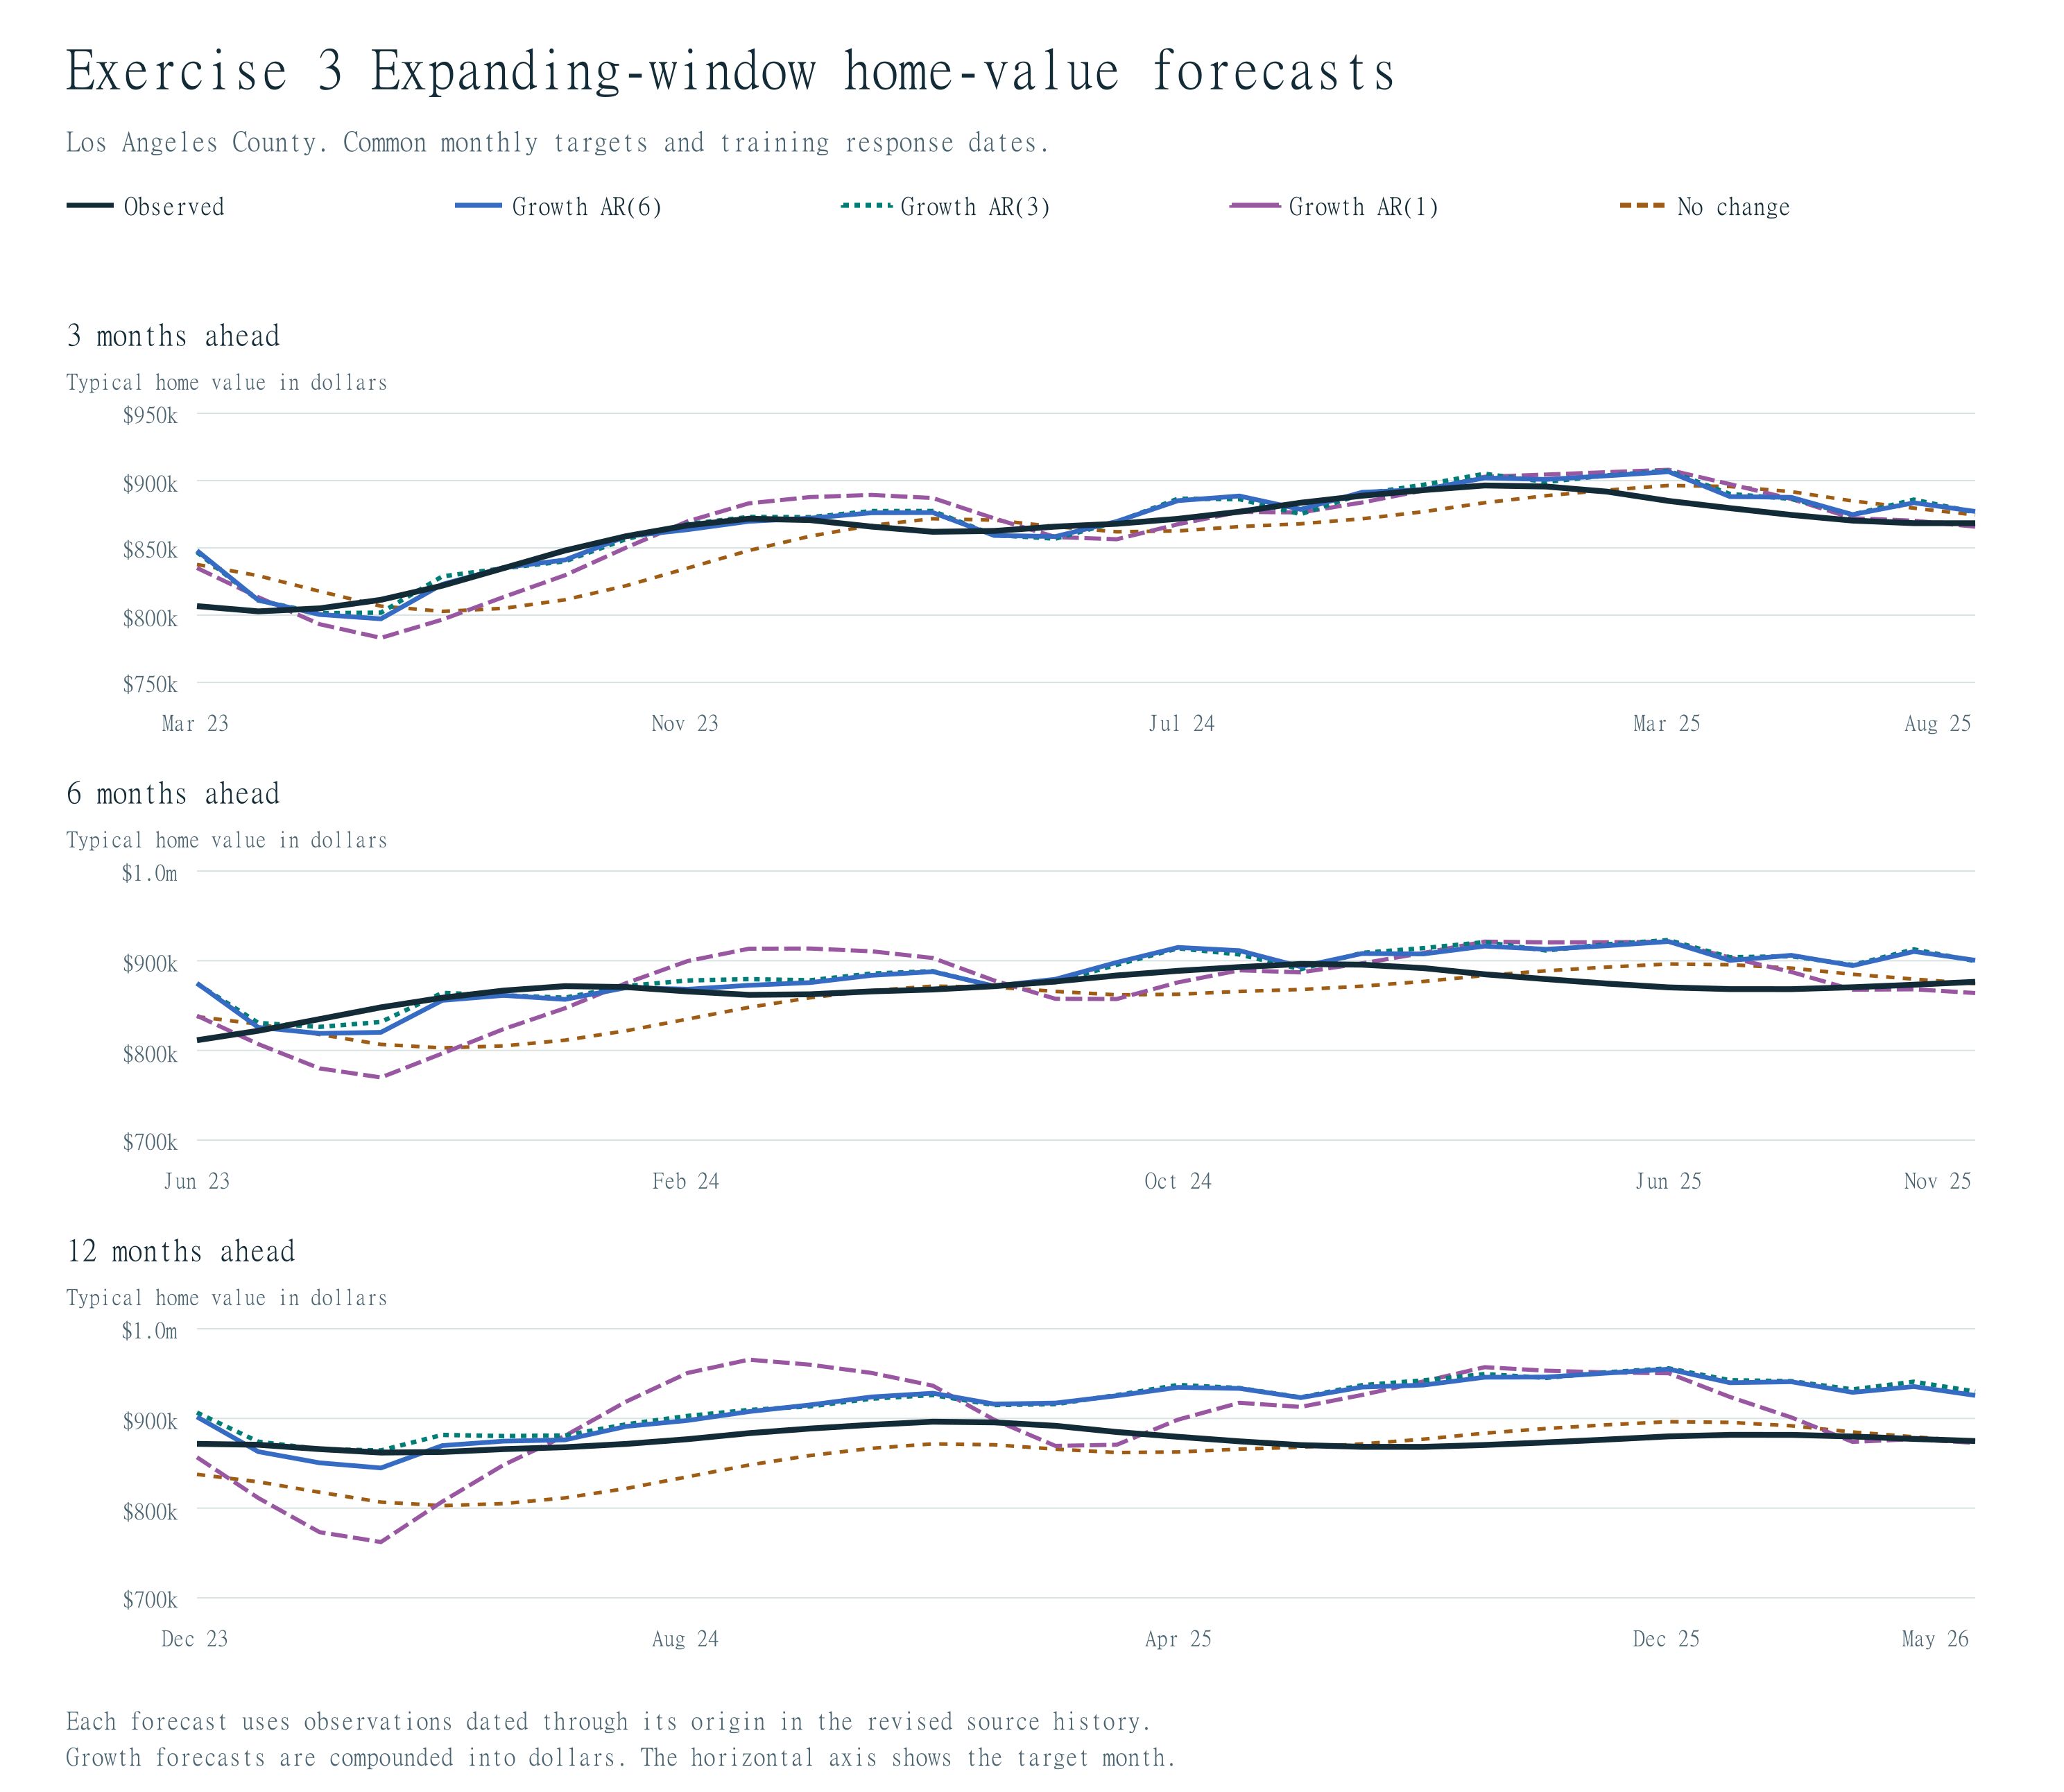
3.6 Keep an early validation period for choosing specifications and reserve a later independent test period.
Validation origins run from 2020-12 through 2021-12. Test origins run from 2022-12 through 2025-05. For independent evaluation, choose a model and training start using the minimum validation RMSE for that horizon, then assess that choice on the later test origins.
Horizon | Validation choice | Start | Validation RMSE | Test MAE | Test RMSE | No-change test RMSE
3 | Level AR(1) | 2015-01 | 7,819 | 16,360 | 20,147 | 18,241
6 | Level AR(1) | 2015-01 | 13,308 | 25,372 | 30,160 | 27,766
12 | Growth AR(1) | 2015-01 | 31,351 | 46,040 | 54,856 | 31,587

The validation-selected specifications have equal or larger test RMSE than no change at all three horizons. Good fitted values and even good validation performance do not guarantee performance in a later market period. All comparisons use matching dates, and adjacent multi-month errors overlap.
3.7 How is leakage avoided, and what limitation remains?
At each origin, slice the observed history before creating differences or lags and estimating coefficients. Recursion uses predicted future growth whenever a lag extends beyond the origin. Actual future values enter only the subsequent error calculation. No full-sample standardization or additional smoothing is applied. Provider revisions and smoothing are already embedded in the published histories, so these results are explicitly retrospective rather than real-time reconstructions of past information sets.

Exercise 4 Rent growth forecasts
4.1 Estimate AR(1) for rent growth and state the LHS and RHS.
Use the active all-homes-plus-multifamily ZORI, which Zillow smooths and seasonally adjusts. Let $r_{t}$ = 100 × [ln($R_{t}$) − ln($R_{t−1}$)]. The LHS is $r_{t}$ and the RHS is an intercept plus $r_{t−1}$. Recover forecast rent levels by compounding predicted growth from the origin rent.
4.2 Repeat with three and six lags.
AR(3) adds $r_{t−2}$ and $r_{t−3}$; AR(6) additionally includes $r_{t−4}$, $r_{t−5}$, and $r_{t−6}$, each with its own coefficient. All three fits use the same response months. The next tables give the fitted equations and test MAE/RMSE in dollars per month.
Model | Raw start | First fitted month | Last fitted month | N | Training RMSE | R squared
Growth AR(1) | 2015-01 | 2015-08 | 2022-12 | 89 | 0.1529 | 0.7909
Growth AR(3) | 2015-01 | 2015-08 | 2022-12 | 89 | 0.1414 | 0.8213
Growth AR(6) | 2015-01 | 2015-08 | 2022-12 | 89 | 0.1340 | 0.8394

Model | Raw start | Term | Coefficient
Growth AR(1) | 2015-01 | intercept | 0.044194
Growth AR(1) | 2015-01 | log_growth_pct_lag_1 | 0.891254
Growth AR(3) | 2015-01 | intercept | 0.057681
Growth AR(3) | 2015-01 | log_growth_pct_lag_1 | 0.837147
Growth AR(3) | 2015-01 | log_growth_pct_lag_2 | 0.398861
Growth AR(3) | 2015-01 | log_growth_pct_lag_3 | -0.371603
Growth AR(6) | 2015-01 | intercept | 0.059472
Growth AR(6) | 2015-01 | log_growth_pct_lag_1 | 0.915880
Growth AR(6) | 2015-01 | log_growth_pct_lag_2 | 0.339349
Growth AR(6) | 2015-01 | log_growth_pct_lag_3 | -0.652550
Growth AR(6) | 2015-01 | log_growth_pct_lag_4 | 0.347820
Growth AR(6) | 2015-01 | log_growth_pct_lag_5 | 0.133767
Growth AR(6) | 2015-01 | log_growth_pct_lag_6 | -0.223141

Specification | 3m MAE | 3m RMSE | 6m MAE | 6m RMSE | 12m MAE | 12m RMSE
Growth AR(1) | 10.60 | 14.46 | 18.28 | 25.77 | 39.09 | 52.74
Growth AR(3) | 12.39 | 16.61 | 22.58 | 31.16 | 49.43 | 62.26
Growth AR(6) | 11.36 | 15.13 | 20.65 | 29.49 | 52.32 | 64.57
No change | 14.83 | 17.50 | 28.22 | 31.06 | 54.70 | 58.51

The best rent lag specification by test RMSE is Growth AR(1) at all three horizons.
4.3 Is rent growth more or less predictable than home-value growth over the same dates?
The following percentage errors compare rents and home values on identical dates.
Model | Horizon | Home-value MAPE | Rent MAPE
Growth AR(1) | 3 | 1.44% | 0.39%
Growth AR(1) | 6 | 3.36% | 0.67%
Growth AR(1) | 12 | 5.26% | 1.42%
Growth AR(3) | 3 | 1.01% | 0.45%
Growth AR(3) | 6 | 2.41% | 0.83%
Growth AR(3) | 12 | 4.70% | 1.80%
Growth AR(6) | 3 | 0.97% | 0.42%
Growth AR(6) | 6 | 2.33% | 0.76%
Growth AR(6) | 12 | 4.60% | 1.91%

At six months, growth AR(3) has rent MAPE of 0.83% and price MAPE of 2.41%. Rent has lower percentage forecast errors in every matched model/horizon comparison in the table, so it is more predictable on this recovered-level metric. This is a comparison of growth-model forecasts recovered into published index levels; it does not equate low level MAPE with a high explained share of monthly growth variation.
4.4 Are the rent and price indexes seasonally adjusted or smoothed?
Both active ZORI and ZHVI are provider-smoothed and seasonally adjusted. No additional smoothing or seasonal adjustment is applied. The archived non-seasonally-adjusted ZORI vintage is excluded. Provider processing can affect apparent persistence and predictability, and revised histories limit real-time interpretations.
Rent forecasts and observed values
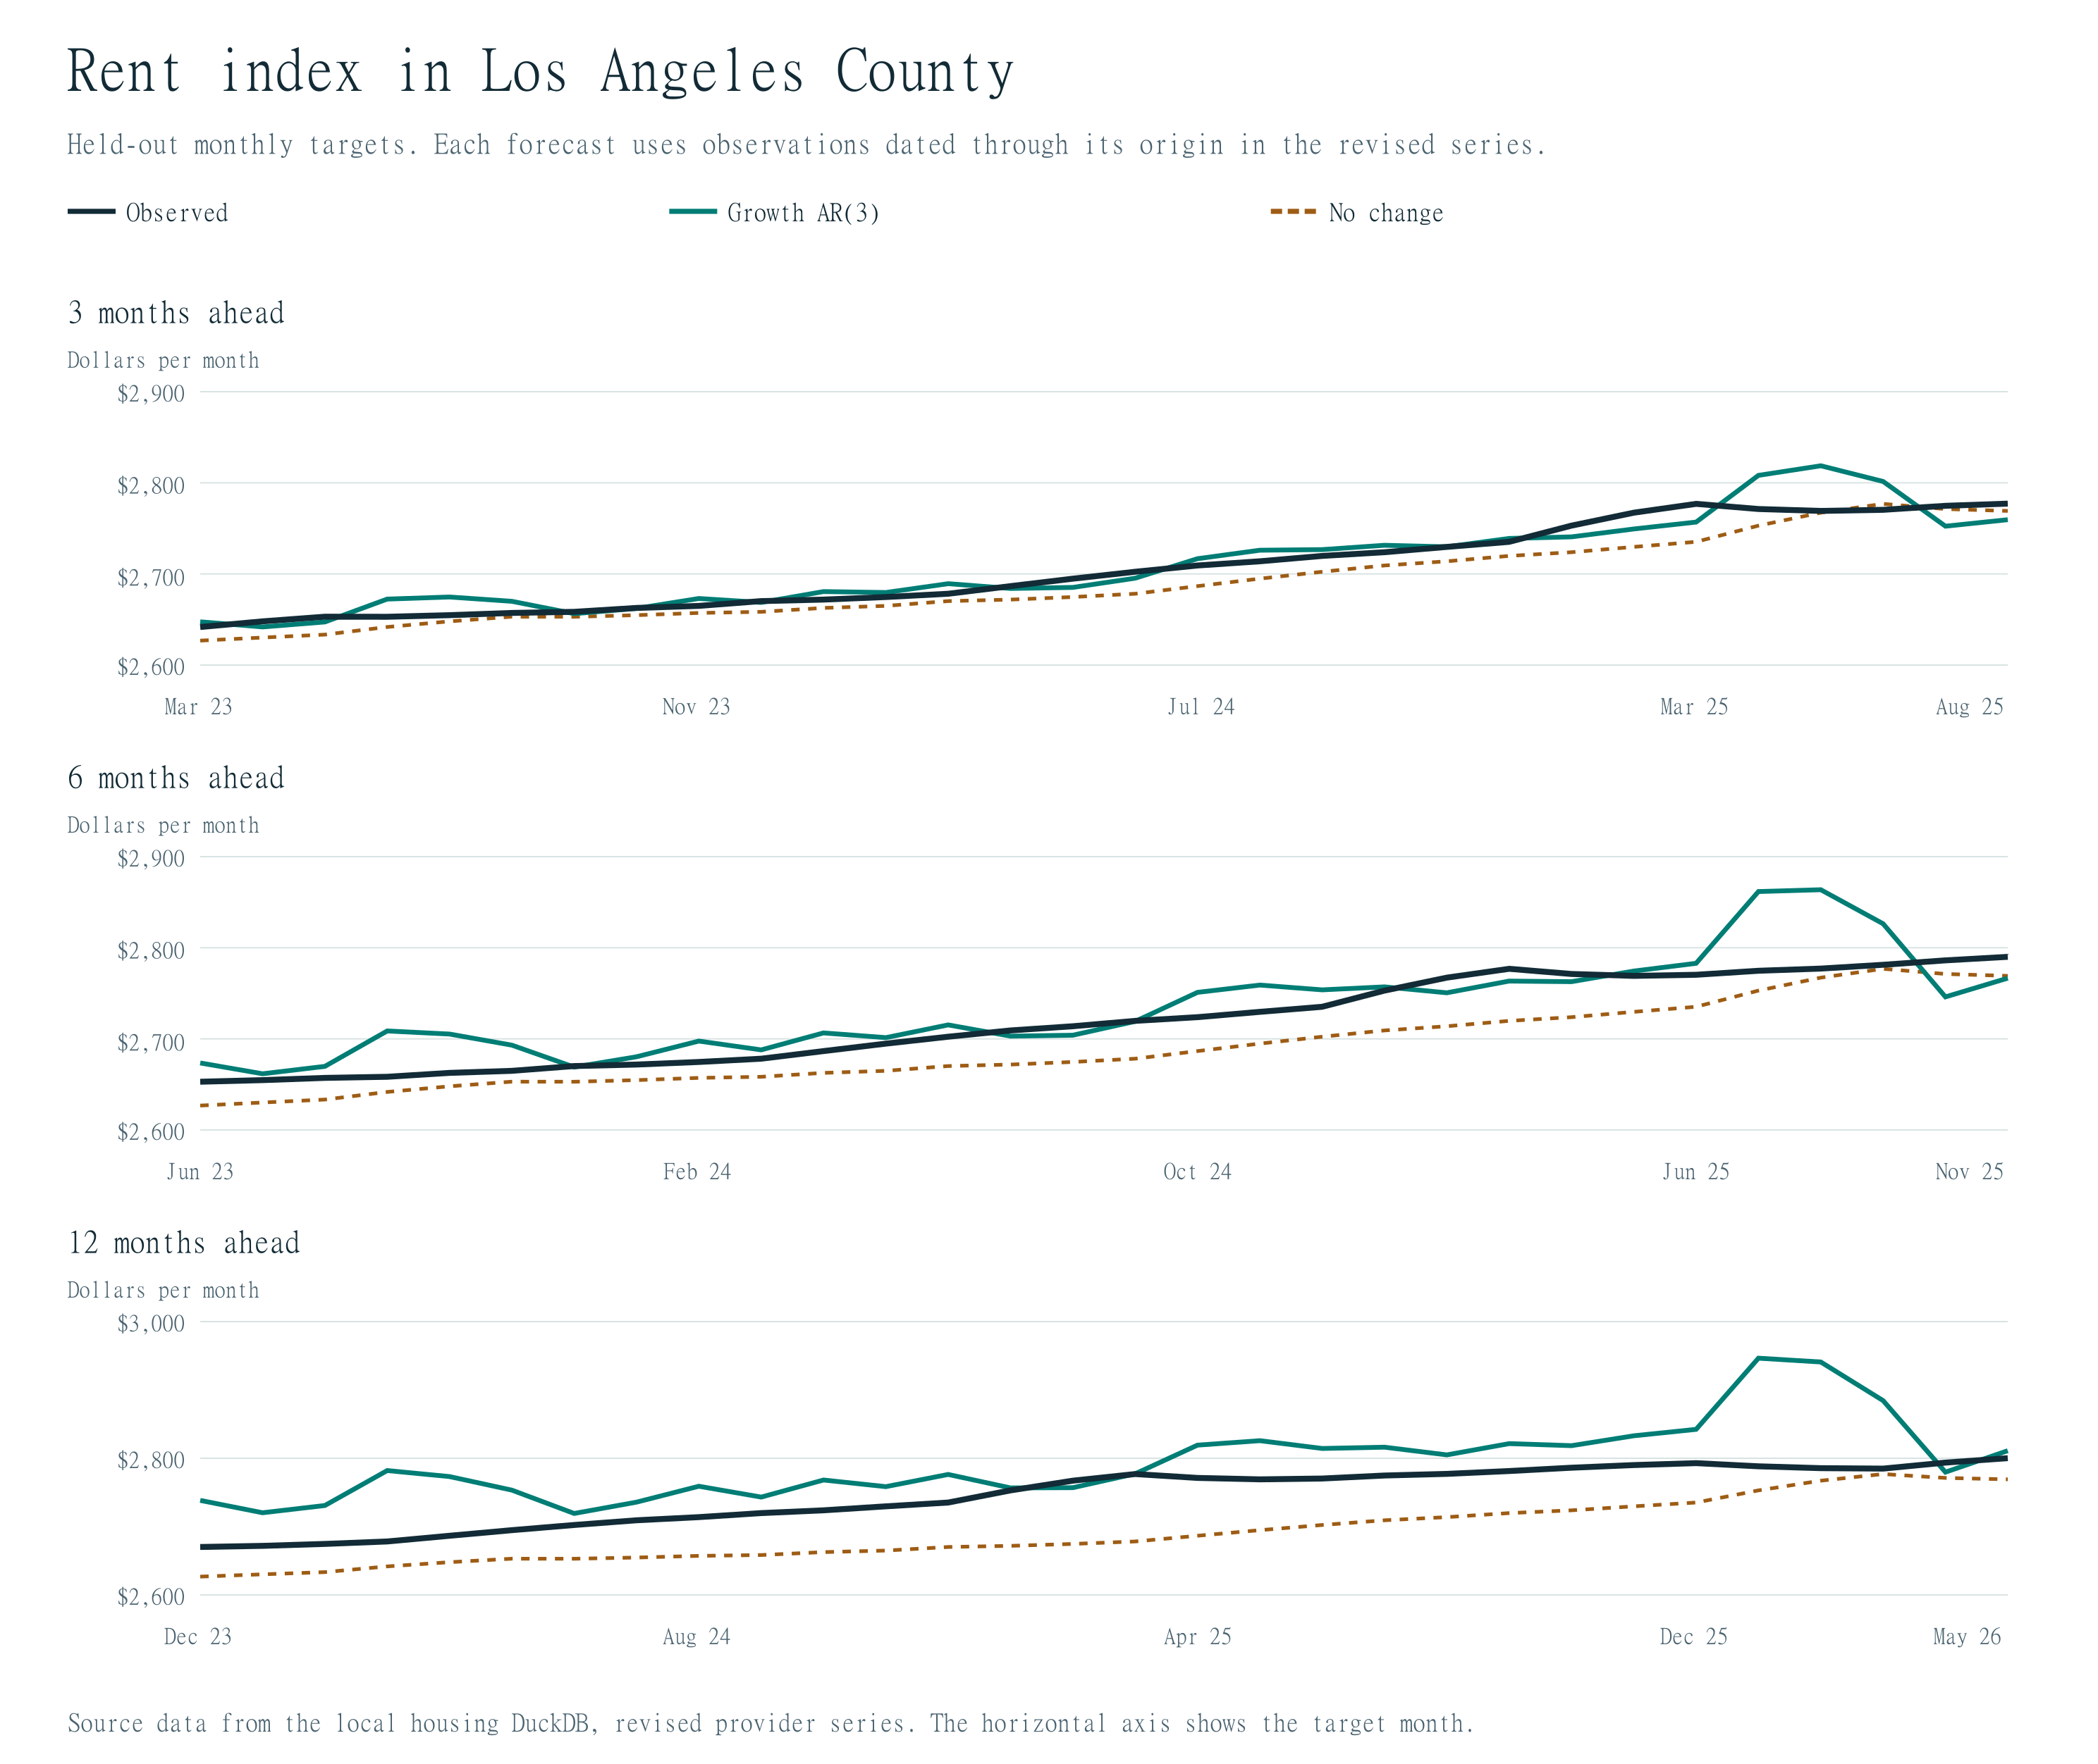

Exercise 5 Housing permit activity
5.1 Construct a trailing three-month moving average of permits.
Permits measure housing units authorized during each month. Construct $M_{t}$ as (${permits}_{t}$ + ${permits}_{t−1}$ + ${permits}_{t−2}$) / 3. The average uses the current and two prior months only; it never includes a future observation. The first two raw months initialize the average.
5.2 Regress the current moving average on its own first lag.
The fitted equation is $M_{t}$ = a + b $M_{t−1}$ + $e_{t}$. Its LHS is the current three-month mean; the RHS contains an intercept and the preceding month's three-month mean. The tables also show the raw-permit AR(1), with current monthly permits on the LHS and last month's permits on the RHS.
Model | Raw start | First fitted month | Last fitted month | N | Training RMSE | R squared
Level AR(1) | 2015-01 | 2015-04 | 2022-12 | 93 | 595.4199 | 0.0065
Mean AR(1) | 2015-01 | 2015-04 | 2022-12 | 93 | 246.4189 | 0.3967

Model | Raw start | Term | Coefficient
Level AR(1) | 2015-01 | intercept | 1990.774302
Level AR(1) | 2015-01 | level_lag_1 | -0.078742
Mean AR(1) | 2015-01 | intercept | 695.820634
Mean AR(1) | 2015-01 | mean3_lag_1 | 0.623226

5.3 Compare forecasts with a model estimated directly on raw monthly permits.
Raw monthly target. MAE and RMSE are in permitted units per month.
Specification | 3m MAE | 3m RMSE | 6m MAE | 6m RMSE | 12m MAE | 12m RMSE
Level AR(1) | 348.98 | 445.98 | 341.65 | 444.52 | 420.75 | 714.57
No change | 421.07 | 524.59 | 454.27 | 574.95 | 539.53 | 823.53
Seasonal naive | 407.77 | 489.71 | 410.73 | 491.59 | 539.53 | 823.53

Common trailing-mean target. Every row forecasts the same observed three-month mean. For the raw AR(1) comparison, average its predicted monthly levels, using observed components whenever those components fall on or before the origin.
Specification | 3m MAE | 3m RMSE | 6m MAE | 6m RMSE | 12m MAE | 12m RMSE
Mean AR(1) | 208.99 | 254.41 | 242.81 | 277.40 | 346.81 | 490.55
Raw AR(1) | 236.67 | 275.13 | 240.75 | 275.68 | 345.49 | 488.60
No change | 224.80 | 303.23 | 309.32 | 397.08 | 448.60 | 645.74
Seasonal naive | 273.39 | 357.26 | 278.64 | 362.50 | 448.60 | 645.74

At six months, direct mean AR(1) has RMSE 277.4, raw AR(1) followed by averaging has 275.7, all on the common mean target. The direct mean model has lower RMSE at 3 months. Smoothing therefore does not automatically produce the better forecasting method once the target is held fixed.
5.4 Compare with a seasonal-naive forecast.
Seasonal naive repeats the value from twelve months before the target. Its mean-target variant averages the three corresponding year-earlier monthly values. At six months its raw-target RMSE is 491.6, versus 444.5 for raw AR(1); its mean-target RMSE is 362.5, versus 277.4 for direct mean AR(1). The horizon-specific tables above retain the full comparison.
5.5 Why does overlapping smoothing create persistence, and how should forecast errors be compared?
Adjacent averages share two monthly observations, which creates persistence mechanically. For example, $M_{t}$ and $M_{t−1}$ both contain ${permits}_{t−1}$ and ${permits}_{t−2}$, even if raw monthly flows were independent. A smoother target also has less variation. Compare competing methods against the same observed target; a lower RMSE for means than for raw flows is not by itself evidence of improved forecasting. The raw and averaged targets therefore have separate tables. Census flags provider imputation in most monthly estimates, and monthly coverage expanded in 2022.
Permits forecasts on a common trailing-mean target
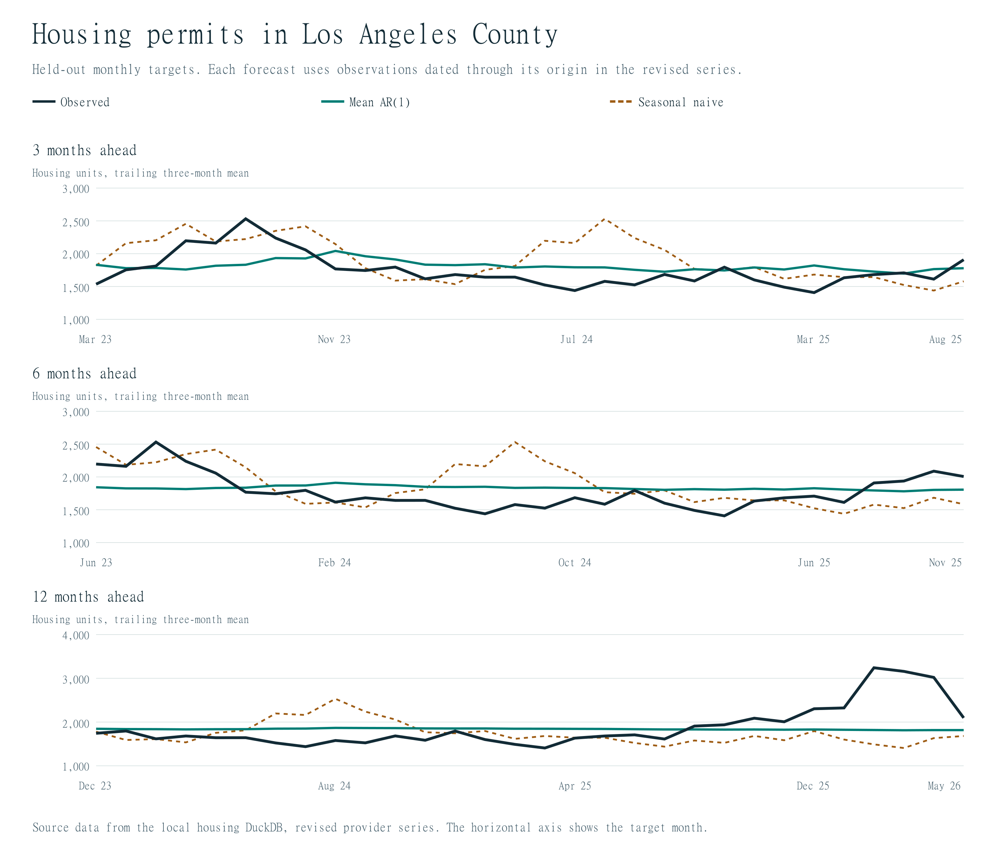

Exercise 6 Housing inventory
6.1 Verify whether a suitable inventory series is available.
Use Redfin county active inventory, an unadjusted monthly stock. The level models regress actual county inventory; no ZIP active-listings measure is relabeled as inventory. The data inventory at the start of this report records its observed coverage and confirms a complete monthly study interval.
6.2 Estimate AR(1) and AR(3) in inventory levels.
AR(1) has ${inventory}_{t}$ on the LHS and an intercept plus ${inventory}_{t−1}$ on the RHS. AR(3) adds ${inventory}_{t−2}$ and ${inventory}_{t−3}$, each separately. Both use the same fitted response months within the level comparison.
6.3 Consider log changes if the inventory observations are positive.
All available inventory observations are positive. Level-regression training RMSE is measured in homes, and growth-regression training RMSE in percentage points.
Define $q_{t}$ = 100 × [ln(${inventory}_{t}$) − ln(${inventory}_{t−1}$)]. The growth specifications regress $q_{t}$ on an intercept and its first lag or its first three lags. Forecast growth is compounded back into homes, so every row in the test table can be compared on the same level target.
Model | Raw start | First fitted month | Last fitted month | N | Training RMSE | R squared
Level AR(1) | 2015-01 | 2015-04 | 2022-12 | 93 | 1119.0147 | 0.8326
Level AR(3) | 2015-01 | 2015-04 | 2022-12 | 93 | 972.1093 | 0.8737
Growth AR(1) | 2015-01 | 2015-08 | 2022-12 | 89 | 7.3864 | 0.1566
Growth AR(3) | 2015-01 | 2015-08 | 2022-12 | 89 | 7.3320 | 0.1690

Model | Raw start | Term | Coefficient
Level AR(1) | 2015-01 | intercept | 1106.066081
Level AR(1) | 2015-01 | level_lag_1 | 0.927616
Level AR(3) | 2015-01 | intercept | 1785.654142
Level AR(3) | 2015-01 | level_lag_1 | 1.407950
Level AR(3) | 2015-01 | level_lag_2 | -0.551196
Level AR(3) | 2015-01 | level_lag_3 | 0.029065
Growth AR(1) | 2015-01 | intercept | -0.427468
Growth AR(1) | 2015-01 | log_growth_pct_lag_1 | 0.409131
Growth AR(3) | 2015-01 | intercept | -0.434843
Growth AR(3) | 2015-01 | log_growth_pct_lag_1 | 0.454884
Growth AR(3) | 2015-01 | log_growth_pct_lag_2 | -0.117960
Growth AR(3) | 2015-01 | log_growth_pct_lag_3 | -0.014314

Specification | 3m MAE | 3m RMSE | 6m MAE | 6m RMSE | 12m MAE | 12m RMSE
Level AR(1) | 1,528.40 | 1,917.90 | 2,051.78 | 2,548.54 | 2,173.34 | 2,599.07
Level AR(3) | 1,620.74 | 1,973.80 | 2,408.69 | 2,776.82 | 2,124.24 | 2,689.29
Growth AR(1) | 1,570.80 | 1,991.22 | 2,351.95 | 3,093.94 | 3,161.39 | 3,569.32
Growth AR(3) | 1,602.66 | 2,005.85 | 2,285.76 | 3,020.66 | 3,152.59 | 3,617.67
No change | 1,589.47 | 1,979.00 | 2,143.37 | 2,824.03 | 2,744.13 | 3,248.19
Seasonal naive | 3,126.27 | 3,490.20 | 3,215.90 | 3,522.12 | 2,744.13 | 3,248.19

Between the two level models, the lower test RMSE comes from Level AR(1) at all three horizons. Across all four fitted inventory models, the best RMSE comes from Level AR(1) at all three horizons.
6.4 Compare with a seasonal-naive benchmark.
The seasonal benchmark uses inventory in the target calendar month one year earlier. At six months it has RMSE 3,522 homes, versus 2,549 for level AR(1). The table reports its 3- and 12-month errors as well. Strong seasonality alone does not guarantee that a year-earlier observation forecasts well when the overall inventory level changes.
6.5 Does inventory have stronger seasonality than prices?
Calendar-month means explain 87.4% of monthly inventory log-change variation versus 5.5% for prices over matching dates through the first test origin. The inventory series has a stronger seasonal pattern in this comparison, while ZHVI is already smoothed and seasonally adjusted by its provider.
Inventory forecasts and seasonal benchmark
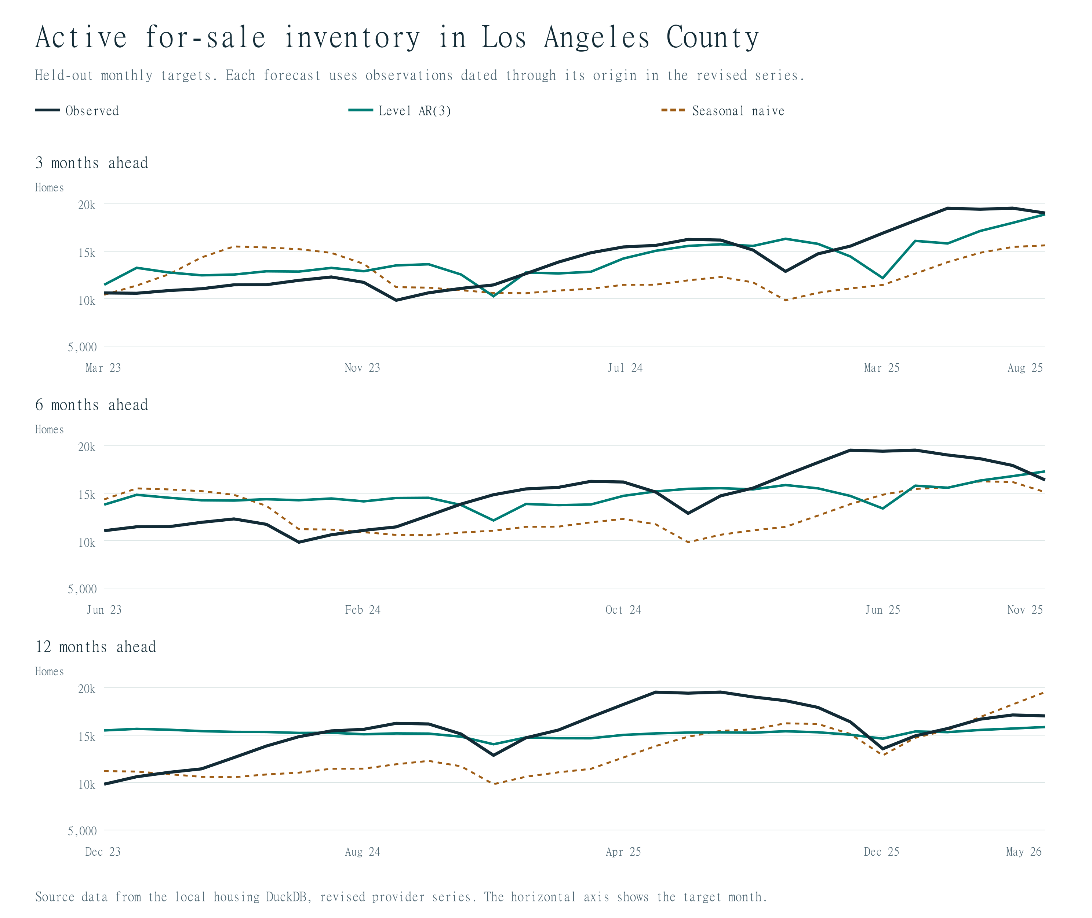

Exercise 7 California county comparison
7.1 Verify comparable data for at least two other counties and estimate AR(1) and AR(3).
Repeat growth AR(1) and AR(3) for Orange, Riverside and San Diego in addition to LA. All four have complete ZHVI histories for the study interval, as recorded in the inventory table. The county accuracy table below reports the results, and the full county coefficients and sample dates are retained in regressions.csv.
7.2 Keep units, transformations, lag definitions, horizons, and evaluation dates comparable.
All use the same ZHVI definition in dollars, log-growth transformation, raw training start, six-growth-month initialization, forecast horizons and test dates.
County | Model | 3m MAE | 3m RMSE | 6m MAE | 6m RMSE | 12m MAE | 12m RMSE
Los Angeles | Growth AR(1) | 12,229 | 14,938 | 29,023 | 35,224 | 46,040 | 54,856
Los Angeles | Growth AR(3) | 8,688 | 11,761 | 20,829 | 25,911 | 41,226 | 47,851
Los Angeles | No change | 15,192 | 18,241 | 21,830 | 27,766 | 25,688 | 31,587
Orange | Growth AR(1) | 12,467 | 14,983 | 28,574 | 35,234 | 55,255 | 65,377
Orange | Growth AR(3) | 9,320 | 11,621 | 23,515 | 27,428 | 45,860 | 51,647
Orange | No change | 22,221 | 25,308 | 39,882 | 45,899 | 62,197 | 77,460
Riverside | Growth AR(1) | 3,699 | 4,795 | 10,350 | 13,529 | 27,164 | 32,251
Riverside | Growth AR(3) | 3,275 | 3,989 | 10,253 | 12,075 | 30,214 | 33,230
Riverside | No change | 6,488 | 7,301 | 11,393 | 12,728 | 17,853 | 20,320
San Diego | Growth AR(1) | 9,453 | 11,357 | 23,976 | 28,765 | 52,543 | 60,569
San Diego | Growth AR(3) | 7,159 | 8,795 | 21,917 | 25,857 | 47,725 | 59,601
San Diego | No change | 13,857 | 17,486 | 25,886 | 31,576 | 42,295 | 51,184

7.3 Does the same lag length work best in each county?
County | Lower RMSE at 3m | At 6m | At 12m | 6m AR(3) MAPE | Growth SD in pp
Los Angeles | Growth AR(3) | Growth AR(3) | Growth AR(3) | 2.41% | 0.647
Orange | Growth AR(3) | Growth AR(3) | Growth AR(3) | 2.12% | 0.601
Riverside | Growth AR(3) | Growth AR(3) | Growth AR(1) | 1.69% | 0.370
San Diego | Growth AR(3) | Growth AR(3) | Growth AR(3) | 2.36% | 0.596

The preferred lag depends on both county and horizon. At 3 months: Los Angeles favors Growth AR(3), Orange favors Growth AR(3), Riverside favors Growth AR(3), San Diego favors Growth AR(3). At 6 months: Los Angeles favors Growth AR(3), Orange favors Growth AR(3), Riverside favors Growth AR(3), San Diego favors Growth AR(3). At 12 months: Los Angeles favors Growth AR(3), Orange favors Growth AR(3), Riverside favors Growth AR(1), San Diego favors Growth AR(3).
7.4 Are forecast errors larger in more volatile markets?
Los Angeles has the highest growth standard deviation and Los Angeles the highest six-month AR(3) MAPE. Riverside has the lowest volatility and Riverside the lowest MAPE. The full ranking differs, so greater volatility does not consistently imply a larger error. The six-month MAPE and growth standard deviation use matching target months. MAPE removes the immediate effect of different dollar price levels. The relationship is partly consistent at the extremes, but four counties do not establish a general statistical or causal relationship.
7.5 If statewide data are available, estimate a comparable statewide model.
Statewide ZHVI has no observations in this database, so a statewide model could not be estimated. The optional state comparison is therefore governed by actual source availability and the same fixed-date eligibility checks as the county models.
7.6 Can an unweighted average of the available counties be treated as a statewide index?
No. These four counties do not cover California, and equal county weights ignore differences in housing stock and the provider's index construction. No county average is substituted for an official statewide series.

Final interpretation questions

1. How much of future housing-market behavior can be predicted from the variable’s own past?
What the question means. I interpret 'how much' as the amount of useful predictive information in a variable's history. How far ahead that information remains useful is one part of the answer; the technical term for months ahead is the forecast horizon. The assignment tests 3, 6 and 12 months, rather than asking for one maximum number of predictable months. We should therefore report both forecast accuracy and its change with the horizon. A forecast can be calculated farther ahead without being accurate enough to use.
How predictive value is measured here. Compare errors on later observations with the no-change forecast, which carries the last observed level forward. RMSE is in the outcome's units and gives more weight to large misses. In the following tables, RMSE reduction = 100 × (1 − model RMSE / benchmark RMSE). Positive values indicate improvement; negative values indicate larger errors. A 36% RMSE reduction means a 36% smaller error measure, not that 36% of future market behavior has been explained. Training R squared likewise describes fit to known outcomes, not a percentage of future behavior that we can predict. This distinction follows the treatment of held-out forecast accuracy in Forecasting: Principles and Practice, Section 5.8.
LA home values: useful short-horizon dynamics, weaker evidence at one year. For the main 2015-start comparison, the following are test results for growth AR(6), the strongest of the three tested growth-lag models in this run.
Horizon | AR(6) RMSE, USD | No-change RMSE, USD | RMSE reduction
3 | 11,590 | 18,241 | +36.5%
6 | 25,467 | 27,766 | +8.3%
12 | 46,323 | 31,587 | -46.7%

At three months, the reduction is 36.5%; at six months it is 8.3%. At twelve months, the growth-model error is 46.7% larger than no change. Within this comparison, estimating recent growth dynamics helps most at three months and provides a smaller gain at six months. Extending the same growth dynamics to one year does not improve the forecast. The log ARIMA benchmark has twelve-month RMSE $31,380, only 0.7% below no change. Thus the data do not show a substantial, broadly shared one-year improvement for the fitted LA price models.
The distinction between an observed winner and a usable selection rule matters. The AR(6) comparison above is descriptive: its relative success is observed on the test period. The specifications chosen using only earlier validation results perform as follows.
Horizon | Validation-selected model | Selected test RMSE, USD | RMSE reduction vs no change
3 | Level AR(1) | 20,147 | -10.4%
6 | Level AR(1) | 30,160 | -8.6%
12 | Growth AR(1) | 54,856 | -73.7%

In this run, the validation-selected LA price models lose to no change at all three horizons. This means the process did not reliably identify in advance the model that would perform best in the later market period. It would therefore overstate the evidence to say 'we can reliably predict prices six months ahead.' No change itself uses the variable's past, so failing to beat it does not mean historical information is useless.
The useful horizon also depends on the outcome. The fixed-model test comparisons give the following reductions relative to each outcome's own no-change forecast. These are descriptive comparisons, not the performance of the validation-selected procedure.
Outcome and model | 3m RMSE reduction | 6m RMSE reduction | 12m RMSE reduction
Rent: growth AR(1) | +17.4% | +17.0% | +9.9%
Inventory: level AR(1) | +3.1% | +9.8% | +20.0%

These rent and inventory models improve on no change even at twelve months, so six months is not a universal cutoff across housing variables. Our evidence is limited to the tested 3-, 6- and 12-month horizons. We have not established accuracy beyond twelve months, an exact cutoff between the tested horizons, or a single percentage of predictable behavior. Whether an error is tolerable also depends on the purpose of the forecast.

2. How sensitive are the results to lag length, training period, and prediction horizon?
Lag length: most of the LA price gain comes from moving from one to three lags. Hold the raw start at January 2015 and use identical response months and forecast origins. The table reports RMSE in dollars for recovered home-value levels.
Growth specification | 3m RMSE | 6m RMSE | 12m RMSE
Growth AR(1) | 14,938.09 | 35,224.48 | 54,855.57
Growth AR(3) | 11,761.14 | 25,910.80 | 47,851.26
Growth AR(6) | 11,589.69 | 25,467.32 | 46,322.93

At six months, moving from AR(1) to AR(3) lowers RMSE by 26.4%. Moving from AR(3) to AR(6) provides a further 1.7% reduction. The additional AR(3)-to-AR(6) reduction is 1.5% at three months and 3.2% at twelve months. More lags help within this family, but the incremental gains after three lags are small, and none of these main-window growth models beats no change at twelve months. A six-lag model uses six past monthly growth rates; it is not limited to forecasting six months ahead.
Training period: more recent data do not automatically yield better forecasts. Keep the AR(3) specification and evaluation dates fixed. The sample sizes and training RMSE below are the December 2022 fit snapshot; training RMSE is in percentage points of monthly log growth, while test RMSE is in dollars.
Raw start | Fitted N | Training RMSE, pp | 6m test RMSE, USD | 12m test RMSE, USD
2010-01 | 149 | 0.308 | 23,469 | 41,869
2015-01 | 89 | 0.310 | 25,911 | 47,851
2019-01 | 41 | 0.232 | 27,720 | 48,776

Extending the start from 2015 to 2010 lowers six-month RMSE by 9.4%; shortening it from 2015 to 2019 raises that error by 7.0%. The recent window has the smallest training residuals but larger forecast errors. Because these windows contain different response months, their training errors describe different samples; the matched test errors provide the fair forecast comparison.
The coefficients also change. At the common December 2022 origin, the first-lag coefficients for starts 2010-01, 2015-01, 2019-01 are 1.498, 1.486, 1.610, and the second-lag coefficients are -0.672, -0.705, -0.901. The recent fit estimates a stronger immediate response and a larger subsequent reversal. It contains fewer observations and puts more weight on pandemic-era and rate-transition conditions. Those differences can change fitted persistence, but these regressions do not identify which economic shock caused the coefficient changes.
Prediction horizon: the dollar errors grow substantially and benchmark rankings change. For the main AR(3), RMSE rises from $11,761 at three months to $25,911 at six months and $47,851 at twelve months. The twelve-month error is 4.07 times the three-month error. Recursive forecasts use predicted growth as future lag inputs, so errors can accumulate; changes in market dynamics also matter. Models share target dates within each horizon. Across horizons, the target calendar shifts, so the observed increase reflects both distance ahead and the market months being forecast.
The same model is therefore not uniformly preferable across horizons or estimation periods. Earlier validation selected level AR(1) at three and six months and growth AR(1) at twelve months, but those selections underperformed no change on the later test. The main practical finding is sensitivity of the model choice itself, not merely a gradual increase in error as forecasts extend farther ahead.

3. Do the same simple models work across home prices, rents, permits, inventory, and California counties?
The modeling framework transfers; the best specification and its advantage do not. Each outcome can be studied with univariate lag models and common backtesting rules, but the suitable transformation, lag length, benchmark and target definition differ. Dollar errors for home values, monthly rent errors, permit flows and inventory counts must be interpreted in their own units.
Prices versus rents. Among the growth models with the common January 2015 start, LA price accuracy favors Growth AR(6) at all three horizons, while rent accuracy favors Growth AR(1) at all three horizons. At six months, rent AR(1) has RMSE $25.77 per month, compared with $31.16 for AR(3), $29.49 for AR(6), and $31.06 for no change. Training fit and test accuracy answer different questions; the winning rent lag length is stated above. Using the same AR(3) specification and dates, six-month MAPE is 0.83% for rents and 2.41% for home values. Rent levels are more predictable on this proportional-error metric; this is not a comparison of explained monthly-growth variance. Both indexes are provider-smoothed and seasonally adjusted.
Permits: a volatile monthly flow and a target-definition issue. At six months, raw permit AR(1) has RMSE 444.5 units, compared with 574.9 for no change and 491.6 for seasonal naive. On the common trailing-three-month-mean target, the direct mean AR(1) has RMSE 277.4, forecasting raw flows then averaging has 275.7, and seasonal naive has 362.5. The direct mean model does better at three months, whereas the raw-then-average method does slightly better at six and twelve. The lower error of an averaged series cannot itself establish a better method: adjacent means share two months, creating persistence and reducing volatility. Provider imputation and the 2022 coverage change also qualify the economic interpretation.
Inventory: a level model works better than these growth models. Level AR(1) has six-month RMSE 2,549 homes, compared with 2,777 for level AR(3), 3,094 for growth AR(1), 3,021 for growth AR(3), and 3,522 for seasonal naive. The level AR(1) also has the lowest fitted-model test RMSE at three and twelve months. Inventory is an unadjusted stock with pronounced seasonal movement, but repeating last year's calendar month still performs poorly when the overall level changes. The presence of seasonality does not guarantee that seasonal naive is the strongest benchmark.
Counties: short-horizon transfer is stronger than one-year transfer. The following table compares the same 2015-start growth AR(3) with each county's no-change forecast. Relative RMSE reductions put counties with different price levels on a comparable benchmark-relative scale.
County | 3m RMSE reduction | 6m RMSE reduction | 12m RMSE reduction
Los Angeles | +35.5% | +6.7% | -51.5%
Orange | +54.1% | +40.2% | +33.3%
Riverside | +45.4% | +5.1% | -63.5%
San Diego | +49.7% | +18.1% | -16.4%

AR(3) beats AR(1) in all four counties at three and six months. At twelve months, Riverside favors AR(1), while the other three still favor AR(3). However, being the better AR model does not guarantee beating the benchmark: only Orange County's AR(3) improves on no change at twelve months. The same lag structure therefore has more consistent benchmark gains at short horizons than at one year. LA's high volatility and Riverside's low volatility align with their six-month proportional errors, but Orange and San Diego reverse that ranking. Four counties provide descriptive evidence rather than a general volatility-error law. Statewide ZHVI is unavailable in this run; an unweighted average of these counties is not a California index.
Can the observed winning specification be selected in advance? The following summarizes the actual validation-selection procedure. It guards against treating the best model observed after the test as a model we would necessarily have chosen beforehand.
Outcome | Horizon | Validation-selected model | Test RMSE reduction vs no change
Prices | 3 | Level AR(1) | -10.4%
Prices | 6 | Level AR(1) | -8.6%
Prices | 12 | Growth AR(1) | -73.7%
Rents | 3 | Growth AR(3) | +5.1%
Rents | 6 | Growth AR(6) | +5.1%
Rents | 12 | Growth AR(6) | -10.4%
Inventory | 3 | Growth AR(3) | -1.4%
Inventory | 6 | Seasonal naive | -24.7%
Inventory | 12 | No change | +0.0%

For rents, validation selections improve slightly at three and six months but lose at twelve; inventory selections lose at three and six months and tie the benchmark at twelve because no change was selected. Useful fixed-model relationships therefore coexist with instability in model selection. The evidence supports outcome- and horizon-specific evaluation, keeping simple benchmarks in the candidate set.
Scope of the conclusions. These are point-forecast comparisons from 30 test origins per horizon. Adjacent multi-month errors overlap. We have not established statistical significance of small RMSE differences or calibrated prediction intervals. Revised provider histories and smoothing make the exercise retrospective. The results describe how the tested methods performed in this sample; they do not guarantee future accuracy or identify causal economic mechanisms.
Full numerical evidence is retained in accuracy.csv, regressions.csv, forecasts.csv, selections.csv and transformation_log.csv.

