**How to Compile the Othello Turbo C code**

1. Download the WinTC191.exe

<https://drive.google.com/drive/folders/0B0CbOwDvxUo6aVpia0FkbTJYQzA>

1. Install WinTC software in **WinXP** system with default folder. You can use the VM Box :)
2. Download the source code zip file and extract to C driver root folder, please do not leave any Chinese characters in the folder paths.
3. Open WinTC and import the heibai.c file.
4. Click WinTC menu, Run(运行), Compile settings(编译配置), select “Super big memory mod”(特大存贮模式), then click OK (确定) button.

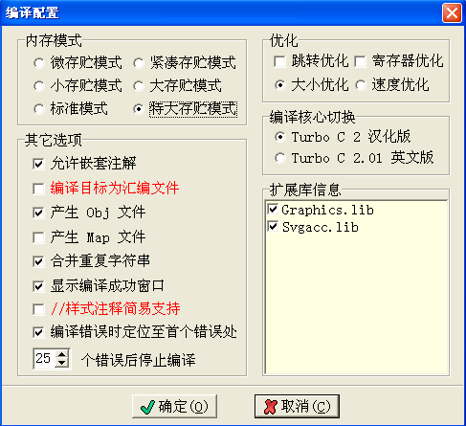

1. Compile the code, it will be show a compile successfully message.

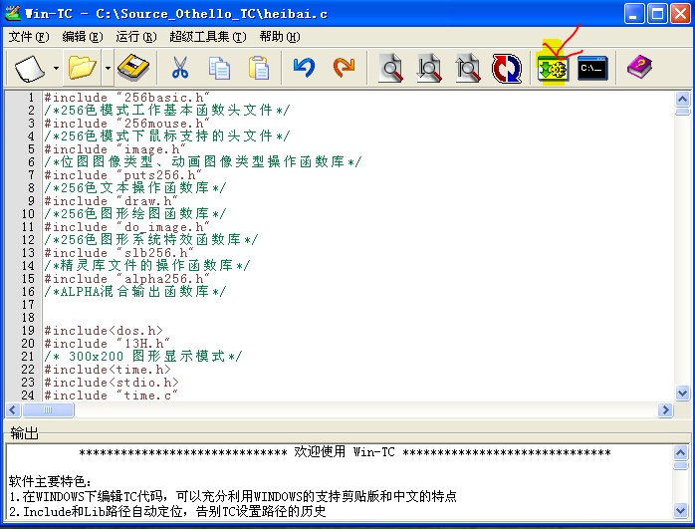

If you face any compile issue, please sent mail to me [cicistudio@qq.com](mailto:cicistudio@qq.com)