# 1,配置BusyBox

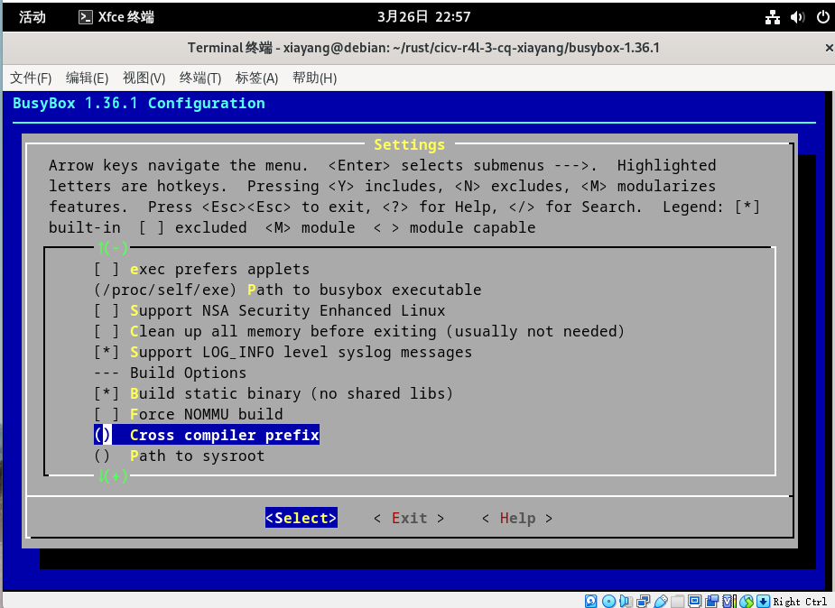

# 2.安装QEMU

xiayang@debian:~/rust/cicv-r4l-3-cq-xiayang/busybox-1.36.1$ qemu-system-x86_64 --version

QEMU emulator version 7.2.9 (Debian 1:7.2+dfsg-7+deb12u5)

Copyright (c) 2003-2022 Fabrice Bellard and the QEMU Project developers

[xiayang@debian:~/rust/cicv-r4l-3-cq-xiayang/busybox-1.36.1$](mailto:xiayang@debian:~/rust/cicv-r4l-3-cq-xiayang/busybox-1.36.1$)

# 3配置Linux文件夹

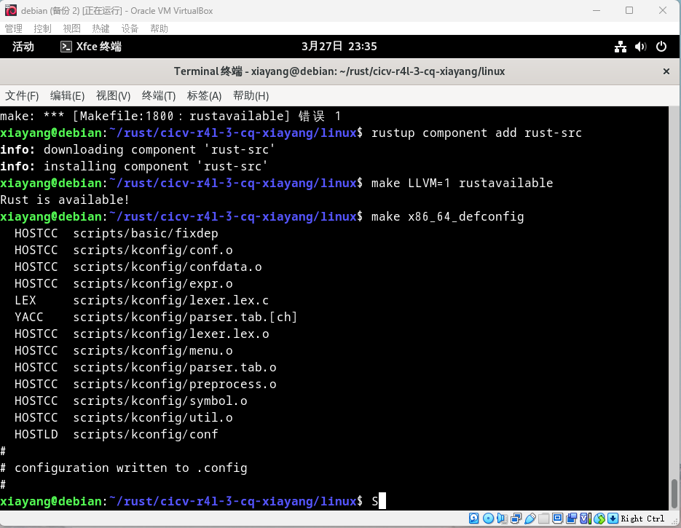

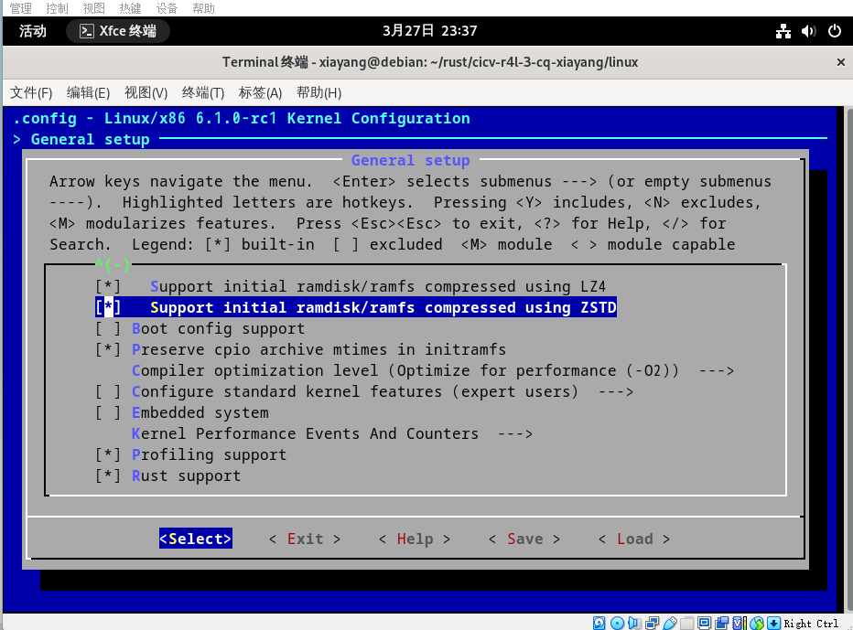

# 4编译Linux内核

# 

