# Reporting a Suspicious E-Mail in Outlook

## Examples

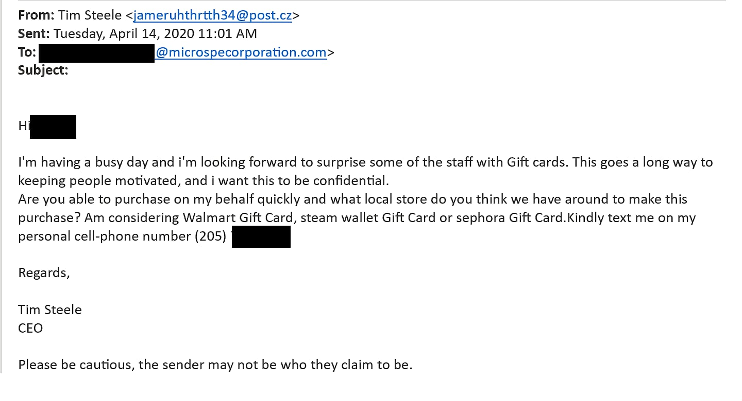

## Desktop Application

1. When you suspect an e-mail is malicious, ensure you do not click links and if you have contact IT.
2. While the suspicious email is selected click the “Home” tab on the top-right of the Outlook window.



1. 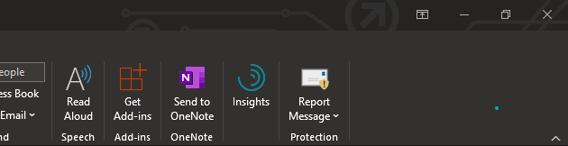Under the Home category, on the right side click “Report Message”.
2. 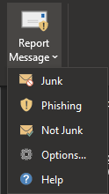After, click what you are reporting the message for.
3. 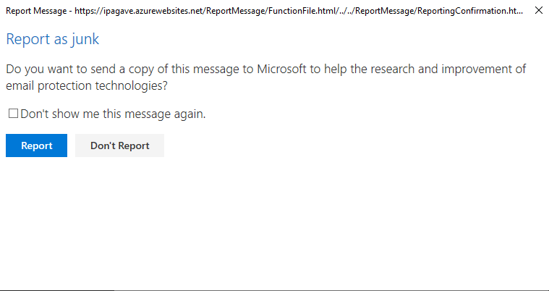Outlook will ask you if you would like to send the report to Microsoft.
4. Our IT team will receive the report and review the e-mail.

## Browser Application

1. 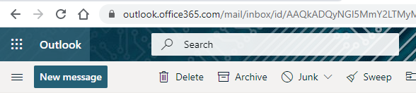While the suspicious e-mail is selected, in the top of the Outlook webpage, click “Junk”.
2. 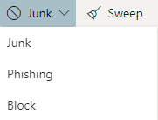After, click what you are reporting the message for.
3. 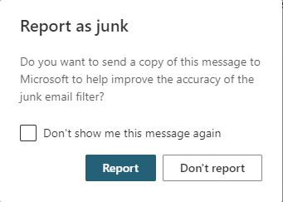Outlook will ask you if you would like to send the report to Microsoft.
4. Our IT team will receive the report and review the e-mail.