**Done by SinKau Chu**

**Select for Sin Kau's own table**

Purpose of the script

* Select all columns from the MEDICATIONS table
* Filter the rows to include only those with 2 or more refills
* Sort the results first by the number of refills in descending order
* and then by medication ID in ascending order for records with the same number of refills

-- Select for Sin Kau's own table

SELECT* FROM MEDICATIONS

WHERE REFILLS >= 2

ORDER BY REFILLS DESC, MEDICATIONID ASC;

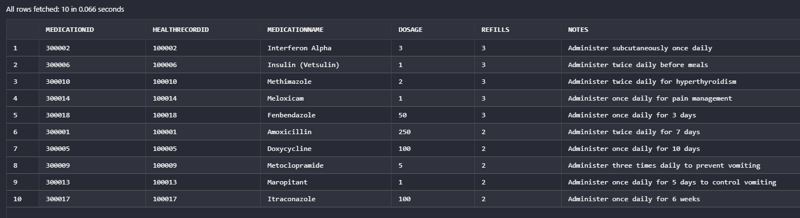

**Done by SinKau Chu**

**Select for other's table by Sin Kau**

Purpose of the script

* Select all columns from the HEALTHRECORDS table
* Filter the rows to include only those with PETID in the specified
* Sort the results by health record ID in ascending order

SELECT* FROM HEALTHRECORDS

WHERE PETID IN (20110,20111,20112,20113,20114,20115,20120)

ORDER BY HEALTHRECORDID ASC;

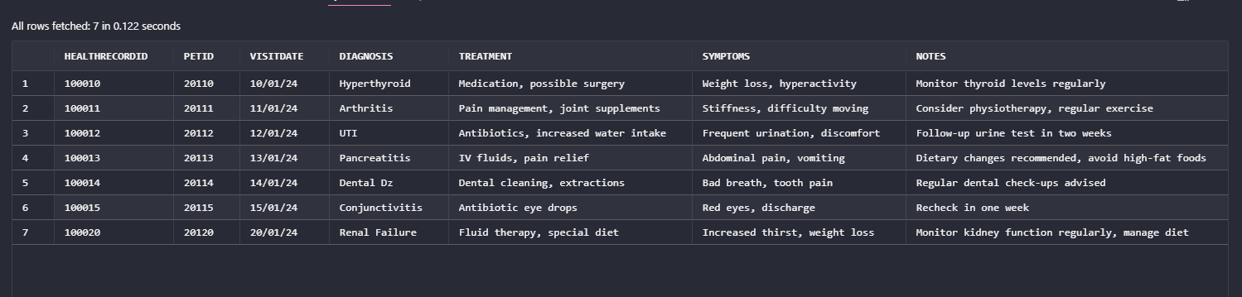

**Done by SinKau Chu**

**Join for Sin Kau's own Healthrecords table with other's Pets TABLER**

Purpose of the script

* Select specific columns from the HEALTHRECORDS table
* Perform an inner join between HEALTHRECORDS and PETS tables on PETID
* Filter the rows to include only records with HEALTHRECORDID less than or equal to 100016
* Further filter the rows to include only those where DIAGNOSIS starts with 'P'
* Sort the results by HEALTHRECORDID in ascending order

-- Join for Sin Kau's own Healthrecords table with other's Pets TABLER

SELECT hr.HEALTHRECORDID, hr.PETID, hr.DIAGNOSIS, hr.TREATMENT

FROM HEALTHRECORDS hr

JOIN PETS p ON hr.PETID = p.PETID

WHERE hr.HEALTHRECORDID <= 100016

AND hr.DIAGNOSIS LIKE 'P%'

ORDER BY hr.HEALTHRECORDID ASC;

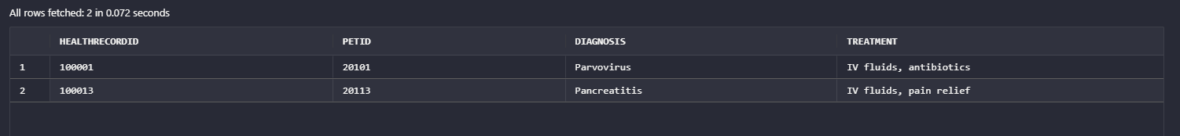

**Done by SinKau Chu**

**Create view for Sin Kau's own Healthrecords table and join to other's VETS table**

* Create a view named vwVETS_DIAGNOSIS
* Select specific columns from the VETS and HEALTHRECORDS tables
* Perform an inner join between HEALTHRECORDS and VETS tables on VETID
* Filter the rows to include only records with HEALTHRECORDID less than or equal to 100016
* Further filter the rows to include only those where NOTES starts with 'R'
* Sort the results by vet ID in ascending order

--Create view for Sin Kau's table and join to other's VETS table

CREATE VIEW vwVETS_DIAGNOSIS AS

SELECT v.VETID, v.FIRSTNAME || ' ' || v.LASTNAME AS VETSNASME, hr.HEALTHRECORDID, hr.PETID, hr.DIAGNOSIS, hr.TREATMENT

FROM HEALTHRECORDS hr

JOIN VETS v ON hr.VETID = v.VETID

WHERE hr.HEALTHRECORDID <= 100016

AND

hr.NOTES LIKE 'R%'

ORDER BY v.VETID ASC;

