Submission from

Sin Kau, Chu 155131220

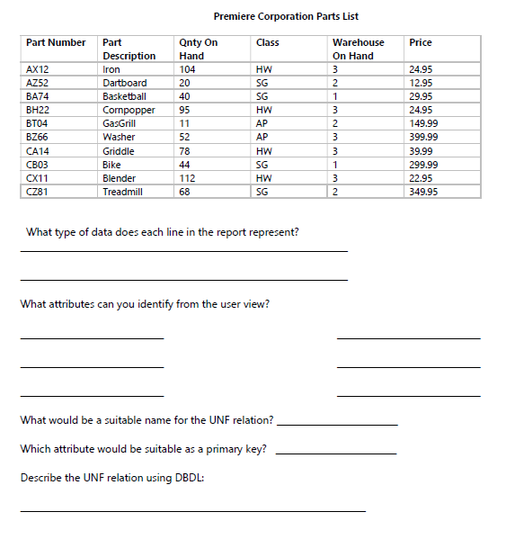

Step 1: Create UNF Relation from a User View. The goal here is to create a single relation

for the data found in the user view.

**What type of data does each line in the report represent?**

* **Part Number**: VARCHAR,A unique identifier for each part (e.g., AX12, AZ52).
* **Part Description**: VARCHAR, A brief description of the part (e.g., Iron, Dartboard).
* **Qnty On Hand**: INT, The quantity of the part currently available in inventory (e.g., 104, 20).
* **Class**: VARCHAR, The classification or category of the warehouse where the part is stored (e.g., HW for Hardware, SG for Sporting Goods, AP for Appliances).
* **Warehouse On Hand**: INT, The warehouse or storage location where the part is found (e.g., 3, 2).
* **Price**: DECIMAL, The price of the part (e.g., 24.95, 12.95).

**What attributes can you identify from the user view?**

* **Part_No** for Part Number
* **Part_Des** for Part Description:
* **PartQty** for Qnty On Hand
* **PartClass** for Class
* **Part_Warehouse_On_Hand** for Warehouse On Hand
* **PartPrice** for Price

What would be a suitable name for the UNF relation?

* PartsInventory

Which attribute would be suitable as a primary key?

* Part_No

The most suitable attribute for the primary key in this case would be the Part Number, renamed the attribute to Part_No. because of the uniqueness as each part number is unique to a specific part, making it a good candidate for uniquely identifying each row in the Inventory relation.

Describe the UNF relation using DBDL:

* PartsInventory[**Part_No,** Part_Des, PartQty, PartClass, Part_Warehouse_On_Hand, PartPrice]

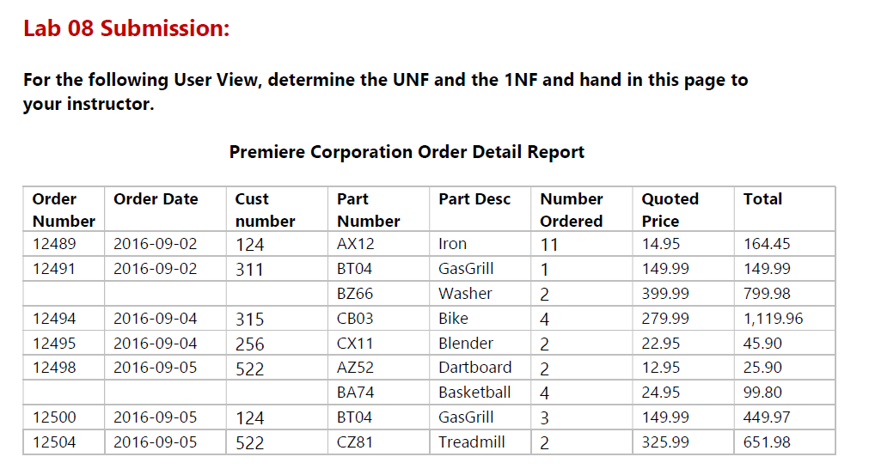

Step 1: Create UNF Relation from a User View. The goal here is to create a single relation

for the data found in the user view.

The attributes of the table are, OrderNo (Order Number), OrderDate(Order Date), CustNo (Cust number), PartNo (Part Number), PartDesc (PartDesc), NoOrdered (Number Ordered), QuoPrice (QuotedPrice), Total (Total)

The possible name of this UNF relation is PartOrderReport

The Primary Key of PartOrder could be **OrderNo**

Therefore the UNF relation in DBDL of the table with would be like:

PartOrderReport[**OrderNo**, OrderDate, CustNo, PartNo, PartDesc, NoOrdered, QuoPrice, Total]

Step 2: Recognize Multi-valued Dependencies

Taking Order Number 12491 as an example, it is possible to have multiple Part Number for each Order Number. Therefore, the repeating group would be like the following.

PartOrderReport[**OrderNo**, OrderDate, CustNo, (PartNo, PartDesc, NoOrdered, QuoPrice, Total)]

Step 3: Create 1NF relations from UNF

The primary key for the chosen multi-valued dependency would be PartNo, OrderNo

Therefore the possible relation would be like

PartOrderReport[**OrderNo**, OrderDate, CustNo]

PartOrder[**PartNo**, **OrderNo**, NoOrdered, QuoPrice, Total]

Part[**PartNo,** PartDesc]