iMicroSeq Testing Instructions
Testing the iMicroSeq contextual data specification
Item | Detail
Document | iMicroSeq_Testing-Instructions_v1.2.docx
Version | 1.2
Status | Draft for testing round 1 - revised 2026-09-16
Specification | iMicroSeq contextual data specification v1.0 - 155 fields: 13 required, 48 recommended, 94 optional
Project | iMicroSeq, Genome Canada eDNA Surveillance Program / Centre for Infectious Disease Genomics and One Health, Simon Fraser University
Contact | iMicroSeq data structures team: Emma Griffiths, emma_griffiths@sfu.ca

Testing the specification not the tool
You will use the DataHarmonizer to try out the iMicroSeq specification. We want your feedback on the specification - its fields, terms, definitions and rules - not on the DataHarmonizer.

1. Why we are asking you to do this
The iMicroSeq specification is a set of ontology-based fields and terms for describing water-based microbial genomics data. It was drafted from a review of existing standards and consultations with 24 people working across wastewater, surface and drinking water, aquaculture, mining, environmental monitoring and One Health. No one outside the development team has used it on real data yet.
A specification that has never been applied to real data is a hypothesis. Testing is what turns it into a useful resource. The purpose of this testing is to find out where the specification is unusable, ambiguous, missing terms, or asking for information nobody actually holds, while it is still easy to change.
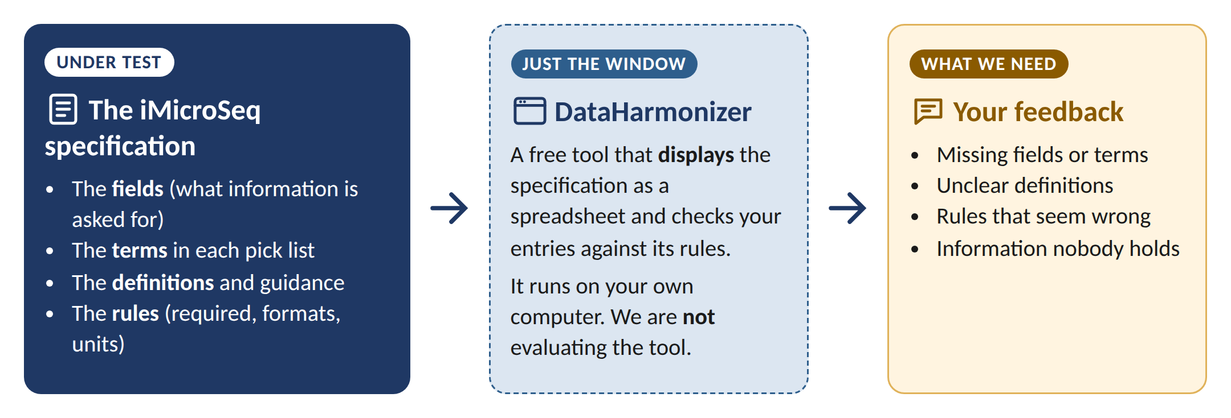
Figure 1. The specification is what is under test. The DataHarmonizer is simply the tool you use to see and apply it.
One thing in particular needs your judgement. The iMicroSeq contextual data specification is meant to be a common denominator, not a superset: a core set of fields and terms that the majority of groups working with water-based microbial genomics can realistically complete, whatever water type, method or mandate they work under. Please tell us whether it fits your work - and whether you think it would fit other groups too.

What we are not asking
We are not testing you. If a field is confusing, that is a problem with the specification - and it is the most useful thing you can report.
We are not testing the DataHarmonizer. If the tool stops you working, tell us briefly, but please keep your feedback focused on the specification.
We are not asking for your data. Everything happens on your own computer. Only your feedback comes back to us.

2. Before you start
You need | Details
A computer and web browser | Chrome, Firefox or Edge. Nothing to install.
The DataHarmonizer with the iMicroSeq template | Download it in a few minutes - see Section 4.
The testing package | This document, the worked example scenarios, answer keys and feedback forms - see Section 3.
The Master Reference Guide and Curation SOP | Found in the Reference Guide and SOPs folders of the iMicroSeq GitHub repository.
10 to 20 records of your own | Water-based microbial genomics data you have curated. Real data is best; representative synthetic data is fine. It never leaves your computer.
About 4 to 6 hours | It does not have to be done in one sitting.

3. What is in the testing package
File or folder | What it is
iMicroSeq_Testing-Instructions_v1.2.docx | This document.
iMicroSeq_Worked-Example-Scenarios_v1.2.docx | The three fictional scenarios you curate in Part B.
Answer Keys/ | One workbook per scenario (S1 to S3). Compare your work against the Answer Key (FICTIONAL) sheet. Only the three v1.2 workbooks are part of this round.
Answer Keys/iMicroSeq_Blank-Template_v1.2.xlsx | An empty template plus a Field guide sheet listing every field with its requirement level, permitted values, definition and an example. Handy to keep open for reference.
Feedback/ | The feedback form and the field-level feedback workbook.

4. Set up the DataHarmonizer
This takes about 10 minutes. The DataHarmonizer is normally downloaded as part of the Pathogen Genomics Package (PGP); for this round, use the version on the iMicroSeq GitHub repository, which includes the iMicroSeq template. Once testing is complete, and the specification is finalised this will be available as part of the PGP.
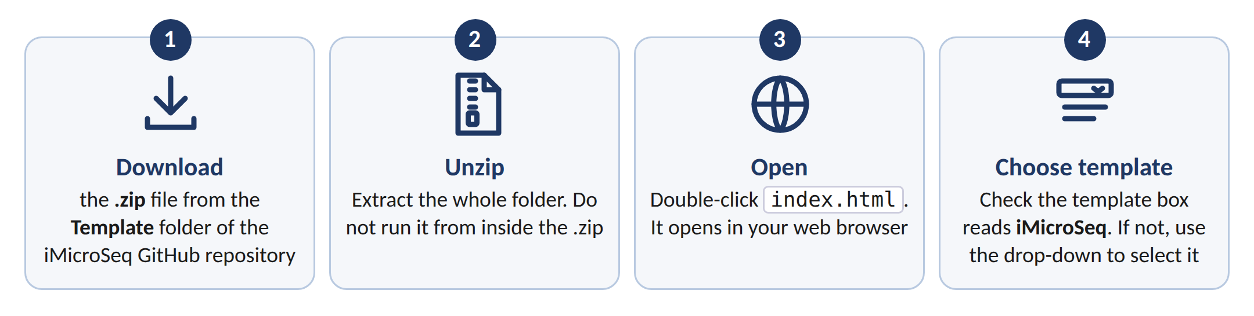
Figure 2. Getting the DataHarmonizer running with the iMicroSeq template.
- Go to the iMicroSeq GitHub repository and open the Template folder.
- Click DataHarmonizer.zip then click the Download button (the downward arrow at the top right of the file view).
- Unzip the file. Windows: right-click it and choose Extract All. macOS: double-click it.
- Open the unzipped folder and double-click index.html. The DataHarmonizer opens in your web browser. It runs on your computer - nothing you enter is uploaded.
- Check the template box at the top reads iMicroSeq. If it does not, click it (or go to File > Change Template), choose iMicroSeq from the drop-down and click Open.

5. The testing protocol
There are four parts, all done on your own computer. Please do them in order: Part B makes you comfortable with the template, so that Part C tells us about the specification rather than about the tool.
Part | What you do | Roughly
A - Orientation | Read the SOP, reference guide and the worked examples; open the template. | 30 min
B - Guided exercise | Curate all three worked-example scenarios from the narratives alone, then compare against the answer keys. | 1.5-2 h
C - Real data | Curate 10 to 20 records of your own data into the template. The file stays with you. | 1.5-2 h
D - Feedback | Complete the feedback form and the field-level workbook; optional debrief. This is the deliverable. | 30-45 min

Part A - Orientation (about 30 minutes)
- Read the Curation SOP. Note anything unclear as you go - first impressions are the easiest to lose.
- Skim the Master Reference Guide, focusing on the sections closest to your work.
- Open the iMicroSeq template in the DataHarmonizer and scroll through the fields. Note the colours: yellow = required (13 fields), purple = recommended (48), white = optional (94).
- Before curating anything, write down on the feedback form your first impression of the template - too long, about right, or too short for your use case. We want this before familiarity sets in.

Part B - Guided exercise with the worked examples
There are three scenarios and we ask you to curate all three. They are short and between them they cover municipal wastewater, drinking and source water, and industrially influenced water. Part B is a warm-up, not an exam: its job is to get you fluent enough in the template that Part C tells us about the specification rather than about the tool.
 | Scenario | Records | Answer key
S1 | Municipal wastewater treatment plant influent | 4 | iMicroSeq_AnswerKey_S1_Municipal-Wastewater_v1.2.xlsx
S2 | Source and drinking water - community-triggered monitoring | 3 | iMicroSeq_AnswerKey_S2_Drinking-Source-Water_v1.2.xlsx
S3 | Landfill leachate and mining-influenced water - AMR metagenomics | 3 | iMicroSeq_AnswerKey_S3_Leachate-Mining-AMR_v1.2.xlsx

In Parts B and C you repeat the same short loop for each set of records:
- Take the scenarios in order, S1 to S3. Read the narrative in the Worked Example Scenarios document. Do not open the answer key yet.
- Start a new sheet in the DataHarmonizer (File > New).
- Curate the scenario into the template from the narrative alone, one row per record. Fill all required and recommended fields, and optional fields where the narrative supports it. Where information is genuinely absent, use a null value such as Not Applicable [GENEPIO:0001619] rather than leaving a blank.
- Validate. Click Validate, then use Next Error to step through each highlighted cell. Fix it and validate again until no errors remain.
- Note the time you spent, and as you go, every field where you had to guess, could not find a suitable term, or had to look something up.
- Save with File > Save As, for example <organisation>_partB_S1_<YYYY-MM-DD>.xlsx.
- Now open the answer key - the Answer Key sheet - and compare row by row. Answer the relevant questions to this section on the feedback form.
OPTIONAL: Record each difference on the Scenario comparison sheet of the field-level feedback workbook, along with the time you spent.

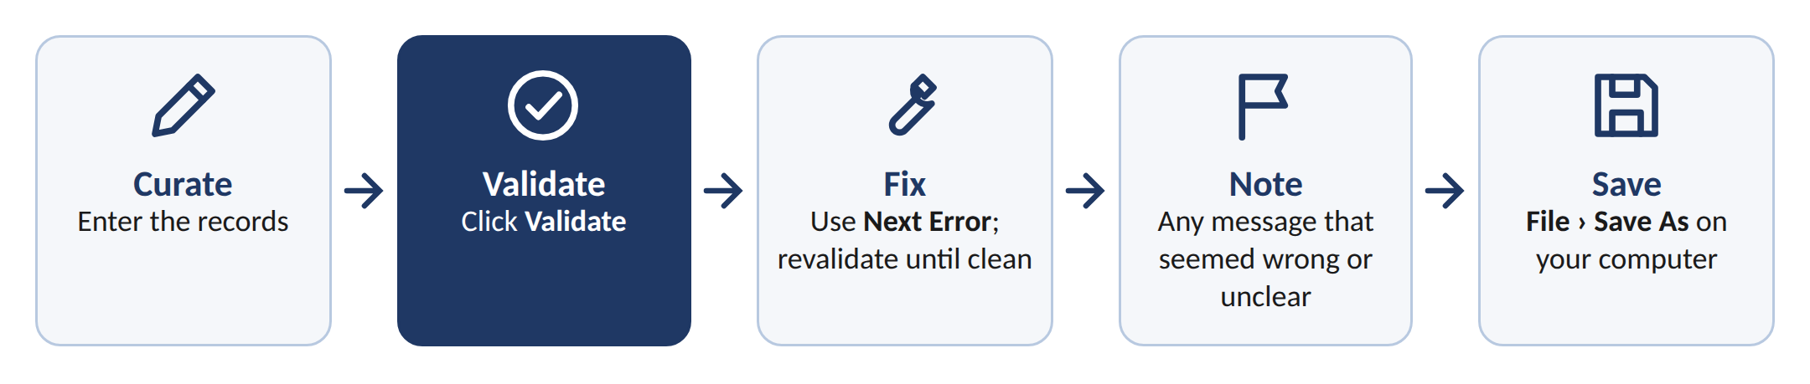
Figure 3. The curate - validate - fix loop used in Parts B and C.

The answer keys are not authoritative
Each answer key is one defensible curation of the scenario. Several fields have more than one reasonable answer, and a few have no good answer at all - those are the gaps we are hunting for. Disagreement is data, and we are not scoring you. Everything in the scenarios and answer keys is invented: fictional projects, organisations, people, sites, coordinates and results, flagged as such in the files themselves.

Validation messages come from the specification
The DataHarmonizer checks your entries against the specification's own rules: required fields, pick-list terms, formats and units. So a message that seems wrong usually points to a problem in the specification

Part C – Curate your own data
- Choose 10 to 20 records typical of your own water-based microbial genomics data. Choose records typical of your work rather than the easiest ones.
- Map your fields onto the iMicroSeq fields, capture missing fields in the feedback form (OPTIONAL: Anything in your data with nowhere to go goes on the Missing fields sheet)
- Curate the records into a new sheet. If a field asks for something you do not hold, use a null value. If the term you need is not in a pick list, use the closest option or a null value, and add the term you needed to the Missing terms sheet.
- Validate. Click Validate, work through Next Error, and validate again until no errors remain. Record any message you think is wrong or unclear on the Validation issues sheet - the message only, not your data.
- Save the file on your own computer. It stays with you.
- Note the time it took, how many records you completed, and roughly how much of the specification you could fill in.

Your data stays with you
Part C is done entirely on your own machine and the file you produce is not returned to us. You do not need to de-identify it, coarsen it, or strip values, because we never see it. Its purpose is to give you something real to push the specification against, so that your feedback is grounded in your actual records rather than in a hypothetical.
Please still follow your own organisation's data governance and any applicable data sharing agreements. Where Indigenous data governance principles apply, they take precedence over anything in this package.

Part D - Feedback
- Complete the feedback google form. Every question is optional, but we appreciate as much detail as you are able to give.
- OPTIONAL: Complete the field-level feedback workbook (iMicroSeq_Field-Level-Feedback_v1.2.xlsx). Use only the sheets that apply. You do not need to comment on every field - only the ones that gave you trouble.
- OPTIONAL: Raise new term requests using the issue forms in the iMicroSeq GitHub repository. Or simply list them on the Missing terms sheet and we will raise them for you.
- Tell us on the feedback form whether you would join a 45-minute debrief conversation.

6. What to send back
Send | Needed? | Notes
Feedback form | Yes | The core deliverable.
Field-level feedback workbook | Optional | Only the sheets that apply to you.
Part B scenario files | Optional | Fictional data only. Shows where people read the specification differently.
Part C file (your own data) | No | Please keep it. Tell us about it on the feedback form instead. Return only if desired and your governance permits.
New term requests | Optional | GitHub issue forms, or the Missing terms sheet.

Name files <organisation>_<feedback|partB>_<YYYY-MM-DD> and email them to Emma Griffiths (emma_griffiths@sfu.ca) by 16th October.

7. What happens to your feedback
- Feedback is combined across testers into a revision list, versioned x.y.z: x for a field change, y for a term or identifier change, z for a definition, guidance or formatting change.
- Field and term changes are raised as requests on the specification repository, so the reasoning is public and traceable.
- All testers receive a summary of what changed, and why, before the next release.
- Testers are acknowledged by name and organisation in the release notes, unless you ask us not to.

Ethics and consent
This round collects opinions about a data specification from professional participants. It does not collect participant datasets: testing is performed locally and only feedback is returned. Please let us know if you have any questions around ethics.

8. Glossary
Term | Meaning in this package
Specification | The fields, terms, definitions and rules that make up iMicroSeq. This is what is being tested.
DataHarmonizer | A free, open-source tool that shows the specification as a spreadsheet and checks entries against it. Used here only as the way to apply the specification.
Field | One column in the template, for example sample collection start date.
Term | One permitted value in a field's pick list, for example Grab sampling [GENEPIO:0100953].
Required field | Must be filled in. Yellow. There are 13.
Recommended field | Should be filled in where the information exists. Purple. There are 48.
Optional field | Fill in if you have the information. White. There are 94.
Null value | A term recording why a value is absent: Not Applicable, Missing, Not Collected, Not Provided or Restricted Access. Always better than a blank cell.
Validate | The DataHarmonizer button that checks every entry against the specification's rules and highlights problems.
Answer key | A completed scenario showing one reasonable way to curate it.
New term request | A structured request to add or change a field or term, raised on the specification repository.

