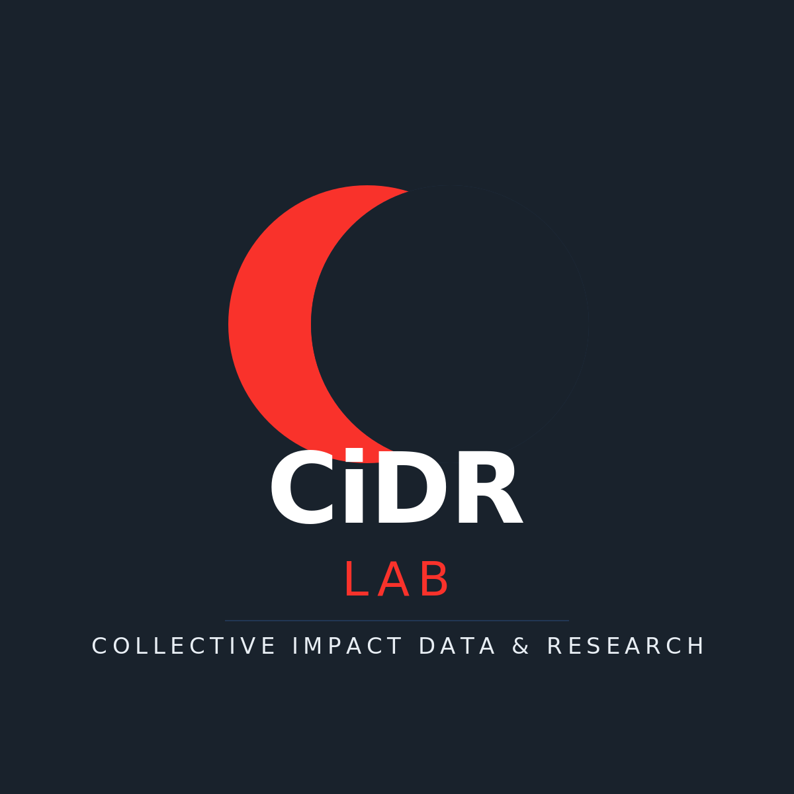
Boondock Map
BRAND & STYLE GUIDE
Collective Impact Data & Research Lab
Version 1.0 | April 2026

Overview
Boondock Map is an offline-capable topo map application built by the CiDR Lab for boondocking, hiking, and off-road exploration. The app follows CiDR Lab brand guidelines to maintain visual consistency across the lab's products and research tools.
This document defines the color palette, typography, iconography, and UI patterns used in the Boondock Map application. All styling decisions derive from the CiDR Lab master brand (see BRAND.md in the CiDR Lab library repository).

Color Palette
The Boondock Map palette is derived directly from the CiDR Lab brand colors, adapted for a dark-theme map application. The three brand colors anchor the interface, with derived tints and opacities filling out the full dark UI system.

Brand Colors
Name | Hex | CiDR Role | Boondock Usage
Red | #F9322B | Primary accent, mark circle | --accent, buttons, record, active track, default waypoint pin
Dark Navy | #19222C | Headers, footers, dark backgrounds | --bg-secondary, toolbar, sidebar, glass overlays
Blue Navy | #223754 | Body text, nav, secondary accent | --bg-elevated, layer cards, elevated surfaces
Cool Blue | #e8eef4 | Light background tint | --text-primary, primary text color against dark navy

Dark Theme Background Ramp
The background ramp extends the brand navy into a smooth gradient for layered UI depth. Each step is derived from the CiDR dark and blue navies.
CSS Variable | Hex | Usage
--bg-primary | #10151c | App background, deepest layer
--bg-secondary | #19222C | Toolbar, sidebar, modals (CiDR dark navy)
--bg-tertiary | #1e2a38 | Input fields, nested containers
--bg-elevated | #223754 | Layer cards, elevated surfaces (CiDR blue navy)
--bg-hover | #2a4060 | Hover states on interactive elements
--bg-active | #324a6a | Active/pressed states

Typography
The app uses the system font stack (SF Pro Text on macOS, Segoe UI on Windows) for UI elements to ensure native feel and crisp rendering at small sizes. The CiDR Lab brand font DM Sans is reserved for the document title block in this style guide and any future splash/about screens.
Context | Size | Font
Brand wordmark | 14px / 600 | System stack (-apple-system, BlinkMacSystemFont)
UI labels & inputs | 13px / 400–500 | System stack
Sidebar headings | 12px / 600 | System stack, uppercase tracking
Status bar | 11px / 400 | System stack, monospace for coordinates
Map popups | 13px / 400 | System stack

Iconography
All icons are custom SVG monoline icons defined in Icons.jsx. The icon library follows Lucide/Feather conventions: 24x24 viewBox, 1.5px stroke, round caps and joins, no fill. Icons accept size, color, and className props. The library contains 40+ icons covering navigation, location, layers, waypoints, actions, and tracking.

Waypoint Pin Colors
Type | Hex | Icon | Notes
Generic | #F9322B | MapPin | CiDR red — default pin
Camp | #22c55e | Tent | Green — campsite
Water | #38bdf8 | Droplet | Sky blue — water source
Hazard | #fbbf24 | AlertTriangle | Amber warning
Trailhead | #f59e0b | Footprints | Warm amber
Viewpoint | #a78bfa | Camera | Soft purple
Fuel | #fb923c | Fuel | Orange
Parking | #e8eef4 | ParkingCircle | CiDR cool blue tint

UI Patterns

Glass Effect
Map controls, popups, and overlays use a translucent glass effect: rgba(25, 34, 44, 0.90) background with backdrop-filter: blur(16px). This keeps map content partially visible while maintaining legibility of UI controls.

Border Radii
Three radius tokens are used consistently: --radius: 10px for cards and modals, --radius-sm: 6px for buttons and inputs, and --radius-xs: 4px for small toggles and chips. Recording pills use a full 100px radius.

Button System
Four button variants are defined: btn-primary (CiDR red background, white text), btn-secondary (elevated navy background, muted text, border), btn-ghost (transparent, icon-only actions), and btn-danger (red-tinted background for destructive actions). The record button uses --accent (brand red) for both its border and the filled circle icon.

Map Layers
Seven base layers and four overlays are defined in shared/layers.js. The default base layer is USGS Topo (modern style). The default active overlays are roads and USFS trails. Overlays use zoom-interpolated opacity expressions for progressive disclosure at different zoom levels.

File Reference
Key files controlling visual style:
File | Controls
styles/global.css | CSS custom properties (all colors, radii, shadows)
styles/app.css | Layout, MapLibre overrides, button system, modals
components/Icons.jsx | SVG icon library, waypoint color + icon maps
components/Toolbar.css | Toolbar, record/stop button, brand wordmark
components/Sidebar.css | Search, layer picker, waypoint list, toggles
components/Map.jsx | Marker SVG rendering, track colors, bbox draw
shared/layers.js | Tile URLs, overlay opacity curves, default center

