CISC 699 — Hard Stop 2: Design Review Package
Placement as Schema: A GraphQL Federation Layer with Backend Placement Declared in the Type System, and the Workload Point Where Federation Stops Paying
Jai Behl · Supervisor: Majid Shaalan, Ph.D.
September 27, 2026 · Version 0.2
Contents
§ | Section | § | Section
0 | Package summary | 8 | Environment plan
1 | AI usage log | 9 | Build order, week by week
2 | Traceability | 10 | Test and evaluation plan
3 | Architecture views | 11 | Data validation and evidence strategy
4 | Component and interface specifications | 12 | Design review: risks, dependencies, gaps
5 | Data design | 13 | Supervisor review record and revision log
6 | Computational method | 14 | ADR index and references
7 | API and integration contracts

0. Package summary
This package commits the project to one buildable design: a Python federation engine that reads backend placement from @store directives in GraphQL SDL, pushes predicates and join keys into PostgreSQL and MongoDB, joins in memory, and is judged against a consolidated-PostgreSQL oracle and four measurement arms. It builds directly on the HS1 Proposal Approval Package (v0.1, 9/13/2026); objective, criterion, work-package and risk IDs (O-, SC-, WP-, R-) are carried over unchanged.
Field | Value
Project | Placement as Schema: A GraphQL Federation Layer with Backend Placement Declared in the Type System, and the Workload Point Where Federation Stops Paying
Student | Jai Behl
Supervisor | Majid Shaalan, Ph.D.
Hard stop | HS2 — Design Review (Week 4)
Repository | github.com/ciel57142-wq/CISC699
Document version | v0.2 (design); supersedes nothing in HS1, amends it where §13 says so
Four design decisions this package makes that HS1 left open.
- Workload data is generated, not downloaded. UniBench’s schema and query shapes are kept; its data is not used. The UniBench repository shows no licence file, and its data is derived from LDBC, DBpedia and the Amazon product dataset, which contains real user-written reviews. That conflicts with HS1 assumption A5 (synthetic data only). A seeded generator on the UniBench schema replaces it (§5, ADR-0005).
- Parser: graphql-core 3.2, not hand-written. graphql-core exposes schema directive arguments through get_directive_values on a field’s ast_node, which closes R8 at design level (ADR-0002).
- Cross-store joins use a bind join. The driving side’s join keys are pushed into the second backend as an IN / $in filter. Without it, federated bytes scale with table size rather than with k, and the crossover would measure a strawman (§6, ADR-0006).
- A second schema directive, @ref, declares join keys. HS1 §5.3 #6 excluded directives other than the placement annotation. The engine cannot join without a declared key, so @ref is added and counted as a concept in the SC-6 study (§13, amendment H2-A1).
Carry-over status from HS1 (Week 3–4 gates). Items marked confirm are ones only the student can verify; this package does not claim them done.
HS1 item | Status in this package
M1 — Compose stack up, dependency table closed | Dependency table closed at design level (§8). Stack running: confirm
M1 — Unibench licence resolved | Resolved: not used as a data source (decision 1)
M1 — Hasura account verified | Open. Local build still needs a DDN login (§12, highest-risk dependency)
M2 — ADR-0003 @store syntax frozen | Proposed in §5 and §7; commit to docs/decisions/: confirm
M3 — Data loaded, both placements equivalent | Moved to Week 6 because the generator is new work (§9)
HS1 §11 Decisions 1–7 | Outcomes to be recorded in §13

1. AI usage log (continued from HS1 §1)
AI assistance for HS2 was substantial and is itemized below; every design decision in this package is mine to defend in the walkthrough. No number in this document is a measurement. All thresholds remain the HS1 provisional thresholds.
# | Date | Tool | Task | Nature of use
1–3 | 9/13 | Claude (Anthropic) | HS1 proposal | As recorded in HS1 §1.2
4 | 9/27 | Claude (Anthropic) | HS2 package structure | Drafted section structure, tables and the week-by-week plan from my HS1 package
5 | 9/27 | Claude (Anthropic) | Dependency verification | Web lookups on UniBench provenance, graphql-core directive access and Hasura DDN local builds; findings cited in §14
6 | 9/27 | Claude (Anthropic) | Method and pseudocode | Drafted resolver, planner, bind-join and crossover-estimation pseudocode for my review
7 | 9/27 | Claude (Anthropic) | Design risks | Proposed the resource-parity and Python-overhead threats in §12, which I had not identified
Student review obligation. Before submission I will re-derive every pseudocode block in §6, check each cited page in §14 myself, and revise any row above that understates what the assistant did.

2. Traceability: requirements to design to evidence
Every HS1 objective maps to at least one component below and every success criterion to a named test or measurement; no component exists that serves no criterion.
Objective | Criterion | Design element (§) | Verified by (§10 test ID) | Evidence artifact
O1 annotation + resolver | SC-2, SC-6 | Schema loader, placement resolver, @store/@ref (§4.1, §5.2) | T-U1, T-U2, T-C1 | tests/unit/test_resolver.py, ADR-0003
O2 two-backend read-only execution | SC-1, SC-2 | Planner, executor, PG and Mongo adapters (§4.3–4.6) | T-C1, T-I0 | Conformance report (operator × backend)
O3 pushdown + bytes reduction | SC-3 | Rewriter rules R1–R4, byte counters (§6.3, §6.5) | T-U3, T-E2 | Paired A1/A4 byte table
O4 differential oracle | SC-1 | Oracle, consolidated mirror, reference SQL (§4.7) | T-O1, T-P1 | CI oracle log per commit
O5 benchmark harness | SC-4, SC-9 | bench/ runner, run manifest (§8.4, §10.3) | T-H1, T-H2 | bench/runs/<run-id>/manifest.json
O6 crossover | SC-5 | Selectivity-controlled sweep, crossover estimator (§6.6) | T-E3 | Crossover plot + estimator output
O7 configuration complexity | SC-6 | Fixed task, counting protocol (§10.4) | T-E4 | eval/complexity/PROTOCOL.md + counts
O8 report + reproducibility | SC-9 | One-command make reproduce (§8.4) | T-H3 (clean-machine rehearsal) | Rehearsal log, M9
— quality | SC-7, SC-8 | Issue severity labels, pytest --cov gates (§10.1) | CI gates | Coverage report, triage record
— acceptance | SC-10 | Decision records (§13) | Supervisor sign-off | docs/decisions/

3. Architecture views
The engine is one Python process with six components; the only thing that changes between the federated and consolidated configurations is the placement map produced from the schema.

3.1 Container and component view (C4 levels 2–3)
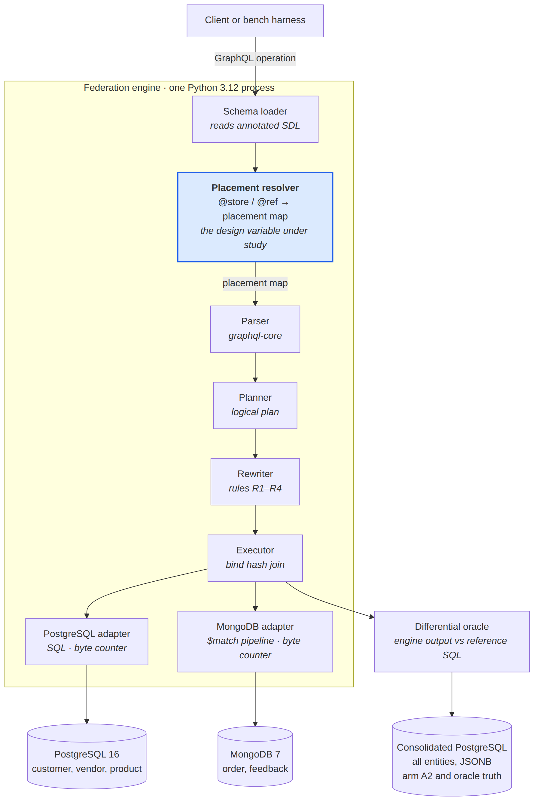
Figure 1. Component view: engine, adapters, stores and oracle. Placement is read from the schema, and every answer is checked.
The resolver (highlighted) turns schema directives into a placement map at load time; everything below it runs per query. Redis and Neo4j adapters (extensions E-3, E-4) slot in beside the two shown without changing any other component.

3.2 Sequence view: one two-store query with pushdown (arm A1)
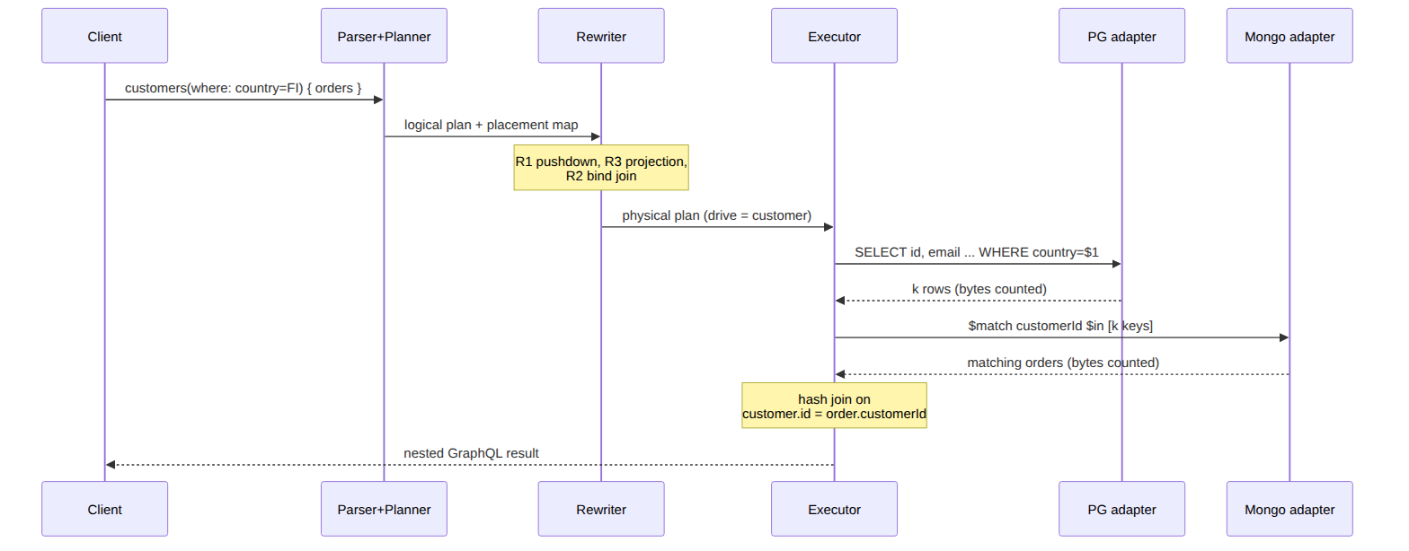
Figure 2. Sequence of one two-store query under arm A1 (pushdown on).
Arm A4 (pushdown off) runs the same plan with R1–R3 disabled, so both backends return full collections. Arm A3 skips the engine and runs hand-written full fetches plus a Python loop join.

3.3 Deployment view (single host)
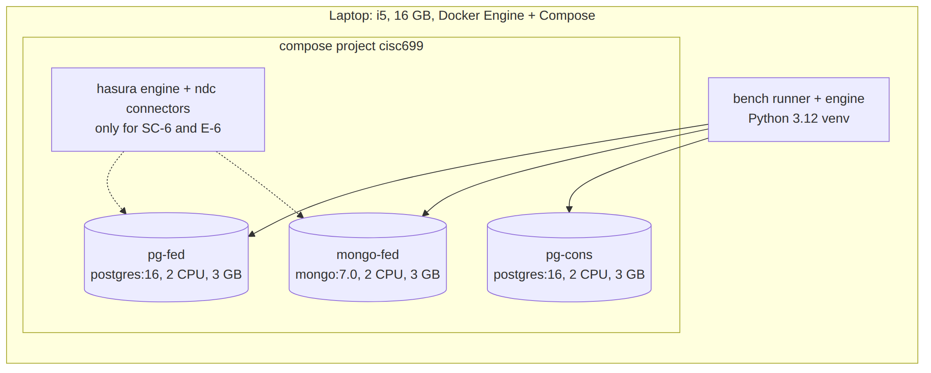
Figure 3. Deployment view on one laptop. Dashed lines: Hasura services, used only for SC-6 and E-6.
Every database container gets identical CPU and memory limits (§8.3 explains why the federated pair does not simply get double the resources). The Hasura services are stopped during timing runs of arms A1–A4.

4. Component and interface specifications
Each component has one responsibility, a typed interface, and its own test file; components talk only through the dataclasses named here.
# | Component | Module | Responsibility | Consumes | Produces | Failure behaviour
4.1 | Schema loader + placement resolver | engine/schema/ | Parse SDL, read @store / @ref, validate, derive root fields and where input types | schema.graphql, backends.toml | GraphQLSchema, PlacementMap | Refuses to start: unknown backend, type without @store, @ref to a missing field, key type mismatch
4.2 | Parser + validator | engine/parse/ | Parse and validate the operation against the augmented schema; reject anything outside the MVA subset | operation text, variables | validated DocumentNode | GraphQL error UNSUPPORTED_OPERATION naming the construct
4.3 | Logical planner | engine/plan/ | Build the logical plan: Scan, Filter, Project, Join, Aggregate, Limit | AST, PlacementMap | LogicalPlan tree | Planner errors are bugs: raise, never return partial plans
4.4 | Rewriter | engine/rewrite/ | Apply rules R1–R4 in fixed order; each rule is a pure function plan → plan | LogicalPlan, RuleConfig | PhysicalPlan of per-backend ScanFragments + in-engine operators | A rule that cannot prove safety leaves the plan unchanged
4.5 | Executor | engine/exec/ | Run fragments, hash-join, aggregate residuals, shape the nested GraphQL result; record timing spans | PhysicalPlan | ExecutionResult + Trace | Backend error → GraphQL error BACKEND_UNAVAILABLE; no partial data
4.6 | Adapters (PG, Mongo) | engine/adapters/ | Translate a ScanFragment to SQL or an aggregation pipeline; count bytes | ScanFragment | iterator of row batches + ByteCount | Unsupported fragment feature → CapabilityError at plan time, not run time
4.7 | Oracle | oracle/ | Run the reference SQL for each workload query on pg-cons; compare order-insensitively | engine result, reference result | OracleVerdict (match / diverge + diff) | Divergence fails CI and opens a severity-1 issue
4.8 | Bench runner | bench/ | Execute arms in randomized order, collect timings and bytes, write the run manifest | workload file, arm list, seed | runs/<run-id>/ | Aborts the run if the oracle is not green at the commit being measured

4.9 Internal interfaces
These are the contracts the components share. They are frozen at the end of Week 5; later changes need an ADR.
@dataclass(frozen=True)
class Placement:
type_name: str # GraphQL type, e.g. "Order"
backend: str # key in backends.toml, e.g. "mongo"
collection: str # table or collection name
key: str # primary key field, default "id"
@dataclass(frozen=True)
class Ref:
owner: str; field: str # Customer.orders
target: str # Order
local_key: str # Customer.id
remote_key: str # Order.customerId
cardinality: Literal["one", "many"]
@dataclass(frozen=True)
class Pred:
field: str; op: Literal["eq","lt","gt","lte","gte","in"]; value: Any
@dataclass(frozen=True)
class ScanFragment:
placement: Placement
predicates: tuple[Pred, ...] = ()
projection: tuple[str, ...] | None = None # None = all fields
key_filter: tuple[str, frozenset] | None = None # bind join: (field, keys)
order_by: tuple[tuple[str, bool], ...] = ()
limit: int | None = None; offset: int = 0
class Adapter(Protocol):
name: str
def capabilities(self) -> Capabilities: ...
def row_count(self, collection: str) -> int: ... # join ordering (E-2)
def scan(self, frag: ScanFragment) -> Iterator[list[dict]]: ...
def last_bytes(self) -> ByteCount: ... # bytes of last scan

5. Data design
Five UniBench-shaped entities are placed by data model — relational entities in PostgreSQL, document entities in MongoDB — and mirrored whole into one PostgreSQL instance for the oracle and arm A2.

5.1 Logical schema
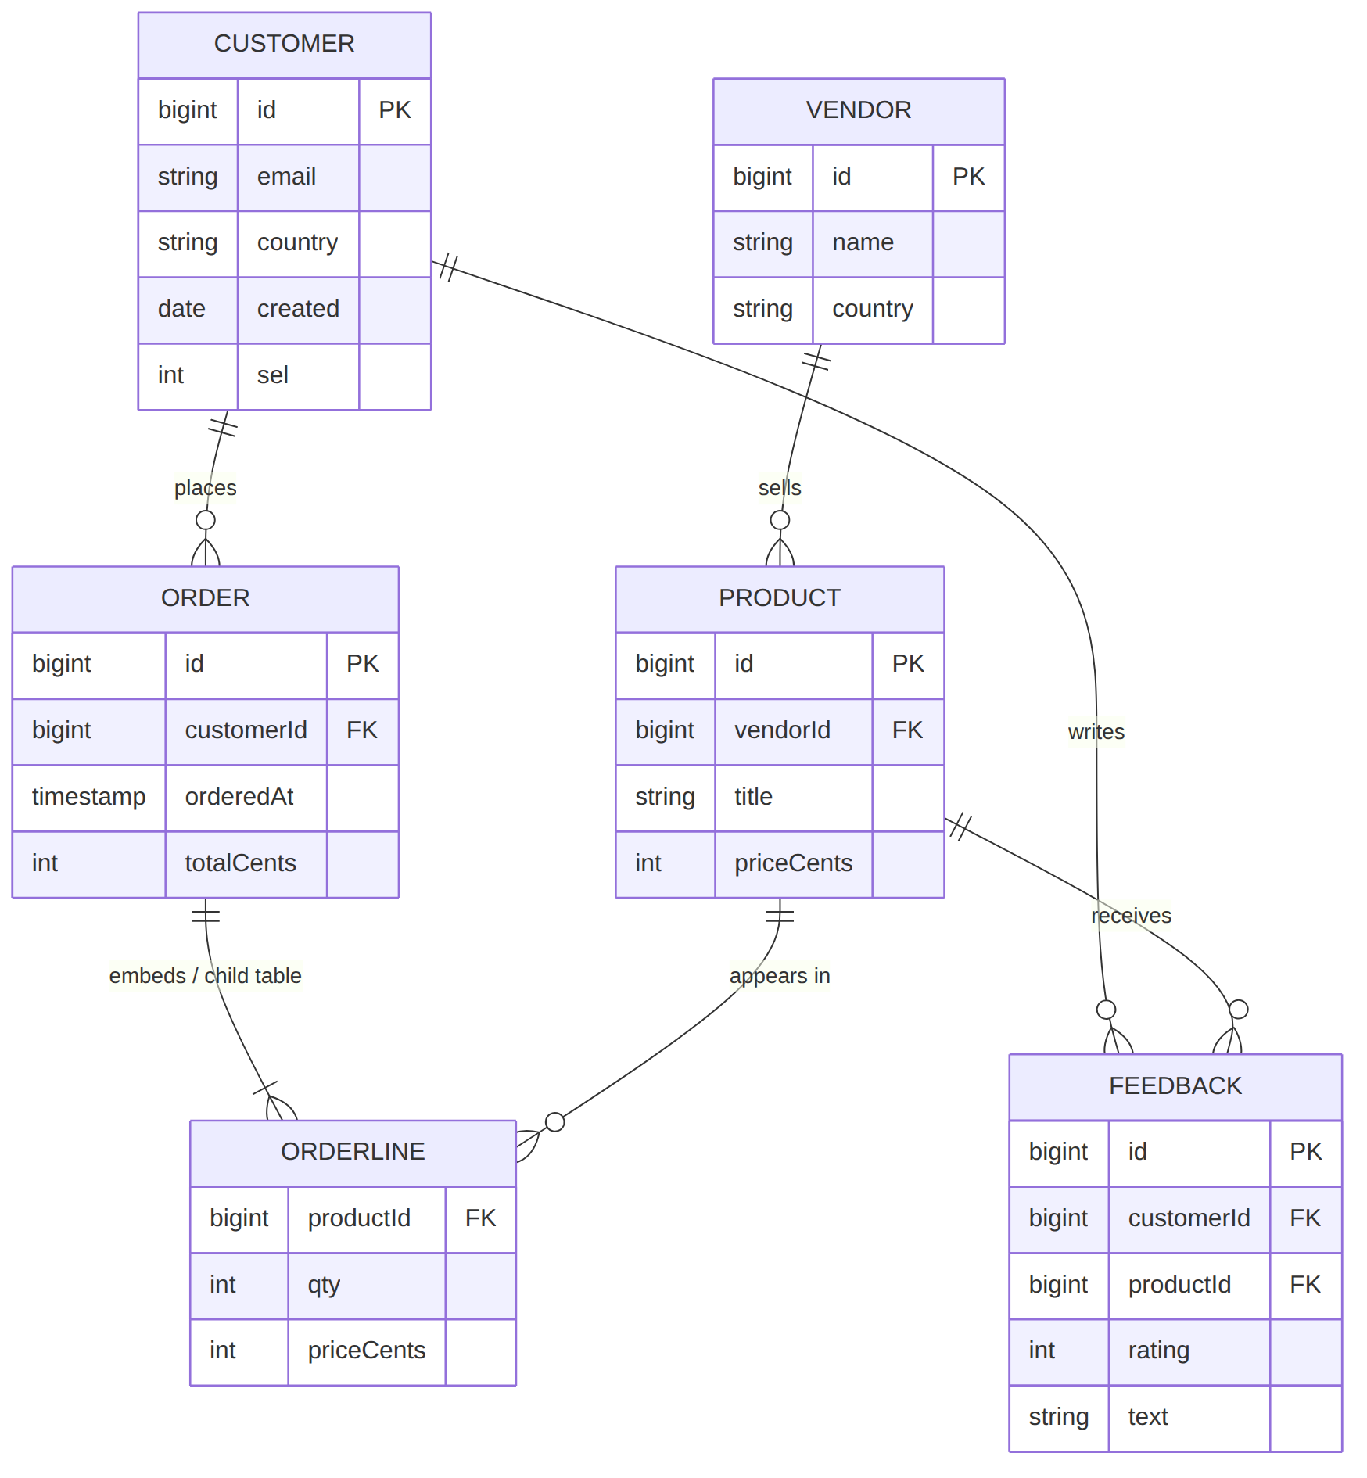
Figure 4. Logical schema (ER). Order lines are embedded in the Order document in MongoDB and a child table in the consolidated mirror.

5.2 Placement map and the annotated schema (ADR-0003, proposed)
Type | Floor placement | Consolidated placement | Why this store
Customer | pg-fed.customer | pg-cons.customer | Flat, keyed, filtered by attribute
Vendor | pg-fed.vendor | pg-cons.vendor | Flat reference data
Product | pg-fed.product | pg-cons.product | Flat, joined to vendor
Order | mongo-fed.orders | pg-cons.orders + order_line | Nested order lines: natural document
Feedback | mongo-fed.feedback | pg-cons.feedback (text column) | Semi-structured review text
directive @store(backend: String!, collection: String, key: String = "id") on OBJECT
directive @ref(localKey: String!, remoteKey: String!) on FIELD_DEFINITION
type Customer @store(backend: "pg", collection: "customer") {
id: ID!
email: String!
country: String!
orders: [Order!]! @ref(localKey: "id", remoteKey: "customerId")
}
type Order @store(backend: "mongo", collection: "orders") {
id: ID!
customerId: ID!
totalCents: Int!
lines: [OrderLine!]! # embedded, same store: no @ref
customer: Customer! @ref(localKey: "customerId", remoteKey: "id")
}
Change from HS1 §6.3. HS1 put @store on the relationship field (orders: [Order!]! @store(name: "mongo")). That duplicated Order’s own placement and still gave the engine no join key. Placement now lives only on the type; a field crosses a process boundary exactly when its target type’s @store differs from its owner’s, which the resolver computes and the schema reader can see. Rejected alternatives recorded in ADR-0003: field-level @store (duplicated, can disagree), a single @store(on:) carrying join keys (overloads one directive with two concepts), placement by naming convention (invisible, the opposite of the design claim).
The derived operation surface (customers(where:, limit:, offset:, orderBy:), ordersAggregate(where:, groupBy:)) is generated by the resolver from these types, so the developer writes no root Query fields. Connection strings stay out of the schema in backends.toml; that file is counted in SC-6.

5.3 Workload data: seeded generator (ADR-0005)
UniBench’s repository carries no licence file, and its README says the data comes from the LDBC, DBpedia and Amazon product datasets, used for academic research. The Amazon-derived reviews are real people’s text, which breaks HS1 assumption A5. The design therefore keeps UniBench’s schema and query shapes and replaces its data:
- Generator bench/data/gen.py, pure Python, numpy.random.Generator(PCG64(seed)). Same seed → byte-identical output (tested, T-D1).
- Scale parameter S. Entity ratios are taken from the row counts of the UniBench SF1 release (counts only, recorded in bench/data/ratios.json; no UniBench data is committed). Default S = 1 for development; measurement scale fixed at the midpoint baseline.
- Selectivity control. Every Customer gets sel, uniform on 0–9,999. The predicate sel < t returns t/10,000 of customers in expectation, so k (§6.6) is set by t rather than by searching for natural predicates.
- Skew option. Orders per customer are drawn from a Zipf distribution (exponent recorded per run) so the join fan-out is realistic; uniform fan-out is a secondary configuration.
- Text. Feedback text is drawn from a fixed synthetic vocabulary; names and emails are generated tokens (c000123@example.invalid).
- Nothing generated is committed. The repository holds the generator, the seed list and the checksums; make data regenerates.

5.4 Representation rules that keep both placements equal
These rules exist because each is a known source of false oracle divergences between PostgreSQL and MongoDB.
Hazard | Rule
Floating-point money | All money as integer cents (int4/int64, BSON long). No floats in stored data
Timestamp precision | Generator emits millisecond precision, UTC; PG column timestamptz(3) matches BSON date precision
Missing vs null | Generator never omits fields; canonical form treats a missing Mongo field as null
Id types | Integer ids everywhere; GraphQL ID serialized as string in both arms
Embedded order lines | Mongo: array in the order document. Consolidated: order_line child table with line_no to preserve order
avg results | Compared with relative tolerance 1e-9; all other values compared exactly

5.5 Equivalence check (gate M3)
For each entity: row count equal, and an order-insensitive checksum equal. Checksum = SHA-256 over the sorted list of SHA-256 hashes of each record’s canonical JSON (keys sorted, rules in §5.4 applied). The check runs after every load and its output goes into the run manifest.

6. Computational method
The method is rule-based rewriting over a small logical algebra, executed by an in-memory hash join, and evaluated by a controlled parameter sweep; the pseudocode below is specific enough to reimplement without this repository.

6.1 Placement resolution (load time)
resolve(sdl, backends):
schema <- graphql_core.build_schema(sdl)
S <- schema.get_directive("store"); R <- schema.get_directive("ref")
for each object type T (not Query, not introspection):
a <- get_directive_values(S, T.ast_node)
if a is None:
if T is reachable only as a field of one stored type:
T is EMBEDDED in that type's placement
else: fail "type T has no @store"
else:
require a.backend in backends
placement[T] <- (a.backend, a.collection or snake(T), a.key)
for each field f of each stored type T:
r <- get_directive_values(R, f.ast_node)
U <- named_type(f.type)
if r is not None:
require r.localKey in fields(T), r.remoteKey in fields(U),
scalar types compatible
refs += Ref(T, f, U, r.localKey, r.remoteKey,
many if f is list else one)
elif U is a stored object type: fail "relationship T.f has no @ref"
crosses(ref) := placement[ref.owner].backend != placement[ref.target].backend
derive root fields and <T>Where inputs; return augmented schema, PlacementMap

6.2 Logical plan
A query becomes a tree over six operators: Scan(T), Filter(preds), Project(fields), Join(left, right, on, cardinality), Aggregate(groupBy, fns), Limit(n, offset). The root field gives Scan(root) under Filter from its where; each selected @ref field adds a Join whose right side is Scan(target) under that field’s own where. Depth is capped at 2 in the MVA.

6.3 Rewrite rules (applied once each, in this order)
Rule | Fires when | Rewrite | Safety argument | Status
R1 Predicate pushdown | Filter(p) directly over Scan(T), every field of p on T, adapter supports each operator | Move p into ScanFragment.predicates → SQL WHERE / Mongo $match | Conjunctive comparisons on one type commute with scan | Floor
R1b Aggregate pushdown | Aggregate over a single-store scan | GROUP BY / $group | Same-store aggregation is the backend’s own semantics; avg tolerance per §5.4 | Floor
R2 Bind join | Equi-Join across stores | After the driving side runs, give the other side key_filter = (remoteKey, distinct driving keys) in batches of B = 1,000 | Semi-join reduction never removes a row that would join | Floor (with R1)
R3 Projection pushdown | Any Scan | Request only selected fields ∪ join keys ∪ residual predicate and sort fields | Unrequested columns cannot affect the result | E-1
R4 Limit pushdown | Limit over the root scan, root ordered by a total order (engine appends key as tiebreaker), no residual filter above the scan | Push LIMIT/OFFSET / $skip/$limit into the root fragment | A to-many nested join does not change root cardinality | Floor
J Join ordering | Two-store join, E-2 enabled | Drive from the side with pushed predicates; tie → smaller row_count | Affects cost only, never results | E-2
A per-parent limit on a nested field (orders(limit: 5)) is never pushed across a bind join; it stays a residual operator. The oracle’s property tests (T-P1) target exactly these boundaries.

6.4 Execution: bind hash join
execute_join(L, Rf, ref, B=1000):
drive <- materialize(adapter[L].scan(L)) # k rows
keys <- distinct(r[ref.localKey] for r in drive)
index <- map key -> list
for batch in chunks(sorted(keys), B): # deterministic batches
for rows in adapter[Rf].scan(Rf with key_filter=(ref.remoteKey, batch)):
for r in rows: index[r[ref.remoteKey]].append(r)
for d in drive:
d[ref.field] <- index.get(d[ref.localKey], []) if many else first-or-null
return drive
Time is O(k + m) and memory O(m), where m is the number of matched right-side rows. With R2 off (arm A4) the right side is scanned whole, so bytes and time grow with collection size instead of with k: the contrast SC-3 measures.

6.5 What is timed and what is counted
- Latency: time.perf_counter_ns() from the call to engine.execute() until the nested Python result is fully built. Arm A2 is timed from sending the reference SQL until its rows are reshaped into the same nested form, so both arms pay result shaping.
- Span breakdown per query from the executor’s Trace: parse+plan, backend L, backend R, decode, join, shape. This separates Python overhead from data movement (risk R18, §12).
- Bytes, primary: payload bytes decoded from each backend (PG: sum of text-format field lengths reported by psycopg; Mongo: BSON size of each returned document via RawBSONDocument).
- Bytes, validation: container network counters (/sys/class/net/eth0/statistics/tx_bytes inside each DB container) before and after each run; must agree with the primary figure within protocol overhead, else the run is flagged.
- Intermediate cardinality k: rows returned by the driving scan, recorded per run, not assumed from t.

6.6 Crossover estimation (SC-5)
The sweep sets the threshold t in Customer.sel < t to nine pre-registered values: 1, 3, 10, 30, 100, 300, 1,000, 3,000, 10,000 (out of 10,000). Each point runs 3 discarded warm-ups and 7 timed repetitions per arm, arm order shuffled per repetition with a recorded seed.
for each point i: D_i <- median_A1(i) - median_A2(i); IQR_a(i) recorded per arm
bracket <- first i with D_i <= 0 < D_{i+1}
if no bracket: report "no crossover in range" and the sign of D throughout
else:
log k* <- log k_i + (-D_i / (D_{i+1} - D_i)) * (log k_{i+1} - log k_i)
if the arms' IQRs overlap at i or at i+1:
report k* as INDETERMINATE, with both brackets
pre-registered refinement: add 3 log-spaced points inside [k_i, k_{i+1}],
rerun, re-estimate once
The expected shape (to be tested, not assumed): federation is competitive at small k because both backends filter locally, and loses as k grows because every driving key crosses the process boundary twice. A crossover in the opposite direction, or none, is reported as found.

6.7 Statistics
Medians with IQR, as pre-registered in HS1 §6.4. As a supplementary statistic only, a bootstrap 95% interval of the median difference (10,000 resamples) is reported per point; it never changes an SC verdict. gc.collect() runs before each timed repetition; the collector stays enabled during it, and GC pause count per run is recorded.

7. API and integration contracts
The engine exposes one GraphQL contract and consumes three external ones; each is pinned, has an example payload below, and has a planning-level test that runs before any feature depends on it.
Contract | Direction | Form | Auth | Planning-level test (Week 5)
Engine GraphQL API | exposed | Python Engine.execute(query, variables) -> ExecutionResult; optional POST /graphql (Starlette) for E-6 parity with Hasura | none (local only; R11) | T-I0: one query round-trips through both entry points
PostgreSQL wire | consumed | psycopg 3, server-side parameters, text format | user/password from .env (never committed) | T-I0: SELECT 1 + one parameterized WHERE
MongoDB wire | consumed | pymongo 4, aggregate() with RawBSONDocument | same .env | T-I0: $match + $in on 1,000 keys
Hasura DDN (comparator) | consumed | DDN CLI, OpenDD/HML metadata, local engine in Docker, GraphQL over HTTP | Hasura Cloud login for the CLI (see §12) | Spike S-1: local supergraph over pg-fed + mongo-fed with one cross-connector relationship

7.1 Example: request, response, and what each backend receives
query FinnishCustomers {
customers(where: {country: {eq: "FI"}, sel: {lt: 100}}, limit: 2) {
id
email
orders(where: {totalCents: {gte: 5000}}) { id totalCents }
}
}
PostgreSQL receives (R1 + R3 + R4):
SELECT id, email FROM customer
WHERE country = $1 AND sel < $2
ORDER BY id LIMIT 2; -- $1='FI', $2=100
MongoDB receives (R1 + R2 + R3), one batch of at most 1,000 keys:
[ {"$match": {"customerId": {"$in": [104, 2211]}, "totalCents": {"$gte": 5000}}},
{"$project": {"_id": 0, "id": 1, "customerId": 1, "totalCents": 1}} ]
Response (shape only; values illustrative, not measured):
{ "data": { "customers": [
{ "id": "104", "email": "c000104@example.invalid",
"orders": [ { "id": "88120", "totalCents": 7350 } ] },
{ "id": "2211", "email": "c002211@example.invalid", "orders": [] } ] },
"extensions": { "trace": { "plan_ms": 0,
"backends": {"pg": {"bytes": 0}, "mongo": {"bytes": 0}} } } }

7.2 Error contract
Errors follow the GraphQL spec errors array with a stable extensions.code, so conformance tests assert codes rather than message text.
Code | Raised by | Example cause
SCHEMA_INVALID | resolver, at start-up | @store(backend: "redis") with no redis in backends.toml
UNSUPPORTED_OPERATION | validator | inline fragment on a union, depth-3 traversal, mutation
BACKEND_UNAVAILABLE | executor | connection refused or timeout (5 s) from an adapter
INTERNAL | anywhere | planner invariant violated: always a bug, always a severity-1 issue

7.3 Hasura DDN comparator contract (SC-6 and E-6)
Hasura’s local workflow scaffolds a supergraph, introspects each connector and writes Hasura Metadata Language (HML) files per model; ddn supergraph build local produces the engine build. Two findings shape the plan. The local build uses Hasura’s hosted metadata build service, so a Cloud login and network access are needed even for a local-only run. The CLI’s docker-start pulls the latest engine image, so the comparator must be run with an explicit pinned engine image to avoid mid-semester drift (R9). The SC-6 task counts every file the DDN workflow creates or edits, including generated files the developer must commit; the counting protocol (§10.4) decides in advance how generated-but-unedited files are counted.

8. Environment plan
One laptop, one Compose project, one lock file: every run records the exact image digests, package hashes and hardware it ran on, and make reproduce rebuilds the full result set from a clean checkout.

8.1 Runtime and packages
Layer | Choice | Pinning | Notes
OS | confirm: Windows 11 + WSL2 Ubuntu 24.04, or native Linux | kernel and distro in manifest | On Windows, repo and data live in the WSL2 filesystem, never under /mnt/c
Python | 3.12.x | .python-version | One venv managed by uv
Package lock | uv lock | uv.lock with hashes, committed | Satisfies HS1 “hash-locked”
Parser | graphql-core 3.2.x | lock | ADR-0002
Drivers | psycopg 3.x (binary), pymongo 4.x | lock | LGPL psycopg is used, not linked into distributed code
Data + analysis | numpy 2.x, pandas, matplotlib | lock | Generator and figures
Tests | pytest 8.x, pytest-cov, hypothesis | lock | Hypothesis drives T-P1
Optional HTTP | starlette + uvicorn | lock, extras group | Only for E-6
Containers | Docker Engine + Compose v2.20+ | versions in manifest | Compose ≥ 2.20 is also Hasura’s local requirement
DB images | postgres:16, mongo:7.0 | by @sha256 digest in compose.yaml | Digests recorded at Week 5 lock
Comparator images | Hasura v3 engine, ndc-postgres, ndc-mongodb | by digest after spike S-1 | Never latest

8.2 Hardware assumptions
Intel Core i5 (core count: confirm, at least 4 assumed), 16 GB RAM, NVIDIA RTX GPU (unused). Memory budget during timing runs: three DB containers at 3 GB each (9 GB), engine and runner up to 2 GB, OS the rest; Hasura services stopped. If the i5 has fewer than 4 cores, container limits drop to 1 CPU each and the change is recorded as an ADR.

8.3 Resource parity between arms
The federated arm touches two database containers and the consolidated arm one, so giving each container its own cores would hand federation twice the hardware. The design pins all three database containers to the same two cores (cpuset: "2,3") with identical limits (cpus: 2, mem_limit: 3g), and the engine and runner to cores 0–1. Only one arm runs at a time, and a bind join runs its two backends one after the other, so neither arm gains parallelism. Cache sizes are matched: PostgreSQL shared_buffers = 768MB on both PG containers, MongoDB wiredTigerCacheSizeGB = 0.75.

8.4 Reproducibility mechanics
- make reproduce = compose up (pinned) → make data SEED=… → load both placements → equivalence check → oracle → bench → analysis → figures.
- Each run writes bench/runs/<utc-timestamp>-<git-sha>/ with manifest.json: git SHA and dirty flag, uv.lock hash, image digests, config SHA-256, seeds, hardware fingerprint (CPU model, cores, RAM, OS, kernel, Docker version), equivalence checksums, and timings.csv + bytes.csv raw.
- A number appears in the report only if a script regenerates it from a committed run directory (SC-9).
- CI (GitHub Actions, Ubuntu runner, PG and Mongo service containers) runs unit, conformance and oracle tests at S = 0.01 on every push. Timing runs never happen in CI.

9. Build order, week by week
The order is fixed by three gates — data equivalence before execution, oracle green before any timing, counting protocol committed before either system is measured — and it slips HS1’s M3 by two weeks to absorb the new data generator.
Week (dates) | Build | Exit evidence | Gate
4 (9/21–9/27) | This package; ADR-0002, 0003, 0005, 0006 drafted | HS2 submitted | HS2
5 (9/28–10/4) | Close M1 leftovers: uv.lock, digests in compose.yaml; generator v1; resolver + validator; spike S-1 (Hasura local build, one day) | make data deterministic (T-D1); resolver tests green; S-1 note with pinned digests or GraphQL Mesh fallback triggered | M1, M2
6 (10/5–10/11) | Loader for both placements; equivalence check; PG and Mongo adapters for single-store MVA ops | Equivalence checksums match (T-D2); single-store conformance green | M3 (moved from W4)
7 (10/12–10/18) | Planner; R1, R1b, R4; bind hash join; two-store traversals | Two-store query returns results | M4
8 (10/19–10/25) | Oracle: reference SQL for every workload query, order-insensitive comparison, CI job, Hypothesis property tests | 100% agreement at S = 0.01 and S = 1 | M5 hard gate; HS3 midpoint: baseline run, thresholds revised once and frozen
9 (10/26–11/1) | Byte instrumentation both ways; arm A4 switch; commit SC-6 counting protocol | A1 vs A4 byte table at one point; PROTOCOL.md committed with hash in issue tracker | M6, M7
10 (11/2–11/8) | Bench runner: four arms, randomized order, manifests; E-1 projection pushdown if on track | Unattended run of all arms at 3 sweep points | HS4
11 (11/9–11/15) | Buffer. SC-6 measurement on both systems. E-2 or E-3 only if nothing slipped | Complexity counts committed raw | —
12 (11/16–11/22) | Full nine-point sweep; refinement points if a bracket is found | Raw runs committed | M8, HS5 analysis draft
13 (11/23–11/29) | Buffer. Clean-checkout rehearsal on a second machine; report writing | Rehearsal log reproduces headline numbers | M9
14 (11/30–12/6) | Code freeze; defect triage; report complete | Zero open severity-1 | M10, HS6
15 (12/7–12/13) | Recorded walkthrough; final package | Submission | HS7
Cut order when a week slips is HS1 §5.2 unchanged: projection pushdown first, the usability study last. Floor work is never cut to protect an extension.

10. Test and evaluation plan
Sixteen named tests cover correctness, coverage, pushdown, latency, crossover, complexity and reproducibility; every threshold is the HS1 provisional value, revised once at HS3 and then frozen.

10.1 Evaluation matrix
ID | Type | What it checks | Metric | Threshold (HS1) | Baseline / comparison | Evidence | Runs
T-U1 | Unit | Resolver on ≥ 20 valid and invalid SDL fixtures | pass rate, error codes | 100% | expected placement map per fixture | pytest report | every push
T-U2 | Unit | Planner output per operator shape | plan tree equality | 100% | hand-written expected plans | pytest report | every push
T-U3 | Unit | Each rewrite rule fires when it should and not when it must not | before/after plan assertions | 100% | negative cases per rule | pytest report | every push
T-C1 | Conformance | Every MVA operator × backend pair end to end | executable pairs | 100% MVA; ≥ 80% with extensions (SC-2) | operator list HS1 §6.4 | conformance table | every push
T-I0 | Contract | Each external contract round-trips (§7) | pass | 100% | — | pytest report | Week 5, then nightly
T-D1 | Data | Generator determinism | SHA-256 of output, two runs, same seed | identical | — | manifest | every make data
T-D2 | Data | Placement equivalence (§5.5) | counts + checksums | identical | consolidated mirror | manifest | every load
T-O1 | Differential | Whole workload, engine vs reference SQL | agreement | 100%, zero unexplained divergences (SC-1) | reference SQL on pg-cons | CI oracle log | every push
T-P1 | Property | Hypothesis-generated predicates, limits, thresholds | agreement | 100% over 500 examples per run | same oracle | shrunk counterexamples kept as regression tests | every push
T-H1 | Harness | Timer resolution; byte counters vs network counters | disagreement | within protocol overhead, else run flagged | — | self-test log | each run
T-H2 | Harness | Manifest completeness | required fields + hashes verify | 100% | — | validator output | each run
T-H3 | Reproducibility | Clean checkout, second machine | headline numbers reproduced | 100% traceable (SC-9) | original run | rehearsal log | Week 13
T-E1 | Performance | Single-store latency, W1–W4 | median ratio A1 / A2 | ≤ 3× (SC-4) | A2 consolidated | timings.csv, figure | M8
T-E2 | Performance | Pushdown bytes on selective queries (t ≤ 1,000, i.e. ≤ 10%) | bytes reduction A1 vs A4 | ≥ 70% (SC-3) | A4 pushdown off | bytes.csv, table | M6, M8
T-E3 | Performance | Crossover on W5 over the nine-point sweep | k* with IQR, or no-crossover finding | reported either way (SC-5) | A2; A3 and A4 as context | crossover figure + estimator output | M8
T-E4 | Design study | Add one backend-resident type with one cross-store relationship | files, config lines, concepts | ≥ 40% fewer files vs Hasura DDN (SC-6), raw counts both ways | Hasura DDN, or GraphQL Mesh if S-1 fails | eval/complexity/ | Week 11
Quality gates: pytest --cov ≥ 80% line coverage on engine/schema, engine/plan, engine/rewrite (SC-8); zero open severity-1 issues at freeze and ≤ 5 severity-2 (SC-7).

10.2 Workload
Ten query templates, each with a hand-written reference SQL query reviewed before the engine is run against it.
ID | Shape | Stores | Serves
W1 | Filter + sort + limit on Customer | PG | T-E1
W2 | Filter on Order totals and dates | Mongo | T-E1
W3 | Aggregate Order totals grouped by customer | Mongo | T-E1, R1b
W4 | Aggregate Product prices grouped by vendor | PG | T-E1, R1b
W5 | Customer (filtered by sel < t) → orders | PG → Mongo | T-E2, T-E3 (the sweep)
W6 | Order (filtered) → customer, to-one | Mongo → PG | T-E2
W7 | Product → feedback with rating filter | PG → Mongo | T-E2, held out
W8 | Vendor → products, same store, depth 2 | PG | T-C1
W9 | Root limit/offset with nested per-parent limit | PG → Mongo | R4 boundary
W10 | Named fragments over W5’s shape | PG → Mongo | T-C1, held out

10.3 Measurement protocol
Idle machine on AC power, sync and indexing off, 10-minute thermal settle before each run. Per sweep point: 3 discarded warm-ups, then 7 timed repetitions; within each repetition the arm order is shuffled with a recorded seed so drift cannot favour one arm. Database caches are warm by design; a cold-cache variant is an extension, not a floor measurement.

10.4 SC-6 counting protocol (outline; full text committed at M7, before either system is measured)
- Task: add Feedback as a new MongoDB-resident type with a relationship from Product (PostgreSQL), starting from a working two-type system in each tool. The task mirrors Hasura’s own documented add-a-model-and-relationship flow.
- Files touched: any file created or edited, generated or hand-written, that must be committed for the change to work. Generated-but-unedited files are reported in a separate column, not dropped.
- Configuration lines: non-blank, non-comment lines added or changed, from git diff --numstat on the task commit.
- Concepts: distinct named constructs the developer must know to complete the task, from a fixed glossary written before counting (for this engine: type, @store, @ref, backend key; for Hasura: its metadata kinds as used).
- Reporting: both counts raw, then the ratio. A null or reversed result is stated in the abstract.

11. Data validation and evidence strategy
This is not a learning project, so there is no train/test split; its equivalent is a separation between what the engine is tuned on and what it is measured on, plus checks that make a wrong answer or a biased timing visible before it reaches the report.

11.1 Data-validation steps (every load)
- Schema check: generated records validate against a JSON Schema per entity (types, required fields, id ranges).
- Referential check: every Order.customerId, Feedback.customerId, Feedback.productId and order-line productId resolves; orphan count must be 0.
- Distribution check: observed sel is uniform (chi-square, 100 bins, p > 0.01) and orders-per-customer matches the configured Zipf exponent within 5%. Failures stop the pipeline.
- Equivalence check (§5.5) between federated and consolidated placements.
- Manifest: checksums and check results written into the run manifest; a run without them is invalid.

11.2 The development/measurement split
Held apart | Development | Measurement | Why
Data seed | seed 1 | seeds 2, 3, 4 (one per measurement pass) | Rules cannot be tuned to one dataset’s quirks
Query templates | W1–W6, W8, W9 | all ten; W7 and W10 are never timed before M8 | Two templates the rewriter was never tuned against test generalization within the workload
Sweep points | 3 pilot points at HS3 baseline | nine pre-registered points | Pilot points inform the one threshold revision, nothing else
Thresholds | provisional | frozen after HS3 | Pre-registration (HS1 R3)
The held-out templates still pass the oracle at M5; only their timings are withheld.

11.3 Bias and error checks
Threat | Check | What happens if it fires
Wrong answers measured as fast answers | Oracle green is a precondition the runner checks at the measured commit | Run refused
Order or thermal drift favouring an arm | Randomized arm order per repetition; drift test comparing first vs last repetition medians | Point rerun; drift reported
Resource asymmetry between arms | Shared cpuset and identical limits (§8.3), recorded in manifest | Run invalid if limits differ
Python overhead read as “federation cost” | Span breakdown per query (§6.5); report shows data-movement and engine-overhead shares separately | Crossover stated with and without engine overhead
Strawman baseline | A3 is reported as context, never as the comparison for any SC; SC-4 and SC-5 compare A1 against A2 only | —
Self-designed workload | UniBench shapes; entity ratios from its SF1 row counts; W7, W10 held out | Deviations listed in the report
Byte counter error | Primary payload count cross-checked against container network counters (T-H1) | Run flagged; primary figure not used until explained
Skew sensitivity | Main sweep on Zipf fan-out; one repeat of W5 on uniform fan-out | Both reported if the crossover moves
Single machine | Stated as a scope limit (HS1 §5.3 #17); rehearsal machine gives a second data point for ordering, not for absolute times | —

12. Design review: risks, missing dependencies, evaluation gaps
The highest-risk dependency is Hasura DDN: it is the only floor dependency outside my control, SC-6 rests on it, and its local build still calls a hosted service. It is de-risked by a one-day spike in Week 5, before anything else depends on it.

12.1 Answer to the supervisor prompt
Which part of the design is the highest-risk dependency, and how will it be de-risked early?
- External: Hasura DDN. Risks: account or terms change (R7), the hosted metadata build service being unavailable, the latest-image default drifting the comparator, and uncertainty whether the MongoDB connector can be the target of a cross-connector relationship. Spike S-1 (Week 5, one day): build a local supergraph over pg-fed and mongo-fed with one PG → Mongo relationship, pin every image by digest, save the generated HML, and read the current terms on publishing comparisons. Pass → continue. Any fail → trigger the GraphQL Mesh fallback that week, record ADR-0007, and state the substitution in the report.
- Internal: the bind hash join and its oracle. Every measurement depends on it being correct. De-risked by building the oracle in the fortnight after the join (Weeks 7–8) and by the M5 hard gate.

12.2 Design risks added or changed at HS2
ID | Risk | L | I | Mitigation | Residual
R6 (closed) | UniBench unavailable or unlicensed | — | — | Closed by ADR-0005: data generated, not downloaded | —
R8 (reduced) | Parser does not expose directive metadata | Low | Med | graphql-core get_directive_values on ast_node confirmed; T-U1 proves it in Week 5 | Low
R16 | Real-person data via UniBench’s Amazon-derived reviews | Med | High | Generator replaces all data; no UniBench data committed or loaded | Low
R17 | Resource asymmetry inflates federation’s apparent speed | Med | High | Shared cpuset, identical limits and caches (§8.3) | Low
R18 | Python engine overhead dominates small-k timings, so the crossover measures the language, not the architecture | High | Med | Span breakdown; report crossover with and without engine overhead | Med: disclosed
R19 | Hasura local build needs hosted service and login; image drift | Med | Med | Spike S-1; pinned digests; Mesh fallback | Low
R20 | Bind-join batch size B shifts the crossover | Med | Med | B fixed at 1,000 before measurement; one sensitivity run at B = 100 and 10,000 on W5, reported | Low
R21 | 16 GB RAM is tight for three DB containers plus runner | Med | Med | 3 GB limits; Hasura stopped during timing; S can be reduced at HS3 | Low
R22 | Generator is new work and delays M3 | Med | Med | M3 moved to Week 6; generator is small and tested by T-D1 | Low

12.3 Missing dependencies
Dependency | State | Owner action | Due
Hasura Cloud login + terms on published comparisons | Unverified | Spike S-1 | Week 5
Exact CPU core count of the laptop | Unknown | lscpu into manifest; adjust §8.2 limits | Week 5
UniBench SF1 row counts for ratios.json | Not yet counted | Download release locally, count rows, delete data, commit counts only | Week 5
Second machine for the Week 13 rehearsal | Not identified | Ask supervisor or use a cloud VM free tier | Week 9
IRB position in writing (HS1 Decision 6) | Pending | Supervisor | HS3

12.4 Evaluation gaps that remain after this design
- SC-6 measures configuration effort, not comprehension. Counting files and concepts cannot show that visible placement helps a developer reason about performance. Only the conditional usability study (E-7) could, and it may be cut.
- One query shape carries the crossover. W5 is the only swept template; a different join shape could cross elsewhere. The report scopes the finding to W5’s shape.
- No cold-cache results. Warm caches favour whichever arm re-reads more. Cold-cache runs are an extension.
- A2 is hand-written SQL, not the engine. It measures the best consolidated plan, not the engine running on consolidated placement. An engine-on-consolidated arm needs same-store join pushdown, which is not in scope; the gap is stated.
- Absolute times do not transfer. Only the relative ordering of arms is claimed beyond this hardware.

13. Supervisor review record and revision log
The supervisor review has not happened yet; the table below is the agenda and the record to fill in during it, and nothing in it is presented as feedback received.

13.1 Review meeting record (fill in during the meeting)
Item | Question for the supervisor | Outcome | Revision required
HS1 Decision 1 | Is a design claim plus a measurement an acceptable contribution?
HS1 Decision 2 | Is a rigorously measured negative result success? (written)
HS1 Decision 3 | Is a local containerized demonstration sufficient?
HS1 Decisions 4–7 | Thresholds, backends, IRB, workload source
H2-A1 | Accept @ref as a second schema directive (amends HS1 §5.3 #6)?
H2-A2 | Accept generated data on the UniBench schema in place of UniBench data?
H2-A3 | Accept the slip of M3–M5?
Risk | Agree that Hasura DDN is the highest-risk dependency and S-1 is the right de-risking step?
Gaps | Are the gaps in §12.4 acceptable as stated limits?
Resources | Can a second machine be provided for the Week 13 rehearsal?
Meeting date: ____________ · Attendees: Jai Behl, Majid Shaalan · Notes filed at docs/reviews/hs2.md.

13.2 Amendments to the HS1 package
ID | HS1 section | Change | Reason
H2-A1 | §5.3 #6, §6.3 | Add @ref(localKey, remoteKey); @store moves to types only | The engine needs join keys; field-level @store duplicated placement
H2-A2 | §6.4, §6.6, A1, R6 | UniBench schema and query shapes kept; data generated | No licence file; Amazon-derived real review text conflicts with A5
H2-A3 | §7.2 | M3 Week 4 → 6; M4 Week 6 → 7; M5 Week 7 → 8 | Generator is new work; HS3 midpoint follows M5
H2-A4 | §6.4 | Bind join (R2) made an explicit floor rule | Without it A1 would scale with table size, making the crossover a strawman
H2-A5 | §6.5 | A2 defined as hand-written reference SQL, timed including result shaping | Same queries serve the oracle; shaping cost kept equal across arms
H2-A6 | §6.1 | Resource parity rule added (shared cpuset, identical limits) | Federation would otherwise get twice the hardware
H2-A7 | §12 | Brief still showed [name] and [date] placeholders | Housekeeping: fix in HS1 v0.1.1 in the repository

13.3 Revision log of this package
Version | Date | Change
v0.2 | 9/27/2026 | First design review draft, before supervisor review
v0.2.1 | ____________ | Revisions from the §13.1 meeting

14. ADR index and references

14.1 Architecture decision records
ADR | Title | State at HS2
0001 | Record architecture decisions (process) | Accepted at HS1
0002 | Parser: graphql-core 3.2 | Proposed here, accept Week 5 after T-U1
0003 | @store on types, @ref on fields; rejected alternatives | Proposed here
0004 | Derived root fields and where inputs | Proposed here
0005 | Seeded generator on the UniBench schema instead of UniBench data | Proposed here
0006 | Bind hash join, batch size B = 1,000 | Proposed here
0007 | Comparator: Hasura DDN or GraphQL Mesh | Decided by spike S-1, Week 5

14.2 References
HS1 references 1–8 (Stonebraker & Çetintemel 2005; Lu & Holubová 2019; Duggan et al. 2015; Begoli et al. 2018; Kolev et al. 2016; Zhang & Lu 2019/2021; Hartig & Pérez 2018; Hasura NDC and DDN documentation) carry forward. Verify pagination, DOIs and the Zhang & Lu year against the style guide before submission; the UniBench README cites that paper as Distributed and Parallel Databases, 2019. Added for HS2:
- Zhang, C., Lu, J., Xu, P., & Chen, Y. (2018). “UniBench: A benchmark for multi-model database management systems.” TPCTC 2018, Springer.
- Brown, S. The C4 model for visualising software architecture — notation for §3.1.
- MacIver, D. R., et al. (2019). “Hypothesis: A new approach to property-based testing.” Journal of Open Source Software, 4(43) — basis of T-P1.

14.3 Sources consulted for this package (as of 9/27/2026)
- HY-UDBMS/UniBench repository and README — no licence file at root; data provenance from LDBC, DBpedia and the Amazon product dataset; SF1 release.
- graphql-core issue #65: obtaining schema directive values — get_directive_values(directive, field.ast_node).
- Hasura: local development support for DDN — engine and connectors run locally in Docker.
- Hasura DDN CLI: ddn supergraph build local — local build uses the DDN hosted metadata build service.
- Hasura DDN self-hosted guide — login, connector init, model and relationship add, local build sequence.
- Hasura CLI FAQ — docker-start pulls the latest engine image.

