A DFT study to develop a SiO2 mesoporous surface model

Ciellie Jansen van Vuuren

6/12/2017

Table of Contents

Introduction 1

Experimental work 2017 2

1. Amorphous SiO2 Bulk 2

1. Method: 2

2. Results: 2

3. Experimental data 5

4. Conclusion 5

2. Modeling SiO2 surface 6

K-point convergence for bulk SiO2 (Alpha Quartz) 6

SiO2 surface characterristics 6

References 8

# Introduction

Grubbs catalysts for alkene metathesis have a vast range of advantages, but the fact that these catalysts are homogeneous makes extraction of the catalyst from the post-reaction mixtures very difficult. Because of cost implications, the re-use of the catalyst became very important (Jordaan, 2007).

A heterogeneous catalyst can be a solution to the above-mentioned issue. In general, the activity and selectivity of heterogeneous catalysts are lower than homogeneous catalysts, but the advantage of separation, recovery and recycling outweigh these shortcomings.

According to literature mesoporous support materials, are ideal heterogeneous support materials (Thielemann *et al.*, 2011),(Balcar & Čejka, 2013). In this study, we decided to focus on the SBA-15 and MCM-41 mesoporous support material.

The first step in modelling a SBA-15 or MCM-41 mesoporous surface is to create an amorphous SiO2 bulk using an alpha-quartz (space group 180). (Balcar & Čejka, 2013) The 3X3X3 super cell was submitted to dynamics studies using Materials Studio’s CASTEP module and VASP 5.3 (Izumi *et al.*, 2004),(Ugliengo *et al.*, 2008). This was done and I will discuss the procedure that I followed to accomplish this.

# Experimental work 2017

## 1. Amorphous SiO2 Bulk

### 1. Method:

A 3x3x3 alpha-quartz, space group 180, super-cell was built in the Materials Studio software package.

1. The annealing process of the alpha-quartz to obtain an amorphous solid was simulated using the CASTEP dynamic study module of the Materials Studio software package.
2. The bulk was heated to 4000, 5000 and 6000K in 50, 100 and 150 steps of 1fs each. After the heating step, the bulk was quenched to 1K in two 1fs steps.
3. Each resulting structure was again heated to 1000K in the same number of steps as in the first heating step and finally cooled down to 300K in the same number of steps.

The resulting structures (Figure 2) was each submitted to a DFT calculation to determine various indicating properties. The calculated and measured properties included:

* Energy
* Bond Angles
* Density of states (Izumi *et al.*, 2004)

### 2. Results:

According to (Group, 2014) if Alpha Quartz are melted and cooled down very quickly it will preserve the structure obtained during the melting phase, it is also seened in (Table 1) and in the results that will follow. We will focus only on the results obtained during the melting and quenching steps and compare these results to experimental data.

##### .

#### Energy diviation

|  |  |  |  |  |
| --- | --- | --- | --- | --- |
| Step | Melting | Quenching | Anealing | Cooling |
| B-4000-50 | 14.868330 | 12.303313 | -133.47306 | -122.94020 |
| C-4000-100 | 7.389067 | 5.143338 | -131.30382 | -147.54388 |
| D-4000-150 | -27.006410 | -29.795691 | -126.67915 | -145.41787 |
| E-5000-50 | 77.389310 | 74.280163 | -113.59576 | -143.47558 |
| F-5000-100 | 58.360560 | 55.060881 | -115.94542 | -135.78931 |
| G-5000-150 | 33.496077 | 29.797096 | -119.82338 | -142.63743 |
| H-6000-50 | 102.169790 | 99.032252 | -92.27010 | -73.23567 |
| I-6000-100 | 89.882010 | 86.476856 | -114.69271 | -116.81287 |
| J-6000-150 | 127.892450 | 123.973285 | -78.72192 | -31.85867 |

Table 1: Energy diviation.

#### Energy diviation during the melt and quenching steps

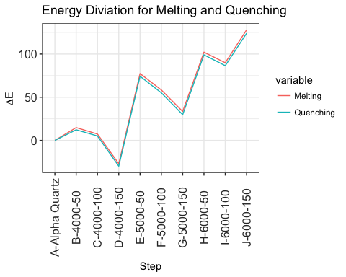

Figure 1: Energy per experemental step

##### .

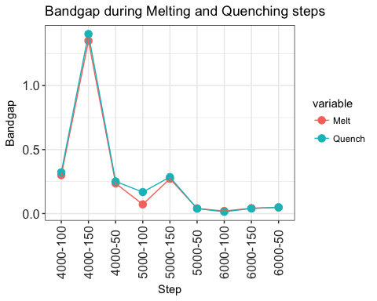

Figure 2: Bandgap during Melting and Quenching steps

As we expected (Figure 2) conclude that the band gap decreases as the temperature and reaction time increase. Therefore as the alpha-quartz become amorphous, there is also an increase in reactivity as seen in (Figure 1).

#### Bond Angle diviation

|  |  |  |  |  |  |
| --- | --- | --- | --- | --- | --- |
|  | Step | Melting | Quenching | Annealing | Cooling |
| 1 | 4000-50 | 6.324 | 6.271 | 0.737 | 5.433 |
| 2 | 4000-100 | 19.665 | 19.577 | 1.865 | 10.574 |
| 3 | 4000-150 | 12.045 | 11.999 | 1.940 | 15.151 |
| 4 | 5000-50 | 19.225 | 19.246 | 10.141 | 2.409 |
| 5 | 5000-100 | 19.180 | 19.144 | 6.154 | 4.549 |
| 6 | 5000-150 | 30.070 | 30.001 | 9.275 | 30.070 |
| 7 | 6000-50 | 26.742 | 26.646 | 6.604 | 26.646 |
| 8 | 6000-100 | 35.009 | 34.938 | 23.254 | 18.168 |
| 9 | 6000-150 | 11.029 | 10.946 | 15.867 | 15.867 |

Table 2: Bond angle diviation

##### .

### 3. Experimental data

|  |  |  |  |
| --- | --- | --- | --- |
|  | Info | deg | E |
| 1 | Experimental | 10.8 | 0.28 |
| 2 | Structural parameters of the unrelaxed amorphous silica | 17.7 | 0.19 |

Table 3: Literature results obtained at 4000K

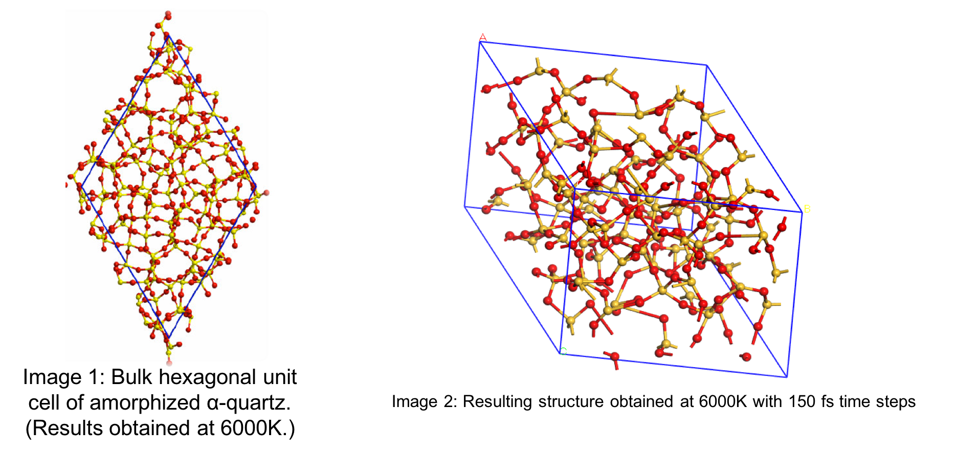

Figure 3: Literature vs Experimental structional results(Izumi *et al.*, 2004)

### 4. Conclusion

* The bond angle deviation shown in (Table 2) can be related to experimental data obtained as seen in (Table 3).
* At 4000K the Ε correlate with the experimental values obtained in (Table 3).

##### .

## 2. Modeling SiO2 surface

To do surface calculations it became very difficult, using the amorphous SiO2 bulk. We decide to use a crystalline 3X3X3 SiO2 bulk, using VASP 5.3. An Ab Initio Molecular Dynamics study will be done on all surfaces using VASP 5.3.

### K-point convergence for bulk SiO2 (Alpha Quartz)

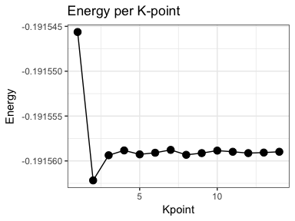

### SiO2 surface characterristics

The following surface characteristics will be determined

1. Cutting planes: I will focus on the planes (100,110,200) as indicated in the XRD results see (Figure 5)

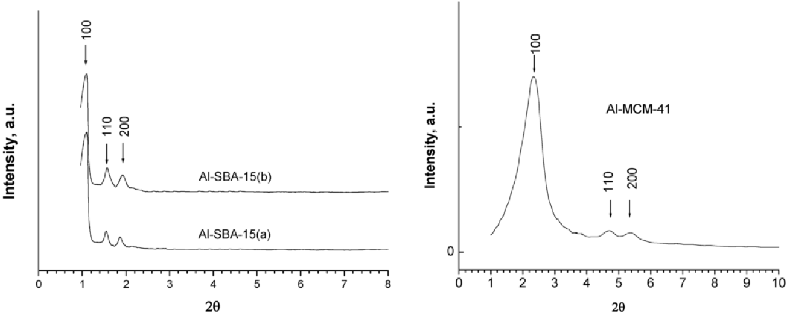

Figure 5: XRD Data

* For each plane the following characteristics will be determined
  + Slab Thickness
  + Vacuum Gap size
  + Surface thickness (The number of unrelaxed surface layers)

1. Create a amorphous surface layer from the ideal surface determined from characteristics obtained above.
2. Compare the amorphous surface reactivate with the crystalline surface

##### .

## References

Balcar, H. & Čejka, J. 2013. Mesoporous molecular sieves as advanced supports for olefin metathesis catalysts. *Coordination Chemistry Reviews*. 257(21-22):3107–3124.

Group, T.S. 2014. Overview of silica polymorphs.

Izumi, S., Hara, S., Kumagai, T., & Sakai, S. 2004. Classification of amorphous-silicon microstructures by structural parameters: Molecular dynamics study. *Computational Materials Science*. 31(3-4):258–268.

Jordaan, M. 2007. Experimental and theoretical investigation of new grubbs-mae catalysts for the metathesis of alkenes (Journal Article). North West University South Africa.

Thielemann, J.P., Girgsdies, F., Schlogl, R., & Hess, C. 2011. Pore structure and surface area of silica sba-15: Influence of washing and scale-up. *Beilstein J Nanotechnol*. 2:110–8.

Ugliengo, P., Sodupe, M., Musso, F., Bush, I.J., Orlando, R., & Dovesi, R. 2008. Realistic models of hydroxylated amorphous silica surfaces and mcm-41 mesoporous material simulated by large-scale periodic b3lyp calculations. *Advanced Materials*. 20(23):4579–4583.